MAHENDRA INSTITUTE OF ENGINEERING AND TECHNOLOGY

COLLEGE CODE ­– 6115

SMART WATER MANAGEMENT

INNOVATION

TEAM:PROJ_223284_TEAM_1

TEAM ID :565

TEAM MEMBERS;

1.KANNAN.S

2.KATHIR KUMAR.S

3.KISHORE.S

4.KAMESH.V

5.KARUPPUSAMY.M

FACULTY MENTOR NAME :

SANTHANARAJ . M

**1.INTRODUCTION**

Water, our planet’s essential component, is needed for agriculture, manufacturing, electricity production, and sustaining human health. Approximately one billion people throughout the world do not have access to safe drinking water. Water transmission pipes lose 20 percent to 30 percent of the water that passes through them on a regular basis, with losses exceeding 50 percent in older systems, particularly those that have suffered from inadequate maintenance. Water loss in transmission pipelines can be caused by a variety of factors, including leaks, metering problems, public use, and theft. Water and energy loss, as well as significant property damage, are among the issues. Due to the lengthy time and high expense associated with leak detection in the present situation, not all water leaks can be identified; as a result, some leaks continue to occur, resulting in the concerns listed above. Water leak management can be improved if leaks can be detected quickly and repaired quickly. The large disparity between supply and demand for water resources is mostly caused by global population increase and urbanization. Furthermore, aging water infrastructure is putting a pressure on the world's water supply. Cities must change into Smart Cities as the population and urbanization grow. Water is an essential resource for human life, hence smart water management systems play an important role in smart cities. Smart water management technology can improve the effectiveness and stability of a water delivery system, cutting costs and enhancing durability.

1. **METHODS** 
   1. **Water Level Indication**

To measure the water quantity and identify the water level present in the water tank, this Water Level Indication system is implemented. The definition of the water level indicator - it is an indicator that tells you how much water is present in your tank.

**How does the water level indicator work?**

* + - To know the water level present in the tank, we divided the water level of the tank into three different levels: low level, medium level and high level. So, by doing this, our indicator will help us to know the water level present in the tank easily and according to that we can refill the water in the tank. We can also save water instead of overflowing.
    - We used a few LEDs, battery and some wire connection to build this water level indicator and inside the tank we put wires in different lengths for different levels which will show water level by sending a signal back to LEDs.

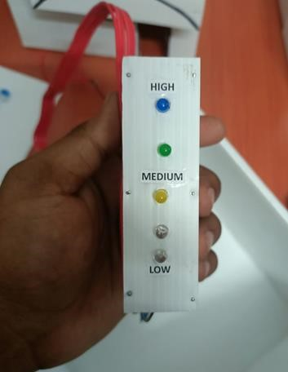

**Fig. 1**: Level-wise indication using LEDs

**The advantages of this indicator include:**

* + - The consumption of electricity will be less because the indicator helps to stop the unnecessary running of the motor after the tank gets filled. ● Overflow of water is stopped/avoided.
    - The cost of implementation is less, so we can save money.
    - The design planning of the indicator is simple.
    - This system can be implemented easily.

* 1. **Checking Purity of Water**

To check the Purity of Water we have chosen a TDS meter. The full form of TDS in drinking water is “Total Dissolved Solids”, and it is the measure of all inorganic and organic substances that are dissolved in water. Using a TDS meter, you can determine how many dissolved ions are present in a solution. Since dissolved ionized solids, such as salts and minerals, increase the conductivity of a solution, a TDS meter measures the conductivity of the solution and estimates the TDS from that reading. When the water is impure, it becomes harmful and cannot be used for any other purposes like drinking, washing or bathing. By measuring TDS levels in the water, you will be able to make sure whether the water you are drinking is pure or impure.

**Working:**

In our project the water comes from the river, and is collected in a collective tank for a street or area in which the TDS values are checked manually using the TDS meter. The collected data is converted into estimated total dissolved solids (TDS) in milligrams per liter (mg/L). If the TDS value is less than 500(mg/l), water will be sent to the next stage.

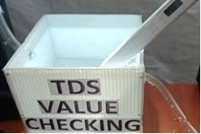

**Fig. 2:** TDS value checked using TDS meter

**2.3 Reach of Water to the Destination**

The mechanism carried out over here is to measure the volume of the water passing through the pipe. This allows us to learn if a person is extracting a higher amount of water using an external motor, which is not the right way. Also, this mechanism helps the person find if there is any shortage of water in the pipelines and between which point of the pipe due to any fault.

**Working:**

For this purpose, we have deployed a Hall effect Water flow sensor(**Model No.:**

**YFS401**) that is capable of connecting 1 inch pipe which we have utilized in our project. In case PVC pipes are used in the house, a sensor capable of connecting 1½ inch can be utilized. The pipe connection is made at both the ends of the sensor so that the water flows through entering at one end of the sensor and exiting at the other end. These deployed sensors sense the amount of water flowing through the pipe in terms of high or low pulse.

The collected data is sent to the system via a pair of **jumper wires** and **breadboard**. The arduino code is designed in such a way that it first converts the high/low pulse to time and then to frequency. From the obtained frequency value the volume of the water is calculated.

**Advantages:**

* Illegal Extraction of water can be identified.
* In case of shortage of water flow inside the pipes can also be found out.

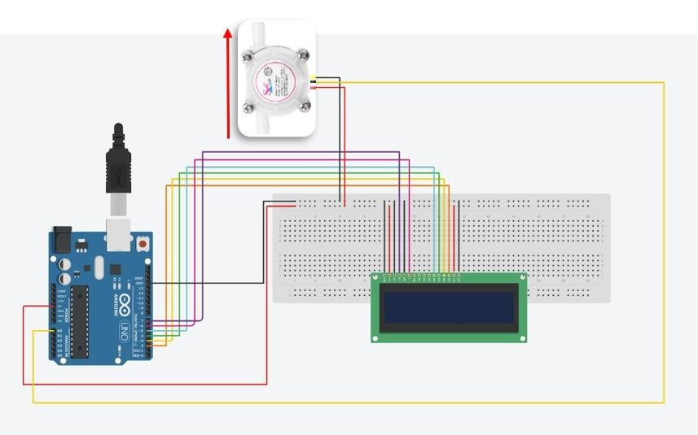

**Fig. 3 :** Design of Reach of Water to the Destination

**2.4 Leakage Detection**

**What is water leakage detection?**

The water leakage detection system is to find the water leakage in the pipes.

**Material Required:**

The leakage of water in pipes can be found by using Led Display, Arduino UNO and two water flow sensors **(Model No:YFS401)**.

**How does water leakage detection work?**

We have to find the constant flow of water by finding the flow frequency of each sensor. Using the flow frequency, we detect the time taken for the water flow between the two flow sensors and compare with the estimated time known.

We get four results,

1. If the calculated time exceeds the estimated time, more water flows through the pipe
2. If the calculated time is equal to the estimated time,water flow is normal
3. If the calculated time is lesser than the the estimated time, the water overflows from the pipe 4. If calculated time is zero then there is no water flow through the pipe

❖ **The graph is generated using data of calculated time and frequency helps us to understand easily whether the water leaks from the pipe.**

**Advantages of this water leakage detection system:**

1. This system can detect the leakage between the pipes as fast as possible using the flow sensor
2. It can stop the leakage of water
3. It helps us to save water

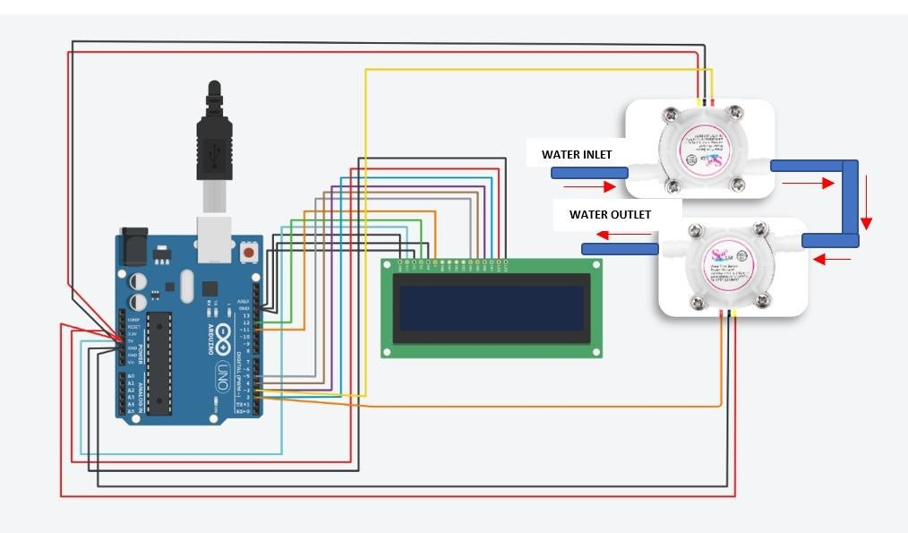Systematic Diagram of Water Leakage Detection

**2.5 Rainwater Harvesting**

The term rainwater harvesting is generally taken to intend the immediate collection of rainwater running off surfaces upon which it has fallen directly. It is a very efficient technique of conserving water. The belief behind rainwater harvesting is to no longer waste the rainwater and prevent it from running off.

In this rooftop harvesting, the roof becomes the catchment, and the rainwater is collected from the roof of the house/building and equipping the roof with pipes that direct to a tank. These pipes will divert the water falling on the roof in the tank to save water from falling off.

This is a very economical and efficient way to harvest rainwater and also prevents water wastage. The need for implementation of measures to ensure that rain falling over a vicinity is tapped as completely as possible via rainwater harvesting.

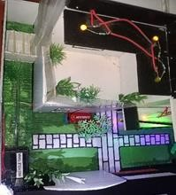

Rainwater harvesting system

**2.6 Recycling of Water:**

This is the main process of this model where the used water like kitchen, bathroom, washing clothes and all these types of water can be used for recycling purposes. This recycle tank is designed in a way of eight chambers. Starting from the **Kitchen water** ➜ **Solid waste removing** ➜ **Oil / Grease separation** ➜ **Sedimentation process** ➜ **Oxygen supply** ➜ **Non-Oil / Grease water** ➜ **Plants** ➜ **then Recycled water.** With the help of this process the water is purified in the last stage in that recycled water we can leave some fishes in it. Hence it will not form any bacteria, mosquitos etc. Thus, it helps to purify and have a better quality of recycled water. This recycled water can be used for various purposes such as gardening, irrigation etc.

**Working of this Process:**

Basically this Recycle Tank has 8 chambers to recycle the water.

* Coming to the **1st chamber** we have our **kitchen water** which comes directly from the kitchen with all types of solid wastes.
* Then in the **2nd chamber**, the **solid wastes** are removed and only the water with all types of grease and oil is moved to the 3rd chamber.

Recycle Tank Architecture

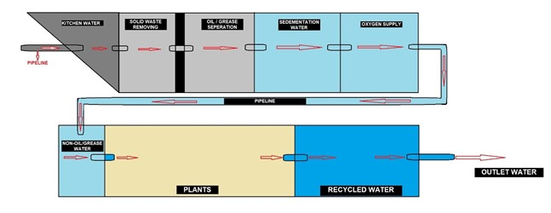

* In this **3rd chamber**, the water comes slowly because the **oil and grease** always float on the water and the water stays below. Hence it ensures that only the water is moved to the next chamber.
* Coming to the **4th chamber** here we do the **sedimentation process** for the water because since the water has been coming from the kitchen directly with some detergent here we do the sedimentation process. Where all the soap materials are sedimented down and only the water at the top portion is allowed to the next chamber.
* In the **5th** **chamber**, we give some **oxygen supply** to the water hence it should not form any hazardous gasses where the dissolved oxygen level goes to higher energy.
* This leaves the water very well because the organic bacteria grow and eat up all the carbon material inside the water. **Hence we have put a net-like structure to the chambers.**
* Water then comes out from these chambers and it is allowed to a **sanded filter** where this water is free from oil and grease. Here we have the sand and the plants growing, the type of plant which we use here is vetiver plant.
* **Vetiver plants** have also been found to be useful for water purification purposes.
* The attribute of vetiver is its capacity to purify water, and thus it helps in wastewater treatment.
* Vetiver is a species widely present in India, Which can absorb many heavy metals, nitrogen, and phosphorus from water.
* The roots of the vetiver go into the water and take away the phosphates from it. Where the phosphate is coming from the detergent hence this is how the sand filter is done.
* Here for a model we have used normal grass and plants to filter since Vetiver is a large tufted bunchgrass that can reach up to 1.5 meters in height we cannot set it up in this model.
* Finally, we have our recycled water here, where this water can be used for landscaping purposes. One of the indicators that we have is to put fish in the water because it helps us to remove the mosquitoes and larvae from the water. We have an overflow pipe. If the chamber gets filled with water the overflow pipe leads into a recharge well outside so the excess water is put back into the ground.

❖ **This way we can take the kitchen water for productive use for plants and excess water to the recharge well.**

1. **RESULTS AND DISCUSSION**

* 1. **Water Level Indication**

We tested this indicator with a demo and we noticed that it is working fine. If the water is present at the 25% of tank capacity then the LED labeled low is glowing. If the water in the tank is between 75% to 100% then the LED labeled high is glowing and intermediate water level shown by medium level LED. The indicator is showing the level of water on emptying and filling the tank by glowing the LEDs perfectly. It is very easy to implement on the field.

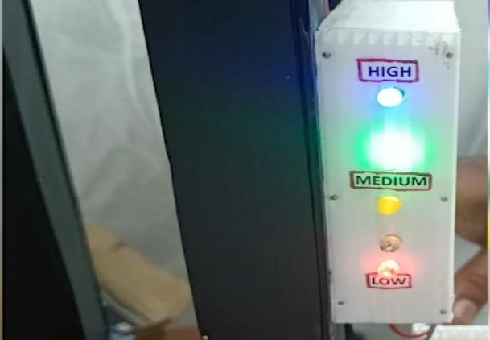

LED showing water level

* 1. **Checking the Purity Of Water**

We tested the purity of water which comes from the river and found that it has a TDS value of 394, which is safe for drinking.

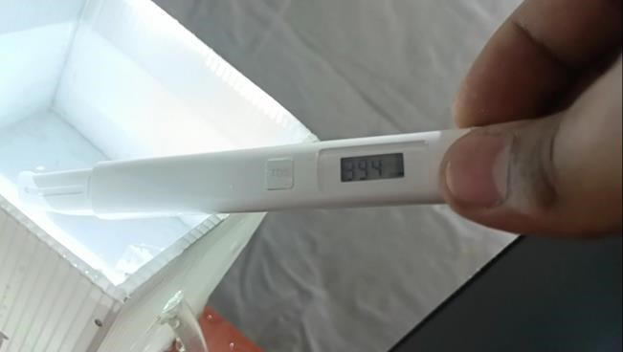

TDS meter showing value 394

**Table 1:**

TDS Range

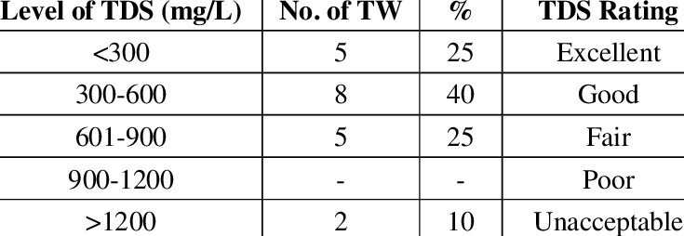

* 1. **Reach of water to the Destination**

The Water flow sensor has detected and sent the data to the arduino that later gives the command to print the Volume of the water after calculations and the LCD displays it.

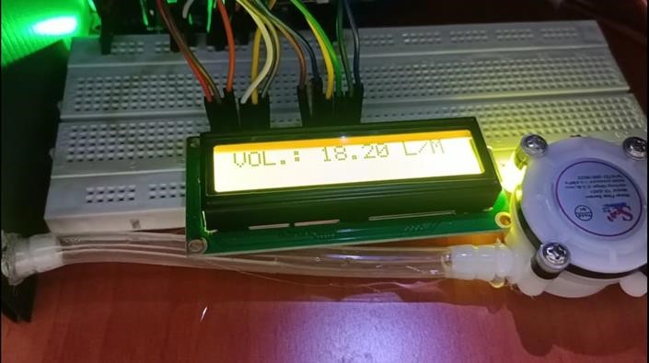 **Fig. 9:** LCD displaying Volume of Water

* 1. **Leakage Detection**

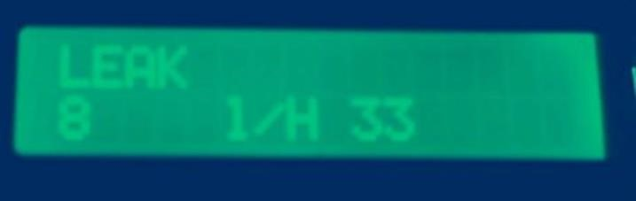

Display that water leaks from the pipe

**Graph 1:**

Water Leakage Detection

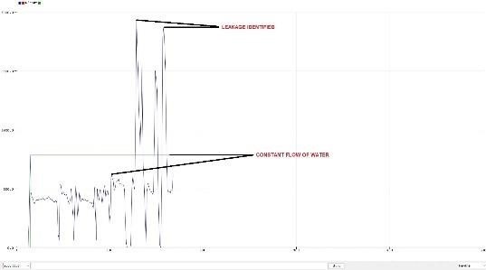

From the above graph, if the reading shows high then leakage of water in pipes is detected and if the reading shows low then no leakage is detected.

* 1. **Rain water harvesting**



Rain water harvesting

Rainwater harvesting has various benefits and uses. However, harvesting systems are practiced to operate and store water in a considerable amount for future purposes.

* 1. **Recycle Tank:**

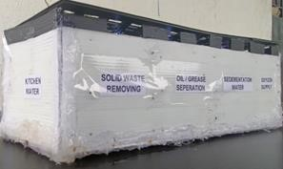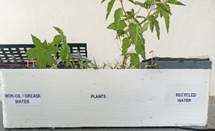

Recycle tank

This Recycle tank consists of 8 chambers in it followed by various methodologies. The output of this tank gives us purified water. Which can be used for other utilities like gardening, irrigation, car washing etc.

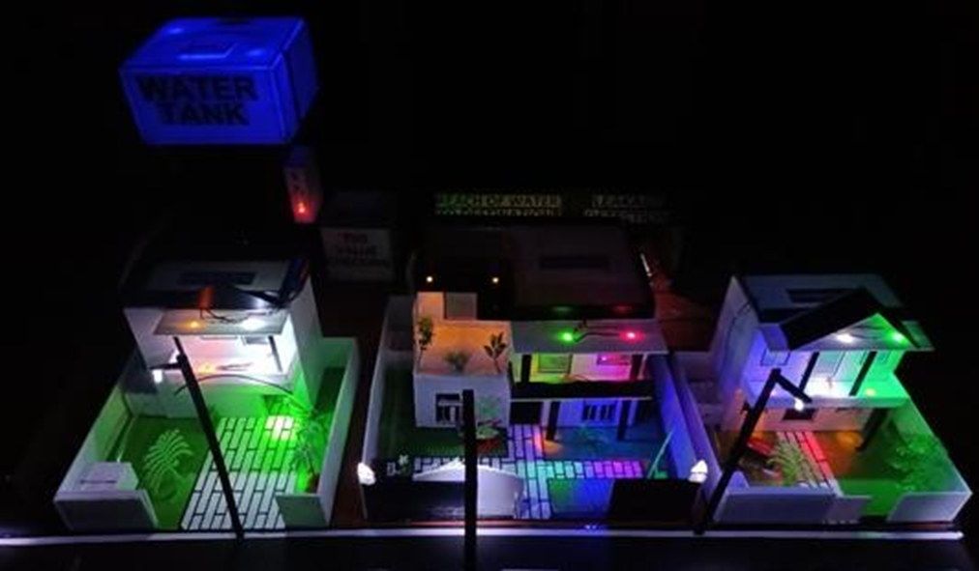

**4.CONCLUSION**

We have created a system to control the supply system's variables such as water pressure, water quality, and water pollution. This system is proven to be evident to manage and supply the need for water in urban areas. For backup of water, a rainwater harvesting mechanism is implemented for each house. Major water related issues like water leakage and shortage are identified using the leakage detection along with the reach of water to the destination mechanisms. Immediate alert for any leakage or shortage of water is notified through the leak showing graph and lcd display.

Circumstances like water overflow are avoided using water level indication to be aware of the amount of water filled in the tank. Later, the same concept can be applied to a large number of distribution tanks and consumers. As part of safe usage of water, its purity is checked with the help of a **TDS** meter. A vital mechanism of this system, which is recycling of water, has been included to reuse the waste water coming from the kitchen sink and washing machine outlet. The obtained water after recycling is safe to use for gardening and washing cars.

For the advancing and evolving world, as we step into transforming our surroundings into an enhanced and sustaining environment with the help of smart technologies and many more, our smart water supply and management system proposed here would be beneficial. This system can be utilized in smart cities, towns, villages and places where managing and distributing water in a smart and sophisticated way is needed.

[View publication stats](https://www.researchgate.net/publication/360269606)