PROJECT REPORT
E-Commerce Customer Churn
Analysis & Prediction
An End-to-End Data Analytics and Machine Learning Project

Submitted By | SK Ismail
Registration No. | 250320100153
Programme | Master of Computer Applications (MCA)
Institution | Centurion University of Technology & Management, Bhubaneswar
Internship | IBM SkillsBuild Data Analytics with AI Internship 2026
Internship ID | IBMUEDA2574

Internship Period: 17 August 2026 – 30 September 2026
Trainer: Mr. Kartik Hooda

DECLARATION
I, SK Ismail, declare that this project report titled “E-Commerce Customer Churn Analysis & Prediction” has been prepared as part of the IBM SkillsBuild Data Analytics with AI Internship 2026. The work presented in this report describes the data analysis, machine learning development and interactive application implementation carried out for the project.
I further declare that the project work has been prepared for academic and internship learning purposes and that the results reported are based on the dataset, experiments and implementation described in this report.

Particular | Details
Name | SK Ismail
Registration No. | 250320100153
Internship ID | IBMUEDA2574
Date | 24/09/2026

ACKNOWLEDGEMENT
I would like to express my sincere gratitude to BharatCares, AICTE and IBM SkillsBuild for providing the opportunity to participate in the Data Analytics with AI Internship 2026. The internship provided exposure to data analytics, predictive modeling, AI tools and practical project development.
I am thankful to the mentors and subject matter experts, especially Mr. Kartik Hooda, for their guidance during the learning and project-development process. I also acknowledge Centurion University of Technology & Management for supporting my learning journey and providing an academic environment in which I could apply the concepts learned during the internship.
Finally, I am grateful to everyone who supported me during the development, testing and documentation of this project.

ABSTRACT
Customer churn is an important business problem in e-commerce because losing an existing customer can affect revenue, repeat purchases and long-term customer value. This project develops an end-to-end machine learning workflow for analysing customer behaviour and predicting whether an e-commerce customer is likely to churn.
The project uses customer-level behavioural and transaction-related attributes such as tenure, warehouse-to-home distance, registered devices, preferred order category, satisfaction score, marital status, number of addresses, complaints, days since last order and cashback amount. The workflow includes data inspection, missing-value handling, duplicate removal, exploratory data analysis, categorical encoding, train-test splitting, Random Forest model training, evaluation and feature-importance analysis.
After preprocessing, the working dataset contained 3,270 customer records. The trained Random Forest model achieved 90.98% accuracy on the held-out test set. A Streamlit application was developed to provide an interactive interface for entering customer details and displaying churn probability and risk level.

CONTENTS
Declaration
Acknowledgement
Abstract
1. Internship Context
2. Introduction
3. Problem Statement
4. Objectives
5. Dataset Description
6. Methodology
7. Data Preprocessing
8. Exploratory Data Analysis
9. Machine Learning Model
10. Model Evaluation
11. Feature Importance
12. Prediction Demonstration
13. Streamlit Application
14. Key Findings
15. Limitations
16. Future Scope
17. Conclusion
18. Project Structure
19. References

1. INTERNSHIP CONTEXT
The project was completed as part of the 6-week Virtual IBM SkillsBuild Data Analytics with AI Internship 2026 offered in collaboration with AICTE. The official offer letter identifies the internship as an industry-focused programme intended to build foundational knowledge in Data Science and Data Analytics with hands-on exposure to AI tools.
The internship was scheduled from 17 August 2026 to 30 September 2026. The learning structure covered data analytics, data cleaning and preprocessing, exploratory data analysis, predictive analytics, machine learning basics, AI-driven insights and visualization. The programme also required development and submission of a final project.
Internship Element | Details
Internship | IBM SkillsBuild Data Analytics with AI Internship 2026
Internship ID | IBMUEDA2574
Duration | 17 August 2026 – 30 September 2026
Collaboration | BharatCares – AICTE – IBM SkillsBuild
Institution | Centurion University of Technology & Management, Bhubaneswar
Project Domain | Data Analytics / Predictive Analytics / Machine Learning
Trainer | Mr. Kartik Hooda

The official offer letter describes the programme as unpaid and lists participation, learning-plan completion, project development and final submission among its requirements.

2. INTRODUCTION
E-commerce platforms collect large volumes of information about customer interactions, order preferences, satisfaction and purchasing behaviour. Analysing this information can help identify patterns associated with customer churn.
Customer churn refers to a customer becoming inactive or discontinuing engagement with a business. In this project, churn is treated as a binary classification problem. The machine learning system learns from historical customer records and predicts whether a customer belongs to the churn or non-churn class.
The project follows a practical analytics lifecycle: understand the dataset, clean and prepare the data, explore patterns, transform features, train a predictive model, evaluate the model and present the result through an interactive Streamlit application.
3. PROBLEM STATEMENT
The objective is to develop a machine learning solution that analyses e-commerce customer behaviour and estimates the likelihood that a customer will churn.
Component | Description
Input | Customer demographic, satisfaction, order and behavioural attributes
Processing | Data cleaning, encoding, train-test split and machine learning
Output | Churn / Not Churn prediction and churn probability
Application | Interactive Streamlit dashboard

4. OBJECTIVES
- Inspect the customer dataset and identify data-quality issues.
- Handle missing values and remove duplicate records.
- Explore churn distribution and relationships with customer and order attributes.
- Transform categorical variables into model-ready numerical features.
- Train a Random Forest classification model for churn prediction.
- Evaluate the model using accuracy, precision, recall and F1-score.
- Analyse feature importance to understand influential variables in the trained model.
- Build an interactive Streamlit application for customer-level prediction.
- Deploy the application so it can be accessed through a web browser, including on mobile devices.

5. DATASET DESCRIPTION
The project uses an e-commerce customer churn dataset containing customer behaviour and transaction-related attributes. The initial dataset contained 3,941 records and 11 columns. Three columns contained missing values and duplicate records were present.
Column | Description
Tenure | Customer tenure in months
WarehouseToHome | Distance between warehouse and customer home
NumberOfDeviceRegistered | Number of registered customer devices
PreferedOrderCat | Preferred order category
SatisfactionScore | Customer satisfaction score
MaritalStatus | Customer marital status
NumberOfAddress | Number of addresses associated with customer
Complain | Whether the customer submitted a complaint
DaySinceLastOrder | Days since the last order
CashbackAmount | Customer cashback amount
Churn | Target variable: churn / non-churn

After data cleaning and duplicate removal, the working dataset contained 3,270 records and 11 columns. The target distribution contained 534 churned customers and 2,736 non-churned customers, corresponding to an overall churn rate of 16.33%.
6. METHODOLOGY
The project was implemented as an end-to-end analytics and machine learning workflow:
- Dataset loading and initial inspection
- Missing-value and duplicate analysis
- Data cleaning and export of the processed dataset
- Exploratory Data Analysis and visualization
- Feature-target separation
- Categorical feature encoding using one-hot encoding
- Stratified 80:20 train-test split
- Random Forest classifier training
- Model evaluation using classification metrics and confusion matrix
- Feature importance analysis
- Model and feature-column serialization using pickle
- Streamlit application development
- Deployment of the interactive application

7. DATA PREPROCESSING
The initial dataset was inspected for shape, data types, missing values and duplicate records. The initial shape was 3,941 × 11. Missing values were present in Tenure, WarehouseToHome and DaySinceLastOrder. A total of 671 duplicate rows were identified.
Preprocessing Step | Result
Initial records | 3,941
Initial columns | 11
Missing-value columns | Tenure, WarehouseToHome, DaySinceLastOrder
Duplicate rows identified | 671
Final records after cleaning | 3,270
Final missing values | 0
Categorical encoding | One-hot encoding with drop_first=True

After cleaning, the processed dataset was saved as cleaned_ecommerce_churn.csv. For model development, the target column Churn was separated from the input features and categorical columns were converted into numerical indicator variables.
8. EXPLORATORY DATA ANALYSIS
Exploratory analysis was performed to understand the target distribution and examine relationships between churn and customer behaviour. The analysis included churn distribution, churn rate by preferred order category, satisfaction score, customer complaints, tenure and days since last order.

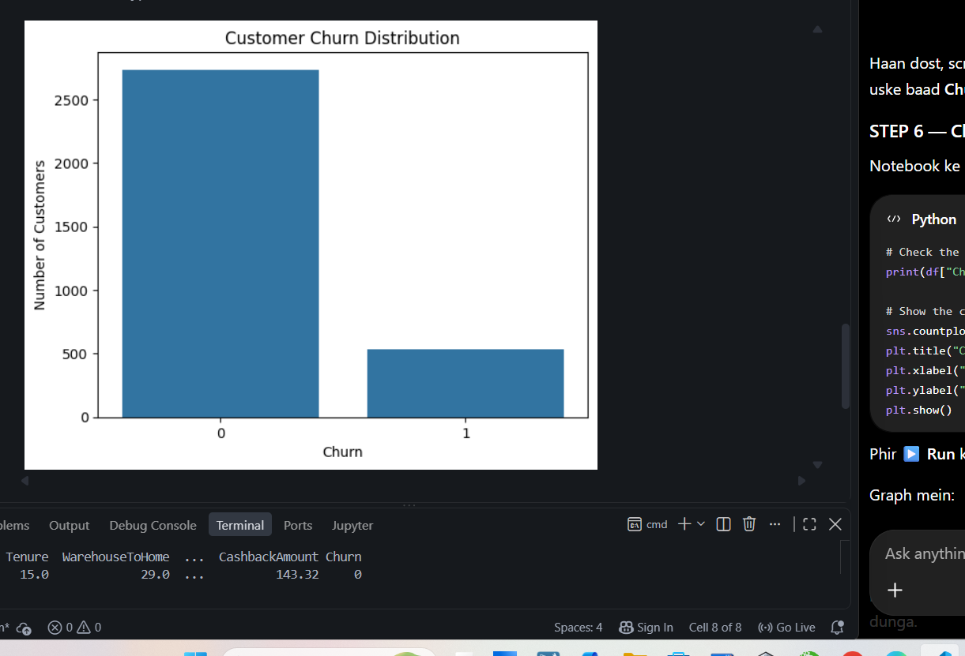
Figure 1: Customer churn distribution.

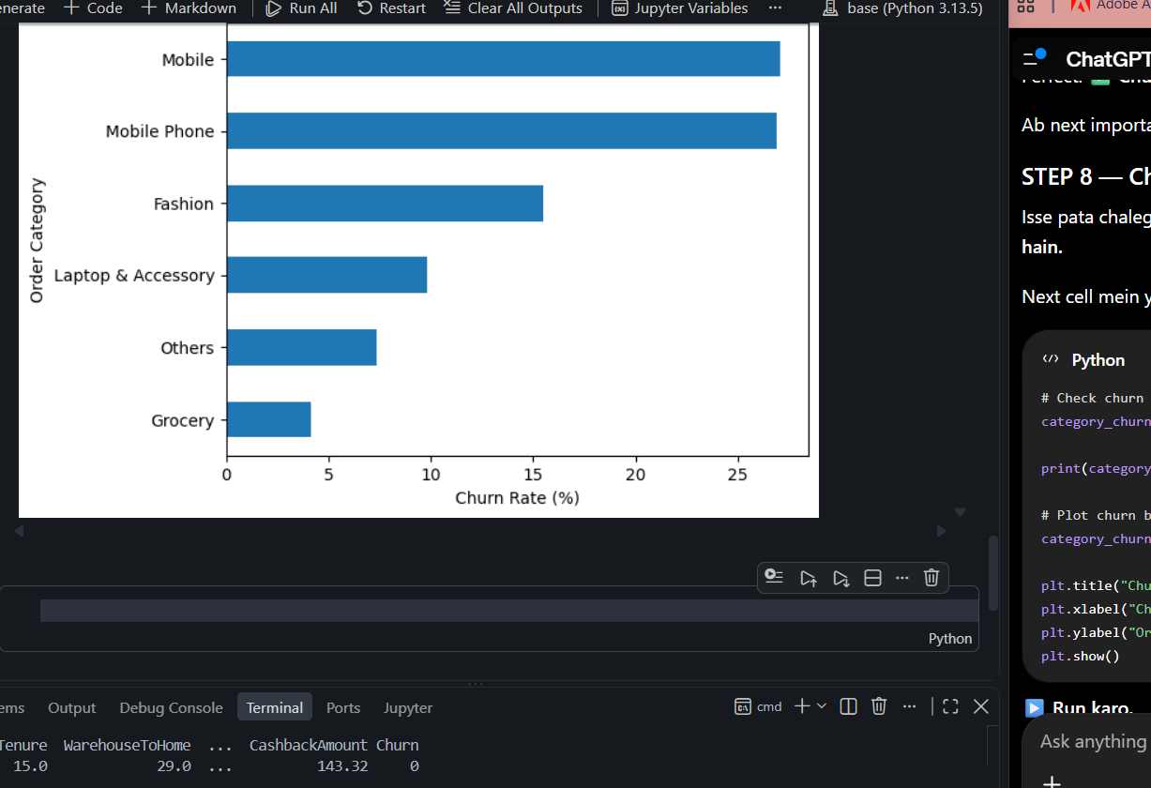
Figure 2: Churn rate by preferred order category.
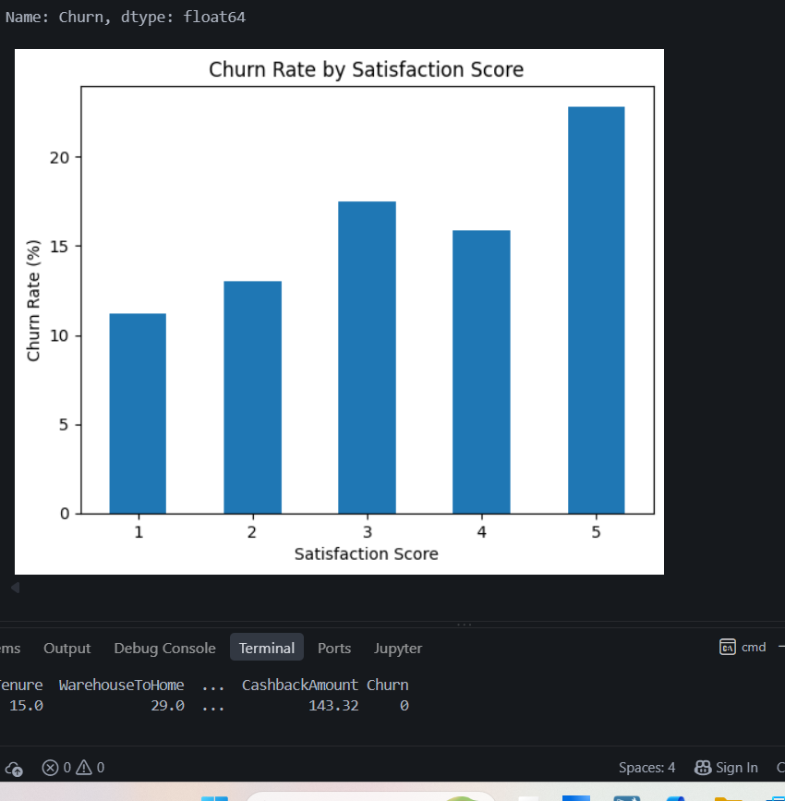
Figure 3: Churn rate by satisfaction score.
The dataset is imbalanced toward the non-churn class. The overall churn rate is 16.33%. The EDA charts are descriptive and show patterns in the dataset; they do not by themselves establish causal relationships.
9. MACHINE LEARNING MODEL
A Random Forest Classifier was used for customer churn prediction. Random Forest is an ensemble classification method that combines multiple decision trees and aggregates their predictions. It is suitable for mixed customer-behaviour features after categorical encoding.
The feature matrix contained 15 model-ready features after one-hot encoding. The data was divided into training and testing subsets using an 80:20 split with random_state=42 and stratification on the target variable.
Model Setting | Value
Algorithm | Random Forest Classifier
Number of estimators | 100
Random state | 42
Train set | 2,616 records
Test set | 654 records
Input features | 15
`10. MODEL EVALUATION
The model was evaluated on the held-out test set. The resulting accuracy was 90.98%. The classification report showed different performance across the two classes, which is important because the churn class is smaller than the non-churn class.
Metric | Class 0 (Not Churn) | Class 1 (Churn) | Macro Avg | Weighted Avg
Precision | 0.93 | 0.77 | 0.85 | 0.91
Recall | 0.96 | 0.64 | 0.80 | 0.91
F1-score | 0.95 | 0.70 | 0.82 | 0.91
Support | 547 | 107 | 327 | 654

Confusion matrix: 526 non-churn customers were correctly classified, 21 non-churn customers were predicted as churn, 38 churn customers were predicted as non-churn, and 69 churn customers were correctly classified.
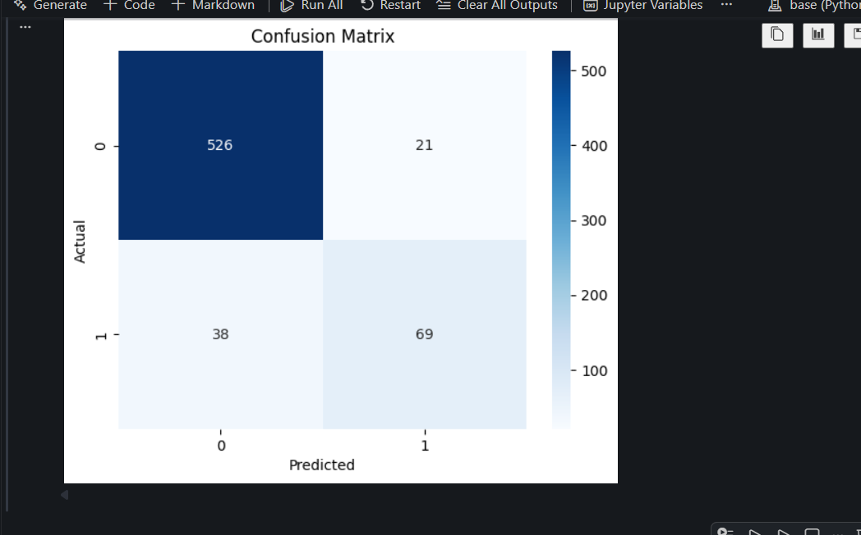
Figure 4: Confusion matrix of the Random Forest classifier.
11. FEATURE IMPORTANCE
Feature importance was extracted from the trained Random Forest model to understand which input variables contributed most to the model's decision process. Tenure was the most important feature in the recorded model, followed by CashbackAmount, WarehouseToHome, NumberOfAddress and DaySinceLastOrder.
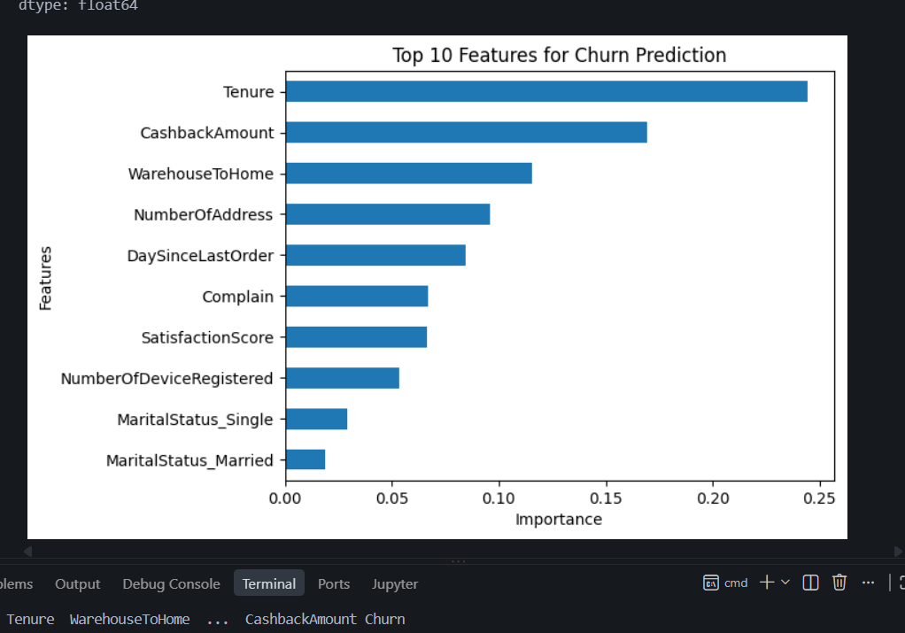
Figure 5: Top features used by the trained Random Forest model.
Feature | Relative interpretation in the trained model
Tenure | Highest recorded feature importance
CashbackAmount | High relative importance
WarehouseToHome | Important behavioural/transaction-related feature
NumberOfAddress | Moderate importance
DaySinceLastOrder | Moderate importance
Complain | Additional behavioural signal
SatisfactionScore | Customer experience signal
NumberOfDeviceRegistered | Customer usage signal

Feature importance indicates how the trained model used the available variables; it should not be interpreted as proof that a feature causes churn.
12. PREDICTION DEMONSTRATION
The Streamlit interface allows a user to enter customer information such as tenure, registered devices, number of addresses, marital status, satisfaction score, preferred order category, warehouse-to-home distance, days since last order, complaint status and cashback amount.
For the demonstration shown in the application, the model returned a “Likely to Stay” status with a displayed churn probability of 1.00% and a Low Risk level.
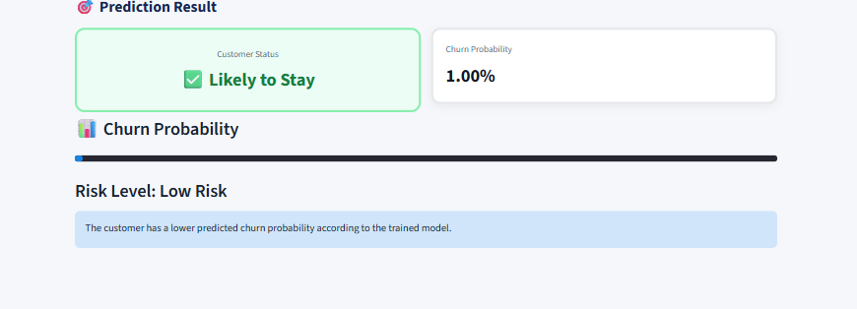
Figure 6: Example customer churn prediction result.
13. STREAMLIT APPLICATION
A Streamlit application was developed to make the trained model accessible through an interactive web interface. The dashboard presents business-level metrics, churn distribution, category-level analysis, important churn factors and a customer-level prediction form.
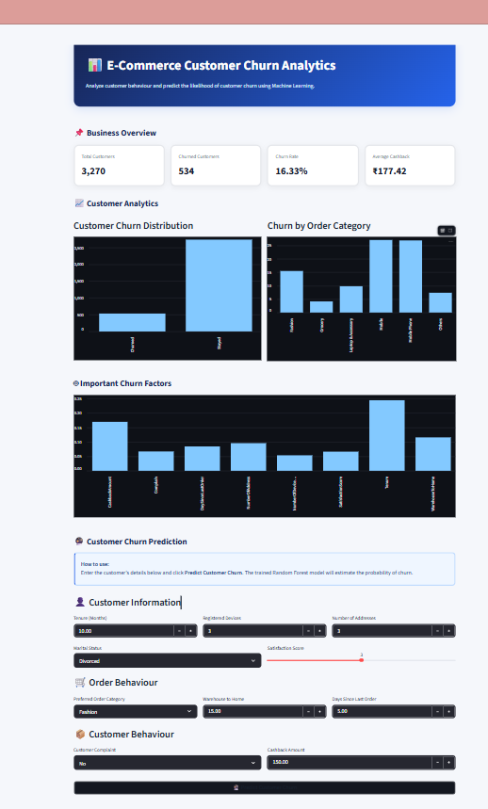
Figure 7: E-Commerce Customer Churn Analytics Streamlit dashboard.
The application loads the trained model and the saved feature-column list. User inputs are converted into the same model-ready feature structure used during training, after which the application displays the predicted class, churn probability and risk level.
The deployed application is browser-based, so the same web application can be opened from a desktop or a mobile browser. Mobile presentation can vary with screen size and browser settings.
14. KEY FINDINGS
- The cleaned working dataset contains 3,270 customer records.
- There are 534 churned customers, giving an overall churn rate of 16.33%.
- The non-churn class is substantially larger than the churn class, so class-wise metrics are important alongside accuracy.
- The Random Forest model achieved 90.98% accuracy on the held-out test set.
- The model identified Tenure as the most important feature in the recorded feature-importance analysis.
- CashbackAmount, WarehouseToHome, NumberOfAddress and DaySinceLastOrder also showed notable importance.
- The Streamlit application provides an interactive prediction workflow and communicates churn probability and risk level.
15. LIMITATIONS
- The model is trained on one historical customer dataset and may not generalize to other e-commerce businesses or populations.
- The dataset contains a smaller churn class, which affects recall and other class-specific metrics.
- The model's predictions are data-driven estimates and should not be treated as guaranteed future outcomes.
- Feature importance reflects the trained model and dataset; it does not establish causality.
- The application is a project demonstration rather than a production customer-retention decision system.
- Additional validation on newer and independent customer data would be required before operational use.
16. FUTURE SCOPE
- Evaluate additional algorithms such as Gradient Boosting, XGBoost and calibrated ensemble models.
- Perform hyperparameter tuning and cross-validation.
- Experiment with class-weighting or resampling methods to improve churn-class recall.
- Add model explainability using SHAP or similar techniques.
- Add customer segmentation and retention-oriented dashboards.
- Track model performance and data drift as new customer data becomes available.
- Integrate the application with a secure database or business analytics platform after suitable validation.
17. CONCLUSION
This project demonstrates an end-to-end data analytics and machine learning workflow for e-commerce customer churn analysis and prediction. The work covers data inspection, cleaning, exploratory analysis, feature encoding, model training, evaluation, feature-importance analysis and interactive deployment.
The cleaned dataset contains 3,270 customer records, including 534 churned customers. The Random Forest classifier achieved 90.98% accuracy on the held-out test set, while the class-wise evaluation highlights the importance of examining precision, recall and F1-score for the minority churn class.
The Streamlit application converts the analytical workflow into an interactive tool where customer information can be entered and the trained model can return a churn prediction, probability and risk level. The project therefore combines data analytics, machine learning and application development into a single practical use case.
18. PROJECT STRUCTURE
The final project repository is organized as follows:
ecommerce-customer-churn-analysis/
├── data/
│ ├── data_ecommerce_customer_churn.csv
│ ├── check_data.py
│ └── processed/
│ └── cleaned_ecommerce_churn.csv
├── models/
│ ├── churn_model.pkl
│ └── feature_columns.pkl
├── notebooks/
│ └── ecommerce_churn_analysis.ipynb
├── app.py
├── README.md
├── requirements.txt
├── .gitignore
└── .gitattributes
19. REFERENCES
- BharatCares – AICTE Internship Offer Letter for SK Ismail, IBM SkillsBuild Data Analytics with AI Internship 2026.
- IBM SkillsBuild – Data Analytics and AI learning resources.
- Scikit-learn documentation – Random Forest classification and model evaluation.
- Streamlit documentation – Python-based interactive data applications.
- Python, Pandas, NumPy, Matplotlib and Seaborn documentation.
- Project dataset and implementation files maintained in the project GitHub repository.

APPENDIX A – DEPLOYED APPLICATION
The project was deployed as a Streamlit web application. The deployed dashboard presents the same analytical components and prediction workflow described in this report.

Figure 8: Deployed E-Commerce Customer Churn Analytics application.
APPENDIX B – INTERNSHIP OFFER DETAILS
The official internship offer letter records the student's Internship ID as IBMUEDA2574 and confirms the internship period from 17 August 2026 to 30 September 2026. The offer letter also describes the programme's learning structure and final project submission requirements.

