Modeling the impact of influenza epidemics on the agricultural workforce and
food production in the United States

Abstract.

Introduction.

Methods.
Data. County-level population sizes, proportion of crowded households, and proportion of agricultural workers were obtained from the US Census Bureau’s 2022 American Community Survey (ACS). Crowded households are defined as those with >1 individual per room. Agricultural workers were defined as those involved in “_______”. We aggregated the county-level data to the regional level using population-weighted averages.

Data on household size and household crowding are recorded separately. For our analysis, we need both values together, i.e., the fraction of households of a given size that are crowded. To assign crowding levels by household size, we used the relation
____

Here, ____ (note that, by the US Census definition of crowding, households of size 1 cannot be crowded). This relation ensures that the overall fraction of crowded households is maintained, while distributing that crowding differently among households of various sizes: the parameter ___ reflects how much more likely it is for a household of size 7+ to be crowded than a household of size 2. For the baseline analysis, we assumed _____, i.e., all households of size > 1 are crowded at the same frequency. For sensitivity analyses, we allowed ____ to range up to ____, reflecting a scenario where households of size 7+ are ___ times more likely to be crowded than households of size 2.

For agricultural workers, regional household sizes and the proportion of crowded households were obtained from the 2018-2022 National Agricultural Worker Survey (NAWS). For each region, we calculated the weighted proportion of households of size 0, 1, 2, … 7+ and the weighted proportion of crowded households (those with >1 individual per room).

[Crop calendars]

Some types of lettuce are harvested multiple times per head; maybe stick with iceberg (https://coststudyfiles.ucdavis.edu/uploads/pub/2023/08/04/2023-iceberglettuce-full-final.pdf) since it’s generally only harvested once, at maturity [x].

Strawberries are harvested every 2-3 days, suggesting they need to be harvested within that window to maintain quality [x]. For the time a crop can spend in the field, we might try 3 days for strawberries, one week for lettuce, and 60 days for oranges [x]. So, we might have a plot showing labor lost over time (not accounting for field storage) and crop lost, accounting for field storage. This emphasizes that the epidemic would probably lead to delays in the orange harvest but lost harvest for lettuce and especially strawberries.

Disease transmission model. To simulate the spread of disease, we used a deterministic household-structured susceptible-infectious-recovered (SIR) model built upon an existing framework [x]. The model accounts for within- and between-household transmission and explicitly accounts for both household size and crowding. The model structure is illustrated in Figure Sxx. Mathematical details are provided in the Supplementary Information.

For the main analysis, we simulated disease transmission at the regional level among agricultural workers and the general community. We initialized the fraction of the population in each group, along with the distribution of household sizes within these groups, using the ACS and NAWS data.

To set the within-household transmission rate τ, we used estimates of the secondary attack rate. The expected secondary attack rate is equal to τ / (τ + γ), where γ is the recovery rate. By fixing the recovery rate (we used γ = 1/5 for a mean recovery time of 5 days [x]), we can calculate τ. For the base analysis, we assumed that the secondary attack rate was xx% for uncrowded households and xx% for crowded households, in line with evidence from household studies on the secondary attack rate for influenza. In sensitivity analyses, we allowed τ for crowded households to vary from xx to xx.

With τ fixed, we chose the β value that yielded a reproduction number of 1.2. This reflects the estimated reproduction number for influenza [x] and is in line with the effective reproduction number during surges of COVID-19 [x]. In sensitivity analyses, we considered reproduction numbers from 1.1 – 3.

To account for preferential mixing among agricultural workers, we defined a mixing matrix with parameter $ϵ$, where $ϵ∈\left[0,1\right]$ reflects a continuum between perfectly random mixing ($ϵ= 0$) and strictly group-based mixing, i.e., agricultural workers only interact with other agricultural workers and vice versa ($ϵ= 1$). We used a baseline value of $ϵ=$_____. In the sensitivity analyses, we considered $ϵ=$____, ____, and ____ (Supplementary Information).

Data
- ACS: county-level population sizes, crowding, household size, proportion of agricultural workers, rural/urban.
- NAWS: regional household sizes
- Crop calendars and labor requirements from UC Davis and USDA.

Disease transmission model.
- Built around a household structured disease transmission model.
  - Household sizes from 1 – 8
  - Crowding from data
  - Assign crowding in various ways: from uniform to more likely in larger households.
- Include two groups: agricultural workers and general community members.
- Accounting for household crowding.
- Specifying $τ$ and $β$ (and $γ$).
- Two main analytic parameters: $ϵ$ and $τ_{\text{boost}}$. (and maybe crowding differential? And really $β$, too).

Disease transmission analysis.
- Regional (main) analysis: aggregate the ACS data to the regional level; simulate cases; calculate infections over time, total cases over time (for final size), relative number of infections in A vs. C over time.
- County-level (auxiliary) analysis: impute household sizes and crowding for ag workers at the county level by scaling by the deviations from the regional mean at the county level. Measure the same outcomes.

Assessing the impact on food production.
- Measure hours of lost work overall.
- Seed epidemics at different times of year. Depict the impact on food production of three major crops at different onset times.

Results.

Crowding is more frequent among agricultural worker households.
- Mean household size is similar among agricultural households and the general population, though households with 4+ individuals tend to be more common for households with an agricultural worker.
- Crowding, on the other hand, is substantially higher among agricultural worker households.

Household crowding leads to higher disease prevalence among agricultural workers.
- For regional models, we see higher peak and higher final size
- These differences are sensitive to the reproduction number
- These differences are reflected in county-level simulations

Respiratory disease outbreaks among agricultural workers can lead to major productivity losses.
- Overall productivity loss under basic assumptions
- Case studies: Harvesting losses by season for three major crops (the seasonality of the outbreak will impact which crops are most affected). Do this for California.

Discussion.

Findings:
- Asdf

Context:
- asdf

Limitations:
- No disease transmission seasonality
- Lack of county-level information on agricultural workers
- Lack of information on assortativity of contacts
- Lack of other things that could impact transmission risk (e.g., exposure to chemicals – NAWS finds higher rates of baseline respiratory disease in ag workers; differentials in comorbidities; differences in access to care).
- Focus on just three labor intensive crops, but the impacts will be felt more broadly.
- Impact of respiratory viral disease on the food system extends well beyond harvests, extending to food processing (e.g., meat processing during the COVID-19 pandemic) and demand-side issues (stockpiling, or avoiding certain food products for fear of disease)
- Consider the impact of human disease; the impact of animal and plant diseases has been examined elsewhere; we haven’t considered zoonotic/cross-species jumps of disease, where maybe both humans and birds could be infected.
- In the crop-level analysis, we don’t consider multiple crops simultaneously: it’s hard to know how the amount that labor is “stretched” across multiple crops being harvested at the same time might impact the availability of labor.
- A potential point about the R0: we might expect lower apparent R0 at higher spatial scales since we’re summing a bunch of epidemic curves that take place over a long timespan – lots of the curves we add will be zeros.

References.

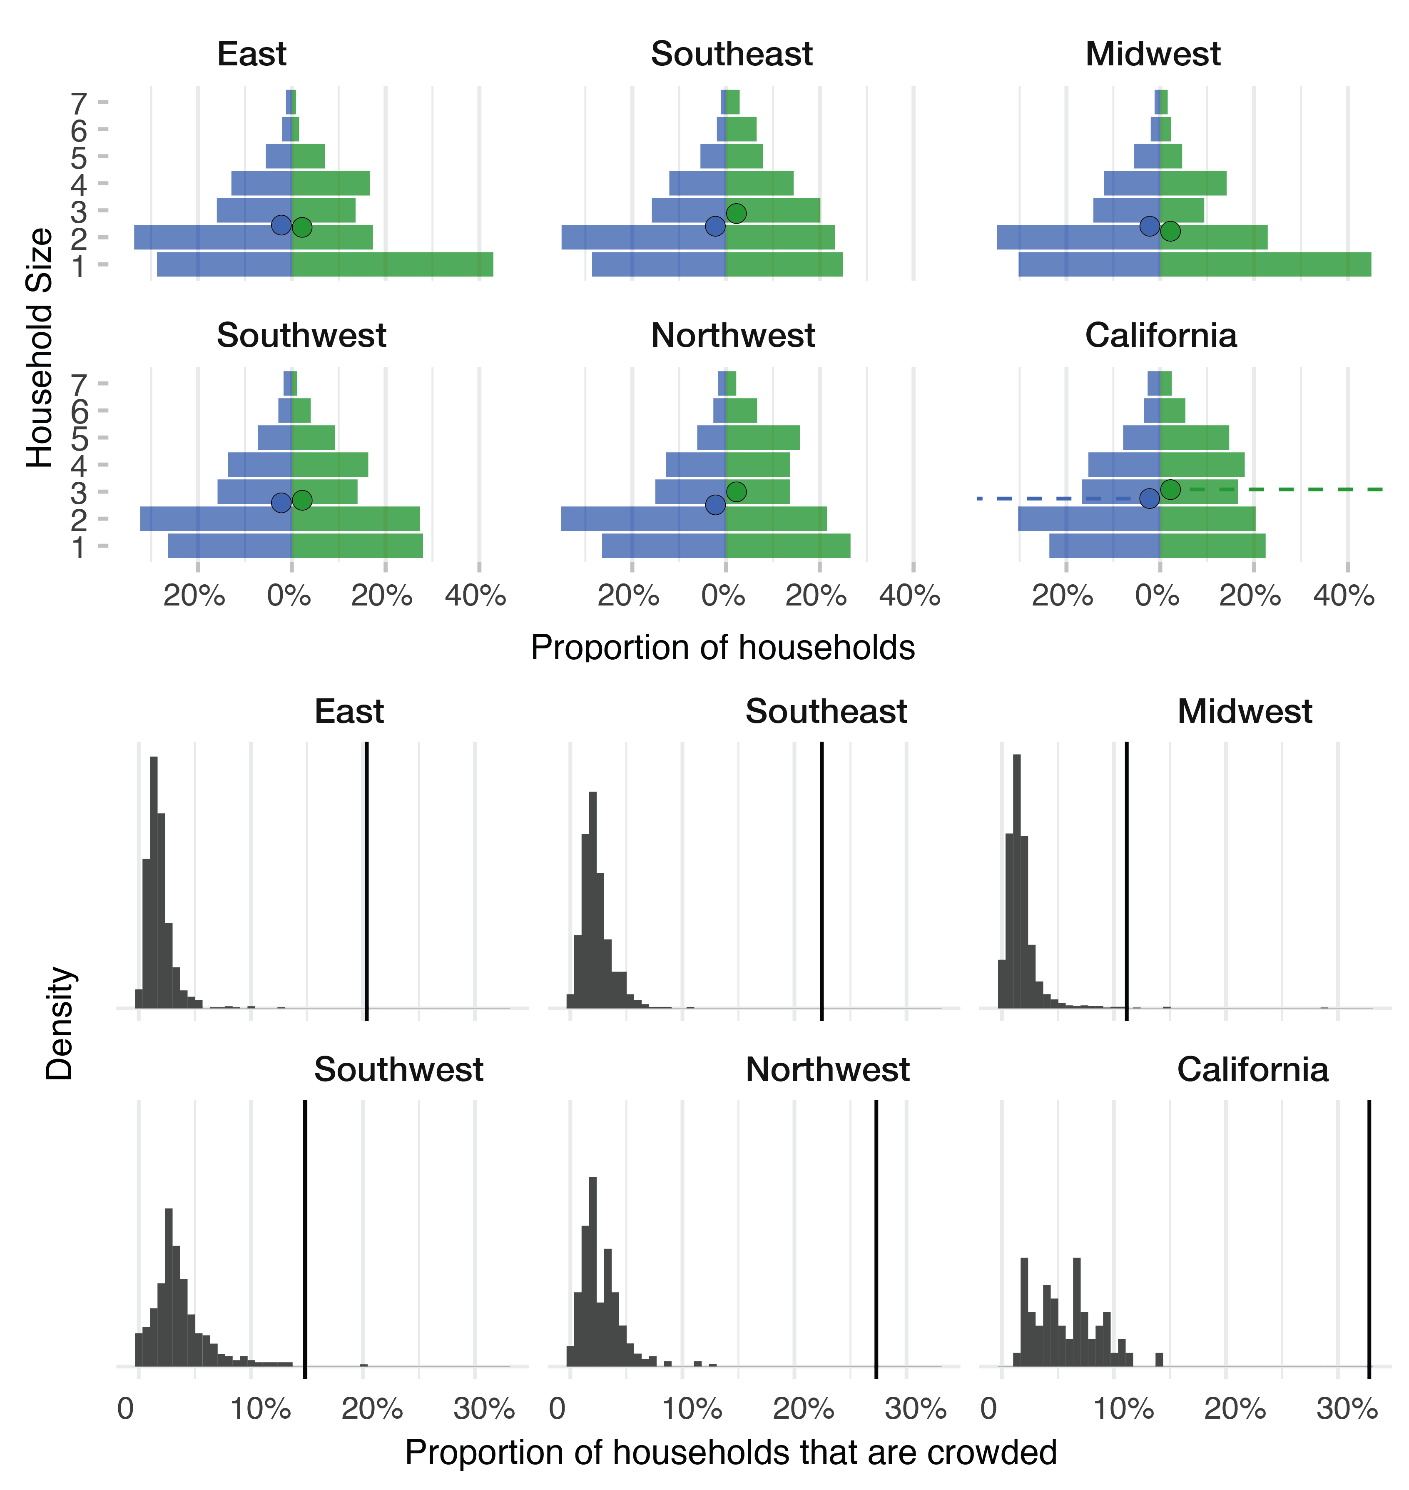
Figure 1. Household composition among agricultural workers and the general US population.

Supplement.

Mathematical model.

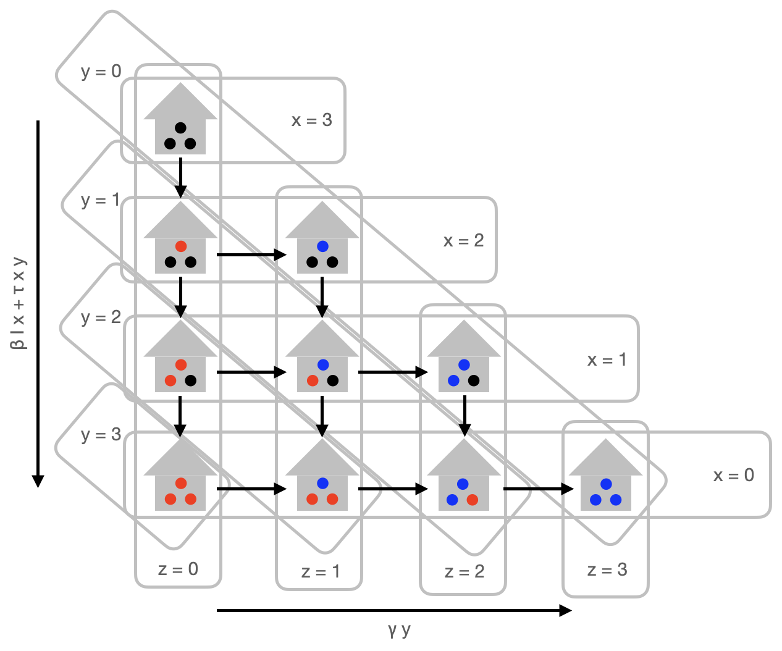

Sensitivity analyses:
- Varying SAR boost for crowded households
- Varying Rt
- Varying relationship between [odds of being crowded] and [household size]
- Varying assortment

