**Modeling the impact of influenza epidemics on the agricultural workforce and**

**food production in the United States**

**Abstract.**

**Introduction.**

**Methods.**

Data. County-level population sizes, proportion of crowded households, and proportion of agricultural workers were obtained from the US Census Bureau’s 2022 American Community Survey (ACS). Crowded households are defined as those with >1 individual per room. Agricultural workers were defined as those involved in “_______”. We aggregated the county-level data to the regional level using population-weighted averages.

For agricultural workers, regional household sizes and the proportion of crowded households were obtained from the 2018-2022 National Agricultural Worker Survey (NAWS). For each region, we calculated the weighted proportion of households of size 0, 1, 2, … 7+ and the weighted proportion of crowded households (those with >1 individual per room).

[**Crop calendars**]

Disease transmission model. To simulate the spread of disease, we used a deterministic household-structured susceptible-infectious-recovered (SIR) model built upon an existing framework [x]. The model accounts for within- and between-household transmission and explicitly accounts for both household size and crowding. The model structure is illustrated in **Figure xx**. Mathematical details are provided in the **Supplementary Information**.

For the main analysis, we simulated disease transmission at the regional level among agricultural workers and the general community. We initialized the fraction of the population in each group, along with the distribution of household sizes within these groups, using the ACS and NAWS data.

To set the within-household transmission rate τ, we used estimates of the secondary attack rate. The expected secondary attack rate is equal to τ / (τ + γ), where γ is the recovery rate. By fixing the recovery rate (we used γ = 1/5 for a mean recovery time of 5 days), we can calculate τ. For the base analysis, we assumed that the secondary attack rate was xx% for uncrowded households and xx% for crowded households, in line with evidence from household studies on the secondary attack rate for influenza. In sensitivity analyses, we allowed τ for crowded households to vary from xx to xx.

With τ fixed, we chose the β value that yielded a reproduction number of 1.2. In sensitivity analyses, we considered reproduction numbers from 1.1 – 3.

To account for preferential mixing among agricultural workers

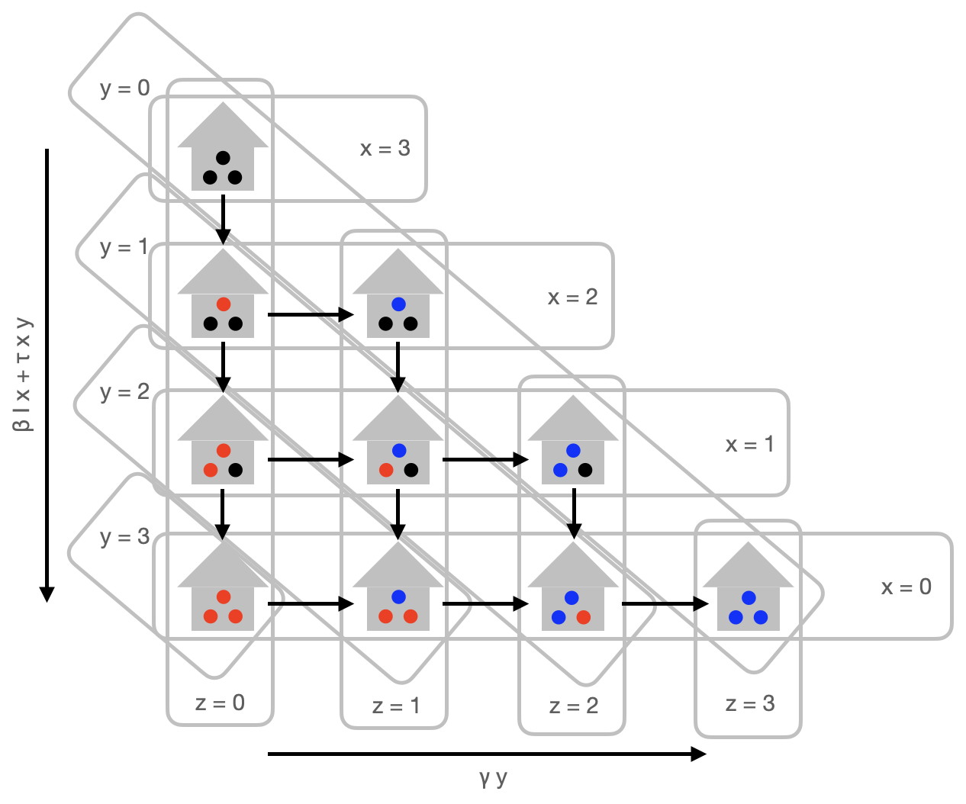

Data

* ACS: county-level population sizes, crowding, household size, proportion of agricultural workers, rural/urban.
* NAWS: regional household sizes
* Crop calendars and labor requirements from UC Davis and USDA.

Disease transmission model.

* Built around a household structured disease transmission model.
  + Household sizes from 1 – 8
  + Crowding from data
  + Assign crowding in various ways: from uniform to more likely in larger households.
* Include two groups: agricultural workers and general community members.
* Accounting for household crowding.
* Specifying $τ$ and $β$ (and $γ$).
* Two main analytic parameters: $ϵ$ and $τ_{\text{boost}}$. (and maybe crowding differential? And really $β$, too).

Disease transmission analysis.

* Regional (main) analysis: aggregate the ACS data to the regional level; simulate cases; calculate infections over time, total cases over time (for final size), relative number of infections in A vs. C over time.
* County-level (auxiliary) analysis: impute household sizes and crowding for ag workers at the county level by scaling by the deviations from the regional mean at the county level. Measure the same outcomes.

Assessing the impact on food production.

* Measure hours of lost work overall.
* Seed epidemics at different times of year. Depict the impact on food production of three major crops at different onset times.

**Results.**

Crowding is more frequent among agricultural worker households.

Household crowding leads to higher disease prevalence among agricultural workers.

* For regional models, we see higher peak and higher final size
* These differences are sensitive to the reproduction number
* These differences are reflected in county-level simulations

Respiratory disease outbreaks among agricultural workers can lead to major productivity losses.

* Overall productivity loss under basic assumptions
* Integration with FoodTwin: losses by sector by geography
* Case studies: Harvesting losses by season for three major crops (the seasonality of the outbreak will impact which crops are most affected).

**Discussion.**

Findings:

* Asdf

Context:

* asdf

Limitations:

* No disease transmission seasonality
* Lack of county-level information on agricultural workers
* Lack of information on assortativity of contacts
* Lack of other things that could impact transmission risk (e.g., exposure to chemicals – NAWS finds higher rates of baseline respiratory disease in ag workers; differentials in comorbidities; differences in access to care).
* Focus on just three labor intensive crops, but the impacts will be felt more broadly.
* Impact of respiratory viral disease on the food system extends well beyond harvests, extending to food processing (e.g., meat processing during the COVID-19 pandemic) and demand-side issues (stockpiling, or avoiding certain food products for fear of disease)
* Consider the impact of human disease; the impact of animal and plant diseases has been examined elsewhere; we haven’t considered zoonotic/cross-species jumps of disease, where maybe both humans and birds could be infected.

**References.**

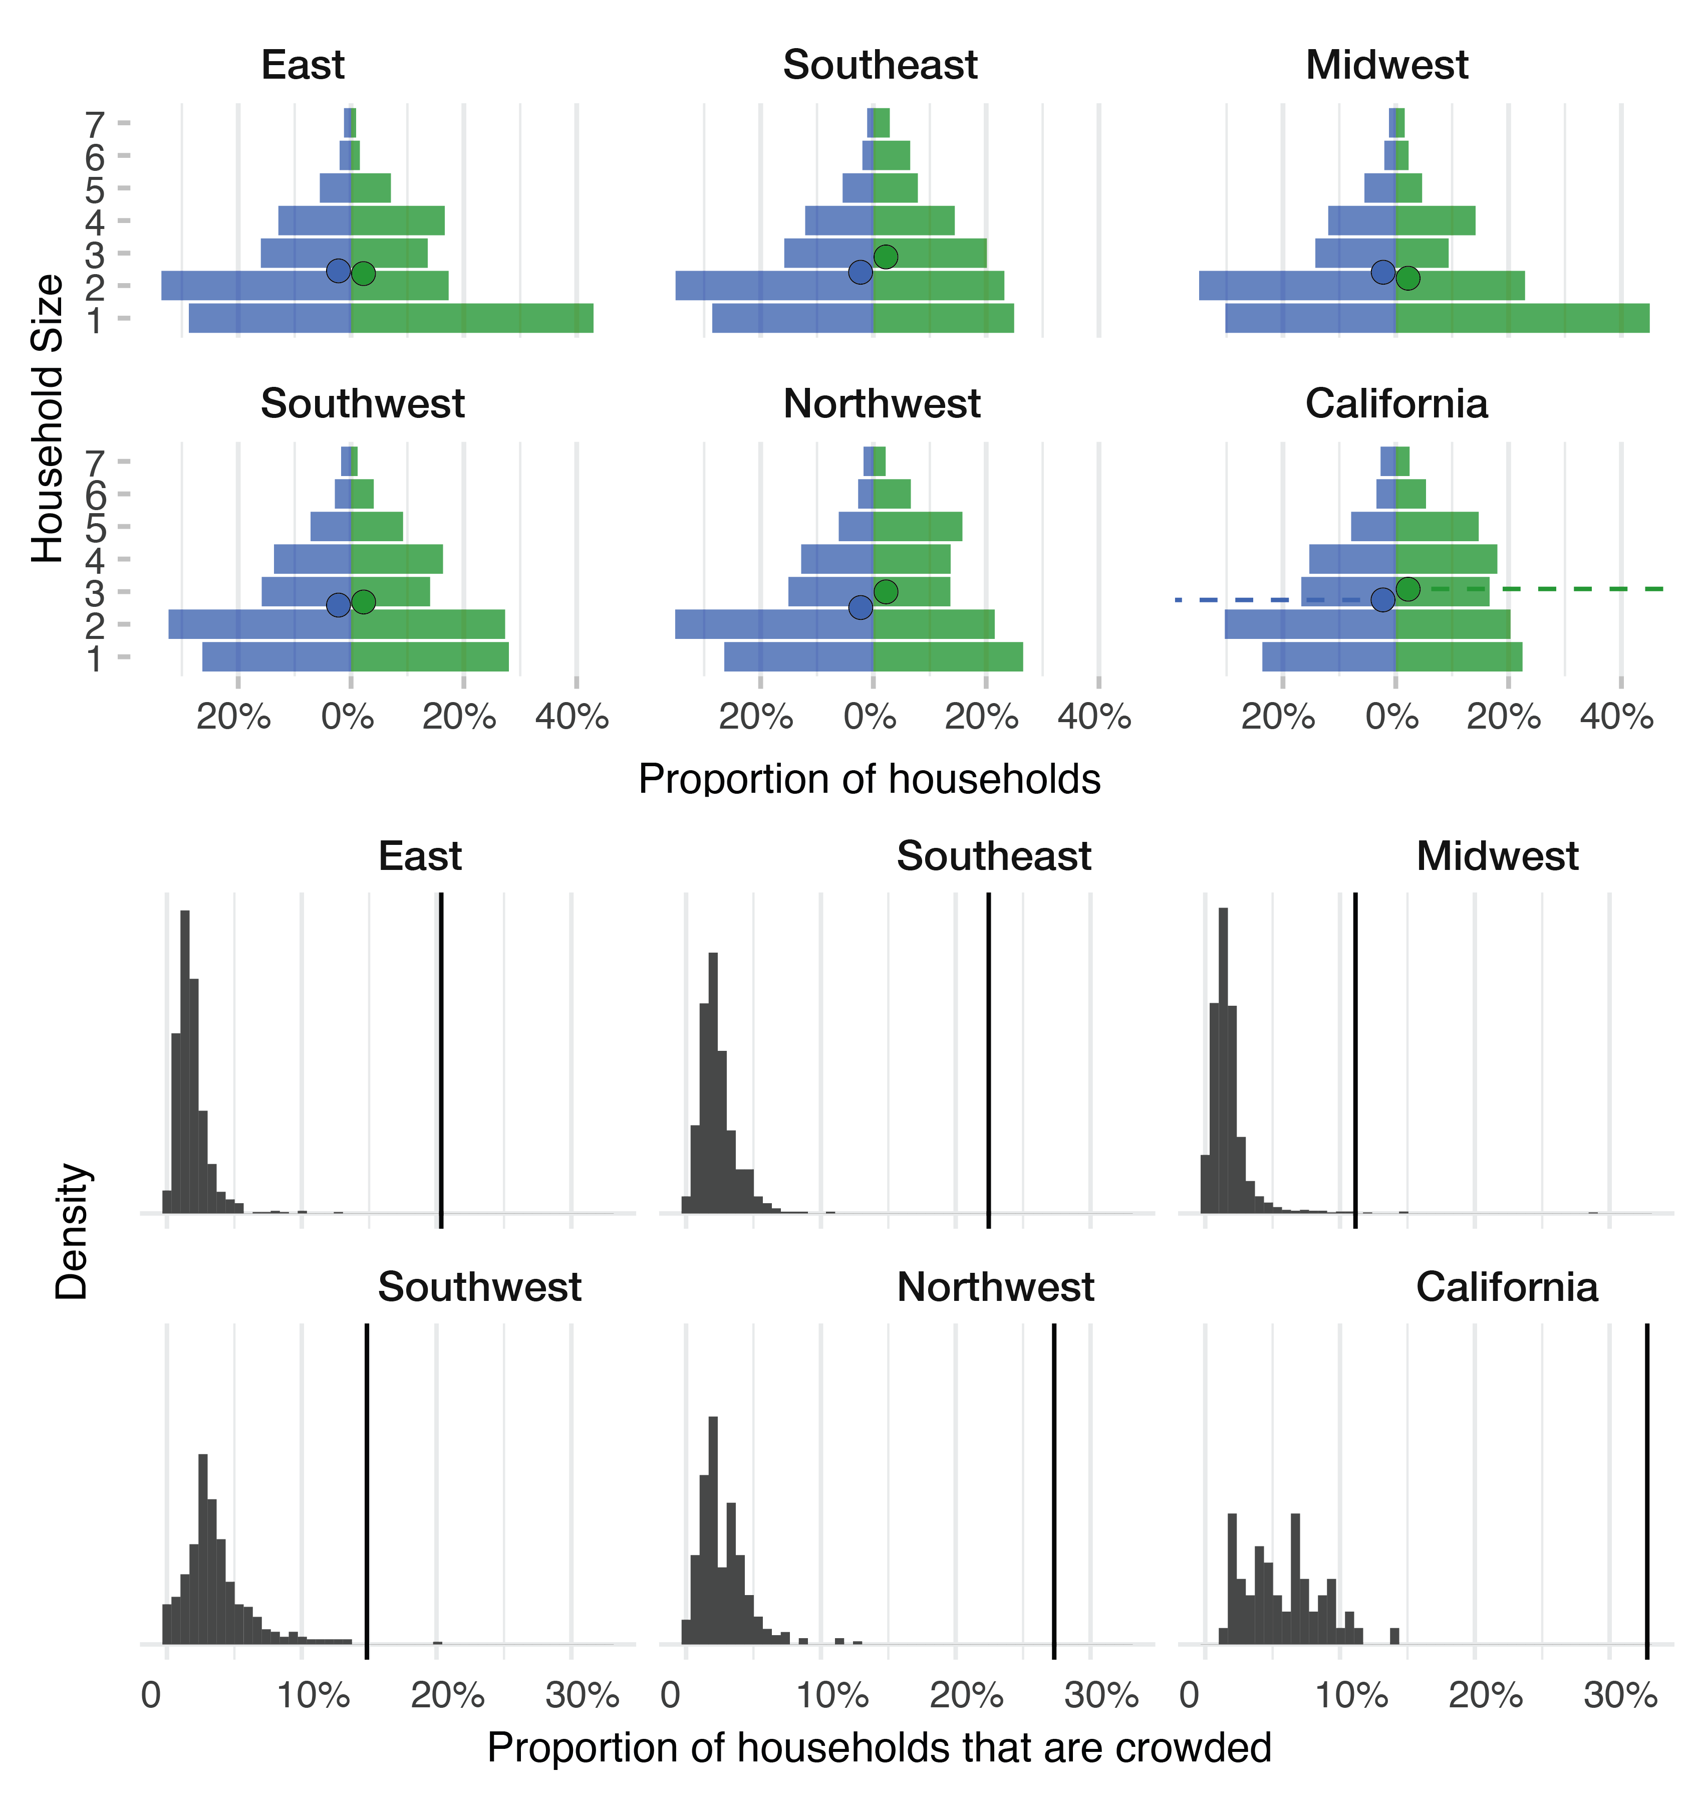

**Supplement.**

Sensitivity analyses:

* Varying SAR boost for crowded households
* Varying Rt
* Varying relationship between [odds of being crowded] and [household size]
* Varying assortment