Pasabuy Tracker
User Guide
A step-by-step guide to running your pasabuy trips: orders, payments, deliveries, reports and backups.
Version 1.0 · October 2026 · Android & Web
Contents
1. Introduction 3
1.1 Key terms 3
1.2 The overall flow 3
2. Getting around the app 4
2.1 Status badges 4
3. Step-by-step guide 5
Step 1: Create your first trip 5
Step 2: Read the Trip dashboard 7
Step 3: Switch, edit or delete a trip 8
Step 4: Check your luggage budget 9
Step 5: Add a customer 10
Step 6: Create an order 11
Step 7: Work with the order details 13
Step 8: Record payments 14
Step 9: Move the order through its progress 16
Step 10: Hand over the order 17
Step 11: Find any order 18
Step 12: Follow up on payments 19
Step 13: Review reports and export 20
4. More menu 22
4.1 Customers 22
4.2 Settings and backups 23
4.3 Support the developer 24
5. How amounts are calculated 25
5.1 Worked example 25
6. Rules and important notes 26
6.1 What the app allows 26
6.2 Your data 26
6.3 Android vs. web version 26
7. Troubleshooting & FAQ 27

Note: If the list above is empty, right-click it in Word and choose "Update Field".

1. Introduction
Pasabuy Tracker helps you run a pasabuy (buy-for-others) business while travelling. You set up a trip, take orders from customers, let the app compute your service and handling fees, record every payment, track each order until it is handed over, and review your earnings at the end of the trip.
Everything is stored on your phone only. The app works fully offline and nothing is uploaded to a server, so remember to export backups regularly (see section 4.2).

1.1 Key terms
Term | Meaning
Trip | One buying trip from an origin to a destination, with travel dates, an order cutoff date, a baggage allowance and your fee rates.
Customer | A person who orders from you. Saved with name, contact, address and email.
Order | Everything one customer ordered on one trip. Each order gets a reference number such as ORD-2481.
Item | A product inside an order: name, unit cost, quantity and an optional photo.
Service fee | Your percentage on top of the item cost (for example 15%).
Handling fee | A charge per kilogram of the order’s total packed weight (for example ₱150/kg).
Order cutoff | The last day you accept new orders for the trip.
Handover code | A 4-digit code the customer reads back to you when you release their items.

1.2 The overall flow
A typical trip follows these steps. Each one is explained in detail in section 3.
- Create a trip: route, dates, cutoff, baggage and fees.
- Add customers.
- Create orders with their items. The app computes what the buyer pays.
- Collect payments: downpayments, full payments and receipts.
- Buy the items, then pack and weigh each order.
- Hand over each order with a code and delivery proof.
- Review reports and export a backup.

2. Getting around the app
The app has five tabs at the bottom of the screen.
Tab | What it is for
Trip | Dashboard of the active trip: cutoff countdown, luggage used, money collected and owed, and orders that need attention.
Orders | All orders on the active trip, with search and status filters. Start new orders here.
Payments | Who has paid, who has a partial balance, and who has not paid at all.
Reports | Earnings, statistics, top buyers, and PDF/CSV export.
More | Opens a menu with Customers, Settings and Support the developer.

2.1 Status badges
Orders and trips show coloured badges so you can see their state at a glance.
Badge | Meaning
CONFIRMED | The order was created and is waiting to be bought.
BOUGHT | You have bought the items.
PACKED | The order is weighed and packed in your luggage.
DELIVERED | The order was handed over to the customer.
UNPAID / PARTIAL / PAID | No payment yet / part of the total received / the full total received.
OPEN / CLOSED (trips) | Whether the trip still accepts new orders.

3. Step-by-step guide

Step 1: Create your first trip
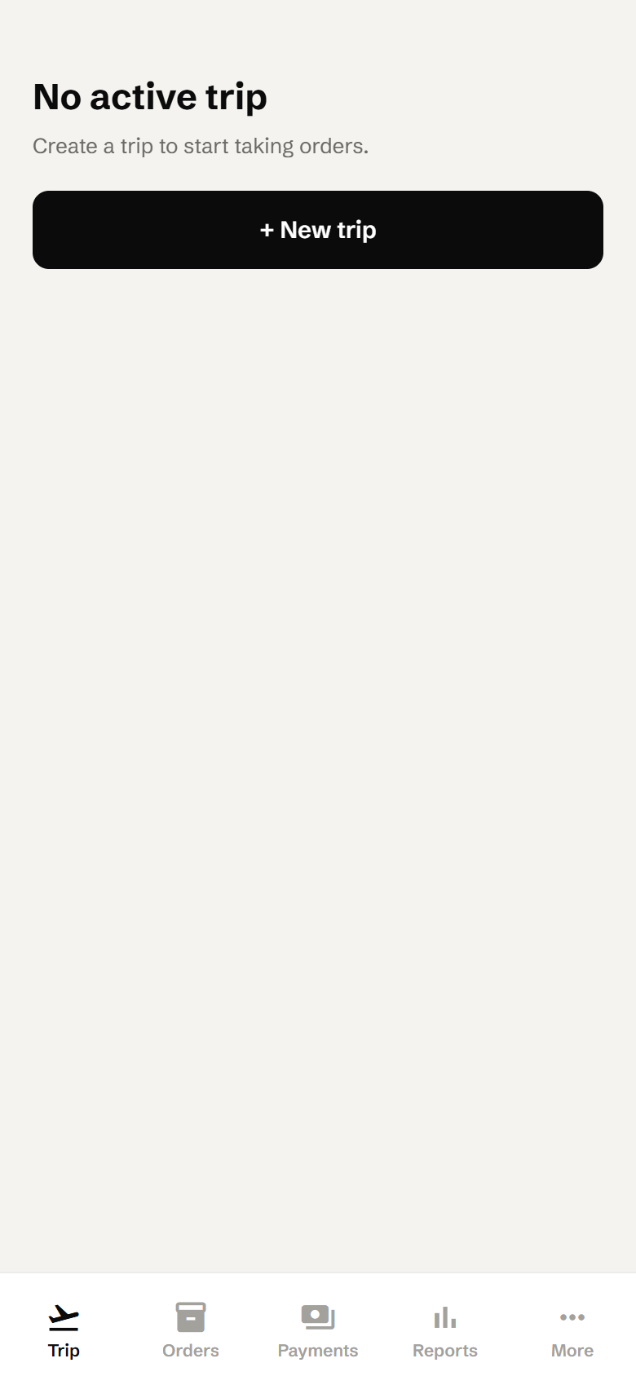  Figure 1. First launch | When you open the app for the first time you will see No active trip.  - Tap + New trip.  Tip: You need at least one trip before you can add orders.

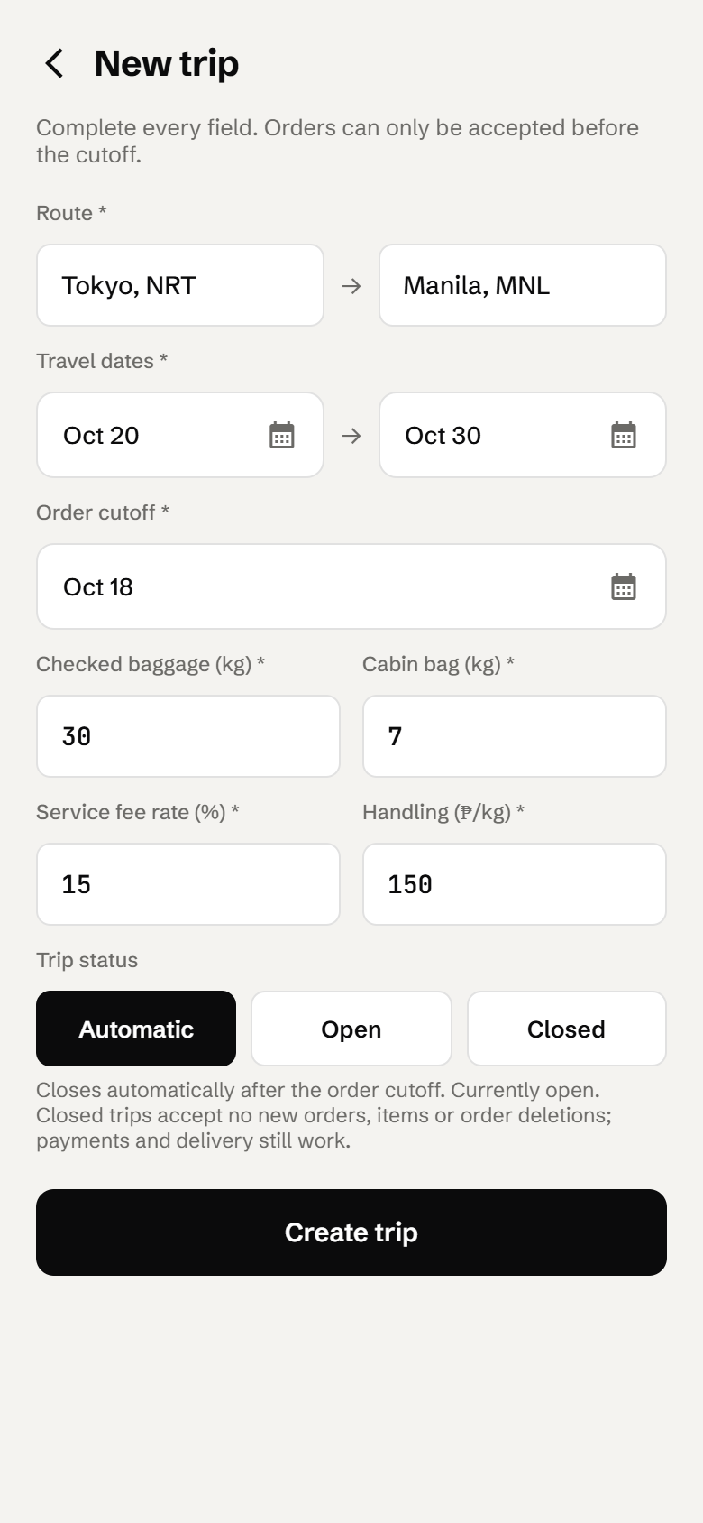  Figure 2. New trip form | - Route: type where you are buying from (e.g. "Tokyo, NRT") and where you are going (e.g. "Manila, MNL").  - Travel dates: pick the departure date and the return date.  - Order cutoff: the last day to accept orders. It must be on or before the departure date.  - Checked baggage (kg) and Cabin bag (kg): your luggage allowance.  - Service fee rate (%) and Handling (₱/kg): your default charges.  - Trip status: leave it on Automatic (the trip closes the day after the cutoff), or force it Open or Closed.  - Tap Create trip.  Note: Every field is required. If something is wrong, a red message appears under the field, for example "Return date must be on or after departure".

Step 2: Read the Trip dashboard
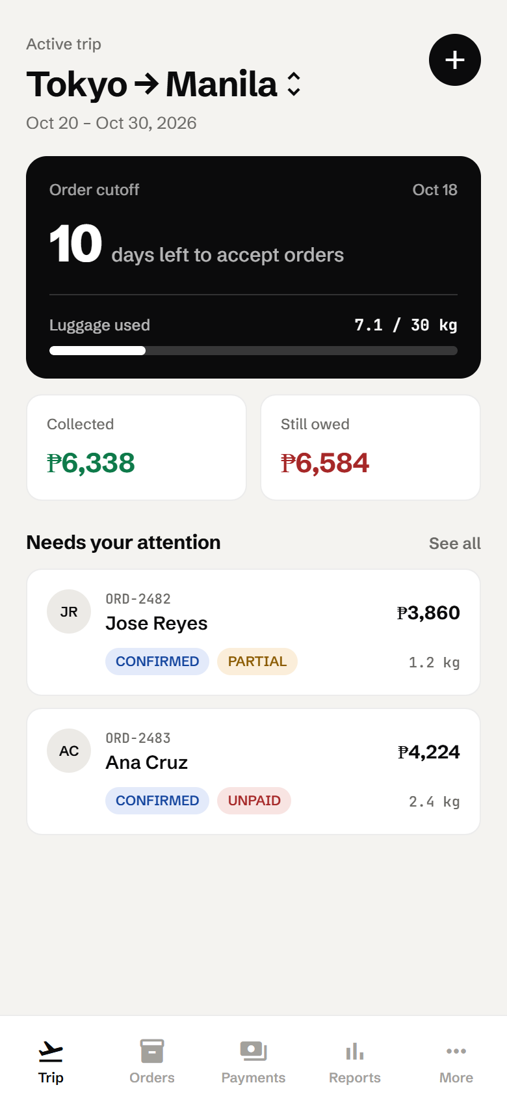  Figure 3. Trip dashboard | The Trip tab is your home screen for the active trip.  - Order cutoff: how many days are left to accept orders.  - Luggage used: total weight of all orders against your checked allowance. Tap it to open the Luggage budget (Step 4).  - Collected (green) and Still owed (red): money received and money still due.  - Needs your attention: orders that are not yet fully paid. Tap See all to open the Orders tab.  - The round + button creates another trip.

Step 3: Switch, edit or delete a trip
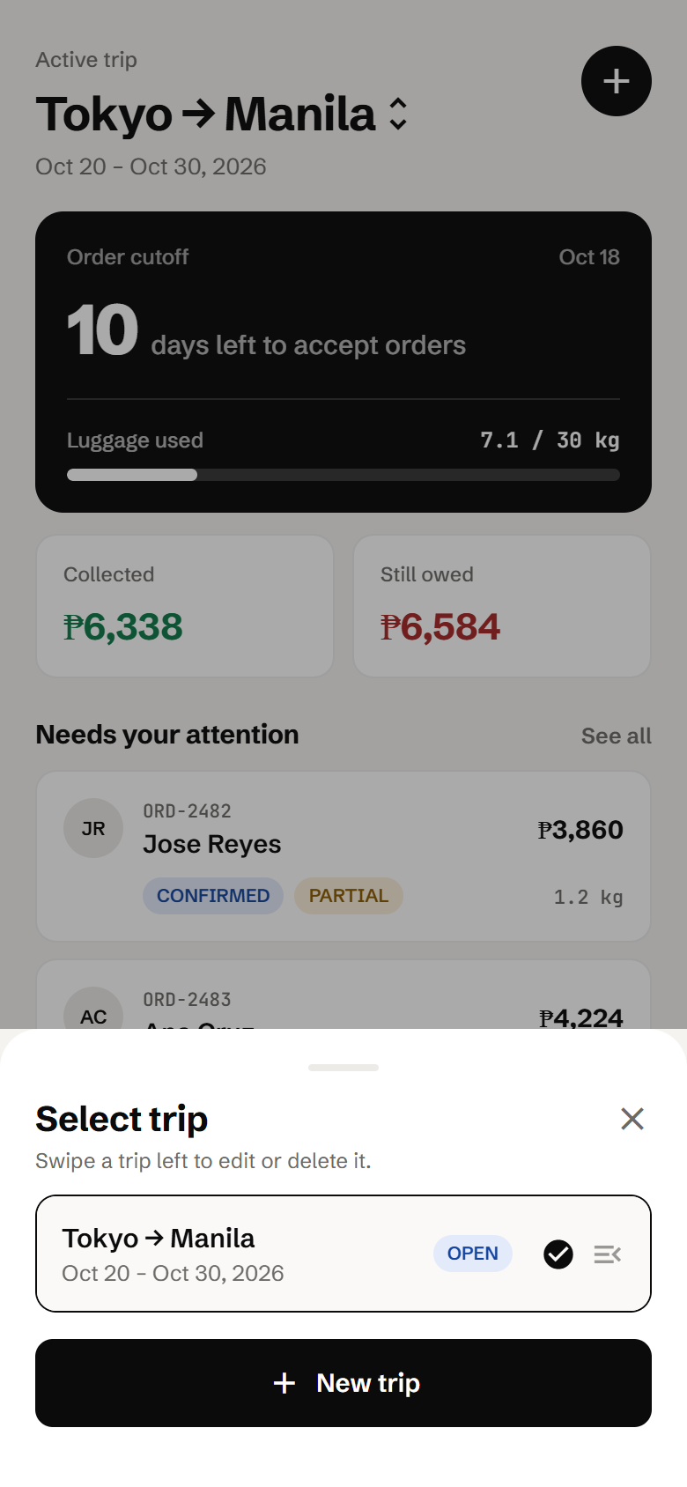  Figure 4. Select trip sheet | - On the Trip tab, tap the route name (the one with the ↕ arrows).  - In Select trip, tap a trip to make it the active trip.  - To change a trip, swipe it to the left and tap Edit or Delete.  - Tap + New trip to add another trip.  Note: When you edit fee rates, the new rates apply only to items added afterwards. Existing items keep their original fees.  Important: Deleting a trip also deletes its orders, items and payments.

Step 4: Check your luggage budget
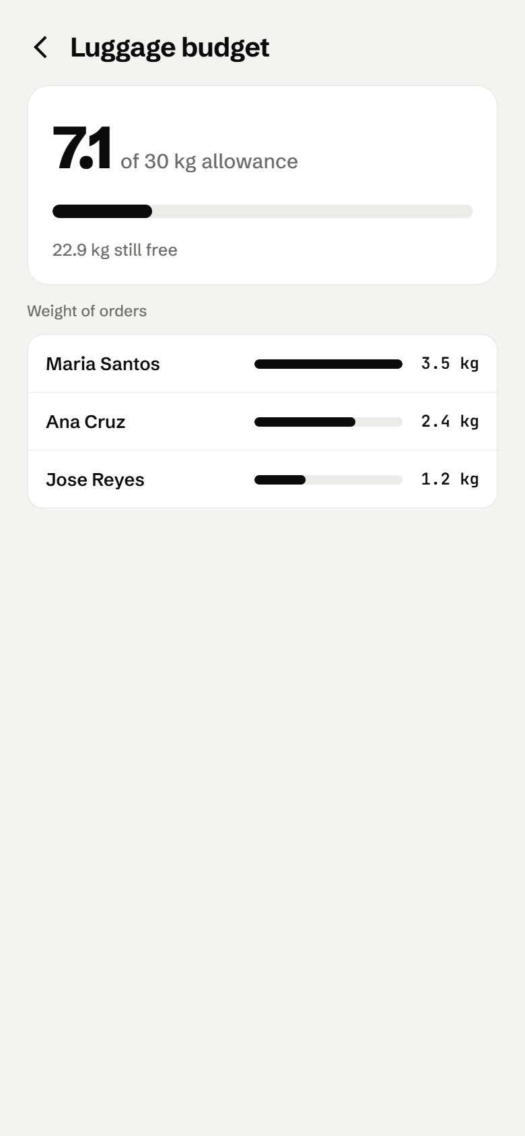  Figure 5. Luggage budget | Tap Luggage used on the Trip dashboard to open this screen.  - The big number shows kilograms used out of your allowance.  - Below the bar you can see how many kg are still free.  - Weight of orders lists your heaviest orders, so you know where the space is going.  Note: Weights come from the "Total order weight" you enter on each order (Step 7).

Step 5: Add a customer
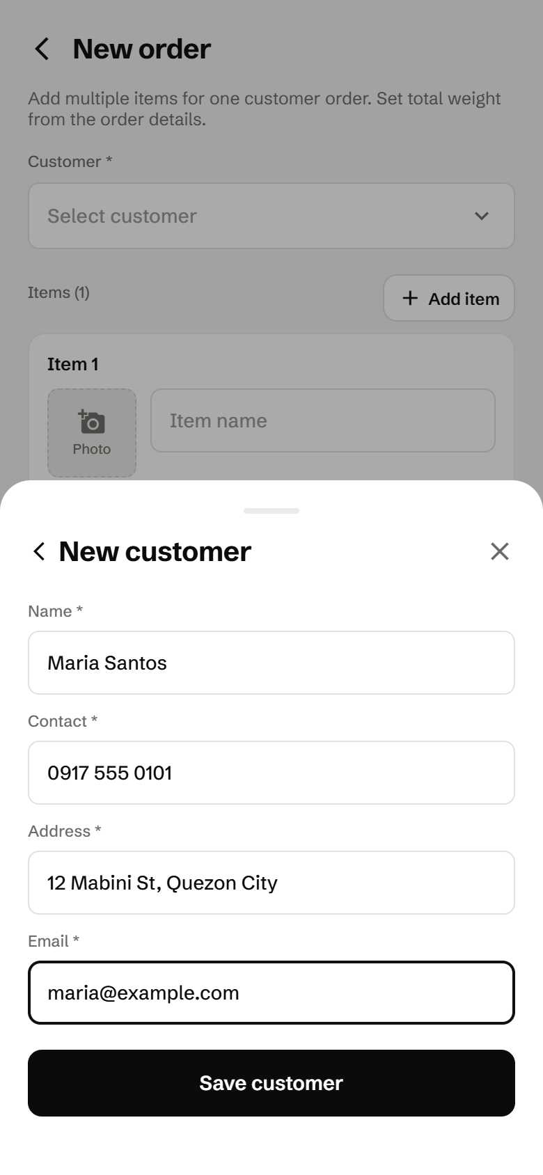  Figure 6. New customer form | You can add customers in two places:  - More → Customers → Add, or  - while creating an order: Select customer → Create new customer.  - Enter the Name, Contact (phone or messaging handle), Address and Email.  - Tap Save customer. A customer created from the order form is selected automatically.  Note: All four fields are required and the email must be valid. Deleting a customer later keeps their past orders.

Step 6: Create an order
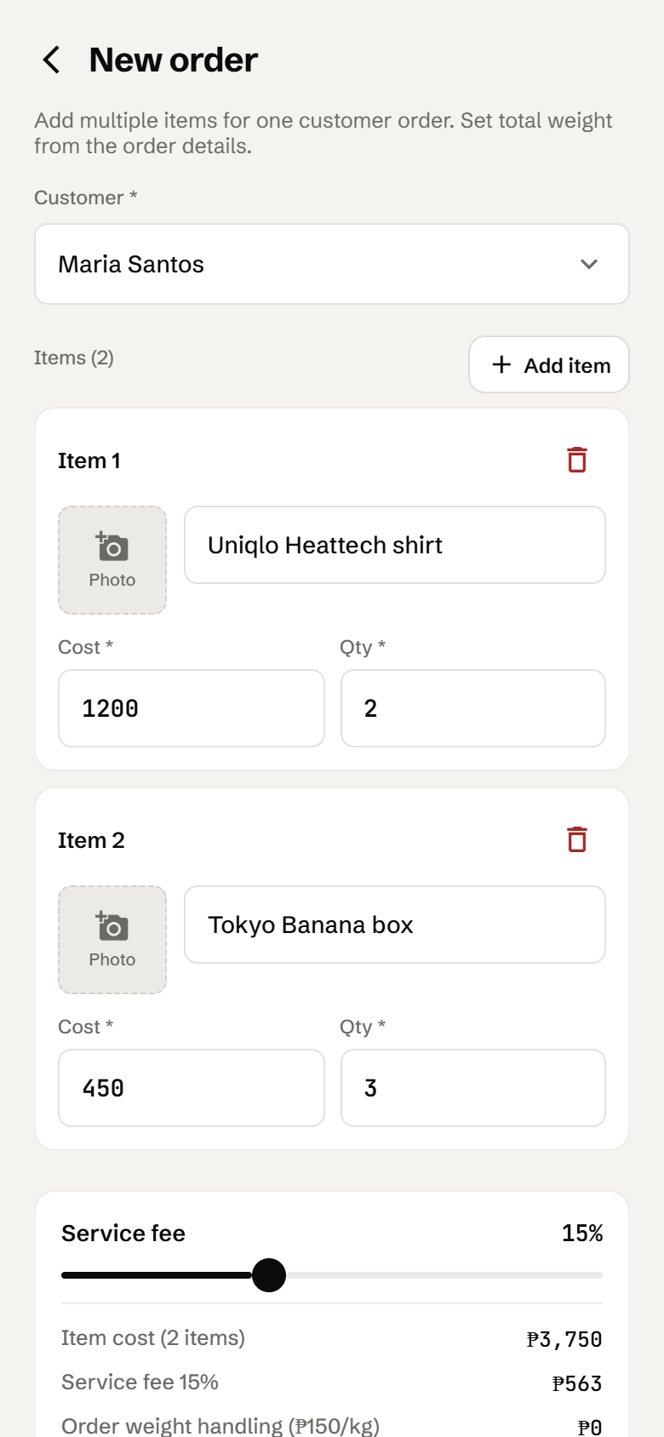  Figure 7. New order: customer and items | - Go to the Orders tab and tap + New order.  - Tap Select customer and choose the buyer.  - For Item 1, optionally tap Photo to attach a picture, then enter the Item name, the Cost (price of one unit in ₱) and the Qty.  - Tap + Add item to add more items to the same order. Use the red trash icon to remove an item.

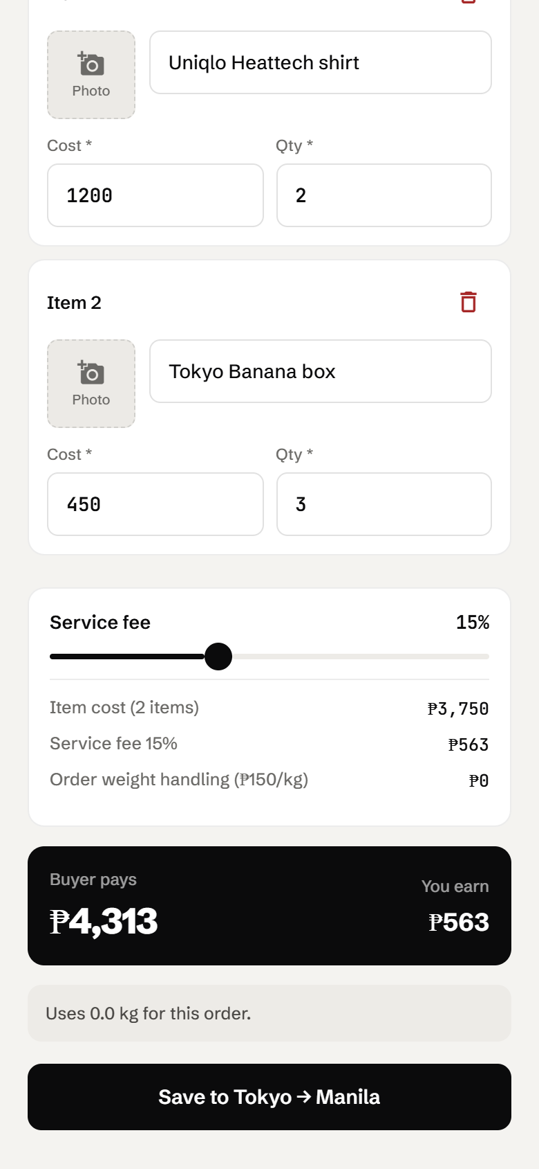  Figure 8. New order: fees and total | - Adjust the Service fee slider (0–40%) if this customer gets a different rate. It starts at the trip’s rate.  - Check the breakdown: Buyer pays is the amount the customer owes, and You earn is your fee.  - Tap Save to <route>. The new order opens automatically.  Note: Handling is ₱0 at this point because the order has no weight yet. You add the weight after packing (Step 7).  Tip: If the customer already has an open order (not fully paid and not delivered) on this trip, the new items are added to that order instead of creating a second one.

Step 7: Work with the order details
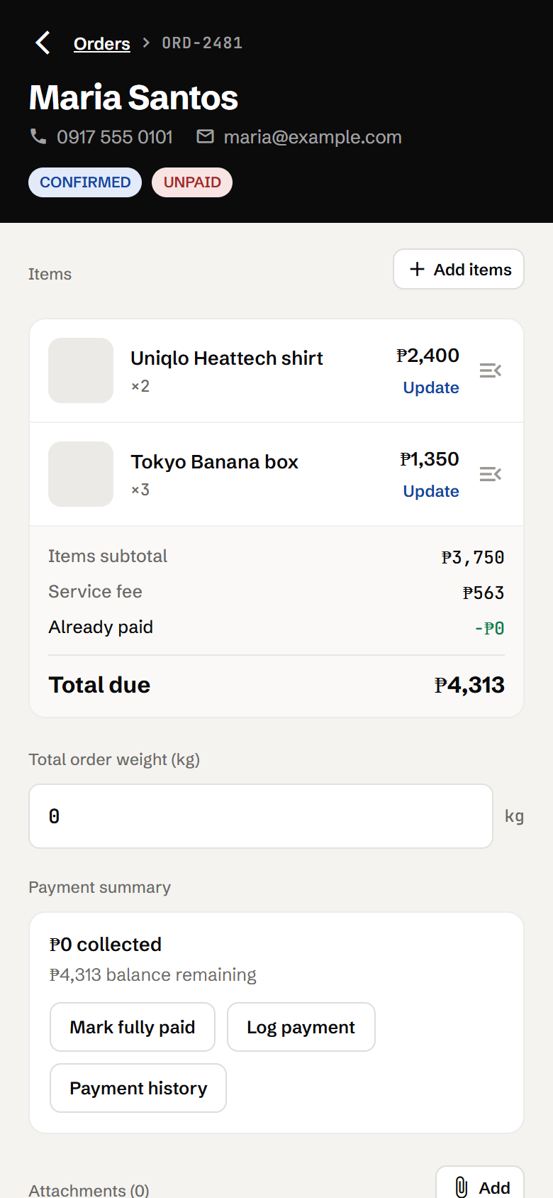  Figure 9. Order details | Tap any order card to open its details.  - Header: reference number, customer contact details, and status and payment badges.  - Items: tap Update to edit an item, swipe left to delete it, or tap + Add items.  - Totals: items subtotal, service fee, amount already paid, and Total due.  - Total order weight (kg): enter the packed weight. The handling fee is added to the total automatically.  - Payment summary: Mark fully paid, Log payment and Payment history.  - Attachments: tap Add to attach files, photos from the gallery, or a new camera photo.

Step 8: Record payments
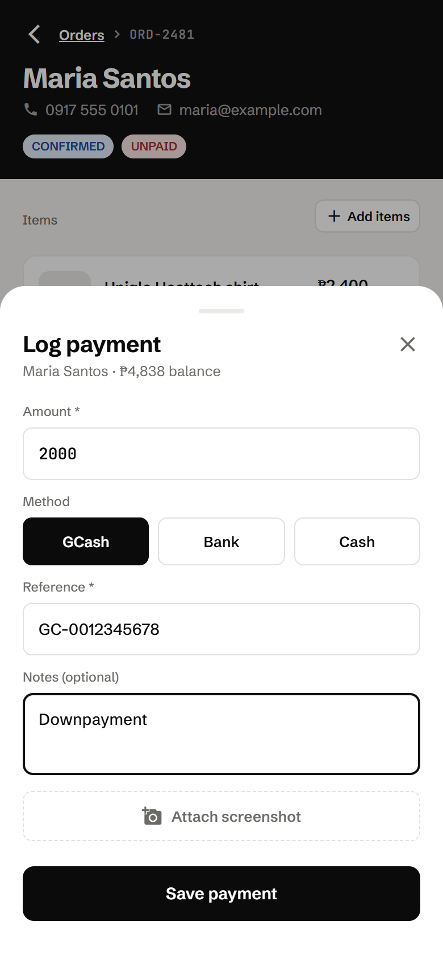  Figure 10. Log payment sheet | - On the order, tap Log payment.  - The Amount starts with the remaining balance. Change it for a downpayment.  - Choose the Method: GCash, Bank or Cash.  - Enter the Reference number (required), and optional Notes.  - Tap Attach screenshot to save a copy of the receipt (optional).  - Tap Save payment.  Tip: Mark fully paid records a cash payment for the whole remaining balance in one tap.

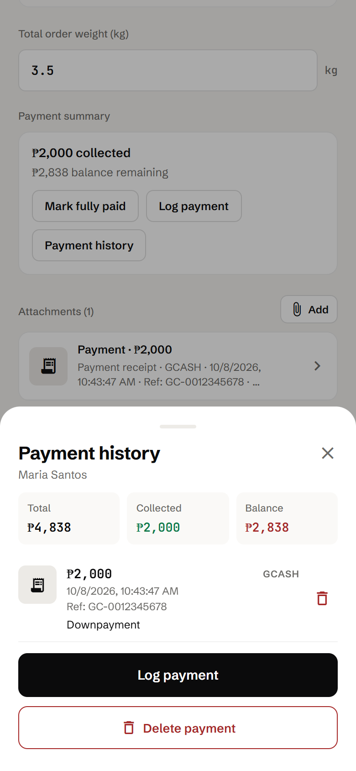  Figure 11. Payment history | Tap Payment history to see every payment for the order.  - The top shows the order Total, the amount Collected and the Balance left.  - Each payment shows its amount, method, date, reference and notes. Tap a receipt thumbnail to view or download it.  - Use the trash icon to remove a single wrong payment.  Important: On a fully paid order the button changes to Mark as unpaid, which removes all of the order’s payment records.

Step 9: Move the order through its progress
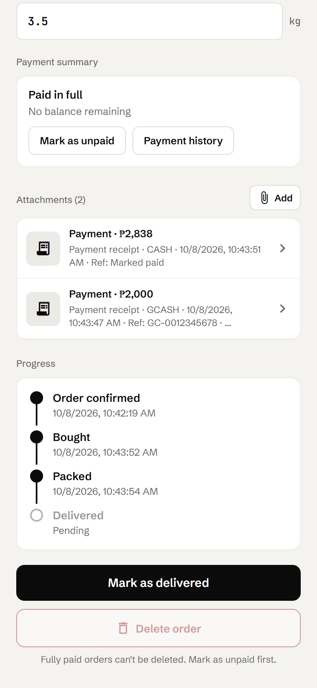  Figure 12. Progress timeline | Scroll down on the order to the Progress timeline. Every step records the date and time it happened.  - After buying the items, tap Mark as bought.  - Enter the Total order weight, then tap Mark as packed.  - When the customer has paid in full, tap Mark as delivered to open the hand-over screen (Step 10).  Note: Mark as packed needs a weight, and Mark as delivered needs the order to be fully paid.  Note: Payment receipts appear automatically in Attachments.

Step 10: Hand over the order
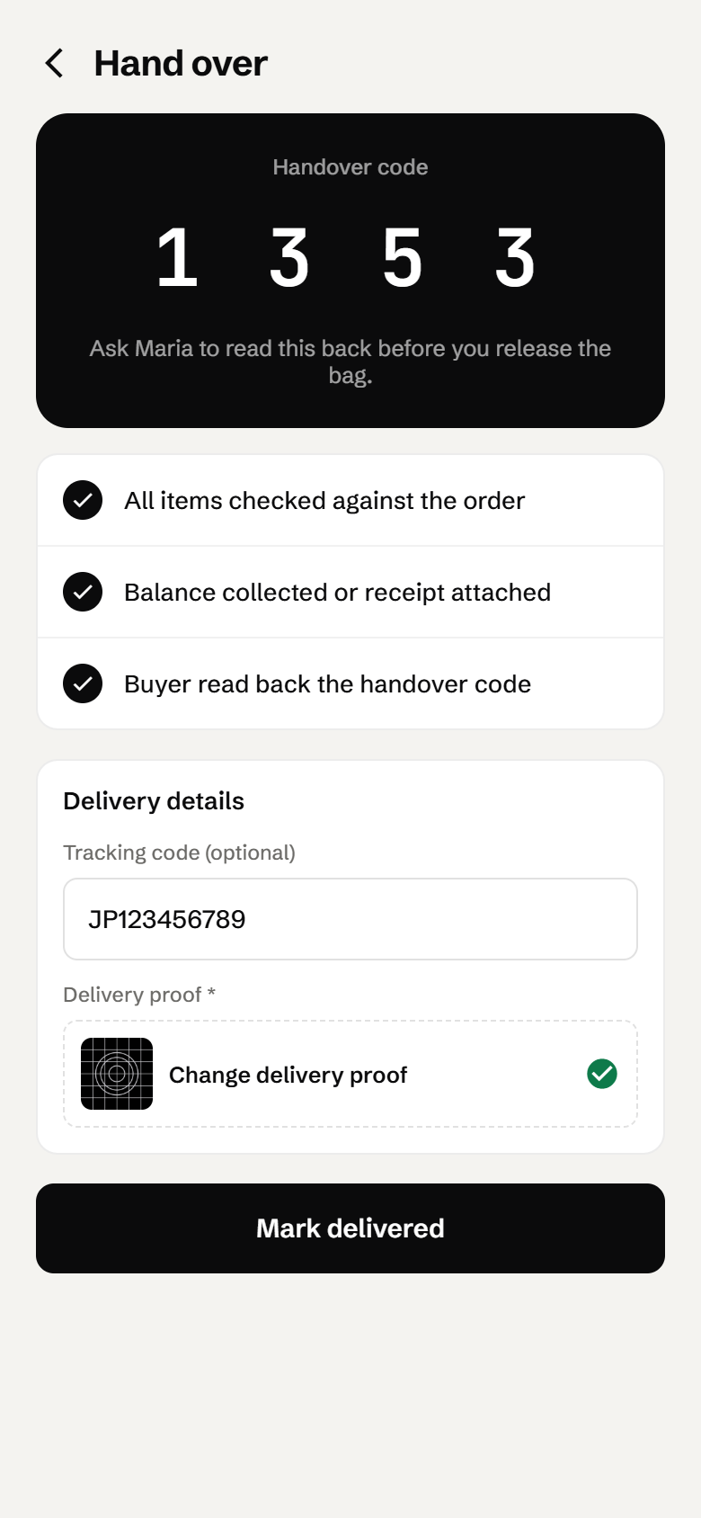  Figure 13. Hand over screen | - Show the customer the 4-digit Handover code and ask them to read it back to you.  - Tick all three checklist items: All items checked against the order, Balance collected or receipt attached, and Buyer read back the handover code.  - Optionally enter a Tracking code if you shipped the parcel by courier.  - Tap Delivery proof and attach a photo (required).  - Tap Mark delivered. The order becomes DELIVERED.  Note: Until everything is complete, the button tells you what is missing, for example "Finish the checklist first" or "Attach delivery proof first".

Step 11: Find any order
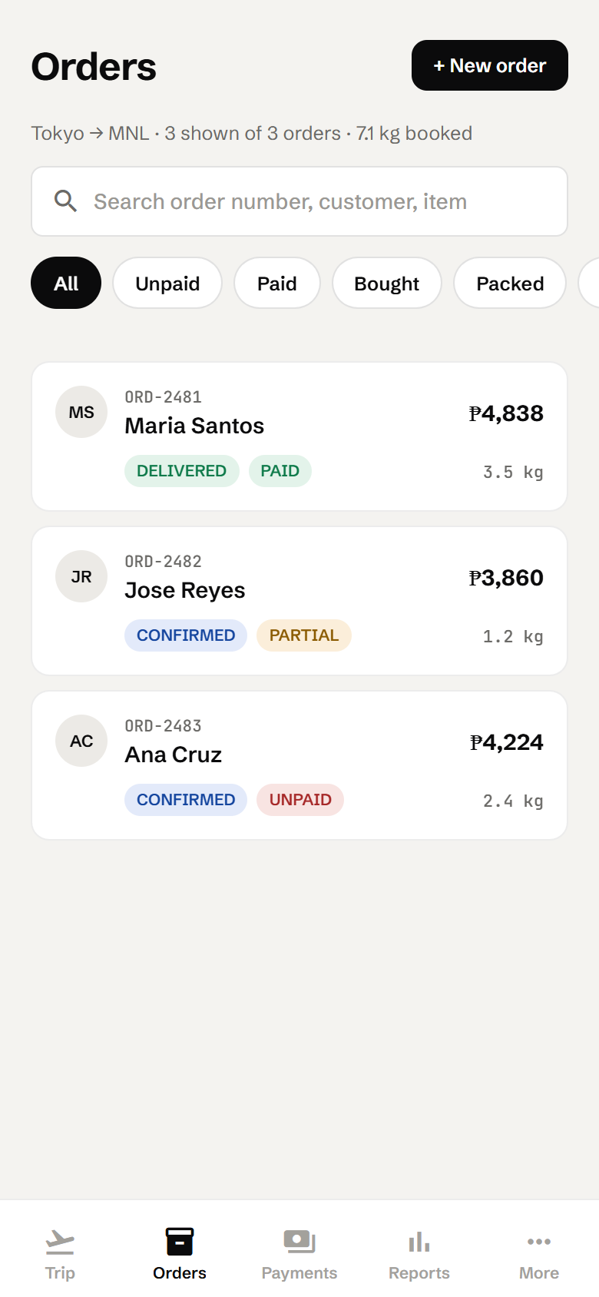  Figure 14. Orders tab | - The line under the title shows the route, how many orders are shown, and the total kg booked.  - Search by order number, customer name or item name.  - Use the filters All, Unpaid, Paid, Bought, Packed and Delivered.  - Pull down to refresh. Scroll to the bottom and tap Load more for long lists.  - Tap an order card to open its details.

Step 12: Follow up on payments
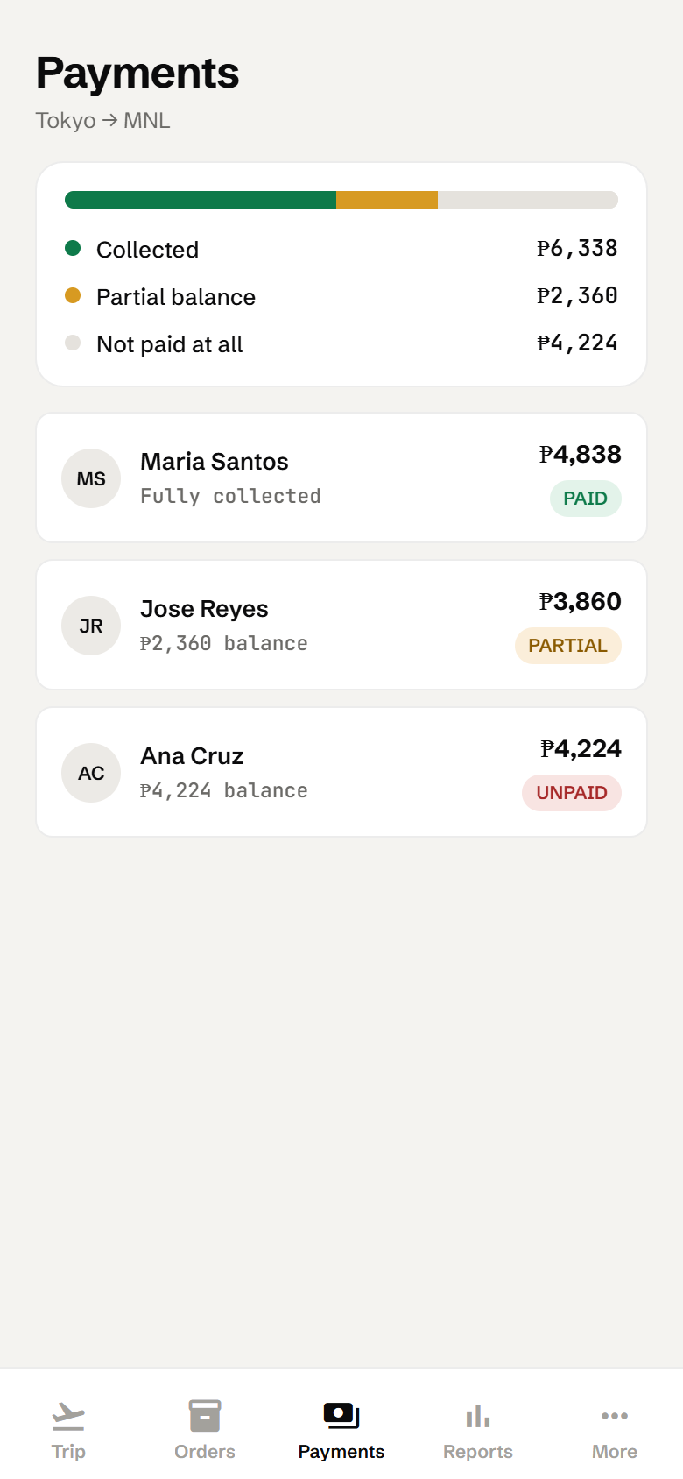  Figure 15. Payments tab | - The coloured bar and legend show how much is Collected, the Partial balance, and what is Not paid at all.  - Each row shows the customer, their balance (or "Fully collected"), the order total and a payment badge.  - Tap a row to open Payment history, where you can also Log payment.

Step 13: Review reports and export
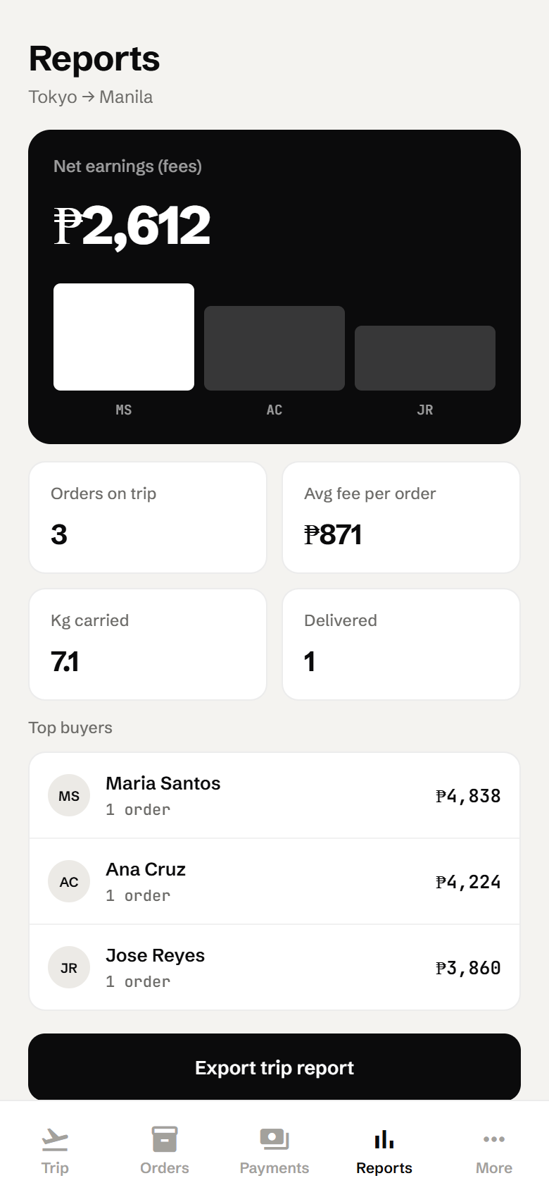  Figure 16. Reports tab | - Net earnings (fees): your total service and handling fees for the trip, with a bar chart per buyer.  - Orders on trip, Avg fee per order, Kg carried and Delivered.  - Top buyers: your biggest customers by amount.

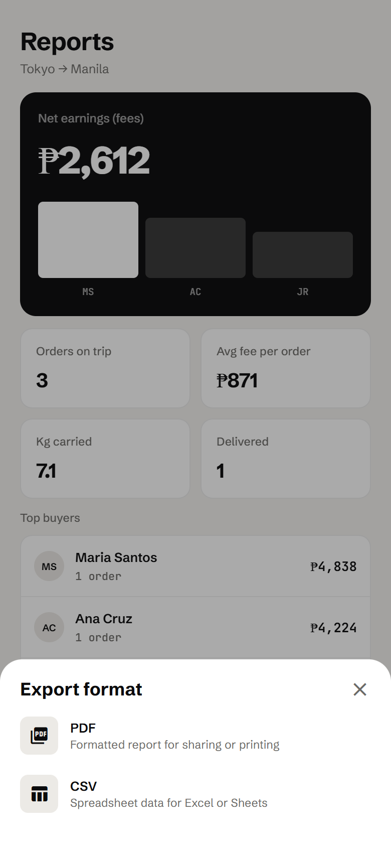  Figure 17. Export format | - Tap Export trip report.  - Choose PDF (a formatted report for sharing or printing) or CSV (spreadsheet data for Excel or Google Sheets).  - Save or share the file using your phone’s share menu. On the web version it downloads to your browser’s Downloads folder.

4. More menu
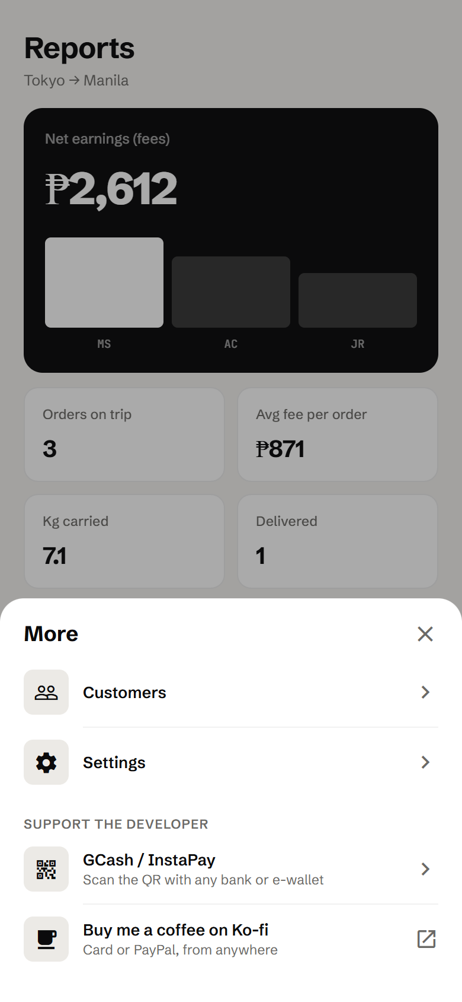  Figure 18. More menu | Tap the More tab to open this menu.  - Customers: add, edit and delete customers (same form as Step 5). Tap a customer to edit them, or use the red icon to delete.  - Settings: backups and data reset (section 4.2).  - Support the developer: optional donations (section 4.3).

4.1 Customers
The Customers screen lists every saved customer with their contact details. Tap Add to create one, tap a customer to edit them, or tap the red delete icon. Deleting a customer only removes them from the customer list. Their past orders stay.

4.2 Settings and backups
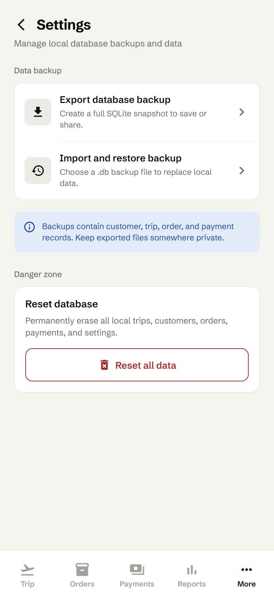  Figure 19. Settings | Export database backup  Creates a complete copy of all your data as a .db file named like pasabuy-backup-YYYYMMDD-HHMMSS.db. Save it to Google Drive, email it to yourself, or keep it on a computer.  Import and restore backup  Choose a .db backup file to bring your data back, for example on a new phone.  Important: Restoring replaces everything currently in the app with the backup’s contents.  Reset all data  Permanently erases all trips, customers, orders, payments and settings. You will be asked to confirm twice.  Important: Export a backup before resetting. A reset cannot be undone.

4.3 Support the developer
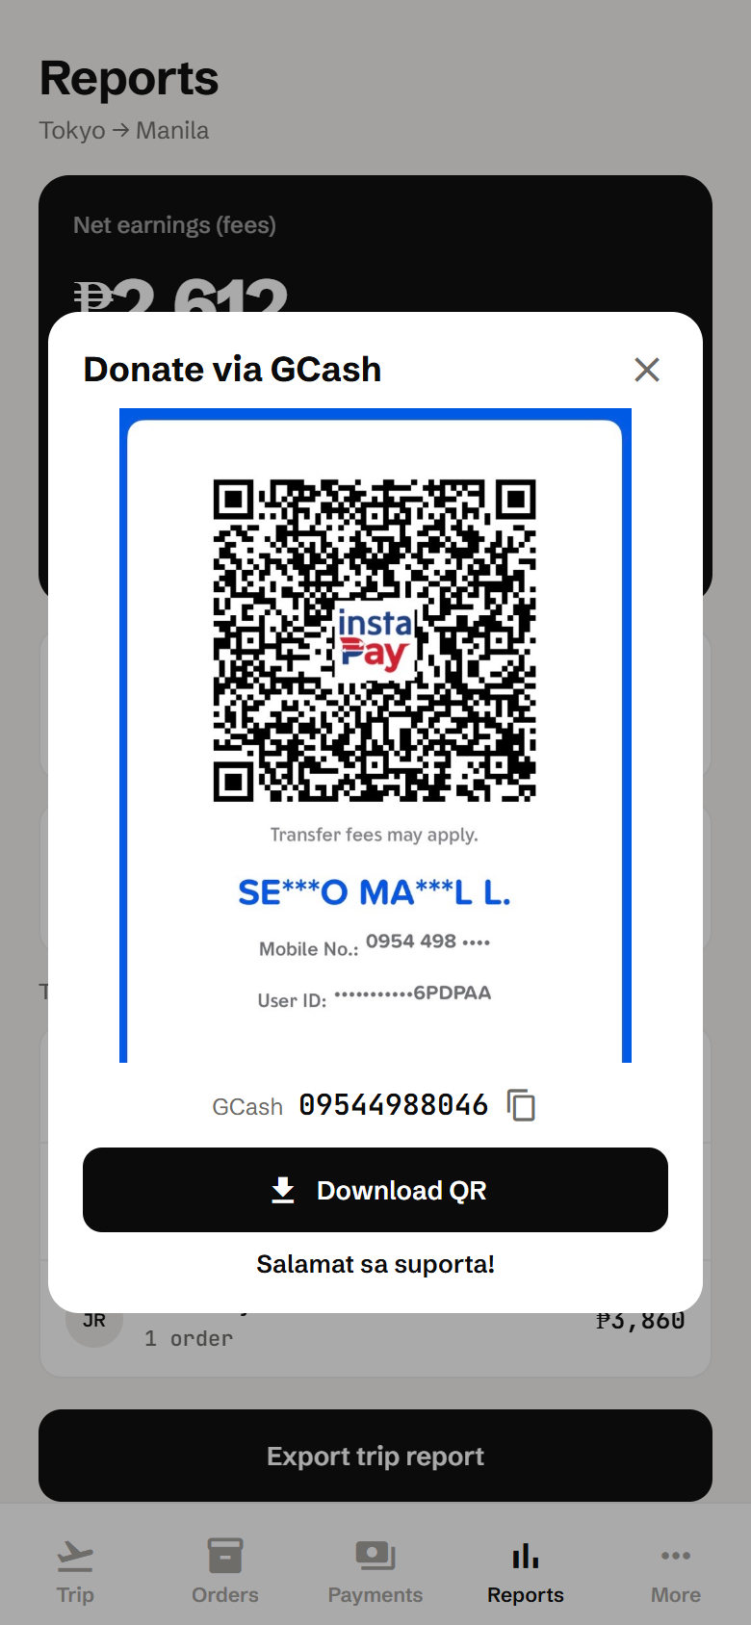  Figure 20. Donate via GCash | Pasabuy Tracker is free. If it helps your business, you can send a small donation:  - GCash / InstaPay: scan the QR code with any bank or e-wallet app. Tap the copy icon next to the number to copy 09544988046, or tap Download QR to save the code to your gallery.  - Buy me a coffee on Ko-fi: opens ko-fi.com/serjolio00 to pay by card or PayPal.  Tip: To pay from the same phone, download the QR (or take a screenshot), then in GCash go to QR → Upload QR.

5. How amounts are calculated
Amount | How it is calculated
Items subtotal | Sum of (unit cost × quantity) for every item.
Service fee | Each item’s subtotal × the service fee % that applied when the item was added.
Handling fee | Total order weight (kg) × handling rate (₱/kg).
Total (buyer pays) | Items subtotal + service fee + handling fee.
You earn | Service fee + handling fee.
Balance | Total − all payments logged.
Payment status | UNPAID if nothing is paid, PARTIAL if some is paid, PAID when payments reach the total.

5.1 Worked example
Line | Amount
2 × Uniqlo Heattech shirt @ ₱1,200 | ₱2,400
3 × Tokyo Banana box @ ₱450 | ₱1,350
Items subtotal | ₱3,750
Service fee 15% | ₱563
Handling: 3.5 kg × ₱150 | ₱525
Total (buyer pays) | ₱4,838
You earn (563 + 525) | ₱1,088
Note: Amounts are shown rounded to the nearest peso.
Note: If an order’s weight goes over your checked baggage allowance, the order form warns you. Excess baggage costs ₱1,250/kg.

6. Rules and important notes

6.1 What the app allows
Situation | What happens
Trip is CLOSED | No new orders or items, and orders cannot be deleted. Payments and deliveries still work. To reopen, edit the trip and set its status to Open.
Automatic trip status | The trip closes automatically the day after the order cutoff.
Order is fully paid or delivered | No more items can be added.
Deleting an order | Not allowed while it is fully paid. Use Mark as unpaid first.
Mark as packed | Requires the total order weight.
Mark as delivered | Requires full payment, the 3-item checklist, and a delivery proof photo.
Changing trip fees | Applies only to items added afterwards.
Deleting a trip | Also deletes its orders, items and payments.
Deleting a customer | Removes them from selection lists. Their past orders are kept.

6.2 Your data
- All data stays on this device. Uninstalling the app or clearing its storage erases everything.
- Export a backup after each trip, or weekly during busy periods, and keep the file somewhere private. It contains customer details.
- To move to a new phone: export a backup on the old phone, install the app on the new one, then use Import and restore backup.

6.3 Android vs. web version
- On Android, exports and backups open the share menu so you can save them to Drive, email and so on.
- On the web version, files download straight to your browser’s Downloads folder, and Download QR saves the image there too.
- The web version keeps its own separate data in the browser. It does not share data with the Android app.

7. Troubleshooting & FAQ
Problem | What to do
Nothing happens when I tap Save. | Scroll up and look for red messages under the fields. Every field marked * is required.
I can’t add a new order. | The trip is probably CLOSED (past the cutoff). Edit the trip and set Trip status to Open.
"Mark as delivered" is disabled. | The order must be fully paid first. Log the remaining payment or tap Mark fully paid.
"Mark as packed" asks for a weight. | Enter the Total order weight (kg) on the order.
I can’t delete an order. | Fully paid orders, and orders on a closed trip, cannot be deleted. Mark the order as unpaid or reopen the trip first.
I logged a wrong payment. | Open Payment history and delete that payment with the trash icon, then log it again.
Download QR fails. | Allow photo access when asked, or take a screenshot of the QR instead.
I got a new phone. | Export a backup on the old phone, then use Import and restore backup on the new one.

Thank you for using Pasabuy Tracker. Salamat!

