Jason Schriner

Assignment 2.3

11/1/24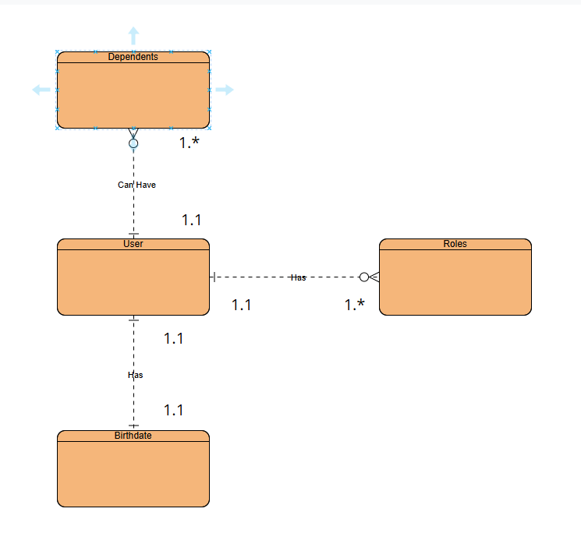

NOSQL Format:

{

“User”: John Doe

“Birthdate”: 01/01/2020

“Roles”: [

{“role_1”: “father”},

{“role_2”: “math_teacher” }

],

“Dependents”: [

{“dependent_1”,“jane_doe”, “relationship”: “daughter”},

{“dependent_2”, “joe_doe”, “relationship”: “son”}

]

}