Jason Schriner

Normalized tables

Assignment 3.2

11/8/24

Assumptions

I assumed that the author may have multiple phone numbers, so I separated them with a work and home phone. I assumed that the publisher’s name was atomic and could not be split like the author’s name is split into first and last. I assumed that the address was the full mailing address, so I split it into street city state zip code. I assumed that there would be only one email address listed. I also assumed that multiple books may have the same price.

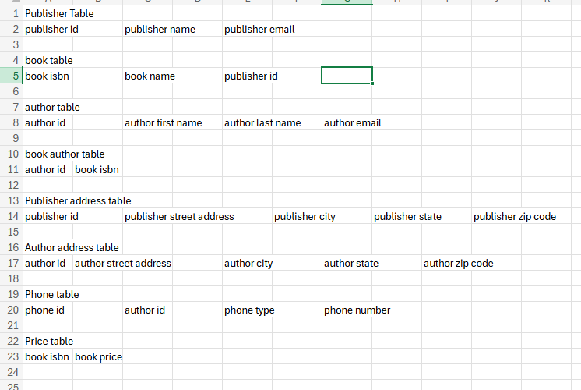

References:

Learn Learn Scratch Tutorials (2020) First, Second, and Third Normal Form (Database Normalization) YouTube. <https://www.youtube.com/watch?v=J-drts33N8g>