Jason Schriner

Module 4.2

11/13/24

Initial Connection

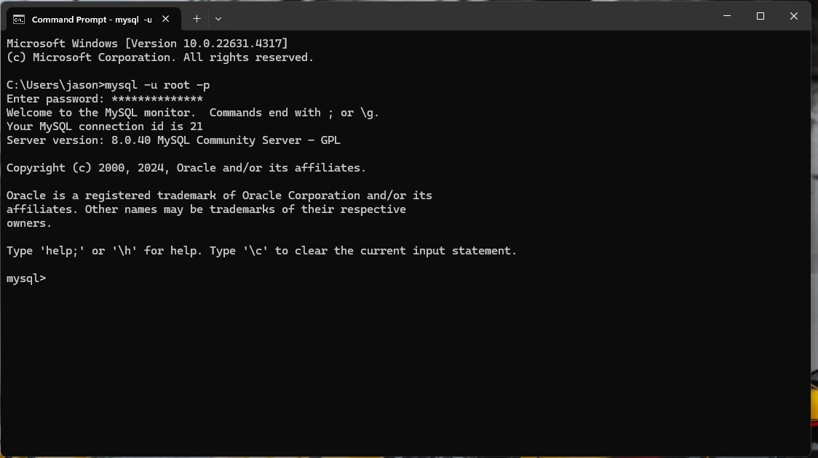

Show Databases input

