Jason Schriner

Module 5.2

11/14/24

The CHARLENGTH() function gives you the total number of characters in a string. An example of when you would want to use this function is when you want to check to see if a string meets a length criteria such as a password.

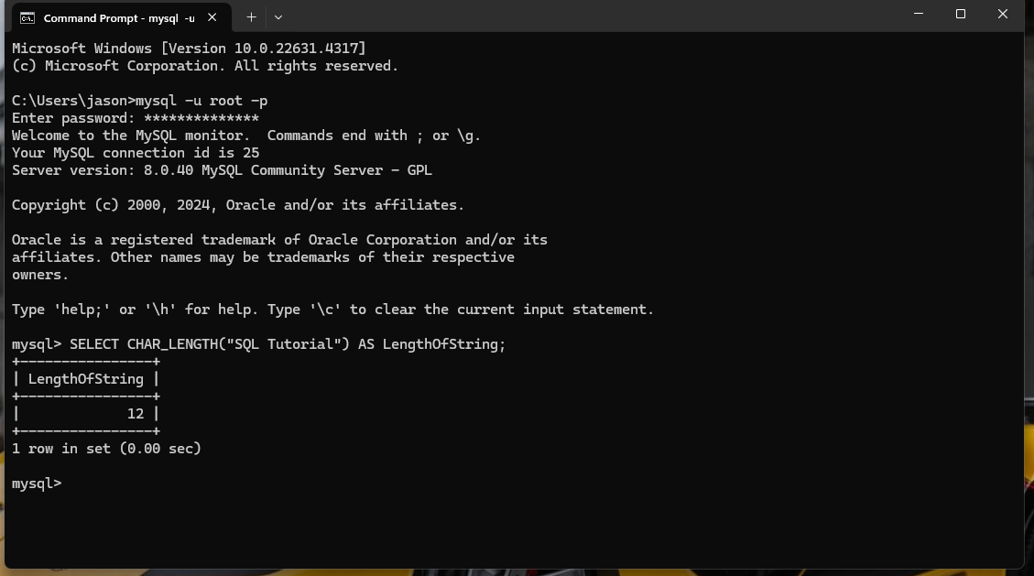

The DAYNAME() function returns the day of the week based on the given date. It might be used to identify events on a specific day of the week. For example, it could be used to return all appointments on a Monday.

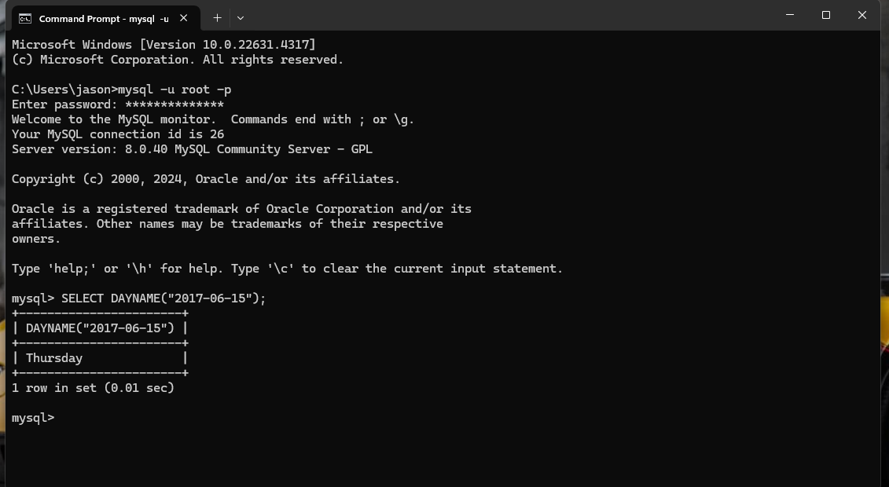

The CONCAT() function adds expressions together. In trying to keep a database in atomic form you may separate a mailing address into street address, city, and state. The CONCAT() function would allow you to join them back together to form the complete address.

