Jason Schriner

Module 11

12/21/24

Proper Install

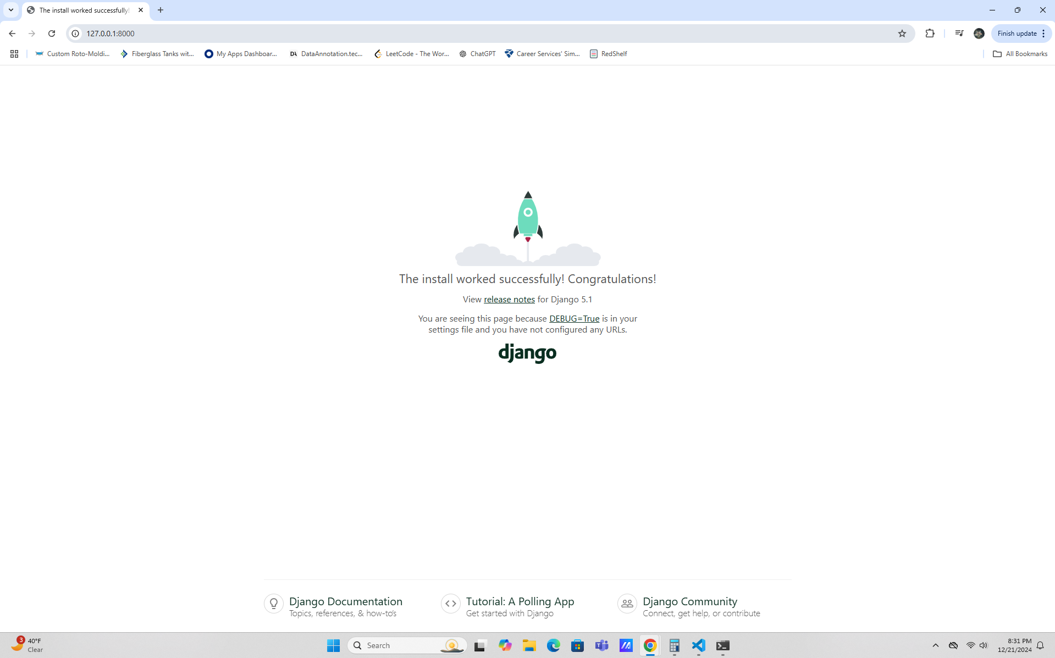

Displayed Code

