Jason Schriner

Assignment 2.2

10/25/24

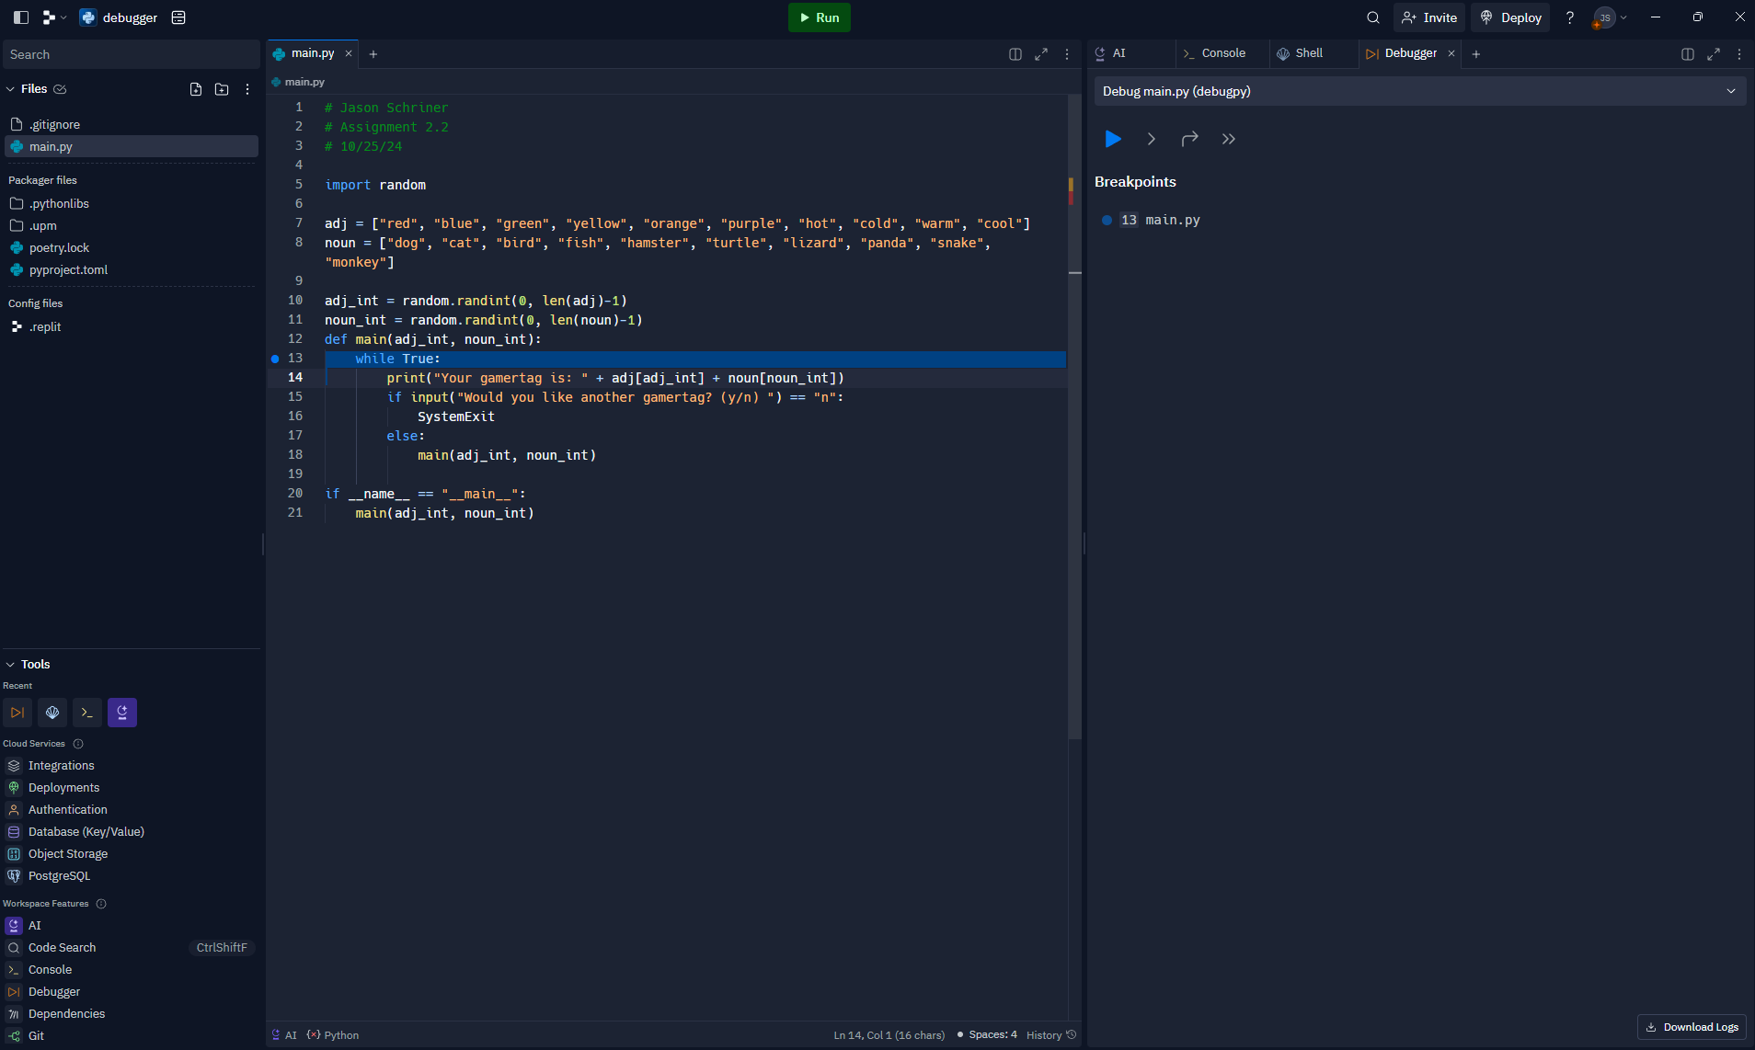

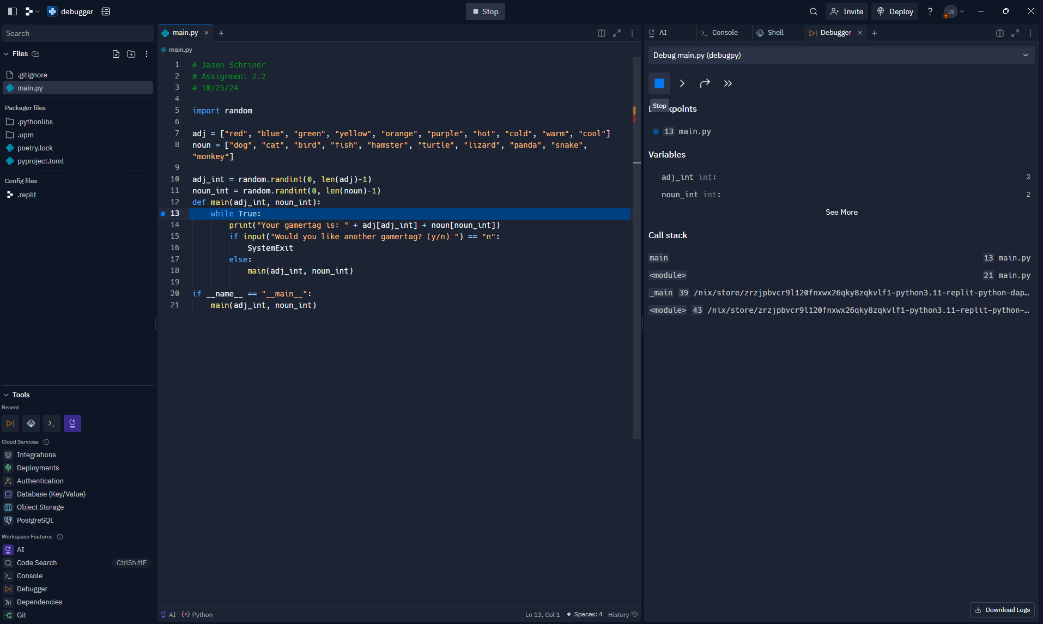

Working with the debugger I realized that the random numbers being generated outside of the function would remain the same no matter how many times you called the function.

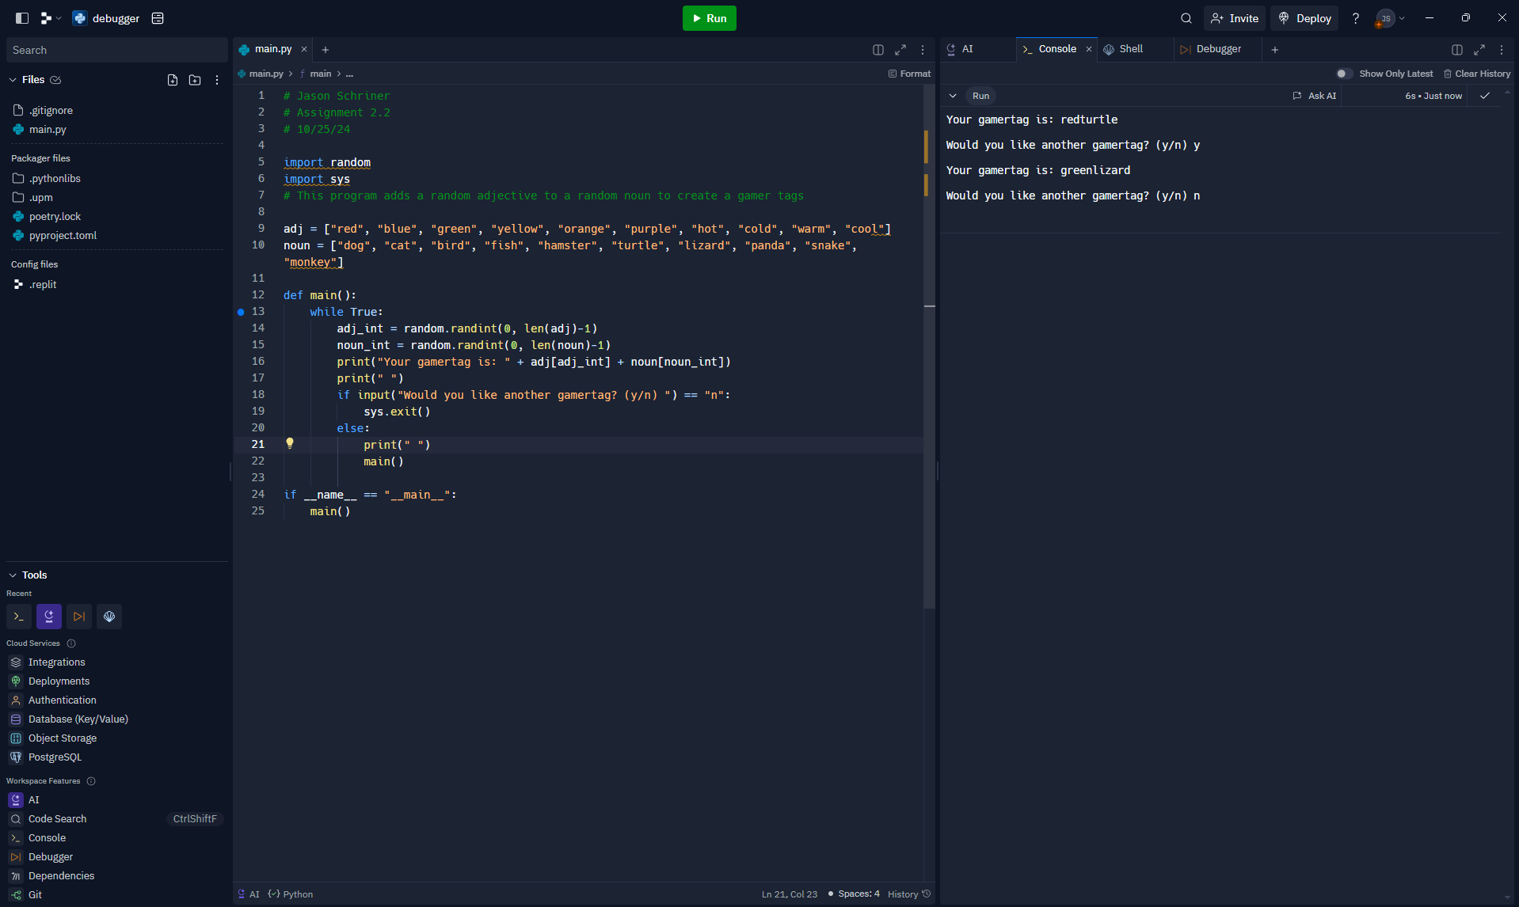

I inserted the variables into the function so that they generate a random number everytime it is called. I also imported sys so that I could call sys.exit() function. I added a line in between each output to make it more readable.

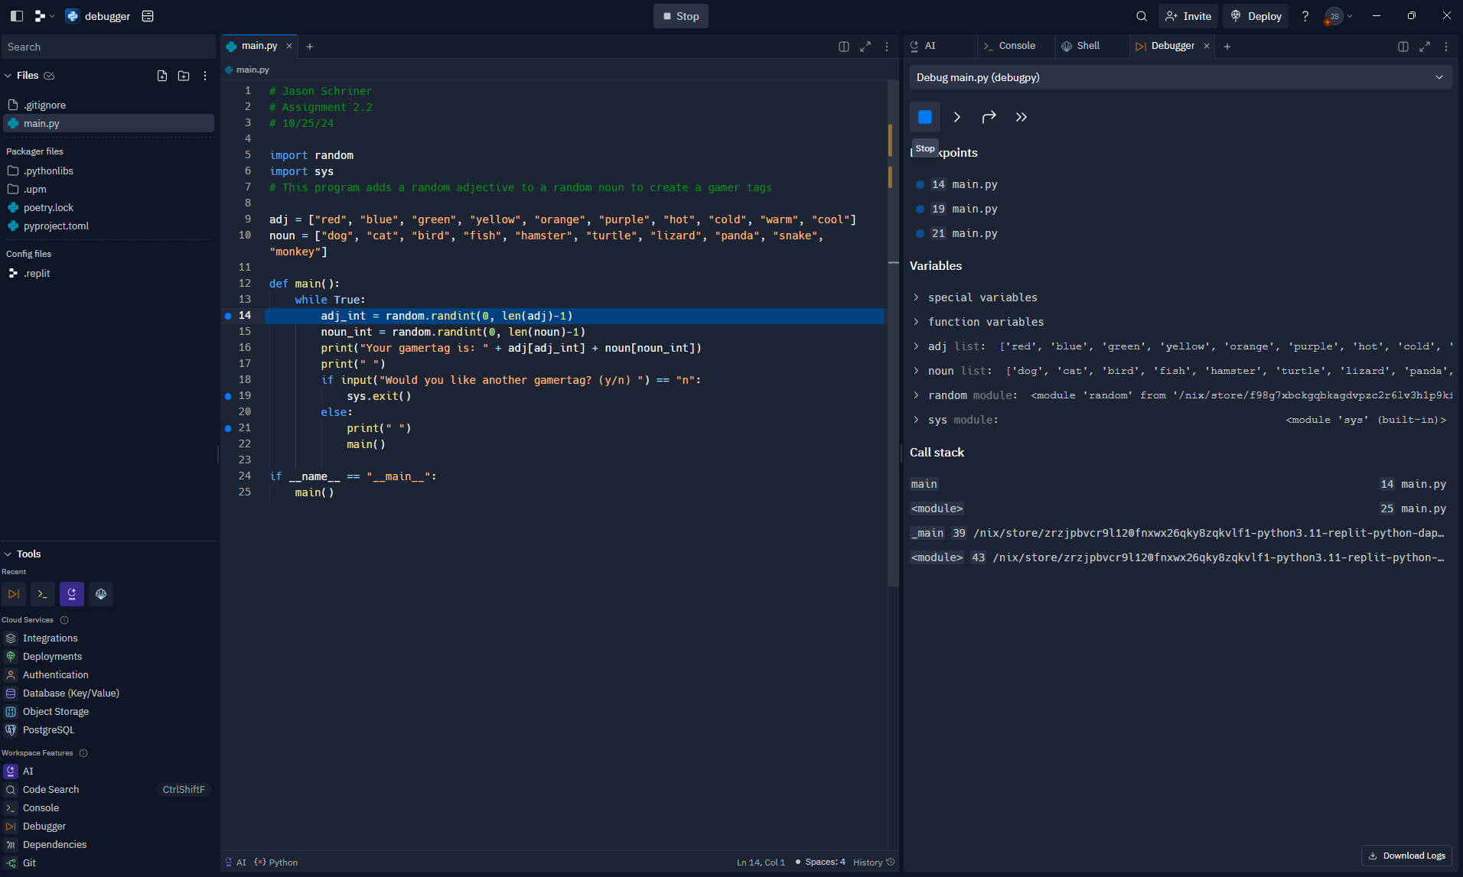

This is the debugger for the updated program.