Jason Schriner

Assignment 7

12/1/24

Formatted function with manual test:

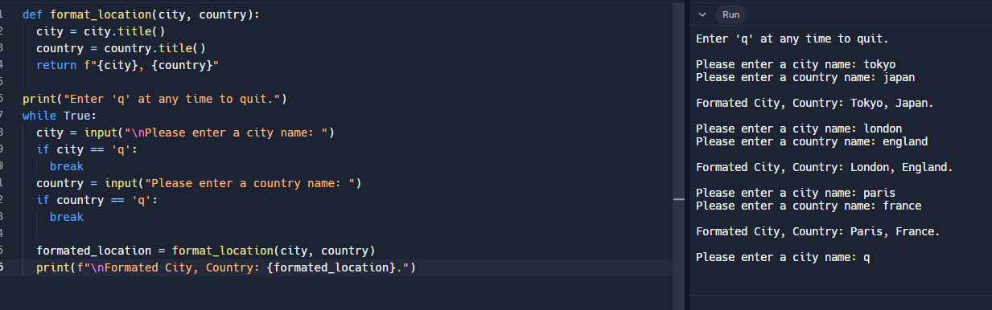

Test function pass

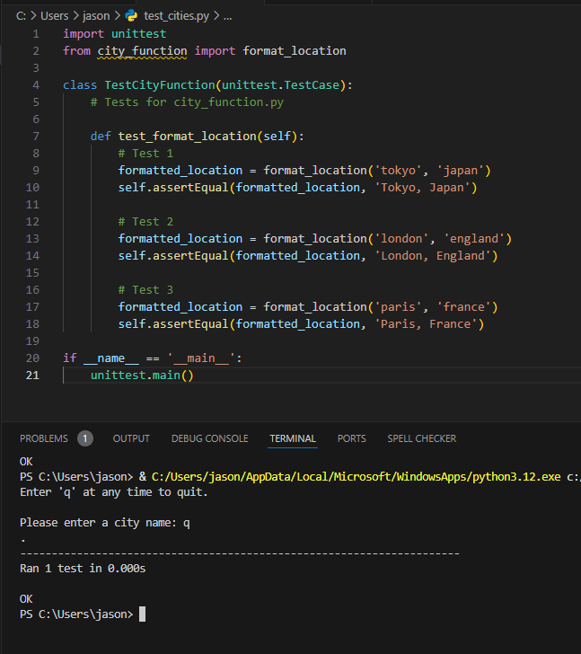

Test function fail due to new argument population

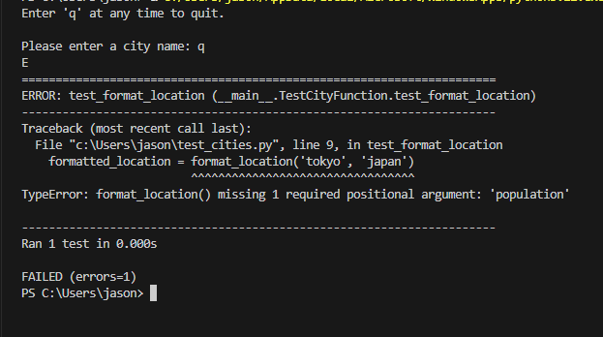

Test function pass with population input optional

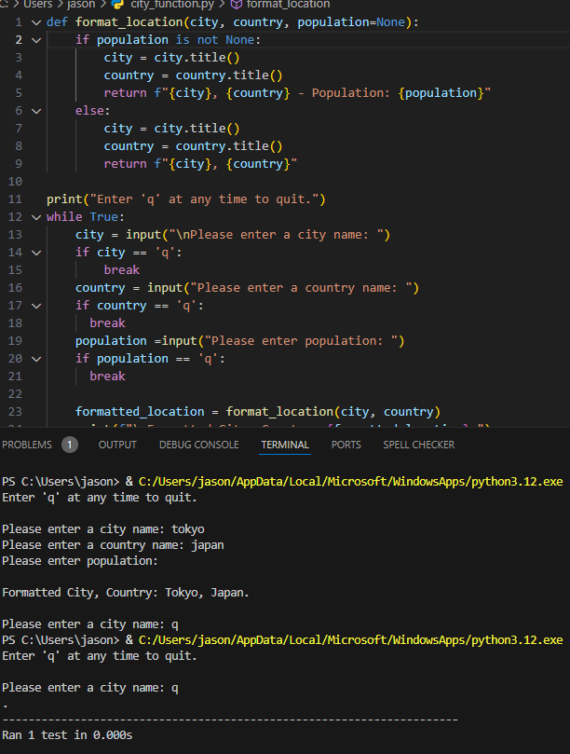

Test fail due to new argument language

