Jason Schriner

Assignment 8.2

12/7/24

Screenshot

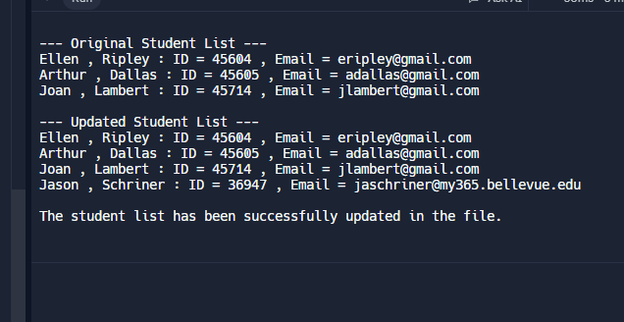

Copy of updated json file

[

{

"F_Name": "Ellen",

"L_Name": "Ripley",

"Student_ID": 45604,

"Email": "eripley@gmail.com"

},

{

"F_Name": "Arthur",

"L_Name": "Dallas",

"Student_ID": 45605,

"Email": "adallas@gmail.com"

},

{

"F_Name": "Joan",

"L_Name": "Lambert",

"Student_ID": 45714,

"Email": "jlambert@gmail.com"

},

{

"F_Name": "Jason",

"L_Name": "Schriner",

"Student_ID": "36947",

"Email": "jaschriner@my365.bellevue.edu"

}

]