Jason Schriner

Assignment 9.2 Api

12/8/24

Invalid Request

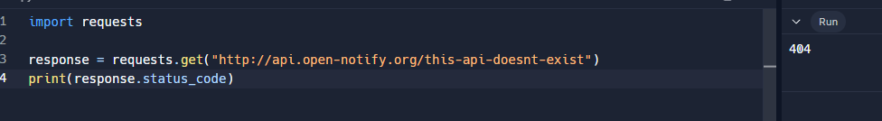

Request returned in Json format

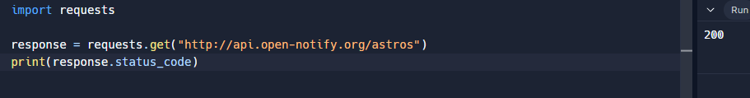

Modified print for Json

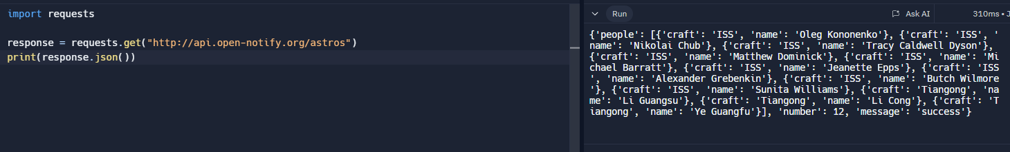

Formatted the print function for Json

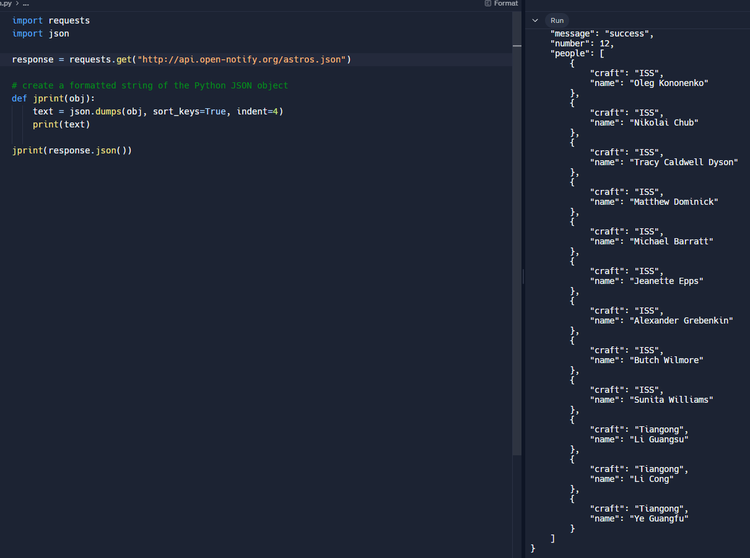

Sub-Saharan Africa API

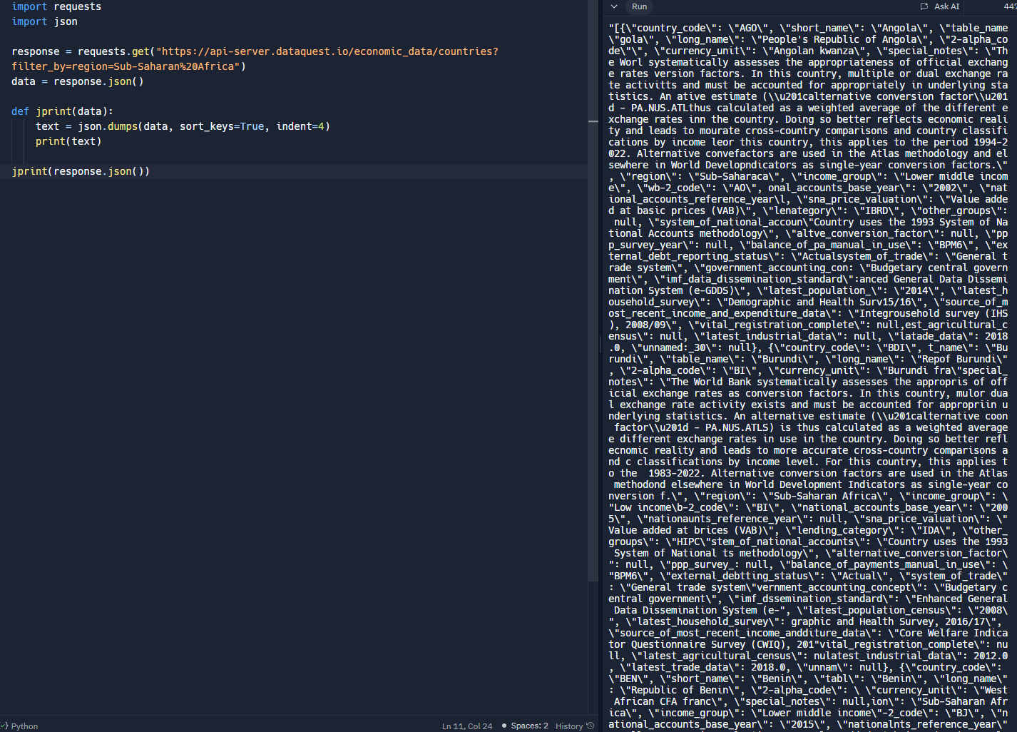

Poke Api test connection

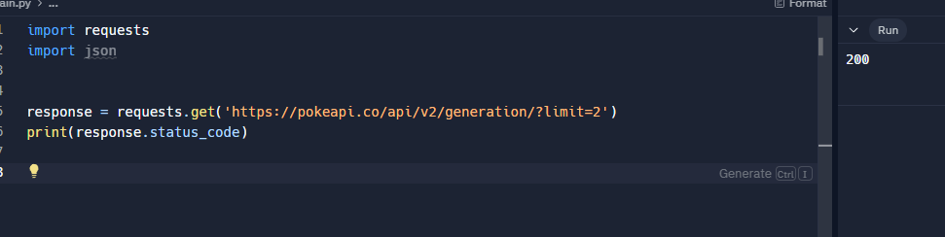

Poke Api print no format

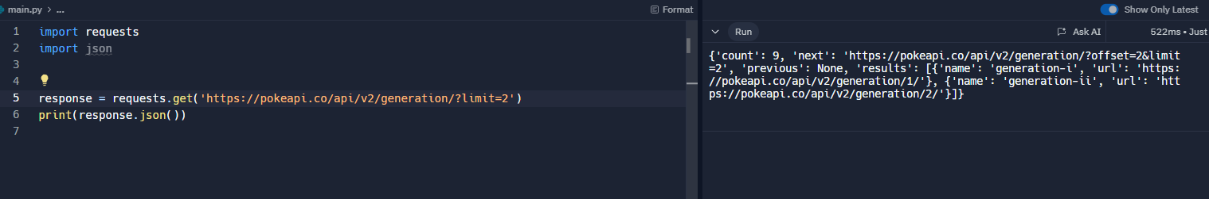

Poke Api formatted

