Jason Schriner

Assignment 1.3

1/12/25

Github: <https://github.com/skitch518/csd-340>

HTML errors:

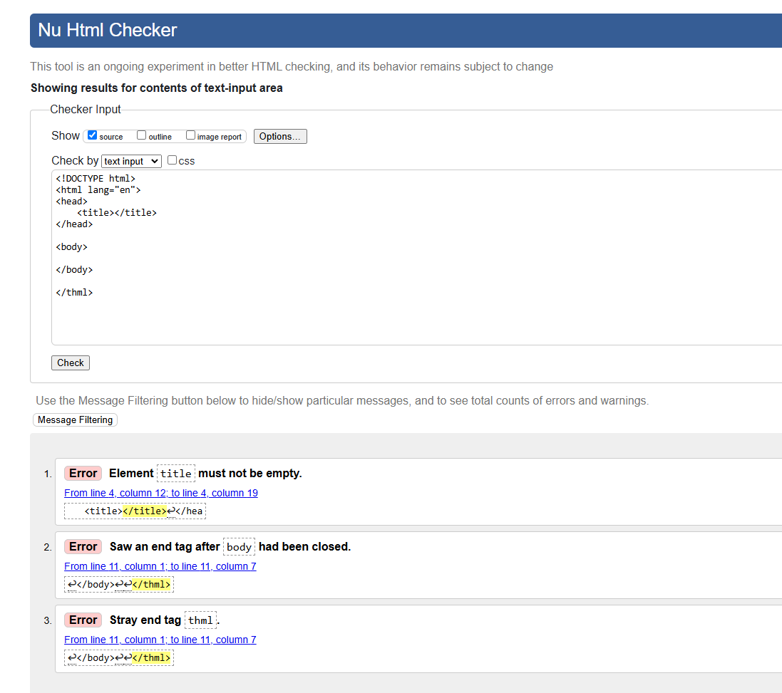

Corrected HTML:

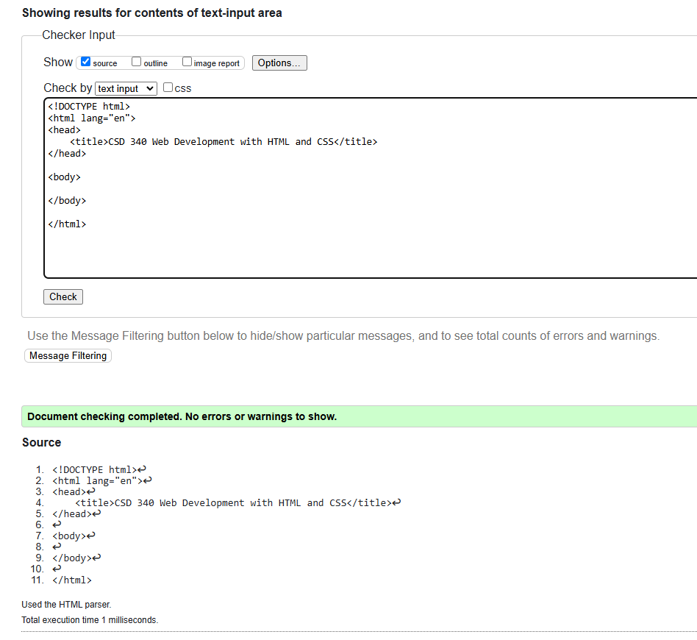

HTML code with updates & No errors

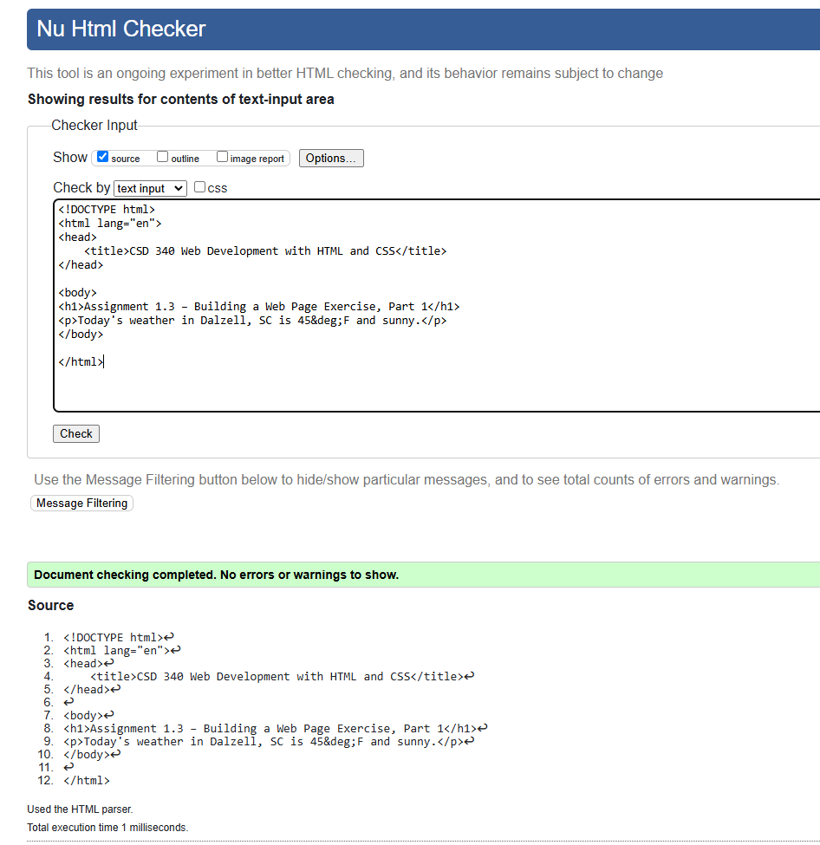

Output in Web browser

