Jason Schriner

Module 3.2

1/19/25

HTML Validated:

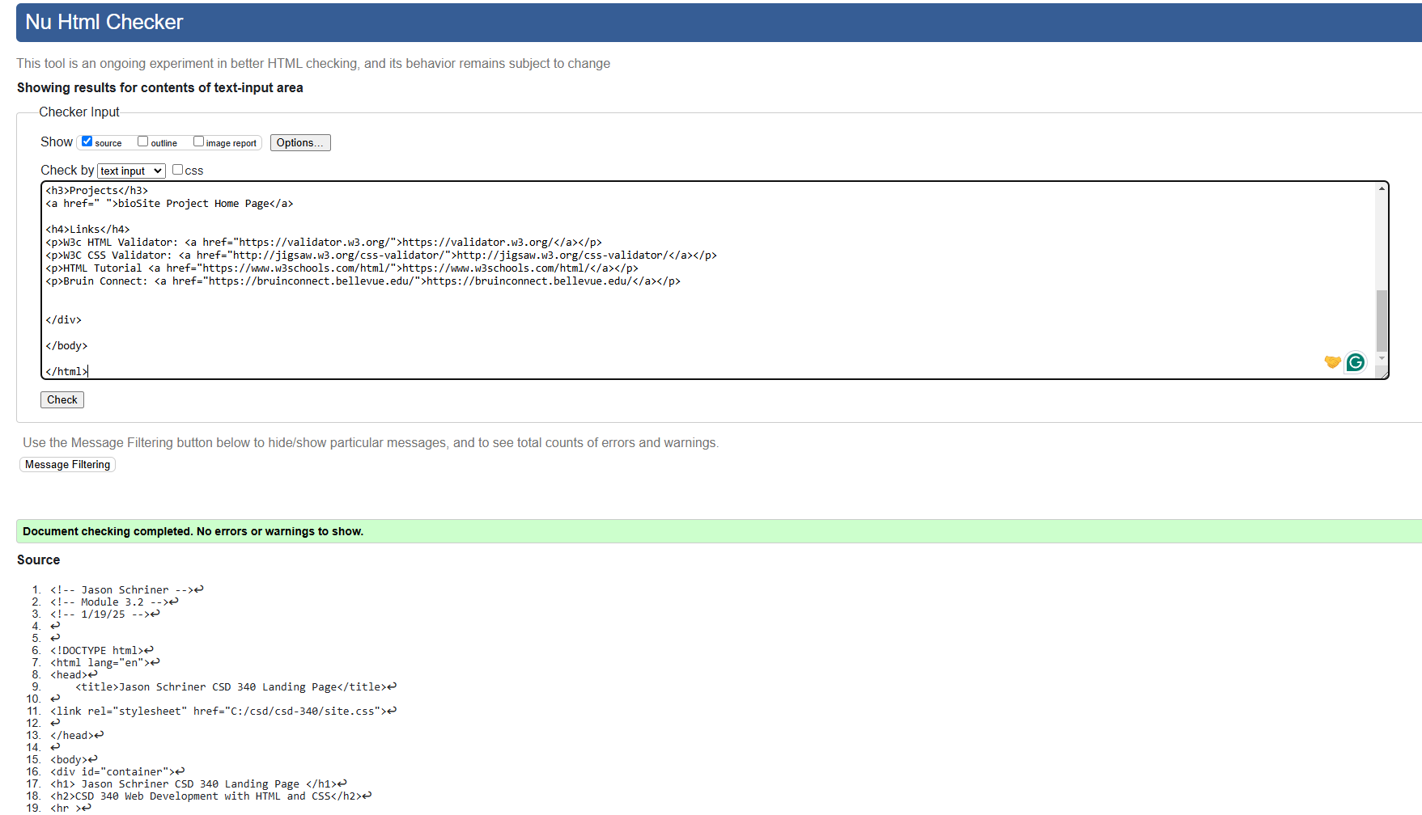

CSS Validated:

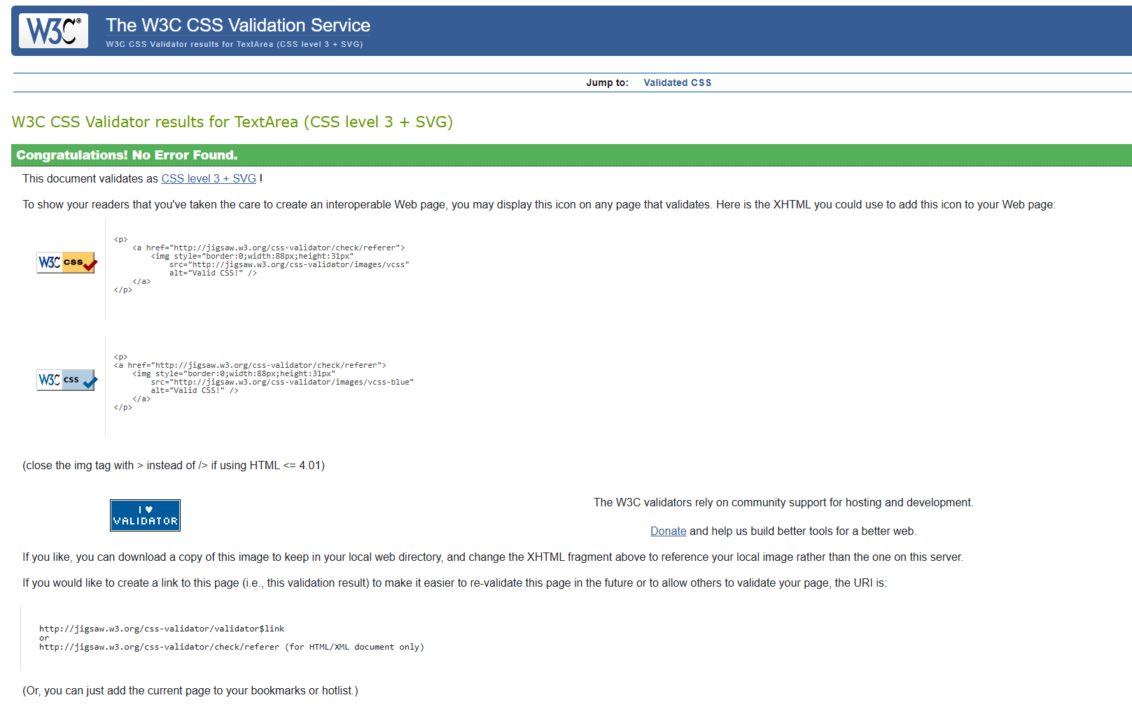

Site Screenshot:

