Jason Schriner

Module 1

5/31/25

Screenshot of Eclipse:

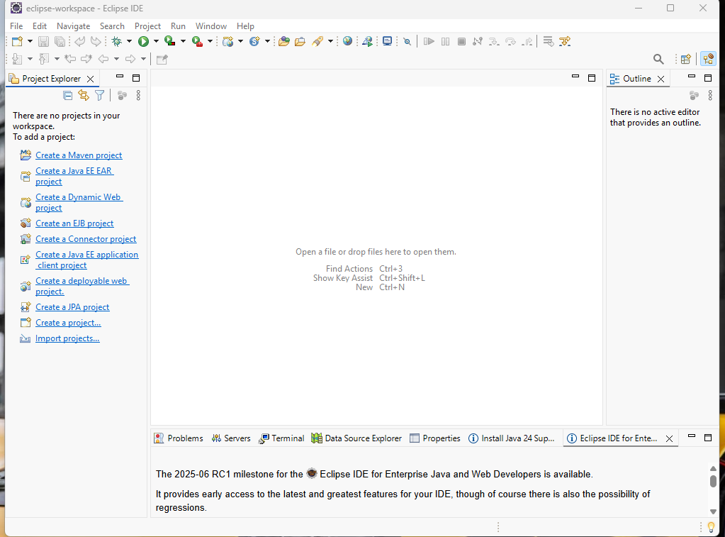

Screenshot of Tomcat (forgot to take during installation took this instead):

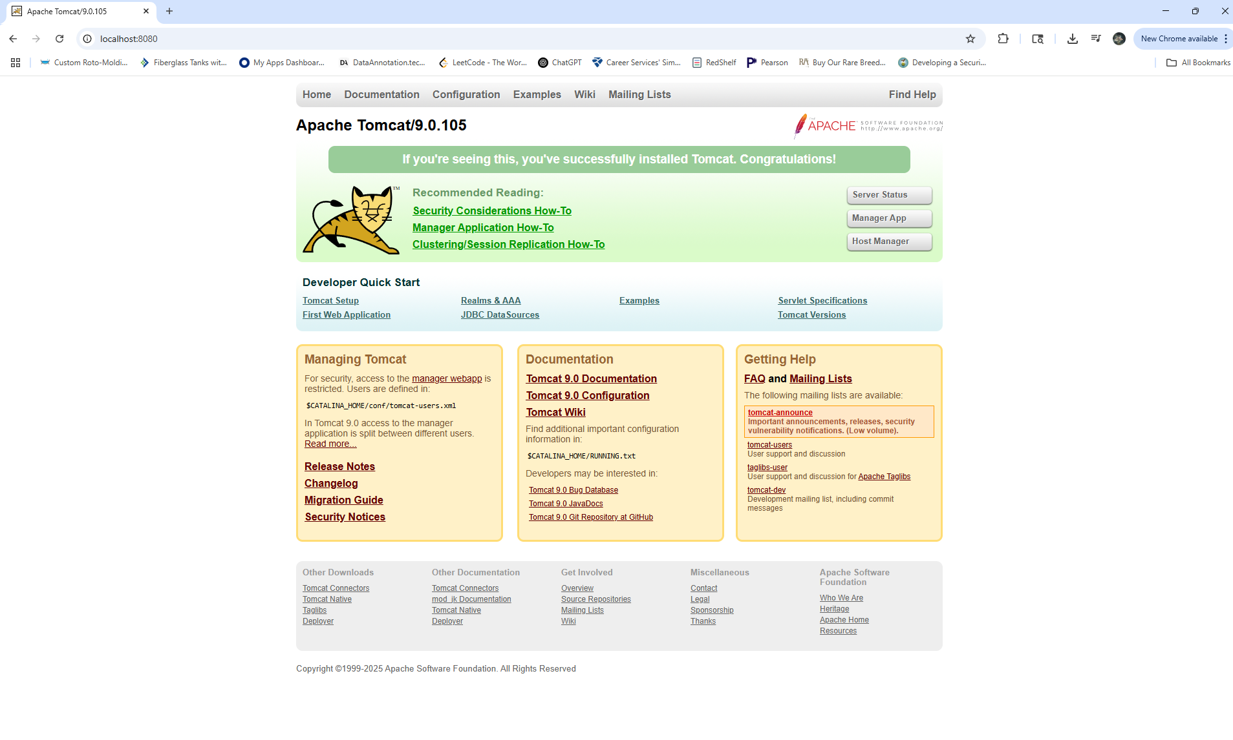Screenshot of Java version:

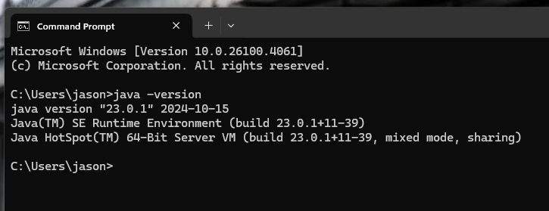

Screenshot of JSP file executed:

