Lucca's Pizza and Market

2195 Station Village Way #A

San Diego, CA, 92108

Tel #

Website : [www.luccaspizzamarket.com](http://www.luccaspizzamarket.com/)

Build your Own Pizza

Choice of Sauce

Homemade Tomato Sauce, Alfredo Sauce, Pesto Sauce, BBQ Sauce

Choice of Veggies

Roma Tomatoes, Mushrooms, Baby Spinach, Scallions, Red Onions, Artichoke, Olives, Sun dried tomatoes, Cilantro, Capers, Bell peppers, pepperoncini, Serrano peppers, Avocados, Cherry tomatoes, Sliced Baked Eggplant

Choice of Meat

Genova Salami, Italian Sausage, Canadian Bacon,

Aged Pepperoni, Grilled Chicken

Choice of Cheeses

Mozzarella, Provolone, Gorgonzola, Parmesan

Artisan Pizza Specials

1.MARGHERITA

Semi dried tomatoes, fresh basil and fresh mozzarella on a light rosemary garlic olive oil sauce

Small 8'' $8.99 Large $18.99

2.Bella

Spinach, topped with aged mozzarella blend, roasted garlic, prosciutto and white truffle oil on an Extra Virgin olive oil base

Small 8'' $8.99 Large 14'' $18.99

3.BBQ CHICKEN

Aged mozzarella, grilled Chicken, red onions, BBQ and homemade Tomatoes sauce

Small 8 ''–$8.99. 14″ – $18.99

4) Roma

Italian Sausage, Spinach, Mushroom, Sun dried Tomatoes, Capers topped with fresh Basil and Roma Tomatoes

Small 8” $8.99 Large 14'' $18.99

6) All Meat …………………

Italian Sausage, Salami, Aged Pepperoni, Canadian Bacon, Aged Mozzarella Cheese, Tomato Sauce

Small 8'' $8.99 Large14” $18.99

7) House Special

Shrimp, Sun dried tomatoes, Black olives, Aged mozzarella Cheese and our homemade pesto sauce…. Small 8” $8.99 Large 14” $18.99

8) Vegetarian

Sun dried Tomatoes, Scallions, Olives, Capers, Artichoke, Mushroom, Spinach, Fresh Roma Tomatoes, Mozzarella Cheese, Tomato sauce

Small 8” $8.99 Large 14” $18.99

9.Baja

Homemade tomato sauce, green onions, ground beef, topped with fresh serrano, cilantro, and roma tomatoes

Small 8'' $8.99 Large 14'' $18.99

Artisan Italian Sandwiches

Capicola Motedella Salami

Served on a French roll with extra virgin olive oil and provolone chees.............................................$11.95

Prosciutto

Served on a French roll with extra virgin olive oil and provolone cheese.............................................$11.95

Hot pastrami

Dipped in onion broth under melted mozzarella, with kosher dill slices and mayo.

$11.65

Herbed Chicken

Wine poached chicken breast on a bed of fresh greens, red and yellow peppers and topped with an herbed lemon Dijon dressing.

$11.65

Choice of cheese

Aged Mozzarella, Provolone Piccante, Romano

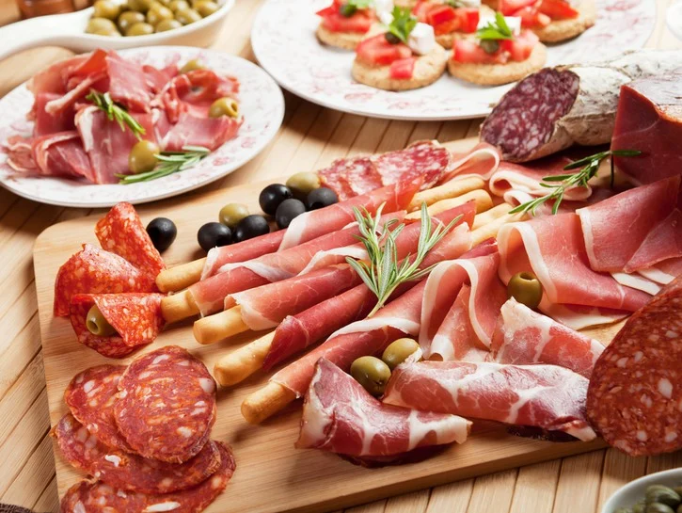

SIDE ORDERS

Wings

6 Pieces of boneless wings

GARLIC KNOTS

Half-dozen of our freshly baked, garlic-soaked little breads $4.95

House Salad

Mixed Veggie topped with pepperoncini and homemade Italian dressing $4.95

Add-Grilled Chicken.................................... $1.99

Caesar Salad $4.99

Romaine Lettuce, Garlic herb Croutons, Parmesan Cheese mixed with our homemade Caesar dressing

Add - Grilled chicken $1.99

Greek Salad

Romaine Lettuce, Tomatoes, Cucumber, Red Onion, Black Greek Olives, Green Olives, Feta Cheese with homemade Italian dressing $4.99

Kale Salad with Carrot Ginger Dressing

We have great selection of Juice bar please login to our website

CATERING AVAILABLE - 20 PERSON OR MORE

Birthday Parties,Anniversaries,Business Meeting

0r Any Event of any Size

Our Facility is Available for all Events

FOR DETAILS PLEASE CONTACT THE RESTAURANT MANAGER

Delivery and Service charges extra

FOR RESERVATIONS PLEASE Call

EMAIL: Luccaspizzamarket@gmail.com