Mark Wagner

Project 03

CMIS242

Recursion

Test Cases:

|  |  |  |  |  |  |  |
| --- | --- | --- | --- | --- | --- | --- |
| Input | Exp Iter | Actu Iter | Effic | Exp Recu | Actu Recu | Effic |
| 0 | 0 | 0 | 0 | 0 | 0 | 1 |
| -5 | exception | exception | n/a | Exception | Exception | n/a |
| 100 | 6 digits | -673178324 | 99 | Same as 100 | Crashed Machine | n/a |
| 1000 | High number | -739764424 | 999 | Crash | Crash | n/a |
| 1 | 1 | 1 | 0 | 1 | 1 | 1 |

Crash occurred due to an ArraySizeException and a NegativeArraySizeException

Faliure:

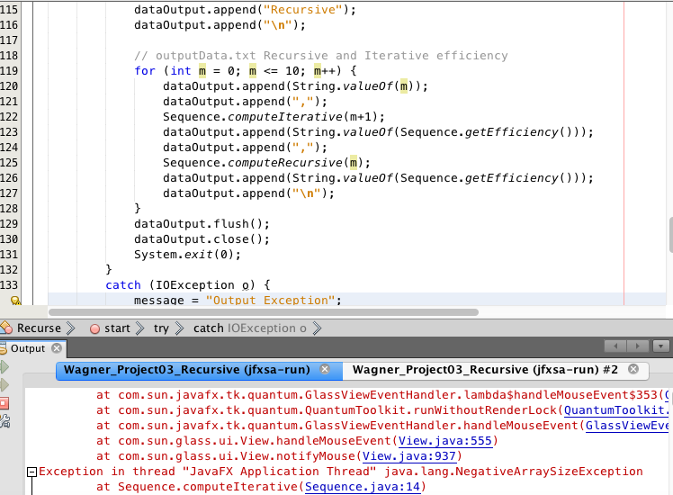

Success @ 10:

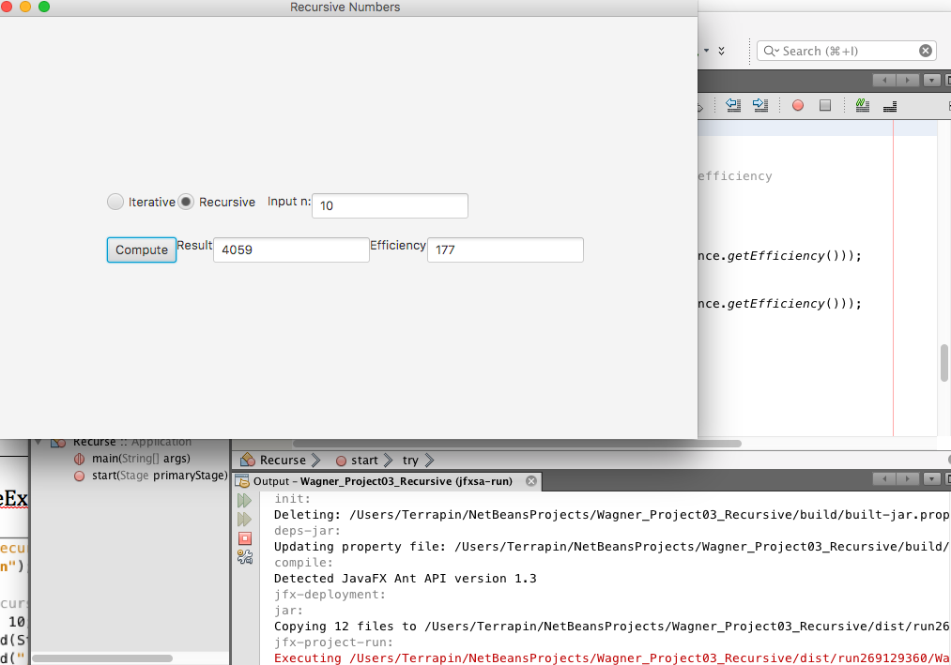

Success at 1:



Success @ 0:



Faliure at 1000:

What this means is that as the input grows higher, the number of required recursions into the method exponentially grows leading to an increase in CPU usage.

The higher the red line, the LESS efficient the program is at reaching the result.

