**CMIS 320 Project 4**

|  |  |  |  |  |  |
| --- | --- | --- | --- | --- | --- |
| **­­­GIRL** | **GROUP** | **AGE** | **GAME** | **CATEGORY** | **PRICE** |
| Charlotte | 5 year olds | 5 | Mirror | Makeup | 4.88 |
| Susan | 6 year olds | 6 | Lipstick | Makeup | 5.95 |
| Jane | 5 year olds | 5 | Chess | Games | 7.55 |
| Susan | 6 year olds | 6 | Checkers | Games | 5.95 |
| Susan | 6 year olds | 6 | Mirror | Makeup | 4.88 |
| Carrie | 6 year olds | 6 | Lipstick | Makeup | 5.95 |
| Jacqueline | 5 year olds | 5 | Visual Basic | Prog. Languages | 199.99 |

Examine the following relation and its attributes and answer the following questions. Assume these are the values for “all time”. Assume girls with the same name are the same person.

1. This table is 1NormalForm because it meets the criteria applicable to it:

* Every column in the table must be unique
* Each table must be identified with a unique column or concatenated columns called the primary key
* No rows may be duplicated
* no columns may be duplicated
* no row/column intersections contain a null value
* no row/column intersections contain multivalued fields

It does NOT, however make it all the way to the 2nd NF because it lacks a unique primary key or 3rd Normal Form because it has transitive functional dependencies.. e.g. the age changing Age column would also make the same entry need to change groups into a different age group.

2. There is not a single primary key, but a tuple can be formed into a composite key. This could be the girl’s name and game played because if you join those two distinctive features, there is a unique constraint respective to all the other possibilities.

3. Deleting Jacqueline would remove any instances of the “Prog. Languages“category from the table. This would have to be addressed to reach Boye-Codd Normal Form.

4.

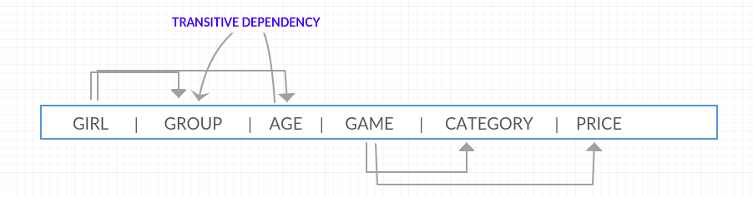

5. The initial relation is only first normal form because there are multiple partial dependencies present due to the composite key. Key should be composed of prime attributes.

6.

|  |  |  |  |
| --- | --- | --- | --- |
| GIRL | GROUP | AGE | GAME |
| Charlotte | 5 yo | 5 | Mirror |
| Susan | 6 yo | 6 | Lipstick |
| Jane | 5 yo | 5 | Chess |
| Susan | 6 yo | 6 | Checkers |
| Carrie | 6 yo | 6 | Lipstick, Makeup |
| Jacqueline | 5 yo | 5 | Visual Basic |
|  |  |  |  |

|  |  |
| --- | --- |
| GAME | CATEGORY |
| Mirror | Makeup |
| Lipstick | Makeup |
| Chess | Games |
| Visual Basic | Programming Languages |
| Checkers | Games |

There are **two** 3NF relations.

In better practice, I would have gone for FIVE higher NF relation tables, but that would mean they are spurious and indicate a lossy decomposition

1) Is this relation in at least 1NF? Why or why not?

2) What is the primary key of the initial relation (assume the values shown are the only possible tuples for all time)? Remember that a primary key must be unique and not null.

3) Describe the specific data anomalies that exist if we DELETE the tuple containing Jacqueline.

4) Draw a functional dependency diagram for the initial relation. This diagram should agree with the primary key you selected in above.

5) Based on your diagram, what normal form is the initial relation in? Why?

6) If necessary, decompose the initial relation into a set of non-loss 3NF relations by showing the relations, attributes, and tuples. Show complete relations with attribute headings and all data values in the tuples of your relations. Determine the number of 3NF relations you end up with after normalization, write this number, and then circle the number.

.