Wagner, Mark Project 2 Mom & Pop Video

Relationship Sentences:

Customer is connected to charges and rental history via chargeID or CustomerID.

Charges are connected to rentals via rental ID.

Rental is associated with Movie by it’s unique item number.

Movie has a type.

Each movie came out of an order batch.

Each order batch came from a distributor.

ERD: (dotted lines for reference ability – are not direct relationships

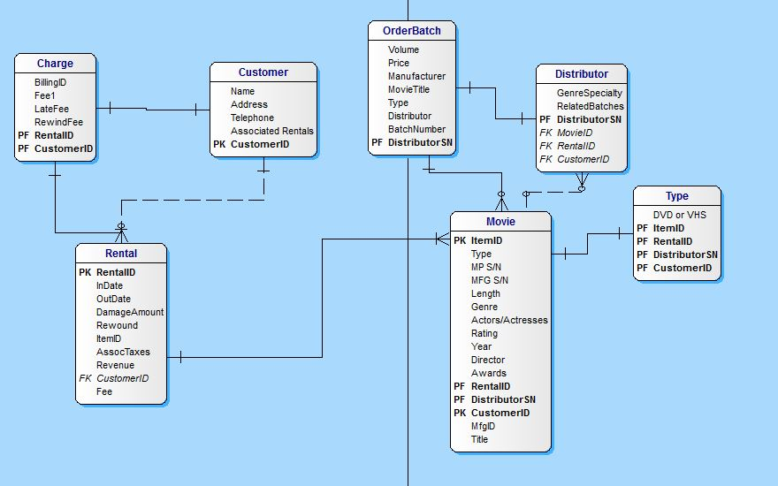 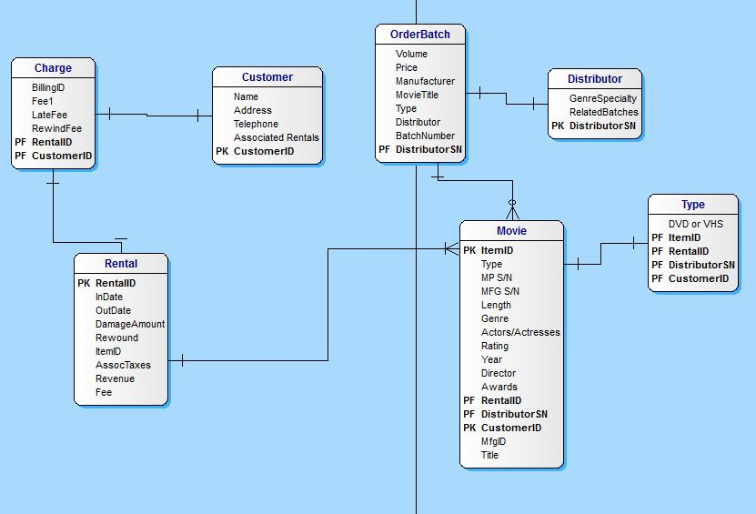

Metadata:

|  |  |  |  |  |  |  |  |
| --- | --- | --- | --- | --- | --- | --- | --- |
| FK Right>> PK Below vvv | Charge | Customer | OrderBatch | Distributor | Type | Movie | Rental |
| Charge | _________ | CustomerID | _________ | _________ | _________ | _________ | BillingID |
| Customer | RentalID | _________ | _________ | _________ | Via Movie | CustomerID | CustomerID |
| OrderBatch | _________ | _________ | _________ | DistributerNo | _________ | Title | _________ |
| Distributor | _________ | _________ | BatchNo | _________ | Via Movie | MovieTitle | _________ |
| Type | _________ | Via RentalID | _________ | _________ | _________ | <Binary Type> | _________ |
| Movie | _________ | RentalID | DistributorSN | DistributorSN | ItemID | _________ | ItemID |
| Rental | Revenue | RentalID | _________ | _________ | ItemID | RentalD | _________ |