Project 2 - php

Wagner, Mark

SDEV300-7893 – Professor Cooper

Spring 2019

Below is the screenshot of the first set of graphs. The final results are generated by custom functions.

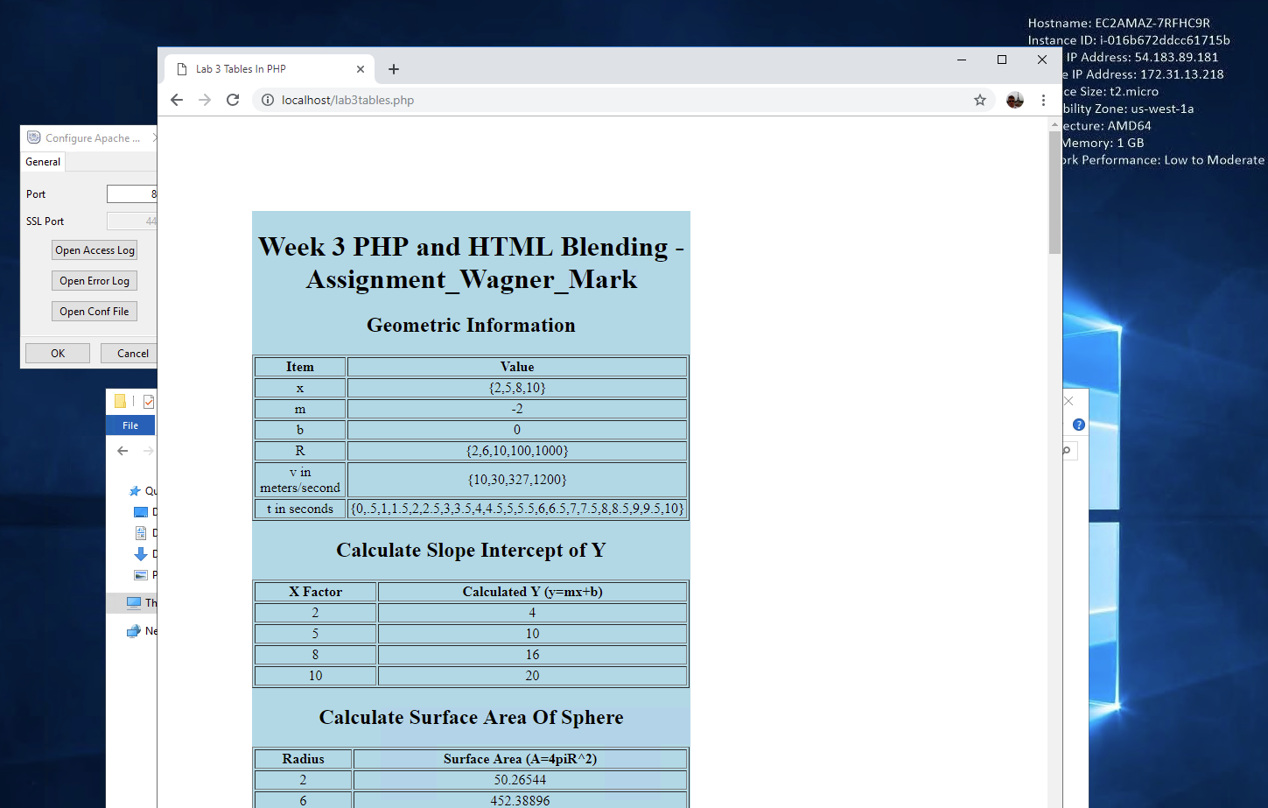

The second part of this script of php and html, shown on the following page, utilizes the upper case and string shuffle internally included php functions.

