The weighted bi-directional graph describing the conveyor system.

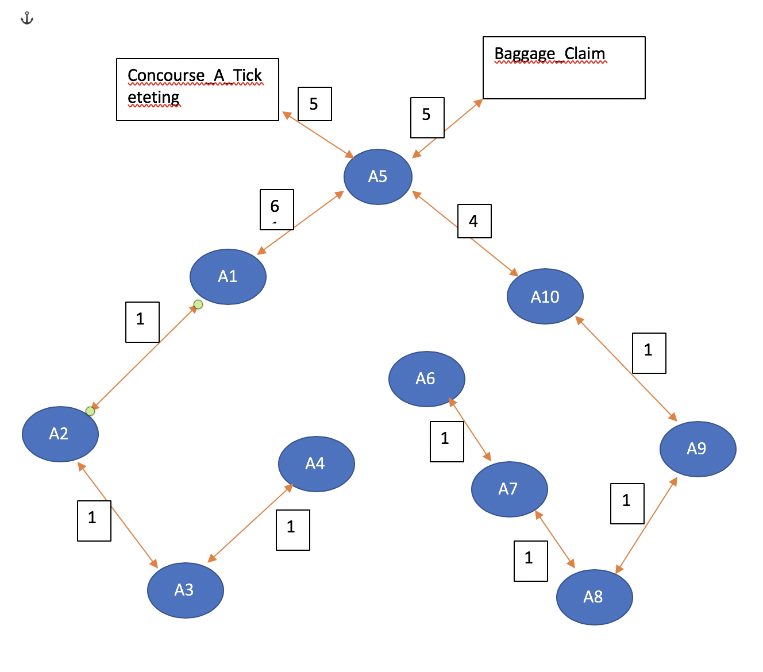

The Given Flights and gates are

**fltNbr Gate City Time**

UA10 A1 MIA 08:00

UA11 A1 LAX 09:00

UA12 A1 JFK 09:45

UA13 A2 JFK 08:30

UA14 A2 JFK 09:45

UA15 A2 JFK 10:00

UA16 A3 JFK 09:00

UA17 A4 MHT 09:15

UA18 A5 LAX 10:15

Given Baggage Directions

**BagId Gate FltNbr**

0001 Concourse_A_Ticketing UA12

0002 A5 UA17

0003 A2 UA10

0004 A8 UA18

0005 A7 ARRIVAL

By considering the baggage’s in an order, to find there optimum path to reach their destination gate.

1. 0001 Concourse_A_Ticketing UA12

The gate for UA12 is A1, so need to find the baggage path from Concourse_A_Ticketing to A1.

The shortest distance baggage reaching to A1 gate from Concourse_A_Ticketing gate is Via gate A5

Concourse_A_Ticketing 🡪 A5 🡪 A1 and the total distance covered is 11.

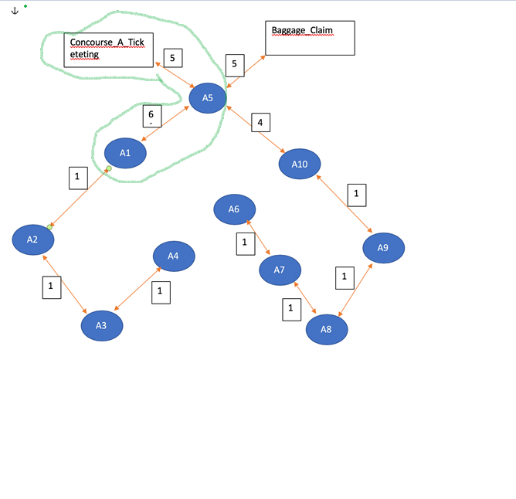

2. 0002 A5 UA17

The gate for UA17 is A4, so need to find the baggage path from A5 to A4.

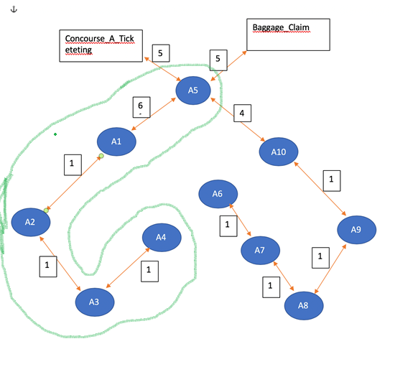

The shortest distance baggage reaching to A4 gate from A5 gate is Via A1, A2 and A3

A5 🡪 A1 🡪 A2🡪 A3🡪 A4 and the total distance covered is 9.

1. 0003 A2 UA10

The gate for UA10 is A1, so need to find the baggage path from Concourse_A_Ticketing to A1.

The gate for UA17 is A4, so need to find the baggage path from A2 to A1.

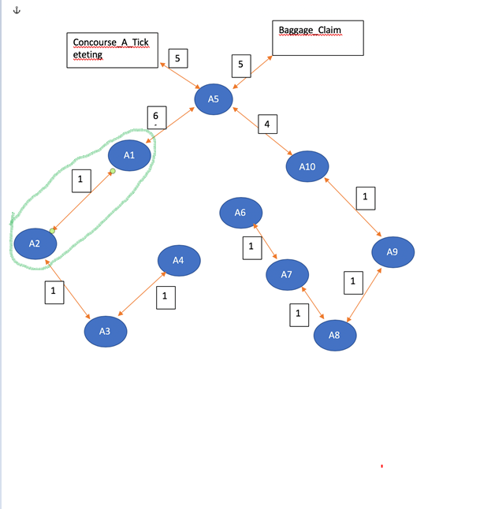

The shortest distance baggage reaching to A2 gate from A1 is 1.

A2🡪 A1 and the total distance is 1.

1. 0004 A8 UA18

The gate for UA18 is A5, so need to find the baggage path from A8 to A5.

The shortest distance baggage reaching to A8 gate from A5 is A8🡪 A9🡪 A10🡪 A5.

And the total distance is 6.

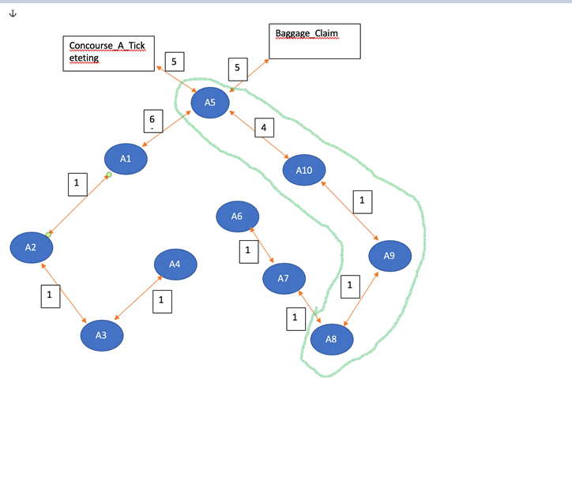

1. 0005 A7 ARRIVAL

The gate for ARRIVAL is Baggage claim, so need to find the baggage path from A7 to Baggage_claim.

The shortest distance that baggage reaching to baggage claim from A7 is A7🡪A8🡪 A9🡪 A10🡪 A5🡪 Baggage Claim And the total distance is 12