UML Diagram for all the classes.

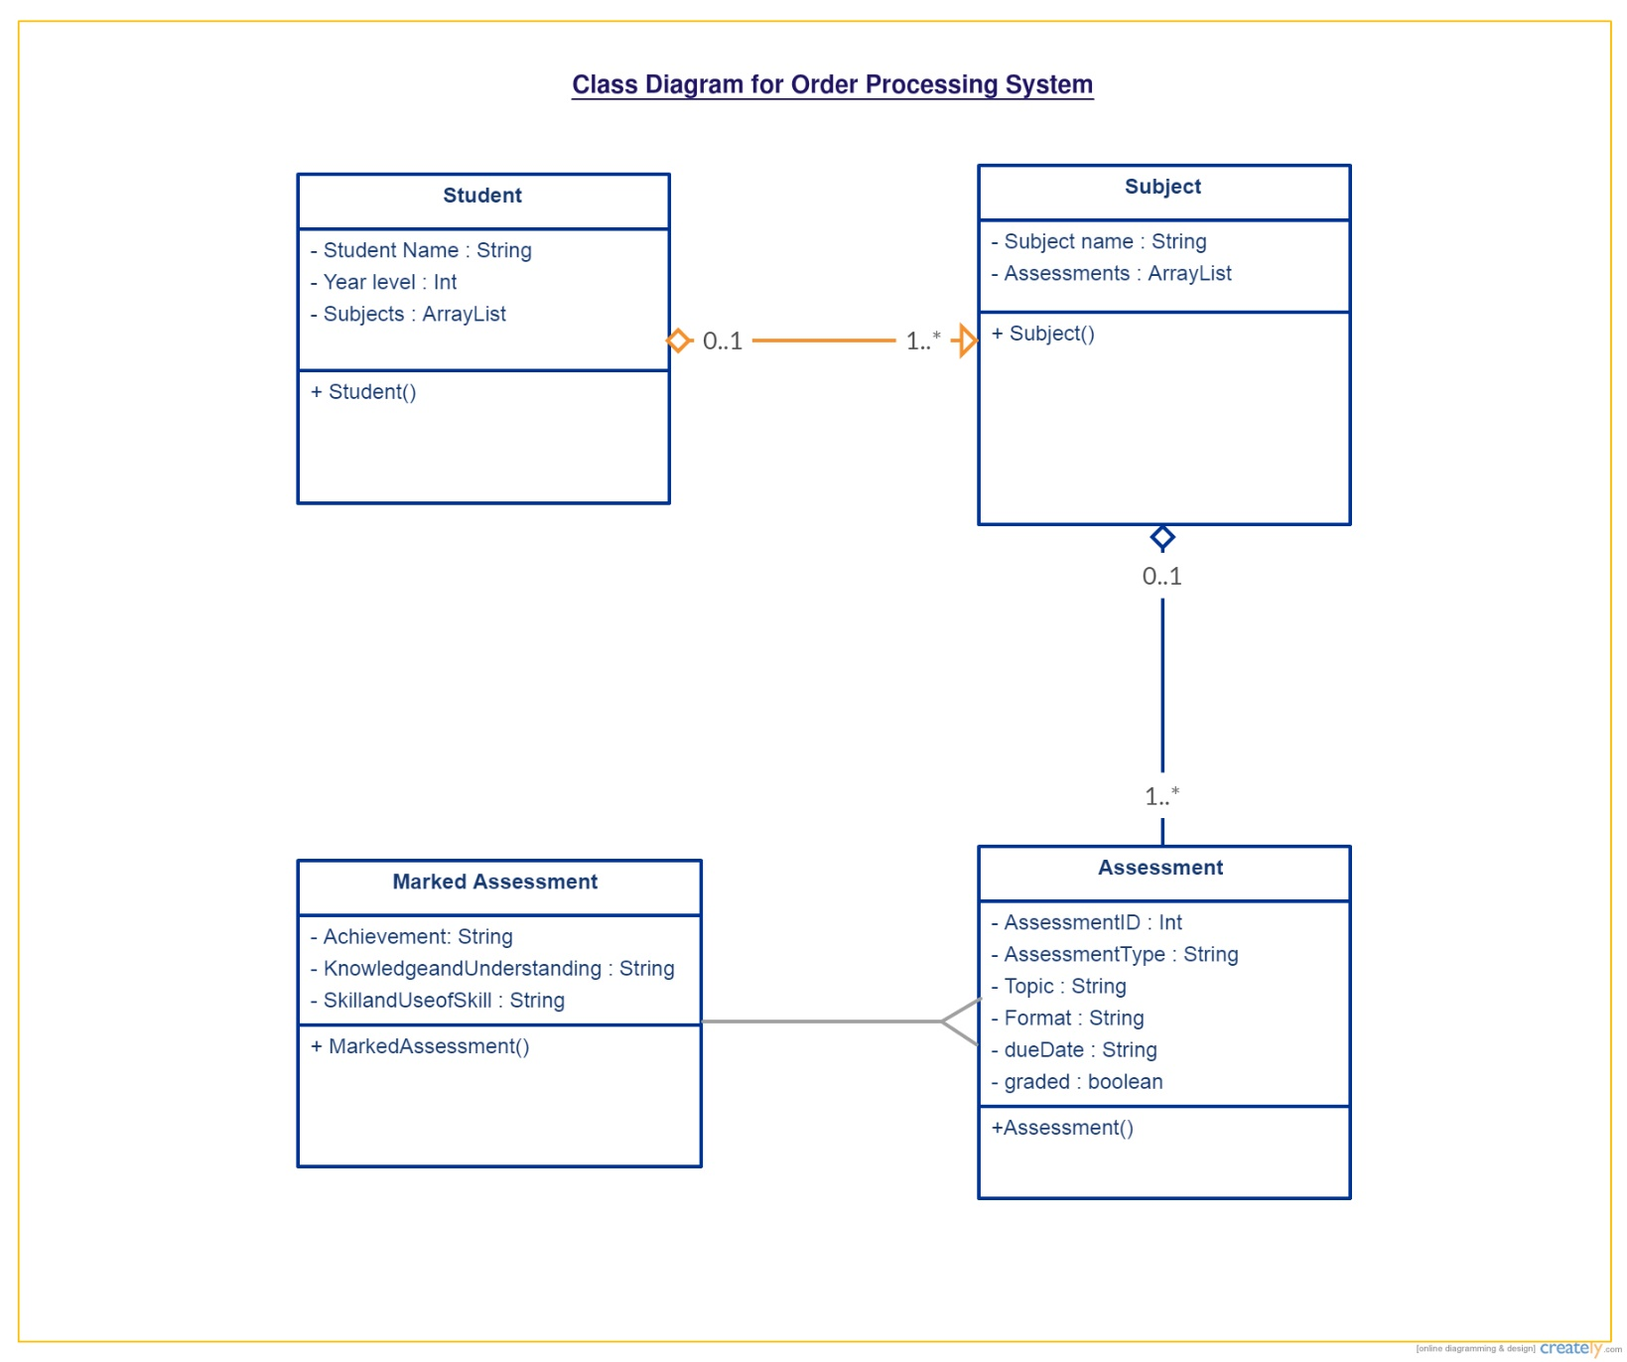

Test data and Results: