**Topics: Normal distribution, Functions of Random Variables**

1. The time required for servicing transmissions is normally distributed with *μ* = 45 minutes and *σ* = 8 minutes. The service manager plans to have work begin on the transmission of a customer’s car 10 minutes after the car is dropped off and the customer is told that the car will be ready within 1 hour from drop-off. What is the probability that the service manager cannot meet his commitment?
2. 0.3875
3. **0.2676**
4. 0.5
5. 0.6987

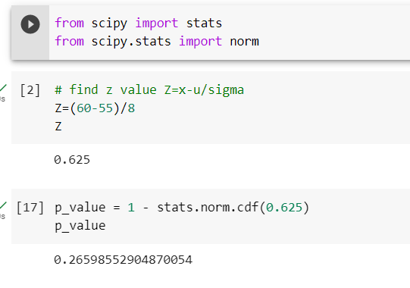

1. The current age (in years) of 400 clerical employees at an insurance claims processing center is normally distributed with mean *μ* = 38 and Standard deviation *σ* =6. For each statement below, please specify True/False. If false, briefly explain why.
2. More employees at the processing center are older than 44 than between 38 and 44.

Ans : False

1. A training program for employees under the age of 30 at the center would be expected to attract about 36 employees.

Ans : True

1. If *X1* ~ *N*(μ, σ2) and *X*2 ~ *N*(μ, σ2) are *iid* normal random variables, then what is the difference between 2 *X*1 and *X*1 + *X*2? Discuss both their distributions and parameters.

According to the Central Limit Theorem, any large sum of independent, identically distributed(iid) random variables is approximately Normal.

The Normal distribution is defined by two parameters, the mean, https://tex.z-dn.net/?f=%5Cmu, and the variance, https://tex.z-dn.net/?f=%5Csigma%5E%7B2%7D and written as https://tex.z-dn.net/?f=X%20%5Csim%20N(%5Cmu%2C%20%5Csigma%5E2).

Given https://tex.z-dn.net/?f=X_1%20%5Csim%20N(%5Cmu%2C%20%5Csigma%5E2)~~%5Cmbox%7Band%7D~~%20X_2%20%5Csim%20N(%5Cmu%2C%20%5Csigma%5E2)  are two independent identically distributed random variables.

From the properties of normal random variables,

if https://tex.z-dn.net/?f=X%20%5Csim%20N(%5Cmu_1%2C%20%5Csigma_1%5E2) and https://tex.z-dn.net/?f=Y%20%5Csim%20N(%5Cmu_2%2C%20%5Csigma_2%5E2) are two independent identically distributed random variables then

* the sum of normal random variables is given by

https://tex.z-dn.net/?f=X%20%2B%20Y%20%5Csim%20N(%5Cmu_1%20%2B%20%5Cmu_2%2C%20%5Csigma_1%5E2%20%2B%20%5Csigma_2%5E2%20),

* and the difference of normal random variables is given by

https://tex.z-dn.net/?f=X%20-%20Y%20%5Csim%20N(%5Cmu_1%20-%20%5Cmu_2%2C%20%5Csigma_1%5E2%20%2B%20%5Csigma_2%5E2%20)

* When  https://tex.z-dn.net/?f=Z%20%3D%20aX, the product of X is given by

https://tex.z-dn.net/?f=Z%20%5Csim%20N(a%5Cmu_1%20%2C%20a%5E2%5Csigma_1%5E2%20)

* When  https://tex.z-dn.net/?f=Z%20%3D%20aX%20%2B%20bY, the linear combination of X and Y is given by

https://tex.z-dn.net/?f=Z%20%5Csim%20N(a%5Cmu_1%20%2B%20b%5Cmu_2%2C%20a%5E2%5Csigma_1%5E2%20%2B%20b%5E2%5Csigma_2%5E2%20)

Given to find, https://tex.z-dn.net/?f=2X_1

Thus, following the property of multiplication, we get

https://tex.z-dn.net/?f=2X_1%20%5Csim%20N(2%5Cmu%2C%202%5E2%5Csigma%5E2)%5Cimplies2X_1%20%5Csim%20N(2%5Cmu%2C%204%5Csigma%5E2)

and following the property of addition,

https://tex.z-dn.net/?f=X_1%2BX_2%5Csim%20N(%5Cmu%20%2B%20%5Cmu%2C%20%5Csigma%5E2%20%2B%20%5Csigma%5E2%20)%20%5Csim%20N(2%5Cmu%2C%202%5Csigma%5E2%20)

And the difference between the two is given by

https://tex.z-dn.net/?f=2X_1-(X_1%2BX_2)%20%5Csim%20N(2%5Cmu%20-%202%5Cmu%2C%202%5Csigma_1%5E2%20%2B%204%5Csigma_2%5E2%20)%5Csim%20N(%200%2C6%20%5Csigma%5E2)

The mean of https://tex.z-dn.net/?f=2X_1 and https://tex.z-dn.net/?f=X_1%2BX_2 is same but the var(https://tex.z-dn.net/?f=%5Csigma%5E2) of  https://tex.z-dn.net/?f=2X_1 is 2 times more than the variance of https://tex.z-dn.net/?f=X_1%2BX_2.

The difference between the two says that the two given variables are identically and independently distributed.

1. Let X ~ N(100, 202). Find two values, *a* and *b*, symmetric about the mean, such that the probability of the random variable taking a value between them is 0.99.
2. 90.5, 105.9
3. 80.2, 119.8
4. 22, 78
5. **48.5, 151.5**
6. 90.1, 109.9

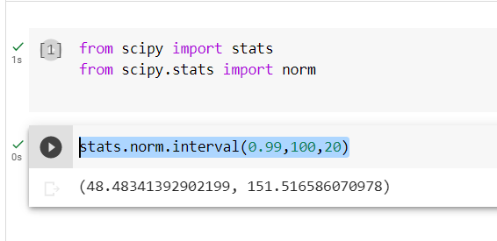

1. Consider a company that has two different divisions. The annual profits from the two divisions are independent and have distributions Profit1 ~ N(5, 32) and Profit2 ~ N(7, 42) respectively. Both the profits are in $ Million. Answer the following questions about the total profit of the company in Rupees. Assume that $1 = Rs. 45
2. Specify a Rupee range (centered on the mean) such that it contains 95% probability for the annual profit of the company.

Ans : 540 M

1. Specify the 5th percentile of profit (in Rupees) for the company

Ans : 169.875 M

1. Which of the two divisions has a larger probability of making a loss in a given year?

Ans : 1