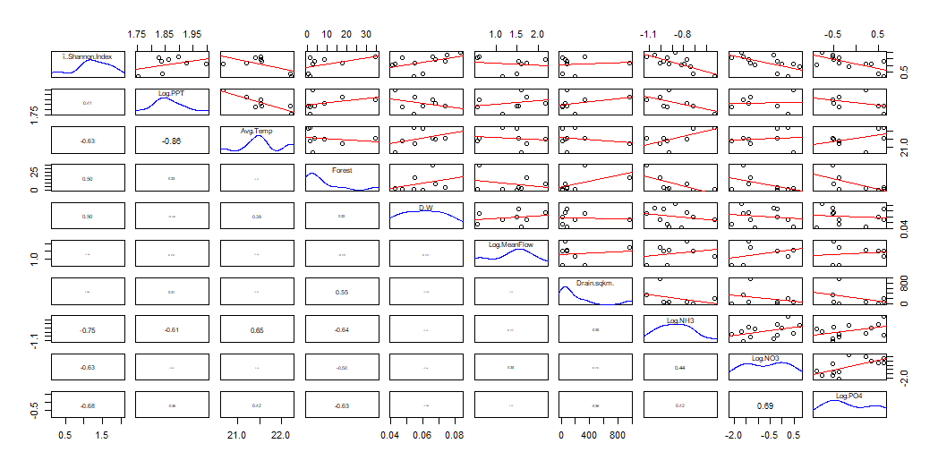

**Figure 1:** displays Augmented Pairs Plot for all environmental explanatory factors and The fish diversity (Shannon Index). Correlation coefficients for each regression are displayed at variable intersections to the left. Regression plots fore each regression are displayed at variable intersections to the right

**Table 1:** displays the multi-variable linear regression models predicting fish diversity and their associated summary statistics.

|  |  |  |  |
| --- | --- | --- | --- |
| **Fish Diversity** | Model.9.forward | Model.49 | Model.Backward |
| Intercept | -0.9173 | -5.2226 | 16.2384 |
| Log of Ammonia | -2.3174 |  |  |
| Log of Precipitation |  | 3.2213 |  |
| Air Temperature |  |  | -0.769 |
| Depth/Width Ratio |  |  | 20.0771 |
| Log of Nitrates |  | -0.415 | -0.3345 |
| R^2 | 0.6594 | 0.7048 | 0.936 |
| Adj R^2 | 0.6027 | 0.5867 | 0.888 |
| F Statistic | 11.62 | 5.968 | 19.5 |
| Df1 | 1 | 2 | 3 |
| Df2 | 6 | 5 | 4 |
| p-value | 0.01434 | 0.04735 | 0.007514 |
| Max vif | NA | 1.001 | 1.219 |

**Figure 2:** displays a plot of Fish Diversity as a function annual precipitation. The regression equation and R^2 are displayed in the top right of the figure.

**Figure 3:** displays a plot of fish diversity (Shannon Index) as a function of the depth/width ratio of the wetted channel. The regression equation and R^2 are displayed in the top right.

**Figure 4:** displays a plot of fish diversity (Shannon Index) as a function of the concentration of Nitrates. The regression equation and R^2 are displayed in the top right.

**Figure 5:** displays a plot of fish diversity (Shannon Index) as a function of the annual mean air temperature (°C). The regression equation and R^2 are displayed in the top right.

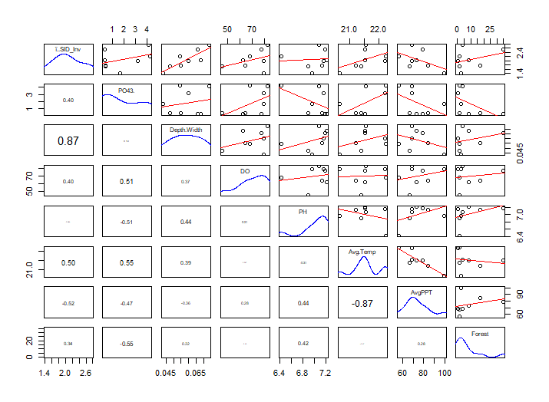**Table 2**: displays the multi-variable linear regression models predicting invertebrate diversity and their associated summary statistics.

**Figure 6:** displays Augmented Pairs Plot for all environmental explanatory factors and the invertebrate diversity (Shannon Index). Correlation coefficients for each regression are displayed at variable intersections to the left. Regression plots fore each regression are displayed at variable intersections to the right

|  |  |  |  |
| --- | --- | --- | --- |
| **Invertebrate Diversity** | Model.5 | Model.3 | Model.Backward |
| Intercept | -0.07441 | 3.36539 | 26.514988 |
| Precipitation |  | -0.01752 | -0.082152 |
| Phosphates |  |  | -0.235538 |
| Dissolved Oxygen |  |  | 0.057341 |
| Air Temperature |  |  | -1.017958 |
| Depth/Width Ratio | 36.49285 |  |  |
| R^2 | 0.7518 | 0.2705 | 0.9591 |
| Adjusted R^2 | 0.7104 | 0.1489 | 0.9045 |
| F Statistic | 18.17 | 2.224 | 17.57 |
| Df1 | 1 | 1 | 4 |
| Df2 | 6 | 6 | 3 |
| p-value | 0.005303 | 0.1864 |  |
| Max vif | NA | NA | 10.7 |

**Figure 7:** displays a plot of invertebrate diversity (Shannon Index) as a function of the concentration of phosphates. The regression equation and R^2 are displayed in the top right.

**Figure 8:** displays a plot of invertebrate diversity (Shannon Index) as a function of the annual mean air temperature (°C). The regression equation and R^2 are displayed in the top right.

**Figure 9:** displays a plot of invertebrate diversity (Shannon Index) as a function of the mean annual precipitation (cm). The regression equation and R^2 are displayed in the top right.

**Figure 10:** displays a plot of invertebrate diversity (Shannon Index) as a function of the % saturation of dissolved oxygen. The regression equation and R^2 are displayed in the top right.