**Identifying Climate-Driven effects on animal diversity in Texas Coastal Streams**

**Abstract**

This report analyzes existing correlations between environmental factors and the biodiversity of fish and macroinvertebrate communities. The study uses data from the USGS in conjunction with manned surveys from the Spring of 2017. The streams span the coastal bend of the Texas Coastal Prairie, where there is a significant precipitation gradient. In this preliminary study, I used linear regressions and multivariate regressions to identify the most significant environmental factors in predicting fish diversity and invertebrate diversity. The results indicate that fish diversity is negatively impacted by high nutrient concentrations which may be regulated by air temperature, precipitation, and riparian buffering by undeveloped woodlands. Contrarily, invertebrate diversity is positively correlated with nutrients and temperature. I suspect eutrophication is the likely mechanism by which nutrients exert selective pressures on fish communities which has cascading trophic effects throughout the food web. Thus, further analysis of this hypothesis needs to correlate climate factors with a long term monitoring of stream metabolism (dissolved oxygen content) and nutrient concentrations over time to analyze the frequency of algal bloom and anoxic fish kills that result from eutrophication.

Sean Kinard

skinard@islander.tamucc.edu

(509) 951-8767

Texas A&M Corpus Christi

Natural Resource Center 3204

6300 Ocean Dr, Corpus Christi, TX 78412

**Introduction**

The current literature indicates that stream order is the primary determinant of stream biodiversity in accordance with the river continuum concept (Cianfrani et al. 2009. In this study, we seek to identify alternative, environmental factors that influence stream ecosystem biodiversity. This report analyzes the preliminary surveys of 10 streams in the Texas Coastal Prairie, along a sharp precipitation gradient while maintaining similar elevations and stream orders. Our primary question is whether precipitation is a direct or indirect driver of biodiversity in freshwater streams.

**Methods**

*Data Collection*

The Texas Coastal Prairie is characterized by a naturally sharp precipitation gradient along the coastal bend of the Gulf of Mexico. The mean annual precipitation changes from 55 cm/year (semi-arid) to 135 cm/year (sub-humid) over a 300km distance (0.27cm.yr-1 per km). In the spring of 2017, 13 streams across this precipitation gradient with USGS gauges were surveyed for stream metabolism, nutrients, water chemistry, habitat characteristics, benthic invertebrates, and fish community composition. In this report we use USGS environmental data in conjunction with our surveys to analyze the relationships between fish and invertebrate communities with environmental factors.

*Data Analyses*

To identify correlated variables, I created augmented pairs plots (Figures 1&2) for fish and invertebrate diversities. Each environmental variable is plotted against every other variable and a regression line is added.The plotted regressions are analyzed for outliers or needed transformations. In variables where relationships or outliers were hard to detect, I applied a log base 10 transformation.The variables directly relevant to our question and those with correlation coefficients greater than |0.45| were compiled and used for multi-variable regression modeling.

I created multi-variable regressions using significant variables to identify the maximum R2 possible for predicting diversity. Using dredge, several models were picked from those with the lowest aICc and p values to examine the explanatory power of various environmental factors. Using the traditional.forward model approach, we sequentially add the most relevant explanatory variable (based on p-value) to generate the most simplistic prediction model. Using the traditional.backward model approach, we sequentially remove the least relevant explanatory variable (based on p-value) from the full model to generate the best prediction model. The models are ranked based on R2 and adjusted R2 to identify the most significant explanatory variables for predicting biodiversity. Using excel, simple regressions were plotted for the top 3 explanatory variables for predicting biodiversity and precipitation (in the interest of our main study question).

**Results**

*Summarizing the Augmented Pairs Plot for Fish Diversity (Figure 1)*

The log of mean annual precipitation (cm) is positively correlated with fish diversity (r= .41) and is colinear with mean annual air temperature (°C) (r= -.86) and the log of Nitrates (mL/L) (r= -.68). The mean annual air temperature (°C) is negatively correlated with fish diversity (r= -.63) and is colinear with the log of Nitrates (mL/L) (r= -.61). The acreage of forest within the watershed is positively correlated with fish diversity (r= .50) and is colinear with Log of ammonia, nitrates, and phosphates (mL/L) (r= -.64, -.50, -.63 respectively). The depth/width ratio of the wetted channel is positively correlated with fish diversity (r= .50) and is not significantly colinear with other variables affecting fish diversity. The log of ammonia, nitrates, and phosphates (mL/L) are negative correlated with fish diversity (r= -.75, -.63, -.68 respectively) and are colinear with one another (r= .44, .69 respectively).

*Summarizing Multi-Variable Regressions Predicting Fish Diversity (Table 1)*

Model.9: Df = -.917 - 2.317N where Df is Fish Diversity in Shannon Index and N is the concentration of Nitrate (mL/L). This model was also produced using the traditional forward method. This model is a significantly better predictor of Fish Diversity than the intercept given that the F-statistic is 11.62 with a p-value of .01

Model.49: Df = -5.222 - 0.415*N + 3.221*P where Df is fish Diversity in Shannon Index, N is the concentration of Nitrate (mL/L), and P is the log of average annual Precipitation (cm). Adding average precipitation to model 9 increases the R2 from .65 to 0.70. Adding average precipitation to model 9 decreased the adjusted R2 from .60 to 0.59. Model 49 is a better predictor of fish diversity than the intercept and maintains an F statistic of 6.0 with a p value of .05.

Model.Backward: Df = 16.238 - .769*T + 20.077*W - .334*N where Df is Fish Diversity in Shannon Index, T is the annual mean air temperature, W is the wetted channel Depth/Width ratio, and N is the concentration of Nitrates (mL/L). Adding the Depth/width ratio and average temperature increased the R2 from 0.70 to 0.94 and increased the adjusted R2 from .59 to .88. This model is the best predictor or fish diversity given its F statistic of 19.5 with a p-value of .008

*Summarizing Fish Diversity Linear Regressions*

Figures 2 and 3 indicate that fish diversity is positively correlated with precipitation (R2 = .17) and stream depth/width ratio (R2 = .25). Figures 4 and 5 indicate that fish diversity is negatively correlated with log of nitrate concentration (R2 = .39) and mean air temperature (R2 = .39).

*Summarizing the Augmented Pairs Plot for Invertebrate Diversity (Figure 6)*

The concentration of phosphates is positively correlated with invertebrate diversity (r= .45) and is colinear with pH (r= -.45), temperature (r= .55), precipitation (r= -.47), and forest (r= -.55). The depth/width ratio of the wetted channel is positively correlated with invertebrate diversity (r= .64). The % saturation of dissolved oxygen is negatively correlated with invertebrate diversity (r=-0.46) and is colinear with pH (r= .66). The pH is negatively correlated with invertebrate diversity (r= -.58). Average air temperature is positively correlated with invertebrate diversity (r= .5) and is colinear with average precipitation (r= -.87) and phosphate. Average annual precipitation is negatively correlated with invertebrate diversity (r= -.52) and is colinear with temperature and phosphate.

*Summarizing Multi-Variable Regressions Predicting Invertebrate Diversity (Table 2)*

Model.5: Di = -0.0744 + 36.493*R where Di is invertebrate diversity in Shannon Index and R is the wetted-channel depth/width ratio. Model.5 has a R2 = .75. This model is a significantly better predictor of Invertebrate Diversity than the intercept given that the F-statistic is 18.17 with a p-value of .005.

Model.3: Di = 3.365 - 0.0175*P where Di is invertebrate diversity in Shannon Index and P is average annual precipitation (cm). Model 3 has a R2 = .14. This model is not a significant predictor of Invertebrate diversity given that it has a F statistic of 2.22 with a p-value of .15.

Model.Backward.Inv: Di = 26.515 - 0.236*S + 0.0573*X - .0821*P - 1.0180*T where Di is invertebrate diversity in Shannon Index, S is concentration of phosphates (ml/L), X is dissolved oxygen (% saturation), P is average annual precipitation (cm), and T is average annual Air Temperature (°C). Model.Backward has a R2 = .96 The backwards model is a significantly better predictor of Invertebrate Diversity than the intercept given that the F-statistic is 17.57 with a p-value of 0.002.

*Summarizing Invertebrate Diversity Linear Regressions*

Figures 7 and 8 indicate positive linear relationships of invertebrate diversity with phosphate concentrations (R2 = .20) and mean air temperature (R2 = .25). Figures 9 and 10 indicate negative linear relationships of invertebrate diversity with annual precipitation (R2 = .27) and dissolved oxygen (R2 = .21).

**Discussion**

*Fish Diversity*

This preliminary analysis indicates that the most impactful factors on fish diversity are air temperature, nutrients, stream morphology, and precipitation. Despite deliberately choosing similar order streams, stream morphology, in accordance with RCC, plays a pivotal role in determining fish diversity (Cianfrani et al. 2009). Table 2 indicates that nutrients alone (model.9) are not the best explanatory factors for fish diversity. Similarly, adding precipitation to nutrient variables isn’t the most powerful predictive model. Incorporation of stream-order driven characteristics in the form of a depth/width ratio to nutrient and climate factors creates a model with an R2 value of .94 (p-value=.008). Thus, the most robust model for predicting fish diversity incorporates climate, nutrient, and stream morphological characteristics.

Strong collinearities between nutrient concentrations and forests, temperature, and precipitation suggests that these linked processes influence fish diversity. Agriculture is a dominant land-use in all of these watersheds, so we suspect that fish diversity is mainly governed through processes that control nutrient inputs to streams. Excessive nutrients stimulate eutrophic processes which in turn degrade habitat for fish. Harmful eutrophic effects include harmful algal blooms and lower dissolved oxygen concentrations from bacterial metabolism (Lee and Jones1991). According to Figures 1 and 3, Nutrients in the form of ammonia, nitrates, and phosphates have the strongest correlations with fish diversity. Their negative correlations (-.75, -.63, -.68) indicate that as nutrient content in streams increases, fish diversity decreases. In order to identify that nutrients are affecting fish diversity through eutrophication future analysis should first convert dissolved oxygen saturations to concentrations and identify minimum daily dissolved oxygen levels.

Contrarily, the positive correlations of precipitation and forest (r =.41 and .50 respectively) indicate that as precipitation and/or forest increases, fish diversity also increases. A strong negative collinearity between precipitation and ammonia (r = -.61) concentrations suggests that increasing precipitation decreases concentrations of ammonia. As rainfall increases nutrients from croplands runoff more frequently than drier climates. In drier areas, sediments become laden with salts and highly concentrated runoff from evaporation is the most likely factor influencing nutrient concentrations (Darwiche-Criado et al. 2012). In order to corroborate this mechanism, we need to control for agricultural development in each watershed while monitoring post-storm runoff nutrient content at sites with a varying annual precipitation.

Temperature can regulate nutrient concentrations via evaporation and the ensuing concentration of solutes in remaining solution. Figure 1 indicates that average temperature is negatively correlated with fish diversity (r= -.63) and not surprisingly with annual precipitation (r= -.86). Since water temperature is not as good of a predictor of fish diversity, we suspect that the temperature of soils and evaporation before runoff reaches streams it the main regulatory mechanism of stream nutrients, rather than the evaporation of water from the stream channel. This mechanism would be supported by an analysis of the ground water nutrient content in watersheds with different mean annual air temperatures.

*Macroinvertebrate Diversity*

Invertebrate diversity trends differ from those of fish diversity in all respects. Invertebrate diversity is positively correlated with phosphate concentrations (figure 7) and average temperature (figure 8). Eutrophication may reduce dissolved oxygen level below vertebrate thresholds without surpassing those of invertebrates. The loss of secondary predators (fish) alleviates predatory limitations on primary predators (invertebrates). Secondly, excessive nutrient inputs stimulate primary productivity and microbial activities, increasing available food sources for primary consumer invertebrates (Vinson and Hawkins 1998). These two effects, reduction in vertebrate predation and increased primary productivity, could result in the observed increase in the overall invertebrate diversity with nutrient concentrations. Further elaboration on this hypothesis should proceed with an analysis of functional diversity and abundances of invertebrates in relation to nutrient concentrations.

The positive correlation of nutrients with invertebrate is conflated with other environmental variables including acreage of forest, annual precipitation, air temperature, pH, and dissolved oxygen saturation (figure 6). As stated in the fish diversity discussion, climate factors such as precipitation and air temperature determine runoff nutrient concentrations via dilution through frequent rains or concentration of solutes via evaporation. I consider pH a dubious collinearity due to the variance in the scatterplot. Dissolved oxygen increases with phosphate concentrations (r = .51) which may indicate an increase in photosynthetic processes brought on by algal blooms stimulated by nutrient runoff (Lee and Jones 1991). In order to explain or discern between conflating environmental factors, future analysis should include monitoring dissolved oxygen levels over time and the co-existing nutrient levels. If indeed eutrophication is the main mechanism driving invertebrate diversity, then we can expect to see a rise in dissolved oxygen following runoff events. Additionally, we should observe drops in dissolved oxygen beyond fish tolerance levels in eutrophic streams.

The most effective model of invertebrate diversity (Model.Backward with an R2 = .96) includes precipitation, phosphate concentration, dissolved oxygen, and air temperature (Table 2). In contrast to simple linear regressions, the multivariate analysis indicates that invertebrate diversity is negatively correlated with precipitation, phosphates, and air temperature. This would mean that invertebrate diversity is similar to fish in regard to nutrient concentrations and air temperature. Again, an analysis of stream metabolism over time rather than a brief snapshot, could provide better insights towards which mechanisms are driving invertebrate diversity. Specifically, we need to examine invertebrate diversity correlated with dissolved oxygen, with the expectation of finding spikes and crashes in dissolved oxygen characteristic of eutrophic waters (Lee and Jones 1991).

*Conclusions*

Fish and Invertebrate diversities can be accurately predicted (R2 > .93) with multivariate linear models using 4 environmental factors. The most influential factors in predicting fish diversity include dissolved nutrients, air temperature, and stream depth/width ratio. I suspect that eutrophication is the mechanism by which fish diversity is limited and that air temperature and precipitation affect runoff nutrient concentrations through evaporative and dilutive processes. Linear and multivariate analyses of invertebrate diversities present conflicting relationships. Linear regressions suggest invertebrate diversity is positively correlated with nutrients and temperature, suggesting a positive impact of eutrophication on invertebrates. I suspect that a reduction in fish predators and boosts in primary productivity benefit invertebrate communities. The multivariate analysis indicates that invertebrate communities are affected by eutrophication events similarly to fish communities. This report provides merely the analysis of a snapshot in time, but provides the hypotheses and methods appropriate in our continued monitoring of these stream communities.

**Figures and Tables**

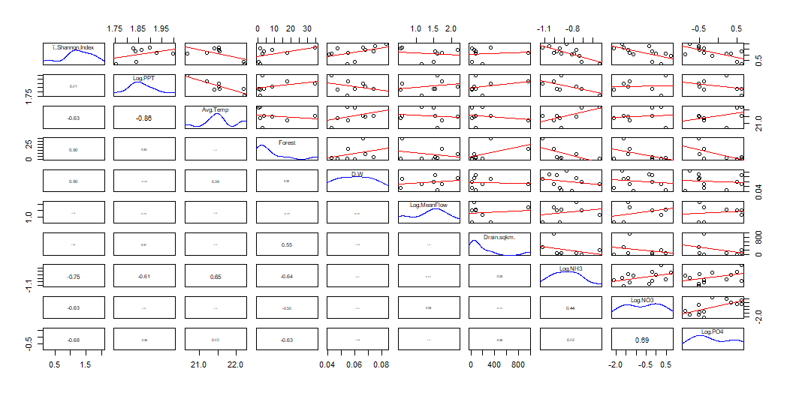

**Figure 1:** displays Augmented Pairs Plot for all environmental explanatory factors and the fish diversity (Shannon Index). Correlation coefficients for each regression are displayed at variable intersections to the left. Regression plots for each regression are displayed at variable intersections to the right

**Table 1:** displays the multi-variable linear regression models predicting fish diversity and their associated summary statistics.

|  |  |  |  |
| --- | --- | --- | --- |
| **Fish Diversity** | Model.9.forward | Model.49 | Model.Backward |
| Intercept | -0.9173 | -5.2226 | 16.2384 |
| Log of Ammonia | -2.3174 |  |  |
| Log of Precipitation |  | 3.2213 |  |
| Air Temperature |  |  | -0.769 |
| Depth/Width Ratio |  |  | 20.0771 |
| Log of Nitrates |  | -0.415 | -0.3345 |
| R^2 | 0.6594 | 0.7048 | 0.936 |
| Adj R^2 | 0.6027 | 0.5867 | 0.888 |
| F Statistic | 11.62 | 5.968 | 19.5 |
| Df1 | 1 | 2 | 3 |
| Df2 | 6 | 5 | 4 |
| p-value | 0.01434 | 0.04735 | 0.007514 |
| Max vif | NA | 1.001 | 1.219 |

**Figure 2:** displays a plot of Fish Diversity as a function annual precipitation. The regression equation and R^2 are displayed in the top right of the figure.

**Figure 3:** displays a plot of fish diversity (Shannon Index) as a function of the depth/width ratio of the wetted channel. The regression equation and R^2 are displayed in the top right.

**Figure 4:** displays a plot of fish diversity (Shannon Index) as a function of the concentration of Nitrates. The regression equation and R^2 are displayed in the top right.

**Figure 4:** displays a plot of fish diversity (Shannon Index) as a function of the annual mean air temperature (°C). The regression equation and R^2 are displayed in the top right.

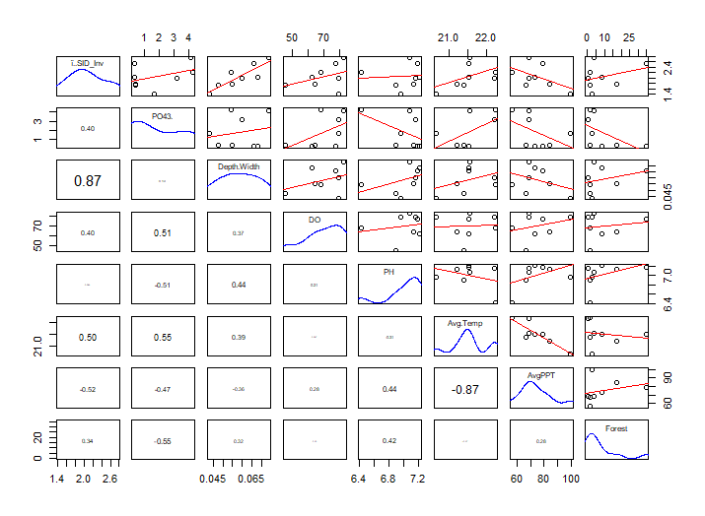**Table 2**: displays the multi-variable linear regression models predicting invertebrate diversity and their associated summary statistics.

**Figure 6:** displays Augmented Pairs Plot for all environmental explanatory factors and the invertebrate diversity (Shannon Index). Correlation coefficients for each regression are displayed at variable intersections to the left. Regression plots fore each regression are displayed at variable intersections to the right

|  |  |  |  |
| --- | --- | --- | --- |
| **Invertebrate Diversity** | Model.5 | Model.3 | Model.Backward |
| Intercept | -0.07441 | 3.36539 | 26.514988 |
| Precipitation |  | -0.01752 | -0.082152 |
| Phosphates |  |  | -0.235538 |
| Dissolved Oxygen |  |  | 0.057341 |
| Air Temperature |  |  | -1.017958 |
| Depth/Width Ratio | 36.49285 |  |  |
| R^2 | 0.7518 | 0.2705 | 0.9591 |
| Adjusted R^2 | 0.7104 | 0.1489 | 0.9045 |
| F Statistic | 18.17 | 2.224 | 17.57 |
| Df1 | 1 | 1 | 4 |
| Df2 | 6 | 6 | 3 |
| p-value | 0.005303 | 0.1864 |  |
| Max vif | NA | NA | 10.7 |

**Figure 6:** displays a plot of invertebrate diversity (Shannon Index) as a function of the concentration of phosphates. The regression equation and R^2 are displayed in the top right.

**Figure 8:** displays a plot of invertebrate diversity (Shannon Index) as a function of the annual mean air temperature (°C). The regression equation and R^2 are displayed in the top right.

**Figure 9:** displays a plot of invertebrate diversity (Shannon Index) as a function of the mean annual precipitation (cm). The regression equation and R^2 are displayed in the top right.

**Figure 7:** displays a plot of invertebrate diversity (Shannon Index) as a function of the % saturation of dissolved oxygen. The regression equation and R^2 are displayed in the top right.

**Bibliography**

Cianfrani, C. M., Sullivan, S. M., Hession, W. C., Watzin, M. C. 2009: Mixed stream channel morphologies: implications for fish community diversity. Aquatic Conservation Marine and Freshwater Ecosystems 19: 147-156.

Darwiche-Criado, N., Comin, F. A., Masip, A., Garcia, M., Eismann, S. G., Sorando, R., 2017: Effects of wetland restoration on nitrate removal in na irrigated agricultural área: The role of in-stream and off-stream wetlands. Ecological Engineering 103: 426-435.

Fierro, P., Bertran, C., Tapia, J., Hauenstein, E., Pena-Cortes, F., Vergara, C., Cerna, C., Vargas-Chacoff, L. 2017: Effects of local land-use on riparian vegetation, wáter quality, and the functional organization of macroinvertebrate assemblages. Science of the Total Environment 609: 724-734.

Hynes, H. B. N. 1970: The Ecology of Stream Insects. Annual Review of Entomology 15: 25-42.

Lee, G. F., Jones, R. A. 1991: Effects of Eutrophication on Fisheries. Reviews in Aquatic Sciences 5(3-4): 287-305.

McConigley, C., Lally, H., Little, D., O’Dea, P., Kelly-Quinn, M. 2017: The influence of aquatic buffer zone vegetation on river macroinvertebrate communities 400: 621-630.

Vinson, M. R.; Hawkins, C. P. 1998: Biodiversity of stream insects: variations at local, basin and regional scales. Annual Review of Entomology 43: 271-293.