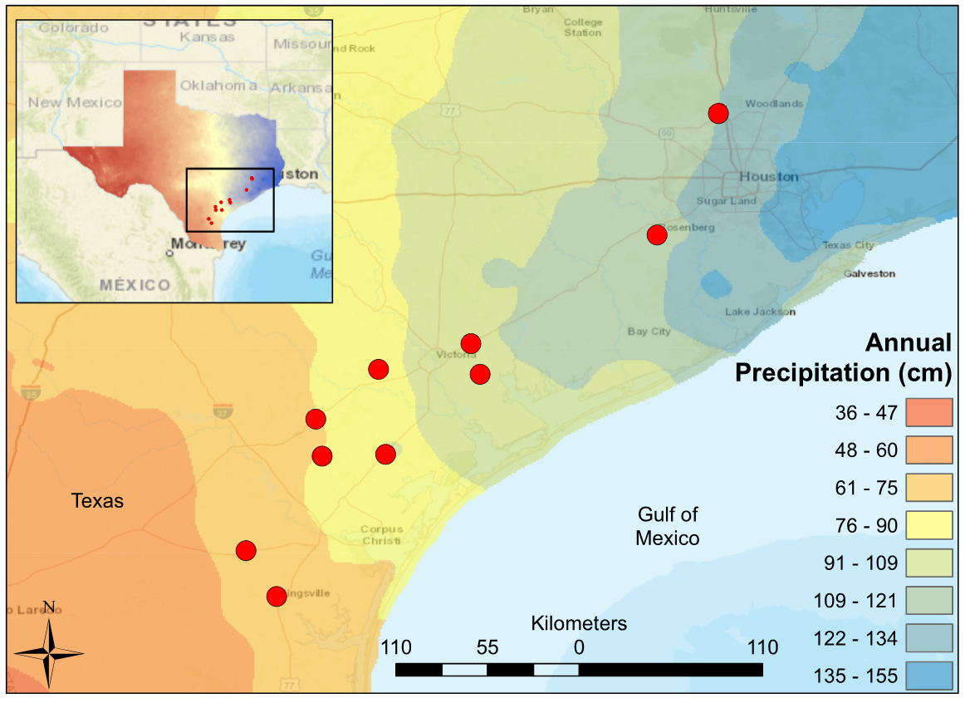

Figure 1. Map of South Central Texas, where 10 USGS gaged Streams were sampled in the Spring of 2017. An annual precipitation overlay indicate that the sample sites span a gradient from 61 cm/yr in the Southwest to 134 cm/yr in the Northeast.

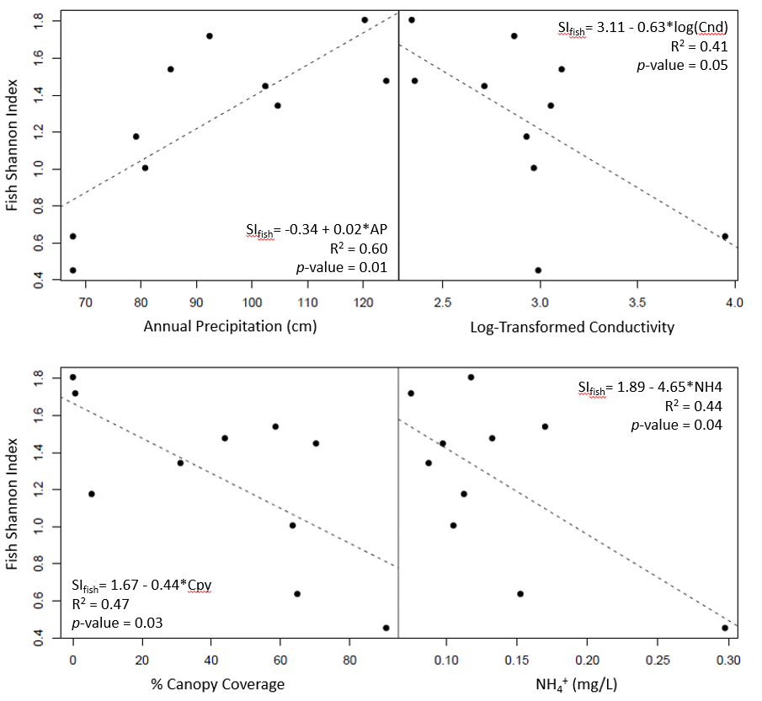

Figure 2. Significant least-square regressions of Fish Shannon Index versus environmental predictors (annual precipitation, log-transformed conductivity, canopy coverage, NH4+).

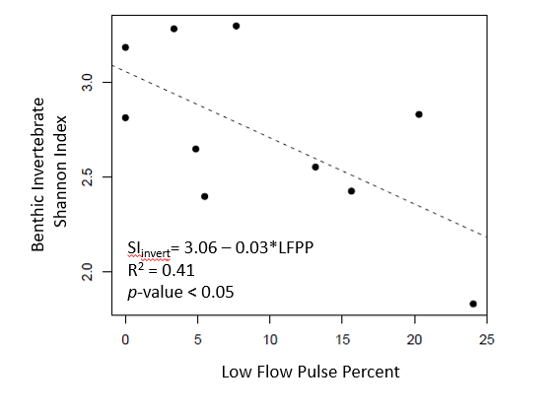

Figure 3. Least-square regression of macroinvertebrate Shannon index versus low flow pulse percent.

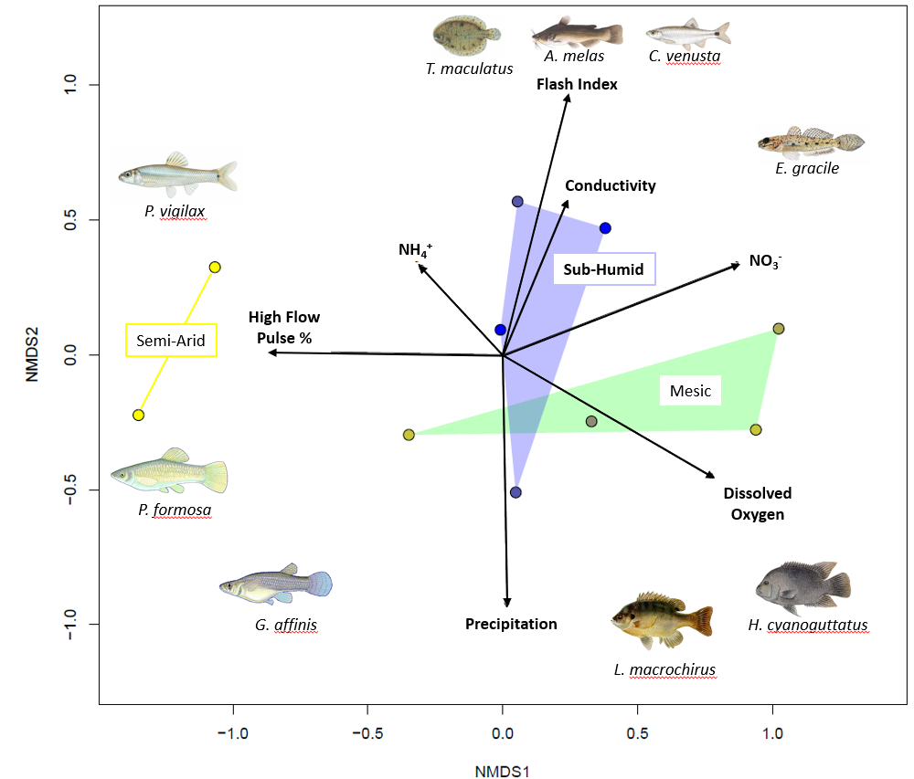

Figure 4. NMDS ordination of fish communities in ten coastal prairie streams in South Texas. Sites are grouped according to Annual Precipitation. Sites are grouped according to Annual Precipitation [Semi-Arid < 80 cm/yr, Mesic <106 cm/yr, Sub-Humid <125 cm/yr]. Distances between sites are proportional to compositional differences in community. The explanatory power of environmental factors is indicated by the length and direction of the arrows. Labeled Illustrations indicate the location of various species within the ordination space.

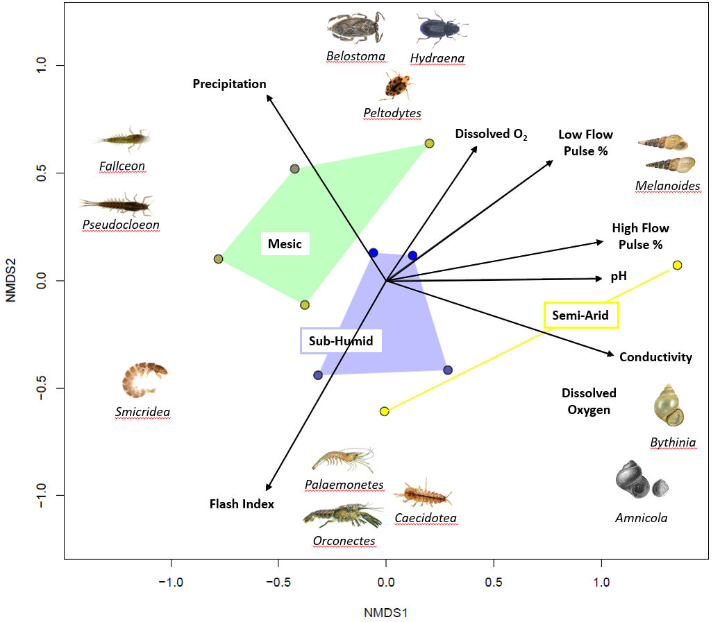

Figure 5. NMDS ordination of Macroinvertebrate communities in eleven coastal prairie streams in South Texas. Sites are grouped according to Annual Precipitation [Semi-Arid < 80 cm/yr, Mesic <106 cm/yr, Sub-Humid <125 cm/yr]. Distances between sites are proportional to compositional differences in community. The explanatory power of environmental factors is indicated by the length and direction of the arrows. Labeled Illustrations indicate the location of various genus within the ordination space.

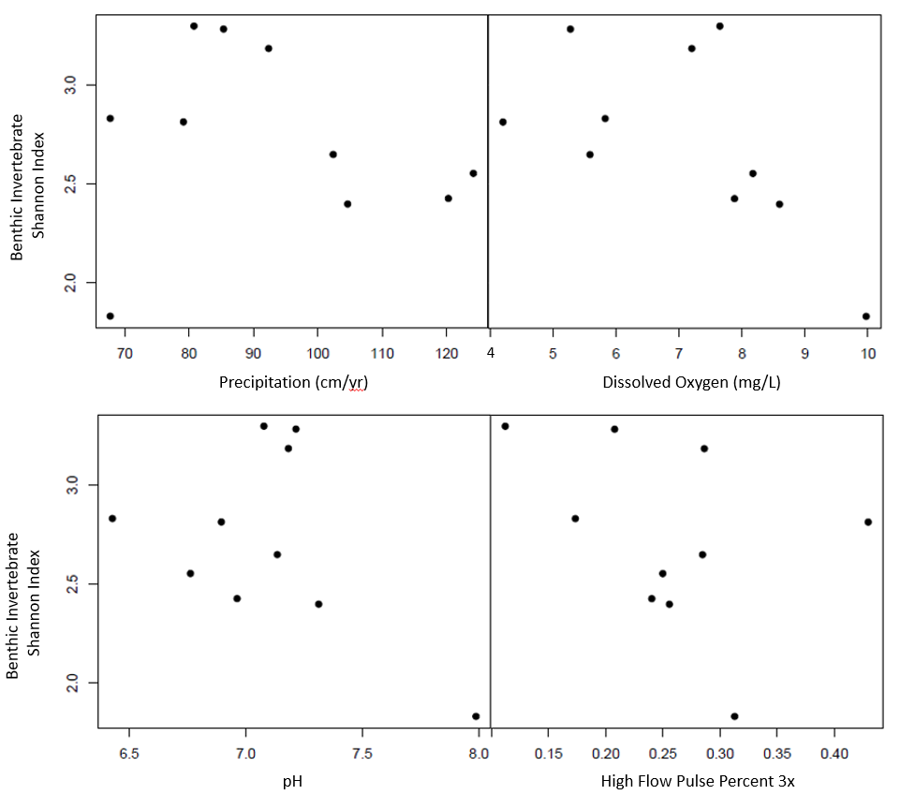

Figure 6. Scatterplot of macroinvertebrate shannon index versus environmental predictors (annual precipitation, dissolved oxygen, pH, high flow pulse percent 3x).

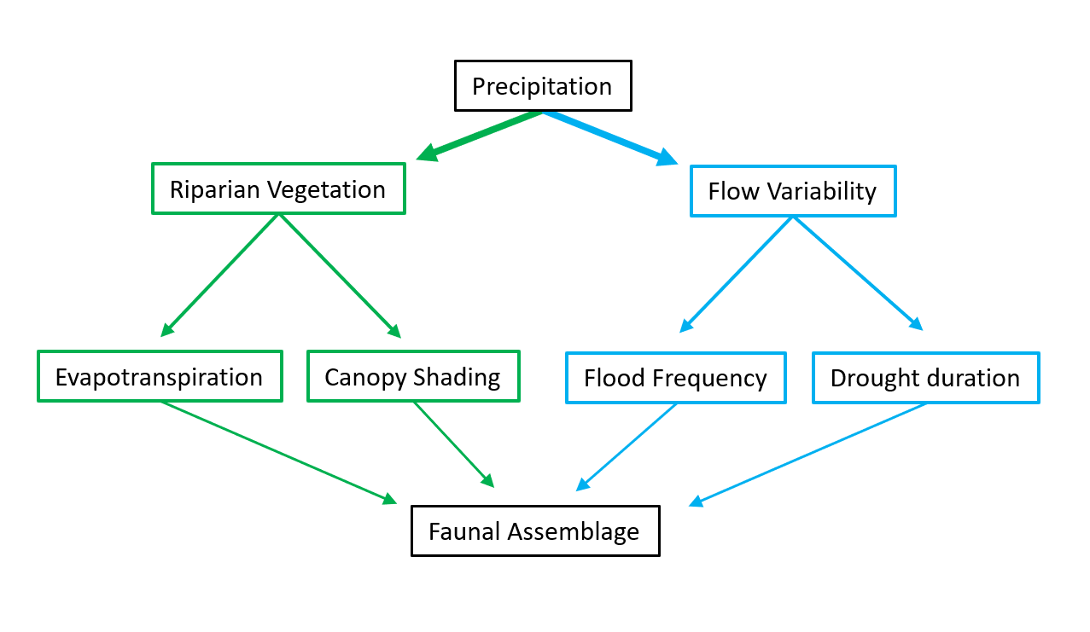

Figure 7. Concept model depicting how long-term precipitation regime drives stream assemblages directly through hydrological pathways and indirectly through riparian-mediated pathways.

|  |  |  |  |  |  |  |
| --- | --- | --- | --- | --- | --- | --- |
| USGS gauge | Precipitation (cm/yr) | Temperature (°C) | Elevation (m) | Drainage (km2) | Latitude | Longitude |
| 8212300 | 61 | 22.1 | 18 | 1303.7 | 27.77253 | -98.0336 |
| 8211900 | 70.96 | 22.1 | 61.6 | 1303.7 | 27.77253 | -98.0336 |
| 8211520 | 81.78 | 22 | 4 | 227.5 | 27.71142 | -97.5019 |
| 8189700 | 82.86 | 21.4 | 46.9 | 631.3 | 28.2825 | -97.6208 |
| 8189300 | 83.72 | 21 | 56 | 527.3 | 28.48305 | -97.6567 |
| 8177300 | 93.41 | 21.4 | 50 | 72.2 | 28.75166 | -97.3172 |
| 8189200 | 97.48 | 21.6 | 8 | 159 | 28.30362 | -97.1125 |
| 8189500 | 99.32 | 21.6 | 14 | 1808.3 | 28.29195 | -97.2792 |
| 8164600 | 105.67 | 21.1 | 20.1 | 253.9 | 28.89138 | -96.8191 |
| 8164800 | 108.1 | 21.2 | 8 | 172.2 | 28.72527 | -96.7689 |
| 8115000 | 121.13 | 20.4 | 23 | 116.7 | 29.47663 | -95.8127 |
| 8068390 | 125.17 | 19.8 | 41 | 40.2 | 30.19056 | -95.4911 |
| 8068450 | 125.41 | 19.9 | 37 | 88.3 | 30.13105 | -95.4813 |

Table 1. Descriptions of climate and geographic characteristics of the selected sample sites (Falcone 2011). Mean annual precipitation at the gauge location is calculated from an 800 m prism using a 30-year record (1971-2000). Note as precipitation increases, drainage area decreases to maintain similar stream hydrological classification.

|  |  |  |  |
| --- | --- | --- | --- |
| Abbreviation | Covariate | Units | Description |
| USGS.gauge | Station Identification | - | USGS Gauge Number associated with the nearest flow gauge |
| AP | Annual Precipitation | cm | Mean annual precipitation for the watershed, from 800m PRISM data. 30 years period of record 1971-2000 |
| Cnd | Conductivity | μS | Conductivity |
| DO | Dissolved Oxygen | mg/L | Dissolved oxygen |
| pH | pH | - | pH expressed in unitless log scale |
| Cpy | Canopy Cover | % | canopy density measured in the mid channel of the stream using a densiometer with 37 vertices |
| NH4 | Ammonia | mg/L | Ammonia concentration |
| NO3 | Nitrate | mg/L | Nitrate and nitrite concentration |
| flsh | flash index | - | Cumulatie changes in day to day daily flow / cumulative flow for a 20 year daily flow record |
| HFPP3 | High Flow Pulse Percent 3x | % | % of time daily flow is above 3 times the median daily flow |
| LFPP | Low Flow Pulse Percent | % | % of time where the daily discharge drops below the 25th percentile |

Table 2. displays the environmental covariates used throughout the statistical analysis. Annual precipitation is obtained directly from USGS GAGES II. Conductivity, dissolved oxygen, pH, canopy cover, ammonia, and nitrate values were obtained during field surveys in March and April of 2017. The flash index, high flow pulse percent 3x, and low flow pulse percent are calculated flow metrics which use the 20 year continuous flow record within the USGS GAGES II data set.

|  |  |  |  |  |  |
| --- | --- | --- | --- | --- | --- |
| Dependent variable | Independent variable | Slope | Intercept | R2 | p-value |
| Fish Shannon Index | Annual Precipitation | 0.017271 | -0.335986 | 0.602 | 0.008336 |
| Fish Shannon Index | Log(Conductivity) | -0.6318 | 3.1111 | 0.4058 | 0.0476 |
| Fish Shannon Index | Canopy Coverage | -0.43929 | 1.666563 | 0.4662 | 0.02956 |
| Fish Shannon Index | Ammonia | -4.6474 | 1.8873 | 0.4451 | 0.03509 |
| Invertebrate Shannon Index | Annual Precipitation | -0.00302 | 3.005858 | 0.01736 | 0.7167 |
| Invertebrate Shannon Index | Dissolved Oxygen | -0.15653 | 3.8281 | 0.3627 | 0.06542 |
| Invertebrate Shannon Index | High Flow Pulse Percent 3x | -2.0832 | 3.2582 | 0.149 | 0.2705 |
| Invertebrate Shannon Index | pH | -0.5174 | 6.3977 | 0.2087 | 0.1844 |
| Invertebrate Shannon Index | Low Flow Pulse Percent | -0.03498 | 3.05718 | 0.4114 | 0.04563 |

Table 3. Univariate linear regressions correlate fish and macroinvertebrate Shannon diversities with environmental predictors. Fish Shannon index values have significant correlations with four environmental predictors (Annual Precipitation, conductivity, canopy coverage and ammonia concentrations), while macroinvertebrate diversity has a singular significant correlation with low flow pulse percent.

|  |  |  |  |
| --- | --- | --- | --- |
| Model | R2 | p-value | AICc |
| Fish_Shannon ~ 0.054010 + (0.015598) AP - (0.0249) LFPP | 0.8175 | 0.002599 | 10.2 |
| Fish_Shannon ~ - 0.335986 + (0.017271) AP | 0.602 | 0.008336 | 12 |
| Fish_Shannon ~ 0.299779 + (0.013090) AP - (0.005809) Cpy | 0.7427 | 0.008642 | 13.6 |
| Fish_Shannon ~ 0.401516 + (0.013176) AP - (2.663321) NH4 | 0.7143 | 0.01246 | 14.7 |
| Invertebrate_Shannon ~ 3.95689 - (3.21078) HFPP3 - (0.04349) LFPP | 0.7411 | 0.008828 | 14.3 |
| Invertebrate_Shannon ~ 3.05718 - (0.03498) LFPP | 0.4114 | 0.04563 | 16.5 |
| Invertebrate_Shannon ~ 4.64023 - (0.10774) DO - (3.36722) HFPP3 - (0.03134) LFPP | 0.8592 | 0.00578 | 17.2 |
| Invertebrate_Shannon ~ 3.82810 - (0.15653) DO | 0.3627 | 0.06542 | 17.3 |

Table 4. Multivariate generalized linear models (GLM) for fish and macroinvertebrate Shannon index values. Top 4 AICc ranked models were selected. The top four fish diversity glms include annual precipitation as a positively correlated predictor. The top three Macroinvertebrate GLMs include low flow pulse percent (LFPP) as a negatively correlated predictor. R2 values reflect the multiple-R2 for each GLM.