# Subject: Spring 2017 Benthic Invertebrate Community analysis along Precipitation Gradient in South Texas

# Analyst: Sean Kinard

# 89 taxa from bio.infer

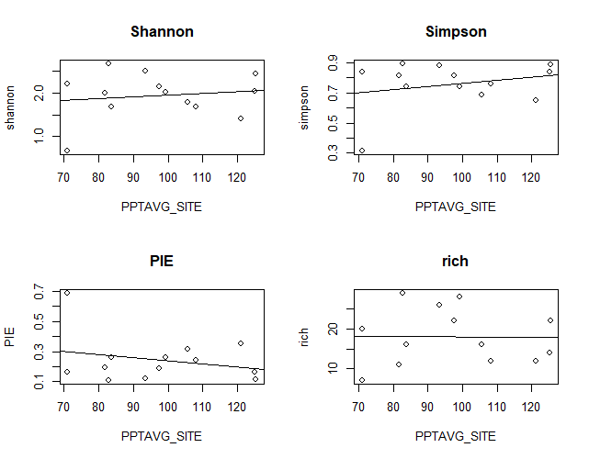

|  |  |  |  |  |  |  |
| --- | --- | --- | --- | --- | --- | --- |
| ~ AvgPPT | slope | R^2 | R^2.adjust | pr(>|t|) | F-stat | DF |
| shannon | 0.003866 | 0.5471 | -0.06972 | 0.6498 | 0.2178 | 11 |
| simpson | 0.002073 | 0.06564 | -0.01931 | 0.3982 | 4.259 | 11 |
| PIE | -0.002083 | 0.06594 | -0.01898 | 0.397 | 0.7765 | 11 |
| rich | -0.004544 | 0.000154 | -0.09074 | 0.968 | 0.001688 | 11 |
| rar.rich | 0.003866 | 0.01942 | -0.06972 | 0.6498 | 0.2178 | 11 |

# These plots indicate little correlation between diversity metrics and climate gradient.

# there appears to be an outlier (8212300=TRC) messing with several regressions

# Shannon and Simpson appear to have potential polynomial relation to ppt

# Here, I run side-by-side regressions with and without TRC (an apparent outlier)

# Shannon - still poor relation

# Simpson - still poor correlation

# PIE - still poor correlation

# rich – weaker

# rare.rich – stronger

# Simple regressions against climate: Not significant

# PCA INVERT - using msterinvert.not since TRC is an apparent outlier

# I just noticed sorting PCA var.coord contributions produces positive and negative values. It appears that precip and temperature are inversely colinear.

# Create trimmed data.frame using variables from PCA

:::::::::::::::::::::::::::::::::::::::::::::::::::::::::::::::::::::::::::::::::::::::::::::::::::::::::::::::::::::::::::::::::::::::::::::::::::::::::

Multivariate linear regressions

trm.invert <- msterinvert[,c("PIE", "rich", "shannon", "PPTAVG_SITE", "WD_BASIN", "RIP100_43", "WD_SITE", "WDMAX_BASIN", "NITR_APP_KG_SQKM", "PHOS_APP_KG_SQKM", "HYDRO_DISTURB_INDX", "RH_BASIN", "turbidity.adjusted", "conductivity", "salinity", "dissolved.oxygen", "pH", "NH3.N", "PO43.")]

# Identified need to log transform: RIP100_43, NITR_APP_KG_SQKM, NO3.NO2, conductivity, PO43.

# Summary of PIE glms:

# Coefficients: Estimate Std. Error t value Pr(>|t|)

# (Intercept) -0.336739 0.166174 -2.026 0.07729 .

# WD_SITE 0.004584 0.001527 3.002 0.01702 *

# PHOS_APP_KG_SQKM 0.169774 0.041063 4.134 0.00328 **

# dissolved.oxygen -0.003810 0.001102 -3.458 0.00860 **

# Residual standard error: 0.04226 on 8 degrees of freedom

# Multiple R-squared: 0.7996, Adjusted R-squared: 0.7245

# F-statistic: 10.64 on 3 and 8 DF, p-value: 0.003636

# Climate: WD_SITE = Site average of annual number of days (days) of measurable precipitation, derived from 30 years of record (1961-1990), 2km PRISM.

# Land Use: Phos_APP = Estimate of phosphorus from fertilizer and manure, from Census of Ag 1997, based on county-wide sales and percent agricultural land cover in watershed, kg/sq km

# water quality: dissolved oxygen

# Summary Shannon glms: similar to PIE (DO, Phos.APP, WD_SITE)

# Summary Richness: not significant

# :::::::::::::::::::::::::::::::::::::::::::::::::::::::::::::::::::::::::::::::::::::::::::::::::::::::::::::::::::::::::::::::::::::::::::::::::::::

# INVERT glm conclusions:

# variation in PIE and Shannon diveristy among the sites in the gradient is largely explained by 3 paramters # days rain, fertilizer application, and dissolved oxygen levels. Keep in mind TRC is not included in this multivariate regression analysis

# ::::::::::::::::::::::::::::::::::::::::::::::::::::::::::::::::::::::::::::::::::::::::::::::::::::::::::::::::::::::::::::::::::::::::::::::::::::

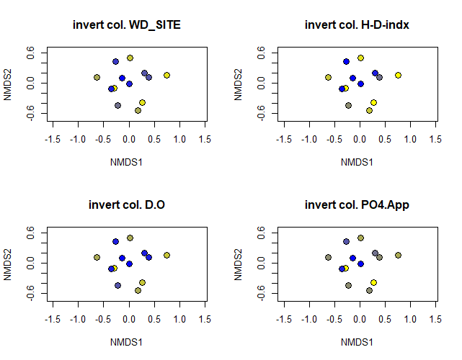

NMDS with sites shaded based on 4 variables ( WD-site, HD-indx, DO, and PO4applicaiton)

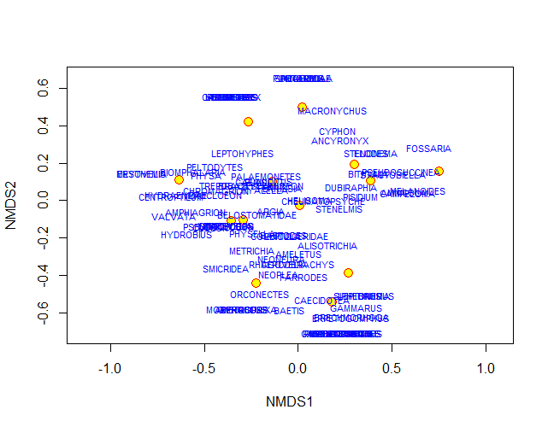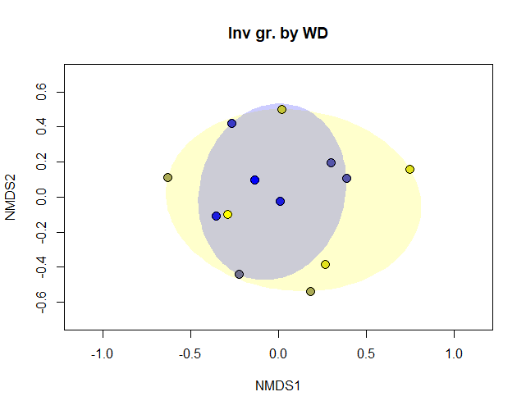

# ::::::::::::::::::::::::::::::::::::::::::::::::

# Final Inv. figure with fitted env does not reveal much.

# Now I wonder how I got the plot I did in my poster analysis. This community matrix is not stratified in 2-D space. Could this be due to relaxed nmds via noshare=.2 ?

# The invertebrate data is unclear. Where did I go wrong?

# Closing Coding Comments:

# Although the invertebrate data contains more entries, the conclusions are unclear since the ordinations cannot be clustered by evident environmental gradients or a-priori group assignments. The multivariate linear regreession analysis reveals potential impacts of climate, land use, and water quality on macroinvertebrate community diversity. The ordination with fitted environmental variables loosely suggests a role of PPT_AVG in driving some of the observered differences in m.invert community compositions.