**Introduction**

Anthropogenic climate change creates an urgent need to understand the relationship between biological communities and climate (Wrona et al. 2006). As concentrations of greenhouse gases rise, the atmosphere retains more infrared radiation, resulting in rising global temperatures (IPCC 2014). A warmer atmosphere is more energetic which intensifies the Hydrological Cycle (i.e. patterns of precipitation and evaporation), causing wet regions to become wetter and dry regions become drier (Allen & Ingram 2002). Simultaneously, the frequency and intensity of extreme weather events are expected to increase (Held et al.2006). The predicted shifts in precipitation regimes will have significant effects on ecosystems, especially in arid and semi-arid regions (Grimm et al. 2013). Streams, with their tight association with precipitation patterns, may be particularly sensitive to changes in precipitation. Subtle changes in rainfall can affect lotic ecosystems in a variety of ways and X% of small (1-3rd order) streams are predicted to experience significant shifts (increases or decreases) in annual rainfall in the next 100 years. However, it is unclear how stream ecosystems will respond or adjust to the predicted changes to the hydrologic cycle. Therefore, it is important to understand the mechanistic links between climate drivers and stream communities to better predict how these ecosystems will be affected by anthropogenic climate change.

Ecological community assembly is constrained by abiotic and biotic filters (Davis et al. 1999, Pockman and Sperry 2000). Assuming organisms can disperse to a habitat, they must be able to survive in the local environment and successfully reproduce in the presence of other organisms exerting pressures such as competition and predation (Patrick & Swan 2011). Abiotic filters are conceptually easy to understand. Species have physiological tolerances which limit their distribution across environmental gradients (Whitaker 1962). Environmental conditions related to precipitation that may act as abiotic filters include water temperature and hydrologic disturbance regime.

INSERT MORE STREAM SPECIFIC STUFF HERE TO LEAD TO HYPOTHESES LATER ON – “Stream communities are sensitive to changes flow magnitude and variability which are directly controlled by precipitation regime (Kormos et al. 2016). The frequency and intensity of flood and/or droughts is directly regulated by precipitation regime (Hyrabayashi et al. 2008). Shifts in streamside vegetation along a precipitation gradient indicates an indirect pathway through which precipitation can influence stream biota. The riparian zone regulates nutrient, carbon and light inputs to streams that fundamentally alter stream primary production and carbon cycling (Schade et al. 2001).” MOVED UP FROM BELOW

Understanding how abotic filters influenced by climate impact local communities enhances our ability to predict how climate change will alter community assembly. However, formalizing and quantifying the role of environmental filters in community assembly remains disjointed due to the vastly different spatial scales of existing biogeographical and community ecology studies (Weiher et al. 2011).

(NEW PARAGRAPH) In contrast, understanding the impact of climate change on biotic interactions is more challenging due to the complex sets of interactions that govern these processes ().

INSERT MORE STREAM SPECIFIC STUFF HERE TO LEAD TO HYPOTHESE LATER ON ABOUT BIOTIC INTERACTIONS AND HOW THEY MIGHT CHANGE ALONG A PRECIPITATION GRADIENT

Observational surveys of existing community patterns along spatial environmental gradients can be used in a space-for-time substitution to infer how communities will change through time as environmental conditions shift (Duune et al.2004). The approach allows for links to be drawn between climate drivers, local environmental conditions, and organism abundances. Species co-occurrence patterns along environmental gradients can also shed light on possible shifts in biotic interactions (). However, the space-for-time substitution approach assumes that observed ecological differences along the spatial gradient are the solely a product of corresponding changes in climate. This assumption may be unfair given that biogeographical studies have revealed that dispersal limitation, habitat heterogeneity, and local evolution can also contribute to current spatial patterns in community composition. These studies are typically large in scale, covering vast distances (thousands of km) in order to capture climate gradients. These large scales make the precise mechanisms for observed biological changes difficult to ascertain due to covarying environmental variables (e.g., elevation, geology, human impacts). Thus while current literature demonstrates that biome shifts occur across temperature and latitudinal gradients (De Frenne et al.2013), the value of these observational studies for forecasting community responses to climate change is hindered by the many confounding variables. The power of using the space-for-time approach for evaluating how changes to the hydrologic cycle will impact ecological communities would be enhanced if there were study systems with limited confounding environmental variables (i.e. temperature, elevation, distance, and underlying geology). Such a system would allow us to delineate the intricacies of hydrologic cycle-ecosystem relationships.

Fortunately, the Texas Coastal Prairie (TCP) is an ideal system evaluating the effect of hydrologic climate change on ecological communities. The Western Gulf coastal grasslands are a subtropical ecotone that spans Louisiana, Texas, and northern Mexico’s coastal areas. From east to west to climate becomes more arid, with gradual change for much of the coast and a region of rapid change located in southern Texas. In this region the annual rainfall changes from 55cm•yr-1 (semi-arid) to 135 cm•yr-1 (sub-humid) over a 300 km gradient (Falcone 2011), but there are minimal changes in elevation, air temperature, underlying geology, and human land use. Thus, studying natural ecosystems that span the TCP maximizes our ability to detect relationships between annual precipitation and ecosystem processes in the absence of covarying factors.

We used a section of the TCP where precipitation changes most quickly as a model system to evaluate how changes in precipitation alter stream communities. As conditions become wetter, there is an observable ecological shift from Thornwood groves in the semi-arid West to Live oak forests Towards the East (Chapman & Bolen 2018). Along the rainfall gradient we surveyed 13 wadeable streams outfitted with USGS gauges for fish, benthic macroinvertebrate, and environmental variables. Our objectives were to: 1) Identify patterns in diversity and composition of fish and macroinvertebrates communities that correspond to changes in precipitation, and 2) identify environmental drivers that mediate the effects of climate on community processes. We expected that annual precipitation would be positively correlated with community diversity because humid precipitation regimes are expected to create more stable environmental conditions by creating habitat heterogeneity and predictable flow regimes which promote the development of greater biodiversity (Boulton et al. 1992). We further expected that evapotranspiration by riparian vegetation combined with low annual precipitation would correspond with higher solute concentrations and low oxygen concentrations in semi-arid streams (Tabbachi et al. 2000), creating environmental filters that limit recruitment of sensitive fish and invertebrates.

**Methods:**

**Study Region:** The Texas Coastal Prairie contains grassland prairie with forested areas occurring primarily along riverine systems. During March and April of 2017, we sampled ten, wadable, perennial streams which span 12 counties from Kleberg County to Montgomery in South-Central Texas, USA. Each study site is located within 100 meters of a USGS stream gauge which continuously monitor streamflow and climate data year-round.

Study sites were chosen to maximize differences in precipitation with minimal changes in underlying geology and elevation. The annual precipitation ranges from 48-125 cm within the study region which spans a linear distance of 378 km (Falcone 2011). The surface geology is characterized by fine clays, quaternary and sedimentary sand. The streams have similar median flows (0.02-22.09 m3⸱min-1), elevations (14-61 m), substrates (quaternary), and average air temperatures (19.9-22.1℃) (Table 1).

**Biological Sampling:** Fish communities were sampled using a Smith-Root LR-24 Backpack in a single pass survey of a 100-meter reach (Lamberti 2007). Fish species are field identified to species using a field guide (Thomas C 2007) and photographed. Several specimens of each species were euthanized using tricaine mesylate (MS-222) and stored in >70% denatured ethanol as voucher specimens for lab confirmation of species identification. Fish Voucher specimens were identified using the Texas Academy of Science dichotomous key (Hubbs 2008) and cross referenced with field identifications.

Single-pass electrofishing surveys are considered contentious in their accuracy. Although most species are caught in the first pass, rare species are often missed until the second or third pass (Pusey, Kennard et al. 1998). The sample reach length for a single-pass survey needs to include a number of representative habitats that depends on the sampling efficiency of the shockers and density of fish within the system. The reach length for a survey of fish assemblages is recommended to be 40 times the wetted width of a given stream (Reynolds, Herlihy et al. 2003). However, idealized electrofishing surveys adhering to this recommendation in wide, shallow streams lose practicality and can last over 10 hours. In our study, the average wetted stream width is 4.89 meters which entails a single-pass shock length of approximately 200 meters. The study sites are characterized by low variation in geomorphology and overall habitat heterogeneity. Shocking intensity is high due to narrow stream widths and homogenous habitat profiles, so we elected to survey a representative 100-meter reach.

Macroinvertebrates were collected using a D-frame net equipped with 500-micron mesh. The netter vigorously disturbed vegetation and substrate in a 1-square foot area while capturing disturbed insects in D-frame net. The debris within the net was rinsed and placed in a sieve bucket with a 500-micron mesh to prevent loss of insects between sweeps. This process was repeated 20 times at each sample location. Specimens were preserved in 95% ethanol for storage. Each sample was sub-divided and picked in a randomized grid approach until 300 individuals were obtained. Samples containing less than 300 individuals were picked to completion. Then, individuals were identified to genus or species (Merritt and Cummins 2008). The sum of individuals in each taxon were multiplied by the fraction of unpicked sample and reported as abundance of individuals per square foot.

**Environmental Sampling:**

Habitat measurements were taken at 4 stream cross-sections spaced 25 meters apart. Variables included canopy coverage measured with a spherical densiometer, riparian vegetation type, sediment grain size, water depth, channel width, bank height, and bank slope. At each station on each visit, two 60 mL water samples were collected and filtered through a pre-combusted (500℃ for 4 hours) glass fiber filter (Whatman GF/F) into acid washed bottles, transferred on ice inside of a cooler, and stored in the lab frozen (-20℃) until analysis for nutrients (NH4+, NO3-, and SRP), dissolved organic carbon (DOC) and total nitrate (TN). Water samples were run by the Oklahoma University Soil Water and Forage Laboratory. Oxygen (mg/L), temperature (℃), conductivity (µcm/S), turbidity (NTU), and pH were measured at each point using a YSI ProDSS multiparameter probe.

**Data Analysis:** In addition to the habitat metrics measured in the field, long term climate averages and flow metrics were obtained from the US Geologic Surveyors Geospatial Attributes of Gages for Evaluating Streamflow, version II (USGS GAGES II) dataset. Several flow metrics including flash index, high flow pulse percent 3x, and low flow pulse percent were calculate using the USGS GAGES II continuous 20-year flow record for each site except Tranquitas CK at Kingsville TX (USGS 08212300) which only has a 4-year record (Table 2).

Fish and Invertebrate communities were analyzed separately. To assess community diversity and evenness, we calculated rarified richness and the Shannon diversity index with the equation, (Shannon 1948). To examine relationships between species diversity and stream environments, single and stepwise multiple regressions were performed on 10 independent variables (Table 2). These included annual precipitation, conductivity, dissolved oxygen, pH, canopy cover, ammonia concentration, nitrate concentration, flash index value, high flow pulse percent 3x, and low flow pulse percent. Conductivity and nitrate concentrations were log transformed prior to regressions. The multivariate generalized linear regressions were generated using the dredge function in R. Regressions are ranked by AIC values from which we selected the top 3 models for interpretation.

We created ordinations using the VEGAN package in R to detect assemblage patterns. First, we performed non-metric multidimensional scaling (NMDS) which uses adequate dissimilarity measures, runs NMDS with multiple starting configurations, compares results, and stops after finding a similar minimum stress solution. The ordination then scales, rotates the solution, and adds species scores to the configuration as weighted averages. Sites were grouped using hierarchical clustering based on environmental traits. Site groupings were visualized using convex hulls. Finally, we fit environmental variables to each ordination in which the arrow displays the direction of the (increasing) gradient, and the length of the arrow is proportional to the correlation between the variable and the ordination. To improve readability, several environmental predictors with low correlation were removed and the species scores were replaced with labeled pictures of prominent taxonomic units.

**Results:**

*Diversity:* Univariate linear regressions indicate Fish Shannon index values correlate positively with annual precipitation and negatively with conductivity, canopy coverage, and ammonia concentrations (Figure 2). This contrasts with macroinvertebrate Shannon index values, which correlate negatively with low flow pulse percent (Figure 3) but lack significant correlations with other environmental predictors including annual precipitation (Figure 6). Significant values were determined to have a *p*-value less than 0.05.

Multivariate generalized linear models (GLMs) indicate annual precipitation as a positive driver of fish diversity in the top four dredge models. Individual models indicate low flow pulse percent, canopy coverage, and ammonia negatively correlate with fish diversity. Macroinvertebrate diversity negatively correlates with low flow pulse percent and high flow pulse percent in three of the top four AICc ranked GLMs. Dissolved oxygen negatively correlates with macroinvertebrate diversity in two of the top four AICc ranked GLMs (Table 4).

*Composition*: The NMDS ordination of fish assemblages indicate compositional shifts across the precipitation gradient (Figure 4). Hierarchical clustering resulted in 3 site groupings labeled “semi-arid” (yellow), “mesic” (green), and “sub-humid” (blue). Semi-arid communities are dominated by *Poecilia formosa*, *Gambusia affinis*, and *Pimephales vigilax*. Communities in mesic and sub-humid climates contain a variety of Lepomis species, but mesic streams uniquely contain *Herichthys cyanoguttatus*. Sub-humid streams uniquely contain *Trinectes maculatus*, *Ameiurus melas*, and *Cyprinella venusta*. Fitted environmental predictors indicate that variation along the NMDS-1 axis correlates with high flow pulse percent with lesser contributions by ammonia, nitrate, and dissolved oxygen concentrations, Variation along the NMDS-2 axis correlates with flash index and annual precipitation with lesser contributions by conductivity, ammonia, nitrate, and dissolved oxygen concentrations.

The NMDS ordination of macroinvertebrate assemblages also display compositional shifts along the precipitation gradient (Figure 5). Macroinvertebrate assemblages in semi-arid climate contain a variety of gastropod taxa including *Amnicola sp. Bythinia sp. And melanoides sp.* Mesic communities contain species from a greater number of taxonomic orders including Ephemeroptera, Trichoptera, Coleoptera, and Hemiptera. Sub-humid communities contain a greater proportion of Crustaceans including *Palaemonetes sp*., *Orconectes sp*., and isopods in the genus *Caecidotea*. Fitted environmental variables indicate that variation along the NMDS-1 axis correlate with High flow pulse percent and to a lesser extent, nitrate, ammonia, and dissolved oxygen concentrations. Variation on the NMDS-2 axis correlate with annual precipitation, flash index and conductivity. The separation of site-groupings within the ordination space coincides with projected axes of the fitted ammonia and dissolved oxygen variables.

**Discussion:**

We expected Shannon diversity to correlate positively with annual precipitation hydrological and riparian-related environmental predictors. Our results indicate that fish community diversity correlates positively with annual precipitation. Conductivity, canopy coverage, and ammonia concentrations correlate inversely with fish community diversity. Conductivity approximates solute concentrations which when elevated can cause osmotic stress on most freshwater fish taxa. Similarly, high ammonia concentrations are toxic to most freshwater fish taxa.

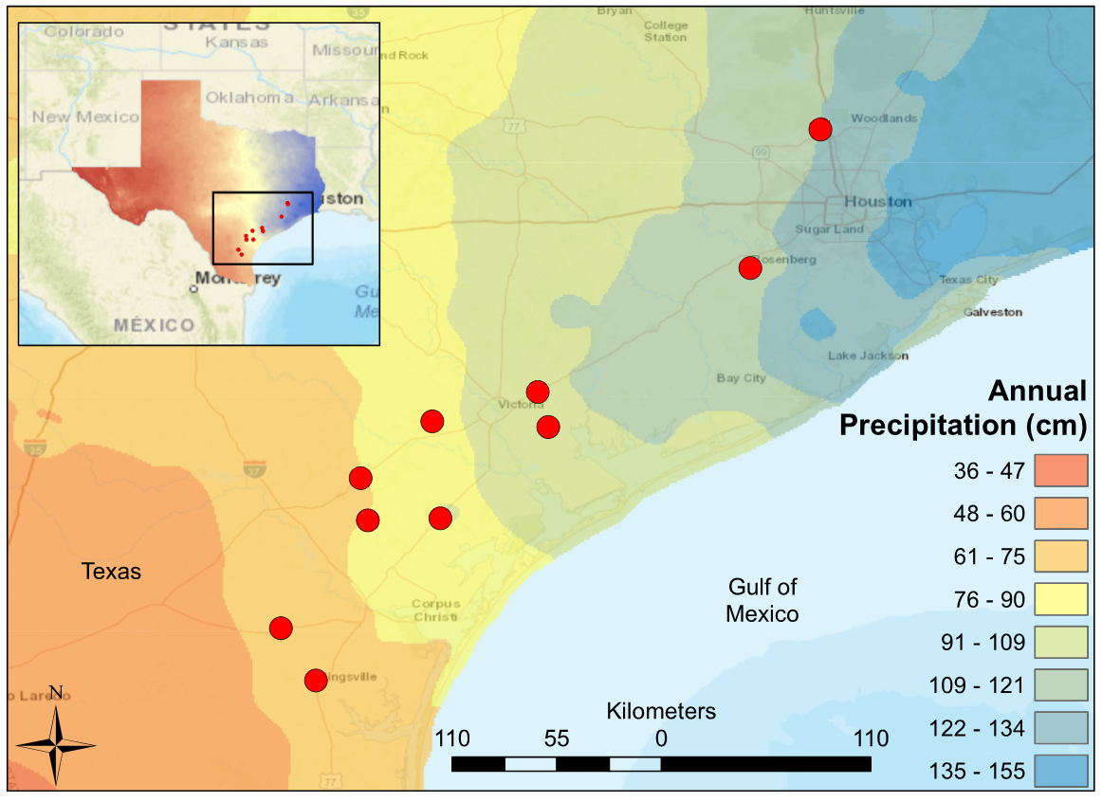

Figure 1. Map of South Central Texas, where 10 USGS gaged Streams were sampled in the Spring of 2017. An annual precipitation overlay indicate that the sample sites span a gradient from 61 cm/yr in the Southwest to 134 cm/yr in the Northeast.

|  |  |  |  |  |  |  |
| --- | --- | --- | --- | --- | --- | --- |
| USGS gauge | Precipitation (cm/yr) | Temperature (°C) | Elevation (m) | Drainage (km2) | Latitude | Longitude |
| 8212300 | 61 | 22.1 | 18 | 1303.7 | 27.77253 | -98.0336 |
| 8211900 | 70.96 | 22.1 | 61.6 | 1303.7 | 27.77253 | -98.0336 |
| 8211520 | 81.78 | 22 | 4 | 227.5 | 27.71142 | -97.5019 |
| 8189700 | 82.86 | 21.4 | 46.9 | 631.3 | 28.2825 | -97.6208 |
| 8189300 | 83.72 | 21 | 56 | 527.3 | 28.48305 | -97.6567 |
| 8177300 | 93.41 | 21.4 | 50 | 72.2 | 28.75166 | -97.3172 |
| 8189200 | 97.48 | 21.6 | 8 | 159 | 28.30362 | -97.1125 |
| 8189500 | 99.32 | 21.6 | 14 | 1808.3 | 28.29195 | -97.2792 |
| 8164600 | 105.67 | 21.1 | 20.1 | 253.9 | 28.89138 | -96.8191 |
| 8164800 | 108.1 | 21.2 | 8 | 172.2 | 28.72527 | -96.7689 |
| 8115000 | 121.13 | 20.4 | 23 | 116.7 | 29.47663 | -95.8127 |
| 8068390 | 125.17 | 19.8 | 41 | 40.2 | 30.19056 | -95.4911 |
| 8068450 | 125.41 | 19.9 | 37 | 88.3 | 30.13105 | -95.4813 |

Table 1: Descriptions of climate and geographic characteristics of the selected sample sites (Falcone 2011). Mean annual precipitation at the gauge location is calculated from an 800 m prism using a 30-year record (1971-2000). Note as precipitation increases, drainage area decreases to maintain similar stream hydrological classification.

|  |  |  |  |
| --- | --- | --- | --- |
| Abbreviation | Covariate | Units | Description |
| USGS.gauge | Station Identification | - | USGS Gauge Number associated with the nearest flow gauge |
| AP | Annual Precipitation | cm | Mean annual precipitation for the watershed, from 800m PRISM data. 30 years period of record 1971-2000 |
| Cnd | Conductivity | μS | Conductivity |
| DO | Dissolved Oxygen | mg/L | Dissolved oxygen |
| pH | pH | - | pH expressed in unitless log scale |
| Cpy | Canopy Cover | % | canopy density measured in the mid channel of the stream using a densiometer with 37 vertices |
| NH4 | Ammonia | mg/L | Ammonia concentration |
| NO3 | Nitrate | mg/L | Nitrate and nitrite concentration |
| flsh | flash index | - | Cumulatie changes in day to day daily flow / cumulative flow for a 20 year daily flow record |
| HFPP3 | High Flow Pulse Percent 3x | % | % of time daily flow is above 3 times the median daily flow |
| LFPP | Low Flow Pulse Percent | % | % of time where the daily discharge drops below the 25th percentile |

Table 2 displays the environmental covariates used throughout the statistical analysis. Annual precipitation is obtained directly from USGS GAGES II. Conductivity, dissolved oxygen, pH, canopy cover, ammonia, and nitrate values were obtained during field surveys in March and April of 2017. The flash index, high flow pulse percent 3x, and low flow pulse percent are calculated flow metrics which use the 20 year continuous flow record within the USGS GAGES II data set.

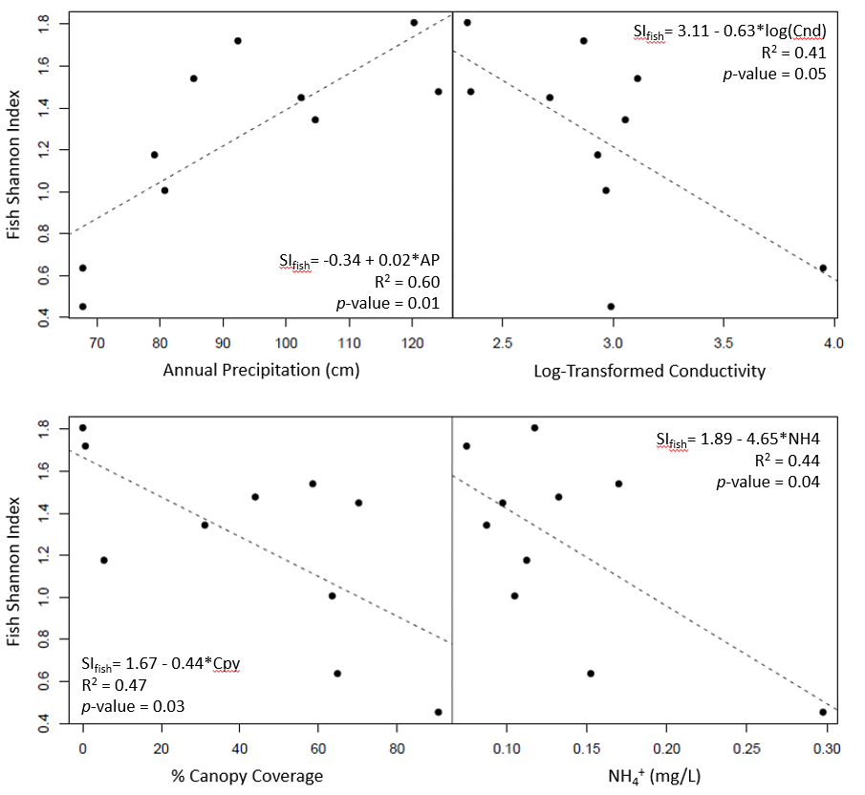

Figure 2. Significant least-square regressions of Fish Shannon Index versus environmental predictors (annual precipitation, log-transformed conductivity, canopy coverage, NH4+).

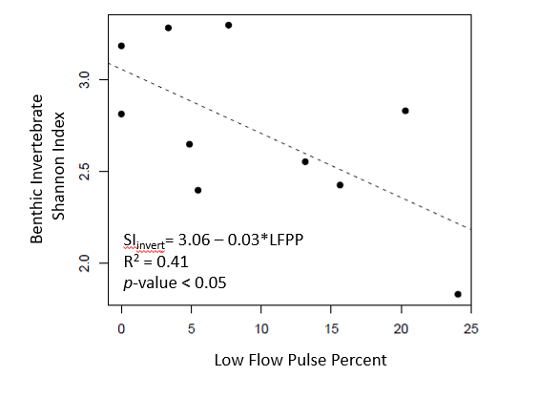

Figure 3. Least-square regression of benthic invertebrate shannon index versus low flow pulse percent.

|  |  |  |  |
| --- | --- | --- | --- |
| Model | R2 | p-value | AICc |
| Fish_Shannon ~ 0.054010 + (0.015598) AP - (0.0249) LFPP | 0.8175 | 0.002599 | 10.2 |
| Fish_Shannon ~ - 0.335986 + (0.017271) AP | 0.602 | 0.008336 | 12 |
| Fish_Shannon ~ 0.299779 + (0.013090) AP - (0.005809) Cpy | 0.7427 | 0.008642 | 13.6 |
| Fish_Shannon ~ 0.401516 + (0.013176) AP - (2.663321) NH4 | 0.7143 | 0.01246 | 14.7 |
| Invertebrate_Shannon ~ 3.95689 - (3.21078) HFPP3 - (0.04349) LFPP | 0.7411 | 0.008828 | 14.3 |
| Invertebrate_Shannon ~ 3.05718 - (0.03498) LFPP | 0.4114 | 0.04563 | 16.5 |
| Invertebrate_Shannon ~ 4.64023 - (0.10774) DO - (3.36722) HFPP3 - (0.03134) LFPP | 0.8592 | 0.00578 | 17.2 |
| Invertebrate_Shannon ~ 3.82810 - (0.15653) DO | 0.3627 | 0.06542 | 17.3 |

Table 4. Multivariate generalized linear models (GLM) for fish and macroinvertebrate Shannon index values. Top 4 AICc ranked models were selected. The top four fish diversity glms include annual precipitation as a positively correlated predictor. The top three Macroinvertebrate GLMs include low flow pulse percent (LFPP) as a negatively correlated predictor. R2 values reflect the multiple-R2 for each GLM.

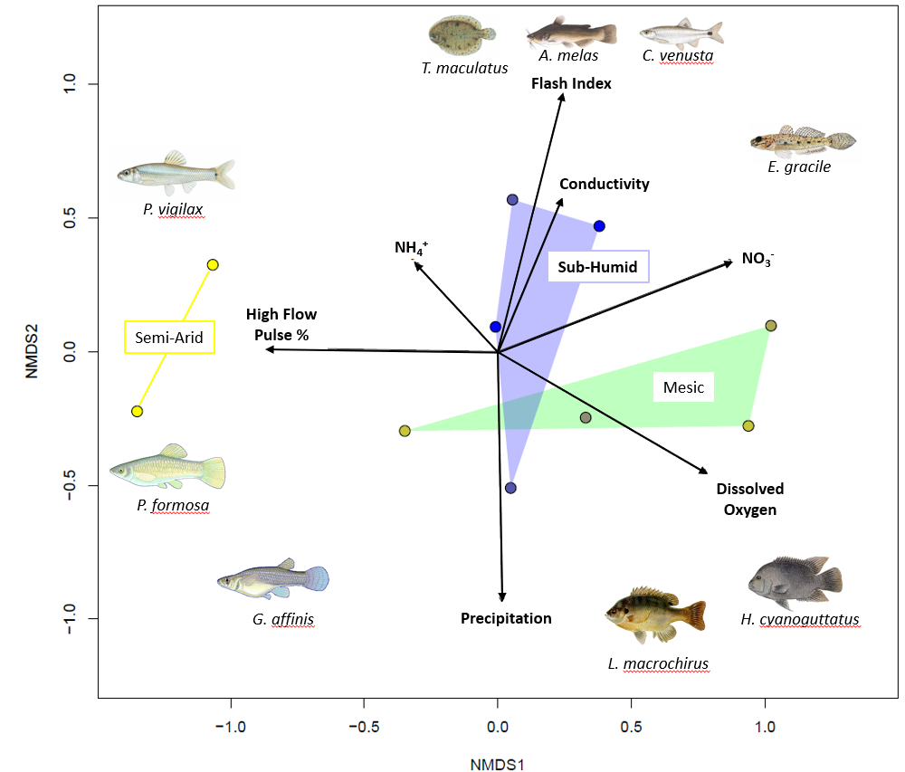

NMDS ordination of fish communities in ten coastal prairie streams in South Texas.

Sites are grouped according to Annual Precipitation. Distances between sites are proportional to compositional differences in community. The explanatory power of environmental factors is indicated by the length and direction of the arrows. Labeled Illustrations indicate the location of various species within the ordination space.

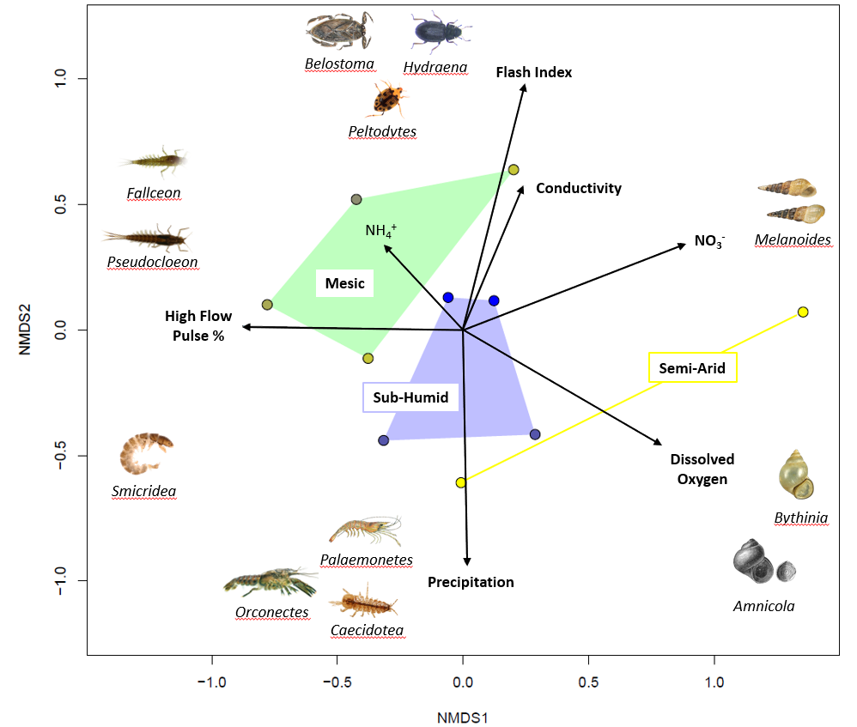

Figure 5. NMDS ordination of Benthic Invertebrate communities in eleven coastal prairie streams in South Texas. Sites are grouped according to Annual Precipitation [Semi-Arid < 80 cm/yr, Mesic <100 cm/yr, Sub-Humid <125 cm/yr]. Distances between sites are proportional to compositional differences in community. The explanatory power of environmental factors is indicated by the length and direction of the arrows. Labeled Illustrations indicate the location of various genus within the ordination space.

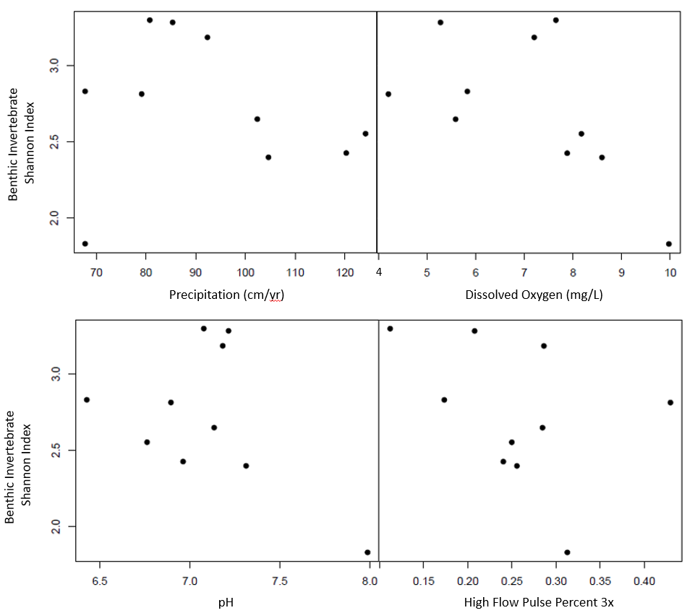

Figure 6. Scatterplot of benthic invertebrate shannon index versus environmental predictors (annual precipitation, dissolved oxygen, pH, high flow pulse percent 3x).

|  |  |  |  |  |  |
| --- | --- | --- | --- | --- | --- |
| Dependent variable | Independent variable | Slope | Intercept | R2 | p-value |
| Fish Shannon Index | Annual Precipitation | 0.017271 | -0.335986 | 0.602 | 0.008336 |
| Fish Shannon Index | Log(Conductivity) | -0.6318 | 3.1111 | 0.4058 | 0.0476 |
| Fish Shannon Index | Canopy Coverage | -0.43929 | 1.666563 | 0.4662 | 0.02956 |
| Fish Shannon Index | Ammonia | -4.6474 | 1.8873 | 0.4451 | 0.03509 |
| Invertebrate Shannon Index | Annual Precipitation | -0.00302 | 3.005858 | 0.01736 | 0.7167 |
| Invertebrate Shannon Index | Dissolved Oxygen | -0.15653 | 3.8281 | 0.3627 | 0.06542 |
| Invertebrate Shannon Index | High Flow Pulse Percent 3x | -2.0832 | 3.2582 | 0.149 | 0.2705 |
| Invertebrate Shannon Index | pH | -0.5174 | 6.3977 | 0.2087 | 0.1844 |
| Invertebrate Shannon Index | Low Flow Pulse Percent | -0.03498 | 3.05718 | 0.4114 | 0.04563 |

Table 3. Univariate linear regressions correlate fish and macroinvertebrate Shannon diversities with environmental predictors. Fish Shannon index values have significant correlations with four environmental predictors (Annual Precipitation, conductivity, canopy coverage and ammonia concentrations), while macroinvertebrate diversity has a singular significant correlation with low flow pulse percent.

**Cited Literature:**

Wrona, F. J., T. D. Prowse, J. D. Reist, J. E. Hobbie, L. M. J. Levesque and W. F. Vincent (2006). "Climate change effects on aquatic biota, ecosystem structure and function." Ambio 35(7): 359-369.

IPCC (2014). Climate Change 2014: Synthesis Report. Contribution of Working Groups I, II and III to the Fifth Assessment Report of the Intergovernmental Panel on Climate Change [Core Writing Team, R.K. Pachauri and L.A. Meyer (eds.)]. Geneva, Switzerland, IPCC. 151 pp.

Allen, M. R. and W. J. Ingram (2002). "Constraints on future changes in climate and the hydrologic cycle." Nature 419(6903): 224-232.

Held, I. M. and B. J. Soden (2006). "Robust responses of the hydrological cycle to global warming." Journal of Climate 19(21): 5686-5699.

Grimm, N. B., F. S. Chapin, B. Bierwagen, P. Gonzalez and P. M. Groffman (2013). "The impacts of climate change on ecosystem structure and function." Frontiers in ecology and the environment 11(9): 474-482.

Gunderson, L. H. (2000). "Ecological resilience - in theory and application." Annual Review of Ecology and Systematics 31: 425-439.

Davis, Mark & Grime, John & Thompson, Ken. (2000). Fluctuating Resources in Plant Communities: A General Theory of Invasibility. Journal of Ecology. 88. 528-536.

Pockman, W., & Sperry, J. (2000). Vulnerability to Xylem Cavitation and the Distribution of Sonoran Desert Vegetation. American Journal of Botany, 87(9), 1287-1299.

Whitaker, T.W. and Davis, G.N. (1962) Cucurbits: Botany, cultivation, and utilization. Interscience Publishers, New York.

Weiher E, Freund D, Bunton T, Stefanski A, Lee T, Bentivenga S. 2011. Advances, challenges and a developing synthesis of ecological community assembly theory. Philos. Trans. R. Soc. B Biol. Sci. 366(1576): 2403-2413

Dunne, J. A., S. R. Saleska, M. L. Fischer and J. Harte (2004). "Integrating experimental and gradient methods in ecological climate change research." Ecology 85(4): 904-916.

De Frenne, P., B. J. Graae, F. Rodriguez-Sanchez, A. Kolb, O. Chabrerie, G. Decocq, H. De Kort, A. De Schrijver, M. Diekmann, O. Eriksson, R. Gruwez, M. Hermy, J. Lenoir, J. Plue, D. A. Coomes and K. Verheyen (2013). "Latitudinal gradients as natural laboratories to infer species' responses to temperature." Journal of Ecology 101(3): 784-795.

Chapman B. R, Bolen E. (2018). The Natural History of Texas. College Station, Texas A&M University Press.

Falcone J, F. (2011). GAUGES-II: Geospatial Attributes of Gauges for Evaluating Streamflow. Reston, Virginia, U.S. Geological Survey.

Kormos, P. R., C. H. Luce, S. J. Wenger and W. R. Berghuijs (2016). "Trends and sensitivities of low streamflow extremes to discharge timing and magnitude in Pacific Northwest mountain streams." Water Resources Research 52(7): 4990-5007.

Hirabayashi, Y.; Kanae, S.; Emori, S.; Oki, T.; Kimoto, M. Global projections of changing risks of floods and droughts in a changing climate. Hydrol. Sci. J. 2008, 53, 754–772.

Schade, J., S. G. Fisher, N. Grimm and J. A. Seddon (2001). The Influence of Riparian Shrub on Nitrogen Cycling in a Sonoran Desert Stream. Ecology 82(12): 3363-3376.

Boulton, A. J., C. G. Peterson, N. B. Grimm and S. G. Fisher (1992). "Stability of an Aquatic Macroinvertebrate Community in a Multiyear Hydrologic Disturbance Regime." Ecology 73(6): 2192-2207.

Tabacchi, Eric & Lambs, L. & Guilloy, Hélène & Planty-Tabacchi, Anne-Marie & Muller, Etienne & Decamps, Henri. (2000). Impacts of Riparian Vegetation on Hydrological Processes. Hydrological Processes. 14. 2959-2976.

Falcone, J. (2011). GAGES-II: Geospatial Attributes of Gauges for Evaluating Streamflow. Reston, Virginia, U.S. Geological Survey.

Hubbs, C. (2008). An Annotated Checklist of the Freshwater Fishes of Texas, with Keys to Identification of Species. R. J. E. a. G. P. Garrett, Texas Academy of Science.

Lamberti, H. (2007). Methods in Stream Ecology, Elsevier Inc.

Merritt, R. W. and K. W. Cummins (2008). An introduction to the Aquatic insects of North America. Dubuque, Iowa, Kendall/Hunt Pub. Co.

Pusey, B. J., M. J. Kennard, J. M. Arthur and A. H. Arthington (1998). "Quantitative sampling of stream fish assemblages: Single- vs multiple-pass electrofishing." Australian Journal of Ecology **23**(4): 365-374.

Reynolds, L., A. T. Herlihy, P. R. Kaufmann, S. V. Gregory and R. M. Hughes (2003). "Electrofishing effort requirements for assessing species richness and biotic integrity in western Oregon streams." North American Journal of Fisheries Management **23**(2): 450-461.

Shannon, C. E. (1948). "A Mathematical Theory of Communication." Bell System Technical Journal **27**(3): 379-423.

Thomas C, B. T., Whiteside BG (2007). A Field Guide: Freshwater Fishes of Texas. College Station, Texas, Texas A&M University Press.