**Precipitation Constrains fish and macroinvertebrate assemblages**

By, Sean Kinard, Christopher Patrick, Fernando Carvallo

**Introduction:** Anthropogenic climate change creates an urgent need to understand the relationship between biological communities and climate (Wrona, Prowse et al. 2006). As concentrations of greenhouse gases rise, the atmosphere retains more infrared radiation, resulting in rising global temperatures (IPCC 2014). A warmer atmosphere is more energetic which intensifies the Hydrological Cycle (i.e. patterns of precipitation and evaporation), causing wet regions to become wetter and dry regions become drier (Allen and Ingram 2002). Simultaneously, the frequency and intensity of extreme weather events are expected to increase (Held and Soden 2006). The predicted shifts in precipitation regimes will have significant effects on ecosystems, especially in arid and semi-arid regions (Grimm, Chapin et al. 2013). Streams, with their tight association with precipitation patterns, may be particularly sensitive to changes in precipitation. X% of 1st-3rd order streams are predicted to undergo significant increase/decrease within the next 100 years. However, it is unclear how these stream ecosystems will respond or adjust to the predicted changes to the hydrologic cycle. Therefore, clarifying mechanistic links between climate drivers and stream biology improves ecological predictions related to anthropogenic climate change.

Stream communities are sensitive to changes water chemistry and flow regime which are directly controlled by precipitation regime (Hirabayashi, Kanae et al. 2008, Kormos, Luce et al. 2016). Stream community assembly is constrained by abiotic and biotic filters (Poff 1997). Assuming organisms can disperse to a habitat, they must be able to survive in the local environment and successfully reproduce in the presence of other organisms exerting pressures such as competition and predation (Patrick and Swan 2011). Abiotic filters are conceptually easy to understand. Species have physiological tolerances which limit their distribution across environmental gradients (Whittaker, Willis et al. 2001). However, understanding the impact of climate change on biotic interactions is more challenging due to the complex sets of interactions that govern these processes (Seabra, Wethey et al. 2015). However, formalizing and quantifying the role of environmental filters in community assembly remains disjointed due to the vastly different spatial scales of existing biogeographical and community ecology studies (Ricklefs and Jenkins 2011). Thus, there is a need to isolate climate effects from other abiotic filters.

Shifts in streamside vegetation along a precipitation gradient indicates an indirect pathway through which precipitation can influence stream biota. The riparian zone regulates nutrient, carbon and light inputs to streams that fundamentally alter stream primary production and carbon cycling (Schade, G. Fisher et al. 2001).

Observational surveys of existing community patterns along spatial environmental gradients can be used in a space-for-time substitution to infer how communities will change through time as environmental conditions shift (Ricklefs and Jenkins 2011). The approach allows for links to be drawn between climate drivers, local environmental conditions, and organism abundances. Species co-occurrence patterns along environmental gradients can also shed light on possible shifts in biotic interactions (D'Amen, Mod et al. 2018). However, the space-for-time substitution approach assumes that observed ecological differences along the spatial gradient are the solely a product of corresponding changes in climate. This assumption may be unfair given that biogeographical studies have revealed that dispersal limitation, habitat heterogeneity, and local evolution can also contribute to current spatial patterns in community composition. These studies are typically large in scale, covering vast distances (thousands of km) in order to capture climate gradients. These large scales make the precise mechanisms for observed biological changes difficult to ascertain due to covarying environmental variables (e.g., elevation, geology, human impacts). Thus while current literature demonstrates that biome shifts occur across temperature and latitudinal gradients (De Frenne, Graae et al. 2013), the value of these observational studies for forecasting community responses to climate change is hindered by the many confounding variables. The power of using the space-for-time approach for evaluating how changes to the hydrologic cycle will impact ecological communities would be enhanced if there were study systems with limited confounding environmental variables (i.e. temperature, elevation, distance, and underlying geology). Such a system would allow us to delineate the intricacies of hydrologic cycle-ecosystem relationships.

Fortunately, the Texas Coastal Prairie (TCP) is an ideal system evaluating the effect of hydrologic climate change on ecological communities. The Western Gulf coastal grasslands are a subtropical ecotone that spans Louisiana, Texas, and northern Mexico’s coastal areas. From east to west to climate becomes more arid, with gradual change for much of the coast and a region of rapid change located in southern Texas. In this region the annual rainfall changes from 55cm•yr-1 (semi-arid) to 135 cm•yr-1 (sub-humid) over a 300 km gradient (Falcone 2011), but there are minimal changes in elevation, air temperature, underlying geology, and human land use. Thus, studying natural ecosystems that span the TCP maximizes our ability to detect relationships between annual precipitation and ecosystem processes in the absence of covarying factors.

We used a section of the TCP where precipitation changes most quickly as a model system to evaluate how changes in precipitation alter stream communities. As conditions become wetter, there is an observable ecological shift from Thornwood groves in the semi-arid West to Live oak forests Towards the East (Chapman BR 2018). Along the rainfall gradient we surveyed 13 wadeable streams outfitted with USGS gauges for fish, benthic macroinvertebrate, and environmental variables. Our objectives were to: 1) Identify patterns in diversity and composition of fish and macroinvertebrates communities that correspond to changes in precipitation, and 2) identify environmental drivers that mediate the effects of climate on community processes. We expected that annual precipitation would be positively correlated with community diversity because humid precipitation regimes are expected to create more stable environmental conditions by creating habitat heterogeneity and predictable flow regimes which promote the development of greater biodiversity (Boulton, Peterson et al. 1992). We further expected that evapotranspiration by riparian vegetation to affect stream chemistry, especially during base flows creating higher solute concentrations in semi-arid streams (Tabacchi, Lambs et al. 2000, Lupon, Bernal et al. 2016), creating environmental filters that limit recruitment of sensitive fish and macroinvertebrates.

**Methods**

*Study Region***:** The Texas Coastal Prairie contains grassland prairie with forested areas occurring primarily along riverine systems. During March and April of 2017, we sampled ten, wadable, perennial streams which span 12 counties from Kleberg County to Montgomery in South-Central Texas, USA. Each study site is located within 100 meters of a USGS stream gauge which continuously monitor streamflow and climate data year-round.

Study sites were chosen to maximize differences in precipitation with minimal changes in underlying geology and elevation. The annual precipitation ranges from 48-125 cm within the study region which spans a linear distance of 378 km (Falcone 2011). The surface geology is characterized by fine clays, quaternary and sedimentary sand. The streams have similar median flows (0.02-22.09 m3⸱min-1), elevations (14-61 m), substrates (quaternary), and average air temperatures (19.9-22.1℃) (Table 1).

*Biological Sampling***:** Fish communities were sampled using a Smith-Root LR-24 Backpack in a single pass survey of a 100-meter reach (Lamberti 2007). Fish species are field identified to species using a field guide (Thomas C 2007) and photographed. Several specimens of each species were euthanized using tricaine mesylate (MS-222) and stored in >70% denatured ethanol as voucher specimens for lab confirmation of species identification. Fish Voucher specimens were identified using the Texas Academy of Science dichotomous key (Hubbs 2008) and cross referenced with field identifications.

Single-pass electrofishing surveys are considered contentious in their accuracy. Although most species are caught in the first pass, rare species are often missed until the second or third pass (Pusey, Kennard et al. 1998). The sample reach length for a single-pass survey needs to include a number of representative habitats that depends on the sampling efficiency of the shockers and density of fish within the system. The reach length for a survey of fish assemblages is recommended to be 40 times the wetted width of a given stream (Reynolds, Herlihy et al. 2003). However, idealized electrofishing surveys adhering to this recommendation in wide, shallow streams lose practicality and can last over 10 hours. In our study, the average wetted stream width is 4.89 meters which entails a single-pass shock length of approximately 200 meters. The study sites are characterized by low variation in geomorphology and overall habitat heterogeneity. Shocking intensity is high due to narrow stream widths and homogenous habitat profiles, so we elected to survey a representative 100-meter reach.

Macroinvertebrates were collected using a D-frame net equipped with 500-micron mesh. The netter vigorously disturbed vegetation and substrate in a 1-square foot area while capturing disturbed insects in D-frame net. The debris within the net was rinsed and placed in a sieve bucket with a 500-micron mesh to prevent loss of insects between sweeps. This process was repeated 20 times at each sample location. Specimens were preserved in 95% ethanol for storage. Each sample was sub-divided and picked in a randomized grid approach until 300 individuals were obtained. Samples containing less than 300 individuals were picked to completion. Then, individuals were identified to genus or species (Merritt and Cummins 2008). The sum of individuals in each taxon were multiplied by the fraction of unpicked sample and reported as abundance of individuals per square foot.

*Environmental Sampling***:** Habitat measurements were taken at 4 stream cross-sections spaced 25 meters apart. Variables included canopy coverage measured with a spherical densiometer, riparian vegetation type, sediment grain size, water depth, channel width, bank height, and bank slope. At each station on each visit, two 60 mL water samples were collected and filtered through a pre-combusted (500℃ for 4 hours) glass fiber filter (Whatman GF/F) into acid washed bottles, transferred on ice inside of a cooler, and stored in the lab frozen (-20℃) until analysis for nutrients (NH4+, NO3-, and SRP), dissolved organic carbon (DOC) and total nitrate (TN). Water samples were run by the Oklahoma University Soil Water and Forage Laboratory. Oxygen (mg/L), temperature (℃), conductivity (µcm/S), turbidity (NTU), and pH were measured at each point using a YSI ProDSS multiparameter probe.

*Analyses***:** In addition to the habitat metrics measured in the field, long term climate averages and flow metrics were obtained from the US Geologic Surveyors Geospatial Attributes of Gages for Evaluating Streamflow, version II (USGS GAGES II) dataset. Several flow metrics including flash index, high flow pulse percent 3x, and low flow pulse percent were calculate using the USGS GAGES II continuous 20-year flow record for each site except Tranquitas CK at Kingsville TX (USGS 08212300) which only has a 4-year record (Table 2).

Fish and Invertebrate communities were analyzed separately. To assess community diversity and evenness, we calculated rarified richness and the Shannon diversity index with the equation, (Shannon 1948). To examine relationships between species diversity and stream environments, single and stepwise multiple regressions were performed on 10 independent variables (Table 2). These included annual precipitation, conductivity, dissolved oxygen, pH, canopy cover, ammonia concentration, nitrate concentration, flash index value, high flow pulse percent 3x, and low flow pulse percent. Conductivity and nitrate concentrations were log transformed prior to regressions. The multivariate generalized linear regressions were generated using the dredge function in R. Regressions are ranked by AIC values from which we selected the top 3 models for interpretation.

We created ordinations using the VEGAN package in R to detect assemblage patterns. First, we performed non-metric multidimensional scaling (NMDS) which uses adequate dissimilarity measures, runs NMDS with multiple starting configurations, compares results, and stops after finding a similar minimum stress solution. The ordination then scales, rotates the solution, and adds species scores to the configuration as weighted averages. Sites were grouped using hierarchical clustering based on environmental traits. Site groupings were visualized using convex hulls. Finally, we fit environmental variables to each ordination in which the arrow displays the direction of the (increasing) gradient, and the length of the arrow is proportional to the correlation between the variable and the ordination. To improve readability, several environmental predictors with low correlation were removed and the species scores were replaced with labeled pictures of prominent taxonomic units.

**Results**

*Diversity:* In total,18 fish species and 95 macroinvertebrate genera were identified. Univariate linear regressions indicate Fish Shannon index values correlate positively with annual precipitation (R2 = 0.60, p ≈ 0.01). Fish diversity correlates negatively with conductivity (R2 = 0.41, p < .05), canopy coverage (R2 = 0.47, p ≈ 0.03) and ammonia concentrations (R2 = 0.45, p ≈ 0.04) (Figure 2). This contrasts with macroinvertebrate Shannon index values, which lack a significant correlation with annual precipitation (Table 3). Macroinvertebrate Shannon diversity did correlate negatively with low flow pulse percent (R2 = 0.41, p < 0.05) (Figure 6). Significant values were determined to have a *p*-value less than 0.05.

Multivariate generalized linear models (GLMs) indicate annual precipitation as a positive driver of fish diversity in the top four dredge models. The highest ranked fish diversity GLM indicates annual precipitation and low flow pulse percentage as positive and negative predictors of fish diversity (R2 = 0.82, p < 0.01) (Table 4). The other highest ranked GLMs canopy coverage and ammonia as negative predictors of fish Shannon diversity. Macroinvertebrate diversity GLMs differ from the fish models in that low flow pulse percent is the most prominent negative predictor. The highest ranked model indicates that high flow pulse percent and low flow pulse percent are both negative predictors of macroinvertebrate Shannon diversity (R2 = 0.74, p < 0.01). The remaining top GLMS indicate dissolved oxygen negatively correlates with macroinvertebrate diversity (Table 4).

*Composition*: The NMDS ordination of fish assemblages indicate compositional shifts across the precipitation gradient (Figure 4). Hierarchical clustering resulted in 3 site groupings labeled “semi-arid” (yellow), “mesic” (green), and “sub-humid” (blue). Semi-arid communities are dominated by *Poecilia formosa*, *Gambusia affinis*, and *Pimephales vigilax*. Communities in mesic and sub-humid climates contain a variety of Lepomis species, but mesic streams uniquely contain *Herichthys cyanoguttatus*. Sub-humid streams uniquely contain *Trinectes maculatus*, *Ameiurus melas*, and *Cyprinella venusta*. Fitted environmental predictors indicate that variation along the NMDS-1 axis correlates with high flow pulse percent with lesser contributions by ammonia, nitrate, and dissolved oxygen concentrations, Variation along the NMDS-2 axis correlates with flash index and annual precipitation with lesser contributions by conductivity, ammonia, nitrate, and dissolved oxygen concentrations.

The NMDS ordination of macroinvertebrate assemblages also display compositional shifts along the precipitation gradient (Figure 5). Macroinvertebrate assemblages in semi-arid climate contain a variety of gastropod taxa including *Amnicola sp. Bythinia sp. And melanoides sp.* Mesic communities contain species from a greater number of taxonomic orders including Ephemeroptera, Trichoptera, Coleoptera, and Hemiptera. Sub-humid communities contain a greater proportion of Crustaceans including *Palaemonetes sp*., *Orconectes sp*., and isopods in the genus *Caecidotea*. Fitted environmental variables indicate that variation along the NMDS-1 axis correlate with High flow pulse percent and to a lesser extent, nitrate, ammonia, and dissolved oxygen concentrations. Variation on the NMDS-2 axis correlate with annual precipitation, flash index and conductivity. The separation of site-groupings within the ordination space coincides with projected axes of the fitted ammonia and dissolved oxygen variables.

**Discussion**

*Diversity:* We expected annual precipitation to drive community diversity. Indeed, annual precipitation correlated positively with fish diversity (R2 = 0.60, *p* ≈ 0.01), but not with macroinvertebrate diversity (Table 3). The size of a regional species pool affects the constraining effects of environmental filtering on species diversity (Poff 1997). Here, the regional species pool is more restricted for fish (18 species) compared to macroinvertebrates (95 genera). Environmental filtering intensifies via increases in flow variability and solute concentrations which restricts fish assemblages to several rugged, drought-tolerant species including *Gambusia affinis* and *Poecilia formosa*. Contrarily, macroinvertebrate assemblages draw from a larger regional pool many of which are able to tolerate drought conditions. Thus, macroinvertebrate community diversity does not correlate with changes in annual precipitation due to an abundant and diversified regional species pool.

Flow and water chemistry parameters have different influences on the observed patterns in macroinvertebrate and fish diversity. LFPP is the only significant negative predictor of macroinvertebrate diversity (R2 = 0.41, p < 0.05), indicating drought duration as a diversity driver (Figure 3). Even in perennial streams, prolonged droughts create physical stress via dewatering, pool isolation, and stagnation. Environmental drivers of fish diversity differ widely from that of macroinvertebrates.

Fish diversity decreases with increases in conductivity, canopy coverage, NH4+ (Figures 2). In South Texas perennial stream headwater sources and base flow conditions are similar across the region, so precipitation would not drive the observed changes in conductivity or NH4+ through flow-mediated processes. We attribute increases in conductivity to be driven by changes in the riparian vegetation. The riparian vegetation in semi-arid locations is dominated by mesquite trees (*Prosopis sp.*). Mesquite is classified as a “Phreatophyte”, which continuously draws water during periods of drought using a 15 ft deep tap root (Mooney, Simpson et al. 1977). This contrasts with hickory trees that typify our sub-humid locations and cannot endure droughts lasting 3 or more weeks (Caladonato 1992). We suspect changes from hickory to mesquite trees promote continuous evapotranspiration, resulting in increasing stream conductivity as precipitation declines.

*Composition*: Communities in semi-arid streams (<75 cm annual precipitation) were composed of rugged species able to tolerate high salinities and flow variability. Euryhaline taxa include *Poecilia latipinna* and *Melanoides tuberculata* with salinity tolerances of 95 psu and 45 psu respectively (Wingard, Murray et al. 2008, NAS 2014). *P. latipinna* and *Gambusia affinis* also have short life cycles, reaching sexual maturity within 21-62 days (Krumholz 1948) . Similarly, most chironmid adults emerge from eggs laid in aquatic habitats within one or two weeks (Bay 2003). The shared ability to repopulate quickly after surviving high salinities or dewatering among these taxa indicate that drought disturbance is a primary regulator of community assemblages in semi-arid streams.

Crustaceans and fish migrations are restricted to the wetted channel and vulnerable to changes in flow regime across the precipitation gradient. HFPP correlates strongly with the NMDS-1 axis for both fish and invertebrate communities (Figures 4 & 5), indicating that shifts in community composition across the precipitation gradient coincide with the annual percentage of high flows. Although salinity tolerance is prevalent in semi-arid communities. Several euryhaline species including *Herichthys cyanoguttatum* (0-27.5 psu) , *Trinectes maculatus* (1-30 psu)*,* and *Palaemonetes pugio* (0-25 psu) are only found in Mesic and Sub-Humid streams (Figures 3 & 4) (Kirby and Knowlton 1976, Koski 1978, Lorenz, Riccobono et al. 2016) . *T. maculatus* and *P. pugio* typically resides in brackish estuaries (1-25psu) and makes seasonal migrations upstream to spawn (Koski 1978). *H. cyanoguttatum* and *P. pugio* seek thermal refugia in deeper pools or estuaries during the winter months until temperatures rise and flows permit dispersal in late Spring (Kirby and Knowlton 1976, Rehage, Blanchard et al. 2016). Although these species can tolerate high salinities, they were not found in the semi-arid sites. We attribute the absence of anadromous and euryhaline taxa in semi-arid streams to increased habitat fragmentation resulting from rare freshets in semi-arid climate (Satake and Ueno 2013).

Extending results to larger concepts and future work:

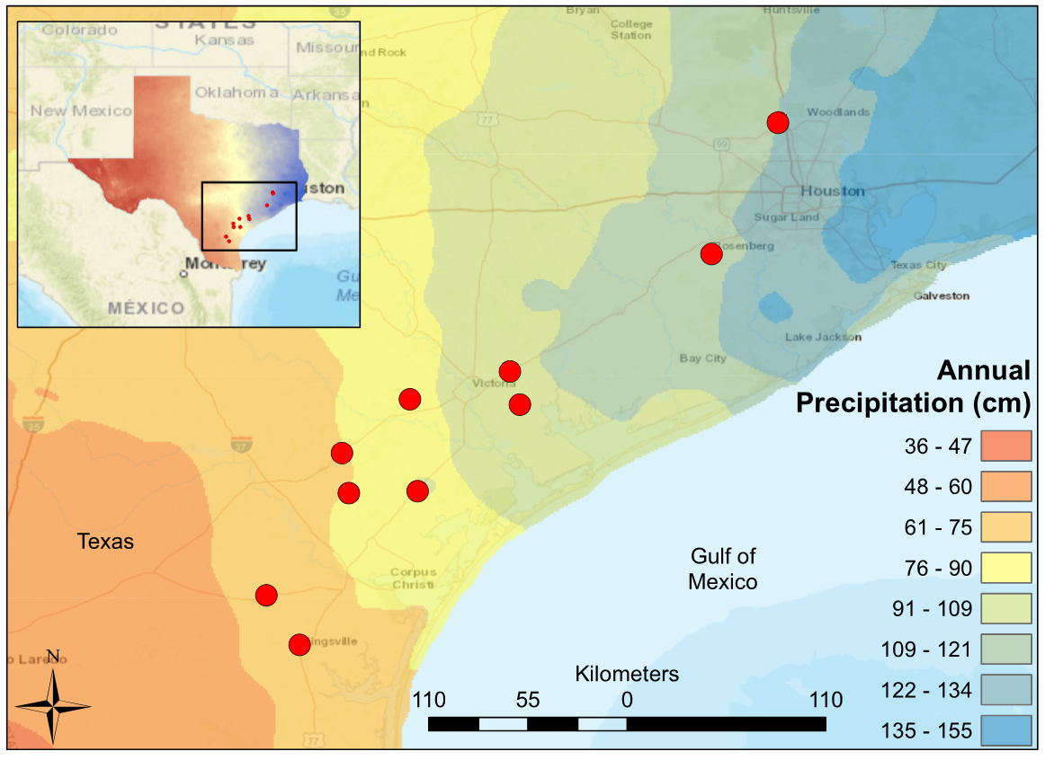

Figure 1. Map of South Central Texas, where 10 USGS gaged Streams were sampled in the Spring of 2017. An annual precipitation overlay indicate that the sample sites span a gradient from 61 cm/yr in the Southwest to 134 cm/yr in the Northeast.

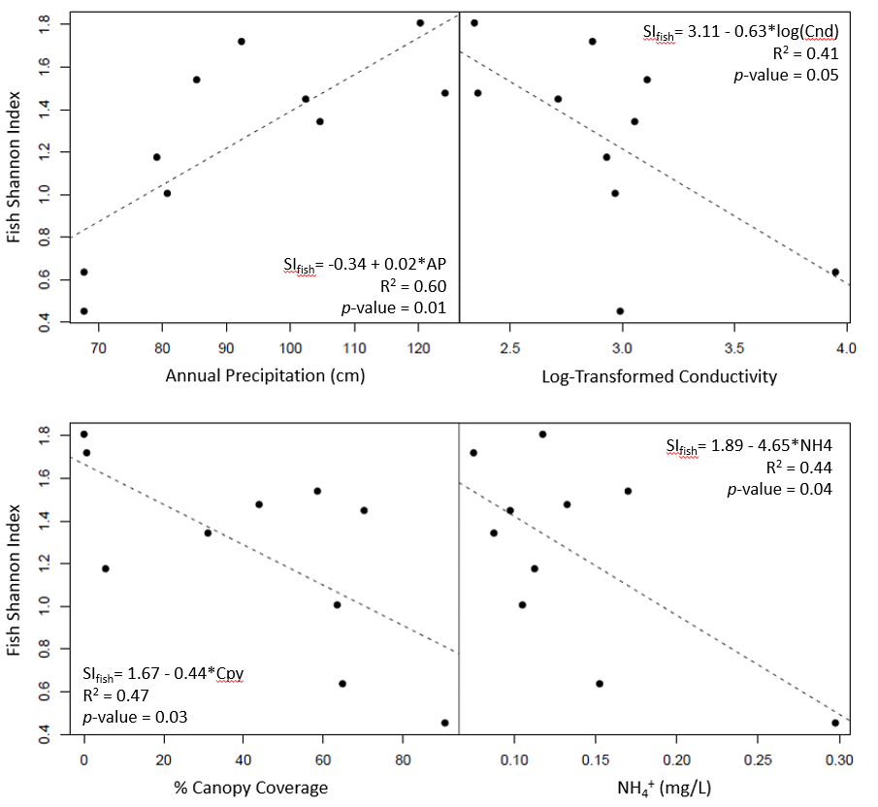

Figure 2. Significant least-square regressions of Fish Shannon Index versus environmental predictors (annual precipitation, log-transformed conductivity, canopy coverage, NH4+).

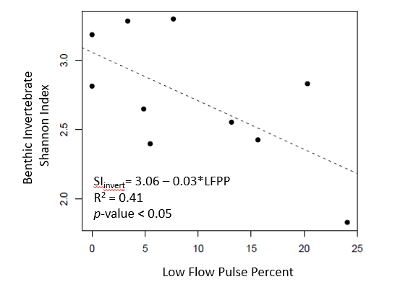

Figure 3. Least-square regression of macroinvertebrate Shannon index versus low flow pulse percent.

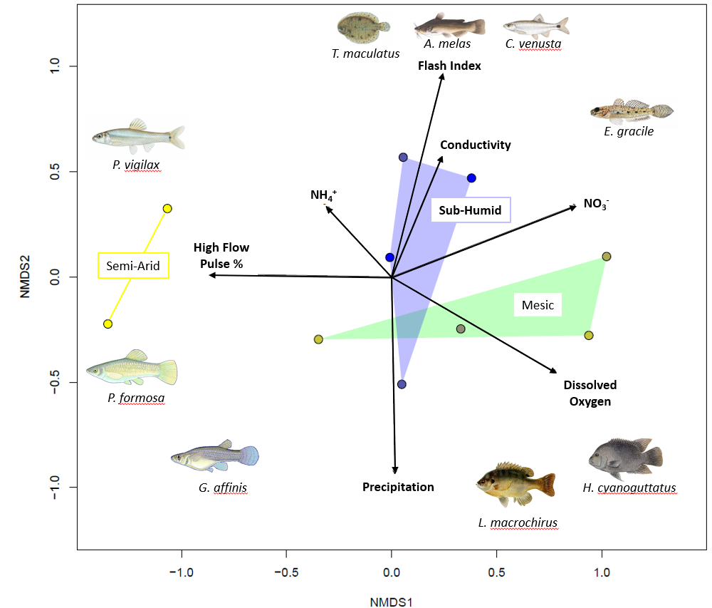

Figure 4. NMDS ordination of fish communities in ten coastal prairie streams in South Texas. Sites are grouped according to Annual Precipitation. Distances between sites are proportional to compositional differences in community. The explanatory power of environmental factors is indicated by the length and direction of the arrows. Labeled Illustrations indicate the location of various species within the ordination space.

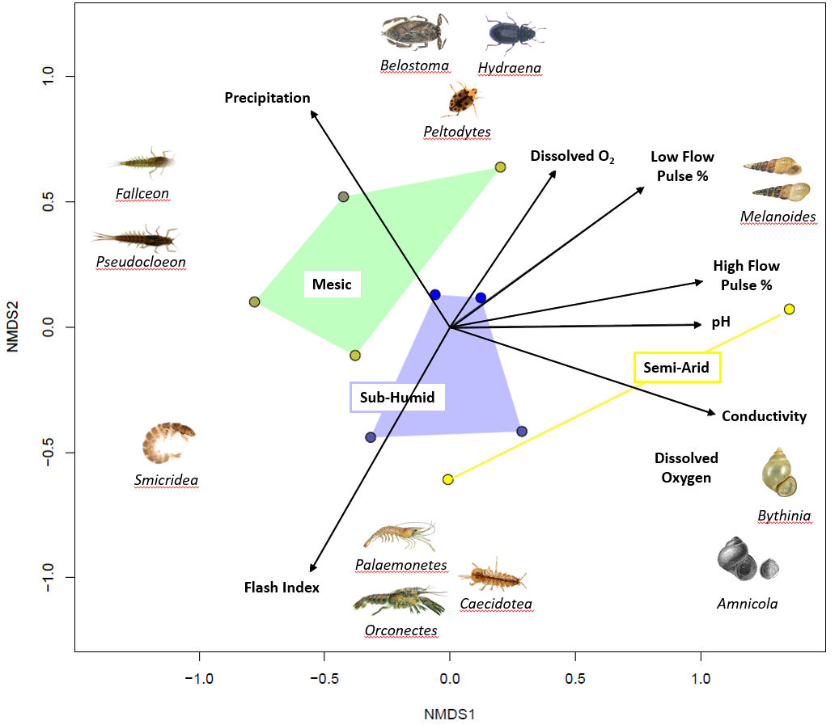

Figure 5. NMDS ordination of Macroinvertebrate communities in eleven coastal prairie streams in South Texas. Sites are grouped according to Annual Precipitation [semi-arid < 80 cm/yr, Mesic <100 cm/yr, Sub-Humid <125 cm/yr]. Distances between sites are proportional to compositional differences in community. The explanatory power of environmental factors is indicated by the length and direction of the arrows. Labeled Illustrations indicate the location of various genus within the ordination space.

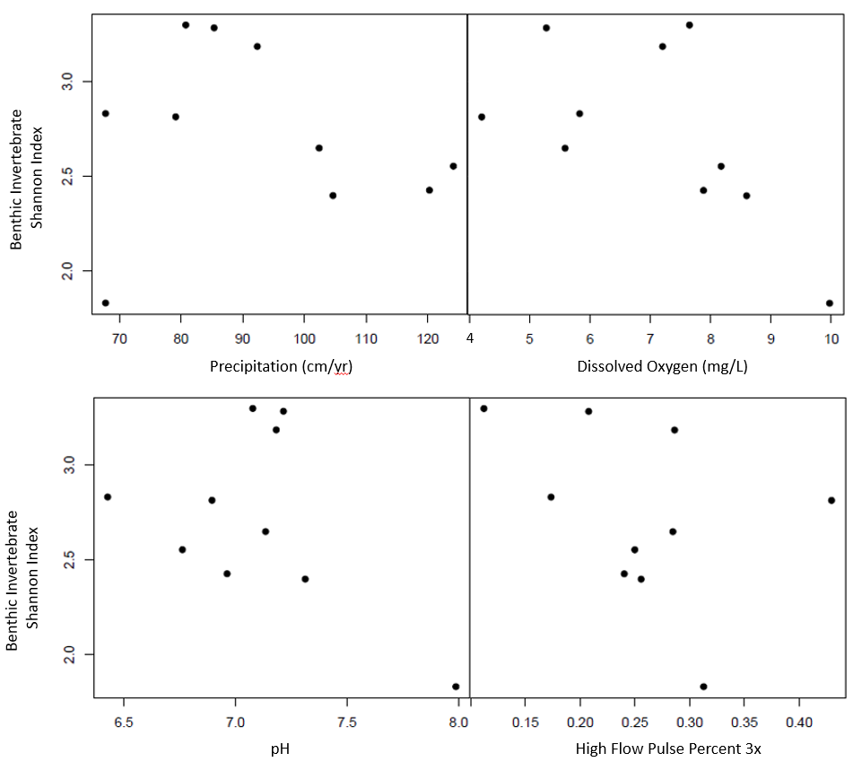

Figure 6. Scatterplot of macroinvertebrate shannon index versus environmental predictors (annual precipitation, dissolved oxygen, pH, high flow pulse percent 3x).

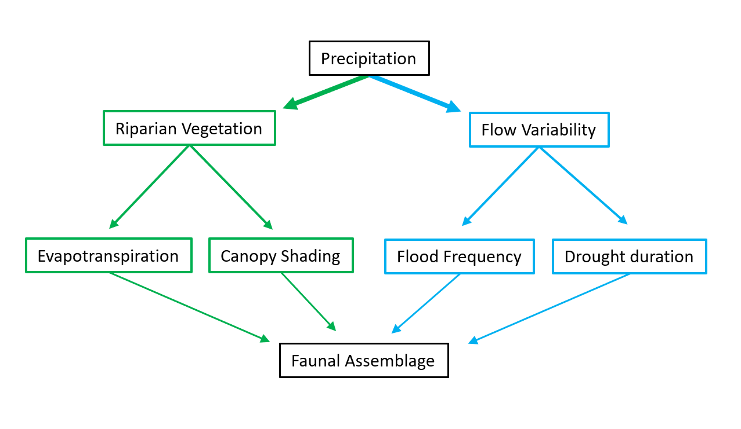

Figure 7. Concept model depicting how long-term precipitation regime drives stream assemblages directly through hydrological pathways and indirectly through riparian-mediated pathways.

|  |  |  |  |  |  |  |
| --- | --- | --- | --- | --- | --- | --- |
| USGS gauge | Precipitation (cm/yr) | Temperature (°C) | Elevation (m) | Drainage (km2) | Latitude | Longitude |
| 8212300 | 61 | 22.1 | 18 | 1303.7 | 27.77253 | -98.0336 |
| 8211900 | 70.96 | 22.1 | 61.6 | 1303.7 | 27.77253 | -98.0336 |
| 8211520 | 81.78 | 22 | 4 | 227.5 | 27.71142 | -97.5019 |
| 8189700 | 82.86 | 21.4 | 46.9 | 631.3 | 28.2825 | -97.6208 |
| 8189300 | 83.72 | 21 | 56 | 527.3 | 28.48305 | -97.6567 |
| 8177300 | 93.41 | 21.4 | 50 | 72.2 | 28.75166 | -97.3172 |
| 8189200 | 97.48 | 21.6 | 8 | 159 | 28.30362 | -97.1125 |
| 8189500 | 99.32 | 21.6 | 14 | 1808.3 | 28.29195 | -97.2792 |
| 8164600 | 105.67 | 21.1 | 20.1 | 253.9 | 28.89138 | -96.8191 |
| 8164800 | 108.1 | 21.2 | 8 | 172.2 | 28.72527 | -96.7689 |
| 8115000 | 121.13 | 20.4 | 23 | 116.7 | 29.47663 | -95.8127 |
| 8068390 | 125.17 | 19.8 | 41 | 40.2 | 30.19056 | -95.4911 |
| 8068450 | 125.41 | 19.9 | 37 | 88.3 | 30.13105 | -95.4813 |

Table 1. Descriptions of climate and geographic characteristics of the selected sample sites (Falcone 2011). Mean annual precipitation at the gauge location is calculated from an 800 m prism using a 30-year record (1971-2000). Note as precipitation increases, drainage area decreases to maintain similar stream hydrological classification.

|  |  |  |  |
| --- | --- | --- | --- |
| Abbreviation | Covariate | Units | Description |
| USGS.gauge | Station Identification | - | USGS Gauge Number associated with the nearest flow gauge |
| AP | Annual Precipitation | cm | Mean annual precipitation for the watershed, from 800m PRISM data. 30 years period of record 1971-2000 |
| Cnd | Conductivity | μS | Conductivity |
| DO | Dissolved Oxygen | mg/L | Dissolved oxygen |
| pH | pH | - | pH expressed in unitless log scale |
| Cpy | Canopy Cover | % | canopy density measured in the mid channel of the stream using a densiometer with 37 vertices |
| NH4 | Ammonia | mg/L | Ammonia concentration |
| NO3 | Nitrate | mg/L | Nitrate and nitrite concentration |
| flsh | flash index | - | Cumulatie changes in day to day daily flow / cumulative flow for a 20 year daily flow record |
| HFPP3 | High Flow Pulse Percent 3x | % | % of time daily flow is above 3 times the median daily flow |
| LFPP | Low Flow Pulse Percent | % | % of time where the daily discharge drops below the 25th percentile |

Table 2. displays the environmental covariates used throughout the statistical analysis. Annual precipitation is obtained directly from USGS GAGES II. Conductivity, dissolved oxygen, pH, canopy cover, ammonia, and nitrate values were obtained during field surveys in March and April of 2017. The flash index, high flow pulse percent 3x, and low flow pulse percent are calculated flow metrics which use the 20 year continuous flow record within the USGS GAGES II data set.

|  |  |  |  |  |  |
| --- | --- | --- | --- | --- | --- |
| Dependent variable | Independent variable | Slope | Intercept | R2 | p-value |
| Fish Shannon Index | Annual Precipitation | 0.017271 | -0.335986 | 0.602 | 0.008336 |
| Fish Shannon Index | Log(Conductivity) | -0.6318 | 3.1111 | 0.4058 | 0.0476 |
| Fish Shannon Index | Canopy Coverage | -0.43929 | 1.666563 | 0.4662 | 0.02956 |
| Fish Shannon Index | Ammonia | -4.6474 | 1.8873 | 0.4451 | 0.03509 |
| Invertebrate Shannon Index | Annual Precipitation | -0.00302 | 3.005858 | 0.01736 | 0.7167 |
| Invertebrate Shannon Index | Dissolved Oxygen | -0.15653 | 3.8281 | 0.3627 | 0.06542 |
| Invertebrate Shannon Index | High Flow Pulse Percent 3x | -2.0832 | 3.2582 | 0.149 | 0.2705 |
| Invertebrate Shannon Index | pH | -0.5174 | 6.3977 | 0.2087 | 0.1844 |
| Invertebrate Shannon Index | Low Flow Pulse Percent | -0.03498 | 3.05718 | 0.4114 | 0.04563 |

Table 3. Univariate linear regressions correlate fish and macroinvertebrate Shannon diversities with environmental predictors. Fish Shannon index values have significant correlations with four environmental predictors (Annual Precipitation, conductivity, canopy coverage and ammonia concentrations), while macroinvertebrate diversity has a singular significant correlation with low flow pulse percent.

|  |  |  |  |
| --- | --- | --- | --- |
| Model | R2 | p-value | AICc |
| Fish_Shannon ~ 0.054010 + (0.015598) AP - (0.0249) LFPP | 0.8175 | 0.002599 | 10.2 |
| Fish_Shannon ~ - 0.335986 + (0.017271) AP | 0.602 | 0.008336 | 12 |
| Fish_Shannon ~ 0.299779 + (0.013090) AP - (0.005809) Cpy | 0.7427 | 0.008642 | 13.6 |
| Fish_Shannon ~ 0.401516 + (0.013176) AP - (2.663321) NH4 | 0.7143 | 0.01246 | 14.7 |
| Invertebrate_Shannon ~ 3.95689 - (3.21078) HFPP3 - (0.04349) LFPP | 0.7411 | 0.008828 | 14.3 |
| Invertebrate_Shannon ~ 3.05718 - (0.03498) LFPP | 0.4114 | 0.04563 | 16.5 |
| Invertebrate_Shannon ~ 4.64023 - (0.10774) DO - (3.36722) HFPP3 - (0.03134) LFPP | 0.8592 | 0.00578 | 17.2 |
| Invertebrate_Shannon ~ 3.82810 - (0.15653) DO | 0.3627 | 0.06542 | 17.3 |

Table 4. Multivariate generalized linear models (GLM) for fish and macroinvertebrate Shannon index values. Top 4 AICc ranked models were selected. The top four fish diversity glms include annual precipitation as a positively correlated predictor. The top three Macroinvertebrate GLMs include low flow pulse percent (LFPP) as a negatively correlated predictor. R2 values reflect the multiple-R2 for each GLM.

**Cited Literature:**

Allen, M. R. and W. J. Ingram (2002). "Constraints on future changes in climate and the hydrologic cycle." Nature **419**(6903): 224-+.

Bay, C. E. (2003). Chironomid Midges. Puyallup Washington USA, WSU.

Boulton, A. J., C. G. Peterson, N. B. Grimm and S. G. Fisher (1992). "Stability of an Aquatic Macroinvertebrate Community in a Multiyear Hydrologic Disturbance Regime." Ecology **73**(6): 2192-2207.

Caladonato, M. (1992). Carya illinoinensis. Fire Effects Information System, U.S. Department of Agriculture, Forest Service, Rocky Mountain Research System.

Chapman BR, B. E. (2018). The Natural History of Texas. College Station, Texas A&M University Press.

D'Amen, M., H. K. Mod, N. J. Gotelli and A. Guisan (2018). "Disentangling biotic interactions, environmental filters, and dispersal limitation as drivers of species co-occurrence." Ecography **41**(8): 1233-1244.

De Frenne, P., B. J. Graae, F. Rodriguez-Sanchez, A. Kolb, O. Chabrerie, G. Decocq, H. De Kort, A. De Schrijver, M. Diekmann, O. Eriksson, R. Gruwez, M. Hermy, J. Lenoir, J. Plue, D. A. Coomes and K. Verheyen (2013). "Latitudinal gradients as natural laboratories to infer species' responses to temperature." Journal of Ecology **101**(3): 784-795.

Falcone, J. (2011). GAGES-II: Geospatial Attributes of Gauges for Evaluating Streamflow. Reston, Virginia, U.S. Geological Survey.

Grimm, N. B., F. S. Chapin, B. Bierwagen, P. Gonzalez and P. M. Groffman (2013). "The impacts of climate change on ecosystem structure and function." Frontiers in ecology and the environment **11**(9): 474-482.

Held, I. M. and B. J. Soden (2006). "Robust responses of the hydrological cycle to global warming." Journal of Climate **19**(21): 5686-5699.

Hirabayashi, Y., S. Kanae, S. Emori, T. Oki and M. Kimoto (2008). "Global projections of changing risks of floods and droughts in a changing climate." Hydrological Sciences Journal **53**(4): 754-772.

Hubbs, C. (2008). An Annotated Checklist of the Freshwater Fishes of Texas, with Keys to Identification of Species. R. J. E. a. G. P. Garrett, Texas Academy of Science.

IPCC (2014). Climate Change 2014: Synthesis Report. Contribution of Working Groups I, II and III to the Fifth Assessment Report of the

Intergovernmental Panel on Climate Change [Core Writing Team, R.K. Pachauri and L.A. Meyer (eds.)]. Geneva, Switzerland, IPCC. **151 pp.**

Kirby, D. F. and R. E. Knowlton (1976). "SALINITY TOLERANCE AND SODIUM BALANCE IN PRAWN PALAEMONETES-PUGIO HOLTHUIS." American Zoologist **16**(2): 240-240.

Kormos, P. R., C. H. Luce, S. J. Wenger and W. R. Berghuijs (2016). "Trends and sensitivities of low streamflow extremes to discharge timing and magnitude in Pacific Northwest mountain streams." Water Resources Research **52**(7): 4990-5007.

Koski, R. T. (1978). "AGE, GROWTH, AND MATURITY OF HOGCHOKER, TRINECTES-MACULATUS, IN HUDSON RIVER, NEW-YORK." Transactions of the American Fisheries Society **107**(3): 449-453.

Krumholz, L. A. (1948). "Reproduction in the Western Mosquitofish, Gambusia-Affinis-Affinis (Baird and Girard), and Its Use in Mosquito Control." Ecological Monographs **18**(1): 1-43.

Lamberti, H. (2007). Methods in Stream Ecology, Elsevier Inc.

Lorenz, O. T., S. A. Riccobono and P. Smith (2016). "Effects of salinity on the survival and aggression of the invasive Rio Grande cichlid (Herichthys cyanoguttatus)." Marine and Freshwater Behaviour and Physiology **49**(1): 1-8.

Lupon, A., S. Bernal, S. Poblador, E. Marti and F. Sabater (2016). "The influence of riparian evapotranspiration on stream hydrology and nitrogen retention in a subhumid Mediterranean catchment." Hydrology and Earth System Sciences **20**(9): 3831-3842.

Merritt, R. W. and K. W. Cummins (2008). An introduction to the Aquatic insects of North America. Dubuque, Iowa, Kendall/Hunt Pub. Co.

Mooney, H. A., B. B. Simpson and O. T. Solbrig (1977). "Mesquite–Its Biology in Two Desert Ecosystems, US/IBP Synth." Phenology, morphology, physiology. **Series No. 4**(B.B. Simpson, ed.): 26-41.

NAS, U. (2014). "Nonindigenous aquatic species database." from <http://nas.er.usgs.gov/>.

Patrick, C. J. and C. M. Swan (2011). "Reconstructing the assembly of a stream-insect metacommunity." Journal of the North American Benthological Society **30**(1): 259-272.

Poff, N. L. (1997). "Landscape filters and species traits: Towards mechanistic understanding and prediction in stream ecology." Journal of the North American Benthological Society **16**(2): 391-409.

Pusey, B. J., M. J. Kennard, J. M. Arthur and A. H. Arthington (1998). "Quantitative sampling of stream fish assemblages: Single- vs multiple-pass electrofishing." Australian Journal of Ecology **23**(4): 365-374.

Rehage, J. S., J. R. Blanchard, R. E. Boucek, J. J. Lorenz and M. Robinson (2016). "Knocking back invasions: variable resistance and resilience to multiple cold spells in native vs. nonnative fishes." Ecosphere **7**(6): 13.

Reynolds, L., A. T. Herlihy, P. R. Kaufmann, S. V. Gregory and R. M. Hughes (2003). "Electrofishing effort requirements for assessing species richness and biotic integrity in western Oregon streams." North American Journal of Fisheries Management **23**(2): 450-461.

Ricklefs, R. E. and D. G. Jenkins (2011). "Biogeography and ecology: towards the integration of two disciplines." Philosophical Transactions of the Royal Society B-Biological Sciences **366**(1576): 2438-2448.

Satake, K. and R. Ueno (2013). "Distribution of freshwater macroinvertebrates in streams with dams and associated reservoirs on a subtropical oceanic island off southern Japan." Limnology **14**(2): 211-221.

Schade, J., S. G. Fisher, N. Grimm and J. A. Seddon (2001). The Influence of Riparian Shrub on Nitrogen Cycling in a Sonoran Desert Stream.

Seabra, R., D. S. Wethey, A. M. Santos and F. P. Lima (2015). "Understanding complex biogeographic responses to climate change." Scientific Reports **5**.

Shannon, C. E. (1948). "A Mathematical Theory of Communication." Bell System Technical Journal **27**(3): 379-423.

Tabacchi, E., L. Lambs, H. Guilloy, A. M. Planty-Tabacchi, E. Muller and H. Decamps (2000). "Impacts of riparian vegetation on hydrological processes." Hydrological Processes **14**(16-17): 2959-2976.

Thomas C, B. T., Whiteside BG (2007). A Field Guide: Freshwater Fishes of Texas. College Station, Texas, Texas A&M University Press.

Whittaker, R. J., K. J. Willis and R. Field (2001). "Scale and species richness: towards a general, hierarchical theory of species diversity." Journal of Biogeography **28**(4): 453-470.

Wingard, G. L., J. B. Murray, W. B. Schill and E. C. Phillips. (2008). "Red-rimmed melania (Melanoides tuberculatus) - a snail in Biscayne National Park, Florida - harmful invader of just a nuisance?" Retrieved 3/5/2020.

Wrona, F. J., T. D. Prowse, J. D. Reist, J. E. Hobbie, L. M. J. Levesque and W. F. Vincent (2006). "Climate change effects on aquatic biota, ecosystem structure and function." Ambio **35**(7): 359-369.