**Effects of a natural precipitation gradient on fish and macroinvertebrate assemblages**

Sean Kinard1, Christopher Patrick1, Fernando Carvallo2

1. Virginia Institute of Marine Science

1370 Greate Road, Gloucester Point, Virginia 23062-1346

1. Texas A&M Corpus Christi

6300 Ocean Dr, Corpus Christi, TX 78412

Target Journal: *Freshwater Biology*

Total Word Count ()

Abstract Count ()

Citations ()

Figures ()

Tables ()

ABSTRACT:

**Introduction:**

Anthropogenic climate change creates an urgent need to understand the relationship between biological communities and climate (Wrona, Prowse et al. 2006). As concentrations of greenhouse gases rise, the atmosphere retains more infrared radiation, resulting in rising global temperatures (IPCC 2018). A warmer atmosphere is more energetic which intensifies the hydrological cycle (i.e. patterns of precipitation and evaporation), causing wet regions to become wetter and dry regions become drier (Allen and Ingram 2002). Simultaneously, the frequency and intensity of extreme weather events are expected to increase (Held and Soden 2006). The predicted shifts in precipitation regimes will have significant effects on ecosystems, especially in arid and semi-arid regions (Grimm, Chapin et al. 2013). Freshwater systems are particularly vulnerable to changes in climate due to their fragmentation and anthropogenic stressors (Woodward, Perkins et al. 2010). Regional changes in precipitation are predicted to produce a 3-fold effect on surface runoff, and subsequent changes in the flow regimes of surface waters (Kingston and Taylor 2010, Tang and Lettenmaier 2012). However, it is unclear how these stream ecosystems will respond or adjust to the predicted changes to the hydrologic cycle. Therefore, clarifying mechanistic links between climate drivers and stream biology will improve our ability to predict to the effects of anthropogenic climate change of lotic ecosystems.

Stream communities are sensitive to changes in both water chemistry and flow regime and these are directly influenced by precipitation regime (Hirabayashi, Kanae et al. 2008, Kormos, Luce et al. 2016). Shifts in streamside vegetation along a precipitation gradient indicates an indirect pathway through which precipitation can influence stream biota. The riparian zone regulates nutrient, carbon and light inputs to streams that fundamentally alter stream primary production and carbon cycling (Schade, G. Fisher et al. 2001).

Hierarchical community assembly models can help us organize our hypotheses regarding impacts of climate change on stream communities. The core concept is that the stream community assembly is constrained by abiotic and biotic filters (Poff 1997). Assuming organisms can disperse to a habitat, they must be able to survive in the local environment and successfully reproduce in the presence of other organisms exerting pressures such as competition and predation (Patrick and Swan 2011). Abiotic filters are conceptually easy to understand. Species have physiological tolerances which limit their distribution across environmental gradients (Whittaker, Willis et al. 2001). However, understanding the impact of climate change on biotic interactions is more challenging due to the complex sets of interactions that govern these processes (Seabra, Wethey et al. 2015). As a result, our understanding of the role of environmental filters on community assembly remains disjointed due to the vastly different spatial scales of existing biogeographical and community ecology studies (Ricklefs and Jenkins 2011). Therefore, there is a need to isolate climate effects from other abiotic filters.

Observational surveys of existing communities spatially distributed along environmental gradients can be used in a space-for-time substitution to infer how communities will change through time as environmental conditions shift (Ricklefs and Jenkins 2011). The approach allows for links to be drawn between climate drivers, local environmental conditions, and organism abundances. Species co-occurrence patterns along environmental gradients can also shed light on possible shifts in biotic interactions (D'Amen, Mod et al. 2018). However, the space-for-time substitution approach assumes that observed ecological differences along the spatial gradient are the solely a product of corresponding changes in climate. This assumption may be unfair given that biogeographical studies have revealed that dispersal limitation, habitat heterogeneity, and local evolution can also contribute to current spatial patterns in community composition. These studies are typically large in scale, covering vast distances (thousands of km) in order to capture climate gradients. These large scales make the precise mechanisms for observed biological changes difficult to ascertain due to covarying environmental variables (e.g., elevation, geology, human impacts). Thus, while current literature demonstrates that biome shifts occur across temperature and latitudinal gradients (De Frenne, Graae et al. 2013), the value of these observational studies for forecasting community responses to climate change is hindered by the many confounding variables. The power of using the space-for-time approach for evaluating how changes to the hydrologic cycle will impact ecological communities is enhanced in study systems with limited confounding environmental variables (i.e. temperature, elevation, distance, and underlying geology), allowing for delineating the intricacies of hydrologic cycle-ecosystem relationships.

Fortunately, the Texas Coastal Prairie (TCP) within the Western Gulf coastal grasslands is an ideal system evaluating the effect of hydrologic climate change on ecological communities. The Western Gulf coastal grasslands are a subtropical ecotone that spans Louisiana, Texas, and northern Mexico’s coastal areas. From east to west to climate becomes more arid, with gradual change for much of the coast and a region of rapid change located in southern Texas. In this region the annual rainfall changes from 55cm•yr-1 (semi-arid) to 135 cm•yr-1 (sub-humid) over a 300 km gradient (Falcone 2011), but there are minimal changes in elevation, air temperature, underlying geology, and human land use. Thus, studying natural ecosystems that span the TCP maximizes our ability to detect relationships between annual precipitation and ecosystem processes in the absence of covarying factors.

We used a section of the TCP where precipitation changes most quickly as a model system to evaluate how changes in precipitation alter stream communities. As conditions become wetter, there is an observable ecological shift from Thornwood groves in the semi-arid West to Live oak forests Towards the East (Chapman BR 2018). In addition to its value as a case study region, there is limited prior biological sampling by state and federal agencies of running waters in the TCP so sampling efforts enhance our understanding of subtropical ecosystems. Along the rainfall gradient we surveyed 10 USGS gauged wadeable streams for fish, benthic macroinvertebrates, and environmental variables. Our objectives were to: 1) Identify patterns in the diversity and composition of fish and macroinvertebrates communities that correspond to changes in precipitation, and 2) identify environmental drivers that mediate the effects of climate on community processes. We expected that annual precipitation would be positively correlated with community diversity because humid precipitation regimes are expected to create more stable environmental conditions by creating habitat heterogeneity and predictable flow regimes which promote the development of greater biodiversity (Boulton, Peterson et al. 1992). We further expected that evapotranspiration by riparian vegetation would increase solute concentrations in semi-arid streams, particularly during base flows (Tabacchi, Lambs et al. 2000, Lupon, Bernal et al. 2016), creating environmental filters that limit recruitment of sensitive fish and macroinvertebrates.

**Methods**

*Study Region***:** The Texas Coastal Prairie contains grassland prairie with forested areas occurring primarily along riverine systems. During March and April of 2017, we sampled ten, wadable, perennial streams which span 12 counties from Kleberg County to Montgomery in South-Central Texas, USA. Each study site is located within 100 meters of a USGS stream gauge which continuously monitor streamflow and climate data year-round. Study sites were chosen to maximize differences in precipitation with minimal changes in underlying geology and elevation. The annual precipitation ranges from 48-125 cm within the study region which spans a linear distance of 378 km (Falcone 2011). The surface geology is characterized by fine clays, quaternary and sedimentary sand. The streams have similar elevations (14-61 m), substrates (quaternary), and average air temperatures (19.9-22.1℃) (Table 1).

*Biological Sampling***:** Fish communities were sampled using a Smith-Root LR-24 Backpack in a single pass survey of a 100-meter reach (Lamberti 2007). Reach length was determined by applying a modified version of the recommended standard of a length 40x the width (Reynolds, Herlihy et al. 2003). We reduced this to 25x the medium stream width (4.1m) because the study sites are characterized by low variation in geomorphology and overall habitat heterogeneity resulting in high success in assessing community composition over a shorter distance. Data from three pass surveys collected in similar streams in the same region found that an average of 91% ± 2SE of total species are typically found in the first electrofishing pass (Patrick Lab – unpublished data). Fish species were field identified to species using a field guide (Thomas C 2007) and photographed. Several specimens of each species were euthanized using tricaine mesylate (MS-222) and stored in >70% denatured ethanol as voucher specimens for lab confirmation of species identification. Fish Voucher specimens were identified using the Texas Academy of Science dichotomous key (Hubbs 2008) and cross referenced with field identifications.

Macroinvertebrates were collected using a 0.305m wide D-frame net equipped with 500-µm mesh. Twenty 0.093 m2 samples were collected via a combination of kick and sweep sampling from a representative distribution of best available habitat (riffles, large woody debris, overhanging vegetation). Samples were pooled and field rinsed in a 500-µm sieve bucket. After removal of rinsed larger sticks and leaves, the entire sample was preserved with the addition of 95% EtOH for transport to the lab. In the lab, samples were spread across a gridded sampling tray and randomly selected grid cells were picked to completion until the total count was > 300 individuals. Samples containing less than 300 individuals were picked to completion. Invertebrates were identified to lowest taxonomic resolution (typically genus) using taxonomic keys cross referenced with species observations recorded by the TCEQ’s (Texas Commission on Environmental Quality) Surface Water Quality Monitoring Program (Wiggins 2015, Merritt, Cummins et al. 2019). The sum of individuals in each taxon were multiplied by the fraction of unpicked sample and reported as abundance of individuals per square meter.

*Environmental Sampling***:**  For each stream, we averaged values for each of the following habitat measurements that were taken at 4 cross-sections spaced 25 meters apart. Canopy cover was measured at the left bank, center channel, and right bank using a spherical densiometer. A Rosgen index value was calculated by dividing the bank-full width by the maximum depth (DL 2001). Bank height was recorded as vertical difference between water level and the height of the first bench. Water depth was measured on the left bank, center channel, and right bank and wetted width was measured in the same location. We estimated Sediment grain size within each cross-section using Wentworth size categories to calculate a median grain-size (Wentworth 1922). Oxygen (mg/L), temperature (℃), conductivity (µcm/S), turbidity (NTU), and pH were measured at each point using a YSI ProDSS multiparameter probe. Two 60 mL water samples were collected and filtered through a pre-combusted (500℃ for 4 hours) glass fiber filter (Whatman GF/F) into acid washed amber bottles, transferred to the lab in a cooler on ice, and stored frozen (-20℃) until analysis for nutrients (NH4+, NO3-, and SRP). Water samples were run by the Oklahoma University Soil Water and Forage Laboratory.

In addition to the habitat metrics measured in the field, we mined climate and watershed data (average annual precipitation, relative humidity, potential evapotranspiration, proportion of forested riparian zone, and proportions of watershed forest, agriculture, and urban development) from the US Geologic Survey Geospatial Attributes of Gages for Evaluating Streamflow, version II dataset (Falcone 2011). A twenty-year continuous flow record was downloaded for each site (except Tranquitas Creek which only had 4 years of available data) from the USGS water services (Falcone 2011). In order to evaluate the flow regime in the context of seasonal droughts, floods, and overall variation in flow, we calculated the following four variables: average daily discharge (Discharge), the flashiness index (LFPP = cumulative changes in day to day daily flow / cumulative flow), the high flow Pulse Percentage (HFPP = Percent of time daily flow is above 3 times the median daily flow), the low flow pulse percentage (LFPP = times where daily discharge drops below the 25th percentile) (Olden and Poff 2003, Patrick and Yuan 2017).

*Analyses***: For each community (fish, invertebrates) we calculated Shannon diversity and rarified taxonomic richness (Hurlbert 1971).** Diversity and richness measures were calculated using the Vegan Library () in the statistical program R (). To evaluate the effect of rainfall on environmental variables that may influence the biota, wee used linear regression to examine relationships between environmental variables and annual precipitation. We then used linear regression to evaluate the effect rainfall and environmental variables on fish and invertebrate community metrics .. Prior to analyses conductivity and NO3- concentrations were natural log transformed to satisfy the test assumption of normality.

To evaluate how community composition changed along the gradient, we ordinated each taxa group (fish, invertebrates) across sites using non-metric multidimensional scaling (NMDS) using the ‘metaMDS’ within the VEGAN R package. The function runs NMDS with multiple starting configurations (n=100), compares results, and stops after finding a similar minimum stress solution. The minimum stress solution is scaled, rotated, and then species scores are added to the configuration as weighted averages (Oksanen, Blanchet et al. 2019). Using the climate data, sites were grouped using Ward’s minimum variance method for hierarchical clustering (Ward 1963). Finally, we fit environmental variables to each ordination using the ‘envfit’ function within the VEGAN R package; this function fits environmental vectors onto the ordination and calculates the maximum correlation with the projection of points (sites in this case). To ease in visual interpretation of the plots we only retained environmental variables that were significant at an α > 0.10 and explained > 40% of the variation. Retained environmental vectors were overlaid on top of the NMDS plots. The direction of the vector indicates the axis of the variable within the ordination space and the length of the arrow is proportional to its correlation with the projected points (Oksanen, Blanchet et al. 2019).

**Results**

*Site Overview:* Proceeding from West to East, there are several environmental variables that covary with increasing annual basin precipitation (67.75 - 124.19 cm). Mean-annual potential evapotranspiration (PET) decreases from 1177 mm/yr to 1062 mm/yr. The Runoff Factor increases from 281 to 376.03 100s ft-tonf in/h/ac/yr. The conductivity decreases from 8923 - 227.13 μS/cm. The ammonia concentration at San Fernando Creek on the arid side (0.3 mg/L) is 2-3 times larger than the other sites which range 0.08 - 0.17. The canopy coverage varied across the region, ranging 44.14 - 89.86 % with an apparent outlier at Bear Branch creek (with a value of 0 % canopy coverage). The proportion of forested riparian zone within 100 m of the stream increases from 3.92 - 14.33 % with an average of 11 and standard deviation of 9.40.

The remaining environmental variables vary across the study region and do not display obvious patterns with geographic location or precipitation. The dissolved oxygen ranged from 4321 - 9.97 mg/L with an average of 7.03 and a standard deviation of 1.76. Turbidity ranged 66.13 - 70.66 NTU, with Big Creek having a larger value of 99.08 NTU. The water temperature ranges 15.88 - 24.63 °C with an average of 20.646 and a standard deviation of 3.04. pH ranges 6.43 - 7.99 with an average of 7.10 and a standard deviation of 0.41. Phosphate concentrations vary across the region, ranging 0.13 - 4.28 mg/L with an average of 1.21 and a standard deviation of 1.64. Nitrate concentrations vary across the region, ranging 0.01 - 2.9 mg/L with an average of 0.599 and a standard deviation of 0.98. Bank height ranges 0.29 - 0.89 meters with an average of 0.54 and a standard deviation of 0.20. The Rosgen index ranges 11.78 - 23.15 with an average of 16.05 and a standard deviation of 3.5. The median grain size for 8 sites is 2 mm, whereas higher values due to artificial substrate addition were observed at two sites ( Placedo Creek - 25mm, Aransas Creek - 32mm). . Relative humidity values varied throughout the study region from 69.6 - 75 %. Only one watershed (Bear Branch) had a majority of urbanized landscape (76.71 %); other sites' development ranged from 2.45 - 10.88 %. The proportion of Forest in each watershed ranged from 1.44 - 9.98 % except for Garcitas (17.53 %) and Perdido (34.85 %). The proportion of agricultural land varies across the study region, with nine sites ranging 27.41 - 78.16 %, and one watershed (Bear Branch) containing 0.82 %. The average soil permeability ranged from 1.27 - 4.45 cm/hr for nine sites and 9.53 cm/hr at Bear Branch. The average soil organic content ranged from 0.48 - 2.55 %. Stream flow flashiness ranged from 0.58 - 1.34 (mean 0.912 ± SD0.20). The HFPP ranged from 0.11 to 0.43 with an average of 0.255 and a standard deviation of 0.09. Two sites (Medio and Perdido) had a LFPP of 0.00, while the remaining sites ranged from 3.36 to 24.06 with an average value of 11.82 and a standard deviation of 7.70. The average daily flow ranged from 1.76 to 115.13 with an average of 33.24 and a standard deviation of 33.61.

*Community*: We observed18 fish species among the surveyed sites. Fish that were common across the region included, Red Shiner (*Cyprinella lutrensis*), Western Mosquitofish (*Gambusia affinis*), Longear Sunfish (*Lepomis megalotis*), and Bullhead minnow (*Pimephales vigilax*). Fish composition also shifted moving along the region from the semi-arid to mesic to sub-humid sites. Semi-arid and mesic sites to the west were home to Sailfin molly (*Poecilia latipinna*), Rio Grande cichlid (*Herichthys cyanoguttatus*), and slough darter (*Etheostoma gracile*). Whereas the more eastern and sub-humid sites were characterized by a greater diversity of centrarchids (green sunfish (*Lepomis cyanellus*), warmouth sunfish (*Lepomis gulosus*), bluegill sunfish (*Lepomis macrochirus*), dollar sunfish (*Lepomis marginatus*), redbreast sunfish (Lepomis auritus), and orangespotted sunfish (*Lepomis humilis*)). Within sites Shannon diversity was an average of 1.26 ± SD 0.4, richness had a mean of 5.7 ± SD 2.21, and rarified richness a mean of 4.07 ± SD 1.44 (Table 3).

A total of 94 invertebrate genera were identified among the study sites. Amphipods in genus *Hyallela,* grass shrimp in genus *Palaemonetes,* and Chironomid midges were common across the entire region, but there were large observational differences in composition of other taxonomic groups. Semi-arid sites were characterized by high numbers of gastropods (> 1000 per m2, particularly for invasive snails *Melanoides tuberculata*), an absence of Ephemeroptera, and low diversity of Coleoptera (only 1 elmid genera, *Stenelmis sp.* observed in arid sites). Composition in the mesic and sub-humid sites was variable, but we observed a diversity of Hemiptera, Coleoptera, Odonata, Trichoptera, and Ephemeroptera. Non-predatory invertebrates tended to fall into generalist feeding groups (collector-gatherers and filter feeders) and there was a noticeable lack of shredding insect taxa. Within sites, richness was 17.60 ± 7.43SD and Shannon index was 2.73 ± 0.46SD (Table 3).

*Relationships between environment and climate:*  We observed several significant relationships between mean annual precipitation and measured environmental variables (Figure 2, Significant Relationships reported in Table X, complete results in Appendix X). Surface runoff was positive related with , whereas conductivity and potential evaporation were negatively related to precipitation (Table X, Figure 2)

*Relationships between community structure and environment*: We observed significant positive relationships between rarified richness of fish and the watershed runoff and the proportion of riparian forest (Figure X, Table X). Watershed runoff and AP were positively related to fish Shannon diversity, while potential evapotranspiration, conductivity, NH4+ and bank height were all negative predictors of fish diversity (Figure X, Table X). Invertebrates rarified richness was not observed to have significant relationships with any predictors, but invertebrate diversity was negatively related to low flow pulse percentage (Figure X, Table X).

*Composition*: The best solutions for NMDS ordinations of fish communities had a stress value of 0.098 indicating a good fit of the data. The first axis of the ordination corresponds to rainfall gradient and this is quantified by the cluster analysis which separated sites into three distinct groups (Fig XA). The semi-arid cluster was characterized by *Poecilia formosa*, *Gambusia affinis*, and *Pimephales vigilax,* whereas the other two clusters shared a diversity of Lepomis species but differed in the prevalence of Rio Grande Cichlid (*Herichthys cyanoguttatus*)which was common in the mesic sites, and the presence of hogchoker (*Trinectes maculatus*), black bullhead (*Ameiurus melas)*, and black tail shiner (*Cyprinella venusta*) in the eastern sub-humid sites.  Environmental variables retained for the vector mapping included low flow pulse percentage, which oriented toward the semi-arid communities, and relative humidity and mean flow which oriented toware the mesic communities (Figure X, Table X).

The best solutions for NMDS ordinations of invertebrate communities had a stress value of 0.156 indicating a good fit of the data (Figure XB). Similar to the fish ordination, the first axes corresponds to the rainfall gradient and this is quantified by cluster analysis into three distinct groups (Fig XB, YOU SHOULD REPORT THE Test statistic and p value for your cluster analysis). The semi-arid cluster was characterized by a variety of gastropod taxa including *Amnicola sp. Bythinia sp.* and *melanoides sp.* The mesic community cluster contained species from a greater number of taxonomic orders including Ephemeroptera, Trichoptera, Coleoptera, and Hemiptera. The sub-humid community clusters contained a greater proportion of crustaceans including *Palaemonetes sp*., *Orconectes sp*., and isopods in the genus *Caecidotea*. Significant fitted environmental variables on invertebrate community NMDS included relative humidity, low flow pulse percentage, and conductivity (Figure XB, Table X).

**Discussion**

Using the Texas Coastal Prairie (TCP) as a model system, our goal was to quantify patterns in the diversity and composition of stream communities along an extreme precipitation gradient to better understanding how streams might respond to future changes in mean annual rainfall. Our observational study identified strong compositional shifts in both fish and invertebrate communities along the precipitation gradient. We also observed a positive relationship between fish diversity and mean annual rainfall, matching expectations, however, invertebrate diversity did not exhibit the expected relationships with rainfall. Environmental data collected at each site suggest several mechanistic drivers of these changes operating through water solute concentrations and flow regimes. Below we discuss these results, place in the context of other literature, and make suggestions for future work.

The lack of observed relationships between annual precipitation (AP) and the majority of environmental variables supports the assertion that TCP is an exemplary region to conduct space for time substitutions to make useful ecological predictions regarding climate change. While we did observe relationships between AP, potential evapotranspiration (PET), and runoff and water quality variables such as conductivity and nutrients as well as riparian cover, these relationships are likely causal and important mechanistic pieces of the relationships between AP and stream communities. The field-measured riparian data (Canopy) proved uninformative due to outlier effects brought on by sub-urban floodway maintenance at our most humid site, Bear Creek. So, we restrict our discussion of riparian-effects on community assembly to the watershed-level metric (Rip.forest), supplied by the USGS.

The fish communities displayed a pattern of increasing diversity (R2 = 0.600 *p* = 0.008), rarified richness (R2 = 0.320 *p* = 0.088), and compositional turnover moving from the drier to wetter sides of the survey region. The wetter sites were characterized by an increase in the diversity of sunfishes and the addition of several marine migrants including hogchoker () and American eel (). These compositional shifts connect with quantitative relationships between environmental variables and diversity, suggesting mechanistic pathways through which precipitation is structuring the stream communities.

As precipitation increases, fish communities structure diversifies to include competitive omnivores and predators. Mesic sites contain a plurality of centrarchids; species with 3-7 year lifespans, annual breeding, nesting strategies, and are omnivores (DATA). Sub-humid sites contain larger predator taxa including catfish, LMB, warmouth sunfish, and green sunfish. Most of these species are ambush predators that reside within alcoves and woody debris, consuming a mixture of insects and small fish. These same taxa likely benefited from rainfall via an indirect effect on riparian vegetation. The relationship between riparian cover and rainfall was positive but non-significant, but riparian cover had a strong positive relationship with fish diversity (R2 = 0.404, *p* = 0.048). Mechanistically, riparian trees may provide appropriate conditions for fish taxa via root-stabilized undercut banks or large woody debris within the channel (CITATION). Large wood and bank stabilization is particularly important in these watersheds because the substrate was largely unconsolidated sand and there is little natural structure

In contrast, co The observed negative relationship between AP and conductivity (R2 = 0.62, p = 0.01), and conductivity and fish diversity (R2 = 0.41, p = 0.048) point to the importance of rainfall acting on solute concentrations to limit fish communities. Arid regions are known for salinization issues (cite), and the high evapotranspiration, lack of rainfall, and presence of agriculture likely contribute to base flow salinity concentrations that act as an environmental filter for less tolerant species (citation). Low flow pulse percentage (LFPP) was also a significant predictor of fish community diversity and while the negative linear relationship with AP was non significant, the semi-arid sites had a higher frequency of low flow events (add something here, a number or test?). found the in semi-arid sites

Although salinity tolerance is prevalent in semi-arid communities. several euryhaline species including *Herichthys cyanoguttatum* (0-27.5 psu), *Trinectes maculatus* (1-30 psu)*,* and American eel *()* are only found in Mesic and Sub-Humid streams (Figures 3 & 4) (Kirby and Knowlton 1976). *T. maculatus* typically reside in brackish estuaries (1-25psu) and make seasonal migrations upstream to spawn (Koski 1978). *H. cyanoguttatum* and *P. pugio* seek thermal refugia in deeper pools or estuaries during the winter months until temperatures rise and flows permit dispersal in late Spring (Kirby and Knowlton 1976, Rehage, Blanchard et al. 2016). All of the sites were a similar distance from downstream estuaries, so the absence of anadromous and euryhaline taxa in semi-arid streams may be due to increased habitat fragmentation in the downstream river cooridor and the unpredictability of freshets triggering upstream migrations in semi-arid climate (Satake and Ueno 2013).

While the invertebrate communities showed compositional shifts along the precipitation gradient, unlike fish, there was not a positive relationship with Shannon diversity. Instead, we observed a hump shaped relationship with the highest invertebrate richness and diversity at sites in the middle of the precipitation gradient (stats?). This may be due to differential responses of invertebrate groups to stressors along the gradient resulting in an area of overlap where semi-arid and sub-humid communities coexist.

, LFPP (R2 = 0.41, p < 0.05), indicating drought duration as a diversity driver (Figure 3). Even in perennial streams, prolonged droughts create physical stress via dewatering, pool isolation, and stagnation.

Invertebrate community compositions shift along the precipitation gradient and these shifts coincide with changes in LFPP (DATA).

Initially, the maximum invertebrate diversity in mesic sites can be attributed to overlapping dispersal from the extreme climate regions. However, the compositional shifts broadly indicate that predation and competition play larger roles in community assembly at mesic and sub-humid sites. Specifically, the distribution of fish predators has large top-down controls on invertebrate community dynamics (CITATION). Here, we believe fish are superior insectivores compared to Hemiptera and Odonata and that fish predation at sub-humid sites restricts invertebrate communities to small and armored grazers (CITATION). As conditions become more arid, fish predators are excluded resulting in a proliferation of insect predators in mesic and semi-arid streams.

*Conclusions*

The precipitation gradient along the TCP is unique in its capacity to deliver useful insights ecological consequences of climate change. Here, we have demonstrated the efficacy of space-for-time substitution climate gradient research in South Central Texas. We confirmed the sensitivity of fish communities to decreasing annual precipitation, mediated by drought conditions. There are compositional shifts of fish and invertebrate taxa across the gradient which indicate that as environmental filtering diminishes, trophic and competitive interactions play larger roles in community assembly. These results point towards additional pressing questions, many of which cannot be answered in this limited single-survey study. How *do* communities along the precipitation gradient respond to droughts, floods, and season? Do basal resources, their production, or consumption vary with precipitation? Do transient marine migrants play a significant role in sub-humid coastal streams?

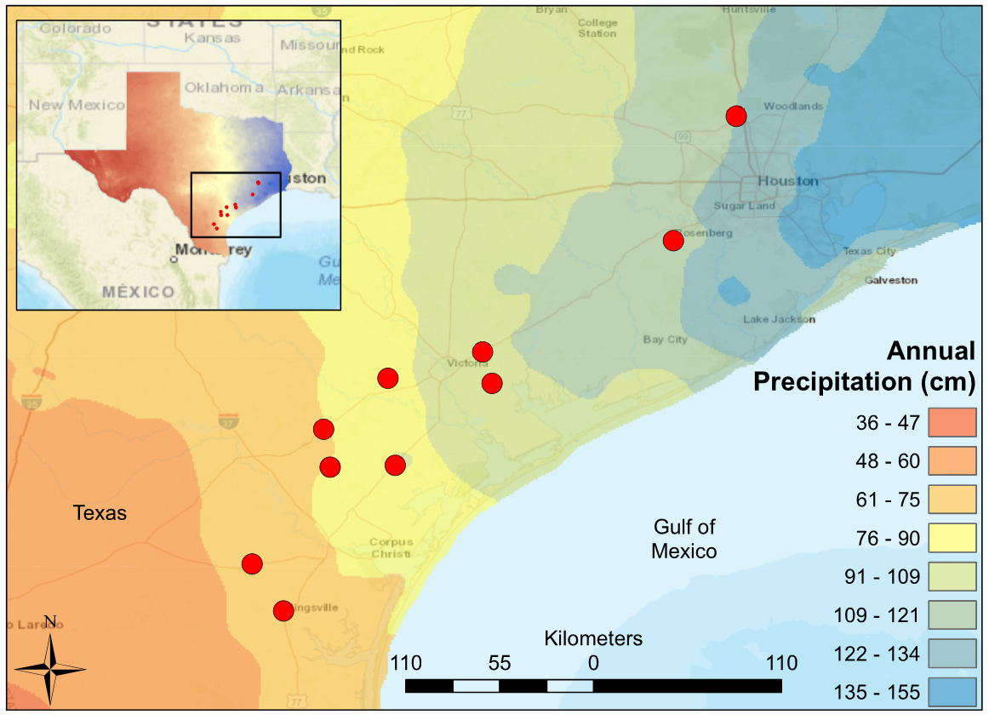

Figure 1. Map of South Central Texas, where 10 USGS gaged Streams were sampled in the Spring of 2017. An annual precipitation overlay indicate that the sample sites span a gradient from 61 cm/yr in the Southwest to 134 cm/yr in the Northeast.

|  |  |  |
| --- | --- | --- |
| Variable | Units | Description |
| STAID | # | USGS gage station identification |
| Ln(Cond) | μS/cm | conductivity |
| DO | mg/L | dissolved oxygen |
| Turbidity | NTU | turbidity |
| T.water | °C | temperature water |
| pH | pH | pH |
| NH4+ | mg/L | ammonia |
| PO4- | mg/L | phosphate |
| Ln(NO3-) | mg/L | nitrate |
| Bank.h | meter | Average bank height |
| Rosgen.I | ratio | bankfull width / depth |
| d50 | mm | median grain size |
| Cpy | % | canopy coverage |
| Rip.forest | % | Riparian 100m buffer "forest", 2006 era. |
| AP | cm | Watershed mean annual precipitation: from 800m PRISM data. 30 years period of record 1971-2000. |
| RH | % | Watershed average relative humidity (percent), from 2km PRISM, derived from 30 years of record (1961-1990). |
| PET | mm/yr | Mean-annual potential evapotranspiration (PET), estimated using the Hamon (1961) equation. |
| Bas.dev | % | Watershed percent "developed" (urban), 2006 era |
| Bas.forest | % | Watershed percent "forest", 2006 era |
| Bas.plant | % | Watershed percent "planted/cultivated" (agriculture), 2006 era |
| Soil.Perm | cm/hr | Average soil permeability |
| Soil.Org | % | Average value of soil organic matter content (percent by weight) |
| Runoff | 100s ft-tonf in/h/ac/yr | Rainfall and Runoff factor ("R factor" of Universal Soil Loss Equation); average annual value for period 1971-2000 |
| FI | ratio | Flashiness Index: Cumulative changes in day to day daily flow / cumulative flow for a 20 year daily flow record |
| HFPP | % | High Flow Pulse Percentage 3 : % of time daily flow is above 3 times median daily flow |
| LFPP | % | Low Flow Pulse Percentage: # times where daily discharge drops below the 25th percentile |
| Av.Flow | cfs | average daily flow based on a 20 year record for all sites except TRC which is based on a 4 year recod |

Table 1. Enviromental variables, units of measure, and descriptions. Water chemistry (ln(Cond), DO, Turbidity, T.water, pH, NH4+, PO4- and NO3-), Morphology (Bank.h and Rosgen.I) and canopy coverage (Canopy) were measured in the field during March and April of 2017. Forested Riparian (Rip.forest), climate metrics (AP, RH and PET), soil variables (Soil.perm and Soil.org), watershed features (Bas.dev, Bas.forest, Bas.plant, Runoff) were obtained from USGS GAGES II dataset (Falcone 2011). The flow metrics (Fash.I, HFPP, LFPP and Av.flow) were calculated from continuous flow records from the USGS (USGS 2020).

|  |  |  |  |  |  |  |  |  |  |  |
| --- | --- | --- | --- | --- | --- | --- | --- | --- | --- | --- |
| Variable | Tranquitas | San Fernando | Aransas | Medio | Perdido | Mission | Placedo | Garcitas | Big Creek | Bear Branch |
| STAID | 8212300 | 8211900 | 8189700 | 8189300 | 8177300 | 8189500 | 8164800 | 8164600 | 8115000 | 8068390 |
| Ln(Cond) | 8923 | 979 | 929.5 | 852.25 | 736.75 | 1291 | 1135.5 | 517.75 | 219.25 | 227.13 |
| DO | 9.97 | 5.83 | 7.65 | 4.21 | 7.2 | 5.28 | 8.6 | 5.59 | 7.88 | 8.17 |
| Turbidity | 66.13 | 67.17 | 66.35 | 68.8 | 66.2 | 68.61 | 70.66 | 66.91 | 99.08 | 67.46 |
| T.water | 22.53 | 23.28 | 19.05 | 19.03 | 18.88 | 23.6 | 24.63 | 22.58 | 15.88 | 17 |
| pH | 7.99 | 6.43 | 7.08 | 6.9 | 7.18 | 7.22 | 7.31 | 7.14 | 6.96 | 6.76 |
| NH4+ | 0.15 |  | 0.11 | 0.11 | 0.08 | 0.17 | 0.09 | 0.1 | 0.12 | 0.13 |
| PO4- | 0.13 | 4.28 | 4.13 | 0.41 | 0.3 | 0.32 | 0.3 | 0.41 | 1.67 | 0.17 |
| NO3- | 0.07 | 1.8 | 0.64 | 0.01 | 0.02 | 0.04 | 0.44 | 0.05 | 2.9 | 0.02 |
| Bank.h | 0.75 | 0.59 | 0.54 | 0.69 | 0.29 | 0.46 | 0.44 | 0.34 | 0.36 | 0.89 |
| Rosgen.I | 17.99 | 15.76 | 11.78 | 18.41 | 15.15 | 14.7 | 13.38 | 18.16 | 23.15 | 12.01 |
| d50 | 2 | 2 | 32 | 2 | 2 | 2 | 25 | 2 | 2 | 2 |
| Canopy | 68.77 | 89.86 | 58.56 | 14.41 | 0.9 | 68.47 | 29.28 | 73.65 | 0 | 44.14 |
| Rip.forest | 3.92 | 3.92 | 7.41 | 2.27 | 32.9 | 11.05 | 5.28 | 19.86 | 9.06 | 14.33 |
| AP | 67.75 | 67.75 | 80.77 | 79.13 | 92.37 | 85.36 | 104.65 | 102.41 | 120.31 | 124.19 |
| RH | 69.6 | 69.6 | 74.1 | 72 | 72.1 | 73.4 | 75 | 74.2 | 71.6 | 71.4 |
| PET | 1177.1 | 1177.1 | 1129.9 | 1135.3 | 1139.2 | 1136.5 | 1126.6 | 1122.6 | 1088.1 | 1062.1 |
| Bas.dev | 4.74 | 4.74 | 8.28 | 5.24 | 2.45 | 3.72 | 11.81 | 4.28 | 10.88 | 76.71 |
| Bas.forest | 1.48 | 1.48 | 3.58 | 1.44 | 34.85 | 8.43 | 2.57 | 17.53 | 2.57 | 9.98 |
| Bas.plant | 28.01 | 28.01 | 52.39 | 40.31 | 27.41 | 35.06 | 78.16 | 50.34 | 77.35 | 0.82 |
| Soil.perm | 3.45 | 3.45 | 2.44 | 2.95 | 2.97 | 2.79 | 1.27 | 4.45 | 1.65 | 9.53 |
| Soil.Org | 0.91 | 0.91 | 0.8 | 0.95 | 0.94 | 0.82 | 0.9 | 0.75 | 2.55 | 0.48 |
| Runoff | 281.68 | 281.68 | 310.86 | 311.53 | 333.93 | 321.63 | 360.22 | 354.04 | 376.03 | 364.53 |
| Flash.I | 0.78 | 0.91 | 1.05 | 0.99 | 1.34 | 0.58 | 0.92 | 0.81 | 0.96 | 0.78 |
| HFPP | 0.31 | 0.17 | 0.11 | 0.43 | 0.29 | 0.21 | 0.26 | 0.28 | 0.24 | 0.25 |
| LFPP | 24.06 | 20.31 | 7.66 | 0 | 0 | 3.36 | 5.48 | 4.87 | 15.63 | 13.15 |
| Av.Flow | 1.76 | 13.83 | 35.04 | 3.12 | 5.41 | 115.13 | 44.72 | 43.98 | 43.54 | 25.88 |

Table 2. Environmental characteristics for 10 surveyed streams spanning a precipitation gradient throughout the Texas Coastal Prairie.

|  |  |  |  |  |  |  |  |  |  |
| --- | --- | --- | --- | --- | --- | --- | --- | --- | --- |
| Site Name | Tranquitas | San Fernando | Aransas | Medio | Perdido | Mission | Placedo | Garcitas | Big Creek |
| STAID | 8212300 | 8211900 | 8189700 | 8189300 | 8177300 | 8189500 | 8164800 | 8164600 | 8115000 |
| Fish Shannon Index | 0.64 | 0.45 | 1.01 | 1.18 | 1.72 | 1.54 | 1.34 | 1.45 | 1.81 |
| Fish Richness | 2 | 3 | 5 | 4 | 6 | 6 | 9 | 7 | 7 |
| Fish Rarified Richness | 2.00 | 2.09 | 3.39 | 3.42 | 6.00 | 6.00 | 4.02 | 4.07 | 5.48 |
| Invertebrate Shannon Index | 1.83 | 2.83 | 3.30 | 2.81 | 3.18 | 3.28 | 2.40 | 2.65 | 2.43 |
| Invertebrate Richness | 7 | 18 | 29 | 17 | 26 | 27 | 11 | 15 | 12 |
| Invertebrate Rarefied Richness | 7 | 18 | 29 | 17 | 26 | 27 | 11 | 15 | 12 |

Table 3. Calculated diversity metrics for fish and macroinvertebrate communities of ten streams spanning a precipitaiton gradient in the Texas Coastal Prairie.

|  |  |  |  |  |  |  |  |  |  |  |
| --- | --- | --- | --- | --- | --- | --- | --- | --- | --- | --- |
| Species | Tranquitas | San Fernando | Aransas | Medio | Perdido | Mission | Placedo | Garcitas | Bear Branch | Big Creek |
| *A. melas* | 0 | 0 | 0 | 0 | 0 | 0 | 3 | 0 | 0 | 0 |
| *A. rostrata* | 0 | 0 | 0 | 0 | 0 | 2 | 4 | 1 | 0 | 0 |
| *H. cyanoguttatus* | 0 | 0 | 1 | 0 | 0 | 1 | 0 | 0 | 0 | 0 |
| *C. lutrensis* | 0 | 0 | 27 | 0 | 0 | 0 | 67 | 0 | 2 | 10 |
| *C. venusta* | 0 | 0 | 0 | 0 | 0 | 0 | 0 | 0 | 3 | 0 |
| *E. gracile* | 0 | 0 | 0 | 0 | 0 | 1 | 0 | 0 | 0 | 0 |
| *F. notatus* | 0 | 0 | 0 | 0 | 1 | 0 | 0 | 0 | 5 | 0 |
| *G. affinis* | 8 | 3 | 0 | 11 | 1 | 1 | 6 | 22 | 1 | 4 |
| *L. auritis* | 0 | 0 | 3 | 0 | 2 | 0 | 0 | 0 | 0 | 0 |
| *L. cyanellus* | 0 | 0 | 0 | 5 | 2 | 0 | 0 | 2 | 0 | 6 |
| *L. gulosus* | 0 | 0 | 0 | 1 | 0 | 0 | 2 | 0 | 2 | 1 |
| *L. humilis* | 0 | 0 | 0 | 0 | 0 | 0 | 0 | 2 | 0 | 0 |
| *L. macrochirus* | 0 | 0 | 5 | 7 | 2 | 1 | 6 | 15 | 21 | 5 |
| *L. marginatus* | 0 | 0 | 0 | 0 | 0 | 0 | 0 | 4 | 0 | 0 |
| *L. megalotis* | 0 | 0 | 3 | 0 | 3 | 5 | 17 | 30 | 29 | 8 |
| *P. latipinna* | 4 | 36 | 0 | 0 | 0 | 0 | 0 | 0 | 0 | 0 |
| *P. vigilax* | 0 | 2 | 0 | 0 | 0 | 0 | 3 | 0 | 3 | 4 |
| *T. maculatus* | 0 | 0 | 0 | 0 | 0 | 0 | 1 | 0 | 0 | 0 |

Table 4. Electrofishing community data reported as abundance within a 75m single pass survey.

|  |  |  |  |  |  |  |  |  |  |  |
| --- | --- | --- | --- | --- | --- | --- | --- | --- | --- | --- |
|  | Tranquitas | San Fernando | Aransas | Medio | Perdido | Mission | Placedo | Garcitas | Big Creek | Bear Branch |
| Coleoptera |  |  |  |  |  |  |  |  |  |  |
| *Ancyronyx* | 0 | 0 | 0 | 0 | 0 | 381 | 0 | 91 | 0 | 0 |
| *Berosus* | 0 | 0 | 0 | 0 | 0 | 0 | 0 | 0 | 0 | 0 |
| *Brachycerus* | 0 | 0 | 0 | 0 | 628 | 0 | 0 | 0 | 325 | 0 |
| *Cyphon* | 0 | 0 | 0 | 0 | 0 | 381 | 392 | 91 | 0 | 0 |
| *Dubiraphia* | 0 | 0 | 1613 | 0 | 0 | 381 | 392 | 91 | 0 | 0 |
| *Elodes* | 0 | 0 | 0 | 0 | 0 | 0 | 0 | 91 | 0 | 0 |
| *Gyretes* | 0 | 0 | 0 | 0 | 0 | 381 | 0 | 0 | 0 | 0 |
| *Heterelmis* | 0 | 0 | 0 | 0 | 0 | 381 | 0 | 0 | 0 | 0 |
| *Hydraena* | 0 | 0 | 0 | 867 | 314 | 0 | 0 | 0 | 0 | 0 |
| *Hydrobius* | 0 | 0 | 0 | 867 | 0 | 0 | 0 | 0 | 0 | 0 |
| *Macrelmis* | 0 | 0 | 1613 | 0 | 0 | 0 | 0 | 0 | 0 | 0 |
| *Macronychus* | 0 | 0 | 0 | 0 | 0 | 0 | 0 | 91 | 0 | 0 |
| *Neoelmis* | 0 | 0 | 0 | 0 | 0 | 0 | 0 | 0 | 0 | 0 |
| *Peltodytes* | 0 | 0 | 0 | 1734 | 0 | 381 | 0 | 0 | 0 | 1158 |
| *Scirtes* | 0 | 0 | 0 | 0 | 0 | 381 | 0 | 0 | 0 | 0 |
| *Sphaeridiinae* | 0 | 0 | 0 | 0 | 0 | 0 | 0 | 0 | 0 | 0 |
| *Stenelmis* | 0 | 1512 | 3226 | 0 | 0 | 381 | 392 | 0 | 650 | 0 |
| Ephemeroptera |  |  |  |  |  |  |  |  |  |  |
| *Ameletus* | 0 | 0 | 3226 | 0 | 314 | 0 | 0 | 0 | 0 | 1158 |
| *Amelobaetidius* | 0 | 0 | 3226 | 0 | 0 | 0 | 0 | 0 | 0 | 0 |
| *Ametropus* | 0 | 0 | 0 | 0 | 0 | 0 | 0 | 0 | 0 | 0 |
| *Baetis* | 0 | 0 | 3226 | 0 | 314 | 0 | 0 | 0 | 0 | 0 |
| *Baetodes* | 0 | 0 | 0 | 0 | 0 | 0 | 0 | 0 | 0 | 1158 |
| *Caenis* | 0 | 0 | 0 | 867 | 0 | 381 | 0 | 0 | 650 | 1158 |
| *Centroptilum* | 0 | 0 | 0 | 867 | 0 | 0 | 0 | 0 | 0 | 0 |
| *Cercobrachys* | 0 | 0 | 3226 | 0 | 314 | 0 | 0 | 0 | 0 | 1158 |
| *Cloeon* | 0 | 0 | 0 | 0 | 0 | 0 | 0 | 0 | 0 | 0 |
| *Fallceon* | 0 | 0 | 0 | 0 | 628 | 0 | 0 | 91 | 325 | 1158 |
| *Farrodes* | 0 | 0 | 1613 | 0 | 314 | 381 | 0 | 0 | 0 | 0 |
| *Isonychiidae* | 0 | 0 | 3226 | 0 | 0 | 0 | 0 | 0 | 0 | 0 |
| *Leptohyphes* | 0 | 0 | 0 | 0 | 314 | 381 | 0 | 0 | 325 | 0 |
| *Plauditus* | 0 | 0 | 0 | 0 | 314 | 381 | 0 | 0 | 325 | 1158 |
| *Procloeon* | 0 | 0 | 0 | 0 | 0 | 381 | 0 | 0 | 0 | 0 |
| *Pseudocloeon* | 0 | 0 | 0 | 0 | 314 | 0 | 0 | 0 | 0 | 0 |
| *Stenonema* | 0 | 0 | 0 | 0 | 0 | 0 | 0 | 182 | 0 | 0 |
| Gastropoda |  |  |  |  |  |  |  |  |  |  |
| *Amnicola* | 3328 | 756 | 0 | 0 | 0 | 0 | 392 | 182 | 0 | 0 |
| *Biomphalaria* | 3328 | 0 | 0 | 867 | 0 | 0 | 0 | 0 | 0 | 0 |
| *Bithynia* | 3328 | 0 | 1613 | 867 | 0 | 0 | 0 | 0 | 325 | 1158 |
| *Campeloma* | 3328 | 0 | 0 | 0 | 0 | 0 | 392 | 0 | 0 | 0 |
| *Fossaria* | 3328 | 0 | 0 | 0 | 0 | 381 | 0 | 0 | 0 | 0 |
| *Gyraulus* | 0 | 0 | 0 | 0 | 0 | 0 | 0 | 0 | 0 | 0 |
| *Helicina* | 0 | 0 | 1613 | 0 | 0 | 0 | 0 | 0 | 0 | 0 |
| *Helisoma* | 0 | 0 | 0 | 0 | 628 | 0 | 392 | 0 | 0 | 0 |
| *Linisa* | 0 | 0 | 0 | 0 | 0 | 381 | 0 | 0 | 0 | 0 |
| *Melanoides* | 9984 | 1512 | 3226 | 867 | 628 | 381 | 0 | 182 | 0 | 0 |
| *Menetus* | 0 | 0 | 0 | 0 | 0 | 0 | 0 | 0 | 0 | 0 |
| *Physa* | 0 | 0 | 0 | 867 | 628 | 381 | 0 | 0 | 0 | 0 |
| *Physella* | 0 | 0 | 1613 | 0 | 314 | 0 | 0 | 0 | 325 | 0 |
| *Planorbula* | 0 | 0 | 0 | 0 | 0 | 0 | 0 | 0 | 0 | 0 |
| *Pseudcosuccinea* | 3328 | 0 | 0 | 0 | 0 | 0 | 0 | 91 | 0 | 1158 |
| *Strobilops* | 0 | 0 | 0 | 0 | 314 | 0 | 0 | 0 | 0 | 0 |
| *Valvata* | 0 | 0 | 0 | 867 | 0 | 0 | 0 | 0 | 0 | 0 |

Table 5. Coleoptera, Ephemeroptera and Gastropoda reported as individuals per square meter.

|  |  |  |  |  |  |  |  |  |  |  |
| --- | --- | --- | --- | --- | --- | --- | --- | --- | --- | --- |
|  | Tranquitas | San Fernando | Aransas | Medio | Perdido | Mission | Placedo | Garcitas | Big Creek | Bear Branch |
| Hemiptera |  |  |  |  |  |  |  |  |  |  |
| *Belostoma* | 0 | 0 | 0 | 0 | 0 | 0 | 0 | 0 | 325 | 0 |
| *Glaenocorisa* | 0 | 0 | 0 | 0 | 0 | 0 | 0 | 0 | 0 | 0 |
| *Hebrus* | 0 | 756 | 0 | 0 | 0 | 0 | 0 | 0 | 0 | 0 |
| *Limnocoris* | 0 | 0 | 0 | 0 | 0 | 381 | 0 | 0 | 0 | 0 |
| *Limnoporus* | 0 | 0 | 0 | 0 | 942 | 0 | 0 | 0 | 0 | 0 |
| *Lipogomphus* | 0 | 0 | 1613 | 0 | 0 | 0 | 0 | 0 | 0 | 0 |
| *Mesovelia* | 0 | 0 | 0 | 867 | 0 | 0 | 0 | 0 | 0 | 0 |
| *Microvelia* | 0 | 0 | 0 | 0 | 314 | 0 | 0 | 0 | 0 | 0 |
| *Morphocorixa* | 0 | 0 | 0 | 0 | 0 | 0 | 0 | 0 | 0 | 0 |
| *Neoplea* | 0 | 0 | 1613 | 0 | 314 | 0 | 0 | 0 | 0 | 0 |
| *Pelocoris* | 0 | 0 | 0 | 0 | 0 | 381 | 0 | 0 | 0 | 0 |
| *Ranatra* | 0 | 0 | 0 | 867 | 0 | 0 | 0 | 0 | 0 | 0 |
| *Rhagovelia* | 0 | 1512 | 3226 | 0 | 0 | 0 | 0 | 0 | 0 | 0 |
| *Rheumatobaetes* | 0 | 0 | 1613 | 0 | 0 | 0 | 0 | 0 | 0 | 0 |
| *Synaptonecta* | 0 | 0 | 0 | 0 | 0 | 0 | 0 | 0 | 0 | 0 |
| *Trepobates* | 0 | 0 | 0 | 0 | 628 | 381 | 0 | 0 | 0 | 0 |
| Odonata |  |  |  |  |  |  |  |  |  |  |
| *Amphiagrion* | 0 | 0 | 0 | 867 | 628 | 0 | 0 | 0 | 0 | 0 |
| *Argia* | 0 | 1512 | 3226 | 867 | 314 | 381 | 0 | 0 | 0 | 0 |
| *Brechmorhoga* | 0 | 756 | 1613 | 0 | 0 | 0 | 0 | 0 | 0 | 0 |
| *Calopteryx* | 0 | 0 | 0 | 0 | 0 | 381 | 0 | 0 | 0 | 0 |
| *Chromagrion* | 0 | 0 | 0 | 0 | 0 | 381 | 0 | 0 | 0 | 0 |
| *Erpetogomphus* | 0 | 1512 | 3226 | 0 | 0 | 0 | 0 | 0 | 0 | 0 |
| *Erythemis* | 0 | 0 | 0 | 867 | 0 | 0 | 0 | 0 | 0 | 0 |
| *Hetaerina* | 0 | 0 | 0 | 0 | 0 | 0 | 0 | 0 | 0 | 0 |
| *Neoneura* | 0 | 756 | 0 | 0 | 0 | 0 | 0 | 0 | 0 | 0 |
| *Siphlonurus* | 0 | 756 | 0 | 0 | 0 | 0 | 0 | 0 | 0 | 0 |
| Trichoptera |  |  |  |  |  |  |  |  |  |  |
| *Alisotrichia* | 0 | 0 | 0 | 0 | 0 | 0 | 0 | 0 | 0 | 1158 |
| *Cheumatopsyche* | 0 | 1512 | 4839 | 0 | 314 | 0 | 392 | 91 | 325 | 2316 |
| *Hydropsyche* | 0 | 0 | 1613 | 0 | 0 | 0 | 0 | 0 | 0 | 0 |
| *Leptoceridae* | 0 | 0 | 3226 | 0 | 0 | 762 | 0 | 0 | 0 | 0 |
| *Leptonema* | 0 | 756 | 0 | 0 | 0 | 0 | 0 | 0 | 0 | 0 |
| *Metrichia* | 0 | 0 | 0 | 0 | 314 | 0 | 0 | 0 | 0 | 0 |
| *Philopotamidae* | 0 | 0 | 3226 | 0 | 0 | 0 | 0 | 0 | 0 | 0 |
| *Potamyia* | 0 | 0 | 0 | 0 | 0 | 0 | 0 | 0 | 0 | 0 |
| *Smicridea* | 0 | 0 | 0 | 0 | 0 | 0 | 0 | 0 | 0 | 0 |
| *Stactobiella* | 0 | 0 | 0 | 0 | 0 | 0 | 392 | 0 | 0 | 0 |

Table 6. Hemiptera, Odonata, and Trichoptera reported as individuals per square meter.

|  |  |  |  |  |  |  |  |  |  |  |
| --- | --- | --- | --- | --- | --- | --- | --- | --- | --- | --- |
|  | Tranquitas | San Fernando | Aransas | Medio | Perdido | Mission | Placedo | Garcitas | Big Creek | Bear Branch |
| Amphipoda |  |  |  |  |  |  |  |  |  |  |
| *Gammarus* | 0 | 756 | 1613 | 0 | 0 | 0 | 0 | 0 | 0 | 0 |
| *Hyalella* | 0 | 756 | 1613 | 867 | 628 | 381 | 392 | 182 | 650 | 2316 |
| Bivalvia |  |  |  |  |  |  |  |  |  |  |
| *Corbicula* | 0 | 756 | 1613 | 0 | 628 | 0 | 0 | 182 | 0 | 3474 |
| *Pisidium* | 0 | 0 | 0 | 0 | 0 | 0 | 392 | 0 | 0 | 0 |
| Decapoda |  |  |  |  |  |  |  |  |  |  |
| *Orconectes* | 0 | 756 | 0 | 0 | 0 | 0 | 0 | 0 | 0 | 0 |
| *Palaemonetes* | 0 | 756 | 1613 | 867 | 314 | 381 | 392 | 182 | 650 | 1158 |
| Isopoda |  |  |  |  |  |  |  |  |  |  |
| *Caecidotea* | 0 | 1512 | 0 | 0 | 0 | 0 | 0 | 0 | 0 | 0 |

Table 7. Amphipoda, Bivalvia, Decapoda and Isopoda reported as individuals per square meter.

|  |  |  |  |  |  |  |
| --- | --- | --- | --- | --- | --- | --- |
| Annual Precipitation |  |  |  |  |  |  |
| Predictor | Slope | df | R2 | F statistic | *p*-value |  |
| NO3+ | 0.27 | 8 | 0 | 0.01 | 0.94 |  |
| PO4- | -4.36 | 8 | 0.13 | 1.16 | 0.31 |  |
| RH | 3.58 | 8 | 0.11 | 1 | 0.35 |  |
| Av.Flow | 0.13 | 8 | 0.05 | 0.42 | 0.53 |  |
| Flash.I | -2.5 | 8 | 0 | 0.01 | 0.94 |  |
| HFPP | -0.1 | 8 | 0 | 0 | 1 |  |
| LFPP | -0.38 | 8 | 0.03 | 0.21 | 0.66 |  |
| Bas.Dev | 0.55 | 8 | 0.38 | 4.86 | 0.06 |  |
| Bas.forest | 0.39 | 8 | 0.04 | 0.36 | 0.57 |  |
| Bas.Plant | 0.17 | 8 | 0.04 | 0.32 | 0.59 |  |
| Rip.forest | 0.72 | 8 | 0.12 | 1.04 | 0.34 |  |
| S.runoff | 0.58 | 8 | 0.94 | 122.45 | < 0.001 |  |
| Soil.Org | 11.16 | 8 | 0.1 | 0.87 | 0.38 |  |
| Soil.Perm | 7.92 | 8 | 0.13 | 1.18 | 0.31 |  |
| DO | 2.29 | 8 | 0.04 | 0.34 | 0.57 |  |
| ln(Cond) | -15.18 | 8 | 0.62 | 12.82 | 0.01 |  |
| Ln(NO3-) | 3.82 | 8 | 0.03 | 0.29 | 0.6 |  |
| NH4+ | -150.58 | 8 | 0.23 | 2.41 | 0.16 |  |
| PET | -0.53 | 8 | 0.87 | 52.49 | < 0.001 |  |
| pH | -9.95 | 8 | 0.04 | 0.34 | 0.58 |  |
| T.water | -3.28 | 8 | 0.25 | 2.63 | 0.14 |  |
| Turbidity | 1.03 | 8 | 0.27 | 2.94 | 0.12 |  |
| Bank.H | -14.13 | 8 | 0.02 | 0.16 | 0.7 |  |
| Canopy | -0.3 | 8 | 0.23 | 2.43 | 0.16 |  |
| d50 | -0.06 | 8 | 0 | 0.01 | 0.92 |  |
| Rosgen | 0.42 | 8 | 0.01 | 0.04 | 0.84 |  |

Table 8. Linear Regressions analysis of annual precipitation (AP) versus environmental predictors.

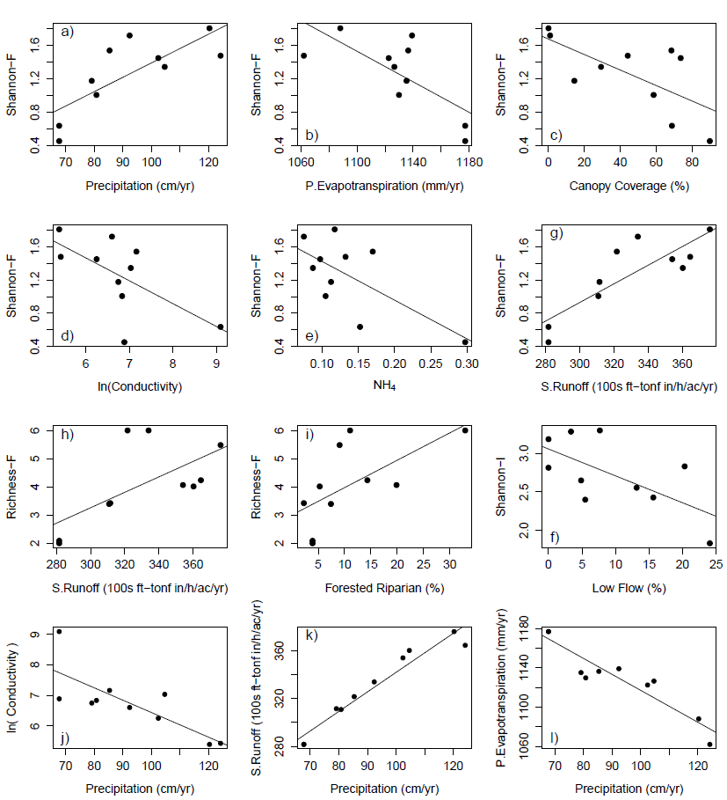

Figure 2. Strongest relationships between environmental variables (a-f) Fish Shannon Diversity, (h,i) Fish Rarified Richness, (f) Invertebrate Shannon Diversity, (j-l) Annual Precipitation.

|  |  |  |  |  |  |  |
| --- | --- | --- | --- | --- | --- | --- |
| Rarified Richness - Fish | | |  |  |  |  |
| Predictor | Slope | df | R2 | F statistic | *p-*value | *p* < .05 |
| PET | -0.021 | 8.000 | 0.268 | 2.928 | 0.125 |  |
| AP | 0.041 | 8.000 | 0.320 | 3.772 | 0.088 |  |
| RH | 0.330 | 8.000 | 0.184 | 1.808 | 0.216 |  |
| Av.Flow | 0.023 | 8.000 | 0.302 | 3.468 | 0.100 |  |
| Flash.I | 0.989 | 8.000 | 0.019 | 0.158 | 0.701 |  |
| HFPP | -0.416 | 8.000 | 0.001 | 0.005 | 0.946 |  |
| LFPP | -0.102 | 8.000 | 0.355 | 4.396 | 0.069 |  |
| Bas.dev | 0.002 | 8.000 | 0.001 | 0.012 | 0.917 |  |
| Bas.forest | 0.078 | 8.000 | 0.331 | 3.959 | 0.082 |  |
| Bas.plant | 0.010 | 8.000 | 0.027 | 0.220 | 0.651 |  |
| Rip.forest | 0.097 | 8.000 | 0.404 | 5.420 | 0.048 | * |
| Runoff | 0.027 | 8.000 | 0.415 | 5.668 | 0.044 | * |
| Soil.Org | 0.767 | 8.000 | 0.090 | 0.792 | 0.400 |  |
| Soil.Perm | -0.139 | 8.000 | 0.008 | 0.062 | 0.809 |  |
| DO | -0.143 | 8.000 | 0.031 | 0.257 | 0.626 |  |
| ln(Cond) | -0.707 | 8.000 | 0.260 | 2.808 | 0.132 |  |
| ln(NO3-) | 0.005 | 8.000 | 0.000 | 0.000 | 0.992 |  |
| NH4+ | -10.672 | 8.000 | 0.227 | 2.343 | 0.164 |  |
| pH | -0.160 | 8.000 | 0.002 | 0.016 | 0.901 |  |
| PO4- | -0.341 | 8.000 | 0.151 | 1.428 | 0.266 |  |
| T.water | -0.148 | 8.000 | 0.097 | 0.864 | 0.380 |  |
| Turbidity | 0.052 | 8.000 | 0.133 | 1.230 | 0.300 |  |
| Bank.H | -4.215 | 8.000 | 0.332 | 3.980 | 0.081 |  |
| Canopy | -0.025 | 8.000 | 0.308 | 3.555 | 0.096 |  |
| d50 | -0.019 | 8.000 | 0.022 | 0.178 | 0.684 |  |
| Rosgen | 0.028 | 8.000 | 0.005 | 0.038 | 0.851 |  |

Table 9. Linear regressions of fish community rarified richness versus environmental predictors.

|  |  |  |  |  |  |  |
| --- | --- | --- | --- | --- | --- | --- |
| Shannon Diversity - Fish | | |  |  |  |  |
| Predictor | Slope | df | R2 | F statistic | *p-*value | *p* < .05 |
| PET | -0.01 | 8 | 0.52 | 8.60 | 0.019 | * |
| AP | 0.02 | 8 | 0.60 | 12.10 | 0.008 | * |
| RH | 0.12 | 8 | 0.24 | 2.49 | 0.153 |  |
| Av.Flow | 0.01 | 8 | 0.16 | 1.56 | 0.247 |  |
| Flash.I | 0.34 | 8 | 0.02 | 0.19 | 0.672 |  |
| HFPP | 0.75 | 8 | 0.02 | 0.17 | 0.693 |  |
| LFPP | -0.03 | 8 | 0.34 | 4.10 | 0.077 |  |
| Bas.dev | 0.00 | 8 | 0.04 | 0.30 | 0.599 |  |
| Bas.forest | 0.02 | 8 | 0.27 | 2.98 | 0.123 |  |
| Bas.plant | 0.00 | 8 | 0.06 | 0.53 | 0.486 |  |
| Rip.forest | 0.03 | 8 | 0.36 | 4.55 | 0.065 |  |
| Runoff | 0.01 | 8 | 0.72 | 20.22 | 0.002 | * |
| Soil.Org | 0.28 | 8 | 0.12 | 1.10 | 0.324 |  |
| Soil.Perm | 0.01 | 8 | 0.00 | 0.00 | 0.945 |  |
| DO | -0.02 | 8 | 0.01 | 0.06 | 0.809 |  |
| ln(Cond) | -0.27 | 8 | 0.41 | 5.46 | 0.048 | * |
| Ln(NO3-) | 0.00 | 8 | 0.00 | 0.00 | 0.997 |  |
| NH4+ | -4.65 | 8 | 0.45 | 6.42 | 0.035 | * |
| pH | -0.03 | 8 | 0.00 | 0.01 | 0.944 |  |
| PO4- | -0.14 | 8 | 0.26 | 2.79 | 0.133 |  |
| T.water | -0.07 | 8 | 0.20 | 1.99 | 0.196 |  |
| Turbidity | 0.02 | 8 | 0.21 | 2.10 | 0.186 |  |
| Bank.H | -1.13 | 8 | 0.25 | 2.61 | 0.145 |  |
| Canopy | -0.01 | 8 | 0.45 | 6.49 | 0.034 | * |
| d50 | 0.00 | 8 | 0.02 | 0.13 | 0.728 |  |
| Rosgen | 0.02 | 8 | 0.03 | 0.22 | 0.649 |  |

Table 10. Linear regressions of fish community Shannon index versus environmental predictors.

|  |  |  |  |  |  |  |
| --- | --- | --- | --- | --- | --- | --- |
| Rarified Richness - Invertebrate | | | |  |  |  |
| Predictor | Slope | df | R2 | F statistic | *p-*value | *p* < .05 |
| PET | 0.016 | 8.000 | 0.006 | 0.045 | 0.838 |  |
| AP | -0.088 | 8.000 | 0.056 | 0.475 | 0.510 |  |
| RH | 1.317 | 8.000 | 0.110 | 0.984 | 0.350 |  |
| Av.Flow | 0.075 | 8.000 | 0.116 | 1.051 | 0.335 |  |
| Flash.I | 10.446 | 8.000 | 0.081 | 0.704 | 0.426 |  |
| HFPP | -38.955 | 8.000 | 0.199 | 1.994 | 0.196 |  |
| LFPP | -0.488 | 8.000 | 0.306 | 3.533 | 0.097 |  |
| Bas.dev | -0.072 | 8.000 | 0.047 | 0.399 | 0.545 |  |
| Bas.forest | 0.278 | 8.000 | 0.159 | 1.514 | 0.253 |  |
| Bas.plant | -0.046 | 8.000 | 0.022 | 0.180 | 0.683 |  |
| Rip.forest | 0.295 | 8.000 | 0.139 | 1.296 | 0.288 |  |
| Runoff | -0.039 | 8.000 | 0.032 | 0.265 | 0.621 |  |
| Soil.Org | -3.178 | 8.000 | 0.058 | 0.491 | 0.503 |  |
| Soil.Perm | -1.140 | 8.000 | 0.019 | 0.158 | 0.701 |  |
| DO | -1.899 | 8.000 | 0.204 | 2.053 | 0.190 |  |
| ln(Cond) | -0.001 | 8.000 | 0.194 | 1.926 | 0.203 |  |
| ln(NO3-) | -1.329 | 8.000 | 0.031 | 0.255 | 0.627 |  |
| NH4+ | -2.871 | 8.000 | 0.001 | 0.005 | 0.946 |  |
| pH | -5.093 | 8.000 | 0.077 | 0.671 | 0.436 |  |
| PO4- | 1.644 | 8.000 | 0.131 | 1.211 | 0.303 |  |
| T.water | -0.176 | 8.000 | 0.005 | 0.042 | 0.843 |  |
| Turbidity | -0.215 | 8.000 | 0.085 | 0.743 | 0.414 |  |
| Bank.H | -12.212 | 8.000 | 0.104 | 0.932 | 0.363 |  |
| Canopy | 0.008 | 8.000 | 0.001 | 0.009 | 0.925 |  |
| d50 | 0.166 | 8.000 | 0.063 | 0.542 | 0.483 |  |
| Rosgen | -0.959 | 8.000 | 0.201 | 2.012 | 0.194 |  |

Table 11. Linear regressions of invertebrate community rarified richness versus environmental predictors.

|  |  |  |  |  |  |  |
| --- | --- | --- | --- | --- | --- | --- |
| Shannon Index - Invertebrate | | | |  |  |  |
| Predictor | Slope | df | R2 | F statistic | *p-*value | *p* < .05 |
| PET | 0.000 | 8.000 | 0.000 | 0.003 | 0.955 |  |
| AP | -0.003 | 8.000 | 0.017 | 0.141 | 0.717 |  |
| RH | 0.095 | 8.000 | 0.150 | 1.411 | 0.269 |  |
| Av.Flow | 0.005 | 8.000 | 0.134 | 1.242 | 0.297 |  |
| Flash.I | 0.624 | 8.000 | 0.075 | 0.652 | 0.443 |  |
| HFPP | -2.083 | 8.000 | 0.149 | 1.401 | 0.271 |  |
| LFPP | -0.035 | 8.000 | 0.411 | 5.592 | 0.046 | * |
| Bas.dev | -0.004 | 8.000 | 0.030 | 0.249 | 0.631 |  |
| Bas.forest | 0.017 | 8.000 | 0.148 | 1.388 | 0.273 |  |
| Bas.plant | -0.002 | 8.000 | 0.010 | 0.079 | 0.786 |  |
| Rip.forest | 0.018 | 8.000 | 0.131 | 1.202 | 0.305 |  |
| Runoff | -0.001 | 8.000 | 0.004 | 0.032 | 0.863 |  |
| Soil.Org | -0.175 | 8.000 | 0.046 | 0.386 | 0.552 |  |
| Soil.Perm | -0.058 | 8.000 | 0.013 | 0.105 | 0.755 |  |
| DO | -0.157 | 8.000 | 0.363 | 4.553 | 0.065 |  |
| ln(Cond) | 0.000 | 8.000 | 0.393 | 5.171 | 0.053 |  |
| ln(NO3-) | -0.058 | 8.000 | 0.015 | 0.124 | 0.734 |  |
| NH4+ | -0.044 | 8.000 | 0.000 | 0.000 | 0.987 |  |
| pH | -0.517 | 8.000 | 0.209 | 2.110 | 0.184 |  |
| PO4- | 0.098 | 8.000 | 0.123 | 1.124 | 0.320 |  |
| T.water | -0.012 | 8.000 | 0.007 | 0.053 | 0.823 |  |
| Turbidity | -0.011 | 8.000 | 0.056 | 0.471 | 0.512 |  |
| Bank.H | -0.829 | 8.000 | 0.126 | 1.149 | 0.315 |  |
| Canopy | 0.000 | 8.000 | 0.000 | 0.002 | 0.966 |  |
| d50 | 0.008 | 8.000 | 0.042 | 0.351 | 0.570 |  |
| Rosgen | -0.054 | 8.000 | 0.168 | 1.613 | 0.240 |  |

Table 12. Linear regressions of invertebrate community Shannon index versus environmental predictors.

|  |  |  |  |  |  |  |  |  |
| --- | --- | --- | --- | --- | --- | --- | --- | --- |
| Fitted Environmental Vectors NMDS - Fish | | | | |  | |  | |
| Predictor | NMDS1 | NMDS2 | R2 | p-value | | p < .10 | |
| PET | -0.68 | -0.73 | 0.38 | 0.19 | |  | |
| Precip. | 0.5 | 0.87 | 0.31 | 0.27 | |  | |
| RH | 0.98 | -0.21 | 0.53 | 0.08 | | * | |
| Av.Flow | 0.83 | 0.55 | 0.45 | 0.1 | |  | |
| Flash.I | 0.04 | -1 | 0.07 | 0.81 | |  | |
| HFPP | -0.53 | -0.85 | 0.23 | 0.4 | |  | |
| LFPP | -0.75 | 0.66 | 0.51 | 0.09 | | * | |
| Bas.Dev | 0.17 | 0.99 | 0.3 | 0.27 | |  | |
| Bas.forest | 0.43 | -0.9 | 0.22 | 0.45 | |  | |
| Bas.Plant | 0.99 | -0.15 | 0.01 | 0.96 | |  | |
| Rip.forest | 0.55 | -0.84 | 0.24 | 0.4 | |  | |
| S.runoff | 0.66 | 0.75 | 0.31 | 0.27 | |  | |
| Soil.Org | -0.95 | 0.31 | 0.01 | 0.97 | |  | |
| Soil.Perm | 0.1 | 0.99 | 0.04 | 0.93 | |  | |
| DO | -0.32 | 0.95 | 0.12 | 0.65 | |  | |
| ln(Cond) | -0.71 | -0.7 | 0.27 | 0.33 | |  | |
| Ln(NO3-) | -0.33 | 0.94 | 0.12 | 0.66 | |  | |
| NH4+ | -0.55 | 0.83 | 0.33 | 0.23 | |  | |
| pH | -0.21 | -0.98 | 0.12 | 0.66 | |  | |
| PO4- | -0.41 | 0.91 | 0 | 0.98 | |  | |
| T.water | -0.68 | 0.74 | 0.07 | 0.74 | |  | |
| Turbidity | 0.05 | 1 | 0.03 | 0.9 | |  | |
| Bank.H | -0.5 | 0.87 | 0.18 | 0.51 | |  | |
| Canopy | -1 | -0.04 | 0.04 | 0.85 | |  | |
| d50 | 0.82 | 0.58 | 0.16 | 0.62 | |  | |
| Rosgen | -0.53 | -0.85 | 0.3 | 0.28 | |  | |

Table 13. Fitted environmental variables for fish NMDS.

|  |  |  |  |  |  |  |  |
| --- | --- | --- | --- | --- | --- | --- | --- |
| Fitted Environmental Vectors NMDS - Invertebrate | | | | | |  | |
| Predictor | NMDS1 | NMDS2 | R2 | p-value | p < .10 | |
| PET | -0.68 | -0.73 | 0.38 | 0.18 |  | |
| Precip. | 0.5 | 0.87 | 0.31 | 0.28 |  | |
| RH | 0.98 | -0.21 | 0.53 | 0.09 | * | |
| Av.Flow | 0.83 | 0.55 | 0.45 | 0.1 |  | |
| Flash.I | 0.04 | -1 | 0.07 | 0.79 |  | |
| HFPP | -0.53 | -0.85 | 0.23 | 0.38 |  | |
| LFPP | -0.75 | 0.66 | 0.51 | 0.09 | * | |
| Bas.Dev | 0.17 | 0.99 | 0.3 | 0.26 |  | |
| Bas.forest | 0.43 | -0.9 | 0.22 | 0.47 |  | |
| Bas.Plant | 0.99 | -0.15 | 0.01 | 0.96 |  | |
| Rip.forest | 0.55 | -0.84 | 0.24 | 0.43 |  | |
| S.runoff | 0.66 | 0.75 | 0.31 | 0.26 |  | |
| Soil.Org | -0.95 | 0.31 | 0.01 | 0.97 |  | |
| Soil.Perm | 0.1 | 0.99 | 0.04 | 0.93 |  | |
| DO | -0.32 | 0.95 | 0.12 | 0.65 |  | |
| ln(Cond) | -0.82 | -0.58 | 0.4 | 0.08 | * | |
| Ln(NO3-) | -0.33 | 0.94 | 0.12 | 0.65 |  | |
| NH4+ | -0.55 | 0.83 | 0.33 | 0.24 |  | |
| pH | -0.21 | -0.98 | 0.12 | 0.64 |  | |
| PO4- | -0.41 | 0.91 | 0 | 0.97 |  | |
| T.water | -0.68 | 0.74 | 0.07 | 0.73 |  | |
| Turbidity | 0.05 | 1 | 0.03 | 0.9 |  | |
| Bank.H | -0.5 | 0.87 | 0.18 | 0.54 |  | |
| Canopy | -1 | -0.04 | 0.04 | 0.85 |  | |
| d50 | 0.82 | 0.58 | 0.16 | 0.58 |  | |
| Rosgen | -0.53 | -0.85 | 0.3 | 0.27 |  | |

Table 14. Fitted environmental variables for invertebrate NMDS.

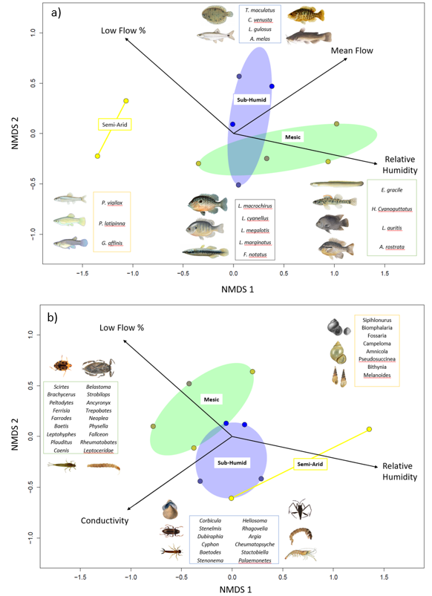

Figure 4. NMDS ordination of (a) fish and (b) invertebrate communities in ten coastal prairie streams in South Texas. Sites are grouped according to Annual Precipitation. Distances between sites are proportional to compositional differences in community. The explanatory power of environmental factors is indicated by the length and direction of the arrows. Labeled Illustrations indicate the location of various species within the ordination space.

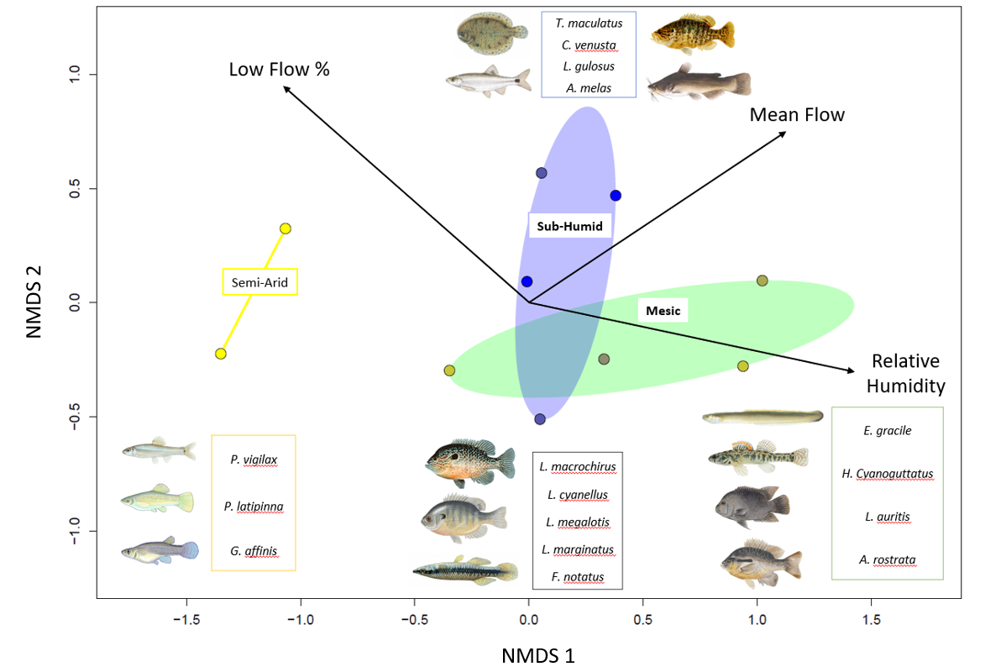

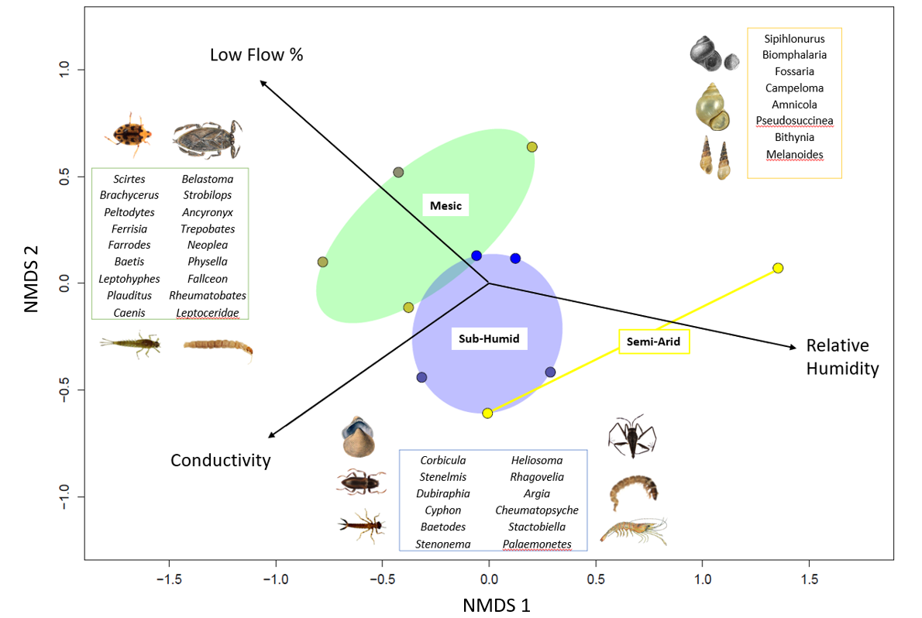

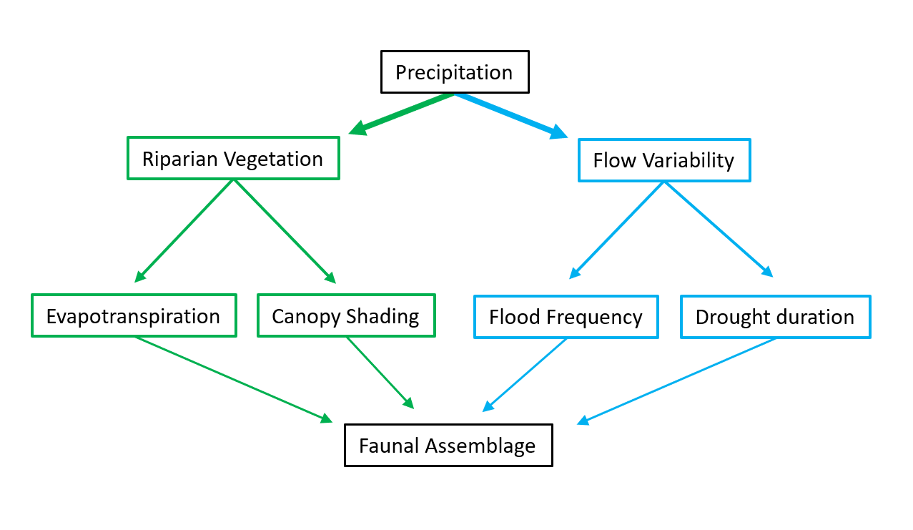

Figure 7. Concept model depicting how long-term precipitation regime drives stream assemblages directly through hydrological pathways and indirectly through riparian-mediated pathways.

|  |  |  |  |  |  |  |
| --- | --- | --- | --- | --- | --- | --- |
|  | ~~Precipitation (cm/yr)~~ | ~~Temperature (°C)~~ | ~~Elevation (m)~~ | ~~Drainage~~ | ~~Latitude~~ | ~~Longitude~~ |
| ~~8212300~~ | ~~61~~ | ~~22.1~~ | ~~18~~ | ~~1303.7~~ | ~~27.77253~~ | ~~-98.0336~~ |
| ~~8211900~~ | ~~70.96~~ | ~~22.1~~ | ~~61.6~~ | ~~1303.7~~ | ~~27.77253~~ | ~~-98.0336~~ |
| ~~8211520~~ | ~~81.78~~ | ~~22~~ | ~~4~~ | ~~227.5~~ | ~~27.71142~~ | ~~-97.5019~~ |
| ~~8189700~~ | ~~82.86~~ | ~~21.4~~ | ~~46.9~~ | ~~631.3~~ | ~~28.2825~~ | ~~-97.6208~~ |
| ~~8189300~~ | ~~83.72~~ | ~~21~~ | ~~56~~ | ~~527.3~~ | ~~28.48305~~ | ~~-97.6567~~ |
| ~~8177300~~ | ~~93.41~~ | ~~21.4~~ | ~~50~~ | ~~72.2~~ | ~~28.75166~~ | ~~-97.3172~~ |
| ~~8189200~~ | ~~97.48~~ | ~~21.6~~ | ~~8~~ | ~~159~~ | ~~28.30362~~ | ~~-97.1125~~ |
| ~~8189500~~ | ~~99.32~~ | ~~21.6~~ | ~~14~~ | ~~1808.3~~ | ~~28.29195~~ | ~~-97.2792~~ |
| ~~8164600~~ | ~~105.67~~ | ~~21.1~~ | ~~20.1~~ | ~~253.9~~ | ~~28.89138~~ | ~~-96.8191~~ |
| ~~8164800~~ | ~~108.1~~ | ~~21.2~~ | ~~8~~ | ~~172.2~~ | ~~28.72527~~ | ~~-96.7689~~ |
| ~~8115000~~ | ~~121.13~~ | ~~20.4~~ | ~~23~~ | ~~116.7~~ | ~~29.47663~~ | ~~-95.8127~~ |
| ~~8068390~~ | ~~125.17~~ | ~~19.8~~ | ~~41~~ | ~~40.2~~ | ~~30.19056~~ | ~~-95.4911~~ |
| ~~8068450~~ | ~~125.41~~ | ~~19.9~~ | ~~37~~ | ~~88.3~~ | ~~30.13105~~ | ~~-95.4813~~ |

~~Table 1. Descriptions of climate and geographic characteristics of the selected sample sites (Falcone 2011). Mean annual precipitation at the gauge location is calculated from an 800 m prism using a 30-year record (1971-2000). Note as precipitation increases, drainage area decreases to maintain similar stream hydrological classification.~~

Table 1. Climate and geographic characterisics of the sample sites

|  |  |  |  |  |  |  |
| --- | --- | --- | --- | --- | --- | --- |
| USGS Gauge | Precipitation (cm/yr) | Temperature (oC) | Elevation (m) | Drainge (km2) | Latitude | Longitude |
| 8212300 | 61 | 22.1 | 18 | 1303.7 | 27.77253 | -98.0336 |
| 8211900 | 70.96 | 22.1 | 61.6 | 1303.7 | 27.77253 | -98.0336 |
| 8211520 | 81.78 | 22 | 4 | 227.5 | 27.71142 | -97.5019 |
| 8189700 | 82.86 | 21.4 | 46.9 | 631.3 | 28.2825 | -97.6208 |
| 8189300 | 83.72 | 21 | 56 | 527.3 | 28.48305 | -97.6567 |
| 8177300 | 93.41 | 21.4 | 50 | 72.2 | 28.75166 | -97.3172 |
| 8189200 | 97.48 | 21.6 | 8 | 159 | 28.30362 | -97.1125 |
| 8189500 | 99.32 | 21.6 | 14 | 1808.3 | 28.29195 | -97.2792 |
| 8164600 | 105.67 | 21.1 | 20.1 | 253.9 | 28.89138 | -96.8191 |
| 8164800 | 108.1 | 21.2 | 8 | 172.2 | 28.72527 | -96.7689 |
| 8115000 | 121.13 | 20.4 | 23 | 116.7 | 29.47663 | -95.8127 |
| 8068390 | 125.17 | 19.8 | 41 | 40.2 | 30.19056 | -95.4911 |
| 8068450 | 125.41 | 19.9 | 37 | 88.3 | 30.13105 | -95.4813 |

|  |  |  |  |
| --- | --- | --- | --- |
| Abbreviation | Covariate | Units | Description |
| USGS.gauge | Station Identification | - | USGS Gauge Number associated with the nearest flow gauge |
| AP | Annual Precipitation | cm | Mean annual precipitation for the watershed, from 800m PRISM data. 30 years period of record 1971-2000 |
| Cnd | Conductivity | μS | Conductivity |
| DO | Dissolved Oxygen | mg/L | Dissolved oxygen |
| pH | pH | - | pH expressed in unitless log scale |
| Cpy | Canopy Cover | % | canopy density measured in the mid channel of the stream using a densiometer with 37 vertices |
| NH4 | Ammonia | mg/L | Ammonia concentration |
| NO3 | Nitrate | mg/L | Nitrate and nitrite concentration |
| flsh | flash index | - | Cumulatie changes in day to day daily flow / cumulative flow for a 20 year daily flow record |
| HFPP3 | High Flow Pulse Percent 3x | % | % of time daily flow is above 3 times the median daily flow |
| LFPP | Low Flow Pulse Percent | % | % of time where the daily discharge drops below the 25th percentile |

Table 2. displays the environmental covariates used throughout the statistical analysis. Annual precipitation is obtained directly from USGS GAGES II. Conductivity, dissolved oxygen, pH, canopy cover, NH4+, and nitrate values were obtained during field surveys in March and April of 2017. The flash index, high flow pulse percent 3x, and low flow pulse percent are calculated flow metrics which use the 20 year continuous flow record within the USGS GAGES II data set.

REFORMAT THIS TABLE TO MATCH THOSE ABOVE, lose the grid lines, shading, and use of bold. Also p in pvalue is always italicized.

|  |  |  |  |  |  |
| --- | --- | --- | --- | --- | --- |
| Dependent variable | Independent variable | Slope | Intercept | R2 | p-value |
| Fish Shannon Index | Annual Precipitation | 0.017271 | -0.335986 | 0.602 | 0.008336 |
| Fish Shannon Index | Log(Conductivity) | -0.6318 | 3.1111 | 0.4058 | 0.0476 |
| Fish Shannon Index | Canopy Coverage | -0.43929 | 1.666563 | 0.4662 | 0.02956 |
| Fish Shannon Index | Ammonia | -4.6474 | 1.8873 | 0.4451 | 0.03509 |
| Invertebrate Shannon Index | Annual Precipitation | -0.00302 | 3.005858 | 0.01736 | 0.7167 |
| Invertebrate Shannon Index | Dissolved Oxygen | -0.15653 | 3.8281 | 0.3627 | 0.06542 |
| Invertebrate Shannon Index | High Flow Pulse Percent 3x | -2.0832 | 3.2582 | 0.149 | 0.2705 |
| Invertebrate Shannon Index | pH | -0.5174 | 6.3977 | 0.2087 | 0.1844 |
| Invertebrate Shannon Index | Low Flow Pulse Percent | -0.03498 | 3.05718 | 0.4114 | 0.04563 |

Table 3. Univariate linear regressions correlate fish and macroinvertebrate Shannon diversities with environmental predictors. Fish Shannon index values have significant correlations with four environmental predictors (Annual Precipitation, conductivity, canopy coverage and NH4+ concentrations), while macroinvertebrate diversity has a singular significant correlation with low flow pulse percent.

|  |  |  |  |
| --- | --- | --- | --- |
| Model | R2 | p-value | AICc |
| Fish_Shannon ~ 0.054010 + (0.015598) AP - (0.0249) LFPP | 0.8175 | 0.002599 | 10.2 |
| Fish_Shannon ~ - 0.335986 + (0.017271) AP | 0.602 | 0.008336 | 12 |
| Fish_Shannon ~ 0.299779 + (0.013090) AP - (0.005809) Cpy | 0.7427 | 0.008642 | 13.6 |
| Fish_Shannon ~ 0.401516 + (0.013176) AP - (2.663321) NH4 | 0.7143 | 0.01246 | 14.7 |
| Invertebrate_Shannon ~ 3.95689 - (3.21078) HFPP3 - (0.04349) LFPP | 0.7411 | 0.008828 | 14.3 |
| Invertebrate_Shannon ~ 3.05718 - (0.03498) LFPP | 0.4114 | 0.04563 | 16.5 |
| Invertebrate_Shannon ~ 4.64023 - (0.10774) DO - (3.36722) HFPP3 - (0.03134) LFPP | 0.8592 | 0.00578 | 17.2 |
| Invertebrate_Shannon ~ 3.82810 - (0.15653) DO | 0.3627 | 0.06542 | 17.3 |

Table 4. Multivariate generalized linear models (GLM) for fish and macroinvertebrate Shannon index values. Top 4 AICc ranked models were selected. The top four fish diversity glms include annual precipitation as a positively correlated predictor. The top three Macroinvertebrate GLMs include low flow pulse percent (LFPP) as a negatively correlated predictor. R2 values reflect the multiple-R2 for each GLM.

**Cited Literature:**

Allen, M. R. and W. J. Ingram (2002). "Constraints on future changes in climate and the hydrologic cycle." Nature **419**(6903): 224-+.

Boulton, A. J., C. G. Peterson, N. B. Grimm and S. G. Fisher (1992). "Stability of an Aquatic Macroinvertebrate Community in a Multiyear Hydrologic Disturbance Regime." Ecology **73**(6): 2192-2207.

Chapman BR, B. E. (2018). The Natural History of Texas. College Station, Texas A&M University Press.

D'Amen, M., H. K. Mod, N. J. Gotelli and A. Guisan (2018). "Disentangling biotic interactions, environmental filters, and dispersal limitation as drivers of species co-occurrence." Ecography **41**(8): 1233-1244.

De Frenne, P., B. J. Graae, F. Rodriguez-Sanchez, A. Kolb, O. Chabrerie, G. Decocq, H. De Kort, A. De Schrijver, M. Diekmann, O. Eriksson, R. Gruwez, M. Hermy, J. Lenoir, J. Plue, D. A. Coomes and K. Verheyen (2013). "Latitudinal gradients as natural laboratories to infer species' responses to temperature." Journal of Ecology **101**(3): 784-795.

DL, R. (2001). "A Stream Channel Assessment Methodology; Proceedings of 7th Federal Interagency Sedimentation Conference." 26.

Falcone, J. (2011). GAGES-II: Geospatial Attributes of Gauges for Evaluating Streamflow. Reston, Virginia, U.S. Geological Survey.

Grimm, N. B., F. S. Chapin, B. Bierwagen, P. Gonzalez and P. M. Groffman (2013). "The impacts of climate change on ecosystem structure and function." Frontiers in ecology and the environment **11**(9): 474-482.

Held, I. M. and B. J. Soden (2006). "Robust responses of the hydrological cycle to global warming." Journal of Climate **19**(21): 5686-5699.

Hirabayashi, Y., S. Kanae, S. Emori, T. Oki and M. Kimoto (2008). "Global projections of changing risks of floods and droughts in a changing climate." Hydrological Sciences Journal **53**(4): 754-772.

Hubbs, C. (2008). An Annotated Checklist of the Freshwater Fishes of Texas, with Keys to Identification of Species. R. J. E. a. G. P. Garrett, Texas Academy of Science.

Hurlbert, S. (1971). "The nonconcept of species diversity: a critique and alternative parameters." Ecology **52**: 577-586.

IPCC ( 2018). Global Warming of 1.5°C.An IPCC Special Report on the impacts of global warming of 1.5°C above pre-industrial levels and related global greenhouse gas emission pathways, in the context of strengthening the global response to the threat of climate change,sustainable development, and efforts to eradicate poverty. Masson-Delmotte, P. Z. V., H.-O. Pörtner et al.

Kingston, D. G. and R. G. Taylor (2010). "Sources of uncertainty in climate change impacts on river discharge and groundwater in a headwater catchment of the Upper Nile Basin, Uganda." Hydrology and Earth System Sciences **14**(7): 1297-1308.

Kirby, D. F. and R. E. Knowlton (1976). "SALINITY TOLERANCE AND SODIUM BALANCE IN PRAWN PALAEMONETES-PUGIO HOLTHUIS." American Zoologist **16**(2): 240-240.

Kormos, P. R., C. H. Luce, S. J. Wenger and W. R. Berghuijs (2016). "Trends and sensitivities of low streamflow extremes to discharge timing and magnitude in Pacific Northwest mountain streams." Water Resources Research **52**(7): 4990-5007.

Koski, R. T. (1978). "AGE, GROWTH, AND MATURITY OF HOGCHOKER, TRINECTES-MACULATUS, IN HUDSON RIVER, NEW-YORK." Transactions of the American Fisheries Society **107**(3): 449-453.

Krumholz, L. A. (1948). "Reproduction in the Western Mosquitofish, Gambusia-Affinis-Affinis (Baird and Girard), and Its Use in Mosquito Control." Ecological Monographs **18**(1): 1-43.

Lamberti, H. (2007). Methods in Stream Ecology, Elsevier Inc.

Lupon, A., S. Bernal, S. Poblador, E. Marti and F. Sabater (2016). "The influence of riparian evapotranspiration on stream hydrology and nitrogen retention in a subhumid Mediterranean catchment." Hydrology and Earth System Sciences **20**(9): 3831-3842.

Merritt, R. W., K. W. Cummins and M. B. Berg (2019). An introduction to the Aquatic insects of North America. Dubuque, Iowa, Kendall/Hunt Pub. Co.

Oksanen, J., F. G. Blanchet, M. Friendly, R. Kindt, P. Legendre, D. McGlinn, P. R. Minchin, R. B. O'Hara, G. L. Simpson, P. Solymos, M. Henry, H. Stevens, E. Szoecs and H. Wagner (2019). "vegan: Community Ecology Package."

Olden, J. D. and N. L. Poff (2003). "Toward a mechanistic understanding and prediction of biotic homogenization." American Naturalist **162**(4): 442-460.

Patrick, C. J. and C. M. Swan (2011). "Reconstructing the assembly of a stream-insect metacommunity." Journal of the North American Benthological Society **30**(1): 259-272.

Patrick, C. J. and L. L. Yuan (2017). "Modeled hydrologic metrics show links between hydrology and the functional composition of stream assemblages." Ecological Applications **27**(5): 1605-1617.

Poff, N. L. (1997). "Landscape filters and species traits: Towards mechanistic understanding and prediction in stream ecology." Journal of the North American Benthological Society **16**(2): 391-409.

Rehage, J. S., J. R. Blanchard, R. E. Boucek, J. J. Lorenz and M. Robinson (2016). "Knocking back invasions: variable resistance and resilience to multiple cold spells in native vs. nonnative fishes." Ecosphere **7**(6): 13.

Reynolds, L., A. T. Herlihy, P. R. Kaufmann, S. V. Gregory and R. M. Hughes (2003). "Electrofishing effort requirements for assessing species richness and biotic integrity in western Oregon streams." North American Journal of Fisheries Management **23**(2): 450-461.

Ricklefs, R. E. and D. G. Jenkins (2011). "Biogeography and ecology: towards the integration of two disciplines." Philosophical Transactions of the Royal Society B-Biological Sciences **366**(1576): 2438-2448.

Satake, K. and R. Ueno (2013). "Distribution of freshwater macroinvertebrates in streams with dams and associated reservoirs on a subtropical oceanic island off southern Japan." Limnology **14**(2): 211-221.

Schade, J., S. G. Fisher, N. Grimm and J. A. Seddon (2001). The Influence of Riparian Shrub on Nitrogen Cycling in a Sonoran Desert Stream.

Seabra, R., D. S. Wethey, A. M. Santos and F. P. Lima (2015). "Understanding complex biogeographic responses to climate change." Scientific Reports **5**.

Shannon, C. E. (1948). "A Mathematical Theory of Communication." Bell System Technical Journal **27**(3): 379-423.

Tabacchi, E., L. Lambs, H. Guilloy, A. M. Planty-Tabacchi, E. Muller and H. Decamps (2000). "Impacts of riparian vegetation on hydrological processes." Hydrological Processes **14**(16-17): 2959-2976.

Tang, Q. H. and D. P. Lettenmaier (2012). "21st century runoff sensitivities of major global river basins." Geophysical Research Letters **39**.

Thomas C, B. T., Whiteside BG (2007). A Field Guide: Freshwater Fishes of Texas. College Station, Texas, Texas A&M University Press.

USGS. (2020). "USGS Water Data for USA." from <https://waterdata.usgs.gov/nwis>.

Ward, J. H. (1963). "HIERARCHICAL GROUPING TO OPTIMIZE AN OBJECTIVE FUNCTION." Journal of the American Statistical Association **58**(301): 236-&.

Wentworth, C. K. (1922). "A scale of grade and class terms for clastic sediments." Journal of Geology **30**(5): 377-392.

Whittaker, R. J., K. J. Willis and R. Field (2001). "Scale and species richness: towards a general, hierarchical theory of species diversity." Journal of Biogeography **28**(4): 453-470.

Wiggins, G. (2015). Larvae of the North American Caddisfly Genera (Trichoptera). University of Toronto Press, Scholarly Publishing Division.

Woodward, G., D. M. Perkins and L. E. Brown (2010). "Climate change and freshwater ecosystems: impacts across multiple levels of organization." Philosophical Transactions of the Royal Society B-Biological Sciences **365**(1549): 2093-2106.

Wrona, F. J., T. D. Prowse, J. D. Reist, J. E. Hobbie, L. M. J. Levesque and W. F. Vincent (2006). "Climate change effects on aquatic biota, ecosystem structure and function." Ambio **35**(7): 359-369.