Securing Mobile Devices Using Speech Biometrics

Anoop Bal and Sunil Kopparapu

Advanced Technology Applications Group, Tata Consultancy Services Limited, Yantra Park, Thane, Mumbai.

{anoop.bal, sunilkumar.kopparapu}@tcs.com

Abstract
Mobile devices are increasingly being used in day to day life by all strata of people. Mobile devices are getting smaller and available in all cost ranges. The effect of this is that the devices can be easily lost. Mobile device manufactures are coming up with novel biometric solutions to make mobile devices more secure. In this paper we propose the use of speech as a biometric to protect mobile devices. The idea is to activate the usage of mobile phone based on his speech characteristics. We describe the implementation of a speaker verification system on a mobile device. We also discuss the accuracy of the implemented speaker verification system.

Keywords: Speaker verification, Embedded system, speech signal processing, biometrics

1. Introduction

Mobile devices, which were earlier perceived as a luxury item, have now become indispensable in all sections of society because of their affordability and usage. With an explosive growth in number of mobile devices, the cases of their misutilization are also on the rise. As per estimates 700,000 phones are stolen each year [3]. With mobile phones getting more and more sophisticated and carrying lots of sensitive and personal data inside them, the extent of their abuse is also very high. A number of mechanisms that could help in protection of mobile devices have been conceived and introduced in the mobile devices. Things like PIN and passwords to authenticate the usage of the phone have been introduced by the mobile device manufacturers, they have the drawback of being hacked by an intruder or being forgotten by the genuine user. More recently mobile device with finger print biometric [8] and face recognition have been introduced. While the introduction of biometric based system to secure a phone is good the device themselves get very expensive. A very natural biometric is to use speech to authenticate the user of the phone. The advantage of such a system is that it is the most non-intrusive biometric that can be used for verification and additionally the phone does not get expensive and most phones have a sound recording option by default.

In this paper we describe the implementation of a speaker verification system for the mobile phones. The implementation is on the Binary Runtime Environment for Wireless (BREW) platform. In Section 2 we describe the speaker verification process and highlight both the training and the testing phase of speaker verification. In Section 3 we describe in brief the BREW environment and give details of the implementation. In Section 4 we explain the experimental results and conclude in Section 5.

2. Speaker Verification
A biometric verification process operates by verifying the claimed identity of an individual by means of his/her distinctive personal characteristics, such as face [9], fingerprint, iris, voice etc. The advantage of a biometric approach is that these characteristics are very difficult to duplicate or impersonate and can not be lost. Constructing a biometric feature set which is measurable, distinctive and robust is a non-trivial task. Figure 1 compares the characteristics of a few biometric systems. Observe that voice biometric [8] has pretty good accuracy and is among the easiest to use additionally it is the most non-intrusive.
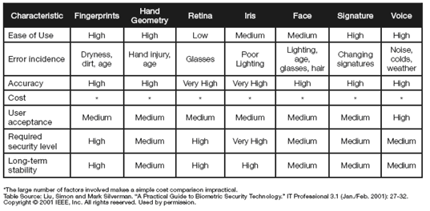
Figure 1: Biometrics at a glance.
The speaker verification task is different from the process of speaker identification. This is shown in Figure 3. Speaker verification tests the hypothesis that a certain individual X is the speaker of a given utterance (``Are you who you claim to be?'', viz., a test with two possible outcomes – yes or no), whereas a speaker identification system determines if the speaker of a given utterance is among a set of ‘n’ registered speakers or that he/she is an unregistered speaker (``Do I know you?'',’ n+1’ possible outcomes).

The conceptual differences also cause differences in accuracy, execution time, scalability and applicability between verification and identification. For identification both accuracy and execution time critically depend on the size of the set of registered speakers: the larger this set size, the lower accuracy and the longer the execution time. The verification process is not affected by the set size. Given this it is easy to see that verification systems are easy to scale up, whereas identification systems are not. In the rest of the section we will discuss the speaker verification process.

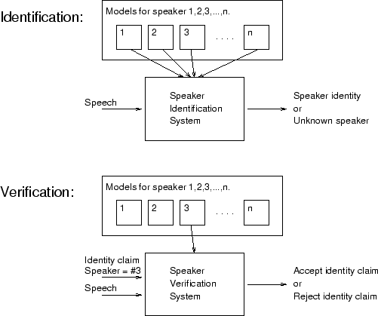
Figure 2: Speaker Identification versus Speaker Verification [8]

Speaker verification is the process of authenticating the claimed identity of a person based on his/her voice characteristics. Speaker verification systems are classified based on the type of speech sample used for the verification purpose. The text of the voice sample may be a fixed and predetermined (text dependent) or dynamically determined and prompted by the system. A user has to enroll with the system before he can be verified. The new user is given a unique identity number by which the system identifies him/her. The complete process of speaker verification is depicted in Figure 33. The system essentially works in two phases: (i) training phase and (ii) verification phase. Whenever a new user enrolls, the system operates in the training phase. In this phase, a model of the user’s voice is created based on the reference speech data (called training data) supplied by the user. When a user tries to gain access to a system subsequently, the system operates in the verification mode. In the verification mode, the person claims that the he is a registered user of the system and communicates the identity number. The registered user whose identity is claimed is called the target speaker. He/She also offers a voice sample as a proof of his/her identity. The system then verifies the authenticity of the claimed speaker by comparing the speech sample with his speech models (generated from reference speech in the training phase).

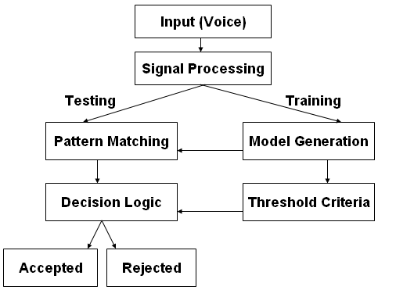
Figure 3: Speaker Verification Block Diagram

A text dependent speaker verification system requires a number of samples of a predefined spoken text (can be chosen by the user) as training data from the same speaker. The training data is used to estimate the model parameters. Speech data is usually modeled using hidden Markov models (HMM). Initially the speech data is segmented into smaller time segments (typically of 30 ms length) called frames. Prior to framing speech signal, the speech signal is passed through a pre-processing stage where the speech file is filtered through a pre-emphasis filter to take care of -6 dB/octave loss because of lip radiation. This is further subjected to smoothing (usually hamming window) to removed introduction of high frequency noise into the frame of the speech. From each frame speech parameters are extracted using signal processing techniques. For purpose of speaker verification the speech parameters used are Mel-Frequency Cepstral Coefficients (MFCC), Δ-MFCC, Δ²-MFCC. This parameterized speech frame is used to construct HMM. For each registered user there is a HMM constructed using his/her speech samples.

During the verification phase, the system computes a score by matching the test speech sample with the HMM of the target speaker. The closeness of the match determines the acceptance of the claim based on a threshold. The threshold is determined for each speaker separately and this speaker dependent threshold is decided during the enrollment phase based on the score of matching the training data with the speaker dependent model.

The performance of a speaker verification system is judged based on two types of errors. False rejection ratio (FRR) is the rejection of a genuine user due to poor match of test data with the genuine user model and false acceptance ratio (FAR) is the acceptance of claim by an imposter due to spurious match of the imposter voice with the model of the target speaker. Observe that these two are opposing in the sense that if the threshold is high, FRR will increase and if the threshold is low then FAR will increase. The acceptance threshold of a speaker verification system is set based on the system. A very secure system has a threshold so that FAR is close to zero while a slack system would have a threshold such that FAR is not necessarily zero (a few times a forgery goes undetected). The average of FAR and FRR is called equal error ratio. The performance of a speaker verification system is determined by how small the ERR is.

3. Implementation

BREW is an open environment based on the universally accepted C/C++ programming language. It is a complete, end-to-end solution for wireless applications development, device configuration, application distribution, and billing and payment for CDMA mobile phones. The BREW client software serves as a common denominator across all types and tiers of devices, from low-end, mass-market phones to high-end smart phones. The BREW client can act as an extended platform for other environments and allow any type of browser (HTML, WAP, cHTML, etc.) to run on BREW as an application. The BREW client’s flexibility is provided by extensions – allowing the software to accommodate established and emerging technologies.

BREW SDK (Software Development Kit) provides a platform where applications for mobile devices can be easily written on a familiar desktop (Personal Computer) environment before being ported to mobile devices. There are xxx components associated with the BREW SDK.

BREW stimulator (Figure 4) is a tool that helps in the software testing process. It emulates a mobile phone environment on a PC. This is a convenient method of testing a mobile application before actually testing it on to the mobile device.
.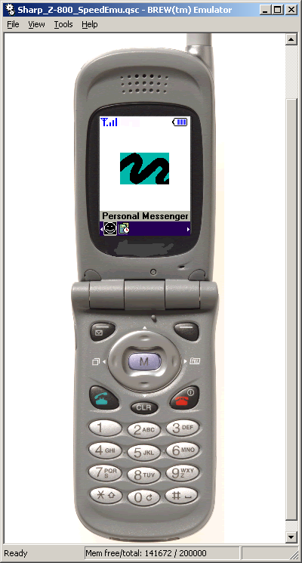
Figure 4: BREW Simulator
BREW Device configurator is a tool that helps in the configuration on the mobile phone emulator. We can specify the screen dimensions, the battery charge level and the network settings.

BREW Resource Editor (Error: Reference source not found) is an important tool that is used in the implementation process. It helps in the allocation of various resources that are required by the program to run successfully and efficiently. The main resources that are allocated through it are the pictures and the text strings that are used by the program.

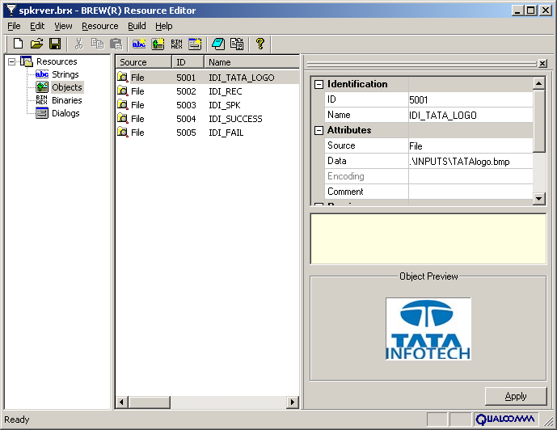
Figure 5: Resource Editor

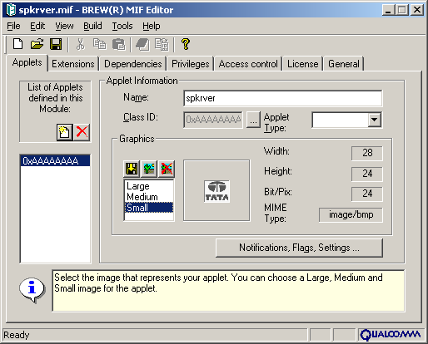
Figure 6: MIF Editor

BREW MIF editor is used during the implementation is the MIF editor (Error: Reference source not found).This tool is used to specify a unique identification number for the application. Details regarding the Privilege levels, License, Access control and General details are specified using the MIF editor. And along with this some pictures were also added to it which will act as application logos, when the application runs on the handset.

Interfaces Used in building Speaker Verification System

IMedia Interface represents an abstract base class for all BREW multimedia objects. It represents one type of multimedia format or a format played thorough a specific device. The BREW multimedia objects can contain a combination of audio, video, and karaoke text. The IMedia Interface provides facilities to play back, record, and perform play/record control functions like seek, stop, pause, resume, and so forth. Imedia supports several formats.
- IMediaMIDI - Handles playback of the standard MIDI format.
- IMediaMP3 - Handles playback of the MP3 format.
- IMediaQCP - Handles playback and recording of the QCP (Pure Voice) format.
- IMediaMIDIOutQCP - Handles playback of the QCP format through the MIDI out device.
- IMediaMIDIOutMsg - Renders MIDI messages directly to the MIDI out device.
- IMediaPMD - Handles playback of the PMD (Web Audio) format that contains, audio, video, and karaoke text.

IImage Interface is used for drawing bitmap images and displaying animated bitmaps to the screen. This interface supports bitmaps in the Windows Bitmap (BMP) format and may support a native bitmap formats specific to each device. Each instance of the IImage Interface is associated with a single bitmap image, which can be read in either from a resource file created with the BREW Resource Editor or directly from a file containing the bitmap. A call to IDISPLAY_Update() or IDISPLAY_UpdateEx() is required to update the screen. The default BREW environment provides the IIMAGE interface for the following image formats:

- PNG (Portable Network Graphics)
- WBMP
- JPEG
- Progressive JPEG
- BCI (Brew Compressed Image)

The process flow of the speaker verification system is shown in Figure 7. The application runs on a BREW enabled CDMA phone. When the mobile device goes into the lock mode, the application runs in the background. To activate the device, the application asks the user to speak into his handset after pressing a button to start the recording process. The application records the spoken voice and compares with a pre-existing HMM of the user. Based on the closeness of the match of the speaker’s voice and the reference HMM model – the application unlocks the mobile device for use when the match is made, else the mobile device stayed locked and unusable.
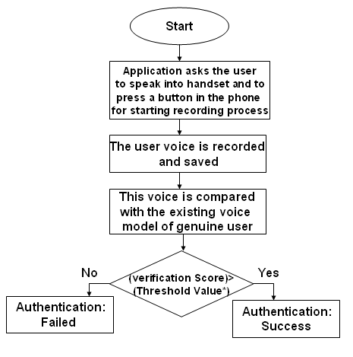
Figure 7: Process Flow

Threshold value (Figure 7) is the value (specified to the system by the developer) below which the authentication fails. For authentication to be successful the closeness measure between the test sample and the reference model should be greater than the threshold value.

4. Experiments
Several experiments were conducted to determine the performance of the speaker verification system. Speech data (30 utterances) was collected from a user. Of the 30 utterances, 20 utterances were used to build the reference HMM and the remaining 10 utterances were used to determine the FRR. Additionally, forged data was collected from four other users (assuming that the person forging was aware of the spoken phrase) and was tested with the HMM to determine the FAR. The results are tabulated in

Threshold | FAR | FRR
Low | 15% | 16%
Mid | 30% | 16%
High | 50% | 2%

5. Conclusions

We have described a speaker verification system to secure a mobile device. The speaker verification system has been implemented on a BREW platform which is an open platform on CDMA devices. The speaker verification system can be easily implemented on other mobile devices using J2ME. Experimental results show that the speaker verification system performs very well.

6. References
- Software Development for the Qualcomm BREW platform: By Ray Rischpater
- Inside COM: By Dale Rogerson
- http://www.halifax.co.uk/insurance/homeinsurance.shtml
- www.qualcomm.brew.com
- www.ispeak.nl
- www.comp.leeds.ac.uk
- www-agki.tzi.de
- http://mobile.softpedia.com/phones/Pantech/Pantech-PG-6200.shtml (accessed on Dec 13, 2006)
- http://ctl.ncsc.dni.us/biomet%20web/BMFacial.html (accessed on Dec 14, 2006)
- http://www.verizonbusiness.com/us/resources/whitepapers/pdf/BioSpeech.pdf

