OneClick: Do not Search the Search Engine

Sunil Kumar Kopparapu  Cognitive Systems Research Lab  Tata Consultancy Services Limited  Navi Mumbai  91-22-5616 3251  sunilkumar.kopparapu@tcs.com | Akhilesh Srivastava  Cognitive Systems Research Lab  Tata Consultancy Services Limited  Navi Mumbai  91-22-5616 3256  akhilesh.srivastava@tcs.com | PVS Rao  Cognitive Systems Research Lab  Tata Consultancy Services Limited  Navi Mumbai  91-22- 5613 5260  pvs.rao@tcs.com

ABSTRACT
The home page of a company is an effective way of show casing their offerings in general and their products and technology in particular. Companies put major effort, time and money in designing their web pages to enable their customers’ access information they are looking for as quickly and as easily as possible. In spite of all these efforts, it is not uncommon for a customer to spend a sizable amount of time trying to retrieve the particular information that he is looking for. Today, he has to go through several hyperlink clicks or manually search the search engine displayed pages to assimilate the information that he is looking for. There is also a good likelihood that the information sought does not exist. With increase in the number of users looking for some particular information about a particular company or product on the web it becomes necessary for a more convenient interface. In this paper we discuss, a system based on a set of Natural Language Processing (NLP) techniques which addresses this problem. The system enables a user to ask for information from a particular website in free style natural English. The NLP based system is able to respond to the query by understanding the intent of the query and then using its understanding to retrieve exact and accurate information from its unstructured info base or structured database before presenting it to the user. The interface avoids the user having to click through several hyperlinked pages and is called OneClick. The foundation of OneClick lies in its question understanding ability without parsing the query. The system is based on identifying key concepts and keywords and then using them to retrieve information. The no parse approach enables the use of OneClick framework to work with different input languages with minimal architectural changes. Further, the key concept-key word approach gives the system an inherent ability to give close answers in the absence of exact answers not being present in the information database or infobase.

Permission to make digital or hard copies of all or part of this work for personal or classroom use is granted without fee provided that copies are not made or distributed for profit or commercial advantage and that copies bear this notice. To copy otherwise, or republish, to post on servers or to redistribute to lists, requires prior specific permission and/or a fee.
TACTiCS – TCS Technical Architects’ Conference’06

INTRODUCTION
Web sites vary in the functions they perform but the baseline is dissemination of information. Companies put significant effort, time and money in designing their web pages to enable their customer’s to access information they are looking for as quickly and as easily as possible. In spite of these efforts, it is not uncommon for a customer to spend a sizable amount of time (hyperlink clicking and/or browsing) trying to retrieve the particular information that he is looking for. Until recently, web sites were a collection of disparate sections of information connected by hyperlinks. The user navigated through the pages by guessing and clicking the hyperlinks to get to the information of interest. More recently, a search engine, usually based on key word search strategy interconnects the disparate pages. The approach adopted is to give the visitor all the information he could possibly want about the company. This usually results in the user having to manually search through the information thrown back by the search engine (searching the search engine). If the user gets a huge hit list or no items found a few times he will probably not use the search facility or more probably leave searching for information. According to a recent survey [1] 82 percent of visitors to Internet sites use on-site search engines. Ensuring that the search engine has an interface that delivers precise, useful and actionable results for the user is critical to improving user satisfaction. In a web-browsing behavior study [6], it was found that none of the 60 participants equally divided into groups representing gender, age and browsing experience was able to complete all the 24 tasks assigned to them in a maximum of 5 minutes per task. In that specific study, users were given a rather well designed home page and specific information to find on a site. They were not allowed to use the site search engine. Participants were asked to complete common tasks such as finding an annual report, a non-electronic gift certificate, the price of a woman’s black belt or, more difficult, how to determine what size of clothes you should order for a man with specific dimensions. The Indian railway website [2], frequented by travelers, requires as many as nine hyperlink clicks to get the information about availability of seat between two valid stations [8].
To provide better user experience, a website should have provision to accept queries in natural language and in response provide (a) the user succinct information rather than show all the (un)related information or (b) necessitate too many interactions in terms of hyperlink clicks. Additionally the user should be given some expected answer in case either the query is incomplete or there is no exact response on the website. Experiments show that, irrespective of how well a website has been designed, on an average, a computer literate information seeker has to go through at least 4 clicks followed by a manual search of all the information retrieved by the search engine before the user gets to the information he is seeking.
Question Answering (QA) system [5][4][3], based on Natural Language Processing (NLP) techniques are capable of enhancing the user experience of the information seeker by removing the labor of clicks and manual search from the user. In effect, the system emulates the several clicks and manual search performed by the user to reach the answers in a single click. Systems using NLP are capable of understanding the intent of the query, in the semantic sense, and hence are able to fetch exact and crisp information related to the query.
In this paper, we describe a NLP based system framework which is capable of understanding and responding to questions posed to it in natural language. The system, built in-house, has been designed to give very precise and crisp information without parsing the query. The system determines the key concept – key word (KC-KW) from the query and uses them to fetch answers. This KC-KW framework enables (a) the system to fetch answers that are close to the query when exact answers are not present in the infobase and (b) gives it the ability to reuse the KC-KW framework architecture with minimal changes to work with other languages. In Section 2 we introduce QA systems and argue that the neither KW based system or a full parsing system are two ends of the spectra and impose a constraint that we can live without. We introduce our framework in Section 3 which does not parse the query followed by a detailed description of our approach. We conclude in Section 4.

Question Answering System
Question Answering (QA) systems are being increasingly used for information retrieval in several areas. QA systems are being proposed as 'intelligent' search engine that can act on a natural language query in lieu of the plain key word based search engines. While there are several QA systems in existence today, the common goal of most Question Answering (QA) systems is to (a) understand the query in natural language and (b) get a correct or an approximately correct answer in response to a query from a predefined infobase or a structured database.
In a very broad sense, QA system can be thought of as being a pattern matching system. The query in its original form (as framed by the user) is preprocessed and parameterized and made available to the system in a form that can be used to match the answer paragraphs. It is, however, assumed that the answers have also been preprocessed and parameterized in a similar fashion. The extracted parameters could be as simple as picking selective key words and/or key phrases from the query and then matching these with the selected key words and phrases extracted from the answer paragraphs. On the other hand it could be as complex as fully parsing the query, to identify the parts of speech of each word in the query, and then matching the parsed information with full parsed answer paragraphs. The preprocessing required would generally depend on the type of parameters being extracted. For instance, for a simple key words type parameter extraction, the preprocessing would involve removal of all words that are not key words while for a fully parsing system it could be retaining the punctuations and verifying the syntactic and semantic accuracy of the query.
Most QA systems take the approach of full parsing [5][4][3]to comprehend the query. While this is good (able to determine who killed who in a sentence like “Rama killed Ravana”) it is far from satisfactory in performance in practice because for accurate and consistent parsing the following is required
- The implemented parser, used by the QA system should know the rules of grammar
- Person writing the sentence (both query and answer paragraph) should know the rules of grammar
If either of the conditions fails, the QA system will not perform to satisfaction. While one can take care of the parser to follow the rules of grammar, it is far more constraining (impractical) to accept the same degree of grammar competence from a casual user of the system. Unless we make sure that the person querying the system is grammatically correct – the flawless parser could run into problem. For example
- a full sentence parser would take a grammatically incorrect constructed query from a user and give a sense to the whole sentence query. The analysis and hence the interpretation of the query by the system could be far from the query intent
- Parsing need not necessarily gives the correct or intended result. "Time flies like an arrow", is a well known example, which can be parsed in several ways, namely,
- time flies (funny critters,) like an arrow?
- time (as in space-time) flies like an arrow?
- time (as a verb) flies like an arrow? (time the flies, as if they were an arrow).
Full parsing is very difficult and we believe that it is not required in general for a QA system especially because we envisage the use of the QA system by
- large number of people who need not be necessarily grammatically correct all the time,
- people would wish to use casual/verbal grammar (intent is conveyed but from a purist angle the sentence construct is not correct).
Our approach is one of middle path, neither too simple not too complex and avoid parsing.

OUR APPROACH: OneClick
OneClick is a web enabled, state of the art intelligent question answering system capable of understanding and responding to questions posed to it in natural English. OneClick is driven by a set of core Natural Language Processing (NLP) modules. The system has been designed, keeping in mind that the average user visiting any web site works with the following constraints:
- the user has very little time, and doesn’t want to be constrained by how he can or can not quiz for information
- user is not grammatically correct all the time (would tend to use transactional grammar)
- a first time visitor, unaware of the organization of the web pages the user knows what he wants and would like to query as he would query any other human in natural English language.
Additionally, the system should
- be configurable to work with input in different languages
- in the absence of exact information he should be presented by information that is close to the information being sought
- allow for typos and misspelt words
The front end of OneClick, shown in Figure 1, is a question box on the web page of a website where the user can type his question in natural English. In response to the query, the system picks up specific paragraphs which are relevant to the query and displays them to the user.
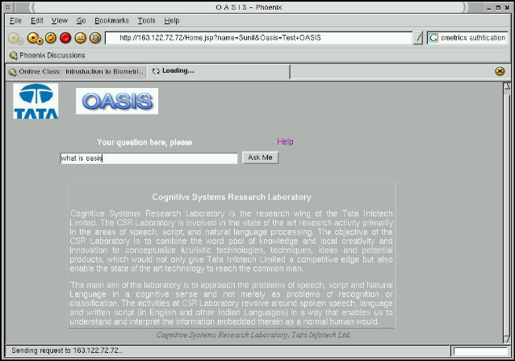
Figure 1: Screen Shot of OneClick system that is used to extract both database related queries and info base related queries accurately and swiftly.

Key Concept-Key Word Approach
The goal of our QA system is (a) to get a correct or an approximate correct answer in response to a query and (b) not to put any constraint on the user to construct syntactically perfect queries. This dictates that we choose an approach which is mid path – neither too simple not too complex. There is no one strategy envisaged – a combination of strategies based on heuristics, we believe work best for a practical QA system. The proposed QA system uses a middle path especially because the first approach (picking up key words) is very simplistic and could result in a high false answer fetching (false acceptance), the second approach, namely, the full parsing approach is complex, time consuming and could end up rejecting valid answers (false rejection), especially if the query is not well formed syntactically. The system is based on two types of parameters -- key words (KW) and key concepts (KC).
A KW is an important word (neither too frequently occurring nor too rarely occurring) that by themselves makes one paragraph different from other (Note that pronouns, connecting words, common words are not KWs because by themselves they don't differentiate one paragraph from another) and a KC is an extra important KW that holds the paragraph together. .For example, given the paragraph
I'll also send you the data that is now on a new ftp server which is accessible using the same user name and password.
The KW's in this paragraph are data, ftp_server, files, user_name, password, while the KC is send
Key Words are generally
- not general words,
- have high entropy and hence are able to distinguish one paragraph of information from another,
- help make more specific the choice of answers, or contain information which helps in narrowing the domain of search.

Key Concept has several interpretations. It can be considered as that word that holds the key to the central idea of a paragraph; if we changed the KC, most likely the central idea of the paragraph changes distinctly. Consider the following
Could I reserve a ticket to go to Bangalore from Mumbai by 2nd class in the first week of March in a train that start in the morning and reaches Bangalore before midnight the same day?
The KC here is reserve. Change the KC to, say, cancel and the whole meaning of the paragraph changes in a significant way. Incidentally, the KWs are ticket, Bangalore, Mumbai, 2nd class, first_week, March. KC can also be looked upon as a mathematical functional which relates other words (mostly KWs) to itself; if you change this functional word (KC), the total meaning of the whole paragraph is bound to change. Representational example,
KC₁ (KW₁, KW₂, KC₂ (KW₃, KW₄))
In most cases verbs in a query serve as KC because they hold the paragraph together. Examples reserve, activity, plan, manage etc
In our approach it is essential to identify KC because it helps in identifying the intent of the query, which in turn is crucial for any QA system. The concept of KC gives OneClick a significant edge over simplistic QA systems which are based on KWs only. Identifying KCs helps in better understanding the query and hence the system is able to answer the query more appropriately. A query in all likelihood will have but one KC but this need not be true with the KCs in the paragraph. If more than one key concept is present in a paragraph, one talks of hierarchy of key concepts. In this paper we will assume that there is only one KC in an answer paragraph. KCs together with KWs help in capturing the total intent of the query. This results in constraining the search and making the query very specific. For example,
reserve (place_from = Mumbai, place to=Bangalore, class=2nd)
makes the query more specific (exact) – ruling out the possibility of a reservation between Mumbai and Bangalore in 3rd AC for instance. In general, KC captures the intent and the KWs make the search domain more specific and help determine what specific information to seek or give.
One can think of a QA system based on KC and KW as one that would save the need to fully parse the query; this comes with a cost, namely, this could result in the system not being able to distinguish who killed who in a sentence “Rama killed Ravana”. The KC-KW based QA system would represent it as kill (Rama, Ravana) which can have two interpretations. But in general, this is not a huge issue unless there are two different paragraphs – the first paragraph describing about Rama killing Ravana and a second paragraph (very unlikely) describing Ravana killing Rama.

System Description
OneClick is driven by a question understanding module (see Figure 2) which not only identifies the intent of the question (by determining the KC in the query) but is also capable of checking the dimensionality syntax . The intent of the question (concept) along with one or several keywords is sent to the query generation module. As in any QA system, preprocessing of the query in the form of (a) removal of stop words and (b) spell checking for miss spelt words is done.
The query module, assisted by a powerful taxonomy tree, uses the information supplied by the question understanding module to specifically and concisely pick relevant paragraphs from with in the website. All paragraphs of information picked up by the query module as being appropriate to the query are then ranked in the decreasing order of relevance to the query. The first ranked paragraph is then displayed to the user along with a prelude (context sensitive generated by a prelude generator module) is displayed to the user. In the event an appropriate answer does not exist in the database or infobase, the query module is designed to fetch information most similar to the information sought by the user in the semantic sense. Such answers are prefixed by You were looking for ....., but I have found ... for you which is generated by the prelude generating module to suggest that the exact information that he is seeking is unavailable. In addition, OneClick boasts of having memory in the sense that it can relate questions in a session. This enables OneClick to ’complete’ a query (in case the query is incomplete) using the KC-KW derived from previous queries as reference.
The system has several individual modules as shown in Figure 2. At the heart of the system are the taxonomy tree and the infolet which is fine tuned to suit a particular domain. The taxonomy tree is essentially a structure which captures the relationship between different words. Typically, relation ships like synonyms, type of, part of are captured. The infolet is knowledge bank of the system and is manually engineered from the information available on the web site. The infobase essentially consists of information paragraphs (infolets) which are derived from the information that exists on the web page.

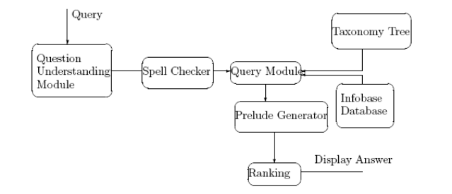
Figure 2: Module level description of OneClick system. The database and info base contain the content on the home page of the company.
The no parsing aspect of OneClick architecture gives it the ability to query the system in a different language (say Hindi) by just using a Hindi to English word dictionary. A front end in Hindi for querying the Indian Railway in natural language has been developed and demonstrated [8].

Examples
The OneClick platform has been used in several applications. Specifically, it has been used to disseminate information from a corporate website, a technical book, a fitness book, yellow pages information retrieval [10] and railway/airline information retrieval. OneClick is capable of addressing queries seeking information of various types.
Figure 3 captures the essential differences between the current search methods and the system using NLP in the context of a query related to an airline website. Queries like ”Is there a flight from Chicago or Seattle to London?” on a typical airline website would require a user to query the website for information about all the flights from Chicago to London and then query the website again to seek information on all the flights from Seattle to London. OneClick can do this in one shot and display all the flights from Chicago or Seattle to London (see Figure 3). Figure 4 and Figure 5 capture some of the questions the KC-KW based is typically able to take care.
A query like ”What are the facilities for passengers with restricted mobility?” today typically require a user to first click the navigation bar related to Products and services; then search for a link, say, On ground Services; browse through all the information on that page and pick out relevant information manually. OneClick it is capable of picking up and displaying only the relevant paragraph of information through a single click and give the correct answer, saving time of the user also saving the user the pain of seeing information that he is not looking for!
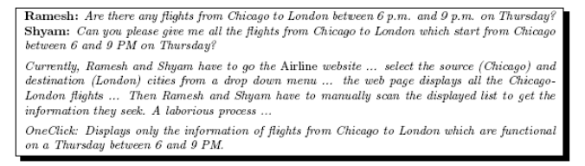
Figure 3: A typical session showing the usefulness of a NLP based information seeking tool against the current information seeking procedure.

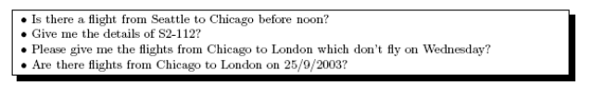
Figure 4: Some queries that OneClick can handle and save the user time and effort (reduced number of clicks)
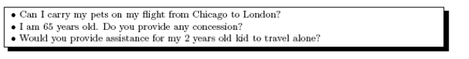
Figure 5: General queries that OneClick can handle and save the user manual search.

CONCLUSIONS
The home page of a company is a window to disseminate information to the user. While a lot of effort and money is spent in making the web pages browser friendly, it is not possible for an average user to get information from the web pages with out having to go through several clicks and manual search. Conventional search engines lack the ability to understand the intent of the query and hence flush out information based on keywords which might not be useful to the user; in addition the user needs to manually search the search engine results for the actual information he is in need. NLP techniques are capable of making information retrieval easy and purposeful. This paper describes a platform which is capable of making information retrieval human friendly. OneClick, built on NLP technology which enables a user to pose a query (the information he is looking for) in natural language(s). In addition it takes away the laborious job of manually clicking several tabs and manual search by presenting the use succinct information. The basic idea behind OneClick is to enable a first time visitor to a web page to fetch precise information without having to surf the web pages. A spell checker takes care of the typos and a prelude generating module gives the system a human like touch. The question understanding module is based on identification of KC-KW which aid in not only making the platform usable with queries in different languages but also helps in ascertaining if the query has all the prerequisite components. The KC-KW approach allows the user to be slack in terms of grammar and works optimally for even informal grammar (verbal/casual communication as against formal communication). The absence of a full sentence parser is not a constraint because in a limited domain (homepage of a company) the context is not ambiguous. A simplistic view of our approach can be summed as the process of template filling. The KC help in identifying the template while the KW fill in the slots. Like UNL, linkages between words, exist implicitly in our approach which are based on the dimensionality of the word of the KW. He proposed system based on NLP techniques is capable of enhancing user experience of the information seeker by removing the labor of hyperlink clicks and manual search. In effect, the system emulates the several clicks and manual search performed by the user.

ACKNOWLEDGMENTS
Our thanks are due to members of the Cognitive Systems Research Laboratory. Several of whom have been involved in developing prototypes to test OneClick, the question answering system in various domains.

REFERENCES
- http://www.coremetrics.com/solutions/on_site_search.html
- Indian Rail. http://www.indianrail.gov.in.
Eugene Agichtein, Steve Lawrence, and Luis Gravano. Learning search engine specific query transformations for question answering. In Proceedings of the Tenth International World Wide Web Conference. 2001.
- AskJeevs. http://www.ask.com
- AnswerBug. http://www.answerbug.com.
- START. http://start.csail.mit.edu/.
- WebCriteria. http://www.webcriteria.com.
- Sunil Kopparapu, Akhilesh Srivastava, PVS Rao KisanMitra: A Question Answering System For Rural Indian Farmers, International Conference on Emerging Applications of IT (EAIT 2006) Science City Kolkata, February 10-11, 2006.
- Sunil Koparapu, Akhilesh Srivastava, PVS Rao Building a Natural Language Interface for the Indian Railway website, NCIICT 06, Coimbatore, July 7-8, 2006.
- Sunil Koparapu, Akhilesh Srivastava, PVS Rao, Succinct Information Retrieval from Web, Whitepaper, Tata Infotech Limited (now Tata Consultancy Services Limited), 2004.
- S Kopparapu, A Srivastava, S Das, R Sinha, M Orkey, V Gupta, J Maheswary, PVS Rao Accessing Yellow Pages Directory Intelligently on a Mobile Phone Using SMS, MobiComNet 2004 Vellore

provided of course that the information is actually present on the web pages
currently available QA systems do a full parsing of the query to determine the intent of the query.
example, punctuation, connecting words, adjectives etc
the system assumes that the query is grammatically correct
In several systems it is important to construct a query is a particular format. In many SMS based information retrieval system there is a 3 alphabet code that has to be appended at the beginning of the query in addition to sending the KWs in a specific order.
In general, verbal communication (especially if one thinks of a speech interface to the QA system) uses informal grammar and most of the QA systems which use full parsing would fail.
in many cases it is a verb
a function of a function
part of speech
when several KCs are present in the paragraph then one KC is determined to be more important than another KC
Pattern to be searched
Dimensionality syntax check is performed by checking if a particular KC has KWs corresponding to an expected dimensionality. For example in a railway transaction scenario the KC reserve should be accompanied by 4 KWs where one KW had the dimensionality of class of travel, 1 KW has the dimensionality of date and 2 KWs have the dimensionality of location.
The dimensionality syntax check enables the system to quiz the user and enable the user to frame the question appropriately.
User can retrieve yellow pages information on the mobile phone. The user can send a free form text as the query (either as an SMS or through a BREW application on a CDMA phone) and receive answers on his phone.
Universal Networking Language uses linkages between words in a sentence to identify the intent of the query.

