Field of Innovation
This invention relates to the field of speech recognition and text to speech conversion.
This invention envisages a tool for automatic creation of a pronunciation lexicon independent of language for proper nouns. These proper nouns are typically names of persons, places.

Background
Text to Speech (TTS) synthesis is an automated encoding process which converts a sequence of symbols (text) conveying linguistic information, into an acoustic waveform (speech). A TTS transforms text into speech after generating a phonetic transcription from text as an intermediate step. Automatic G2P transcription is possible for phonetic transcription of non-proper nouns based on certain rules, but generating phonetic transcriptions of proper nouns, involves human endeavor.

In general, a one to one correspondence between the orthographic representation of a word and its pronunciation is absent more so for proper nouns. In this situation, the default ‘character to phone’ mapping which maps a sequence of characters into a sequence of phones has to be modified according to some predefined rules. The pronunciation lexicon is created by identifying a set of rules that modify the ‘default mapping’ of the characters based on the ‘context’ in which a particular phoneme occurs and is language dependent.

A general purpose rule set can not handle proper names. As a result a proper noun lexicon can not be generated using this set of rules. This requires manual effort to build a pronunciation lexicon. Thus there is a need for a tool for creating a lexicon for proper names automatically.

Objects of the invention
It is an object of this invention to provide a tool for creating a pronunciation lexicon.

Another object of the invention is to provide a pronunciation lexicon for proper names.

Yet another object of this invention is to provide a tool for creating a pronunciation lexicon which is automatic.

Further another object of this invention is to provide a tool for creating a pronunciation lexicon which is independent of language.

Yet one more object of this invention is to provide a tool which reduces the mundane task of transcribing proper names manually.

Summary of the Invention:

In accordance with this invention there is provided a tool for automatic generation of pronunciation lexicon, said tool comprising,

A basis having a set of words such that no word in basis can be constructed by joining one or more words in basis;

A database of proper nouns such that any entry in the said database can be constructed by joining a plurality of words from the basis;

Optimization means to keep the number of basis words used for constructing a name in said database is minimum; and

Means for joining plurality of basis words to form a phonetic transcription.

Brief Description of the Accompanying Drawings:
Fig 1 illustrates a high level view of the automatic pronunciation lexicon generator in accordance with this invention;

Fig 2 illustrates a graphical relation between size of basis |B| and the total number of joins |J| in accordance with this invention; and

Fig 3 illustrates the flow chart for the method in accordance with this invention.

Detailed Description of the Accompanying Drawings:

In accordance with this invention there is provided a tool for automatic generation of pronunciation lexicon for proper names.

Figure 1 shows a high level view of the present invention. The automatic pronunciation lexicon generator takes the proper names database as input and creates the pronunciation lexicon. The construction of the ‘Automatic Pronunciation lexicon creator’ is described as follows.

In vector algebra, among other things a basis is defined as a set of linearly independent vectors that can span the entire vector space. This definition of basis is used in the present invention. Here, the complete set of entries in the proper nouns database is the vector space while the basis is a set of words such that, one can construct an entry in the database by joining one or more words from the basis. Further, no word in the basis can be constructed by joining one or more words in the basis.

The invention optimizes the number of words in the basis such that the number of basis words used to construct a name in the database is the least. The optimizing scheme is described in further detail below.

Let N = {N₁, N₂, …, N_{|N|}} represent all the proper nouns in the database and let B = {b₁, b₂, …, b_{|B|}} denote the basis. The words in the basis are such that for every b_{k}B; b_{k} can not be expressed as b_{i}b_{j…} b_{l,} using any b_{i}, b_{j,}, b_{l} B and b_{k} ≠ b_{i,} or b_{j,} or b_{l}. Additionally, for any proper noun N_{p}N, one can write
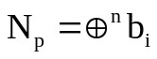 (1)
using n b_{i}s where b_{i}B. Equivalantly, N_{p} can be constructed by a join of n basis resulting in J_{p} = (n-1) joins. The total number of joins required to construct the entire database of |N| elements is
|J|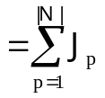 (2)
By formulating a cost function, the transcription problem reduces to one of minimizing the constructed cost function. The developed optimization framework helps in reducing the mundane task of transcribing proper names manually, to a very great extent. A typical plot of the number of elements in the basis |B| versus the total number of joins required to construct all the names in the database |J|, is shown in Figure 2. Two trivial cases of construction of pronunciation lexicon are shown as points A and B in Figure 2. Point A corresponds to the case where every element in the database is a basis and point B corresponds to the case where each alphabet in the proper noun is a basis, this results in a very large number of joins.

The present invention enables identification of the point C in Figure 2 such that the number of joins and the number of words in the basis is small together. The construction procedure is described below:

Let B_{init} be an initial basis. The basis is initialized by sorting the names in the descending order of the number of occurrences in the database and then picking up all the names whose frequency of occurrence is greater than k% (usually k=10) of the maximum frequency. An entry 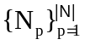in the database can, be completely represented by using some of the words in the basis as N_{p} = b_{i}b_{l}b_{m,} where b_{i,} b_{l,} b_{m} B_{init} (Case (a)) or be partially represented by using some words in the basis, namely, N_{p} = b_{i}n_{b}b_{m,} where b_{i,} b_{m} B_{init,} and n_{b} B_{init} (Case (b)). Case (b) requires the addition of n_{b} to the basis hence increasing size of the basis by 1, namely, |B_{init}|+1. The identification of an optimal basis set reduces to the minimization of a weighted sum of |B| and |J|. Namely,
C = γ |B| + β |J|
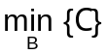 (3)
where γ + β = 1.

Figure 3 shows the fine granular procedure for the construction of the optimal basis set. The basis is initialized by sorting the names in the descending order of the number of occurrences in the database and then picking up all the names whose frequency of occurrence is greater than k% (usually k=10) of the maximum frequency.

For each name N_{p}N, a set B_{p} = {b_{p1}, b_{p2}, …, b_{|Bp|}} is formed such that B_{p}B and can completely or partially construct the N_{p}. If B_{p} is a null set then N_{p} is added to the basis. If B_{p} is not null, then the words in B_{p} may partially or completely construct N_{p} as shown in Equation (1).

If there are r different ways in which N_{p} can be constructed, then all the new words required by all the sequences and their frequency of occurrence are collected. The choice of one of the r sequences to represent N_{p} is one that satisfies cost function C_{pl}. where, LON is the number of alphabets in N_{p} and η_{joins} is the number of joins in the l^{th} sequence.

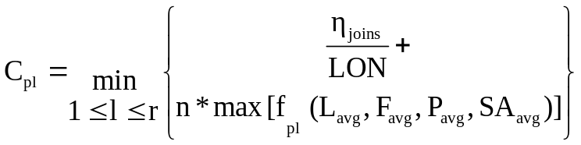

Further L_{avg} is the average length of the words in a sequence and is denoted as
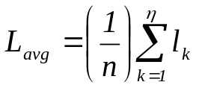

where l_{k} is the length of the k^{th} word s_{k} in N_{pl}. F_{avg} is the average frequency of occurrence of the new words in N_{pl} which can be denoted as

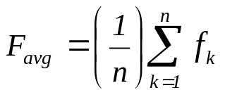

where f_{k} is the frequency of occurrence of s_{k} as a basis element, namely,

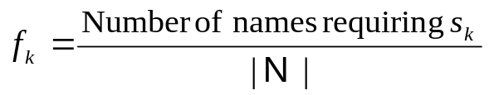

And P_{avg} is the average percentage of acceptance of the new words in the sequence N_{pl} and is given by
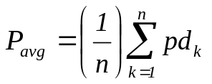

where p_{dk} is the ‘percentage demand’ of the word in all the r sequences, namely,

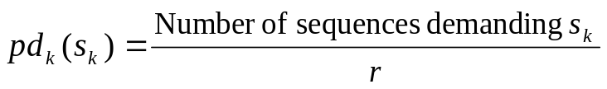

sa_{k} is a binary valued ‘Syntax rule acceptance’ attribute, which checks if the word s_{k} is syntactically acceptable (see Table)
sa_{k} = 1 if s_{k} follows the syntax rules
= 0 if it violates the syntax rules

SA_{avg} is the percentage of new words following the syntactic rules, namely,

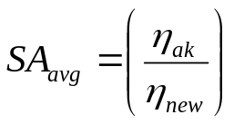

where η_{new} is the number of new words in the N_{pl} and η_{ak} is the number of new words following the syntactic rules.

The following table illustrates the Syntax Rules:

V denotes a vowel and C denotes a consonant.
- CC – reject: Consonants depend on the vowels for their pronunciation. So, the basis element cannot be a pure consonant sequence.
Examples: shashank – sha+sha+nk, shantanu – sha + nth + anu
- All the words which are pure consonant strings may be avoided. I other words, a basis element must have atleast one vowel. (Letters in bold represent the elements to be added to the basis)
- VC – OK
- CV – avoid
- VV – reject: Introducing a split between two vowels is also not reasonable, because most of the times, the combination of two vowel alphabets in English forms a diphthong. Apparently, they are two alphabets but their combination is a single sound.
Example: shailendra - sha + ilendra
- Introducing a split between sh, th, dh is also avoided – they are two characters but their combination is a single phone/sound
Example: bharati – bharat + hi

A typical form of the function f_{pl} (L_{avg}, F_{avg}, P_{avg}, SA_{avg}) takes the form

f_{pl} (L_{avg}, F_{avg}, P_{avg}, SA_{avg}) = λ_{l} L_{avg}+ λ_{f} F_{avg} + λ_{p} P_{avg +} λ_{s} SA_{avg} (5)

where λ_{l}, λ_{f}, λ_{p} and λ_{s} are the weightages assigned to L_{avg}, F_{avg}, P_{avg} and SA_{avg} respectively such that λ_{l} + λ_{f} + λ_{p +} λ_{s} = 1. The sequence which gives the minimum cost is selected and the new words, if any, present in the sequence, are appended to the basis (B_{m} in the Figure 3) if the new word to be added satisfies the basis condition (accomplished by two functions namely isBasis() and makeBasis() in Figure 3). This process is to be repeated for all the proper nouns in the database.
This process of constructing is repeated until no significant growth (ε) in the basis is observed in two successive iterations.

Advantages:
- An efficient, fast and automatic procedure for creating pronunciation lexicon for proper nouns
- Negates the manual effort in transcribing the proper names.
- The process assists in enabling text to speech synthesis system to spell proper nouns reliably and correctly.
- The transcription problem reduces to one of the minimizing the constructed cost function.
- The invention is not restricted to any particular language proper nouns.
- The proposed procedure is applicable for any database of proper nouns

While considerable emphasis has been placed herein on the specific structure of the preferred embodiment, it will be appreciated that many alterations can be made and that many modifications can be made in the preferred embodiment without departing from the principles of the invention. These and other changes in the preferred embodiment as well as other embodiments of the invention will be apparent to those skilled in the art from the disclosure herein, whereby it is to be distinctly understood that the foregoing descriptive matter is to be interpreted merely as illustrative of the invention and not as a limitation.

Dated this 7th day of August 2008

Mohan Dewan
Of R. K. Dewan & Co
Applicants’ Patent Attorneys

