Work Report: Experiments in Speaker Verification

Speaker verification has been in use as a biometric authentication system at the CSR Lab for more than 3 years. Several experiments were conducted to gain understanding on the quality, quantity and spread of training data required to construct statistical models in the speaker verification system. The results have been intuitive and give significant insight into what is the right training data to build a robust speaker verification system.

Usually, the train data is sanitized to weed out data that has noise or any other type of ambiguities (background speech, telephone rings) before training. Sanitization of training data requires manual verification of speech data and is time consuming and is subjective. Controlled experiments were conducted to see if the process of sanitization could be avoided. A raw training data set consisting of 90 samples (T_{original}) were used to train the speaker verification system, call it sv_{original}. A manual sanitization was done to weed out speech signals that were noisy and a reduced set T_{sanitized} was constructed, which consisted of 57 samples. T_{sanitized} samples were used to train the sv_{sanitized} system. The performance of both the system was almost same when tested on T_{sanitized} (see Figure I). As expected, the performance of sv_{sanitized}, sv_{original} differed widely when tested on the weeded out data (T_{original}– T_{sanitized}). Observe the wide variations in Figure II . In both Figure I and Figure II the y-axis represents the log probability score/distance of the speech sample from the model while the x-axis represents the speech sample.

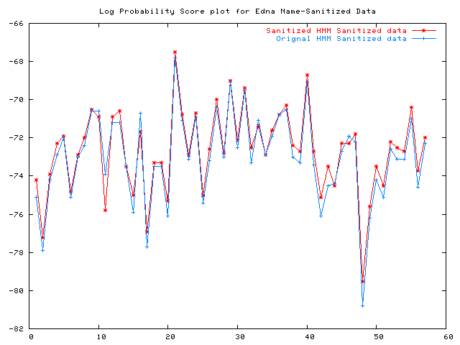
Figure I: Performance of system with sanitized train data. The performance of sv_{original} (blue) and sv_{sanitized} (red) on sanitized data is almost similar.
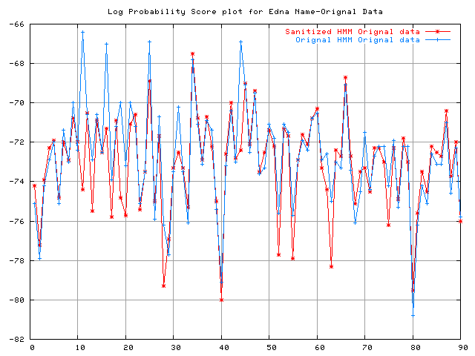
Figure II: Performance of system with raw train data. The performance of sv_{original} (blue) and sv_{sanitized} (red) on is significantly different on the weeded data.
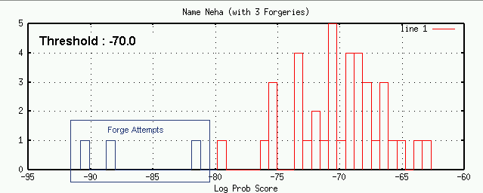
Figure III: Histogram plot of speaker verification system using train data collected over a period of time on genuine and forged samples. Clearly the forged samples are distinguishable by the system.

There is usually a debate on what should be the variability of train data. Is it sufficient for the user to speak differently within a single sitting in a day or is it really necessary to collect train data over a period of time (week or two) to obtain train data. The experimental results establish that it is sufficient to get data spread over a period of week. The speaker verification system was built using 20 speech data samples collected over a couple of days; at different times of the day. The system was tested on data (both forged and genuine) which was different from the train data set. Figure III shows the performance of the speaker verification system. The system is able to distinguish all the three forged samples from the 38 genuine samples (marked in blue). Further experiments need to be carried out to test the performance of the system for train data collected in a single sitting.

Acoustic environment play a major role in the performance of a speaker verification system. In this set of experiments, the train data was collected from environment₁ and the speaker verification system trained. The test data consisted of data from the original environment (the environment used for training the system, namely environment₁) and from a noisy environment₂. Clearly, the performance of the system on the data which came from a different environment (environment₂) has significant influence on the performance of the speaker verification system. Figure IV shows the change in the output of the speaker verification system for the speech samples from different acoustic environment (environment₂). The speech samples from different environment are to the right of the figure and have been boxed to show the distinction.

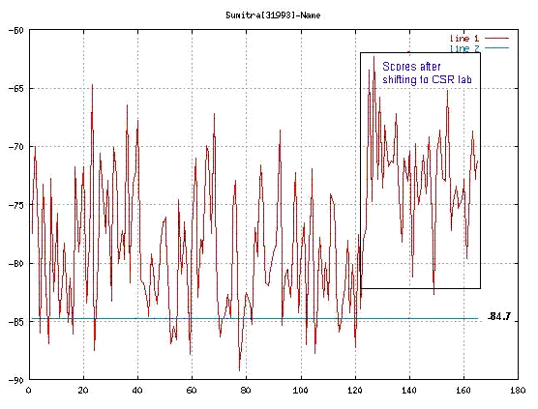
Figure IV: Performance of the speaker verification system under different acoustic conditions.

