Full Paper Format - Place the Title Here - The Title Should Take a Maximum of Three Lines only

First Author ¹, Second Author² and Third Author³

- Undergraduate Student, Department of Civil Engineering, University BDT College of Engineering, Davanagere 577004, India. Email: mnp@gmail.com

- Research Scholar, Department of Computer Science and Engineering, NITK Surathkal, Mangalore 575025, India. Email: xyz@nitk.edu.in

- Professor, Department of Mechanical Engineering, Kurume Institute of Technology, Kurume City, Japan. Email: xyz@gmail.com

ABSTRACT: Abstract should be very precise and clear. It is expected to cover the entire investigation/study. It can be of 10-15 lines maximum. Introduction and methodology of the study/investigation, analysis of results and conclusions must be included here in a simple and easily understandable manner.

Keywords: word1, word2, word3, word4, word5

INTRODUCTION
The format of the full paper will be according to the following instructions. Papers that do not meet the Symposium format will be returned to the author(s) for revision and re-submission. Delay in returning papers and failure of author(s) to meet the Symposium format may cause the papers not to be included in the symposium proceedings. You can replace our sample text in this document with the text of your own paper. However, we recommend that you keep a copy of the original version of this file for reference. Submitted papers should be a MAXIMUM of 10 pages in length. The papers should reach as MS-word files by naming the file with paper reference number given by the organizing committee.

DETAILS OF PAPER FORMATTING
Font: Verdana; Title of paper 16 (bold); author name: 10 (bold), affiliation 10; titles 10 (bold); text 10; 1-column format; single spacing. Margins one inch (2.54cm) on all sides.

PROCEDURE FOR WRITING THE PAPER
Running Text
Model running text is given in the following lines. Follow the same procedure for the preparation of running text all through out the paper.

Tables and Figures
Tables and Figures have to be referred inside the running text wherever required, (i.e. Figure 1, Table 1 etc). Tables and figures can be within the text or at the end (after references section). Figures can be in any colour but should be very clear. All tables and figures should be centre-aligned.

Equations
Equations have to be clearly typed using MS office equation editor and presented wherever required. Eq.1 is given in the following section. Numbering of equation can also be followed the manner given below.
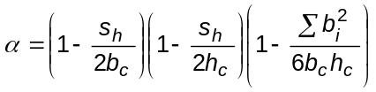 (1)

References inside the text
The references have to be referred by mentioning author’s name and year, for example, Grace et al (2004), Singh and Madappa (2008). At the references section, the references should be listed in alphabetical order.

CONCLUSIONS
The following conclusions are deduced from this study:
- Conclusion xxx.
- Conclusion yyy.

ACKNOWLEDGEMENTS

Acknowledgements, if any, are mentioned here.

REFERENCES
References should be given in alphabetical order. (font to be used: Verdana 8)
Grace, N F et al (2004), Flexural Response of CFRP Prestressed Highway Bridge Box-Beams, PCI JOURNAL, Vol. 49, No.1, pp. 92-104.
Singh S B and Madappa V R (2008), Flexural Capacity of Steel Reinforced ECC beams, Proc. 7th RILEM Symposium on Fiber Reinforced Concrete (BEFIB-2008), Chennai, India, September 17-19, pp. 495-500.
Terzaghi, K and Peck, R B, (1987), Soil Mechanics in Engineering Practice, 2nd ed., McGraw Hill, New York, pp.85-100.
Triantafillou, T C et al. (2006), Concrete Confinement with Textile-Reinforced Mortar Jackets, ACI Structural Journal, Vol.103, No.1, pp 28-37.

Table 1: Comparison of loads & Deflections
Analytical |  | Experimental
Peak load  (kN) | Midspan deflection  (mm) | Peak load  (kN) | Midspan deflection  (mm)
87 | 44 | 76.9 | 43.3
102 | 37.1 | 106.9 | 48.2

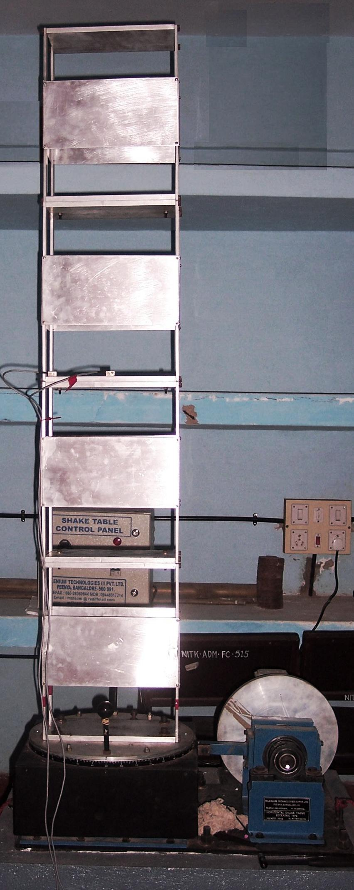
Figure 1: Four-storey building model

