Plain CasMVSNet → SP-RWCV → RAFE + SP-RWCV → Adaptive R2 → R2 + FGDR
实验 | 定位 | Batch | Epoch | 启用模块
Plain CasMVSNet | 基线 | 6 | 16 | 无新增模块
SP-RWCV | 源图权重 | 5 | 16 | SP-RWCV
R2-MVSNet | 当前主线 | 4 | 16 | RAFE + SP-RWCV
Adaptive R2 | 门控消融 | 4 | 16 | RAFE + SP-RWCV + difficulty gate
R2 + FGDR | 第三创新点 | 4 | 16 | RAFE + SP-RWCV + FGDR

实验 | 训练 depth loss | 验证 depth loss | 验证绝对误差 | >2 mm 外点率
Plain CasMVSNet | 3.193151 | 5.150146 | 5.504434 | 16.689%
SP-RWCV | 3.592288 | 5.162159 | 5.521039 | 17.114%
R2-MVSNet | 3.144027 | 5.212629 | 5.550101 | 16.085%
Adaptive R2 | 3.284841 | 5.114466 | 5.450547 | 16.171%
R2 + FGDR | 2.957699 | 4.807476 | 5.146103 | 15.864%

实验 | Accuracy | Completeness | Overall | 相对 baseline
Plain CasMVSNet | 0.334233 | 0.286015 | 0.310124 | +0.000000
SP-RWCV | 0.334978 | 0.278727 | 0.306852 | -0.003272
R2-MVSNet | 0.334543 | 0.277197 | 0.305870 | -0.004254
Adaptive R2 | 0.330682 | 0.283282 | 0.306982 | -0.003142
R2 + FGDR | 0.333778 | 0.277980 | 0.305879 | -0.004245

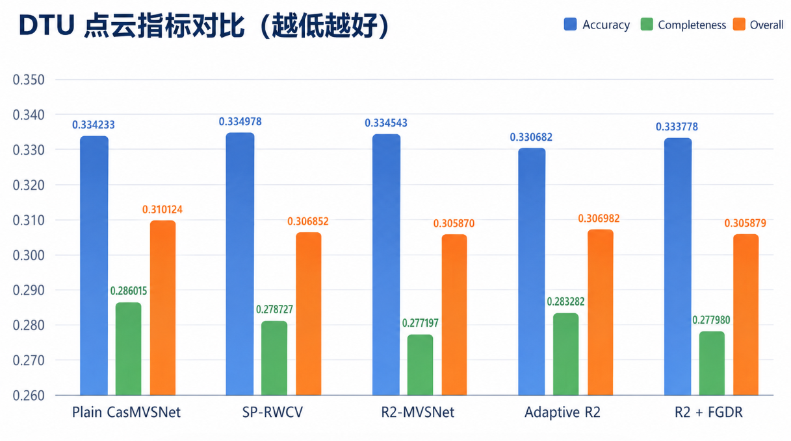
图 2 本地与官方 Overall 对比。

