**Team Project – 3rd Team**

**Requirement Specification**

**of AliExpress Live**

Nov. 1, 2018

**Team Members**

|  |  |
| --- | --- |
| **Name** | **Email** |
| Soolyun Kim | kimsuryeon@gmail.com |
| Dongmin Jang | ehdals338@gmail.com |
| Daegeun Choi | asdf123ggg@gmail.com |
| Minchang Choi | mraz.choi@gmail.com |
| Peiheng Lee | peihenglee1024@gmail.com |
| Yazhini Venugopal | yazhini.yazhl93@gmail.com |

**Revision History**

|  |  |  |  |
| --- | --- | --- | --- |
| **Version** | **Date** | **Author** | **Revisions** |
| 0.1 | 2018.10.18 | 3rd Team | Define requirements and User scenarios |
| 0.5 | 2018.10.25 | 3rd Team | Draw Use-case Diagram |
| 1.0 | 2018.10.30 | 3rd Team | Finish Entire Section |

**Table of Contents**

1. Introduction 3

1.1. System of interest 3

2. System Architecture 5

2.1. Architecture of *AliExpress Live* (Early version) 5

3. System Functionalities 6

3.1. User Scenarios 6

3.2. Actor Extraction 9

3.3. Use-case Diagram 10

3.4. Function Descriptions 11

3.5. Relationship Among Components 16

4. System Behavior 17

4.1. Proxy Behavior 17

4.2. Payment Procedure 17

5. Non-functional Requirements 18

5.1. Quality Attribute Scenarios 18

5.2. Priority of Each Non-Functional Requirements 19

6. System Constraints 20

1. Introduction

This section briefly describes the target system including a description of the technical terms to be used in the future.

* 1. System of interest

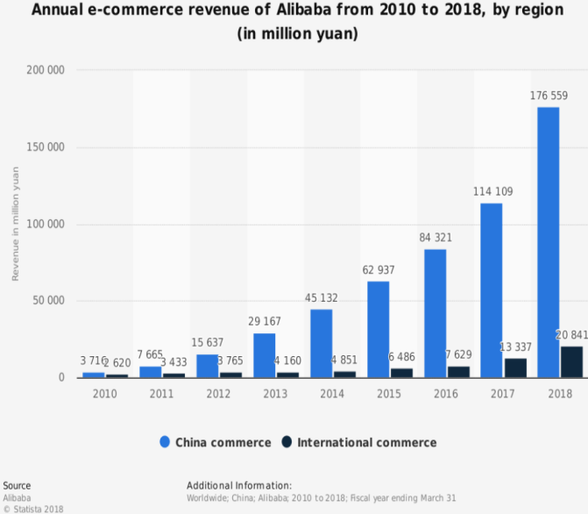Due to the influence of the globalization era, there are many systems and platforms that can be purchased on the other side of the globe. Most of these systems are to purchase goods directly from foreign countries through Internet shopping malls. The representative system, AliExpress, is a B2C (Business to Consumer) site created by Alibaba Group, a Chinese Internet company in 2010. As of 2017, more than 100 million overseas customers are using it, and 20~30s are seen to use it a lot.

Figure 1. Annual e-commerce revenue of Alibaba from 2010 to 2018(in million yuan)

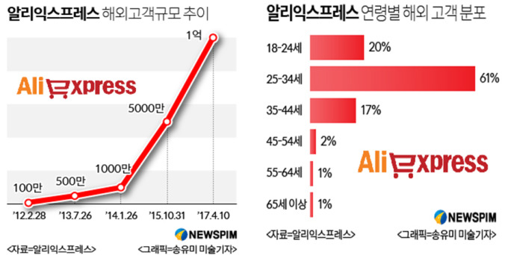

Figure 2. AliExpress 고객 수와 연령별 분포

The representative service of AliExpress is a live commerce system, which enables live video streaming to enable buyers to interact with and order from sellers in real time, and is a live broadcasting system for merchandise sales. The advantage of live streaming is that it is an introduction to live products, so users may have an immediacy to get the desired product information instantly. The buyer can solve the question of the product by asking the seller about the durability test and the wearing of the clothes. Even after the live streaming is finished, even if the buyer does not watch live while uploading the live video to the seller's store, he can check the product information while watching the uploaded video.

The seller of AliExpress can be a company or an individual, and the buyer can confirm the reliability of the seller with the seller rating.

1. System Architecture

This section describes architecture of entire system.

* 1. Architecture of *AliExpress Live* (Early version)

*AliExpress Live* has two types of server which are ‘Web Server’ and ‘Streaming Server’. The Web Server provides typical functions of online-shop. It manages information of products and payment transactions.

The ‘Streaming Server’ is only dedicated for video streams. It is physically separated from the Web Server because it needs to handles large sized multi-media. The data can be temporarily cached to proxy servers for providing better user experience.

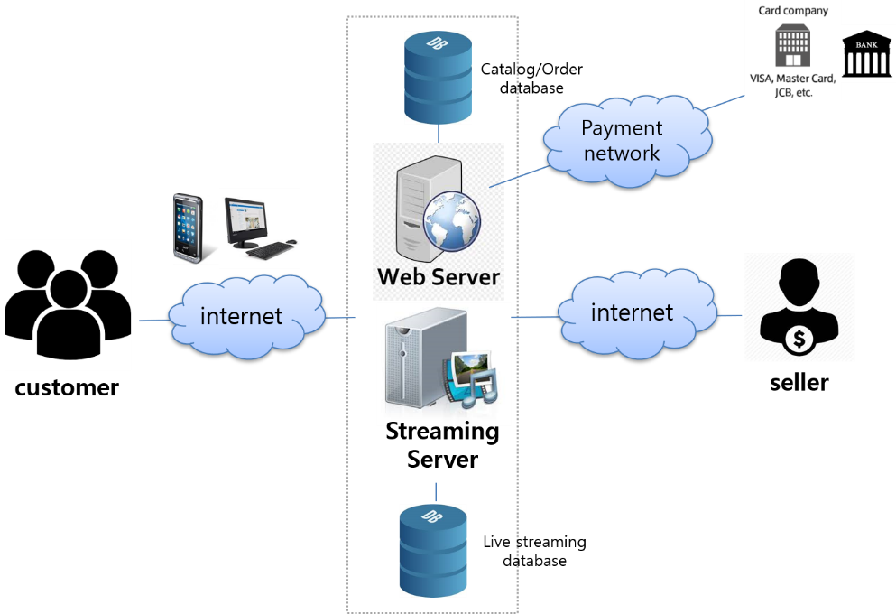

Figure 3. System Overview

* 1. Context of System

Internal and external systems which communicate with *AliExpress Live* is described in below system context diagram.

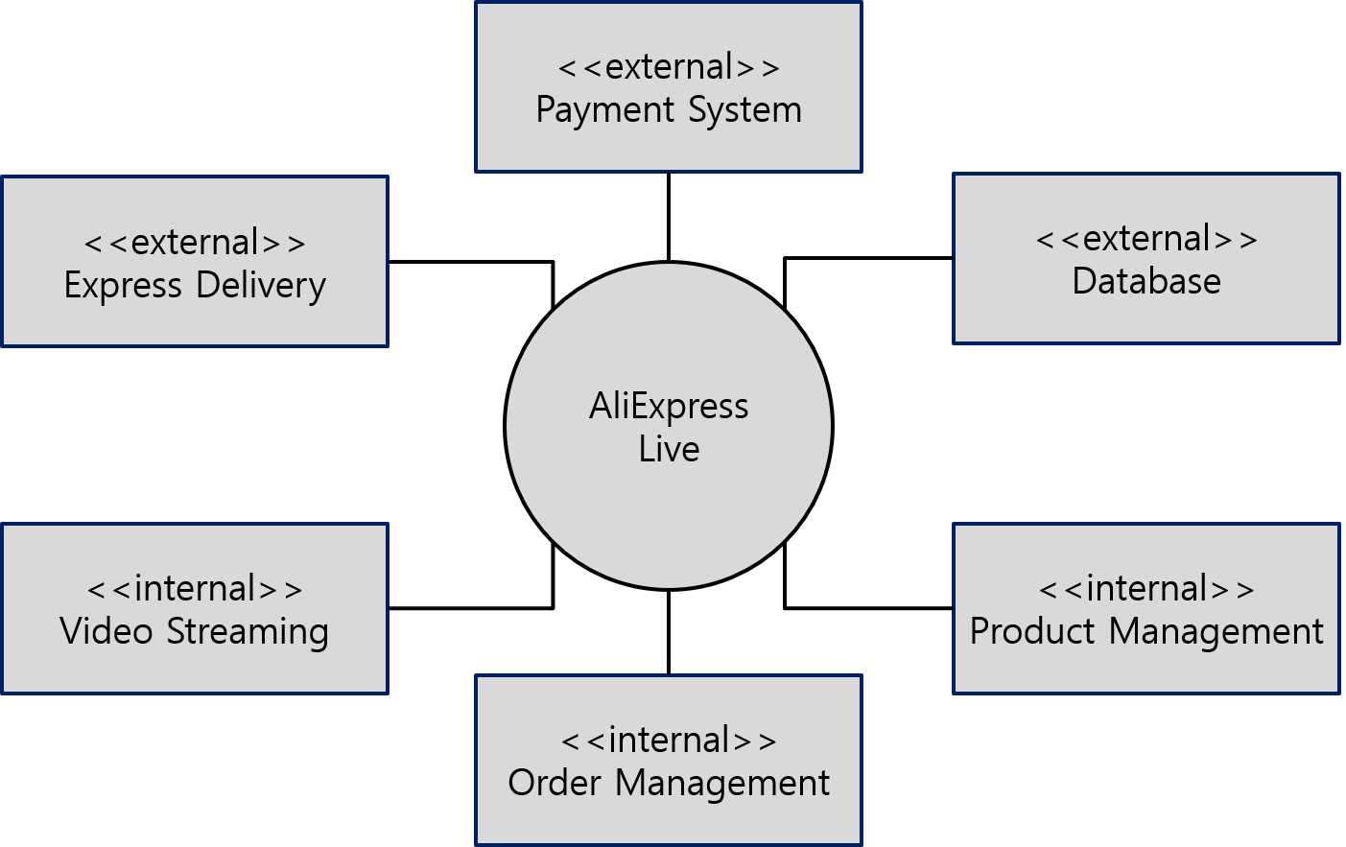

|  |  |
| --- | --- |
| System | Description |
| Payment System | An external system which handles payment transactions |
| Express Delivery | An external system which delivers item selling in *AliExpress Live* |
| Database | An external system which stores every kind of data |
| Video Streaming | An internal system dedicated for managing video streaming service |
| Product Management | An internal system which manages products selling in *AliExpress Live* |
| Order Management | An internal system which manages orders and stores history |

1. System Functionalities

This section defines functions of the system, where a function is described as a specification of behavior between inputs and outputs.

* 1. User Scenarios

1. Customer who wants to use *AliExpress Live* will visit the *AliExpress Live* website.
   1. If the customer is an *AliExpress* member, he/she can login the account.
      1. Customer provides the necessary information to log in.
      2. Web server confirms the login information entered by the client.
   2. If the customer does not have an account, he/she creates an AliExpress account and becomes the member.
      1. Customer provides the personal details by entering a membership application form of the website.
      2. Web server creates a new account with application form, then customer record is created and maintained in web cache.
   3. Customer is allowed to modify his/her account information.
2. A list of stores which currently being broadcasted/to be broadcasted can be viewed from the webpage.
3. When browsing the broadcast schedule page, customer can confirm the future time schedule.
   1. The broadcast schedules can be viewed, not only 3 days before but also 2 weeks later based on the current time.
4. Customer can browse the watch history which has been recorded in the recommended replay page.
   1. It’s available to view the replay by sorting them in the latest/ the most popular way.
   2. On the replay page, a list of each broadcasts’ Best popular product is displayed
5. When the customer clicks on the Live store, it will go to the broadcast webpage. The video window is put at the top of the broadcast page; Use case 01. Watch video
   1. A link which registered for the store and the details of product have been shown at the bottom of the broadcast page.
   2. Customers can share the video or store information via share button (QR link, SNS, etc.) Use case 02. Share video
   3. Customer can be allowed to post comments, like the video, and follow the store after he/she login to the website

Use case 03. Click like button, Use case 04. Live comment

Use case 06. Follow channel

* 1. Customer should be able to view the number of viewers that are watching the video. Use case 05. View number of viewers
  2. When watch ongoing video, customer is allowed to post comments with each other
  3. If customer likes the broadcast, he/she can give positive feedback (such as click like button). Use case 03. Click like button
  4. Coupons are provided when customer watching the live streaming
  5. Customer is allowed to follow any available store.
  6. If the customer wants to order the product, he/she can turn to the payment page by clicking the product

1. Customer is able to view both the whole broadcast list and the lists in different languages.
   1. Extra information can be found when customer scrolls down the broadcast list.

Use case 07. Browse channels

1. The detailed information of products is confirmed on the purchase page.
   1. The name, grade, options as well as transport information of the product can be confirmed obviously.
   2. Also, customer can double check the product details, evaluations, transport payment information and seller warranty information through the purchase page.
   3. The transaction history will be listed in the most recent order and the related products will be shown as well.
   4. Customer selects the quantity of the product, puts the product into the shopping cart or makes payment immediately. Use case 14. Checkout payment
      1. If customer puts the product in shopping cart, he/she can check it out in the shopping cart. Use case 11. Add item to cart
      2. If customer makes purchase immediately, the express information and payment can be performed clearly. Use case 12. Buy item now
2. Customer can move the products to wish list. Use case 13. Add item to wish list
   1. Customer is allowed to access lists from the wish list page
3. When customer clicks on the store ongoing to provide video streaming, the customer goes to the broadcast page, which displays an image with a broadcast announcement (including the broadcast date) instead of the broadcast video.
   1. In the first case, customer can receive a live broadcast notification of the broadcast if he/she press the reminder button.
   2. In another case, if customer follows the store, he/she will receive all notifications from the store.
      1. For the above two cases, AliExpress live system will notifies the customer.
   3. As introduced above, the live streaming page, links of products, and product listings are available for confirmation.
4. When customer clicks the replay button, he/she will go to the replay broadcast page. Familiar functions have been provided as the broadcasting page, except posting comments online.
   1. Actor Extraction

The actors got extracted from user scenarios as below table.

|  |  |
| --- | --- |
| Actor | Description |
| Customer | A user of system who purchases products. |
| Seller | A user of system who sells products. |
| Payment System | An external system which handles payment. |

* 1. Use-case Diagram

The following use-case diagrams show the whole functionality of the target system. It is specified with including actors, use-cases and their relationships.

* Watch / browse live channels

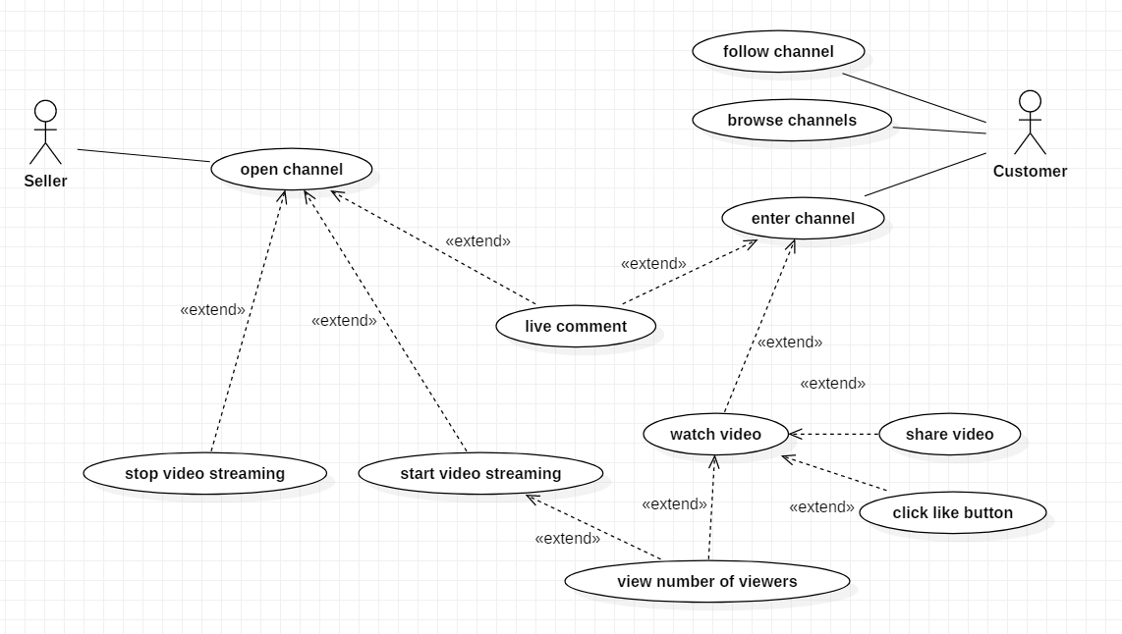

* Order products

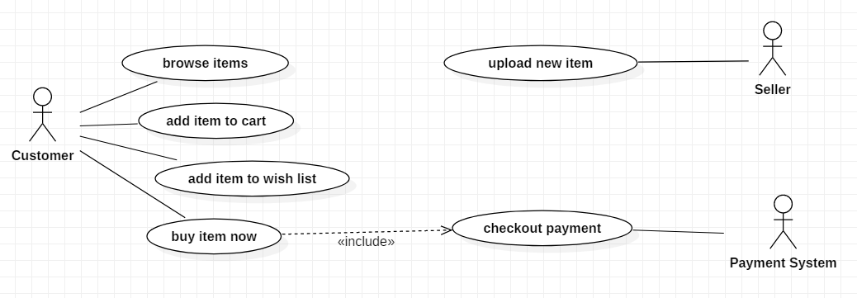

* 1. Function Descriptions
* Watch / browse channels

|  |  |
| --- | --- |
| Function name | 1. **Watch video** |
| Definition | Customers open any channel to watch live streaming. If the channel has ongoing live video, it will be displayed to the customer. Customer can click on the video to watch it |
| Input | Customer opens a channel and click on the video to watch it |
| Output | Any ongoing to live available in the store channel will be displayed on top and customer can watch it. |
| Process | Login to the website and open the ongoing live stream to watch. If there is any live available, it will be displayed. |
| Conditions | 1. Store must have ongoing or already ended video. |

|  |  |
| --- | --- |
| Function name | 1. **Share video** |
| Definition | Customers open any channel to watch live streaming. They are allowed to share the video through other SNS applications. |
| Input | While watching the video customer clicks the share button |
| Output | List of SNS app link will be displayed where customer can share video through any available app. |
| Process | Login to the website and open the ongoing live stream to watch. Clicking on share button will fetch list of available SNS link from DB and display it to the customer. |
| Conditions | 1. Store must have ongoing video. |

|  |  |
| --- | --- |
| Function name | 1. **Click like button** |
| Definition | Customers should be allowed to like the video during live streaming. |
| Input | When watching ongoing live, customer clicks the like button. |
| Output | Likes given during live should be displayed at the bottom of the video screen along with the total like count |
| Process | Login to the website and open the ongoing live stream to watch. Click like button near by the comment section. Every click the like count will be increased. |
| Conditions | 1. Like button should be available only for ongoing videos 2. During live, user can like video as many times as they can but after live it is not possible. |

|  |  |
| --- | --- |
| Function name | 1. **Live comment** |
| Definition | Customers should be allowed to comment during live streaming. |
| Input | When watching ongoing live, customers are allowed to post comments. |
| Output | Comments posted during live will be displayed at the bottom of the video screen -> comment section |
| Process | Login to the website and open the ongoing live stream to watch. Post comments in the comment section. It will be displayed in the video. |
| Conditions | 1. Live comment should be available only for ongoing videos 2. During live, user can post as many comment as they can but after live it is not possible |

|  |  |
| --- | --- |
| Function name | 1. **View number of viewers** |
| Definition | Customers should be able to view number of viewers that are watching the video. |
| Input | Customer watches Ongoing or already ended video |
| Output | When watching ongoing live, customer should be able to see current viewer count. In case of watching already ended video, the highest viewer counting should be available to view. |
| Process | Login to the website and open the ongoing or already ended live stream to watch. At the top of the video window customer can view the total number of viewers count. For ongoing video the viewer count is dynamic. |
| Conditions | 1. Video should be ongoing or already ended |

|  |  |
| --- | --- |
| Function name | 1. **Follow channel** |
| Definition | Customers open *AliExpress Live* and able to follow any available shop. |
| Input | Customer clicks 'Follow' button next to the store name. |
| Output | Customer will be receiving shop's upcoming activities and deals. |
| Process | Login to the website and open the store and click follow button. Customer will be added to the store members DB and will be receiving updates on store. |
| Conditions | 1. Customer should be logged in. In other words, guest users are not allowed to follow the store. |

|  |  |
| --- | --- |
| Function name | 1. **Browse channel** |
| Definition | Customer should be allowed to browse currently open or incoming channels |
| Input | Customer reaches to main page. |
| Output | Recent channel list should be shown. |
| Process | Enters to main page. |
| Conditions | 1. User reaches to main page |

* Order products

|  |  |
| --- | --- |
| Function name | **11. Add item to cart** |
| Definition | Customer can add products to shopping cart from product detail information page. |
| Input | Click the “Add to Cart” button. |
| Output | Customer reaches to shopping cart page. |
| Process | Click “Add to Cart” from the page and customer reaches to shopping cart page. |
| Conditions | 1. Customer should be in product detail page. |

|  |  |
| --- | --- |
| Function name | **12. Buy item now** |
| Definition | Customer can buy products immediately from product detail information page. |
| Input | Click the “Buy Now” button. |
| Output | Customer reaches to order page. |
| Process | Click the “Buy Now” from the page and customer reaches to order page. |
| Conditions | 1. Customer should be in product detail page. |

|  |  |
| --- | --- |
| Function name | **13. Add item to wish list** |
| Definition | Customer can add products to wish list from product detail information page. |
| Input | Click the “Add to Wish List” button. |
| Output | Customer reaches to wish list page. |
| Process | Click the “Add to Wish List” button from the page. Then customer can reach to wish list page. |
| Conditions | 1. Customer should be in product detail page. |

|  |  |
| --- | --- |
| Function name | **14. Checkout payment** |
| Definition | Customer can make order and pay the price finally through checkout payment. |
| Input | Customer enters his or her private information like card holder information, bank information. |
| Output | Send it to the payment system to approve payment. |
| Process | Customer enters his or her payment information and then click “Place Order” button. Payment information will send to the payment system to approve/reject payment. |
| Conditions | 1. Customer should be in order page. 2. Customer should have his or her own payment information. |

* 1. Relationship Among Components

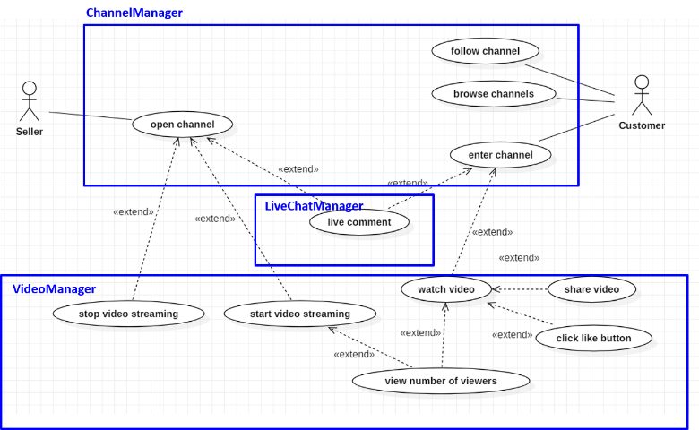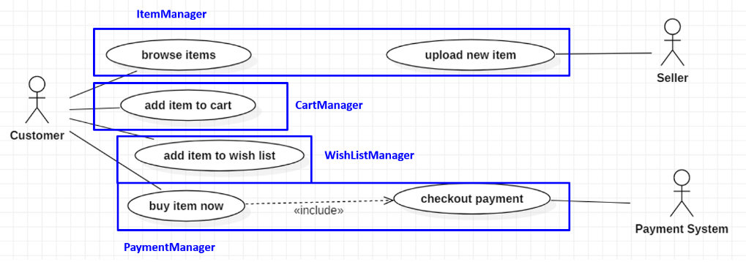

Several components are derived from use-cases. The relationship among components is described in following component diagram.

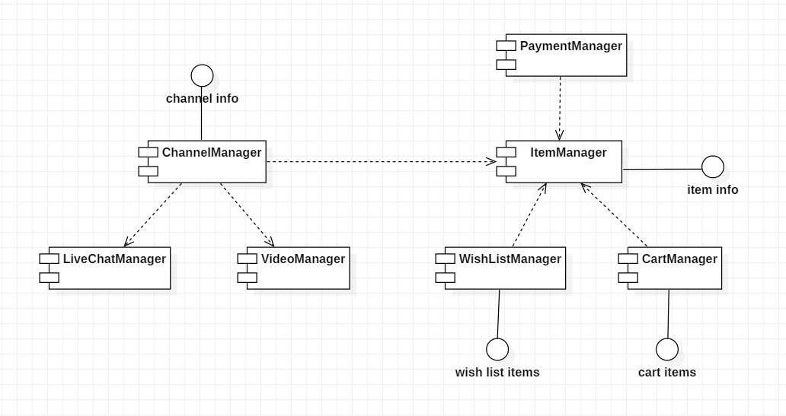

1. System Behavior
   1. Purchase Procedure

Payment is most important function in *AliExpress Live* because it is directly affect to customer’s money. So payment procedure should be handled safely and it should be able to be rejected when the payment system notifies it was failed.

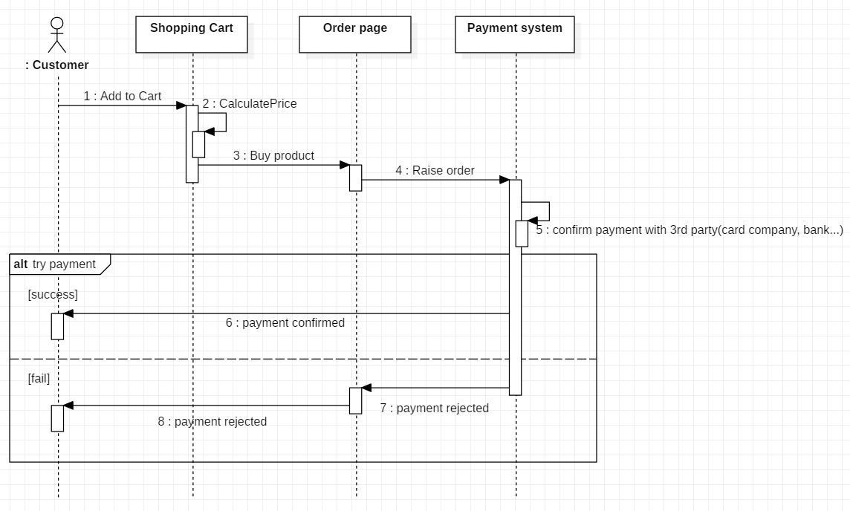

* 1. Live Comment Broadcasting

A user can enter comment while the channel is on air and the comment gets broadcasted to every users in channel.

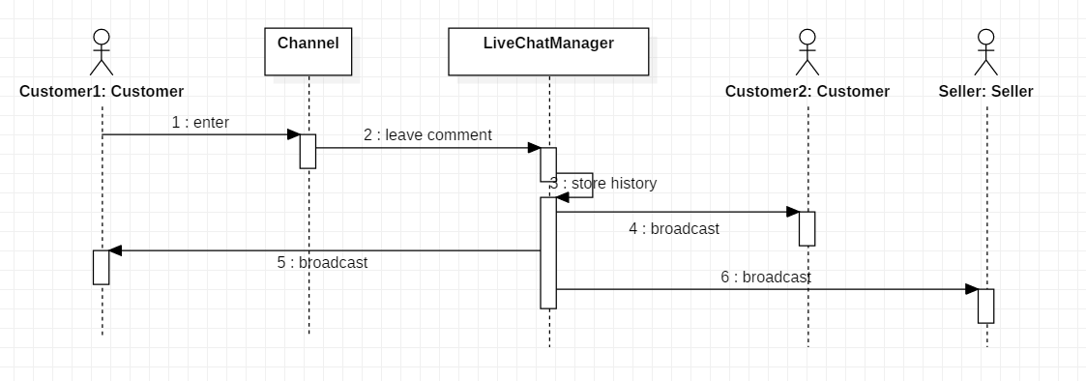

1. Non-functional Requirements

This section specifies criteria that can be used to judge the operation of a system, rather than specific behaviors. They are contrasted with functional requirements that define specific behavior or functions.

* 1. Quality Attribute Scenarios

|  |  |
| --- | --- |
| **Security** | |
| Source | Individual or system that is correctly identified or unknown identity |
| Stimulus | Tries to access to user information or payment information |
| Artifact | Data within system |
| Environment | System is online |
| Response | Hides identity of the user except identified user’s own information |
| Response Measure | Probability of detecting attack. |

|  |  |
| --- | --- |
| **Performance** | |
| Source | Users |
| Stimulus | Requests video stream |
| Artifact | System |
| Environment | Under normal/overload mode |
| Response | Returns video stream |
| Response Measure | Latency and throughput |

|  |  |
| --- | --- |
| **Safety** | |
| Source | Users |
| Stimulus | Requests to pay |
| Artifact | System |
| Environment | Payment system is online or offline |
| Response | Proceeds the payment or rollback when it is not available |
| Response Measure | Probability of incorrect payment |

|  |  |
| --- | --- |
| **Usability** | |
| Source | Users |
| Stimulus | Tries to connect to system with PC or mobile devices. |
| Artifact | System |
| Environment | At runtime |
| Response | Shows different GUI for each devices |
| Response Measure | User satisfaction |

* 1. Priority of Each Non-Functional Requirements

Utility tree is derived from quality attribute scenarios considering business importance and implementation risk.

1. System Constraints
2. Technical constraints
   1. The system should not use Active X and support payment on all kind of web browsers.
   2. The system should work on IOS, Android and Windows.
3. Business constrains
   1. The system should be ready to demo until August 2019
   2. The system should spend less than 1 billion dollars.