**Exhibition for Graduation Project**

**Software Requirements Specification**

**2021.10.31.**

Introduction to Software Engineering

TEAM 12

Team Leader 박다영

Team Member 권윤영

Team Member 김정재

Team Member 안진형

Team Member 왕언문

Team Member 이동혁

Team Member 이하은

**Table of Contents**

1. Preface 4

1.1 Introduction 4

1.2 Glossary 4

1.3 User Requirement 4

1.4 System Architecture 4

1.5 System Requirement 4

1.6 System Model 4

1.7 System Evolution

1.8 Appendices

2. Introduction 6

2.1 Objective 6

2.2 Goal 6

2.3 Needs 6

2.4 Expected Effects

3. Glossary 10

4. User Requirement Definition 11

4.1 Functional Requirement 11

4.1.1 Access to the user 11

4.1.2 Access to the exhibitor 12

4.2 Non-functional Requirement 13

4.2.1 Product Requirement 13

4.2.2 External Requirement 13

5. System Architecture 14

5.1 Objective 14

5.2 Architecture Overview 15

5.3 Authentication System 15

5.4 Exhibit System 16

5.5 Express Likes System 17

5.6 Ranking System 18

5.7 Communicate System 18

6. System Requirements Specification 19

6.1 Functional Requirement 19

6.2 Non-functional Requirement 28

7. System Models 30

7.1 Context Model 30

7.2 Interaction Model 32

7.3 Behavioral Model 37

8. System Evolution 39

9. Appendices 39

10. Index 40

# 1. Preface

This chapter shows outline of document and explains what each section is talking about

## 1.1 Introduction

Introduction contains the goal of this system, needs and expected results. We will explain the goal we want to achieve, why we need this system and what are we expecting for the result of this system.

## 1.2 Glossary

Glossary explain words which will be used in this document.

## 1.3 User Requirement

The elicitation of requirements is an early but critical stage in the development of a project. User requirements parts are describing requirements from the view of users. In this part, we’ll handle requirements describing services the system provides and its operational constraints. We provide requirements divided into functional and non-functional requirements.

## 1.4 System Architecture

At system architecture, we’ll first provide broader perspective to system. This part doesn’t give explanation or figure as a whole system, but separate by services and give explanation for convenience of readers.

## 1.5 System Requirement

This document is the detailed version of functional and non-functional requirements definition. Charts and diagrams are mainly used to show the entire development process and detailed requirements.

## 1.6 System Model

This part shows abstract models of a system, with each model presenting a different view or perspective of that system. We provide three types of models which are context model, interaction model, and behavioral model. Context models are used to illustrate the operational context of a system. More specifically, context models mainly show how the system and outer context communicate. Interaction models are covering the user interaction, system-to-system interaction, and component interaction. Behavioral models are models of dynamic behavior of a system as it is executing.

## 1.7 System Evolution

This part shows the environment surrounding the system, and in based on that, shows how to expect the system to respond to the anticipated changes, and to anticipate the various changes surrounding the system that may occur

## 1.8 Appendices

This part explains constraints not mainly dealt with in this documentation, but also have importance in using our system

# 2. Introduction

## 2.1 Objective

In this section, we’re going to explain goal, needs of the system and the desired results we are expecting.

## 2.2 Goal

The overall goal of this system is implementing online graduation work exhibition. We’re going to make this online exhibition similar to offline graduation work exhibitions we held previously by adding some features such as selecting favorite works or communicating with exhibitors.

## 2.3 Needs

For graduation works, students select topics they want based on the knowledge they have learned while attending university. They write papers or make works based on that topic. And from exhibition of graduation works, students present their graduation works to others, receive feedbacks from professors or visitors and communicate with each other exchanging their opinions. Visitors vote for their favorite work and hold the awards ceremony according to the results of the vote. These processes are important that it helps students who are about to graduate grow one step further.

However, because of COVID-19, all of these things became impossible. COVID-19 is a highly contagious disease, and our daily lives have frozen as COVID-19 has spread since 2020 and this momentum shows no sign of decreasing.

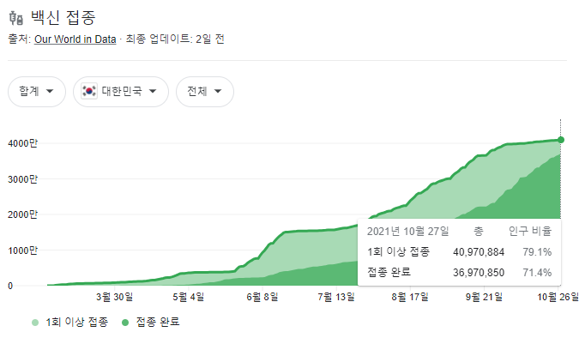

**Figure 1. Number of vaccinated people in Korea**

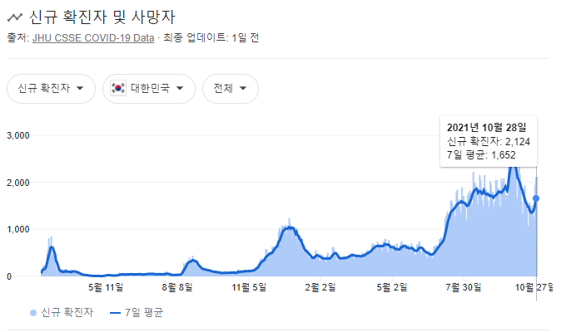

Figure 2. New confirmed cases and deaths in Korea

As we can see from this graph, while the vaccination rate is rising, the number of confirmed cases of COVID-19 has not decreased and is increasing. In particular, in recent cases, concerns about COVID-19 are growing as it hits the highest number ever.

Accordingly, the ‘social distancing’ policies that restrict people’s group life have been strengthened to prevent the spread of COVID-19.

Table 1. Social distancing policy (10.18 ~ 10.31)

Due to this policy, the number of people in public places such as movie theaters, baseball stadiums and restaurants is limited and many events where lots of people gather have been canceled.

In this situation, it is unreasonable to hold an exhibition of graduation works in the existing way. So, the only way we can see graduation works is through school website(<https://cs.skku.edu/gp/>).

Figure 3. Website for graduation works

However, there is no way we can communicate with exhibitors, and it has problems of low immersion because it’s just a simple website, not real exhibition. So, to fix these problems, we decided to implement online exhibition similar to previous offline exhibition.

Table 2. Comparison table between offline and online exhibitions

Above is a comparison table between offline and online exhibitions conducted in research in the past. We can see that there are advantages of online exhibition in that it costs low, and it does not have physical restriction. However, we can see some problems of online exhibition that it has low immersion but we can solve this problem to some extent by implementing realistic online exhibitions using Vrchat platform.

Figure 4. Examples of online exhibition

These are examples of online exhibition that has been held so far or is currently underway. We can see that these are implemented similar to offline exhibition visually, so we can feel like as if we are actually at real exhibition.

Like this, we’re going to implement offline graduation exhibition so that visitors and exhibitors can feel like they are in real graduation exhibition.

## 2.4 Expected Effects

First, the cost of holding exhibition will significantly decreased. Also, it will increase accessibility of exhibition because visitors can easily visit graduation exhibition online which has no time and space restriction.

Also, importantly, it can be the only opportunity for exhibitors to present their works and for visitors to express their opinions, select favorite works and communicate with exhibitors in COVID-19 situation. As I mentioned before, these processes are very important for students to grow up so making these things possible is very meaningful.

# 3. Glossary

|  |  |
| --- | --- |
| Term | Description |
| visitor | People who visit the exhibition |
| exhibitor | People who exhibit their work in exhibition |
| Functional requirements | Functional requirements describe the specific behavior of system functionality when certain conditions are met, for example, "New customer registers a user." |
| Nonfunctional requirements | Nonfunctional requirements describe how the system should operate and what limitations are placed on its functionality |
| Work | Graduation work registered by an exhibitor |
| Scene | The 2D or 3D space the user is in within the app |
| Canvas screen | A pop-up window that appears on the UI screen |
| Board screen | Board-shaped screen that appears in 3D space |

# User Requirements Definition

The elicitation of requirements is an early but critical stage in the development of a project. User requirements parts are describing requirements from the view of users. In this part, we’ll handle requirements describing services the system provides and its operational constraints. We provide requirements divided into functional and non-functional requirements.

## Functional Requirement

## Access to the user

**A. Registration/Login**

The registration function is to ask users to use the personal information required by our services and store this information in a database. Users who want to use our services must go through a registration process. To register for our service, users need to enter their student ID, password and some personal information, such as telephone number, etc. After the registration process is complete, the information is stored in the database.

Login is a user to Login to the system by entering an ID and password pair during registration. If the ID and password pair match those stored in the database, the user will successfully log into our service and accept our service based on the user's information.

**B. Preference survey**

The purpose of the preference survey is to determine which aspects of the graduation project or thesis the user is interested in. Users can choose 2-3 preferred keywords and provide recommendations based on their preferences.

**C. Search**

Search is a function that users can use to search for a specific range or specific graduate works. Users can search by entering search keywords and using search filters. Users can choose the area they are interested in or their graduation works according to the search results.

**D. Work details**

Details Displays details, user comments, and likes for a particular graduation work. Users can directly view the direction and keywords of the graduation work from the detailed information page.

**E. Comments**

The comments feature allows users to write comments. On the graduation work details page, users can see all the comments and likes about the graduation work. User - to - user comments can also be liked. Users with good content can be selected for preferred reviews. Preference comments are affirmations from other users. Can give viewers some suggestions and so on. Each comment shows the commenter's nickname, the date of the comment, and the number of likes.

**F. Thumb up ranking (‘Links’RANK)**

Users can give thumbs up to their favorite graduation work. Graduation works with a lot of likes will enter the ranking. In this way, when new users first use it, they can decide which graduation work to watch according to the ranking of the likes, which will bring some help to new users when they choose to watch the graduation work.

**G. 1:1 Real-time communication**

In the process of the user's graduation work visit, if find any deficiencies in graduation work, user can communicate with the exhibitor through 1:1 real-time communication. Or the user wants to know more about the graduation work, user can also through 1:1 real-time communication, so that exhibitors can provide more detailed introduction and interpretation of graduation works.

## Access to the exhibitor

**A. The exhibition area**

The graduation work display platform we created is divided into different exhibition areas. Participants can choose the exhibition area according to the content of their graduation works.

**B. Work details**

Exhibitors can add a brief introduction and a few keywords to the details page of their graduation works. Set the keyword, in the new user after the registration of preference Settings and search, help to better find their graduation works.

## Non-functional Requirement

## Product Requirement

**A. Security**

The system should provide reliability and anonymity for each customer. Users who register with the service should be given a user-set nickname to ensure privacy when making comments. If the user needs to be anonymous, the system should always provide the customer with an anonymous nickname. And the personal information filled in when the user registers should be encrypted storage.

**B. performance**

The system needs to categorize users' preferences, which can lead to sparse data. The system should be optimized for sparse data.

**C. Environmental requirements**

This system adopts front-end and 3D space development, and uses AWS (Amazon Web Service) provided by Amazon as the server to communicate with front-end and store DB. However, because it is a small project, a DB server and a Web server are created on one server. DB is composed of mysql, App server is composed of Node.js framework.

## External Requirement

**A. Regulatory requirements**

The system should obey the local law terms for personal data usage for collection, protection and treatments.

**B. Moral requirements**

The system is highly dependent on user behavior; This leaves the system vulnerable to abuse or malicious comments. The terms of service provided by the system should include penalties for malicious acts.

**C. Legislative requirements**

Copyright of graduation work is guaranteed. Graduation works exhibition can only be viewed and used for reference, not directly copy. Legal responsibility will be held if plagiarism is found.

# System Architecture

## Objective

This chapter describes the general architecture of the system. The overall structure of the system, the composition of each subsystem, and the relationship between the subsystems are outlined, and each structure is attached with a diagram to help understanding.

## Architecture Overview

Figure 5. Architecture overview

The overall architecture is composed with frontend and backend parts. In our system, the frontend interface is made of authentication feature for sign up/log in, register work and exhibit features, likes express features, likes ranking feature, and communication features.

In backend server, there are six subsystems. Authentication subsystem supports authentication itself and also Communicate subsystem supports communicate itself.. Work information view subsystem and ranking information view subsystem support information lookup and do not need user account authentication information as an argument of API call. The others need to be authenticated to work. Register works subsystem supports feature that store the work information of exhibitors. Plus Likes subsystem supports the number of "likes" update feature of works.

## Authentication System

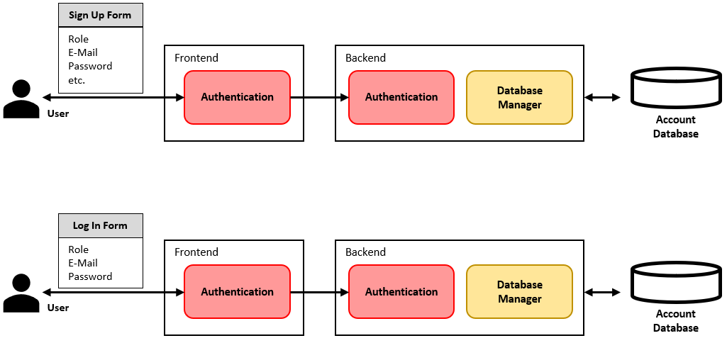

Figure 6. Sign Up

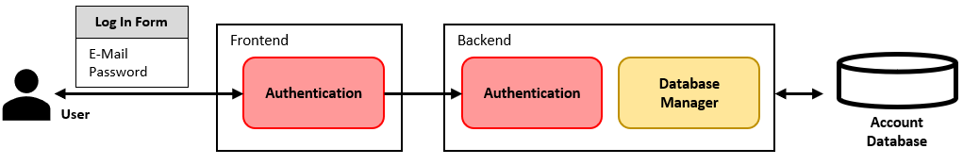

Figure 7. Log In & Out

Authentication system supports the sign-up process and log in & out processes. In this process, the system receives the user's role as an argument to distinguish which functions can be used.

## Exhibit System

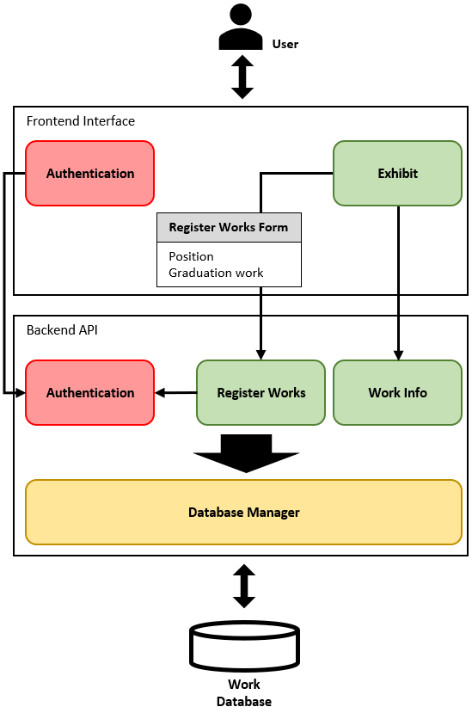

Figure 8. Exhibit System

Exhibit system works to display works in the exhibition hall when the exhibitor determines the location of the works and registers the works information.

It delivers the location of the work and the information on the work in an input form to the Register Works subsystem at the backend. Visitors view the exhibits through the graduation work information received from the Work Info subsystem.

## Express Likes System

Figure 9. Express Likes System

Express Likes system allows visitors express their likes in their favorite works during looking around the exhibition.

When the visitors clicks the "Like" button, the Plus Like subsystem adds one more Like to it. Interact with the Ranking Info subsystem to update the ranking.

## Ranking System

Figure10. Ranking System

Ranking system allows visitors view “Like” ranking of graduation works.

The Ranking Info subsystem interacts with the Plus Like subsystem and updates the like rankings of graduation works in real time and delivers them to the frontend.

## Communicate System

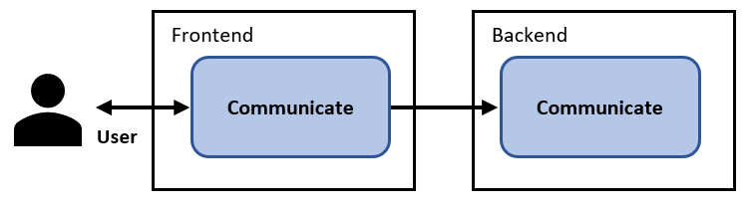

Figure 11. Communicate System

Communicate system serves communication using VR Chat's own communication subsystem.

# System Requirements Specification

## Functional Requirement

## User Authentication (Sign-up and Log-in)

Table 3. User Authentication (Sign-up and Log-in)

|  |  |  |
| --- | --- | --- |
| **Name** | **User Authentication (Sign-up and Log-in)** | |
| **Description** | A Scene that user can sign-up and log-in | |
| **Inputs** | Student ID | Student ID string of user |
| Name | Name string of user |
| **Outputs** | Show a canvas screen that can choose a role | |
| Move to exhibition scene | |
| **Action** | This canvas allows users to identify themselves using their student number and name before using the exhibition service.  When a user enters their student ID and name for the first time, they are automatically registered as a member. If the user reconnects to the service and enters the information, the user will be logged in using the previously entered information.  When signing up, the authentication information (student ID and name) would be inserted in the User DB. | |
| **Requirements** | Student ID and name | |
| **Pre-condition** | The user is not registered to the system yet.  The user enters correct information.  There is no user with the same student ID and name. | |
| **Post-condition** | By signing up, new users would have an account. By logging in, users would be able to participate the exhibition. | |

## Choose a role of the user (an exhibitor or a visitor) and enter a nickname

Table 4. Choose a role of the user (an exhibitor or a visitor) and enter a nickname

|  |  |  |
| --- | --- | --- |
| **Name** | **Choose a role of the user (an exhibitor or a visitor) and enter a nickname** | |
| **Description** | A canvas screen that user can choose a role (an exhibitor or a visitor) and enter a nickname | |
| **Inputs** | Role | Whether the user is an exhibitor or a visitor |
| Nickname | Nickname string of user |
| **Outputs** | Move to exhibition scene when user choose a visitor | |
| Move to the scene that can enter exhibition information when user choose an exhibition | |
| **Action** | On this canvas, the user identifies whether he is an exhibitor or a visitor. The user also enters a nickname, but the nickname may be duplicated with another user's nickname.  When the user chooses a role, the user can see a form to enter a nickname.  When choosing a role and entering a nickname, the information would be updated in the User DB. | |
| **Requirements** | Role and nickname | |
| **Pre-condition** | The user saw this canvas screen through signing-up rather than logging-in. | |
| **Post-condition** | By choosing a role and entering a nickname, new users would have an account that is more detail than before. Now, new users can participate the exhibition or exhibit their works. | |

## Decide where to exhibit graduation work

Table 5. Decide where to exhibit graduation work

|  |  |  |
| --- | --- | --- |
| **Name** | **Decide where to exhibit graduation work** | |
| **Description** | A scene that exhibitor can choose where to exhibit graduation work | |
| **Inputs** | Position | Graduation work’s position  It is expressed by x-axis and y-axis (x-float, y-float) |
| Graduation work | Exhibitor’s graduation work that is 3D object |
| **Outputs** | Graduation work is placed the position which the exhibitor chooses | |
| **Action** | The exhibitor selects his or her graduation work and decides where it will be displayed.  The graduation work is selected from your device folder, and it must be a 3D object that can be used in unity. Also, when determining the position, the position is determined by clicking the mouse.  However, once the initial location is determined, it cannot be modified. | |
| **Requirements** | Position and 3d graduation work | |
| **Pre-condition** | Exhibitors must have graduation work as a 3d object file that can be used in unity on their device. | |
| **Post-condition** | - | |

## Input information of graduation work

Table 6. Input information of graduation work

|  |  |  |
| --- | --- | --- |
| **Name** | **Input information of graduation work** | |
| **Description** | A canvas screen that exhibitor can enter his or her graduation work’s title and detail description of the graduation work | |
| **Inputs** | Title | Graduation work’s title string |
| Description | Graduation work’s description string |
| **Outputs** | - | |
| **Action** | First, the canvas screen containing the input forms appears to the exhibitor.  The exhibitor enters the title of the exhibition work. Then, enter a description of the graduation work.  The entered information is added to the Work DB and can be viewed by visitor in the exhibitions. | |
| **Requirements** | Graduation work’s title and description | |
| **Pre-condition** | The exhibitor should have uploaded the exhibit and have decided on the location as well. | |
| **Post-condition** | The exhibitor entered all information related to the graduation work and his or her exhibition. | |

## Exhibit the work of exhibitors

Table 7. Exhibit the work of exhibitors

|  |  |
| --- | --- |
| **Name** | **Exhibit the work of exhibitors** |
| **Description** | The exhibitor exhibits the work and moves to the exhibition |
| **Inputs** | - |
| **Outputs** | The graduation work is placed on the position with its tile and description |
| **Action** | The exhibitor decides to display all previously entered information. The exhibited works are then displayed in the exhibition.  Exhibitors also move to the exhibition. |
| **Requirements** | - |
| **Pre-condition** | The exhibitor must have entered all information related to the graduation work and his or her exhibition. |
| **Post-condition** | The graduation work must be placed on the right position. The exhibitor moves to the exhibition |

## Click the “Like” button on the work

Table 8. Click the “Like” button on the work

|  |  |  |
| --- | --- | --- |
| **Name** | **Click the "Like" button on the work** | |
| **Description** | The visitor clicks the “Like” button on a particular graduation work that the visitor likes | |
| **Inputs** | Title | Graduation work’s title string |
| “Like” | “Like” button click event |
| **Outputs** | The graduation work’s ”Like” score increases by one point | |
| **Action** | Visitor who participates in the exhibition find his or her favorite graduation work by looking around the exhibition.  The visitor clicks the “Like” button for the work. At this time, an effect occurs due to clicking the “Like” button, and the “Like” score of the work increases by one point. | |
| **Requirements** | - | |
| **Pre-condition** | - | |
| **Post-condition** | The Work DB is updated, and the contents of the "Like" board are also updated. | |

## Show “Like” ranking

Table 9. Show “Like” ranking

|  |  |
| --- | --- |
| **Name** | **Show “Like” ranking** |
| **Description** | A board screen that shows “Like” ranking and scores of graduation works in the exhibition |
| **Inputs** | - |
| **Outputs** | “Like” ranking and scores |
| **Action** | A board screen that shows “Like” ranking and scores of graduation works in the exhibition is placed at the entrance of the exhibition.  By looking at the board screen, the viewer can know what kind of popular graduation works are currently in them, and how popular the graduation works they are interested in are.  The board screen reflects the “Like” score in real time. |
| **Requirements** | - |
| **Pre-condition** | Exhibitors can "like" the graduation works |
| **Post-condition** | - |

## Move avatar (Exhibitors and visitors)

Table 10. Move avatar (Exhibitors and visitors)

|  |  |  |
| --- | --- | --- |
| **Name** | **Move avatar (Exhibitors and visitors)** | |
| **Description** | Move avatar which is an exhibitor or a visitor in the exhibition | |
| **Inputs** | Direction | Direction vector to move the avatar |
| **Outputs** | An avatar that moves in the direction that user want it to go | |
| **Action** | The user (exhibitor or visitor) participates in the exhibition by controlling the avatar. The user controls the avatar using the joystick in the UI. Currently, the body of the avatar looks in the direction of movement, but the direction does not change because the camera is the observer's point of view.  In addition, the user can also move the camera. If you drag after left-clicking the mouse, the camera moves in the dragging direction. | |
| **Requirements** | - | |
| **Pre-condition** | When a user (exhibitor or visitor) participates in an exhibition, an avatar is assigned, and the avatar also displays information (Nickname and role) related to the user.  Only one avatar is assigned to one user, and the movable space is limited to the exhibition space only. | |
| **Post-condition** | - | |

## Communicate with users (Exhibitors and visitors)

Table 1. Communicate with users (Exhibitors and visitors)

|  |  |  |
| --- | --- | --- |
| **Name** | **Communicate with users (Exhibitors and visitors)** | |
| **Description** | In the exhibition scene, users (exhibitors and visitors) can communicate with each other in their voices | |
| **Inputs** | Exhibitor’s voice | Exhibitor’s voice audio |
| Visitor’s voice | Visitor’s voice audio |
| **Outputs** | Communication with each other | |
| **Action** | The visitor sees the description of the graduation work, but they may not understand it correctly and want to ask a question to the exhibitor. At this time, the visitor can ask questions to the exhibitor, and use a microphone at this time. Exhibitors also use microphones to answer.  In this case, they can communicate with each other within a certain distance of each other. | |
| **Requirements** | Users must use a microphone. | |
| **Pre-condition** | To communicate, both users must be able to use a microphone. | |
| **Post-condition** | - | |

## Non-functional Requirement

## Product Requirements

## Usability Requirements

Those who want to display their works can submit their submissions using a separate form and use this program. Participants who want to see the exhibition can go around the exhibition hall through simple mouse clicks or keyboard commands.

## Efficiency Requirements

The system needs to group and categorize exhibitor’s submissions for its liking, which can cause sparse data. The system should optimize for that sparse data. Through database work through Mysql, this number of likes will be managed and Ranking will be performed.

## Dependability Requirements

Since the works of exhibitors must be well delivered and implemented on the metaverse, the system must provide dependability between the front-end application and the back-end service. For example, using the submission received through the form, the back-end service must handle the work through appropriate transaction. Then, the front-end application can place the submission where it corresponds to the section of this submission. This work must be done properly to prevent missing submissions or being displayed in the wrong place.

## Security Requirements

The system should provide reliability and anonymity for all participants and exhibitors. If participants want anonymity, the system should provide anonymous nickname. However, since the verification work on the students of this school must be done.

## Organizational Requirements

## Environmental Requirements

Front-end and 3D space that users will use is developed by Unity. It seems appropriate to use VR Chat for SDK and C# for language. Developers should use AWS(Amazon Web Service) provided by Amazon as a server that communicates with the frontend and stores the DB. Since it is a small project, DB server and web server are created on the server. DB is made of mysql and App server is made of Node.js Framework.

## Operational Requirements

The system must have cloud-base instance which runs Back-end applications. This system should use AWS to run Back-end applications. Thus, the system should provide hardware independency and flexibility for environment changes.

## Development Requirements

Since there are not many deadlines left, this system must be developed at a rapid pace. It seems necessary to have parallel development in which each person divides parts and proceeds at the same time. In addition, it should be designed in plan-driven design.

## External Requirements

## Regulatory Requirements

The system should obey the local law terms for personal data usage for collection, protection and treatments.

## Ethical Requirements

This system relies entirely on the behavior of participants. For example, an exhibitor may submit a submission containing maliciously strange content, or a participant may only leave malicious comments. Therefore, it seems better to display precautions and rules through functions such as bulletin boards and to impose appropriate punishment in case of inappropriate behavior.

## Legislative Requirements

Copyright of graduation work is guaranteed. Graduation works exhibition can only be viewed and used for reference, not directly copy. Legal responsibility will be held if plagiarism is found.

# System Models

## Context Model

## Context diagram

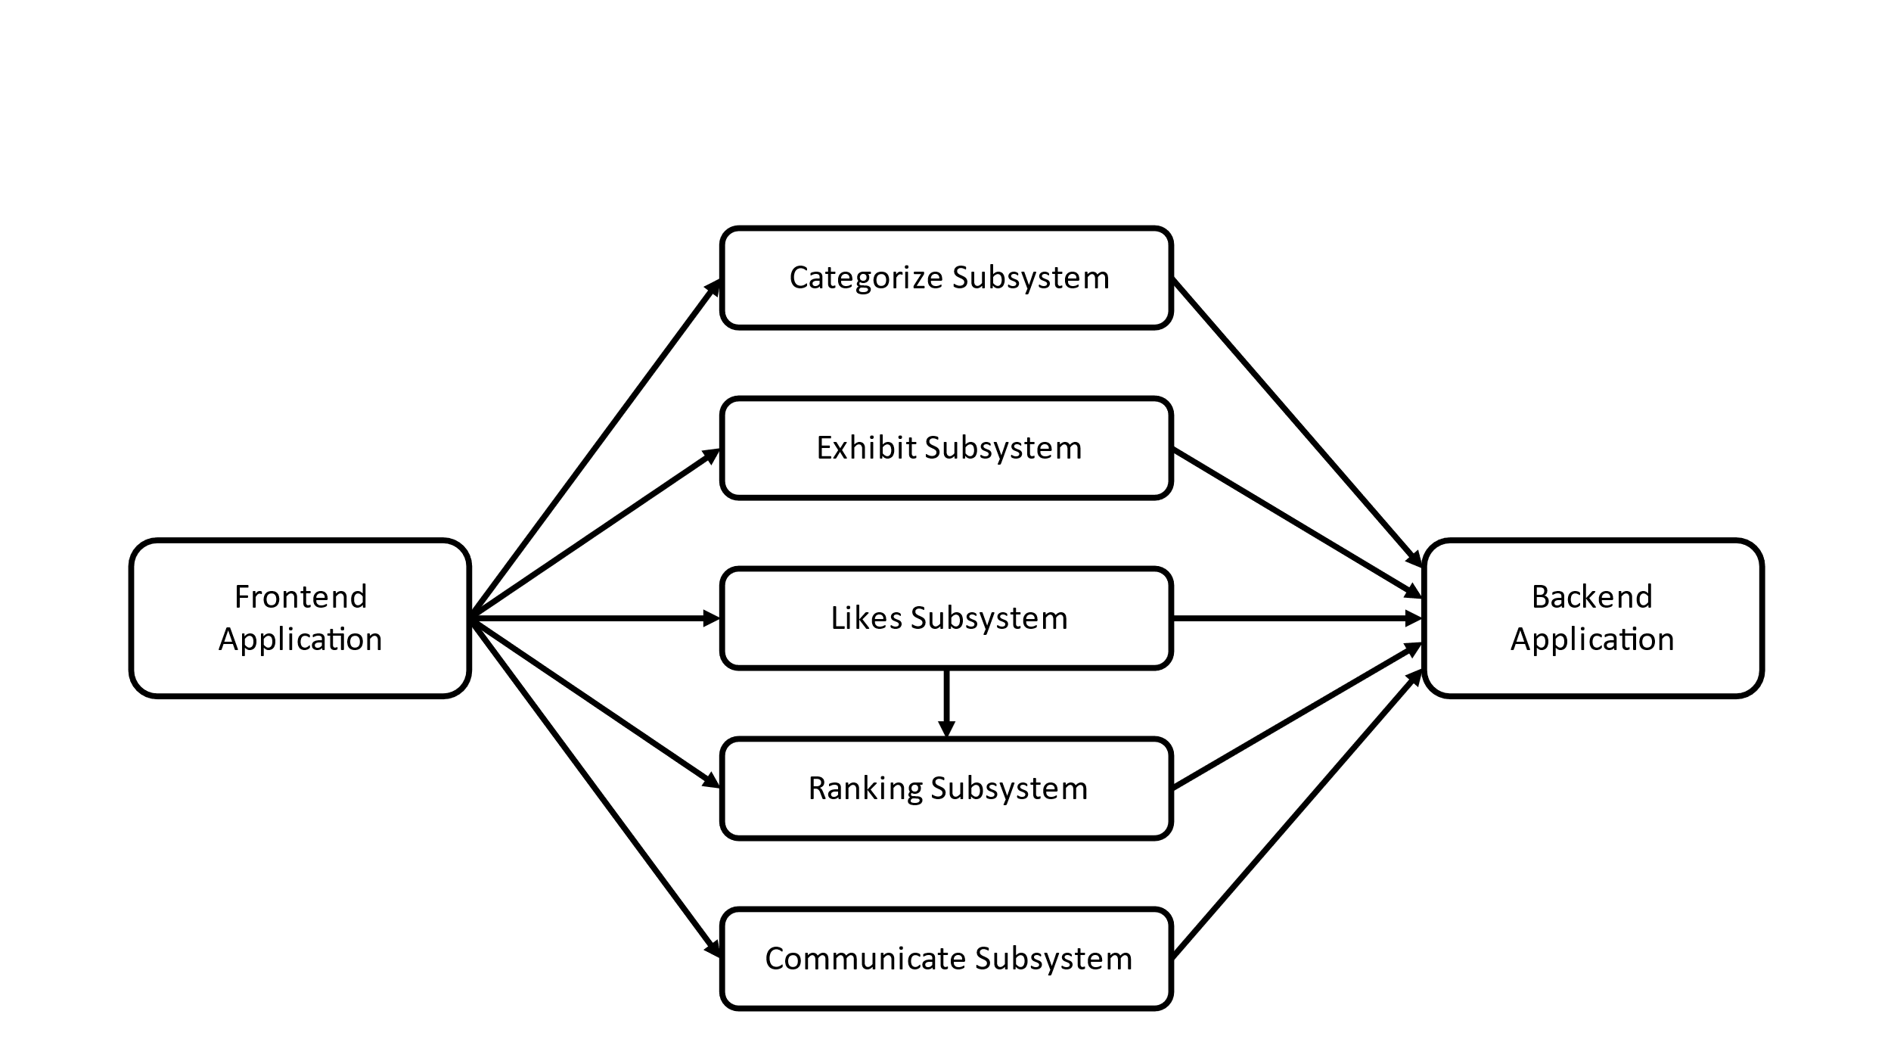

Figure 12. Context diagram

## Process diagram

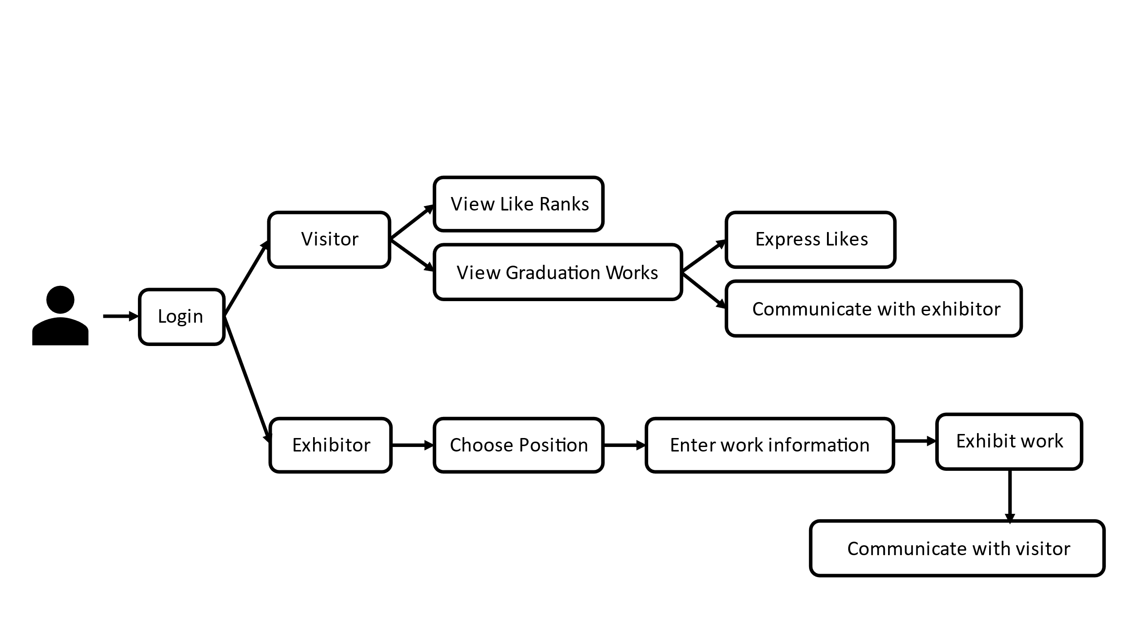

Figure 13. Process diagram

## Interaction Model

## Use Case Diagram

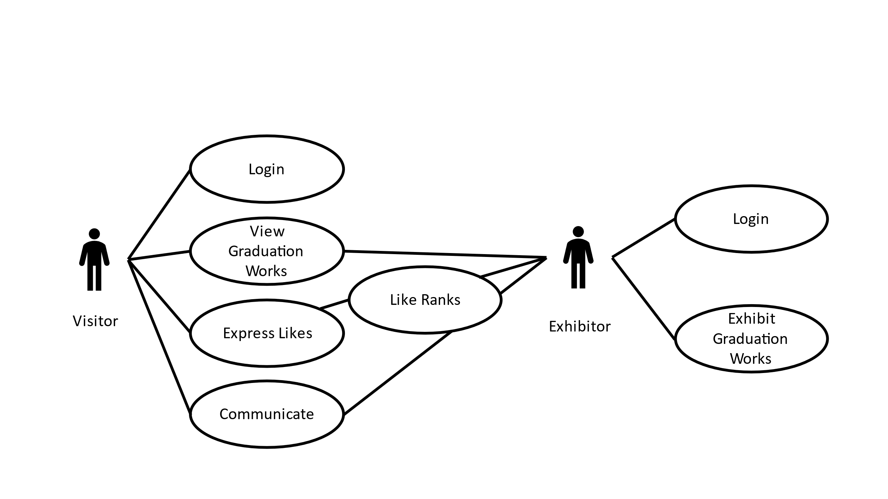

Figure 14. Use Case Diagram

## Tabular Description for Each Use Case

## Login

Table 12. Login

|  |  |
| --- | --- |
| **User Case** | Login |
| **Actor** | Visitor, Exhibitor |
| **Description** | Process of determining whether the accessed user matches the user information registered in the system, and whether the user is a visitor or an exhibitor. |
| **Trigger** | User enter ID and Password |
| **Success Response** | User ID exists in database.  Password matches User ID in database. |
| **Failure Response** | Error message “ID doesn’t exist” or “ID and Password don’t match” is displayed. |

## View Graduation Work

Table 13. View Graduation Work

|  |  |
| --- | --- |
| **User Case** | View Graduation Work |
| **Actor** | Visitor |
| **Description** | Process of viewing the graduation work displayed by the exhibitor. |
| **Trigger** | Graduation Work |
| **Success Response** | Applicable Graduation Work is displayed in the front of the visitor. |
| **Failure Response** | If there is no registered graduation work, blank page will be displayed. |

## Express Likes

Table 14. Express Likes

|  |  |
| --- | --- |
| **User Case** | Express Likes |
| **Actor** | Visitor |
| **Description** | Process of visitors expressing likes by pressing the like button next to the displayed work. |
| **Trigger** | Like button |
| **Success Response** | Graduation work exists. |
| **Failure Response** | No like buttons when there is no graduation work displayed. |

## Like Ranks

Table 15. Like Ranks

|  |  |
| --- | --- |
| **User Case** | Like Ranks |
| **Actor** | Visitor |
| **Description** | Process of ranking the likes from the visitors |
| **Trigger** | # of likes |
| **Success Response** | Show the rank of the likes with the title of the graduation work in descending order. |
| **Failure Response** | Blank rank when there is no likes or no displayed work. |

## Communicate

Table 16. Communicate

|  |  |
| --- | --- |
| **User Case** | Communicate |
| **Actor** | Visitor, Exhibitor |
| **Description** | Process of communicating between the visitor and the exhibitor. The visitor can start communicating by pressing the button next to the displayed work. |
| **Trigger** | Connected Exhibitor |
| **Success Response** | Exhibitor able to communicate when the visitor requires communication. |
| **Failure Response** | Error message displayed when the exhibitor is not available to communicate. |

## Exhibit Graduation Work

Table 17. Exhibit Graduation Work

|  |  |
| --- | --- |
| **User Case** | Exhibit Graduation Work |
| **Actor** | Exhibitor |
| **Description** | Process of exhibiting one’s graduation work. The exhibitor chooses the position which is empty and register one’s work with detailed information. |
| **Trigger** | Position and Graduation Work |
| **Success Response** | Graduation work is successfully registered in the empty spot. |
| **Failure Response** | Error message is displayed when the space is already filled or unmatched size or type of work. |

## Behavioral Model

## Graduation Work System Data Flow Diagram

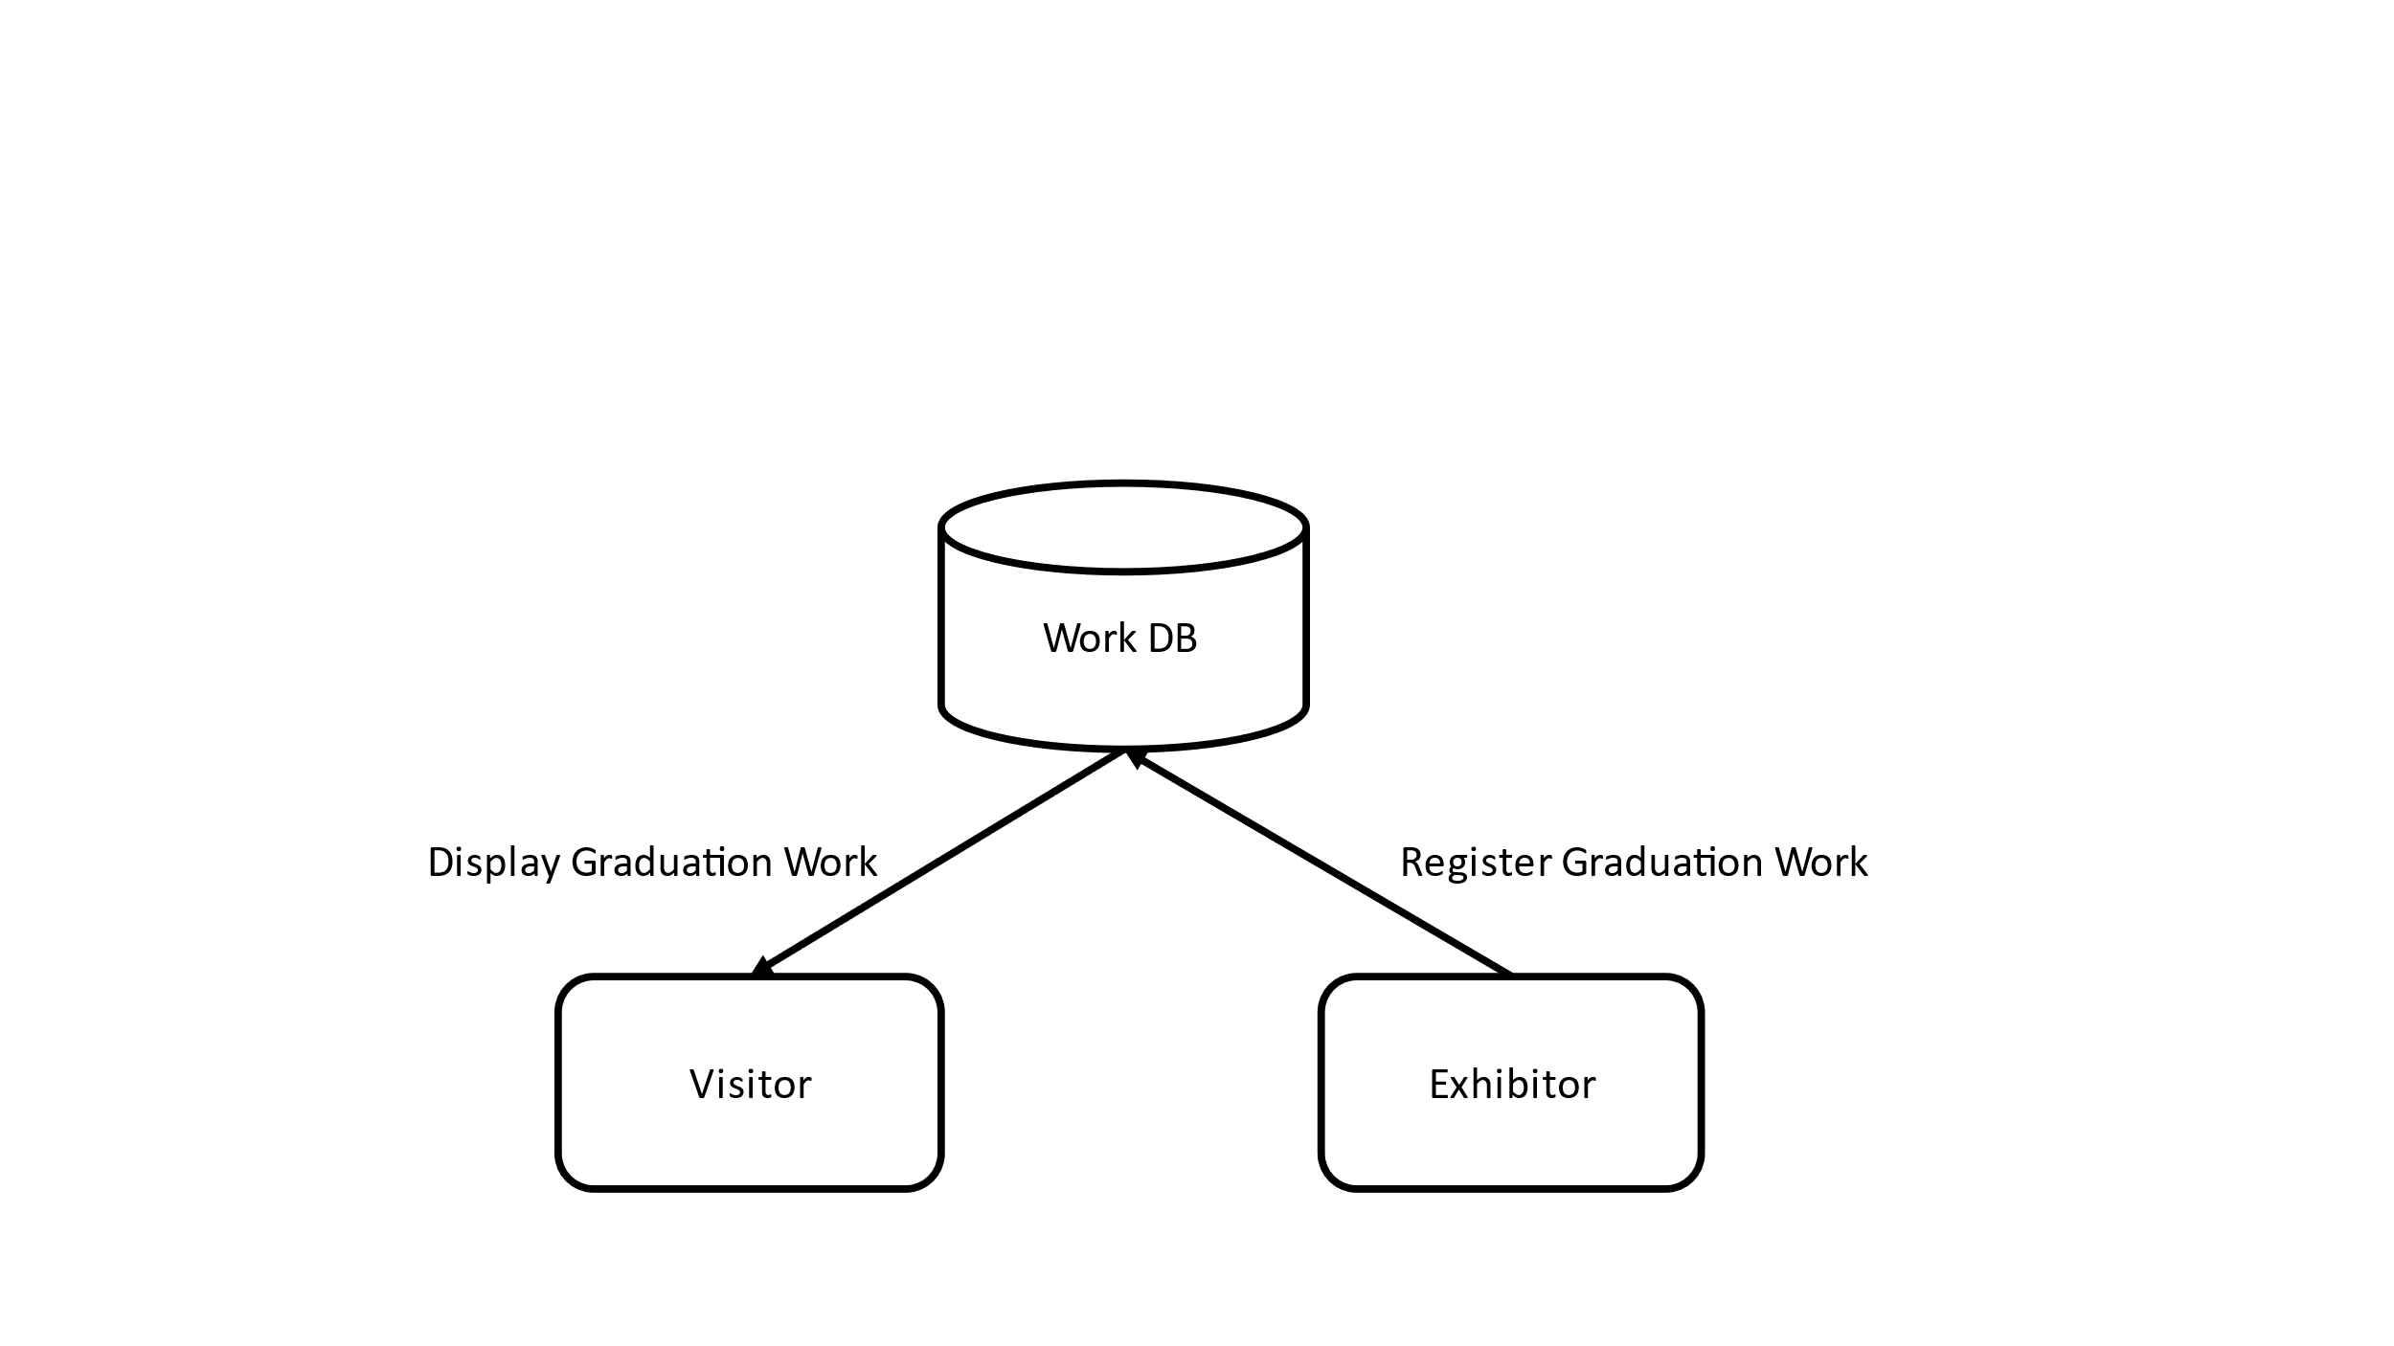

Figure 15. Graduation Work System Data Flow Diagram

## Like Ranking System Data Flow Diagram

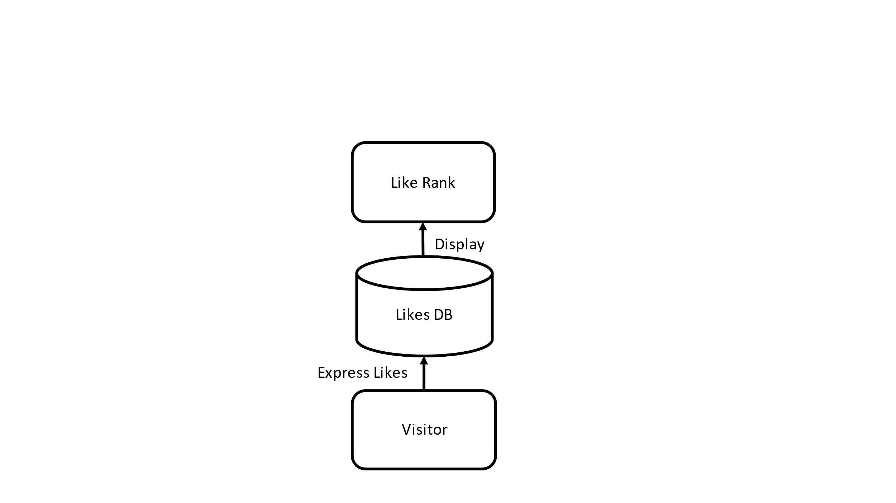

Figure 16. Like Ranking System Data Flow Diagram

## Delivery Sequence Diagram

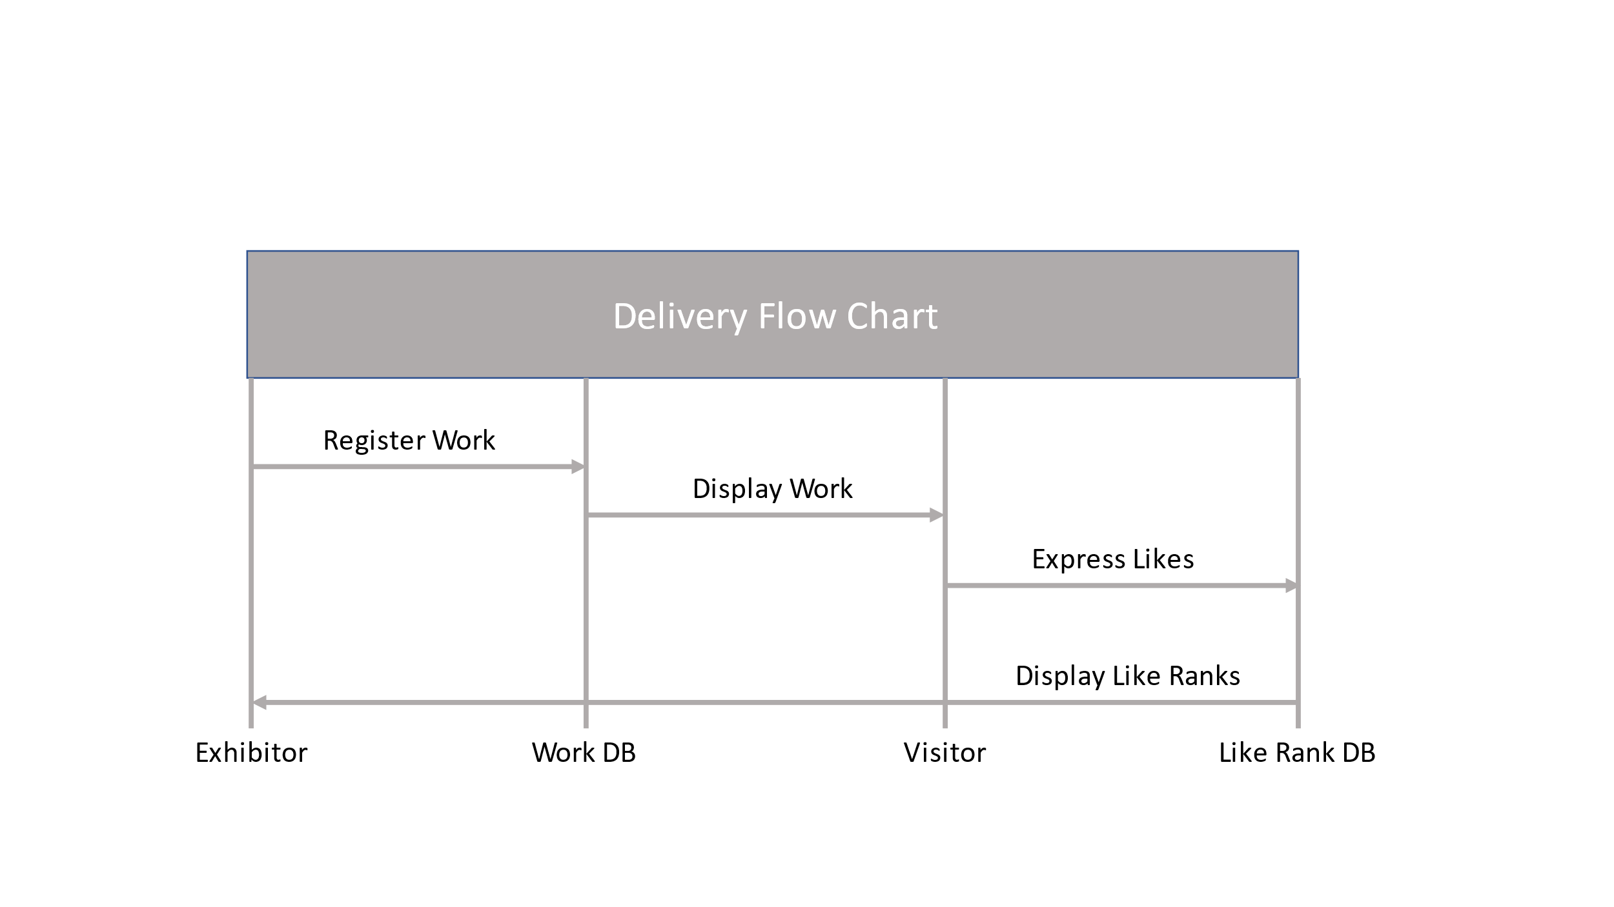

Figure 17. Delivery Sequence Diagram

# System Evolution

In this part, we describe the environment surrounding the system, how to expect the system to respond to the anticipated changes, and to anticipate the various changes surrounding the system that may occur while deploying and operating the system. This eliminates the possibility of side-by-side design changes that may occur in future modifications to the system and lowers the cost of modification.

## Limitations

Currently, we are holding the exhibition with one picture per person. However, depending on the type of the graduation work, for example, an application, only one photo may be insufficient. In that case, there may be a way to support external links when displaying the graduation work, but it will not be implemented in this project for now.

## Video Description

As mentioned, only on photo can be insufficient for people to fully understand the graduation work. Therefore, it might be a good way to support the video upload function so that the exhibitor can upload his of her presentation video.

# Appendices

## Software Requirement Specification

This software requirements specification was written in accordance with the IEEE Recommendation (IEEE Recommended Practice for Software Requirements Specifications, IEEE-Std-830).

# Index

## Figure

Figure 1. Number of vaccinated people in Korea 6

Figure 2. New confirmed cases and deaths in Korea 7

Figure 3. Website for graduation works 8

Figure 4. Examples of online exhibition 9

Figure 5. Architecture overview 14

Figure 6. Sign Up 15

Figure 7. Log In & Out 15

Figure 8. Exhibit System 16

Figure 9. Express Likes System 17

Figure 10. Ranking System 18

Figure 11. Communicate System 18

Figure 12. Context diagram 30

Figure 13. Process diagram 31

Figure 14. Use Case diagram 32

Figure 15. Graduation Work System Data Flow Diagram 37

Figure 16. Like Ranking System Data Flow Diagram 37

Figure 17. Delivery Sequence Diagram 38

## Table

Table 1. Social distancing policy (10.18 ~ 10.31) 7

Table 2. Comparison table between offline and online exhibitions 8

Table 3. User Authentication (Sign-up and Log-in) 19

Table 4. Choose a role of the user (an exhibitor or a visitor) and enter a nickname 20

Table 5. Decide where to exhibit graduation work 21

Table 6. Input information of graduation work 22

Table 7. Exhibit the work of exhibitors 23

Table 8. Click the “Like” button on the work 24

Table 9. Show “Like” ranking 25

Table 10. Move avatar (Exhibitors and visitors) 26

Table 11. Communicate with users (Exhibitors and visitors) 27

Table 12. Login 33

Table 13. View Graduation Work 33

Table 14. Express Likes 34

Table 15. Like Ranks 34

Table 16. Communicate 35

Table 17. Exhibit Graduation Work 36