5. system Architecture-Backend

5.1. Objectives

This chapter describes the structure of the back-end system including DB and API.

5.2.Overall Architecture

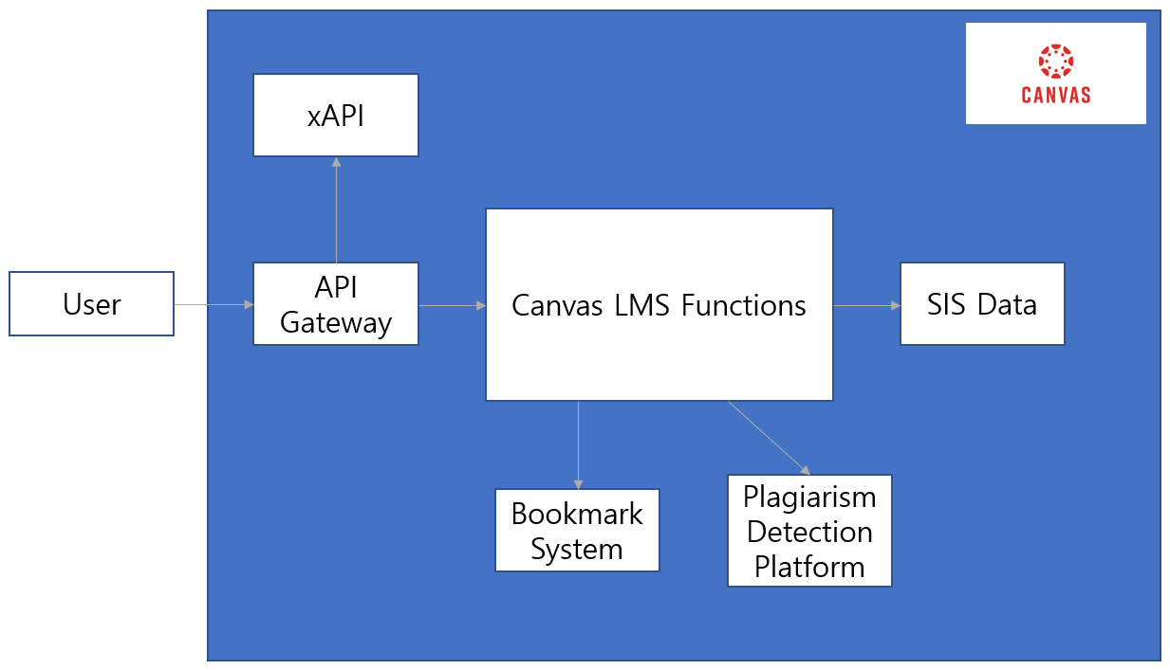

[figure ~~] Overall Architecture

This is the overall architecture of canvas and our bookmark function. The API gateway receives the request from the user. Then there are xAPIs and functions in Canvas LMS such as Accounts, Assignments, Discussions, and quizzes. Bookmark function will be one of the functions in Canvas LMS and SIS(Student Information Services) data will be stored in database. Plagiarism detection platform provides a standard way for LTI2 tool providers to seamlessly integrate plagiarism detection tools with Canvas.

5.3. Subcomponents

5.3.1. Canvas LMS Functions

5.3.1.1. Canvas LMS Functions – Course System

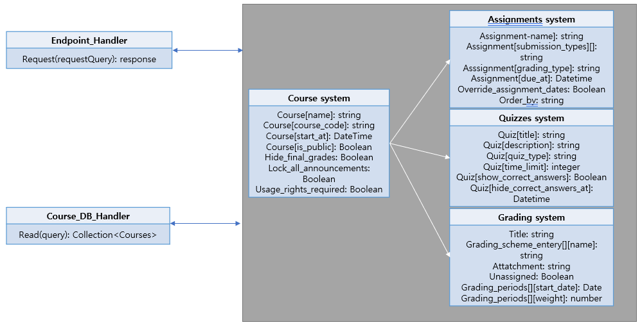

[figure ~~] Class diagram – Course system

5.3.1.1.1 Endpoint Hander

API gateway. Distribute requests form the user to the appropriate controller or API

5.3.1.1.2. Course DB Handler

Interface to communicate with DB with course information. The information about course is stored and gets the course information to show it to the user.

5.3.1.1.3. Course System

System for accessing course information. Users can list, create, delete, update a course and there will be additional systems for assignments, quizzes and grading.

5.3.1.2. Canvas LMS Functions – User System

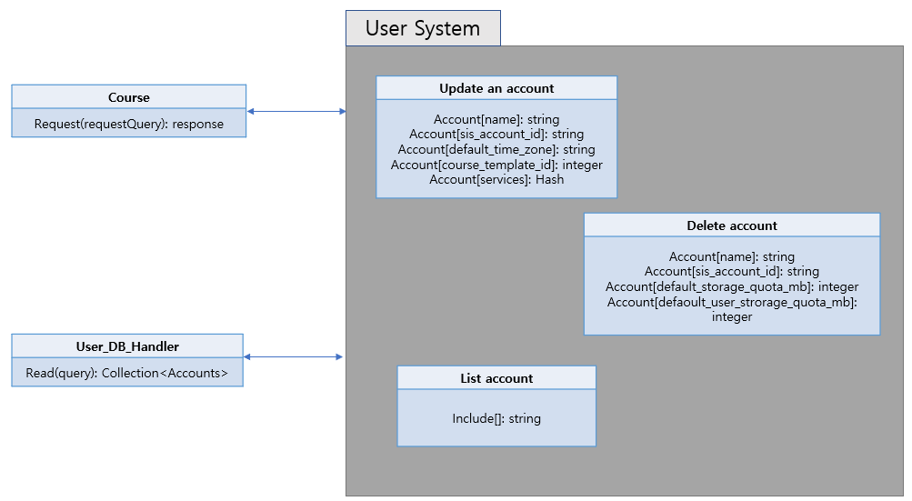

[figure ~~] Class diagram – User system

5.3.1.2.1 User DB Hander

Interface to communicate DB with user information. The information about user accounts is stored and gets the user information to show it to them.

5.3.1.2.2. User System

User can make a new account, update them and delete their account.

5.3.2. xAPI

xAPI(Experience API) is a data and interface standard that lest software applications capture and share data on human performance. There are functions such as Training progress data from a simulation, Chatting with a mentor and Watching a training video, stopping and starting it.

5.3.3. SIS Data

LMS database gets data from DB Importer scripts and sends it to SIS Importer Scripts. Then this information turns into Roster files and is sent to Canvas LMS.

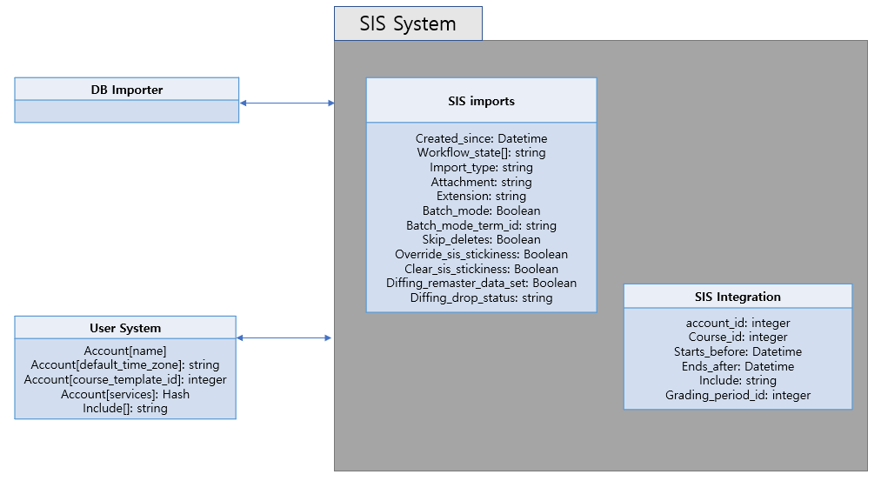

[figure ~~] Class diagram – SIS System

5.3.3.1. SIS imports

Imports data from Student Information Systems. Gets SIS import list, get the current importing SIS import, import SIS data and abort SIS import

5.3.3.2. SIS Integration

Includes helpers for integration with SIS Systems. Retrieves assignments enabled for grade export to SIS, disables assignments currently enabled for grad export to SIS.

5.3.4. Bookmark System

5.3.4.1. Class Diagram

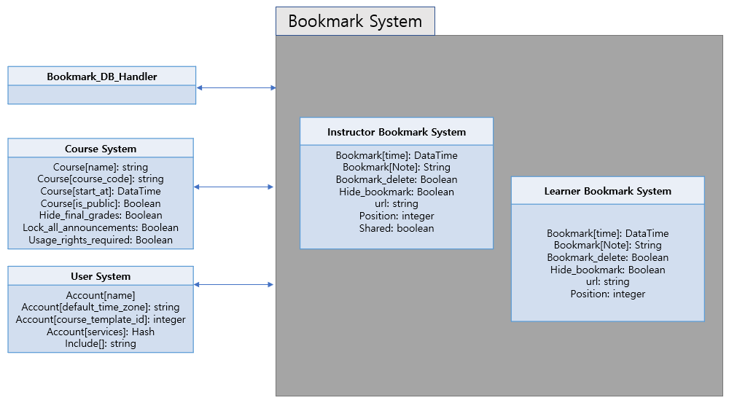

[figure ~~] Class diagram – Bookmark System

5.3.4.2. Sequence Diagram

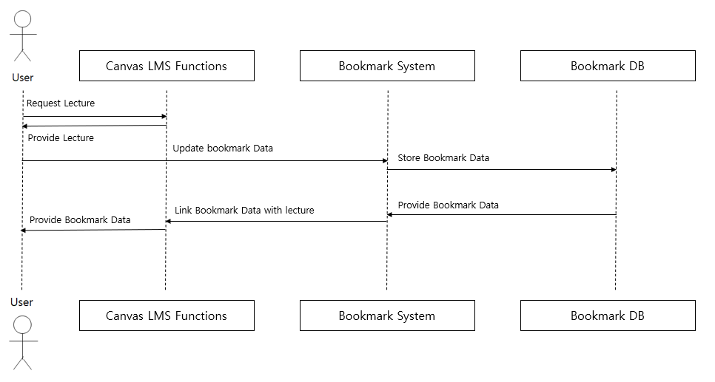

[figure ~~] Sequence diagram – Bookmark System