1. System Architecture – Frontend
   1. Objectives

이 장은 프론트엔드를 구성하는 컴포넌트의 기능, 구조와 각 컴포넌트의 관계를 설명한다.

* 1. Subcomponents
     1. User controller

유저의 type에 따라 다른 권한과 기능을 보여줍니다. 해당 course에서 유저의 type은 Canvas의 course api에서 자동으로 받아옵니다.

* + - 1. Attributes

These are the attributes that user controller object has.

* **ID**: ID of the user (school ID)
* **Position**: 해당 course에서 user의 역할(Instructor or learner.
  + - 1. Methods

These are the methods that user controller class has.

* SetUserData(name, course)
* GetUserID()
* GetUserPosition()
* ShowUI(position)
  + - 1. Class Diagram

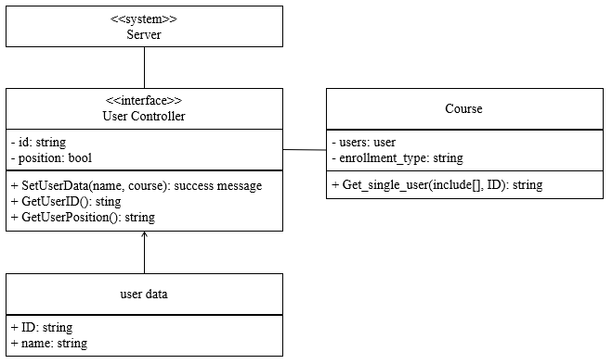

[Figure] Class diagram – User Controller

* + - 1. Sequence Diagram

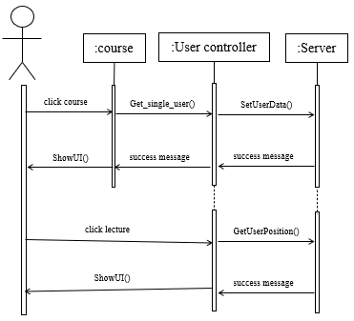

[Figure 6] Sequence diagram – User Controller

* + 1. Bookmark Controller

북마크를 생성, 수정, 삭제 등 관리하고 그 관리를 하는 북마크 테이블을 관리.

* + - 1. Attributes

These are the attributes that bookmark controller object has.

* **bookmark_list**: List of bookmarks made by user.
* **instructor_bookmark_list**: List of bookmarks made by instructor of course. If user is intstructor, this list will be empty.
* **user_controller**: It changes the flow according to user data.
  + - 1. Methods

These are the methods that user controller class has.

* ShowBookmarkTab()
* HideBookmarkTab()
* ShowInst.BookmarkTab()
* HideInst.BookmarkTab()
* AddBookmark(time)
* EditBookmark(time, string)
* DeleteBookmark()
  + - 1. Class Diagram

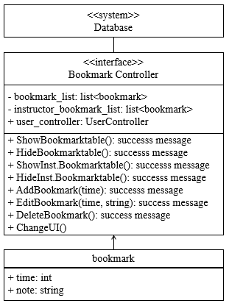

[Figure] Class diagram – Bookmark Controller

* + - 1. Sequence Diagram

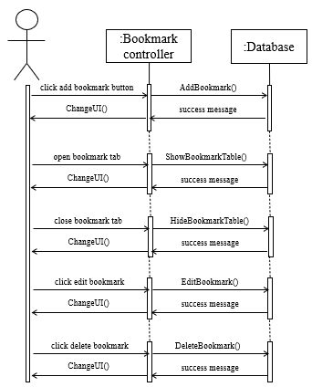

[Figure 6] Sequence diagram – Bookmark Controller

* + 1. Lecture Controller

북마크시 생성되는 북마크 flag를 통해 강의 시간을 조절하고 이를 접는 등 강의를 직접 변경할 수 있음.

* + - 1. Attributes

These are the attributes that bookmark controller object has.

* **user_bookmark_list**: List of bookmark times made by user.
* **instructor_bookmark_list**: List of bookmark times made by instructor of course. If user is intstructor, this list will be empty.
* **Lecture_video**: It contains all the information in the video in the MediaObject object.
  + - 1. Methods

These are the methods that user controller class has.

* ShowBookmarkTab()
* HideBookmarkTab()
* ShowInst.BookmarkTab()
* HideInst.BookmarkTab()
* AddBookmark(time)
* EditBookmark(time, string)
* DeleteBookmark()
  + - 1. Class Diagram

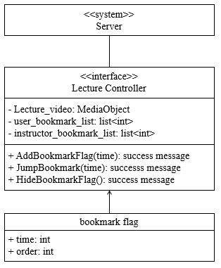

[Figure] Class diagram – Lecture Controller

* + - 1. Sequence Diagram

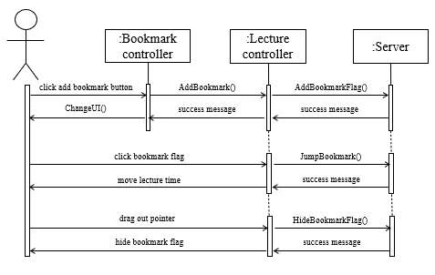

[Figure 6] Sequence diagram – Lecture Controller