

**I-Campus Lecture Sub System**

**Software Requirement Specification**

2021.04.25.

**Introduction to Software Engineering 41**

**TEAM 4**

Team Leader Jisun Lee

Team Member Chihyun Lee

Team Member Deokjae Kang

Team Member Dongjun Lee

Team Member Seongwoo Kim

Team Member Krogross Ryan

**CONTENTS**

1. Introduction 8

1.1. Purpose 8

1.2. Scope 8

1.3. Definitions, Acronyms, and Abbreviation 8

1.4. References 10

1.5. Overview 10

2. Overall Description 10

2.1. Product Perspective 10

2.1.1. System Interfaces 10

2.1.2. User Interfaces 11

2.1.3. Software Interfaces 11

2.1.4. Communications Interfaces 11

2.1.5. Memory Constraints 11

2.1.6. Operations 12

2.1.6.1. System administrator 12

2.1.6.2. User 12

2.1.6.2.1. Instructor 12

2.1.6.2.2. Learner 13

2.2. Product Functions 13

2.2.1. Make Bookmark 13

2.2.2. Jump to Bookmark 13

2.2.3. Edit Bookmark 13

2.2.4. Delete Bookmark 13

2.2.5. Share Bookmark 14

2.2.6. Bookmark tab show/hide 14

2.2.7. Instructor Bookmark tab show/hide 14

2.2.8. Review Analysis 14

2.3. User Characteristics 14

2.3.1. System Administrator 14

2.3.2. User 15

2.3.2.1. Instructor 15

2.3.2.2. Learner 15

2.4. Constraints 15

2.5. Assumptions and Dependencies 16

3. Specific Requirements 16

3.1. External Interface Requirements 16

3.1.1. User Interfaces 16

3.1.2. Hardware Interfaces 21

3.1.3. Software Interfaces 21

3.1.4. Communication Interfaces 22

3.2. Functional Requirements 23

3.2.1. Use Case 23

3.2.2. Use Case Diagram 27

3.2.3. Data Dictionary 28

3.2.4. Data Flow Diagram 31

3.3. Performance Requirements 31

3.3.1. Static numerical requirement 31

3.3.2. Dynamic numerical requirement 31

3.4. Logical Database Requirements 32

3.5. Design Constraints 32

3.6. Standards compliance 32

3.7. Software System Characteristics 32

3.7.1. Product Requirements 32

3.7.1.1. Usability Requirements 33

3.7.1.2. Performance Requirements 33

3.7.1.3. Dependability Requirements 33

3.7.1.4. Security Requirements 33

3.7.2. Organizational Requirements 33

3.7.2.1. Environmental Requirements 34

3.7.2.2. Operational Requirement 34

3.7.3. External Requirements 34

3.7.3.1. Safety / Security Requirement 34

3.7.3.2. Regulatory Requirement 34

3.8. Organizing the Specific Requirements 35

3.8.1. Context Model 35

3.8.2. Process Model 36

3.8.3. Interaction Model 36

3.8.4. Behavior Model 36

3.8.4.1. Data Flow Diagram 36

3.8.4.2. Sequence Diagram 36

3.9. System Architecture 37

3.10. System Evolution 38

3.10.1. Limitation and Assumption 38

3.10.2. Evolutions of Hardware and Change of User Requirements 38

4. Supporting Information 38

4.1. Software Requirement Specification 38

4.2. Document History 39

**LIST OF FIGURES**

[Figure 1] Use case diagram 27

[Figure 2] Entity Relationship Diagram 30

[Figure 3] Data flow diagram 31

[Figure 4] Context model 35

[Figure 5] Overall process model 36

[Figure 6] Sequence diagram 37

[Figure 7] System architecture of the system 37

LIST OF TABLES

[Table 1] Table of acronyms and abbreviations 8

[Table 2] Table of terms and definitions 8

[Table 3] Basic user interface for instructor 15

[Table 4] Basic user interface for learner 16

[Table 5] Interface for user's own bookmark table 17

[Table 6] Interface for make bookmark 18

[Table 7] Interface for edit bookmark 19

[Table 8] interface for instructor's bookmark table for learner user 19

[Table 9] Hardware interface of applicable device for the system 20

[Table 10] Software interface of PostgreSQL database 20

[Table 11] Communication interface of client and host 21

[Table 12] Use case of open own bookmark table 22

[Table 13] Use case of make bookmark 23

[Table 14] Use case of jump to bookmark 23

[Table 15] Use case of edit bookmark 23

[Table 16] Use case of add note 24

[Table 17] Use case of delete bookmark 25

[Table 18] Use case of open instrucor's bookmark 25

[Table 19] learner 27

[Table 20] instructor 27

[Table 21] learner_group 27

[Table 22] subject 27

[Table 23] lecture 27

[Table 24] video 28

[Table 25] bookmark_learner 28

[Table 26] bookmark_instructor 28

[Table 27] Document History 38

1. Introduction
   1. Purpose

This document is a software requirement specification (SRS) for the addition of the ICampus lecture video bookmark and note system. This system is designed and implemented by Sungkyunkwan University's software engineering introduction team4, and this document will be used to guide how the system will be developed and implemented.

This document records the requirements for the features and development methods of the bookmarks, notes that are included in ICampus' lecture system to assist the lecture. Since this feature is a sub-system of the ICampus lecture system, the development language, data transfer, storage format, and so on refer to the canvas open source in github. The intended audience of this document includes students, TA’s, and professors that wish to use this feature in ICampus.

* 1. Scope

This document is a software requirement specification (SRS) for the addition of the ICampus lecture video bookmark and note system. This system is designed and implemented by Sungkyunkwan University's software engineering introduction team4, and this document will be used to guide how the system will be developed and implemented.

This document records the requirements for the features and development methods of the bookmarks, notes that are included in ICampus' lecture system to assist the lecture. Since this feature is a sub-system of the ICampus lecture system, the development language, data transfer, storage format, and so on refer to the canvas open source in github. The intended audience of this document includes students, TA’s, and professors that wish to use this feature in ICampus.

* 1. Definitions, Acronyms, and Abbreviation

The following table explains the acronyms and abbreviations used in this document.

[Table 1] Table of acronyms and abbreviations

| **Acronyms& Abbreviations** | **Explanation** |
| --- | --- |
|  |  |
|  |  |
|  |  |
|  |  |
|  |  |
|  |  |
|  |  |
|  |  |
|  |  |

The following table defines certain technical terms used in this document.

[Table 2] Table of terms and definitions

| **Terms** | **Definitions** |
| --- | --- |
| User | Who uses this system through ICampus. User types are divided into learners and instructors. |
| Instructor | Users who can modify lecture materials such as uploading/deleting lecture contents of ICampus. Professors and TAs of the course are applicable. |
| Learner | Users who are only allowed to access lecture materials in the lecture contents of ICampus. Includes students, auditor, etc. of the class. |
| Bookmark | A device for marking branches or writing notes in lecture video materials. User can optionally write a note. |
| Bookmark flag | If a bookmark is created, mark the location of that bookmark with a small flag in the progress bar of the lecture. Distinguish color between Instructor bookmark and learner bookmark. |
| Bookmark table | After bookmarks are created, bookmark table are created under the lecture video. You can expand and fold tables and modify and delete bookmarks, notes, and notes while the table is expanded. |

* 1. References
* IEEE Std 830-1998: IEEE Recommended Practice for Software Requirement Specification. https://ieeexplore.ieee.org/document/720574
* SRS_TEAM1: Introduce to Software Engineering, 2020 spring, team1. <https://github.com/skkuse/2020spring_41class_team1/tree/master/docs>
  1. Overview

This software requirement document consists of Introduction, Overall Description, Specific Requirement, and Supporting Information. Overall description defines the interaction of systems and related systems as well as the perspective of system functions and users. In the following section, specific requirements specify specific interfaces and functional and non-functional requirements at actual use, and the evolution of future systems. The last section, Supporting Information, also contains information referenced in preparing this requirement specification and a table of document progress. The project was carried out with equal contribution from all team members.

1. Overall Description
   1. Product Perspective

Due to COVID-19, many students are taking class with i-campus. This feature is designed to help students study more efficiently, by making it easier for students to find the exact time they want and take notes linked to lecture. Also, sharing bookmarks could be helpful for instructors who want their lectures to be easier to understand.

* + 1. System Interfaces

This function is based on the Canvas LMS web-based platform. Canvas LMS consists of a web-application framework implemented with Rubi on Rails and is hosted by a native cloud and AWS.

The template uses most-recent web technology based on HTML5.

All API access is over HTTPS and all API responses are in JSON format.

* + 1. User Interfaces

The bookmark user interface will be added under the i-campus lecture page. There will be a “Make Bookmark” button that is accessible from the same page as the lecture video. Once the bookmark is made, it can be edited or deleted.

Users can choose either to hide or show the bookmark tab.

If the user type is instructor, there will be additional “Share” button, which allows the instructor to share their bookmarks and notes with learners. If the user type is learner, there will be one more bookmark tab which is shared by instructor.

The administrator can generate and organize bookmark database and manage the interface of bookmark.

* + 1. Software Interfaces

The function is based on Canvas LMS. The server must have at least 4GB of storage. To be Android compatible, it needs Android OS version at least Android 6.0.

* + 1. Communications Interfaces

User device and server communication is handled with HTTP protocol in JSON format.

* + 1. Memory Constraints

The function requires at least 27MB of memory.

* + 1. Operations
       1. System administrator
  + Administrator can manage and organize the database.
  + Administrator can update the interface of bookmark function.
    - 1. User
  + Make Bookmark
    - User can create a new bookmark by clicking “Make Bookmark” button.
  + Jump to Bookmark
    - Generated bookmarks will appear on both the bookmark tab and the lecture timeline.
    - To study the specific part of lecture again, the user can jump to the exact time by clicking the bookmark.
  + Edit Bookmark
    - After the bookmark is made, the user can edit the bookmark.
    - In the bookmark tab, the user can change the time and note of the bookmark.
  + Delete Bookmark
    - If the user clicks the “delete” tab, an ‘x button’ will be shown beside the bookmarks in the bookmark tab.
  + Show/Hide Bookmark
    - User can choose to show or hide the bookmark tab.
      * 1. Instructor
  + Share Bookmark
  + Instructor will have an additional “Share Bookmark” button. The instructor can click this button to show the bookmarks and notes to learners.
    - * 1. Learner
  + Show/Hide Instructor Bookmark
  + There are two separate bookmark tabs for the learners: instructor bookmark and their own bookmark.
  1. Product Functions
     1. Make Bookmark

There is a “Make Bookmark” button in the lecture. Users can make new bookmarks by clicking it. Then, the bookmark will be added to the bookmark tab along with the time that at which the user clicked it. There will be flag at the time selected in the lecture timeline.

* + 1. Jump to Bookmark

After the user makes bookmarks, the bookmarks’ list is shown in bookmark tab. To return to the exact time in the lecture, the user can click one of the bookmarks.

* + 1. Edit Bookmark

Users can change both the time and note of the bookmark. In the bookmark tab, there is an edit button. By clicking it, the bookmark tab will change to edit-available mode. Users can click where they want to change and save bookmarks.

* + 1. Delete Bookmark

There is a delete button in the bookmark tab. Once the user clicks it, the ‘x’ button will appear beside each of the bookmarks in bookmark tab. Users can delete the specific bookmark by clicking the ‘x’ button.

* + 1. Share Bookmark

This function is only available to instructor. After the instructor creates bookmarks for their lecture, they can choose to share it or not. If they choose to share, learners can see the bookmarks of their instructor. There will be separate bookmark tab and flag marks with a different color(s).

* + 1. Bookmark tab show/hide

Users will have an option to show or hide the bookmark tab. If they choose to see it, the bookmark tab will be shown. If they do not want to see it, they can click the ‘hide’ button and then, the bookmark tab will be invisible.

* + 1. Instructor Bookmark tab show/hide

There is another separate bookmark tab for learners which is Instructor Bookmark Tab. This tab has similar functionality to their own bookmark tab, but they cannot make/edit/delete the bookmarks in here.

* + 1. Review Analysis

Reviews on a device are processed by text-mining methods by the database system. The result would be provided to users as a visualized figure which would help intuitive understanding of the device. Keywords that are important in the review are predefined by the system administrator, the site to be crawled is determined, and the reviews of other users are concatenated to quantify the evaluation of specific keywords and stored in the database.

* 1. User Characteristics
     1. System Administrator

The system administrator must be a person with sufficient knowledge of the ICampus system and database. System administrators must have majored in computer science or have sufficient training to handle networks and databases. It is also assumed that the system administrator can handle and resolve bookmark data problems when they occur. In addition, system administrators must have a basic software engineering ethics to prevent such data from being taken out or used for malicious purposes.

* + 1. User

The User referred to in this document includes all people who use the ICampus system. Furthermore, Users are divided into instructor and learner. It is assumed that they all understand how to use the existing ICampus features and that they can learn new features quickly by receiving a brief user manual after feature updates.

* + - 1. Instructor

Instructor refers to a person who has permission to upload, modify, or delete materials in most of the subject article in ICampus, such as announcements and lecture content. This corresponds to the professor and TA of the subject.

* + - 1. Learner

Learners do not have permission to upload materials to most of the subjects in ICampus and can view materials uploaded by Instructor. This includes students, auditor.

* 1. Constraints

The system is designed and implemented based on this document. Basically, the following matters shall be followed and other matters shall be governed by the developer in a way that does not deviate from the ethics of software engineering:

* + - * When bookmarks are created or deleted, they shall be applied within 3 seconds.
      * Reduce page load speed difference from existing to less than 1 second after bookmark function is added.
      * It provides enough space to store bookmark data for all learners for at least one year.
      * Made by considering system development costs, maintenance costs, and scalability.
      * Optimize source code to reduce system efficiency and operating time.
      * Specify the modifications accurately so that they do not violate the Canvas-lms license.
      * Make all versions supported by canvas-lms compatible.
      * All developments are open source based and should be made available on all devices that are not subject to operating system restrictions in Canvas-lms.
  1. Assumptions and Dependencies

All systems in this document are designed and implemented as internal features of the canvas-lms system. Therefore, the system's constraints are the same as those of canvas-lms and its mobile application Learning-X. For PC versions, it is assumed to be available on search engines such as Safari (MacOS 11.0 or later), Google Chrome, and Firefox. Other search engines may have login or video viewing problems. For mobile devices, the system should work on the Learning X application operating basics of iPhone iOS 13.0 or later, iPad OS 13.0 or later, and Android version 5.0 or later. Other devices may have application usage problems.

1. Specific Requirements
   1. External Interface Requirements
      1. User Interfaces

[Table 3] Basic user interface for instructor

| **Name** | **Basic User Interaction Using Touchscreen** |
| --- | --- |
| Purpose/Description | Users transmit their instructions through a touchscreen of the device |
| Input source/ Output destination | User/ user device equipped with Android OS |
| Purpose/Description | Basic interface for Instructor user in PC and open, close bookmark table/  Users transmit their instructions through a click button |
| Input source/ Output destination | User/ User's screen equipped with chrome in PC and server |
| Time/ Velocity | Asynchronous user input /  Communication time between the server and the user device |
| Function/ Relationship of input/outputs | Open or close the bookmark table/  After receiving the inputs, the user device transmits the input data to the server for processing the input data and request desired output data |
| Format and configuration of screen | 1. PC : An activity screen connected to an html file, mainly composed of btn.  1. Smart Phone : An activity screen connected to an XML file, mainly composed of TextViews  2. The button provides a basis for choosing the following input, and it is ready to receive the inputs from users  3. Users are to click a button to interact with the system |
| Data type | PC : btn class  Smart Phone : int type value of a button code |
| Instruction type | Instruction mapping according to the class name of a button. |
| Exit message | N/A |

[Table 4] Basic user interface for learner

| **Name** | **Search Interface1 – Get User Preference** |
| --- | --- |
| Purpose/Description | Basic interface for learner user in PC and open, close the book mark tables/  Users transmit their instructions through a click button |
| Input source/ Output destination | User/ User's screen equipped with chrome in PC and server |
| Time/ Velocity | Asynchronous user input /  Communication time between the server and the user device |
| Function/ Relationship of input/outputs | Open or close the bookmark table/  After receiving the inputs, the user device transmits the input data to the server for processing the input data and request desired output data |
| Format and configuration of screen | 1. PC : An activity screen connected to an html file, mainly composed of btn.  1. Smart Phone : An activity screen connected to an XML file, mainly composed of TextViews  2. The button provides a basis for choosing the following input, and it is ready to receive the inputs from users  3. Users are to click a button to interact with the system |
| Data type | PC : btn class  Smart Phone : int type value of a button code |
| Instruction type | Instruction mapping according to the class name of a button. |
| Exit message | N/A |

[Table 5] Interface for user's own bookmark table

| **Name** | **Search Interface 2 – Search** |
| --- | --- |
| Purpose/Description | Jump the timeline or make, edit the bookmarks/  Users can jump to bookmark and make or edit their own bookmarks.  Users transmit their instructions through a click button |
| Input source/ Output destination | User / User's screen equipped with chrome in PC and server |
| Time/ Velocity | Asynchronous user input /  Communication time between the server and the user device |
| Function/ Relationship of input/outputs | Jump to marked timeline and open note. Edit or make bookmark and note/  After the work of input finished, the bookmark table is re-opened and delete the output result from the previous input. |
| Format and configuration of screen | 1. PC : An activity screen connected to an html file, mainly composed of btn and input.  1. Smart Phone : An activity screen connected to an XML file, mainly composed of TextViews and EditText  2. The bookmarks created by the user are displayed, and the set time and note are written in each.  3. When the user clicks the button ’edit’ or 'make', show another interface for input function. |
| Data type | PC : btn and input class  Smart Phone : int type value of a button code and EditText |
| Instruction type | Instruction mapping according to the class name |
| Exit message | N/A |

[Table 6] Interface for make bookmark

| **Name** | **Search Interface 3 – Item details** |
| --- | --- |
| Purpose/Description | Make new bookmark for it's leacture video/  The inputs that set the flag and edit bookmark and create button |
| Input source/ Output destination | User / Server |
| Time/ Velocity | After all the input data(flag, note) were received and create button clicked/  Communication time between the server and the user device |
| Function/ Relationship of input/outputs | Set the time flag and write note/  The time of flag should not overlap with existing bookmark. |
| Format and configuration of screen | 1. PC : An activity screen connected to an html file, mainly composed of btn and input.  1. Smart Phone : An activity screen connected to an XML file, mainly composed of TextViews and EditText  2. The input class enables users to set time and write note. And create button that exit this interface  3. If the time overlaps, a warning message appears, and note indicates the limit of the number of characters and the number of written characters. |
| Data type | PC : btn and input class  Smart Phone : int type value of a button code and EditText |
| Instruction type | Instruction mapping according to the class name |
| Exit message | “Bookmark created successfully” |

[Table 7] Interface for edit bookmark

| **Name** | **Customization Interface 1 - Cart** |
| --- | --- |
| Purpose/Description | Edit the existing bookmark for it's leacture video/  The inputs that edit the flag and edit bookmark and save, delete button |
| Input source/ Output destination | User / Server |
| Time/ Velocity | After all the input data(flag, note) were received and the save or delete button clicked/  Communication time between the server and the user device |
| Function/ Relationship of input/outputs | Edit the time flag and write note or delete bookmark/  The time of flag should not overlap with existing bookmark. |
| Format and configuration of screen | 1. PC : An activity screen connected to an html file, mainly composed of btn and input.  1. Smart Phone : An activity screen connected to an XML file, mainly composed of TextViews and EditText  2. The input class enables users to set time and write note. And save, delete button that exit this interface  3. If the time overlaps, a warning message appears, and note indicates the limit of the number of characters and the number of written characters. |
| Data type | PC : btn and input class  Smart Phone : int type value of a button code and EditText |
| Instruction type | Instruction mapping according to the class name |
| Exit message | “Bookmark edited successfully” or “Bookmark deleted successfully” |

[Table 8] interface for instructor's bookmark table for learner user

| **Name** | **Customization Interface 3 - Register** |
| --- | --- |
| Purpose/Description | Jump the timeline/  Users can jump to bookmark/  Users transmit their instructions through a click button |
| Input source/ Output destination | User / User's screen equipped with chrome in PC and server |
| Time/ Velocity | Asynchronous user input /  Communication time between the server and the user device |
| Function/ Relationship of input/outputs | Jump to marked timeline and open note./  After the work of input finished, the bookmark table is re-opened and delete the output result from the previous input. |
| Format and configuration of screen | 1. PC : An activity screen connected to an html file, mainly composed of btn.  1. Smart Phone : An activity screen connected to an XML file, mainly composed of TextViews |
| Data type | PC : btn class  Smart Phone : int type value of a button cod |
| Instruction type | Instruction mapping according to the class name |
| Exit message | N/A |

* + 1. Hardware Interfaces

[Table 9] Hardware interface of applicable device for the system

| **Name** | **Applicable device for the system** |
| --- | --- |
| Purpose/Description | PC : Enable users to take advantage of the service provided by chrome web browser.  Smart Phone : Android OS At least Android 5.0 |

* + 1. Software Interfaces

[Table 10] Software interface of PostgreSQL database

| **Name** | **Firebase Real-time Database** |
| --- | --- |
| Purpose/Description | Query input/output for managing multimedia/meta data |
| Input source/ Output destination | Host server/ User, User/Host server |
| Range/  Accuracy/  Margin of error | Depends on the performance of the PostgreSQL |
| Unit | Query |
| Time/ Velocity | Instant reaction  Within 3 seconds when make or delete a bookmark |
| Relationship with other input/outputs | Related to all inputs/outputs from server |
| Format and configuration of screen | N/A |
| Format and configuration of window | N/A |
| Data type | Query |
| Instruction type | Query statement |
| Exit message | N/A |

* + 1. Communication Interfaces

[Table 11] Communication interface of client and host

| **Name** | **Client and Host** |
| --- | --- |
| Purpose/Description | Each client requests the connection to the host, requesting list of results of bookmarks  Host provides a bookmark table to the client |
| Input source/  Output destination | Client/Host server |
| Unit | packet |
| Time/ Velocity | Within 3 seconds when make or delete a bookmark |
| Relationship with other input/outputs | Related to all inputs/outputs from server |
| Format and configuration of screen | N/A |
| Format and configuration of window | N/A |
| Data type | Query |
| Instruction type | Query statement |
| Exit message | N/A |

* 1. Functional Requirements
     1. Use Case

[Table 12] Use case of open own bookmark table

| **Use case name** | **Register** |
| --- | --- |
| Actor | Instructor and Learner |
| Description | It is a process when an instructor and learner tries to open their own bookmark table |
| Normal Course | 1. All the users can see their bookmark table bar under the video 2. The user click the button that is in bookmark table bar 3. The system check database about bookmark and show bookmark data in database, bookmark flag and buttons to control bookmark. The data and buttons includes    1. Bookmark id    2. Bookmark time    3. Bookmark note    4. Make bookmark button    5. Edit bookmark button 4. Delete bookmark button |
| Precondition | The user is in the lecture page that conclude video  In case of there are no data in database, the system show nothing to page |
| Post Condition | N/A |
| Assumptions | The user want to see their own bookmark table. |

[Table 13] Use case of make bookmark

| **Use case name** | **Log-in/out** |
| --- | --- |
| Actor | Instructor and Learner |
| Description | It is a process when an instructor and learner tries to make bookmark. |
| Normal Course | 1. All the users can see bookmark button when users open bookmark table 2. The user click the “make bookmark” button 3. The system check the time of video and add new row in bookmark table to show new bookmark data to user |
| Precondition | The user is in the lecture page that conclude video  The bookmark table is opened |
| Post Condition | The data about new bookmark should save at database |
| Assumptions | The user want to add new bookmark |

[Table 14] Use case of jump to bookmark

| **Use case name** | **Profile** |
| --- | --- |
| Actor | Instructor and Learner |
| Description | It is a process when an instructor and learner tries to jump to bookmark. |
| Normal Course | 1. All the users can see bookmark time in bookmark table 2. The user click the “bookmark time” 3. The system show the video at "bookmark time” |
| Precondition | The user is in the lecture page that conclude video  The bookmark table is opened  There is at least one bookmark in bookmark table |
| Post Condition | N/A |
| Assumptions | The user want to jump to bookmark |

[Table 15] Use case of edit bookmark

| **Use case name** | **Search** |
| --- | --- |
| Actor | Instructor and Learner |
| Description | It is a process when an instructor and learner tries to edit bookmark. |
| Normal Course | 1. All the users can see “edit bookmark” button when users open bookmark table 2. The user click the “edit bookmark” button 3. The system change the modifiability of data. The data includes    1. Time data    2. Note (if there is a note) 4. The system show several buttons. The buttons includes    1. "add note” button if there is no note with bookmark    2. "delete note” button if there is a note    3. "finish edit” button 5. The user can change the content of time data and note 6. The user can delete note by click the "delete note” button 7. The system show bookmark table page after user click the "finish edit” button |
| Precondition | The user is in the lecture page that conclude video  The bookmark table is opened  There is at least one bookmark in bookmark table |
| Post Condition | The changed data about time and note are save at database |
| Assumptions | The user want to change the data of bookmark |

[Table 16] Use case of add note

| **Use case name** | **Item details** |
| --- | --- |
| Actor | Instructor and Learner |
| Description | It is a process when an instructor and learner tries to add note |
| Normal Course | 1. All the users can see “add note” button when users click the "edit bookmark” button if there are some bookmark with no note 2. The user click the “add note” button 3. The system add new row under the bookmark that user want to add note. The new row is modifiable. 4. The user can write content in new row 5. The system show bookmark table page after user click the "finish edit” button |
| Precondition | The user is in the lecture page that conclude video  The bookmark table is opened  There is at least one bookmark in bookmark table  There is at least one bookmark with no note |
| Post Condition | The note data are save at database |
| Assumptions | The user want to add note |

[Table 17] Use case of delete bookmark

| **Use case name** | **Add to cart** |
| --- | --- |
| Actor | Instructor and Learner |
| Description | It is a process when an instructor and learner tries to delete bookmark |
| Normal Course | 1. All the users can see “delete bookmark” button when users open bookmark table 2. The user click the “delete bookmark” button 3. The system show "delete” button on the right side of bookmarks and one "finish delete” button 4. The user can click the "delete” button to delete the bookmark 5. The user can delete note by click the "delete note” button   The system show bookmark table page after user click the "finish delete” button |
| Precondition | The user is in the lecture page that conclude video  The bookmark table is opened  There is at least one bookmark in bookmark table |
| Post Condition | The delete the data in database |
| Assumptions | The user want to delete bookmark |

[Table 18] Use case of open instrucor's bookmark

| **Use case name** | **Move to purchase page link** |
| --- | --- |
| Actor | Learner |
| Description | It is a process when an instructor and learner tries to open instructor's bookmark |
| Normal Course | 1. All the users can see their bookmark table bar under the video 2. The user click the button that is in bookmark table bar 3. The system check database about bookmark and show bookmark data in database and bookmark flag. The data includes    1. Bookmark id    2. Bookmark time 4. Bookmark note |
| Precondition | The user is in the lecture page that conclude video  In case of there are no data in database, the system show nothing to page |
| Post Condition | N/A |
| Assumptions | The user want to see instructor's bookmark table. |

* + 1. Use Case Diagram

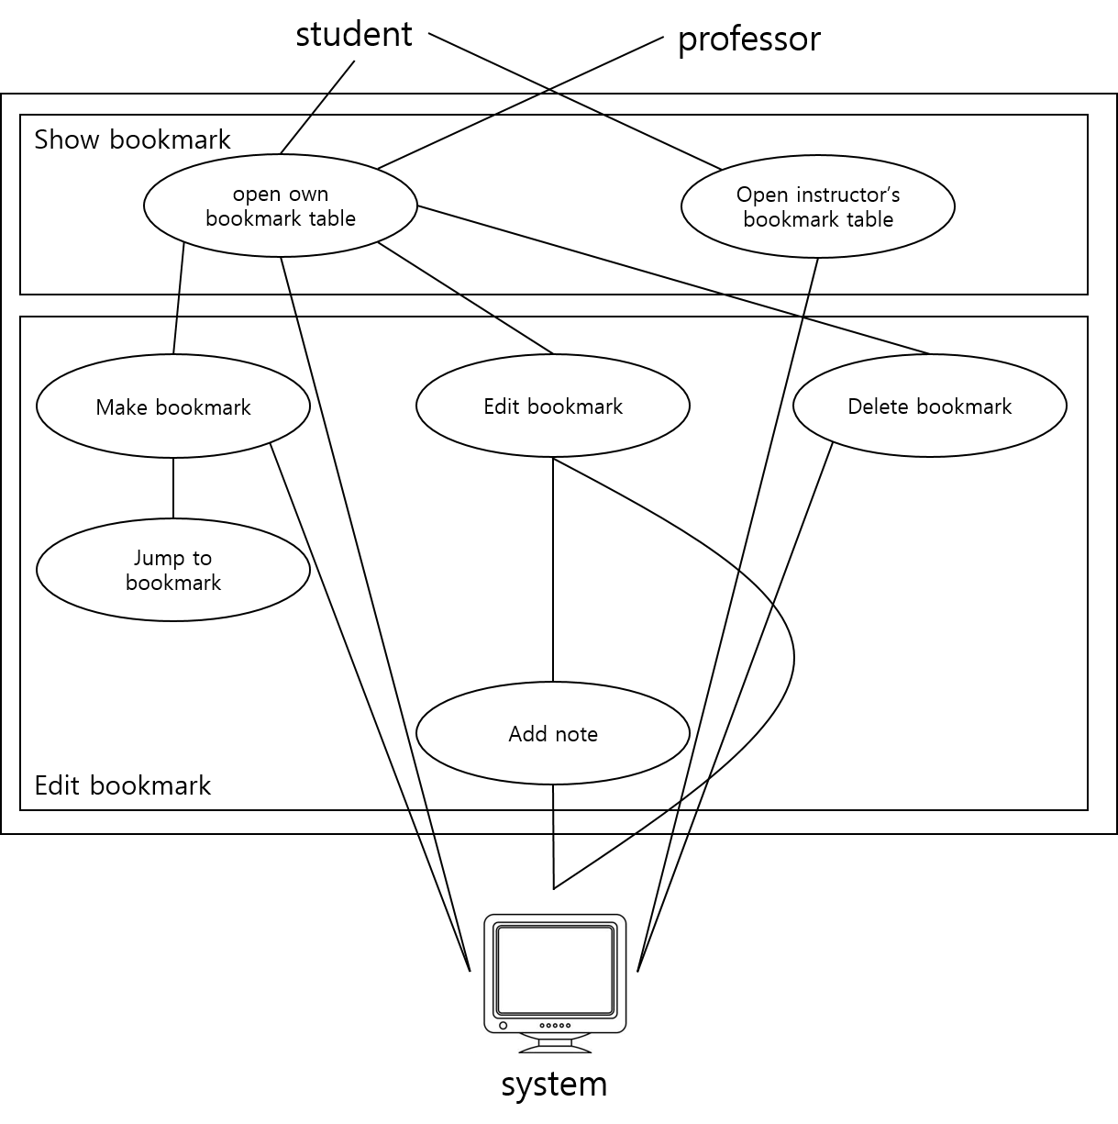

[Figure 1] Use case diagram

* + 1. Data Dictionary

[Table 19] learner

| **Field** | **Key** | **Constraint** | **Description** |
| --- | --- | --- | --- |
| learner_id | PK, FK | Not Null | Learner id(student number) |
| name |  | Not Null | Learner name |
| age |  | Not Null | Learner age |
| gender |  |  | Learner gender |

[Table 20] instructor

| **Field** | **Key** | **Constraint** | **Description** |
| --- | --- | --- | --- |
| instructor_id | PK, FK | Not Null | Instructor id |
| name |  | Not Null | Instructor name |
| major |  | Not Null | Instructor major |

[Table 21] learner_group

| **Field** | **Key** | **Constraint** | **Description** |
| --- | --- | --- | --- |
| group_id | PK | Not Null | Group id |
| subject_id |  | Not Null | Subject id |
| learner_id |  | Not Null | Learner id |

[Table 22] subject

| **Field** | **Key** | **Constraint** | **Description** |
| --- | --- | --- | --- |
| subject_id | PK, FK | Not Null | Subject id |
| subject_name |  | Not Null | Subject name |
| Insructor_id |  | Not Null | Insructor id |

[Table 23] lecture

| **Field** | **Key** | **Constraint** | **Description** |
| --- | --- | --- | --- |
| subject_id |  | Not Null | Subject id |
| lecture_id | PK, FK | Not Null | Lecture id |
| lecture_name |  |  | Lecture name |

[Table 24] video

| **Field** | **Key** | **Constraint** | **Description** |
| --- | --- | --- | --- |
| lecture_id |  | Not Null | Lecture id |
| video_id | PK, FK | Not Null | Video id |
| video_name |  |  | Video name |
| video_time |  | Not Null | Video time |

[Table 25] bookmark_learner

| **Field** | **Key** | **Constraint** | **Description** |
| --- | --- | --- | --- |
| bookmark_id | PK | Not Null | Bookmark id |
| learner_id |  | Not Null | Learner id |
| video_id |  | Not Null | Video id |
| time |  | Not Null | Bookmark time |
| is_note |  | Not Null | Note presence |
| note |  |  | Note content |

[Table 26] bookmark_instructor

| **Field** | **Key** | **Constraint** | **Description** |
| --- | --- | --- | --- |
| bookmark_id | PK | Not Null | Bookmark id |
| instructor_id |  | Not Null | Instructor id |
| video_id |  | Not Null | Video id |
| time |  | Not Null | Bookmark time |
| is_note |  | Not Null | Note presence |
| note |  |  | Note content |

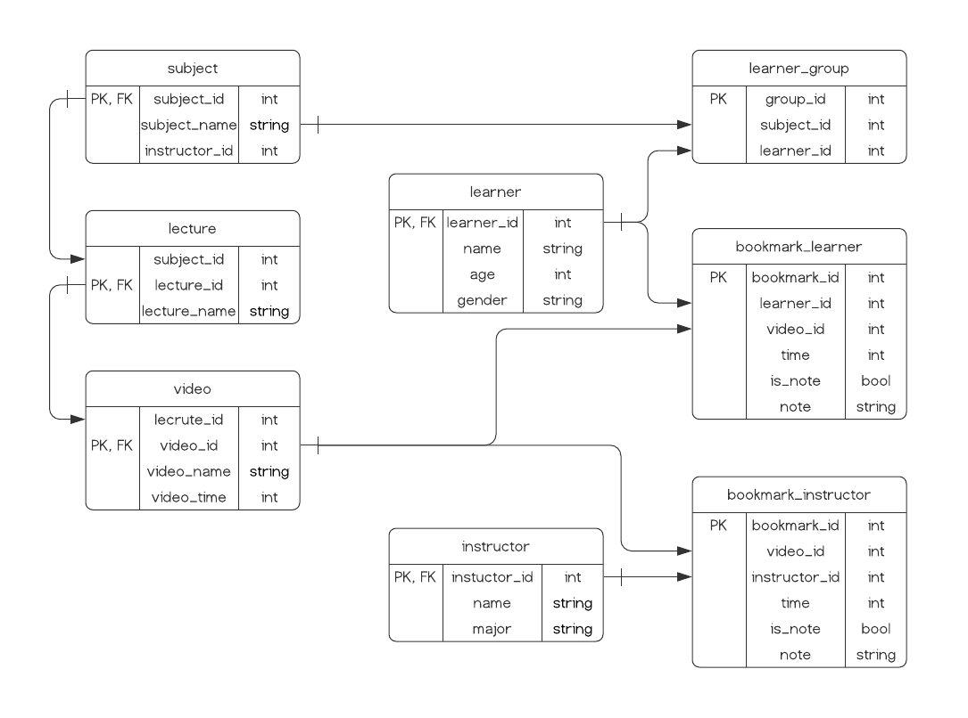

[Figure 2] Entity Relationship Diagram

* + 1. Data Flow Diagram

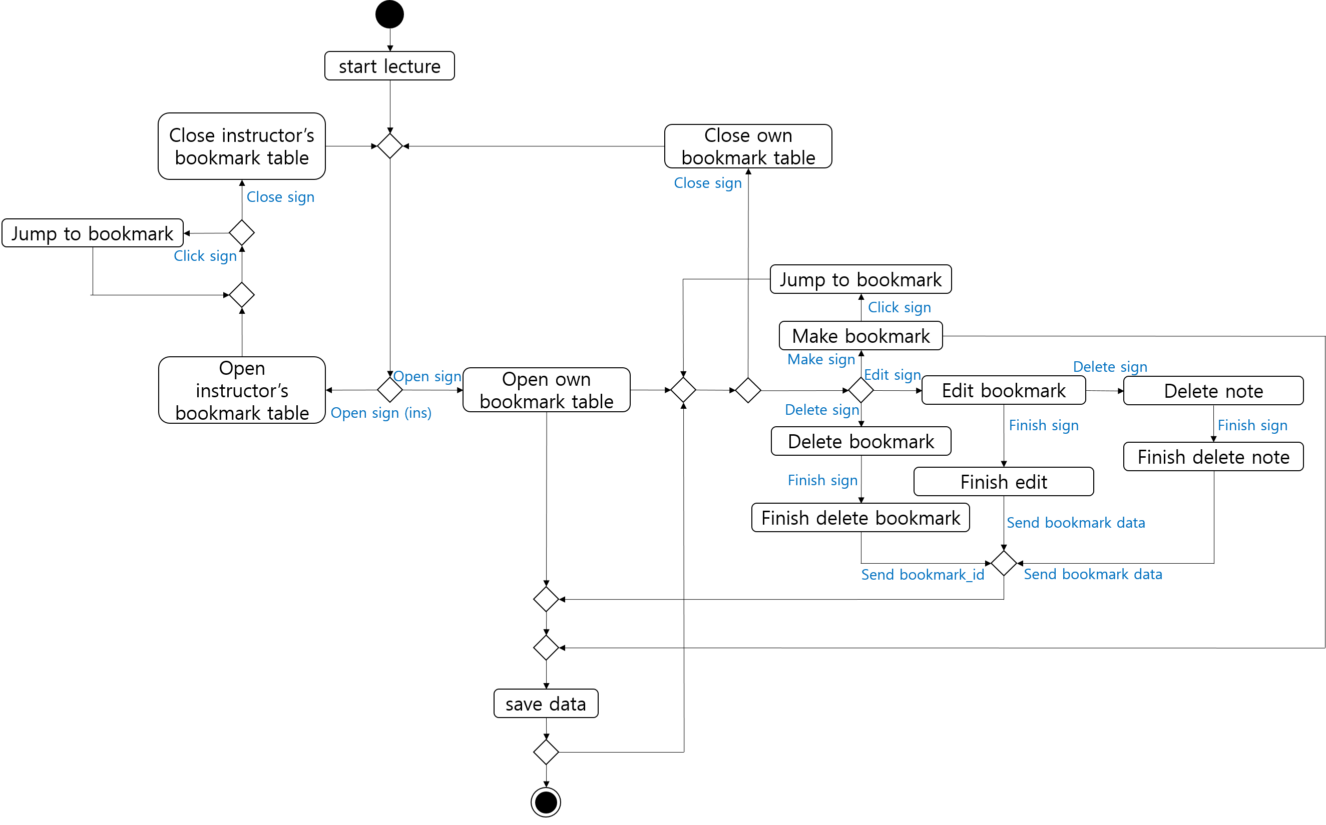

[Figure 3] Data flow diagram

* 1. Performance Requirements

The following requirements are based on estimates and are subject to change.

* + 1. Static numerical requirement
* The system should support access by professors, TA’s, and students alike.
* The system should function properly on mobile devices, laptops, and desktop computers.
  + 1. Dynamic numerical requirement
* The system must properly handle 10,000 simultaneous calls to bookmark related functions.
* An instructor’s bookmark edit should be processed and update student bookmarks within 10 seconds.
* Student bookmark edits should be processed within 3 seconds.
* Any jumping to bookmarks should be processed within 1 second.
  1. Logical Database Requirements

All bookmark data must be stored on the server side. However, student bookmarks must be account specific while TA and professor bookmarks must update all other users that are within their class assignment.

* 1. Design Constraints

When designing the bookmarking software, there must not be any noticeable effects on the other i-Campus functions.

* 1. Standards compliance

The notation, coding conventions, and style must follow the same methods of the other i-Campus software. The software should be written using Ruby.

* 1. Software System Characteristics

This section details some of the non-functional requirements of the system.

* + 1. Product Requirements

Product requirements specify or constrain the runtime behavior of the software. Our system should satisfy following requirements.

* + - 1. Usability Requirements

It is of key importance to us that one is able to add, edit, delete, and jump to video bookmarks on the same window that they watch the video. This ease of use and accessibility is one of the most important requirements of our system.

* + - 1. Performance Requirements

When an instructor edits a bookmark, the video and bookmarks of all people in the class will update within 3 seconds of addition/deletion. When a student edits a bookmark, their personal bookmarks will be updated within 1 second.

* + - 1. Dependability Requirements

The program should work without many issues or errors. There should be less than 5 errors out of every 100 calls. Thus, the probability of failure at any time should not exceed 5%.

* + - 1. Security Requirements

In order for one to make or delete bookmarks, they must be logged into i-Campus first. Instructors will have the ability to add and delete class wide bookmarks, but students should not have this ability. Any actions related to bookmarking should not transfer any user information.

* + 1. Organizational Requirements

These requirements stem from policies and procedures of the customer and related organizations.

* + - 1. Environmental Requirements

For students, the bookmark information should be stored in the same manner as other student specific information such as classes a student is in, their assignments, and personal information. For instructors, the bookmark information should be stored and accessible in a similar way to the videos themselves.

* + - 1. Operational Requirement

Users must sign in to their i-Campus account before being able to access bookmark functions. Once they are logged in, they must go to the tab where the lecture videos are in order to make any bookmark edits.

* + 1. External Requirements

External requirements include all that come from factors external to the system and its development process, policies and procedures of customer and related organizations.

* + - 1. Safety / Security Requirement

Before providing bookmark services to users, the system must first require agreements to terms, conditions, the use of personal information, and provide notification of the handling policy. In addition, if information is provided externally, the user's agreement must precede in advance. In the case of this system, personal information and bookmarks of users should not be leaked, and it is important to pay attention to database management so that users can use the system with confidence.

* + - 1. Regulatory Requirement

In order for users to use the bookmark function, they must be logged in to i-campus to check their personal identities and access videos for the subjects they are taking. After their identity is confirmed, bookmarks provided by professors can be accessed and personal bookmarks can be added, modified, and deleted.

* 1. Organizing the Specific Requirements

In this section, we describe the system model using graphical notation based on Unified Modeling Language (UML) and tabular form. System model describes the relationship among the system, sub-systems, components, and surrounding environments, showing more specific requirements.

* + 1. Context Model

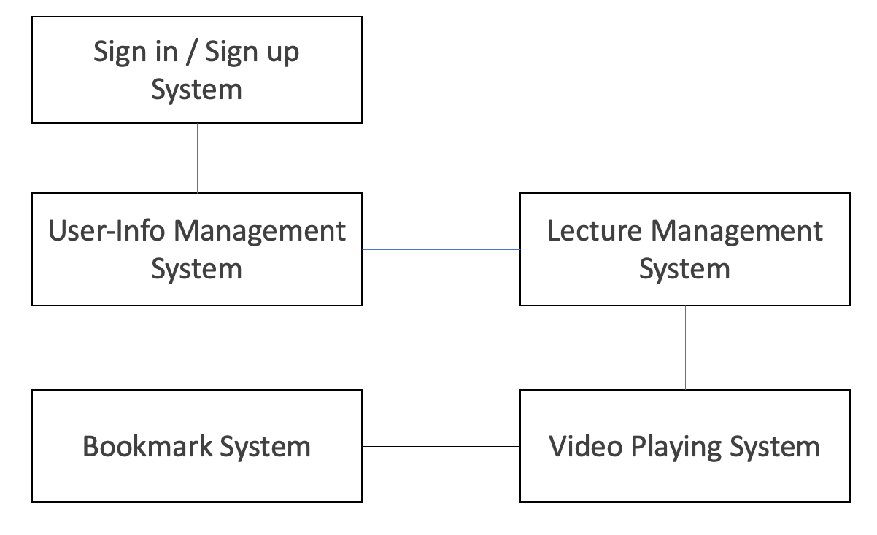

[Figure 4] Context model

* + 1. Process Model

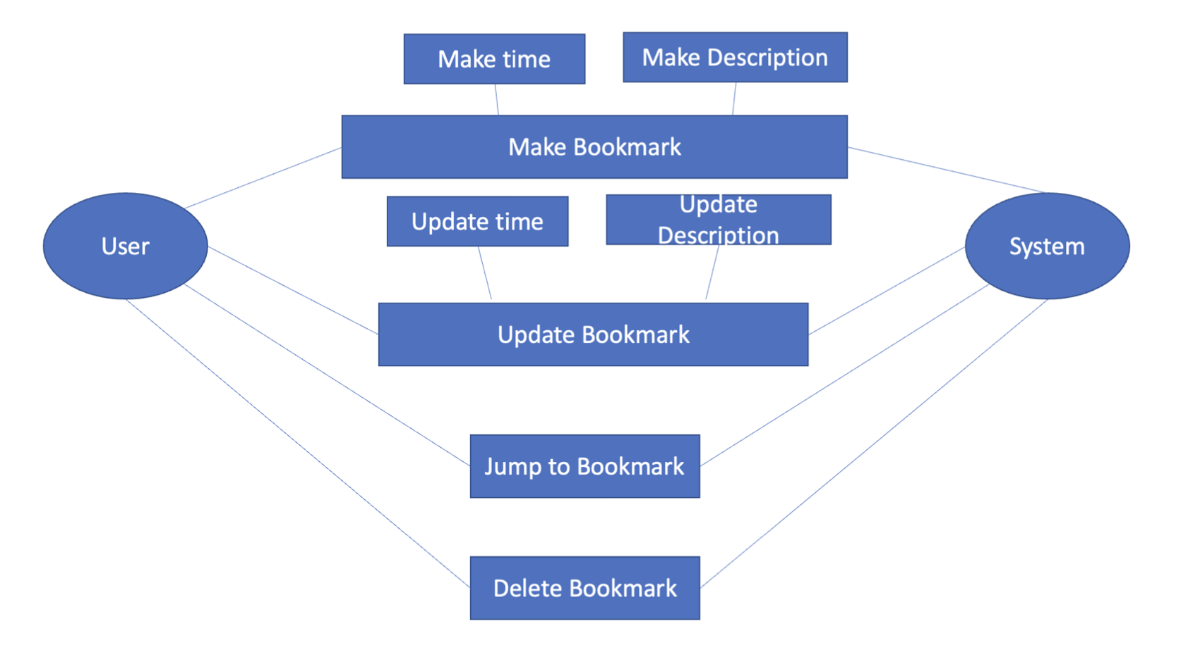

[Figure 5] Overall process model

* + 1. Interaction Model

See 3.2.2. Use Case Diagram

* + 1. Behavior Model
       1. Data Flow Diagram

See 3.2.4. Data Flow Diagram

* + - 1. Sequence Diagram

This describes the sequence of processing recommendation which is our main system.

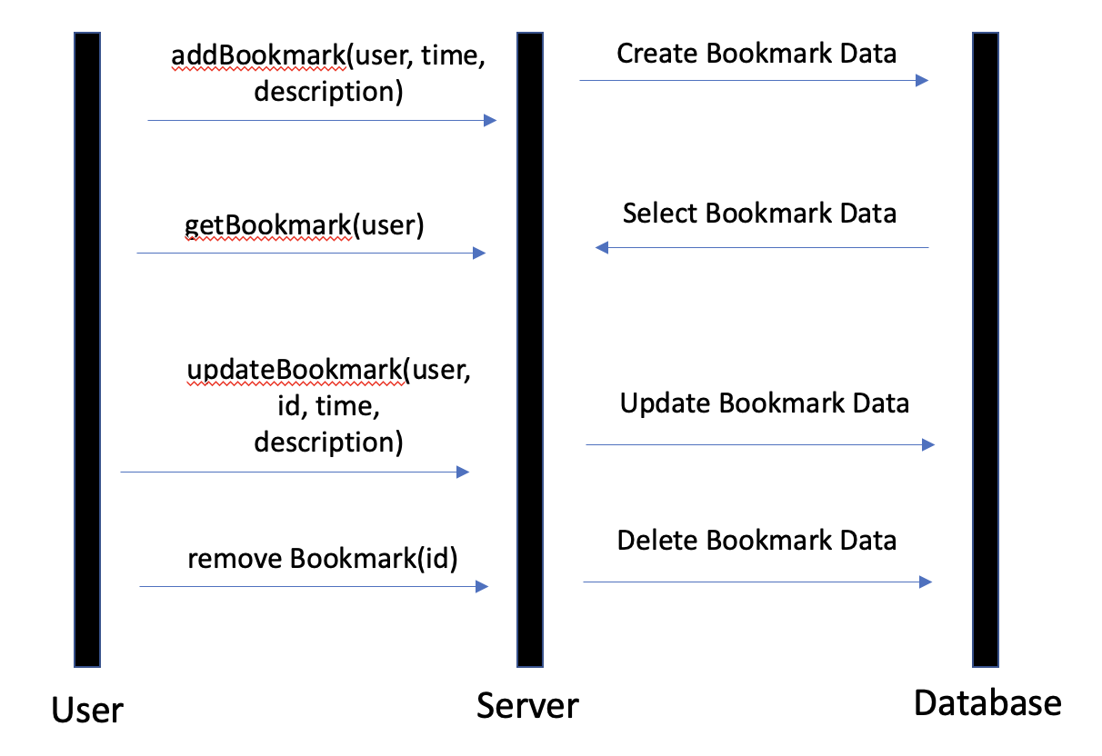

[Figure 6] Sequence diagram

* 1. System Architecture

This section presents a high-level overview of the anticipated system architecture, detailing the distribution of functions across system modules. We use MVC pattern as graphical models of the architecture.

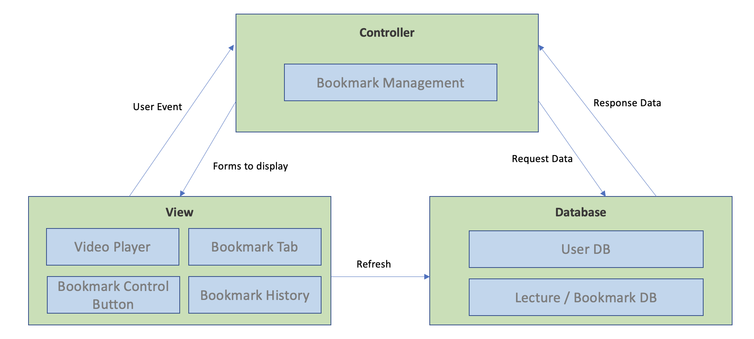

[Figure 7] System architecture of the system

* 1. System Evolution

This section describes the basic assumptions and rules underlying the system and how our team anticipated change due to hardware evolution, software evolution, and changes in user requirements. This section is useful for system designers as it can help them avoid choosing designs that may constrain future changes to the system.

* + 1. Limitation and Assumption

We assume that users can access the system from desktops, laptops, and smartphones, so we need to deal with connections through web browsers and mobile applications. Therefore, we understand that we need to build functions and implement system architecture that are compatible with both web and mobile applications.

* + 1. Evolutions of Hardware and Change of User Requirements

It aims to support the functionality for use on laptops, desktops, and smartphones that are widely used. It also predicts that the Internet of Things technology and wearable devices will evolve in the future and that there will be areas to cope with as technology advances. In addition, we will design programs that easily accommodate change so that additional users' requirements for bookmark functions can be quickly accounted for.

1. Supporting Information
   1. Software Requirement Specification

This software requirements specification was written in accordance with the IEEE Recommendation (IEEE Recommended Practice for Software Requirements Specifications, IEEE-Std-830).

* 1. Document History

[Table 27] Document History

| **Date** | **Version** | **Description** | **Writer** |
| --- | --- | --- | --- |
| 2021/04/20 | 0.1 | Overall Style and form of documents | Jiseon Lee |
| 2021/04/20 | 1.0 | Addition of 2.2, 2.3, 2.4 | Chihyeon Lee |
| 2021/04/20 | 1.1 | Addition of 3.3, 3.4, 3.5, 3.6 | Dongjun Lee |
| 2021/04/22 | 1.2 | Addition of 1.1, 1.2, 1.3 | Jiseon Lee |
| 2021/04/22 | 1.3 | Addition of 3.7, 3.8, 3.9, 3.10, 4.1 | Seungwoo Kim |
| 2021/04/23 | 1.4 | Addition of 2.5, 3.1, 3.2, 3.3 | Deokjae Kang |
|  |  |  |  |
|  |  |  |  |