

**SKKU Online Reading Room**

**Software Requirement Specification**

2021.04.25.

**TEAM 8**

Team Leader 장영재

Team Member 박윤진

Team Member 김지수

Team Member 박세연

**CONTENTS**

1. Introduction 6

1.1. Purpose 6

1.2. Scope 6

1.3. Definitions, Acronyms, and Abbreviation 6

1.4. References 7

1.5. Overview 8

2. Overall Description 8

2.1. Product Perspective 8

2.1.1. System Interfaces 8

2.1.2. User Interfaces 8

2.1.3. Hardware Interfaces 8

2.1.4. Software Interfaces 8

2.1.5. Communications Interfaces 9

2.1.6. Operations 9

2.1.6.1. System administrator 9

2.1.6.2. User 9

2.2. Product Functions 10

2.2.1. Register 10

2.2.2. Show information of user 10

2.2.3. Ranking system 10

2.2.4. Use open chat 10

2.2.5. Participate and Create study 10

2.2.6. Streaming room 10

2.3. User Characteristics 11

2.3.1. System Administrator 11

2.3.2. User 11

2.4. Constraints 11

2.5. Assumptions and Dependencies 11

3. Specific Requirements 12

3.1. External Interface Requirements 12

3.1.1. User Interfaces 12

3.1.2. Hardware Interfaces 20

3.1.3. Software Interfaces 21

3.1.4. Communication Interfaces 22

3.2. Functional Requirements 22

3.2.1. Use Case 22

3.2.2. Use Case Diagram 28

3.2.3. Data Dictionary 28

3.2.4. Data Flow Diagram 31

3.3. Performance Requirements 32

3.3.1. Static numerical requirement 32

3.3.2. Dynamic numerical requirement 32

3.4. Logical Database Requirements 33

3.5. Design Constraints 33

3.6. Standards compliance 33

3.7. Software System Characteristics 33

3.7.1. Product Requirements 33

3.7.1.1. Usability Requirements 33

3.7.1.2. Performance Requirements 34

3.7.1.3. Usability Requirements 34

3.7.2. Organizational Requirements 34

3.7.3. External Requirements 34

3.8. Organizing the Specific Requirements 34

3.8.1. Context Model 35

3.8.2. Process Model 35

3.8.3. Interaction Model 36

3.8.4. Behavior Model 36

3.9. System Architecture 36

3.10. System Evolution 36

4. Supporting Information 37

4.1. Software Requirement Specification 37

4.2. Document History 37

4.1. Date 37

**LIST OF FIGURES**

[Figure 1] Use case diagram 28

[Figure 2] Entity Relationship Diagram 30

[Figure 3] Data flow diagram 31

[Figure 4] Context model 35

[Figure 5] Overall process model 35

[Figure 6] System architecture of the system 36

LIST OF TABLES

[Table 1] Table of acronyms and abbreviations 6

[Table 2] Table of terms and definitions 7

[Table 3] User interface of input processing using touchscreen 12

[Table 4] User interface of register 12

[Table 5] User interface of main page 14

[Table 6] User interface of chat list 15

[Table 7] User interface of open chat 16

[Table 8] User interface of study room list 17

[Table 9] User interface of making study room 18

[Table 10] User interface of making study room 19

[Table 11] Hardware interface of applicable device for the system 20

[Table 12] Software interface of firebase real-time database 21

[Table 13] Communication interface of client and host 22

[Table 14] Use case of register 22

[Table 15] Use case of log-in/out 23

[Table 16] Use case of profile 24

[Table 17] Use case of Ranking 24

[Table 18] Use case of User List 24

[Table 19] Use case of Chat history 25

[Table 20] Use case of Send Message 25

[Table 21] Use case of Room List 26

[Table 22] Use case of Make Room 26

[Table 23] Use case of Enter/exit Room 27

[Table 24] User 28

[Table 25] Chatroom (2 participants) 29

[Table 26] Study Room 29

[Table 27] Major 30

[Table 28] Utterance 30

[Table 29] Document History 37

1. Introduction
   1. Purpose

This document is a Software Requirement Specification for providing ‘SKKU Online reading room’ services. This service designed and implemented by Team 8 of the Introduction to Software Engineering at Sungkyunkwan University in Spring semester 2021. We design and implement the system based on this document, which organized and analyzed the requirements of the service.

This document’s main reader is Team 8, and additionally professor and TAs of this class. Team 8 designs and implements the functions of the SKKU Online reading room service in accordance with this specification.

* 1. Scope
* (function 1) Send email to verify that the Sungkyunkwan university student
* (function 2) Log-in Application
* (function 3) Show the Information of the certified student in main page
* (function 4) Ranking system by study time
* (function 5) Show the open chat list based on the class information of student
* (function 6) Implement open chat for each subject
* (function 7) Show the number of people currently using the streaming service
* (function 8) Create streaming room
* (function 9) Check the time of participation in the streaming room.
  1. Definitions, Acronyms, and Abbreviation

The following table explains the acronyms and abbreviations used in this document.

[Table 1] Table of acronyms and abbreviations

|  |  |
| --- | --- |
| Term | **Description** |
| SRS | Software Requirement Specification |
| UI | User Interface |
| RTSP | Real Time Streaming Protocol |
| API | Application Programming Interface |

[Table 2] Table of terms and definitions

|  |  |
| --- | --- |
| Term | **Definitions** |
| User | Someone who uses a system. In this project, the users of system are Sungkyunkwan University students |
| System administrator | Someone who administrate this application and developer of this project |
| Front end | What appears on the user interface, the part that shows the user what they requested and receives the user’s input. |
| Back end | The part that processes the data or request of the user. |
| Study room | Each live streaming of this application |
| Open chat | Online chat that registered people can send and receive messages anonymously. |

* 1. References
* “IEEE Recommended Practice for Software Requirements Specifications”, The Institute of Electrical and Electronics Engineers, Inc. (1998)
* Kangwon National University. Multimedia service system research Team. Software Requirement Specification of “Multimedia Contents-aware Intelligent Information Service System”. (2007)
* Team 1 of the Introduction to Software Engineering at Sungkyunkwan University in Spring semester 2020. Software Requirement Specification of “Recommend Laptop for Tech Newbies.”
* Software Requirement Specification Guide.
* https://greatgift.tistory.com/attachment/cfile23.uf@217A623357B4478F268BB9.pdf
  1. Overview

This SRS document consists of 4 main parts. The first chapter introduces this document and purpose of the document and explain the references, definitions of several terms. The second chapter provides an overall description of the product perspective, including the several interfaces, the system functionality and the user characteristics of our service. The third chapter describe in detail requirements of the SKKU Online reading room service, including external interface requirements, functional requirements, and performance requirements etc. The fourth chapter provides an additional description of this document like document history.

1. Overall Description
   1. Product Perspective
      1. System Interfaces

The user’s information is stored in SKKU student information system and stored using firebase. After receiving information about user’s courses and departments from the school system, the information is stored in firebase.

* + 1. User Interfaces

An interface is provided through the screen of the mobile phone, and information can be input through a simple touch and enter text of the mobile phone. Depending on the user’s click button, the user can participate open chat or Live study room.

* + 1. Hardware Interfaces

The system is intended for Android mobile phone. The mobile phone must have least 1GB RAM and 1.0 GHz single processor.

* + 1. Software Interfaces

The system is intended for Android OS version at least Android 6.0 (API 23).

* + 1. Communications Interfaces

User device and server communicate with HTTP protocol in JSON format. Each user device communicates in streaming and open chat. In streaming, using video conference server that is open source and provide streaming service.

* + 1. Operations
       1. System administrator
  + Manage member information
    - Administrator store in database for member information management.
  + Manage application UI
    - Modify or update the UI as needed.
  + Manage entire server
    - Administrator manages streaming server.
      1. User
* Register
* User can register into the service by certified as a student of Sungkyunkwan University.
* In this system, user can use their information that already stored in school system.
* Login
* User can login using their ID and PW
* Get study room list
* User can get a study room list by clicking the button.
* Join study room
* User can participate the online streaming that is called study room, by click the study room button.
* User can select study which they want in the list shown.
* Create study room
* User can create new study that provide online live streaming.
* Join open chat
* User can use the chatting by clicking the button each subject what they want.
  1. Product Functions
     1. Register

This service is provided to registered members, that is, students from Sungkyunkwan University who joined through certification. When a user subscribes to the service through authentication, the user’s data is stored in this system’s database based on the school’s student information data. After the membership information is registered in the database, users will be able to use the service through their ID and password.

* + 1. Show information of user

User can check their membership information on the main screen. It is according to their student information. So, it cannot be modified in this service.

* + 1. Ranking system

Each student’s time of participate the study, is collected for each student’s department. Then, the collected time is ranked and displayed by departments with high level of time.

* + 1. Use open chat

According to the log-in user’s information, the list of open chat of the class that student takes is displayed. User can participate in open chat by clicking the button of each class.

* + 1. Participate and Create study

Users can participate in each study they want, by clicking on the study that displayed in the list. Then, user can create study they want. If create the study, the study room list will be updated.

* + 1. Streaming room

When the users click on a study room, they can send their real-time video to other people who participated in same study room, and user can check other people’s video. The time until users participate in a study room, and terminated the connection of streaming that mean exit the study room, is displayed on the screen.

* 1. User Characteristics
     1. System Administrator

In this system, system administrators are the people who developed this system. Also, the system administrator has to be fully known of the system and has an understanding of the system as a whole. The system administrator must have sufficient ability to cope with a system problem. So, in this system, the members of Team 8 can be system administrator.

* + 1. User

The user generally referred to in this document is Sungkyunkwan University student. So, we assumed that a user has the ability to understand this service and how to use this system.

* 1. Constraints

The system will be designed and implemented based on the contents in this chapter. Other details are designed and implemented by the developer, but according to the following items.

* Use the technology that used already widely proven performance.
* Use opensource software if possible.
* Write a good annotation to facilitate maintenance when writing source code.
* Consider the later scalability and availability of the system.
* Do not consider the contents that do not fit the purpose of the system.
* Develop with minimum Android version 6.0 (API 23)
  1. Assumptions and Dependencies

All systems in this document are written on the assumption that they are designed and implemented based on Android devices and open source. Therefore, all contents are written based on the Android operating system and may not be applied to other operating systems.

1. Specific Requirements
   1. External Interface Requirements
      1. User Interfaces

[Table 3] User interface of input processing using touchscreen

|  |  |
| --- | --- |
| **Name** | **Basic User Interaction Using Touchscreen** |
| Purpose / Description | Users transmit their instructions through a touchscreen of the device |
| Input source/ Output destination | User / user device equipped with Android OS |
| Range/Accuracy/ Margin of error | Range according to the number of buttons on the screen/  Accuracy according to the accuracy of touch from users/  Margin of error of touch sensitiveness |
| Unit | A click |
| Time/ Velocity | Asynchronous user input/ Instant execution of a user instruction |
| Relationship with other input/outputs | After receiving all the inputs, the user device transmits the input data to the server for processing the input data and request desired output data |
| Format and configuration of screen | 1. An activity screen connected to an XML file, mainly composed of TextViews and ImageVIews  2. A Textview and an ImageView provide a basis for choosing the following input, and several Buttons are ready to receive the inputs from users  3. Users are to click a desired button to interact with the system |
| Format and configuration of window | N/A |
| Data type | Query, Int type value of a button code |
| Instruction type | Instruction mapping according to the value of a button code |
| Exit message | N/A |

[Table 4] User interface of register

| **Name** | **Customization Interface - Register** |
| --- | --- |
| Purpose/Description | In order to use the service of the system, users have to register to the system, followed by Log-in process. During registration, they are asked to fill out the registration form. |
| Input source/ Output destination | Client/ Server |
| Range/  Accuracy/  Margin of error | N/A |
| Unit | Screen |
| Time/ Velocity | N/A |
| Relationship with other input/outputs | N/A |
| Format and configuration of screen | 1. Several empty slots for filling out necessary information of users in a vertical direction  2. At the bottom of the screen, there is a button ‘send email’ which send an email to verify that user is a school member.  3. After checking email and verifying it, it returns all the information given by a user to the server for saving it  4. After successful registration process, the users are directed to the first page for log-in |
| Format and configuration of window | N/A |
| Data type | Query, Int type value of a button code |
| Instruction type | Instruction mapped to the button |
| Exit message | N/A |

[Table 5] User interface of main page

| **Name** | **Customization Interface - Main page** |
| --- | --- |
| Purpose/Description | After log-in, users can enter the ‘Profile’ page by clicking a button ‘profile’ in order to edit their information and find their previous search histories |
| Input source/ Output destination | User / User |
| Range/  Accuracy/  Margin of error | N/A |
| Unit | Page |
| Time/ Velocity | N/A |
| Relationship with other input/outputs | N/A |
| Format and configuration of screen | 1. It uses ImageView and textView to show profile images and information of logged-in users.  2. If you press the logout button, it will exit the page and return to the first login screen.  3. The time that the user enters the study room and studies is stored in the database. Rankings are shown over time studied utilizing information stored in the database in real-time. This ranking changes with the information in the database every hour.  4. There is a separate button on the page that connects to the study room and open chat, so pressing the desired button leads to the page. |
| Format and configuration of window | N/A |
| Data type | Int type value of a button code |
| Instruction type | Instruction mapped according to the value of a button code |
| Exit message | N/A |

[Table 6] User interface of chat list

| **Name** | **Customization Interface - Open chat list** |
| --- | --- |
| Purpose/Description | It is linked to the school database and brings up a list of classes that users take. Depending on the class list, open chat lists of classes are provided. Click the open chat button for the desired class and it will be linked to the appropriate open chat link. |
| Input source/ Output destination | Server / Client |
| Range/  Accuracy/  Margin of error | N/A |
| Unit | Page |
| Time/ Velocity | N/A |
| Relationship with other input/outputs | N/A |
| Format and configuration of screen | 1. The list of classes taken by users is linked to the school database.  2. Each class lists buttons above the Linear Layout that link to the class's open chat link. |
| Format and configuration of window | 1. An activity screen connected to an XML file in a LinearLayout format, mainly composed of Button shows buttons providing a list of open chat.  2. Users can click an open chat and be directed into Open chat link. |
| Data type | Int type value of a button code |
| Instruction type | Instruction mapped according to the value of a button code |
| Exit message | N/A |

[Table 7] User interface of open chat

| **Name** | **Customization Interface - Open chat** |
| --- | --- |
| Purpose/Description | Send and receive data through socket programming |
| Input source/ Output destination | Client / Client |
| Range/  Accuracy/  Margin of error |  |
| Unit | packet |
| Time/ Velocity | Minimum 10 Mps |
| Relationship with other input/outputs | Each time a user sends a chat, the client sends a request to the server.  On the contrary, when another user sends a chat, the server receives the content and delivers it to the user who has seen it. |
| Format and configuration of screen | 1. Text View showing current chat information  2. A chat window showing all the messages received by clients who participated in the open chat.  3. Chat input window to enter messages to send to the server  4. Send button for sending messages  5. Top right button for resizing the chat room  6. Close button to exit chat and return to open chat list |
| Format and configuration of window | It uses a typical widget, but does not use top-down or pop-up menus. Use the tabs. |
| Data type | Int type value of a button code |
| Instruction type | Instruction mapped according to the value of a button code |
| Exit message | N/A |

[Table 8] User interface of study room list

| **Name** | **Customization Interface - Study room list** |
| --- | --- |
| Purpose/Description | It shows users a list of online study rooms that are currently in progress. Users can participate by clicking on the desired reading room button. |
| Input source/ Output destination | N/A |
| Range/  Accuracy/  Margin of error | N/A |
| Unit | Page |
| Time/ Velocity | N/A |
| Relationship with other input/outputs | N/A |
| Format and configuration of screen | 1. A chat list stored in the DB is imported into the vertical Linear Layout in turn. Layout is a button that connects to each open chat, and when you click the button, it goes to that open chat.  2. Button to create open chats.  3. Button to return to main page |
| Format and configuration of window | 1. An activity screen connected to an XML file in a LinearLayout format, mainly composed of Button shows buttons providing a list of study rooms.  2. Users can click an open chat and be directed into study room link. |
| Data type | Int type value of a button code |
| Instruction type | Instruction mapped according to the value of a button code |
| Exit message | N/A |

[Table 9] User interface of making study room

| **Name** | **Customization Interface - Making study room** |
| --- | --- |
| Purpose/Description | Create a new online study room and participate. |
| Input source/ Output destination | Client/ Server |
| Range/  Accuracy/  Margin of error | N/A |
| Unit | Screen |
| Time/ Velocity | N/A |
| Relationship with other input/outputs | N/A |
| Format and configuration of screen | 1. Several empty slots for filling out necessary information of users in a vertical direction  2. At the bottom of the screen, there is a button ‘Create!’ . After click it, information about the new study room is registered in the DB.  4. After successful creating process, the users are directed to study room list. |
| Format and configuration of window | N/A |
| Data type | Query, Int type value of a button code |
| Instruction type | Instruction mapped to the button |
| Exit message | N/A |

[Table 10] User interface of making study room

| **Name** | **Customization Interface - Open chat** |
| --- | --- |
| Purpose/Description | Send and receive data through socket programming |
| Input source/ Output destination | Client / Client |
| Range/  Accuracy/  Margin of error | N/A |
| Unit | Video |
| Time/ Velocity | Minimum 10 Mps |
| Relationship with other input/outputs | 1. It sends real-time video information of clients participating in the study to the opensource video conference server.  2. The server sends real-time video information received from the client back to all clients who participate in the study.  3. Measure the user's participation time through the usage log while participating in a study, and save the participation time in the user DB when you exit the study. |
| Format and configuration of screen | 1. Show real time video of other users by VideoView  2. Use the Switch Screen button to determine which cameras are used between front and rear cameras  3. Send the client's device screen via the screen sharing button  4. Return to Study List Screen via the Exit Study Room button  5. Provide a list of study participants via the Check Participants button |
| Format and configuration of window | An activity screen connected to an XML file in a VideoView format shows real-time video get by opensource video server. |
| Data type | Int type value of a button code |
| Instruction type | Instruction mapped according to the value of a button code |
| Exit message | N/A |

* + 1. Hardware Interfaces

[Table 11] Hardware interface of applicable device for the system

| **Name** | **Applicable device for the system** |
| --- | --- |
| Purpose/Description | I'm going to use Android Studio to develop Frontend. For user convenience, it assumes the use of a smartphone app that supports Android OS. |

* + 1. Software Interfaces

[Table 12] Software interface of firebase real-time database

| **Name** | **Firebase Real-time Database** |
| --- | --- |
| Purpose/Description | Query input/output for managing multimedia/meta data |
| Input source/ Output destination | Host server/ User, User/Host server |
| Range/  Accuracy/  Margin of error | Depends on the performance of the Firebase |
| Unit | Query |
| Time/ Velocity | Instant reaction |
| Relationship with other input/outputs | Related to all inputs/outputs from server |
| Format and configuration of screen | N/A |
| Format and configuration of window | N/A |
| Data type | Query |
| Instruction type | Query statement |
| Exit message | N/A |

* + 1. Communication Interfaces

[Table 13] Communication interface of client and host

| **Name** | **Client and Host** |
| --- | --- |
| Purpose/Description | Each client requests the connection to the host.  Host provides a list of study room and open chat, and function of them to the client |
| Input source/  Output destination | Client/Host server |
| Unit | packet |
| Time/ Velocity | At least 10Mbps |
| Relationship with other input/outputs | Command code using structure  Various data using structure |
| Instruction type | Communication by send call |
| Exit message | Socket shutdown by close call |

* 1. Functional Requirements
     1. Use Case

[Table 14] Use case of register

| Use case name | Register |
| --- | --- |
| Actor | Unregistered user |
| Description | The use case of an unregistered user trying to register to the system. |
| Normal Course | 1. Encounters the log-in page upon opening the application. 2. Finds the sign-up button on the bottom of the screen and presses it. 3. User is redirected to the register page which requires the following: 4. name, 5. password 6. school email address. 7. major 8. The system sends a verification code to the school email address and waits for the user to enter the verification code. 9. The user enters the verification code, and the registration process is completed. |
| Precondition | 1. The user is not registered. 2. The user enters accurate information. 3. Only one ID can be made with each school email address. 4. Constraints are set for possible inputs in email address and password. |
| Post Condition | The major is only changeable once a semester as the intention of the program is to let people in the same major study together. Also, the password should be stored securely with encryption. |
| Assumptions | N/A |

[Table 15] Use case of log-in/out

|  |  |
| --- | --- |
| Use case name | Login/ out |
| Actor | Registered user |
| Description | The user enters id and password to gain access to the application. The user turns off the application or click the “logout” button to log out of the application. |
| Normal Course | 1. The user turns on the application, and the login page is shown. 2. The user sends the accurate id and password. 3. The system returns success, and the user can use the application. 4. The user presses the logout button, and the user is logged out of the application. |
| Precondition | 1. The user must provide accurate id and password. 2. The user must be logged in to the application to log out. |
| Post Condition | The user must be connected to the network. |
| Assumptions | N/A |

[Table 16] Use case of profile

|  |  |
| --- | --- |
| Use case name | Profile |
| Actor | Registered user |
| Description | The user retrieves and changes profile information from the system. |
| Normal Course | 1. User logs into the application. 2. Profile information is automatically requested to the system. 3. System returns the profile information 4. Profile information is presented in the app page. 5. User changes the major in the profile page. 6. System receives the change and applies it to the database. |
| Precondition | 1. The user should be connected to the server, and must be logged in. 2. Changing the major can happen only once each semester. |
| Post Condition | The user will not be able to change the major for one semester. Also, after the profile information is retrieved, it should be saved as cache temporarily unless there is a change with profile information. The user should also be connected to the network. |
| Assumptions | N/A |

[Table 17] Use case of Ranking

|  |  |
| --- | --- |
| Use case name | Ranking |
| Actor | Registered User |
| Description | In the main page of the application, the study time ranking of each major is displayed on a board. |
| Normal Course | 1. The user logs in to the application, and enters the main page. 2. This triggers the system to return the list of study time rankings of the majors. 3. The list of rankings are displayed on the main page. |
| Precondition | 1. The user must be logged in to the system. 2. Study time of each user should be summed and saved into the system before retrieval. |
| Post Condition | The user must be connected to the network. |
| Assumptions | N/A |

[Table 18] Use case of User List

|  |  |
| --- | --- |
| Use case name | User List |
| Actor | Registered User |
| Description | Displays the list of possible list of users when the user opens the chatting menu. |
| Normal Course | 1. User clicks the chat button from the main menu. 2. The system returns the list of possible users to chat, whom will be most likely from the same major. 3. The user finds the person the chat with. 4. The user clicks chat, which leads to the chatting system where the user can send and read messages. |
| Precondition | 1. The user must be logged into the system. 2. There must be other users in the same major. |
| Post Condition | The user must be connected to the network. |
| Assumptions | N/A |

[Table 19] Use case of Chat history

|  |  |
| --- | --- |
| Use case name | Chat history |
| Actor | Registered User |
| Description | Displays the past chats when the user enters the chatroom with the selected person. |
| Normal Course | 1. The user presses the button to enter chatroom. 2. The system accesses the chatroom data associated with the user and the selected person and retrieves the chat history. 3. The system sends the chat history to the application. 4. The chat history is displayed on the application. |
| Precondition | 1. There must be previous chatting record between the two people. Otherwise chat history is not retrieved. 2. The user must be logged into the system. 3. The selected person should be from the same major. |
| Post Condition | The user must be connected to the network. |
| Assumptions |  |

[Table 20] Use case of Send Message

| Use case name | Send Message |
| --- | --- |
| Actor | Registered User |
| Description | The user sends a message to the selected person. |
| Normal Course | 1. The user types in the message to send to the other person. 2. The user presses the send button on the screen. 3. The system receives the message and updates the chat history from the chatroom instance with the other person. 4. The system sends an event to the other person. 5. The event induces the application to update the display to append the new message. |
| Precondition | 1. For the event to be triggered, the other person should be online. Otherwise, there is no need for the event. 2. The user must be logged into the system. 3. The selected person should be from the same major. |
| Post Condition | The user must be connected to the network. |
| Assumptions | N/A |

[Table 21] Use case of Room List

|  |  |
| --- | --- |
| Use case name | Room List |
| Actor | Registered User |
| Description | The user views all the possible study rooms to choose which one to enter. |
| Normal Course | 1. The user clicks the study room button on the main menu. 2. The system returns all the available rooms for that major to the user. 3. The application displays the possible rooms as a list. |
| Precondition | 1. There should be study rooms made before they could be displayed. 2. The user must be logged into the system. 3. The rooms presented should be from the same major. |
| Post Condition | Rooms that are full cannot be entered.  The user must be connected to the network. |
| Assumptions | N/A |

[Table 22] Use case of Make Room

|  |  |
| --- | --- |
| Use case name | Make Room |
| Actor | Registered User |
| Description | The user makes an online study room for other users to enter. |
| Normal Course | 1. The user clicks the make room button which is located in the page where study rooms are listed. 2. The user enters accurate information to the form. 3. The information in the form is sent to the system. 4. The system adds the room to the DB. 5. The list of rooms is updated with the new study room. |
| Precondition | 1. The user should enter valid information in the form. 2. The user must be logged into the system. |
| Post Condition | The user must be connected to the network.  The room made is belongs to the user’s major. |
| Assumptions | N/A |

[Table 23] Use case of Enter/exit Room

|  |  |
| --- | --- |
| Use case name | Enter/exit Room |
| Actor | Registered User |
| Description | The user enters a video conference room on WebRTC via a webserver with a temporary session to connect to the video room. The study room information is in the study_room data dictionary. |
| Normal Course | 1. The user selects the online study room to participate. 2. A session is created, and the session is used to connect the study room in the video server. The study room information is included in the study_room data. 3. The user’s enter time is recorded as the enter_time in user data dictionary. 4. The user studies with peer students. 5. The user exits the room with the exit button. 6. On exit, the user’s study time is calculated, and is used to update the ranking of the majors. |
| Precondition | 1. The user needs a functioning camera on the phone. 2. The user must be logged in to the network. 3. There should be an available study room. |
| Post Condition | The user must be connected to the network.  The user’s study time should be in an acceptable range. For instance, the user should not be able to submit time by leaving on the study room to manipulate the ranking of study time. |
| Assumptions | N/A |

* + 1. Use Case Diagram

[Figure 1] Use case diagram

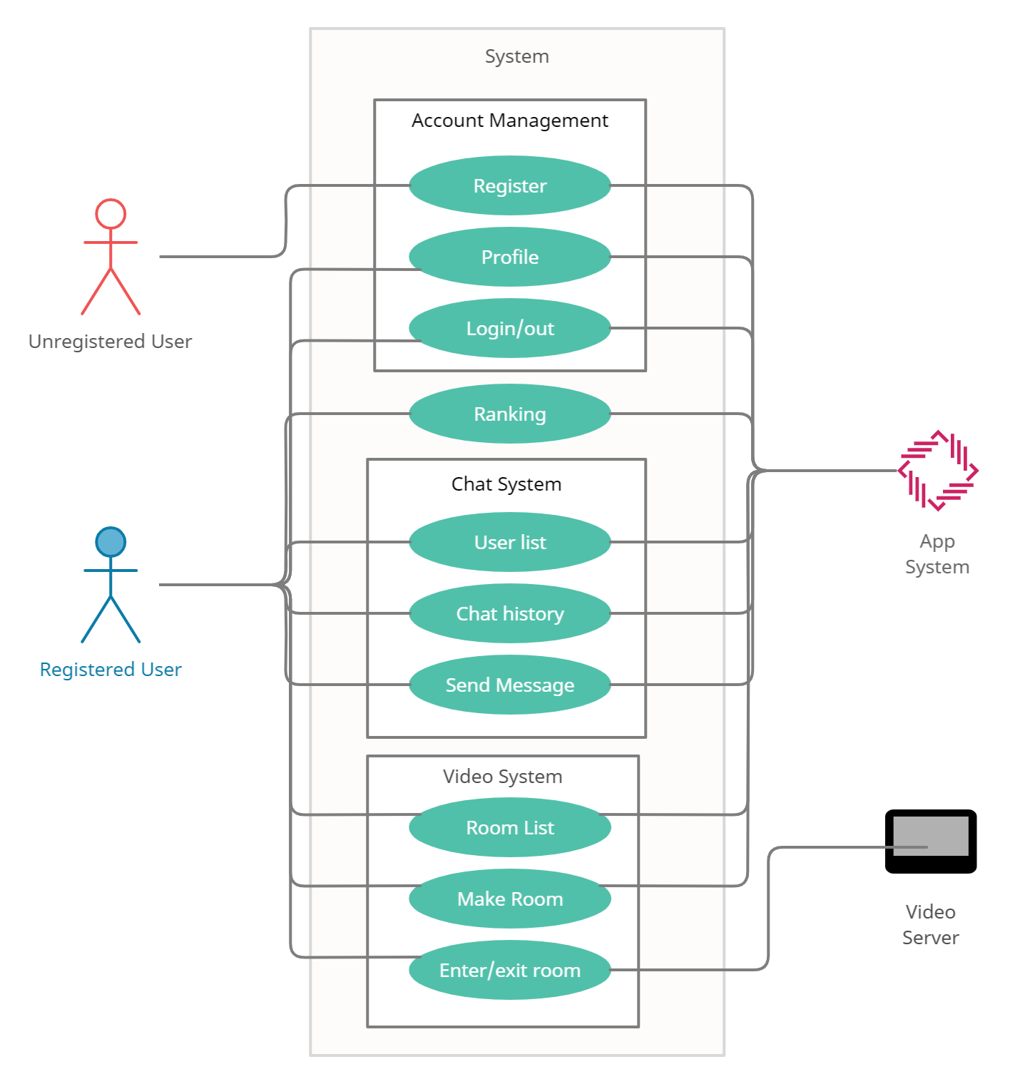

* + 1. Data Dictionary

[Table 24] User

| Field | Key | Constraint | Description |
| --- | --- | --- | --- |
| ID | PK | Not Null | User id |
| Password |  | Not Null | User password |
| name |  | Not Null | User name |
| email |  | Not Null | User email |
| major |  |  | User’s major |
| last_change |  |  | User’s last change in major. |
| study_room_enter |  |  | Used to calculate study_time. |
| study_time |  |  | Time studied in current semester. |
| is_online |  |  | For checking if the user is online. |

[Table 25] Chatroom (2 participants)

|  |  |  |  |
| --- | --- | --- | --- |
| Field | Key | Constraint | Description |
| ID | PK | Not Null | Chatroom id |
| user1 | FK | Not Null | First user |
| user2 | FK | Not Null | Second user |
| message_list |  |  | record of all the past messages |

[Table 26] Study Room

|  |  |  |  |
| --- | --- | --- | --- |
| Field | Key | Constraint | Description |
| ID | PK | Not Null | Study room id |
| title |  | Not Null | Displayed title to users. |
| user_list | FK | List | list of the participating users |
| video_conference_id |  |  | id to access the video conference object on the video conference server. |

[Table 27] Major

| Field | Key | Constraint | Description |
| --- | --- | --- | --- |
| ID | PK | Not Null | Major id |
| major_name |  |  | Major name |
| total_study_time |  |  | sum of all the study_time |
| ranking |  |  | current ranking of major. |

[Table 28] Utterance

| Field | Key | Constraint | Description |
| --- | --- | --- | --- |
| ID | PK | Not Null | Utterance id |
| user | FK |  | the user who sent message |
| time |  |  | sent time |
| sentence |  |  | message content |

[Figure 2] Entity Relationship Diagram

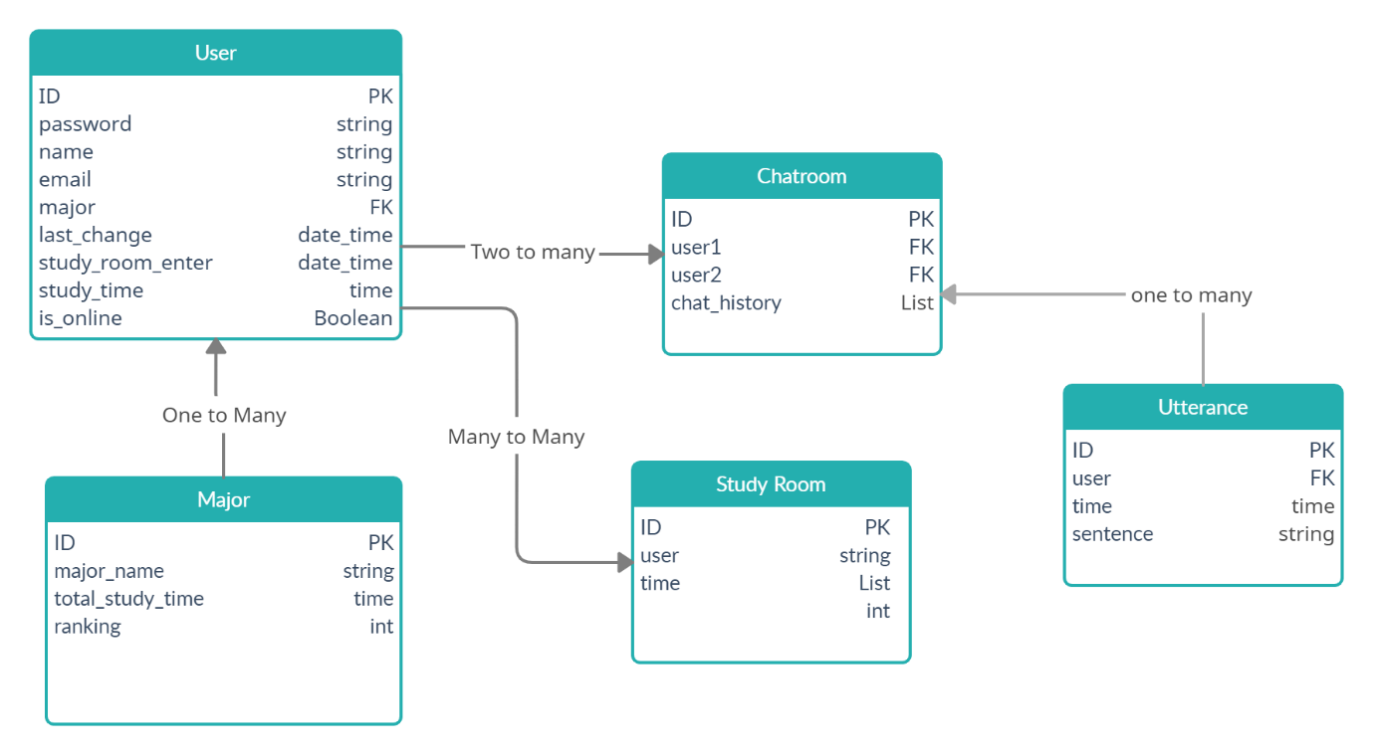

* + 1. Data Flow Diagram

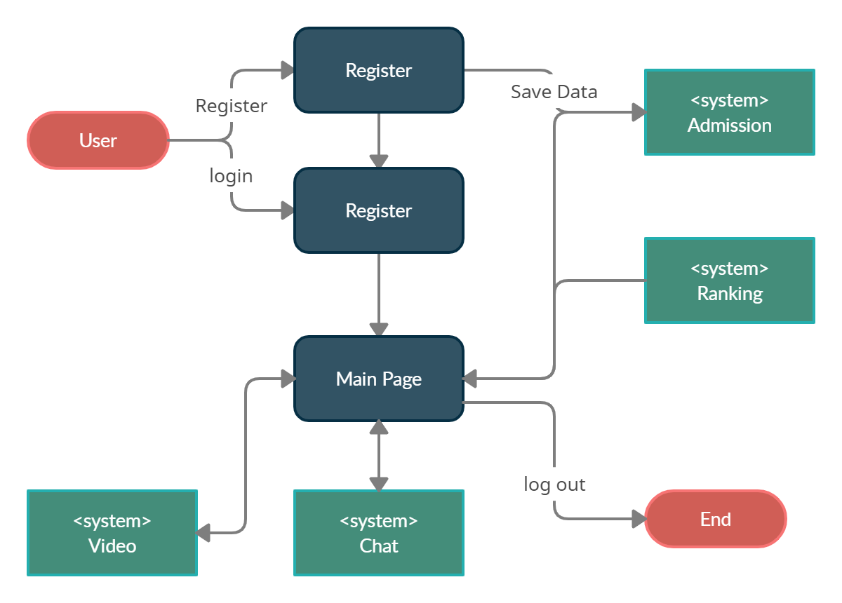

[Figure 3] Data flow diagram

* 1. Performance Requirements

The following requirements can change in actual system.

* + 1. Static numerical requirement
* The system supports the version of Android 6.0 or higher.
* The system does not support multiple connections on the same device. Only one concurrent user is supported for each mobile device. It is possible to switch accounts and access after disconnecting.
* The system will run on a mobile device with at least 1GB RAM and 1.0GHz single processor.
* To download this application, the device needs more than 25MB of storage.
* The system management tool supports only one administrator.
  + 1. Dynamic numerical requirement
* The system supports at least 300 simultaneous users.
* The application should run within 10 seconds.
* When a user signs up, a confirmation email should be sent within 2 minutes.
* The ranking of department must be updated every second.
* Each account must be activated within 5 seconds of linking.
* When the user enters personal information, the data must be stored in the database within 3 seconds, and the database update must be completed within 3 seconds.
* The system must display the list of chat room for each subject within 5 seconds based on the user's information.
* The system should update the list of study rooms and the number of people in the room every 5 seconds.
* Record of study time should be updated every second.
  1. Logical Database Requirements

The system uses Firebase to manage database. Data of user, subject, study room and chat room must be stored in the database.

* 1. Design Constraints
* The system should be designed to be accessible from mobile devices with Android OS.
* The system administrator must be able to manage the system through a web browser.
* The system should be designed to run on Firebase.
* The system must not contain any components that violate copyright.
  1. Standards compliance
* All system should be designed to be accessible from mobile devices with Android OS.
* The system administrator must be able to manage the system through a web browser.
* The system should be designed to run on Firebase.
* The system must not contain any components that violate copyright.
  1. Software System Characteristics

This section describes the non-functional requirements of the system, categorized as product requirements, organization requirements, and external requirements. These are constraints on the services or functions offered by the system.

* + 1. Product Requirements

This section describes requirements which specify that the delivered product must behave in a particular way.

* + - 1. Usability Requirements

The main users of the system are students of Sungkyunkwan University. Therefore, the system should be easy to use even for ordinary users. System should have intuitive and easy-to-use user interface.

To improve security and dependability, the system should check for human error and have multiple barriers which should be different.

* + - 1. Performance Requirements

Chat systems between users should be able to send and receive messages immediately.

The service that creates and retrieves study rooms should have quick response times. The list should be updated every 5 seconds.

* + - 1. Usability Requirements

Users of the system should be authenticated before using the system. Unauthorized users cannot access the services provided by the system and each user cannot access other users' personal information. The administrator of the system also must be authenticated to gain access as an administrator. Administrator can view and manage some of the information of other users.

* + 1. Organizational Requirements

Users of the system should authenticate themselves by sending an email to the user's school account and receiving an appropriate response. This system runs on devices with the Android operating system. It is written according to the JAVA standard using Android Studio. This system provides users with real-time chat function for each subject and real-time video study function. When the user enters the study room, the study time is updated and saved every second.

* + 1. External Requirements

This section describes requirements which arise from factors which are external to the system and its development process.

In order for the system to collect university course information, it needs to obtain permission from the university. All information used by the system must be legally collected. In order for the system to provide a real-time video study function, it must obtain permission to use a camera and microphone from the device. In addition, when collecting and using user’s personal information, the system must not violate the law. The system must protect the privacy of users.

* 1. Organizing the Specific Requirements

This section describes the system model using graphical notation.

* + 1. Context Model

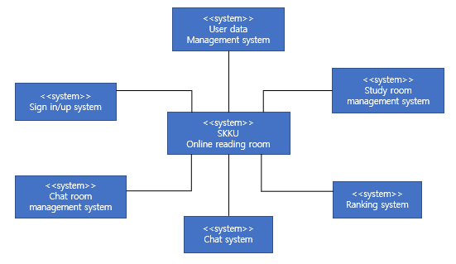

[Figure 4] Context model

* + 1. Process Model

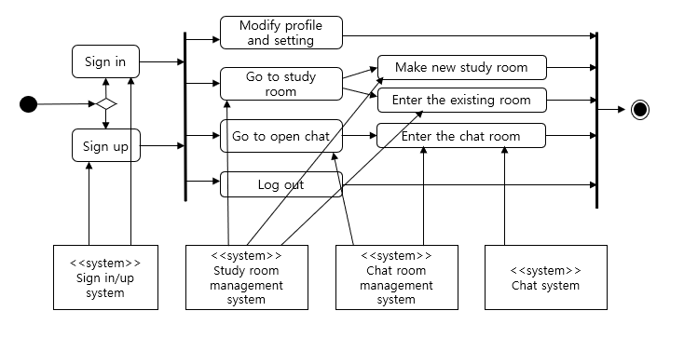

[Figure 5] Overall process model

* + 1. Interaction Model

See 3.2.2. Use Case Diagram

* + 1. Behavior Model

See 3.2.4. Data Flow Diagram

* 1. System Architecture

This Section presents the overall architecture using the MVC pattern.

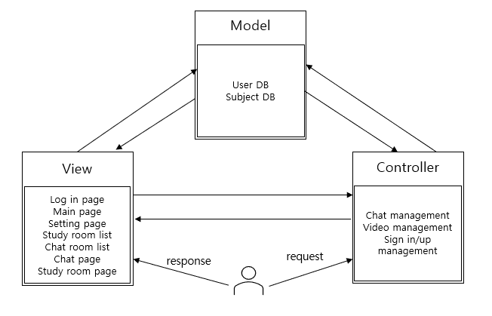

[Figure 6] System architecture of the system

* 1. System Evolution

This section describes the anticipated changes in the system due to various causes.

The system works smoothly only on devices with Android 6.0 or higher. However, the service can be extended to iOS according to the user's requirements. The system is only for Sungkyunkwan University students now. However, the service can be extended to other schools.

There are group chat rooms only for each subject in the system. However, the function for users to create their own chat rooms can be added.

1. Supporting Information
   1. Software Requirement Specification

This software requirements specification is written in accordance with IEEE’s Recommendation (IEEE Recommended Practice for Software Requirement Specification).

* 1. Document History

[Table 29] Document History

|  |  |  |  |
| --- | --- | --- | --- |
| * 1. Date | **Version** | **Description** | **Writer** |
| 2021/4/23 | 0.1 | Addition 1, 2, 4 | Seyeon Park |
| 2021/4/23 | 0.2 | Addition 3.1 | Jisu Kim |
| 2021/4/23 | 0.3 | Addition 3.2 | Youngjae Chang |
| 2021/4/23 | 0.4 | Addition 3.3 ~ 3.10 | YunJin Park |
| 2021/4/24 | 1.0 | Collect and modify the entire content |  |