This file is for testing purposes only
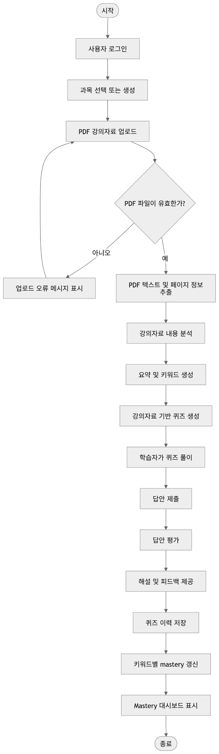

1
22
2
12

$$\frac{dy}{dt}=\overline{test}$$

