BULGARIAN ACADEMY OF SCIENCES
Institute of Biodiversity and Ecosystem Research

Stefania Laslo Klayn

Macrozoobenthic communities as an indicator of ecological state of benthic habitats along the Bulgarian Black Sea coast (Burgas Bay)

SUMMARY
of thesis for .. scientific and educational level „doctor“

Scientific area:
06.01.11 Hydrobiology

Supervisor:
Assoc. Prof. Ventzislav Karamfilov



Sofia, May 2019
The PhD thesis has 220 pages, 47 figures, 30 tables and 4 appendices. The references contain 285 titles, of which 61 are in Cyrillic and 224 – in Latin.

The PhD thesis was developed as part of a regular ... at the Institute of Biodiversity and Ecosystem Research of the Bulgarian Academy of Sciences (IBER-BAS) in the period 2012-2014.

The PhD thesis was reviewed and evaluated at a meeting of the Department of Aquatic Ecosystems of IBER-BAS on 22.05.2019.

The majority of the experimental and field research in this PhD thesis were financed by FP7 project PERSEUS. Some long-term data on water column parameters collected as part of project 218/2008 financed by the Bulgarian National Scientific Foundation, were also used in the analyses.

The thesis defence will be held on 12.09.2019 at 14.00 in the Conference room at Base 1 of IBER-BAS, Sofia, 2 Major Yurii Garagrin Street, at a public meeting of a 5-member scientific committee appointed with order № 60 from 02.07.2019 of the Director of IBER-BAS, as follows:

1. Prof. Yordan Uzunov (IBER-BAS) – president of the committee, reviewer
2. Assoc. Prof, Ventzislav Karamfilov (IBER-BAS) – thesis supervisor
3. Assoc, Prof. Valentina Todorova (IO-BAS) – reviewer
4. Assoc. Prof. Sonya Uzunova (IFR-Varna)
5. Assoc. Prof. Lubomir Kenderov (Sofia University „St. Kliment Ohridski“, Faculty of Biology)

All thesis defence materials are available for consultation at the library of the Institute of Biodiversity and Ecosystem Research, Sofia, 2 Major Yurii Gagarin Street.
- Introduction
Coastal marine ecosystems are characterized by exceptional biodiversity and resources, and so provide a number of ecosystem services. At the same time, these are densely populated areas, where diverse economic activities are concentrated. Some examples of the latter are agriculture, transport, industry, tourism, fisheries and aquaculture, etc. (Halpern et al., 2007). The shallow coastal zone is particularly vulnerable to the negative impacts of these activities, and as a result in recent years a substantial degradation of coastal marine ecosystems has been observed globally (Halpern et al., 2008, 2015).
Against the backdrop of global changes, the Black Sea is also subjected to significant pressure from the anthropogenic activities in all riparian countries. Despite the decrease of anthropogenic eutrophication in the contemporary period, and the gradual recovery of the structure and functioning of Black Sea biological communities, we still observe both positive and negative tendencies in ecosystem dynamics. The coastal zone remains the most vulnerable, and reflects the high variability of the natural and anthropogenic factors (Moncheva and Todorova, 2013a). Therefore, current information on macrobenthic community diversity, and on the ecological state of coastal benthic habitats (with a focus on shallow soft bottoms and seagrass meadows) – the topic of this thesis – is essential for tracing the recovery processes in the Black Sea ecosystems, as well as for ensuring a timely reaction in case of a deterioration. Their effective use as an indicator of the ecological state of their habitats is an important topic, whose study will contribute to the sustainable management and will ensure that coastal ecosystems continue to function, as required by the EU Water Framework Directive (WFD) (EC, 2000) and the Marine Strategy Framework Directive (MSFD) (EC, 2008).
- Purpose and main tasks
The purpose of the current study is to characterize the structure of macrobenthic invertebrate communities and their use as an assessment indicator of the current state of two habitat types – sands and seagrass meadows – in the shallow coastal zone in the southwestern Black Sea (Burgas Bay).
To achieve this goal, we formulated the principal working hypothesis: that anthropogenic pressure (especially pollution) in the study area induces measurable and quantifiable changes in the structure and composition of the macrobenthic communities, which can be used as an indicator of the level of pressure on the coastal marine ecosystems.
To confirm or reject this hypothesis, and achieve the study’s purpose, we outlined the following main tasks:
1. Taxonomic characterization of the composition, and description of the quantitative parameters of the soft-bottom macrozoobenthic communities in twoshallow habitat subtypes – unvegetated soft bottom, and seagrass meadows (type 1110 Sandbanks which are slightly covered by sea water all the time, of the Habitats Directive, and its subtypes according to the Bulgarian national classification; broad habitat type Shallow sublittoral sands of the MSFD).
2. Description of the influence of abiotic factors (with an accent on the anthropogenic ones) on the macrobenthic community structure in a gradient of anthropogenic pressure; study of the mechanisms of this influence.
3. Assessment of the current ecological state of the selected benthic habitats in the shallow coastal zone of the southern Bulgarian Black Sea according to criterion „macrozoobenthic communities“, using biotic indices as per the requirements of the main EU directives related to the marine environment.
4. Comparative analysis of the performance of selected biotic indices used in quality assessments in the shallow coastal marine ecosystems under the WFD and the MSFD; determination of the most suitable index, adaptation and development of an integrated approach of macrobenthic status assessment.
- Literature review
A detailed review of historical research on the composition and structure of zoobenthic communities in the Bulgarian Black Sea was performed, focusing on the shallow coastal zone of Burgas Bay. A comparison of the three main EU directives related to the marine environment was presented, in light of the use of macrozoobenthic communities as an indicator of ecological state.
- Study area
A short description of the geomorphology, bottom sediment grain size, and the main climatic, hydromorphological and chemical parameters in the study area was presented. The main sources of anthropogenic pressure in the area, and their effect on the macrozoobenthic communities, were also described in brief.
- Materials in methods
  - Experimental design
Two coastal habitat types were selected: seagrass meadows of Zostera spp., and unvegetated sands, with a primary goal of characterizing the current structure and composition of the resident macrozoobenthic communities, and then – of testing the indices of assessment of ecological state and comparing their performance and the adequacy of the assessments.
In 2012, a pilot study was conducted in Sozopol Bay in order to test the sampling scheme. 3 sites were studied, located at increasing distance from the main point source of pollution in the bay – an untreated sewage outflow, active during the study period and until a wastewater treatment plant was constructed in 2015. At each one, samples from seagrass beds and the adjacent unvegetated sands were collected.
In 2013 and 2014, studies were conducted in the larger Burgas Bay, along whose coast various anthropogenic activities are concentrated, therefore subjecting the coastal zoobenthic communities to both point and diffuse sources of pressure. The influence of this pressure gradient on the biological communities is evident in the change in the composition and structure of the macroalgal communities in the bay (Berov et al., 2012).
Based on these observations, a working hypothesis was formulated that zoobenthic communities in the innermost parts of the bay are in worse condition than those in the outer parts. Two coastal habitat types were considered – seagrass meadows of Zostera spp. (at 3-4 m depth), and coastal sands (10-13 m depth), located along the gradient of anthropogenic pressure in the bay (Fig. 11).
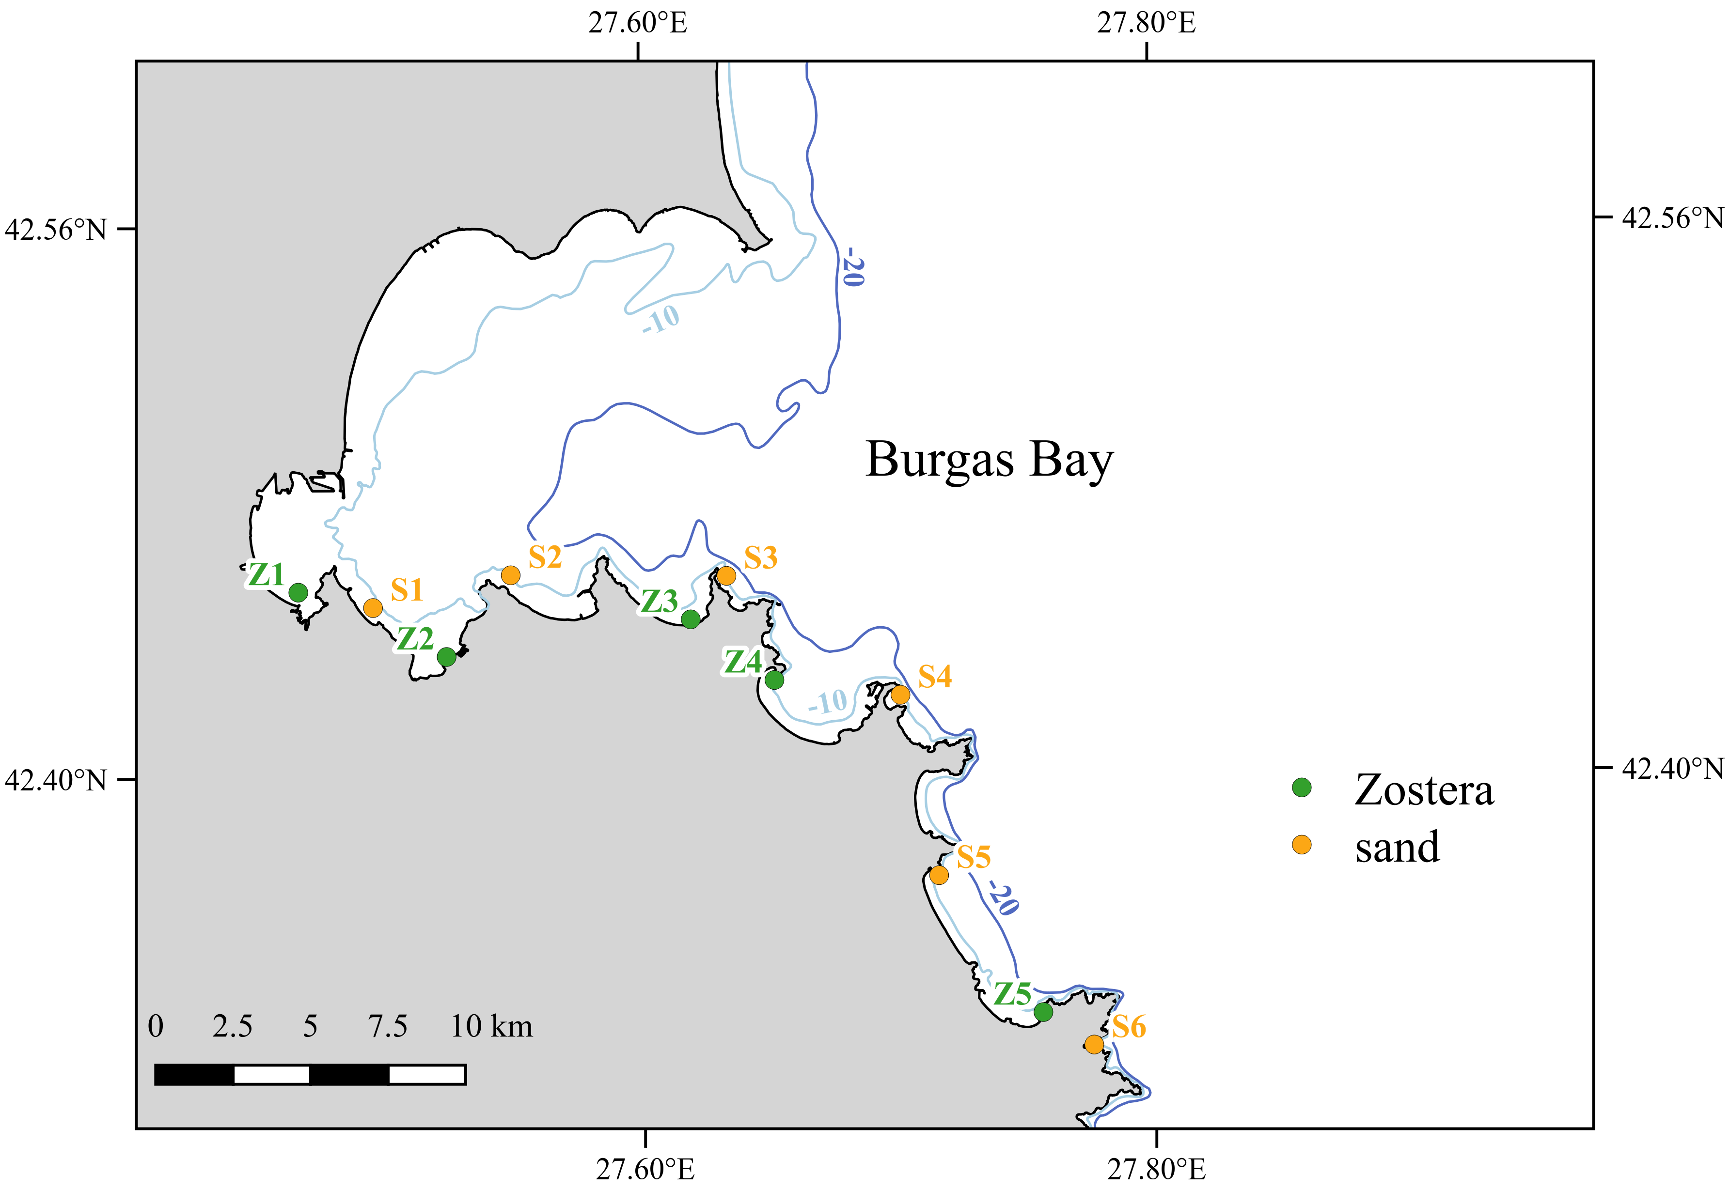Fig. 11. Sampling stations in Burgas Bay (2013-2014). Stations in seagrass meadowos are shown in green and labeled with a Z, and stations in sand – in orange and labeled with an S.
  - Field sampling and laboratory processing
134 quantitative macrozoobenthic samples in total were collected in the shallow coastal zone (56 in seagrass meadows, and 78 in unvegetated sandy habitats). The sampling methodology was based on protocols from Eleftheriou and McIntyre (2005), Todorova and Konsulova (2005), and Short and Coles (2001). Sampling in the seagrass meadows was performed by Scuba divers with a corer with inner diameter 10 cm, and in the unvegetated sand – from a boat using a Van Veen grab with sampling area 0.05 m².
At the same time, samples for several environmental parameters were also collected: water samples for the concentrations of nitrates (N-NO₃⁻), nitrites (N-NO₂⁻), ammonium (N-NH₄⁺), total nitrogen (Ntot) and inorganic nitrogen (Ninorg), phosphates (P-PO₄⁻³), chlorophyll-a (chl-a) and suspended particulate matter (seston), and sediment samples for grain size analysis and sediment organic matter content. Water clarity was measured as Secchi depth (m). Dissolved oxegyn was measured with a CellOx 325 electrode on a Multi 197i (WTW) multiparameter portable measuring instrument. Where possible, the data measured during the study period were complemented with long-term data (2009-2011) from the same stations from Berov (2013).
  - Statistical analyses
All statistical analyses were performed in R (R Core Team, 2015) and additional packages for some specific analyses.
The changes in abiotic parameters (water column and sediments), biometric parameters of seagrasses (where applicable), and the index of anthropogenic pressure LUSI in the study area were characterized by a principal component analysis (PCA). The parameters best correlated with the PCs were retained for use in the subsequent multivariate analyses of the macrobenthic community structure.
The diversity and structure of the macrobenthic communities were described and quantified through the Shannon-Weaver diversity index (Shannon and Weaver, 1949), the Shannon effective diversity (effective number of species), the indices of taxonomic diversity and taxonomic distinctness (Warwick and Clarke, 1998), and ABC curves.
Multivariate analyses were also applied for an in-depth analysis of community composition and structure, and their changes in the anthropogenic pressure gradient:
- classical methods, based on computing a Bray-Curtis distance matrices between each pair of stations and subsequent univariate statistical analyses: non-metric multidimensional scaling (nMDS) – to visualize the changes in community structure; envfit и ordisurf – to determine the environmental parameters best correlated with the observed distribution, and to visualize their variation between stations as isolines derived from generalized additive models (GAM); ANOSIM – to check the statistical significance of the groups observed on the ordination plot; SIMPER (Warwick and Clarke, 1991) – to determine the species that contribute the most to between-group differences and to within-group similarity. PERMANOVA (Anderson, 2001) was applied on the environmental factors in order to identify those with the strongest influence on the observed changes in community composition and structure, as well as their relative contributions.
- model-based methods, which do not reduce the station x species matrix, and model the mean-variance relationship of the data and apply a generalized linear model (GLM) to each species, afterwards combining the single models to describe the changes in community structure: model-based ordination using a latent variable model using the R package boral (Hui, 2016) – to visualize the differences in community structure between stations; multivariate generalized linear models (manyGLM) using the R package mvabund (Wang et al., 2012), with the environmental parameters as predictors – to identify those with the highest influence on the macrobenthic communities, as well as to characterize the reaction of each species to their changes. The best model was determined through backwards step-wise model selection minimizing the information criterion AIC.
  - Biotic indices for ecological state assessment
In order to assess the current state of the selected benthic habitats in the coastal Burgas Bay, several zoobenthic biotic indices were applied and compared. Their performance - the ability to correctly react to changes in macrobenthic community composition and structure under anthropogenic pressure - and their sensitivity towards environmental parameters which reflect this pressure, were tested. A good index is expected to react more strongly to those changes than to the natural differences between communities (e.g. those from different biotopes).
In this study, the national monitoring tools used during the study period were compared (H', AMBI and M-AMBI), as well as an additional index – BENTIX, developed and applied in the Eastern Mediterranean. An additional index was also applied, M-AMBI*n – a simplified version of M-AMBI, which it officially replaced in the Bulgarian national monitoring since 2015.
The ecological class limits (as EQR) used in this study are presented in Table 4.
Таблица 4. Limits of the ecological quality classes of the biotic indices applied in the current study. EQR values from: AMBI, M-AMBI, H' – Trayanova et al. (2008); BENTIX – Simboura and Zenetos (2002), M-AMBI*n – Todorova et al. (2017).
Ecological state (EQR) | H' | AMBI | BENTIX | M-AMBI | M-AMBI*n
excellent | 0.89 | 0.83 | 0.75 | 0.85 | 0.87
good | 0.69 | 0.53 | 0.58 | 0.55 | 0.66
modereate | 0.49 | 0.39 | 0.42 | 0.39 | 0.44
bad | 0.29 | 0.21 | < 0.42 | 0.20 | 0.22
very bad | < 0.29 | < 0.21 | 0 | < 0.20 | < 0.22

The differences in index EQRs were compared between stations and between biotopes (where applicable), in order to assess the influence of the natural variations in community structure and the characteristics of the macrobenthic communities. Spearman rank correlations of the index assessments with environmental parameters were calculated in order to validate the assessments and to check index sensitivity. To determine how comparable the assessments are between indices, the WFD intercalibration criteria were applied – the absolute average class difference (with acceptability cutoff of 0.5 classes difference) and the % agreement (match) of the assessments (van de Bund et al., 2008). According to the requirements of the WFD, the comparability of assessments ensures a common baseline for determining possible deviation from the reference conditions. The proportion of differences which cross the limit good/moderate ecological state was also determined for each pair of indices, as this would determine the need for conservation or recovery measures, and any assessment errors would have the most serious consequences.
- Results and discussion
  - Анализи на параметрите на околната среда
Единствено PCA на параметрите на водния стълб в пясъчното дъно и в морските треви в Бургаския залив беше представителен. За станциите в пясъчното дъно на Бургаския залив, първите два компонента обясняват 68.02% от общата вариация на данните. Станциите се разделят на две групи: тези във вътрешността на Бургаския залив (S1-S3) – с високи стойности на еутрофикационните параметри и LUSI, и тези във външната част на залива (S4-S6) – с характерни ниски стойности на биогените и LUSI и висока прозрачност, което потвърждава предишните изследвания и модели в района (Беров, 2012, 2013). За станциите в морските треви в Бургаския залив, първите три компонента обясняват 76.59% от общата вариация. Станциите не са добре разделени в равнината, определена от PC1-2, вероятно заради характерно големите вариации на стойностите на параметрите на водния стълб. Като цяло обаче заедно се групират пробите с ниски стойности на биогенни елементи, хлорофил-а и суспендирана материя, а също и нисък LUSI (станция Z4), и отделно – пробите с по-скоро високи такива (особено Z1 и Z2). За седиментните параметри в двата типа местообитания и за параметрите на морските треви няма достатъчно данни за представителен PCA; въпреки това те са включени в последващите анализи, тъй като най-често са определящи за структурата и състава на зообентосните съобщества.
  - Таксономичен състав и структура на зообентосните съобщества в крайбрежната зона на Бургаския залив
    - Зообентосни съобщества в морските треви и съседното пясъчно дъно в Созополски залив (2012 г.)
Основната цел на пилотния експеримент в Созополския залив беше изпробване и валидиране на изследователските методи, а също и запознаване с обекта на изследване и доминиращите таксономични групи и видове. Затова са извършени ограничен брой анализи на тези данни и резултатите и изводите са по-скоро предварителни. Резултатите са обобщени и разглеждани на нивото на сайтовете, тъй като не е открита значима разлика между станциите и местообитанията в рамките на всеки сайт.
Установени са общо 39 вида и 19 надвидови таксона, от които 47 са представени в морските треви, а 42 – в съседното пясъчно дъно. 31 таксона са общи за двата типа местообитания; 11 са установени само в пясъчното дъно, а 16 – само в морските треви. Средният брой таксони, численост и биомаса, както и видовото разнообразие на зообентосните съобщества в двата типа местообитания през 2012 г. са сравнително ниски, вероятно поради пилотния характер на изследването и пропуски при регистрирането на част от таксоните. Въпреки това, видовото разнообразие и общата численост са по-високи в морските треви, отколкото в съседните пясъчни местообитания. Видовете с най-голяма численост и биомаса в морските треви са детритоядни (Bittium reticulatum) и растителноядни (Rissoa membranacea, Rissoa sp.) охлюви; миди (Loripes orbiculatus, Mytilaster lineatus, Polititapes aureus) и други филтриращи организми (Amphibalanus improvisus); толерантни към затиняване групи (олигохети, полихети от сем. Capitellidae и Spionidae).
Разликите между сайтовете изглежда се дължат основно на пробите от пясъчното дъно (Фиг. 22). Съобществата на сайт K се различават най-много от тези на другите два сайта; разликите между сайтове R и G не са толкова изразени. На сайт K, който се намира най-близо до точковия източник на антропогенен натиск в залива, числеността на толерантните групи – олигохети, полихети от сем. Capitellidae и Spionidae – е по-голяма, отколкото на другите сайтове, където от своя страна се увеличава пропорцията на по-чувствителните групи. Разликите са особено изразени при пясъчните местообитания, но това би могло да се дължи отчасти и на голямата дисперсия заради твърде малките брой таксони и численост в тези проби.
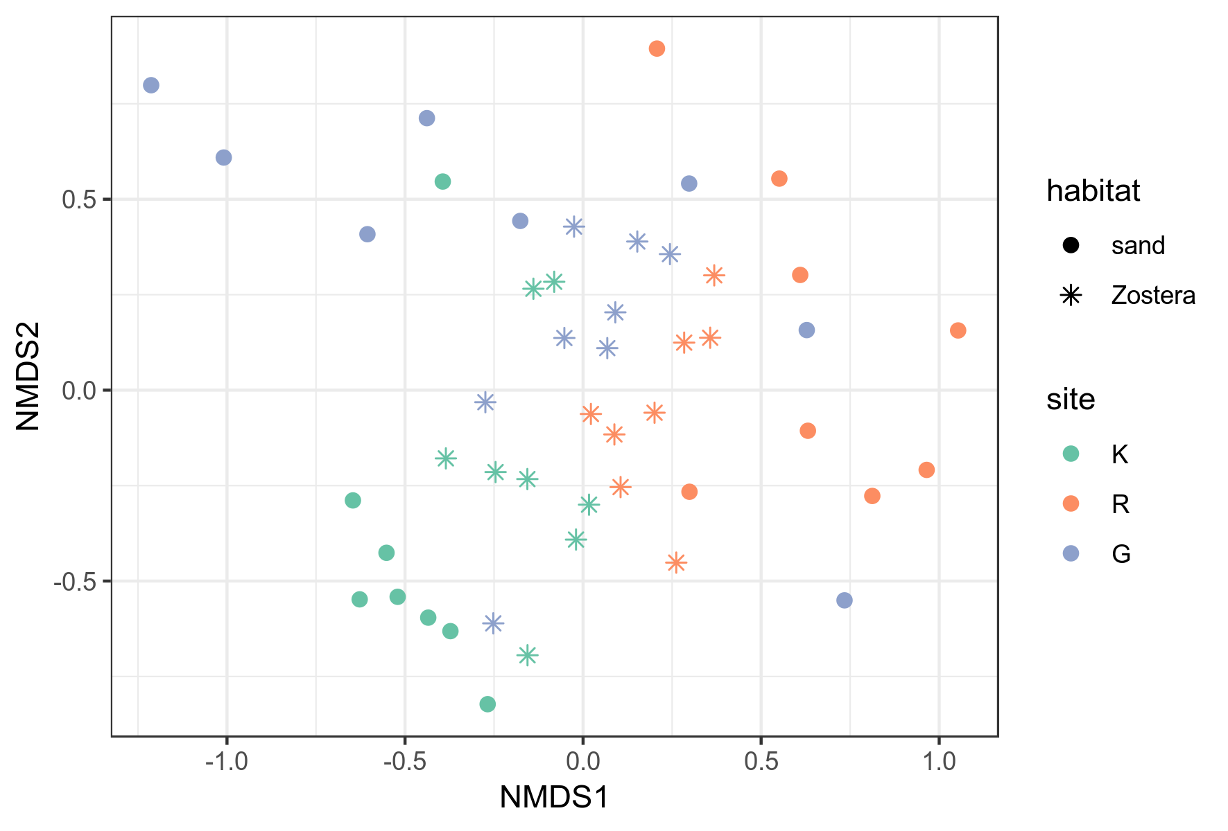Fig. 22. nMDS of the macrobenthic communities in seagrass meadows and adjacent unvegetated sediments in Sozopol Bay, 2012 г.
Въздействието на източника на отпадни води не изглежда да е особено силно; структурата на съобществата дори на най-близко разположения сайт отговаря на средни нива на пертурбация (intermediate disturbance), с характерната първоначална стимулация на разнообразието и присъствие както на чувствителни, така и на толерантни таксони и групи.
    - Зообентосни съобщества в пясъчното дъно в Бургаския залив (2013-2014 г.)
В пясъчното дъно на крайбрежната зона на Бургаския залив са установени общо 129 вида и 16 надвидови таксона. С най-много таксони са представени Polychaeta – 62 (42.76% от общия брой за пясъчното дъно), следвани от Mollusca – 39 (26.9%), и Crustacea – 32 (22.07%). Varia включва 12 таксона (8.28%). Това разпределение е характерно за българското Черно море (Маринов, 1990; Todorova and Konsulova, 2003, 2005).
Общата средна численост на зообентоса е 6764 ± 3723 ind.m⁻² (минимална – 1960 ind.m⁻² на ст. S6, 2013 г.; максимална – 18020 ind.m⁻² на ст. S3, 2013 г.). Общата средна биомаса е 404.42 ± 757.58 g.m⁻² (минимална – 5.81 g.m⁻² на ст. S2, 2013 г.; максимална – 3143.56 g.m⁻² на ст. S4, 2013 г.). Най-многобройните таксони за периода на изследване са представени на Фиг. 25. Някои от тях са масови и се срещат със сравнително висока численост на повечето станции (Chamelea gallina, Oligochaeta), докато други се откриват преобладаващо на определени станции (Microdeutopus versiculatus, Melita palmata на ст. S5, Heteromastus filiformis и Melinna palmata на ст. S1 и S2).
Fig. 25. Top 20 taxa with the highest contribution to the total abundance in the macrobenthic communities of the sandy bottoms in Burgas Bay (all samples, 2013-2014).
Макрозообентосните съобщества от пясъчното дъно в крайбрежната зона на Бургаския залив имат високи видово богатство и разнообразие, обща численост и биомаса, в рамките на типичните стойности за инфралиторалните биотопи по българското черноморско крайбрежие (Тодорова и кол., 2017). На ст. S4 се наблюдава силно доминиране на мидата C. gallina в съобществото, със съответно ниски стойности на H' и индекса за изравненост J'. Таксономичните индекси (Фиг. 27) в по-голямата си част не се отклоняват от очакваните, което говори за сравнително нормална, ненарушена структура на съобществата. За това свидетелстват и ABC-кривите, които са нормални (крива на биомасата над тази на числеността), но все пак сравнително близко разположени. Това се отнася особено за ст. S5, разположена в близост до скални рифове, от които вероятно постъпва естествено детрит и органична материя (предвид липсата на значими източници на антропогенно въздействие в района на станцията).
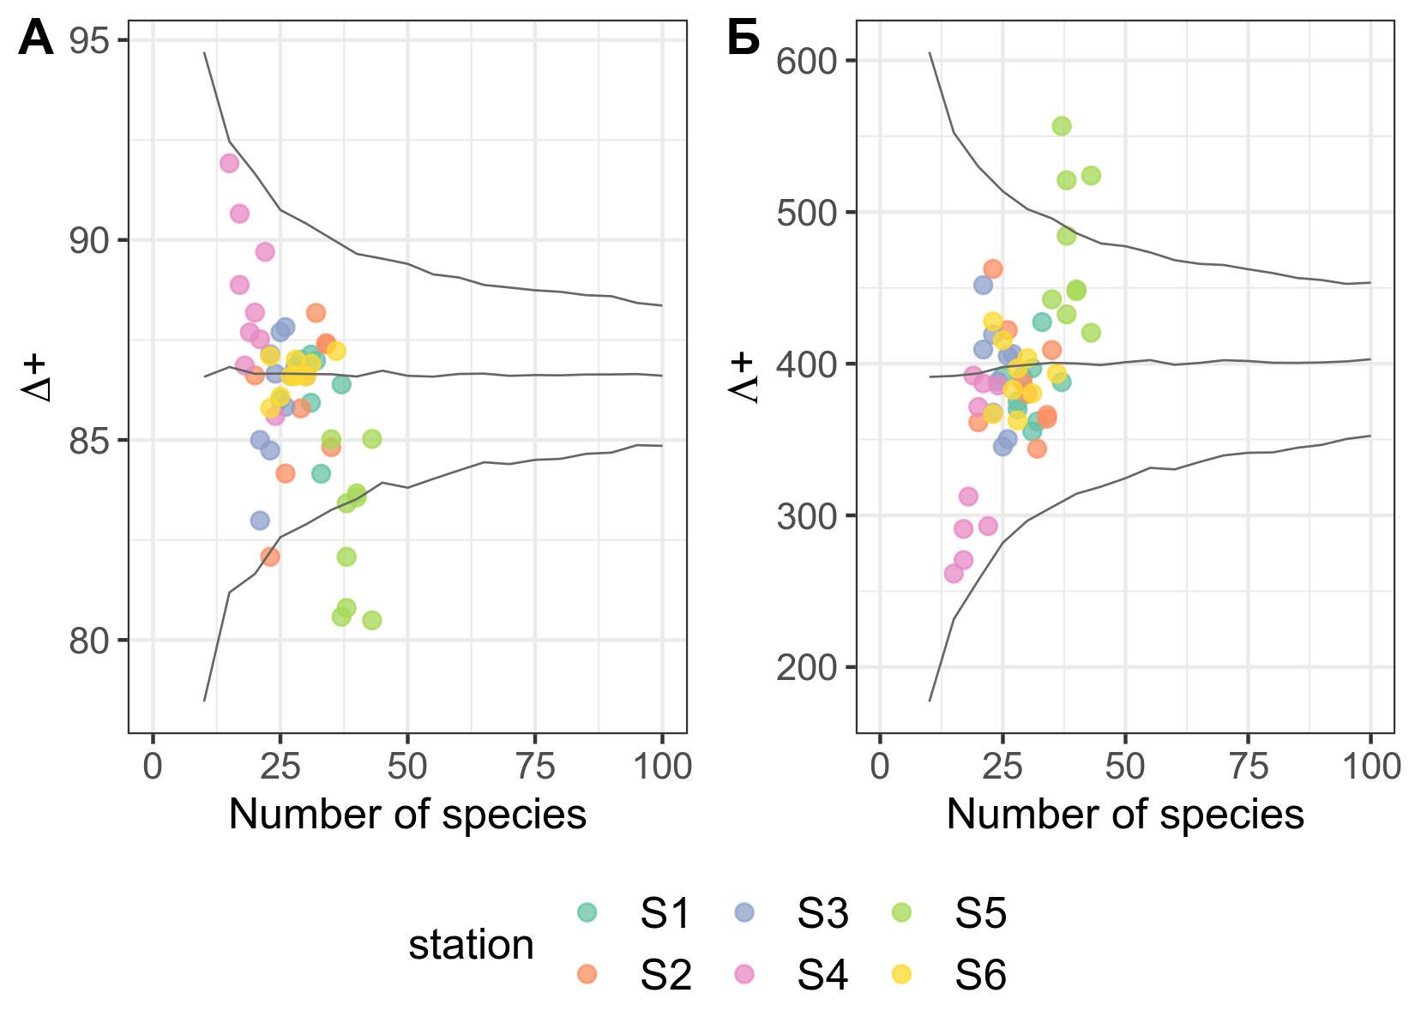Fig. 27. (А) Taxonomic distinctness Δ⁺ and (Б) variation of the taxonomic distinctness Λ⁺ of the macrobenthic communities of the sandy bottoms in Burgas Bay (2013-2014). The horizontal lines represent the mean expected value of each index, and the „funnels“ correspond to their 95% theoretical confidence intervals calculated based on the full invertebrate species list for the Bulgarian Black Sea.
Разликите в структурата на съобществата, проявени още при едномерните и графичните методи, се допълват и изясняват от класическите многомерни анализи (Фиг. 29). Наблюдаваното разпределение се описва от една страна от еутрофикационните параметри/градиента на антропогенно въздействие в района на Бургаския залив (параметри на водния стълб и индекс LUSI), а от друга – от седиментните параметри (гранулометричен състав и съдържание на органична материя).
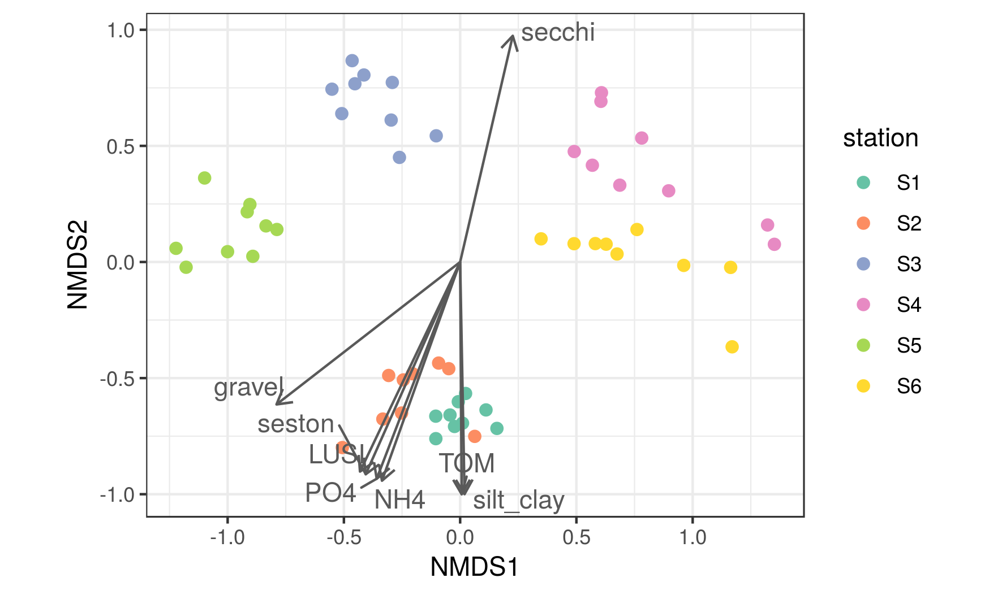Fig. 29. nMDS of the macrobenthic communities of the sandy bottoms of Burgas Bay (2013-2014). The environmental factors best correlated (envfit, p < 0.05) with the observed distribution are shown as vectors: water column parameters – NH4 – ammonium concentration, µg.L⁻¹, PO4 – phosphate concentration, µg.L⁻¹, seston – suspended particulate matter concentration, mg.L⁻¹, secchi – water clarity, m; anthropogenic pressure index LUSI; sediment parameters – TOM – total organic matter content, %, gravel – percent gravel, %, silt_clay – percent silt and clay, %.
Ст. S1 и S2 отговарят на най-силната степен на антропогенно въздействие – с високи стойности на LUSI, концентрации на биогени и суспендирана материя във водния стълб, и високо съдържание на органична материя на седиментите. На тези станции преобладава черупчесто-чакълест субстрат, примесен с тиня. За най-„чистите“ станции – ст. S4 и S6 – са характерни най-ниските стойности на LUSI и най-ниските концентрации на биогени и суспендирана материя във водния стълб, както и най-високата прозрачност на водата. Субстратът на тези станции е чист дребен пясък с малък процент тиня и средно количество органика. Ст. S3 и ст. S5 имат междинно разположение между предните две групи. S3 има междинни стойности на LUSI и биогени и преобладаващо пясъчен субстрат, така че е по-близка до „чистите“ станции; S5 се характеризира с едър пясък, примесен с чакъл и черупки на мекотели и сравнително високо органично съдържание на седиментите заради близостта си до естествения скален риф, заради което се разполага по-близо до „замърсените“ станции на ординацията.
Според дълбочината, преобладаващия субстрат и характерната структура и състав на зообентосните съобщества (SIMPER анализ), изследваните станции спадат към 3 национални биотопа: Инфралиторални дребни и средни пясъци с Chamelea gallina, Lentidium mediterraneum, Tellina tenuis; Инфралиторални черупчести пясъци и чакъли с разнообразна фауна и Инфралиторални едри и средни пясъци с Upogebia pusilla, както и един допълнителен, условно наречен тук Инфралиторални тинести пясъци с Melinna palmata и Anadara kagoshimensis.
Според PERMANOVA анализа, параметрите на средата, които най-добре обясняват разликите между групите, са дългосрочните средни стойности на концентрациите на N-NH₄, P-PO₄ и суспендирана материя във водния стълб, както и прозрачността на водата, а от седиментните параметри – съдържанието на тиня и количеството обща органична материя (TOM) (Таблица 17).
Table 17. PERMANOVA of environmental parameters measured at the sandy bottom stations in Burgas Bay. NH4 – ammonium concentration in the water column, µg.L⁻¹, PO4 – phosphate concentration in the water column, µg.L⁻¹, seston – suspended particulate matter concentration in the water column, mg.L⁻¹, secchi – water clarity, m; anthropogenic pressure index LUSI; TOM – total organic matter content of the sediments, %, gravel – gravel content of the sediments, %, silt_clay – silt and clay content of the sediments, % (based on 999 permutations).
В настоящето изследване, моделната LVM ординация на станциите в пясъчното дъно на Бургаския залив очертава същите основни групи като класическата. Моделният анализ позволява по-прецизно определяне на видовете, съставящи характерното за дадено местообитание съобщество, както и нехарактерните видове – тези, които е малко вероятно да се срещат в този тип местообитание. Като цяло, в настоящето изследване моделният метод е в съгласие с класическия – същите или близки видове са определени като характерни за структурата на групите. Нехарактерните за съответните подтипове местообитания видове и групи са: S1-S2 – Streptosyllis bidentata, Branchiostoma lanceolatum, Magelona papillicornis, Melita palmata, Ophelia limacina; S3 – H. filiformis, A. kagoshimensis, Micronephthys stammeri, Melinna palmata и др.; S5 – A. kagoshimensis, Melinna palmata, P. cirrifera, Polydora ciliata, Abra alba; S4-S6 – Oligochaeta, H. filiformis, A. kagoshimensis, Lagis koreni, Harmothoe reticulata и др.
Според моделния метод (manyGLM), най-силно въздействие върху наблюдаваната структура на съобществата в пясъчното дъно на Бургаския залив имат концентрацията на фосфати – индикатор за еутрофикационното състояние на района на изследване, и количеството чакъл – т.е. гранулометричният състав на седиментите; в по-слаба степен влияние оказват също количеството суспендирана материя и индексът LUSI (Таблица 19). Този резултат е в съгласие с резултата от PERMANOVA анализа, като разликите са по-скоро в конкретните изведени значими параметри и в относителната им сила (Таблица 17).
Table 19. Multivariate model-based analysis (manyGLM) of the structure of the macrobenthic communities of the sandy bottoms of Burgas Bay (2013-2014) as a function of environmental parameters. PO4 – concentration of phosphates in the water column, µg.L⁻¹, seston – concentration of suspended particulate matter in the water column, mg.L⁻¹; anthropogenic pressure index LUSI; gravel – gravel content of the sediments, %. The contribution of the taxa to the total Sum-of-LR (Deviance) of the environmental parameters is presented in brackets after their names. The top 10 taxa with the highest contributions are presented for each parameter.
Тези резултати потвърждават началната експериментална хипотеза за промяна в структурата на съобществата под въздействие на антропогенни фактори – индикатори за еутрофикация и антропогенен натиск са изведени като определящи за наблюдаваните разлики и от двата типа многомерни методи. Значителна част от вариацията обаче се дължи и на естествени фактори, по-специално на гранулометричния състав на седиментите, който играе основна роля в структурирането за зообентоса в мекото дъно (Gray, 1974; Anderson, 2008; Gray and Elliott, 2009). Докато в резултат на различни антропогенни дейности в крайбрежната зона би могло да се стигне до промяна в гранулометрията (например затиняване), това не може да се твърди за настоящето изследване. Тези две групи фактори най-вероятно се допълват в този случай.
    - Зообентосни съобщества в морските треви в Бургаския залив (2013-2014 г.)
В морските треви в Бургаския залив са установени общо 79 вида и 14 надвидови таксона. С най-много таксони са представени Polychaeta – 40 (43.01% от общия брой за морските треви), следвани от Mollusca – 26 (27.96%), Crustacea – 19 (20.43%) и Varia – 8 таксона (8.6%).
Макрозообентосните съобщества в морските треви в Бургаския залив се характеризират с много високи видово богатство, численост и биомаса. Общата средна численост на зообентоса за периода на изследване е 49972 ± 25709 ind.m⁻² (минимална – 17436 ind.m⁻² на ст. Z1, 2014 г.; максимална – 133077 ind.m⁻² на ст. Z5, 2013 г.). Общата средна биомаса е 306.63 ± 244.26 g.m⁻² (минимална – 33 g.m⁻² на ст. Z3, 2014 г.; максимална – 898.96 g.m⁻² на ст. Z4, 2013 г.). Средният брой таксони през периода на изследване е 26 ± 5 (минимален – 13 на ст. Z3, 2014 г.; максимален – 35 на ст. Z4, 2013 г.). Най-многобройните таксони за периода на изследване са представени на Фиг. 34. Съставът на съобществата пред българския бряг е подобен на този, който често се открива в полетата с морски треви в умерената зона, а също и в други райони на Черно море. Обикновено доминират растителноядни и детритоядни видове (R. membranacea, B. reticulatum), както и толерантни към повишено количество тиня и органична материя таксони (олигохети, полихети от сем. Capitellidae и Spionidae, амфиподите M. acherusicum, A. diadema и др.). Характерните за местообитанието миди от сем. Lucinidae също се откриват често.
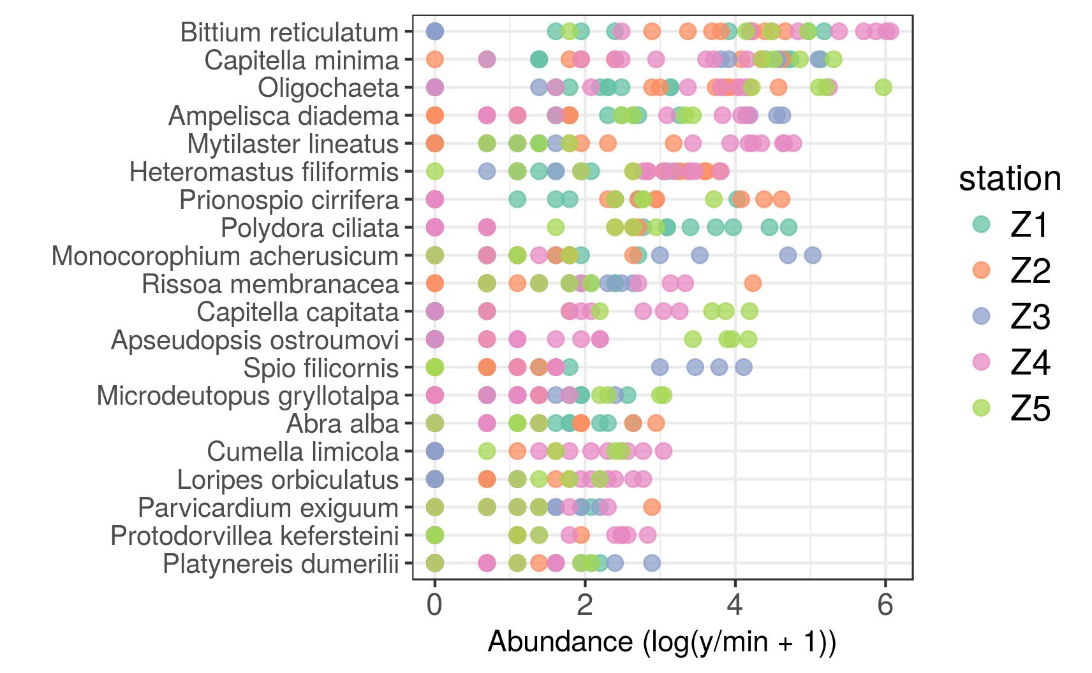Fig. 34. Top 20 taxa with the highest contribution to the total abundance of the macrobenthic communities in the seagrasses in Burgas Bay (all samples, 2013-2014).
Стойностите на индексите за видово разнообразие са високи. Таксономичните индекси не се отклоняват от очакваните стойности, т.е. съобществата имат нормална таксономична структура (Фиг. 36). На АВС кривите на повечето станции тази на биомасата се намира над тази на числеността, но двете криви са разположени сравнително близко една до друга или се пресичат (W < 0.5). Тъй като това се наблюдава на всички станции по продължение на целия градиент на антропогенно въздействие в Бургаския залив, най-вероятно това се дължи на естественото присъствие и развитие на толерантни и опортюнистични видове поради повишеното съдържание на органична материя в седиментите, характерно за полетата с морски треви, но не задължително показателно за стрес (Blanchet et al., 2008).
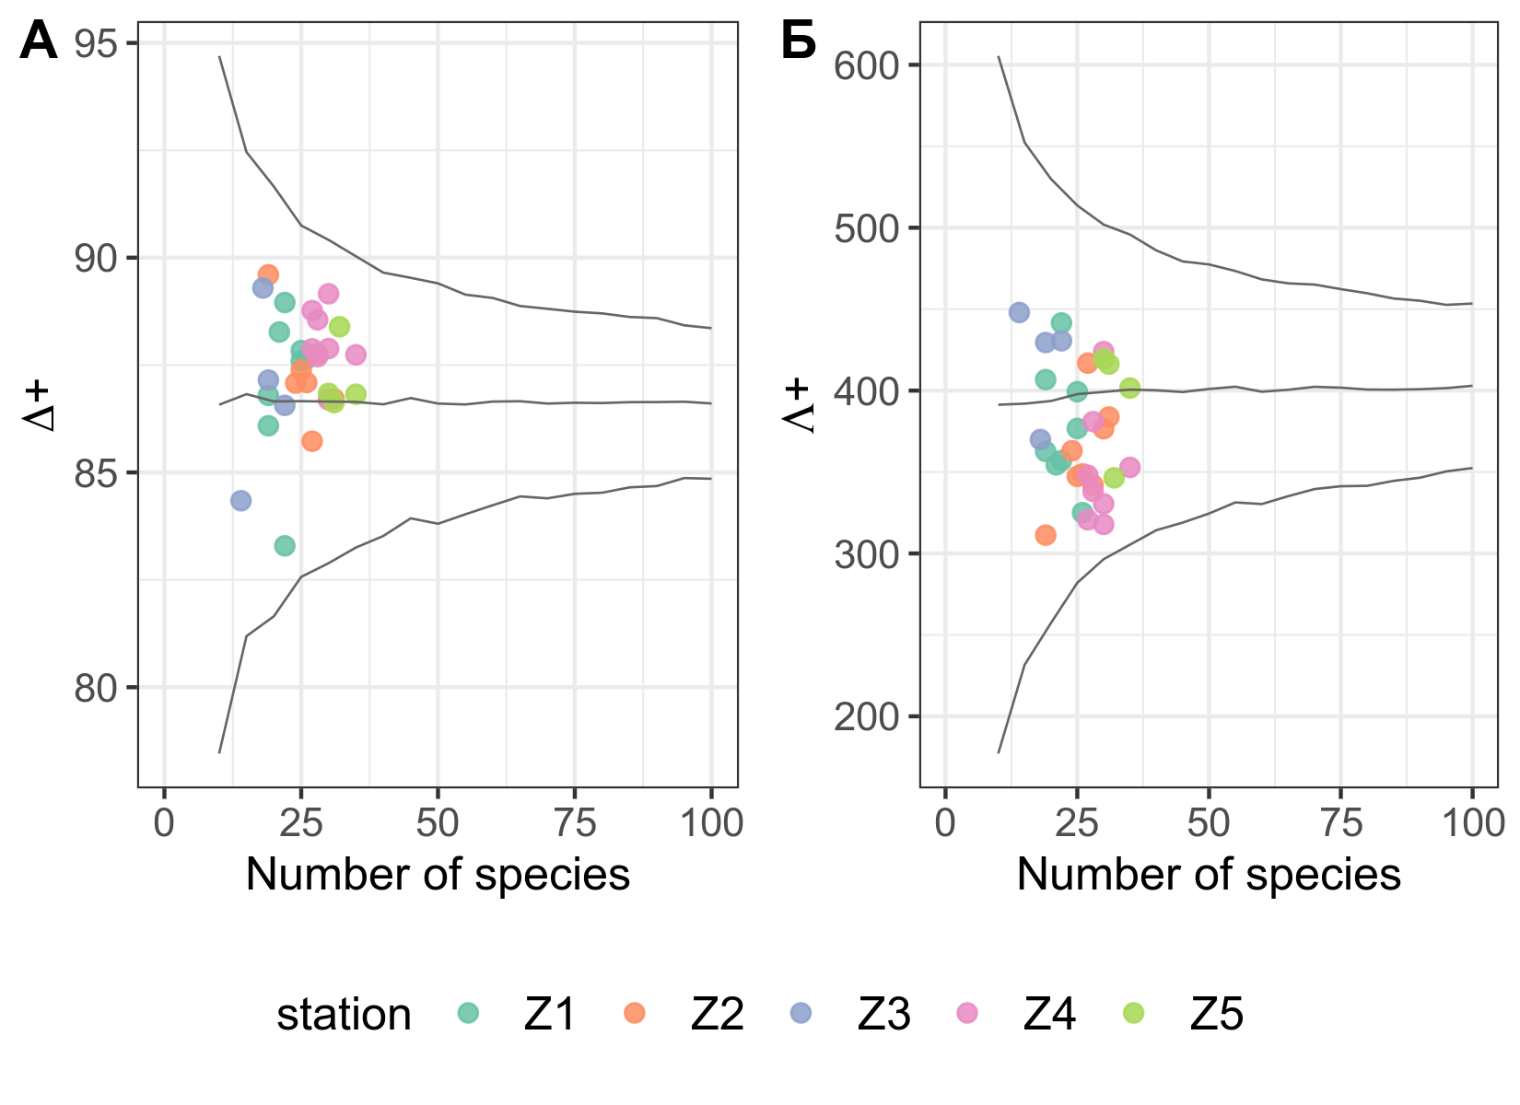Фиг. 36. (А) Taxonomic distinctness Δ+ and (Б) variation of the taxonomic distinctness Λ+ of the macrobenthic communities of the seagrasses in Burgas Bay (2013-2014). The horizontal lines represent the mean expected value of each index, and the „funnels“ correspond to their 95% theoretical confidence intervals calculated based on the full invertebrate species list for the Bulgarian Black Sea.
Макрозообентосните съобщества в морските треви имат сходна структура, което затруднява разграничаването на станциите; наблюдаваните разлики вероятно се дължат на антропогенния градиент на въздействие: ст. Z1 и Z2 от вътрешността на Бургаския залив имат най-високи стойности на индекса LUSI и повишено съдържание на тиня на седиментите; ст. Z4 и Z5 имат най-голяма прозрачност на водата и повече пясък, отколкото тиня в седиментите; ст. Z3 се различава най-много от всички останали (Фиг. 38).
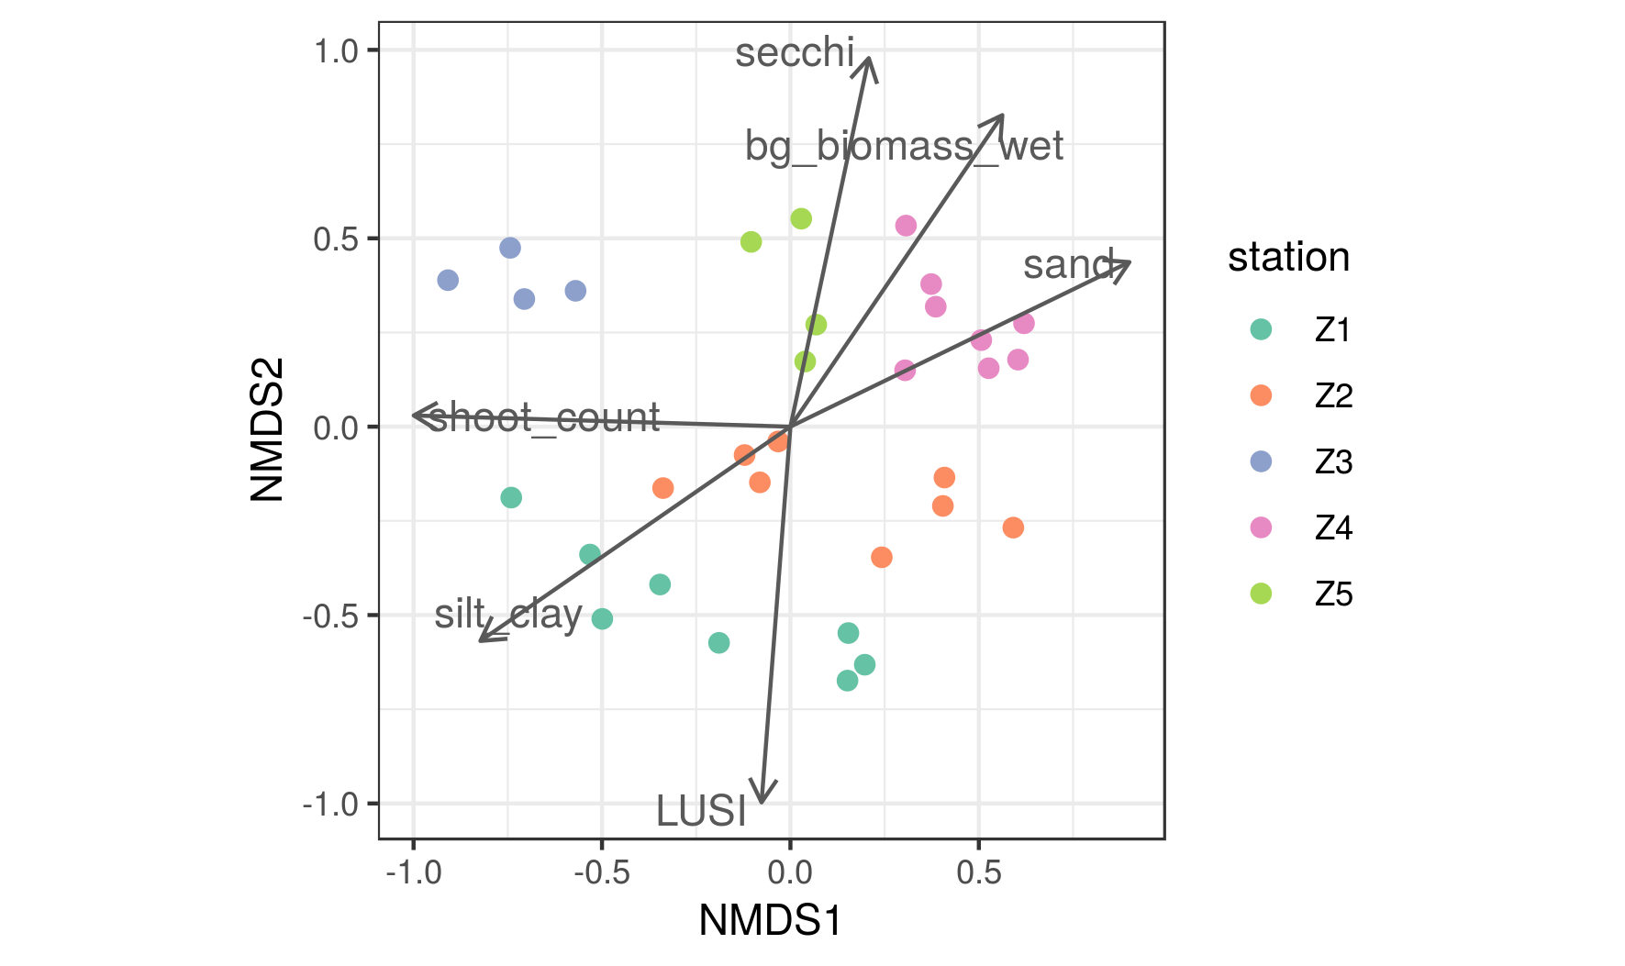Фиг. 38. nMDS of the macrobenthic communities of the seagrasses of Burgas Bay (2013-2014). The environmental factors best correlated (envfit, p < 0.05) with the observed distribution are shown as vectors: water column parameters – secchi – water clarity, m; anthropogenic pressure index LUSI; sediment parameters – sand – percent sand, %, silt_clay – percent silt and clay, %; seagrass parameters – shoot_count – density of seagrass shoots, nb.m⁻²; bg_biomass_wet – below-ground biomass, g.m⁻².
Според SIMPER анализа, най-характерни за на най-вътрешно разположените в залива станции са толерантни към затиняване и органично замърсяване видове и групи – Polydora ciliata, олигохети, Capitella minima на Z1; олигохети, Heteromastus filiformis, Prionospio cirrifera, C. minima, а също B. reticulatum, на Z2. До подобна структура на съобществата води и речният вток на р. Ропотамо на ст. Z5, въпреки че в случая става въпрос за естествен, а не антропогенен натиск – най-характерни са олигохетите, C. minma, C. capitata, но също и Apseudopsis ostroumovi, B. reticulatum. На Z3, в близост до втока на непречистени води на гр. Черноморец, най-характерните видове са също предимно толерантни – A. diadema, C. minima, M. acherusicum, Spio filicornis. За Z4 най-характерни са B. reticulatum, M. lineatus, H. filiformis, C. minima, но и по-чувствителни видове като P. kefersteini, Cumella limicola, L. orbiculatus.
PERMANOVA анализът показва, че наблюдаваното разпределение се обяснява най-добре от антропогенното въздействие (LUSI), характеристиките на седиментите (количество пясък и тиня), и гъстотата на морските треви (Таблица 24).
Table 24. PERMANOVA of environmental parameters measured at the seagrass stations in Burgas Bay. LUSI - anthropogenic pressure index; sand – sand content of the sediments, %, silt_clay – silt and clay content of the sediments, %; shoot_count – density of seagrass shoots, nb.m⁻²; bg_biomass_wet – below-ground biomass (wet weight), g.m⁻² (based on 999 permutations).
Тези резултати могат да се обяснят с промените в биометричните параметри на морските треви, а също и в характеристиките на седиментите, които настъпват в резултат на промените в абиотичните параметри на средата, предизвикани от антропогенния натиск в района на изследване. В екстремни еутрофни условия това може да доведе до загуба на местообитания за зообентосните организми при смъртност на средообразуващите морски треви, както и до директно намаляване и изчезване на чувствителни представители на инфауната и заместването им от толерантни такива поради развитие на хипоксични условия при гниене на фитопланктонна или детритна биомаса (Burkholder et al., 2007). Тъй като през периода на изследване не са измерени екстремни стойности на биогени, може да се приеме, че съобществата, асоциирани с морските треви, са подложени предимно на хроничните ефекти от еутрофикационния градиент в Бургаския залив.
LVM ординацията на станциите от полетата с морски треви в Бургаския залив съвпада с класическата nMDS ординация; всяка станция отново се обособява в отделна група. Същите или близки видове отново са изведени и от manyGLM като характерни за разликите между групите. Подобно на SIMPER анализа, моделният метод разграничава повишеното присъствие на толерантни към антропогенно въздействие видове и групи на най-вътрешните за Бургаския залив станции (Z1, Z2). За разлика от SIMPER обаче, не само видове с голяма дисперсия между станциите и пробите са определени като важни; напр. B. reticulatum според модела проявява значима реакция единствено на станции Z1 (увеличаване) и Z3 (пълно отсъствие).
Най-силно въздействие върху наблюдаваната структура на съобществата имат параметрите на морските треви – подземната биомаса и гъстотата на стръковете, следвани от еутрофикационното състояние на водния стълб (дългосрочната концентрация на общ азот) и характеристиките на седиментите (количеството пясък). (Таблица 26).
Таблица 26. Multivariate model-based analysis (manyGLM) of the structure of the macrobenthic communities of the seagrasses in Burgas Bay (2013-2014) as a function of environmental parameters. Ntotal – concentration of total nitrogen in the water column, µg.L⁻¹; sand – sand content of the sediments, %; shoot_count – density of seagrass shoots, nb.m⁻²; ag_biomass – above-ground biomass (wet weight), g.m⁻², bg_biomass – below-ground biomass (wet weight), g.m⁻². The contribution of the taxa to the total Sum-of-LR (Deviance) of the environmental parameters is presented in brackets after their names. The top 10 taxa with the highest contributions are presented for each parameter.
Положителната връзка между структурната сложност на местообитанията на морските треви и асоциираните зообентосни съобщества се подкрепя и от други изследвания (Bostrom et al., 2006; Sirota and Hovel, 2006; González-Ortiz et al., 2016). Поради метода на пробонабиране, в пробите от настоящето изследване е представена предимно инфауната, затова не е изненадващо, че основно значение има триизмерната структура и съответно различните микрониши, предоставяни от корените и ризомите на морските треви (подземната биомаса). Кореновата система на тревите повишава стабилността на седиментите и, за разлика от силно динамичната надземна биомаса, обикновено варира по-слабо във времето в резултат на сезонност или естествени и антропогенни натиски (Duarte and Chiscano, 1999). Не на последно място, тя вероятно предоставя допълнителна защита и допринася за устойчивостта на асоциираните зообентосни съобщества (Siebert and Branch, 2005, 2007; González-Ortiz et al., 2016). Еутрофикационното състояние на средата, представено от дългосрочната концентрация на общ азот във водния стълб, очевидно също се отразява върху асоциираните зообентосни съобщества, вероятно посредством обсъдените по-горе индиректни ефекти. Изведените тук параметри се различават до известна степен от резултата от PERMANOVA, но поради гореспоменатите характеристики на пробонабирането в този случай резултатите от моделния анализ на параметрите на околната среда са по-логични от екологична гледна точка.
  - Екологично състояние по зообентос на дънни местообитания в плитката крайбрежна зона на Бургаския залив
    - Местообитания в пясъчното дъно в Бургаския залив
Всички изследвани тук биотични индекси реагират на промяната в състава и структурата на макрозообентосните съобщества от пясъчното дъно в градиента на въздействие в Бургаския залив. Те обаче също така силно се влияят и от естествените вариации между различните биотопи (Фиг. 42). За сметка на това, промяната в пропорциите на екологичните групи по чувствителност по продължение на градиента демонстрира добре негативните ефекти на антропогенното въздействие, които не винаги се отчитат от индексите: на вътрешните станции S1-S3 в структурата на съобществата се наблюдава по-висок дял на опортюнистичните и толерантните видове, докато на външните S4-S6 преобладава пропорцията на чувствителните и неутралните видове.
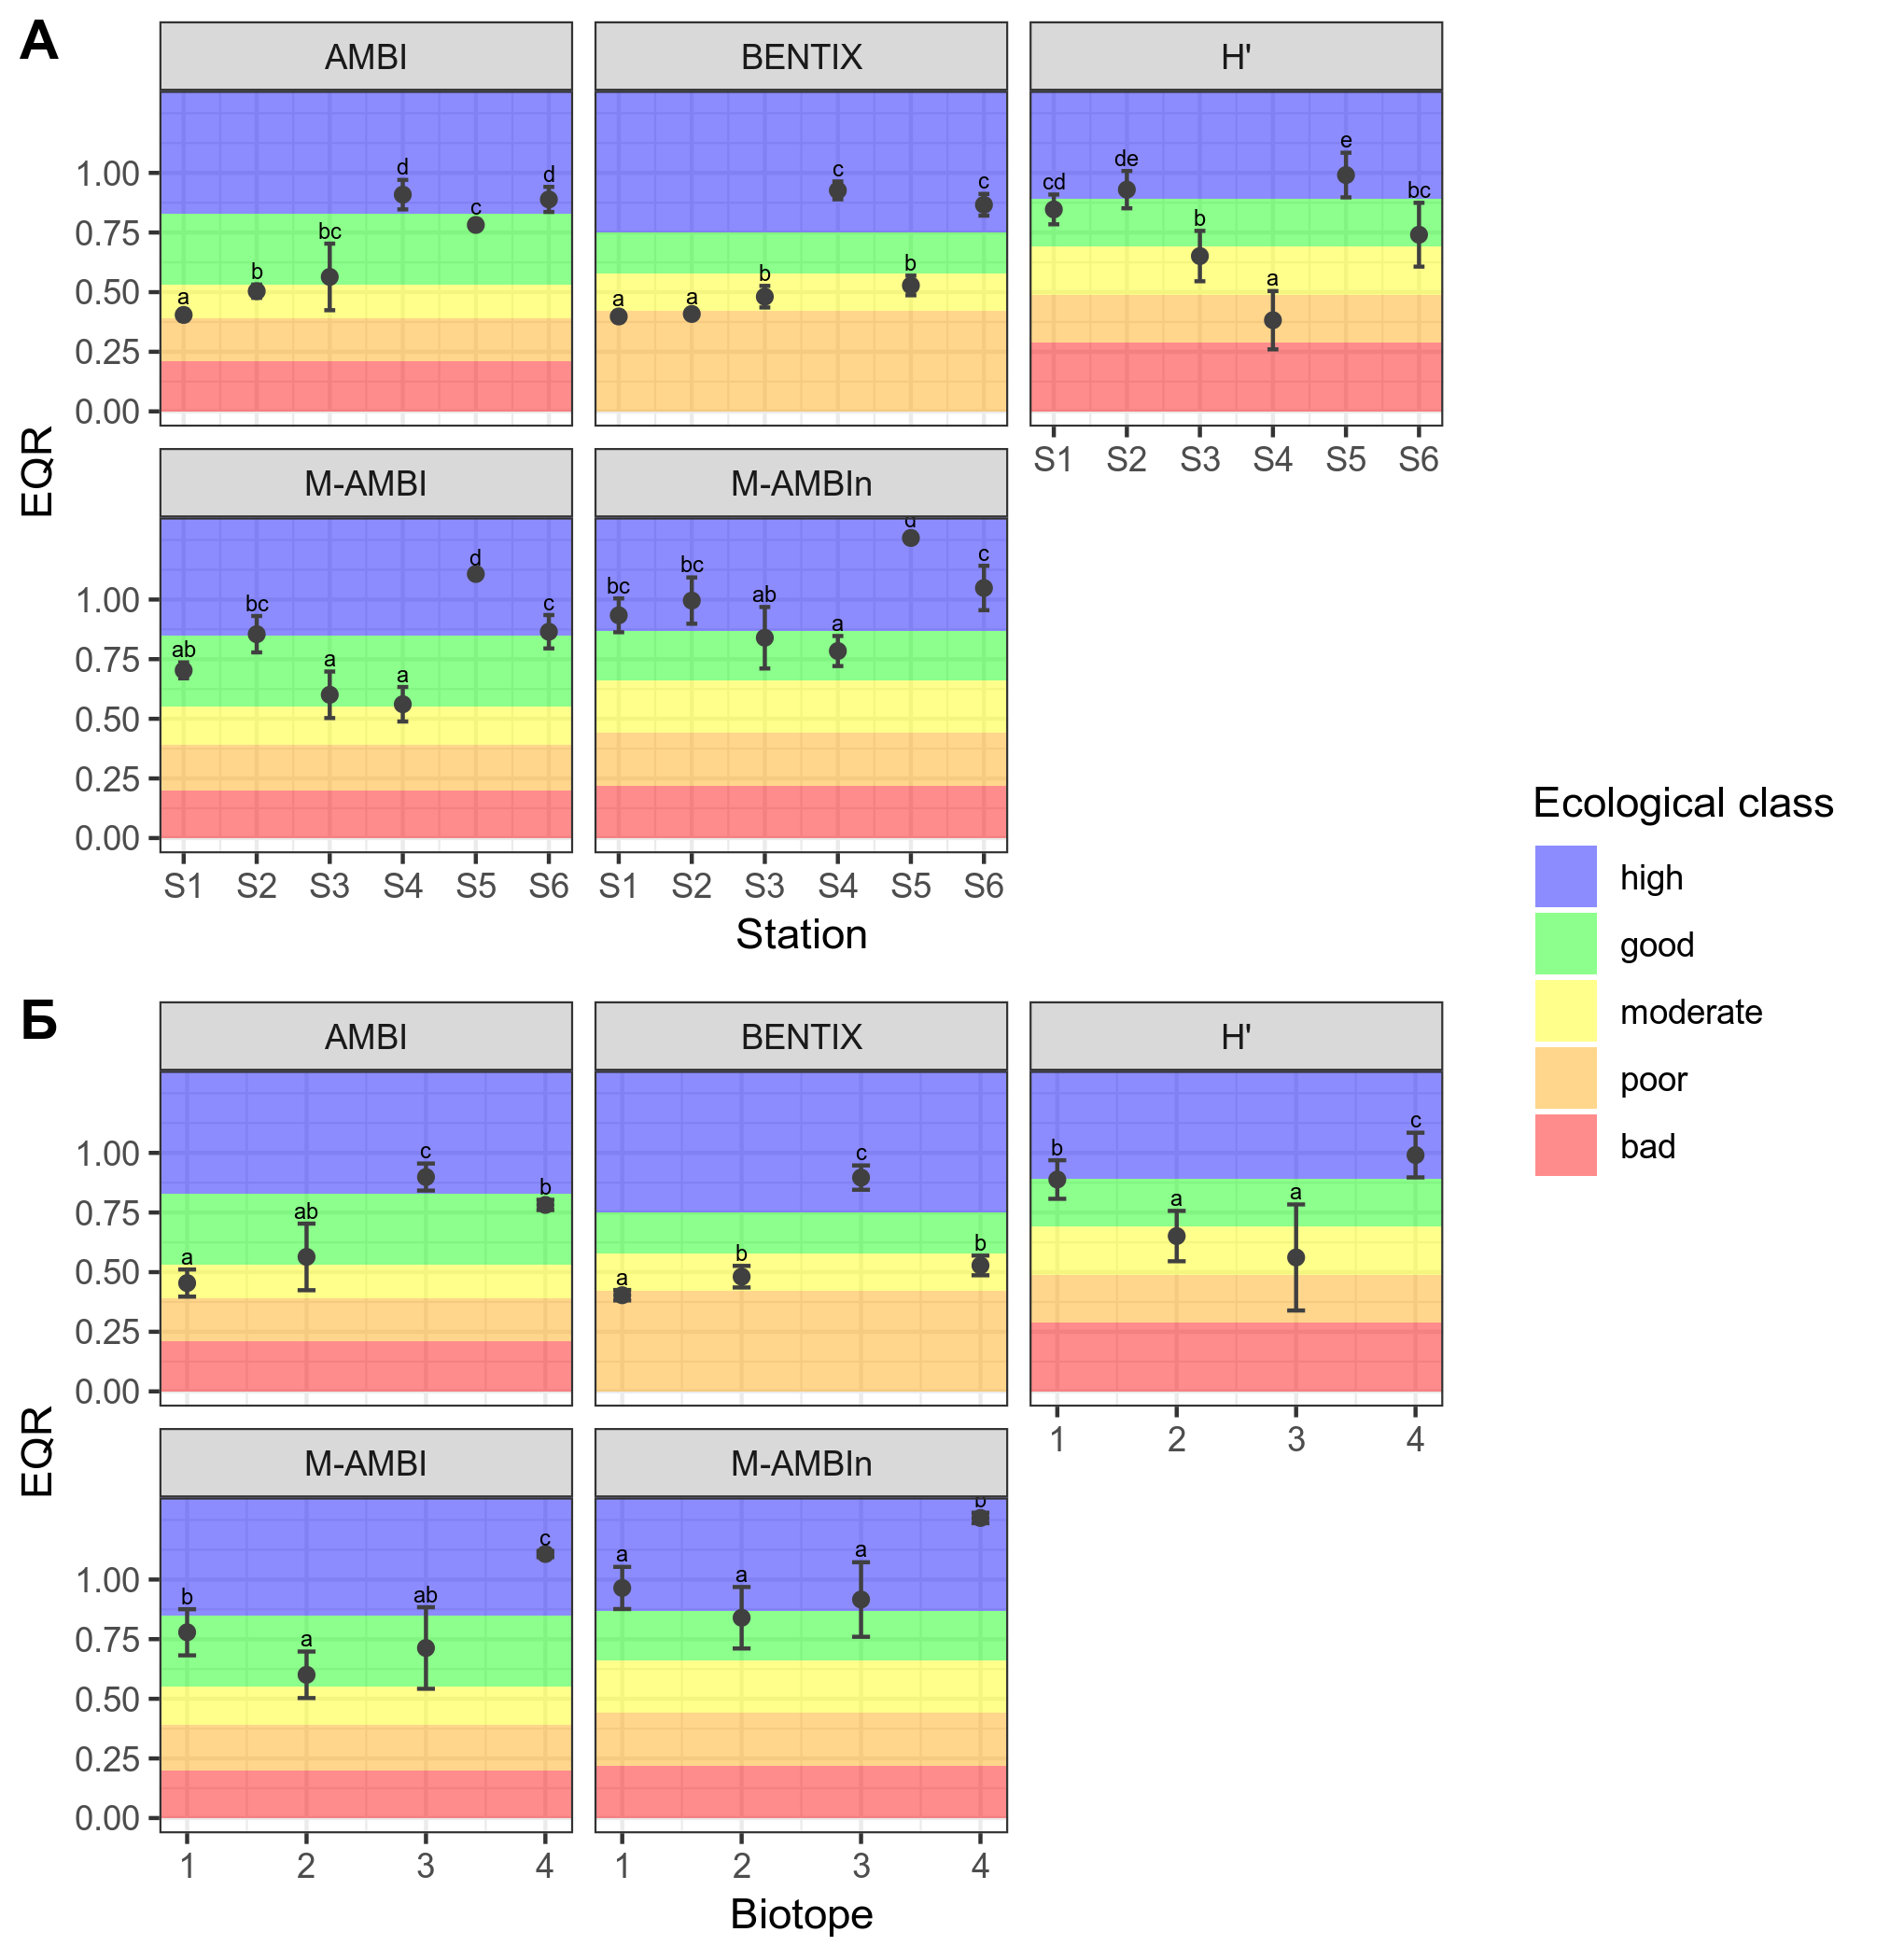Fig. 42. EQR values (mean ± standard deviation) of the macrobenthic biotic indices for ecological state assessment of soft-bottom habitats in the coastal Burgas Bay (2013-2014); А – by stations, Б – by biotopes. Biotope codes: 1 – Infralittoral muddy sands with M.palmata, H.filiformis and A.kagoshimensis; 2 – Infralittoral coarse and medium sands with U.pusilla; 3 – Infralittoral fine and medium sands with C.gallina, L.mediterraneum, T.tenuis; 4 – Infralittoral shelly sands and gravels with varied infauna. Lowercase letters above points denote significant differences (p < 0.05) between stations/biotopes.
Най-адекватно отражение на градиента дават AMBI и BENTIX, които имат и най-добри корелации с параметрите на средата – отрицателни с параметри на замърсяване или натиск и положителни с индикатори за по-чисти условия, както се очаква от един добър биотичен индекс. M-AMBI и H' не реагират толкова добре, вероятно заради особеностите на последния (зависимост от броя видове и проби и от доминиране в съобществата, нелинейна реакция на въздействия). Корелациите им с факторите на средата също са незадоволителни. Където съществуват определени специфични референтни стойности за биотопите, M-AMBI*n е чувствителен и отразява добре градиента на въздействие (Таблица 27).
Table 27. Spearman correlations between biotic index EQRs and environmental parameters and LUSI at the soft-sediment stations in Burgas Bay (2013-2014). For M-AMBI*n, only the samples from biotopes with existing specific reference values were used (S3, S4 и S6). Statistical significance of the correlations: * < 0.05, ** < 0.01, *** < 0.001.
Индексите показват сравнително ниска степен на съгласие; M-AMBI-M-AMBI*n са единствените, които не надвишават границата на допустимост на разликите (0.5 класа за качество), а AMBI-BENTIX и H'-M-AMBI се доближават най-много до нея. BENTIX показва най-големите разлики с всички индекси освен AMBI, на който е базиран; разминаванията им вероятно се дължат на регионални специфики в дизайна на индексите (BENTIX е разработен и калибриран за източно Средиземно море и е съобразен с особеностите на съобществата там (Simboura and Argyrou, 2010). Оценките на H' и M-AMBI*n са сравнително различни, което свидетелства за намалената тежест на H' като компонент на M-AMBI*n и съответно по-ниското влияние на нежеланите му характеристики.
Най-голям процент пълно съгласие има при H' и M-AMBI, M-AMBI и M-AMBI*n, AMBI и BENTIX, H' и M-AMBI*n (Таблица 28). Разминаването при оценките на тези двойки също е най-малко, най-често с един клас за качество, но дори при тях процентът на разликите, които преминават границата добро/умерено състояние, е значителен и понякога дори преобладава. Едно такова разминаване е нежелателно и би имало сериозни практически последици както за опазването на екосистемите, така и за управлението им.
Table 28. Level of agreement with 5 quality classes (%) between biotic indices applied on soft-bottom macrobenthic communities in the coastal Burgas Bay, 2013-2014.
Поради ниската степен на съгласие и честата разлика с преминаване на границата добро/умерено екологично състояние при оценките им, изследваните индекси не са заменяеми. За по-голяма сигурност най-добре е да се използва повече от един, а също да се следи разпределението по екологични групи на чувствителност на зообентоса.
Необходимо е разработването на специфични за биотопите екологични класификационни системи, където все още няма такива, както и на адекватни методи на интеграция на оценките. Наложително е и да се обърне повече внимание на функционалното биоразнообразие на макрозообентосните съобщества, като това бъде отразено и в мониторинговите програми по РДМС.
    - Местообитание на морските треви в Бургаския залив
Средните оценки на индексите в местообитанието на морските треви в Бургаския залив се различават между станциите, но наблюдаваните разлики са сравнително малки (Фиг. 45). Като цяло наблюдаваната тенденция в оценките има смисъл, но класификациите най-вероятно не отговарят на действителността поради липсата на специфични референтни стойности за местообитанието на морските треви. Всички изследвани индекси с изключение на H' отразяват градиента на въздействие, както и естественото натоварване на Z5 от р. Ропотамо; станцията в референтното поле за българското черноморско крайбрежие, Z4, винаги е с най-висока оценка. H' е висок на всички станции поради високото видово богатство и численост на зообентосните съобщества, асоциирани с морските треви.
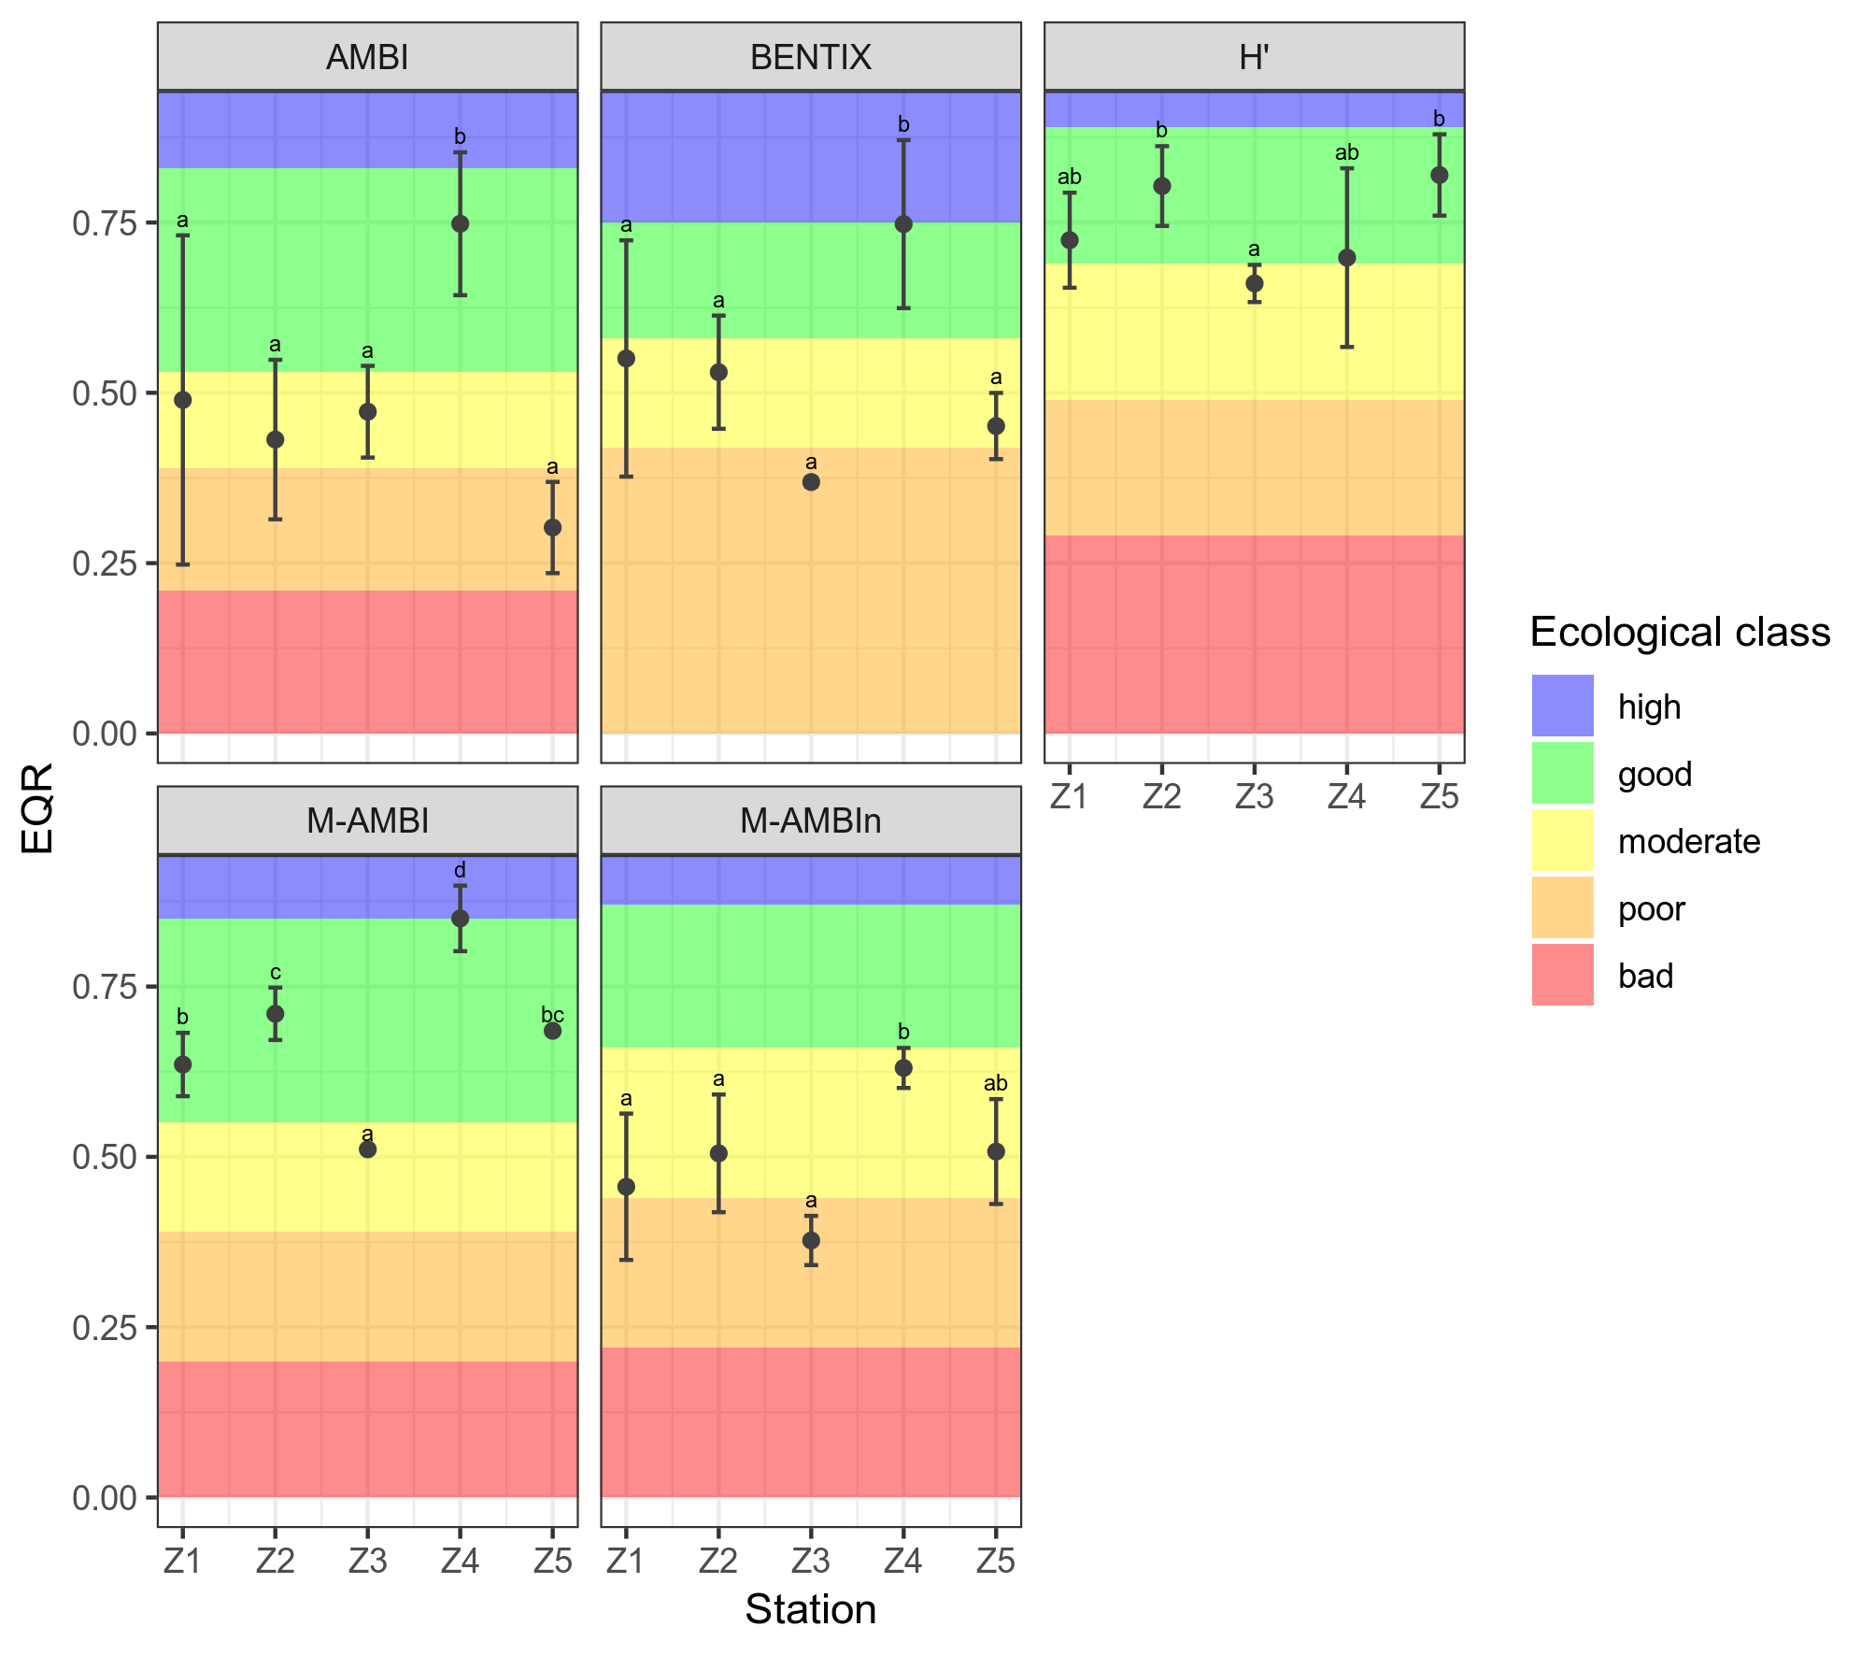Fig. 45. EQR values (mean ± standard deviation) of the macrobenthic biotic indices for ecological state assessment of seagrasses in the coastal Burgas Bay (2013-2014). Lowercase letters above points denote significant differences (p < 0.05) between stations/biotopes.
Всички изследвани биотични индекси са силно повлияни от характерното за морските треви засилено присъствие на толерантни и опортюнистични видове и групи; това заключение се подкрепя и от разпределението по екологични групи на макрозообентоса. Това е естествен феномен, дължащ се на богатите на тиня и органика седименти, и не значи непременно, че съобществата са подложени на стрес, но води до ниски оценки от повечето биотични индекси. Същата загуба на чувствителност на индексите и грешки са добре документирани и се наблюдават и в изследвания на морски треви в други европейски райони (Blanchet et al., 2008; Do et al., 2013).
Корелациите с факторите на средата не са добри за H', но останалите индекси реагират правилно, демонстрирайки отрицателни корелации с индикатори на замърсяване и положителни – с показатели за чисти условия (Таблица 29). Това предполага, че чувствителността им вероятно ще бъде много добра, ако референтните стойности се адаптират за съобществата, асоциирани с морските треви.
Table 29. Spearman correlations between biotic index EQRs and environmental parameters at the seagrass stations in Burgas Bay (2013-2014). Statistical significance of the correlations: * < 0.05, ** < 0.01, *** < 0.001.
Степента на съгласие на оценките е по-висока от очакваното предвид горните резултати, но все пак не е достатъчно добра. Най-голяма съпоставимост на оценките има отново при H'-M-AMBI и при AMBI-BENTIX, които се вписват в рамките на допустимата разлика от 0.5 класа. При съобществата в морските треви H' изглежда не влияе толкова силно на M-AMBI, най-вероятно защото видовото разнообразие на всички изследвани станции е високо и самият H' не варира толкова между тях. Степента на съгласие при 5 класа за качество варира между 0 (M-AMBI-M-AMBI*n) и 62.5% (H'-M-AMBI); в повечето случаи оценките се разминават с 1 клас. Обратно на очакванията, M-AMBI и M-AMBI*n показват най-ниската степен на съгласие; в случая очевидно при M-AMBI*n натежава компонентът на чувствителността (AMBI), което при морските треви води до изкуствено намаляване на крайната оценка и по-изразена разлика с M-AMBI. В повечето случаи разликите са с преминаване на границата добро/умерено състояние – обикновено в повече от 40% от случаите, което е сериозен недостатък. Употребата на тези индекси за оценка на състоянието по зообентос на местообитанията на морските треви без предварителна адаптация следователно не е препоръчителна.
Table 30. Level of agreement with 5 quality classes (%) between biotic indices applied on seagrass macrobenthic communities in the coastal Burgas Bay, 2013-2014.

На базата на това изследване, разработването на специфични референтни стойности за индексите в местообитанията на морските треви не е възможно. Необходими са допълнителни дългосрочни данни, които да са съобразени с високата степен на вариация както в рамките на едно поле, така и между различните полета с морски треви. Въпреки че е изпълнима, една подобна задача по-скоро не е оправдана. Като част от пясъчните крайбрежни местообитания, полетата с морски треви в българската част на Черно море заемат сравнително малка площ. Мониторингът на състоянието им на базата на самите морски треви е много по-лесен и свързан с по-малко разходи на време и средства, отколкото този на базата на зообентосните съобщества.
- Conclusions
  - Summary of results
Based on the present study of the contemporary biodiversity and ecological state of habitats based on macrozoobenthic communities in the coastal zone of the Black Sea (Burgas Bay), the following summarized results and conclusions are defined:
- During the study, the macrozoobenthos in the coastal zone was characterized by a high diversity, undisturbed taxonomic range and distribution, normal dominance structure (ABC curves) – signs of absence of serious perturbations. A continuing tendency of community recovery after the anthropogenic eutrophication period in the 1980s is observed.
- 3 biotopes of the national classification were identified at the studied soft bottom stations in Burgas Bay: Infralittoral fine and medium sands with Chamelea gallina, Lentidium mediterraneum, Tellina tenuis; Infralittoral shelly sands and gravels with varied infauna, and Infralittoral coarse and medium sands with Upogebia pusilla, as well as an additional biotope type – Infralittoral muddy sands with Melinna palmata and Anadara kagoshimensis.
- The stations in the seagrass meadows in Burgas Bay cannot be strictly distinguished into community subtypes, but there are some differences depending on environmental factors: an increase of tolerant taxa, and a decrease of sensitive taxa within the gradient of anthropogenic eutrophication in the bay, as well as in front of Ropotamo River mouth. The composition of the fauna in the seagrasses is characteristic, with a high proportion of herbivorous and detritivorous taxa, as well as taxa tolerant to higher sediment contents of silt and organic matter. The invertebrate communities associated with seagrasses along the Bulgarian coast are similar to those in other parts of the Black Sea, and in other temperate seas.
- The seagrass-associated fauna is characterized by exceptionally high specific diversity, abundance and biomass, which are several times higher than those observed in the unvegetaded soft sediments (although the data here are not directly comparable). The preliminary experiment in Sozopol Bay detected significant differences between macroinvertebrate communities in seagrasses and the adjacent unvegetated sediments, but replication of the experiment with better design and replication is needed in order to draw conclusions. These results underline the significance of the seagrasses in the functioning of the coastal marine ecosystems, and the importance of their conservation.
- The hypothesis that the soft-bottom and seagrass macrozoobenthic communities in Burgas Bay change as a result of the influence of anthropogenic factors is confirmed. At the same time, natural factors such as the predominant sediment type and the biometric parameters of the seagrasses (where applicable) also determine community structure and specific composition. Certain stations (S5, Z5) exhibit the effects of a natural, rather than anthropogenic, disturbance, which can lead to difficulties in correct ecological state assessment of those habitats.
- The environmental parameters that have the highest influence in determining the composition and structure of the sandy-botttom macrobenthic communities are the concentrations of phosphates and suspended particulate matter in the water column, the sediment grain size (gravel content), the index LUSI. In the seagrasses, the most influential factors are the below-ground biomass and the seagrass shoot density, the concentration of total nitrogen in the water column, and the sediment grain size (sand content), the above-ground seagrass biomass.
- The changes in the structure of the macrozoobenthic communities along the eutrophication gradient in the study area are well reflected by the changes of the relative proportions of ecological sensitivity groups. In the seagrasses, the tolerant and opportunistic groups are always present because of the characteristic higher silt and organic matter contents of the sediments.
- The macrobenthic biotic indices for environmental quality assessment in the sense of the WFD and the MSFD have a variable sensitivity in the different shallow coastal habitats of Burgas Bay, and don’t always reflect adequately the observed community changes. This is due in part to the properties of the indices themselves, and in part to the lack of specific reference conditions accounting for community differences between biotopes. The ecological state assessment of the seagrasses based on the studied macrozoobenthic indices is especially affected, and their application as they currently are is not recommended. The adequate ecological state assessment in the shallow coastal zone depends on the definition of biotope-specific reference values and classification system for all habitats/biotopes.
- The expected reaction of a good index is negative to indicators of pollution and pressure, and positive – to indicators of clean, undisturbed conditions. The studied indices demonstrate a reaction to the environmental factors in the study area, but it’s influenced by the above-mentioned considerations, and is not always in the expected direction or magnitude. In the seagrass meadows in Burgas Bay, the correlation of the indices with the environmental parameters is good, which suggests that if the classification system is adapted to the particular biotope, the indices will be sensitive enough.
- In both habitat types the indices display a low level of agreement, i.e. low comparability of results. The differences often cross the good/moderate ecological state limit, which is a serious shortcoming with potential negative consequences for the conservation and management of coastal ecosystems. A combination of several indices or a multimetric index are recommended for greater confidence in the assessment, along with a check of the ecological group proportions in the communities.

  - Contributions
- The contemporary species diversity, composition and structure of the macrozoobenthic communities in the sandy bottom and the seagrass meadows in the shallow coastal Burgas Bay were characterized, as well as their changes along the stable eutrophication gradient in the area.
- The influence of the environmental parameters (both anthropogenic and natural) on the macrobenthic community composition and structure in both habitat types and along the anthropogenic pressure gradient was defined and analyzed.
- The factors with the strongest influence on the zoobenthic communities in the studied habitats in Burgas Bay were determined, as well as the specific reactions of the taxa, with the application of new, contemporary multivariate model-based methods of analysis.
- The performance of the macrozoobenthic biotic indices in assessing the ecological state of sandy bottom habitats and seagrasses in the coastal zone was compared. The reasons for the observed differences between indices were analyzed, as well as their sensitivity to changes in environmental conditions and to the anthropogenic pressure gradient. Practical steps for improvement of the assessments and for complementing the MSFD assessment criteria are suggested.

Scientific publications with results of the PhD thesis
Klayn, S., Karamfilov, V. 2018. Performance and level of agreement of macrozoobenthic indices in the shallow coastal area of the Southern Bulgarian Black Sea (Burgas Bay). Acta zoologica bulgarica, 70 (1): 89-99. ISI IF:0.369
Klayn, S., Deyanova, D., Vasilev, V., Karamfilov, V. 2013. Effect of seagrass meadows (Zostera spp.) on the structure, abundance and diversity of macrozoobenthic communities in Sozopol Bay, South-Western Black Sea coast. В: Семинар по екология - 2013 Сборник доклади и резюмета, Фараго, ISBN:978-954-2961-75-8, 83-88.

Published poster and conference presentation abstracts
Klayn, S., Deyanova, D., Vasilev, V., Karamfilov, V. Effect of seagrass meadows (Zostera spp.) on the structure, abundance and diversity of macrozoobenthic communities in Sozopol Bay, South-Western Black Sea coast. Seminar of Ecology – 2013, 25.04.2013 – 26.04.2013, София, България. (Доклад)
Klayn, S., Karamfilov, V. Diversity of macrozoobenthic communities from Zostera spp. meadows in Sozopol Bay, Bulgaria (South-Western Black Sea). International Conference Marine Research Horizon 2020, 17.09.2013 – 20.09.2013, Варна, България. (Доклад)
Klayn, S., Karamfilov, V. Evaluating the ecological state of shallow coastal habitats in the southwestern Black Sea (Sozopol Bay, Bulgaria): level of agreement of different macrobenthic indices. The 4th Bi-annual Black Sea Scientific Conference "Black Sea – Challenges Towards Good Environmental Status", 28.10.2013 – 31.10.2013, Constanta, Romania. (Доклад)
Klayn, S., Karamfilov, V. Macrozoobenthic community state along a eutrophication gradient in Burgas Bay (southwestern Black Sea). 2nd International Ocean Research Conference "One Planet, One Ocean", 17.11.2014 – 21.11.2014, Barcelona, Spain. (Постер)
Berov, D., Deyanova, D., Klayn, S., Karamfilov, V. Distribution, structure and state of seagrass habitats in the SW Black Sea (Burgas Bay, Bulgaria). Mediterranean Seagrass Workshop Sardinia 2015, 18.05.2015 – 22.05.2015, Oristano, Italy. (Доклад)

Macrozoobenthic communities as an indicator of the ecological state of benthic habitats along the Bulgarian Black Sea coast (Burgas Bay)

Stefania Laslo Klayn

Supervisor: Assoc. Prof. Ventzislav Karamfilov, PhD

Institute of Biodiversity and Ecosystem Research, Bulgarian Academy of
2 Major Yurii Gagarin Str., 1113 Sofia, Bulgaria

Summary of PhD Thesis

The aim of the present study was to investigate the current biodiversity of soft-bottom macrozoobenthic communities in the shallow coastal zone of Burgas Bay, evaluate the changes in their structure and composition under the influence of anthropogenic and natural environmental factors, and analyze the performance and sensitivity of zoobenthic biotic indices in ecological state assessments of coastal habitats. Two types of coastal habitats - unvegetated sandy bottoms and seagrass meadows - were studied, over the course of an initial pilot experiment (Sozopol Bay, 2012), and another, larger-scale experiment in a stable gradient of anthropogenic pressure (Burgas Bay, 2013-2014).
The pilot study in Sozopol Bay revealed significant differences in the biodiversity, abundance, biomass and structure of the macrozoobenthic communities in the seagrass meadows and the adjacent unvegetated sediments. The communities were influenced by the local point source of untreated sewage waters, with a slight increase of the proportion of tolerant and opportunistic taxa at the site closest to it, but the observed effects were not severe and were concordant with the intermediate disturbance hypothesis. Due to the nature of the experiment, these results must be considered preliminary and the study should be replicated to allow more definite conclusions.
In 2013-2014, 147 taxa in total were identified in the soft unvegetated sediments of the shallow coastal Burgas Bay. The diversity, abundance and biomass were high during the study period, and similar to the typical values for the Bulgarian Black Sea. The taxonomic structure of the communities did not deviate significantly from expectations, suggesting relatively low amounts of ecological stress. The multivariate analyses revealed the presence of 4 infralittoral biotopes according to the Bulgarian national classification: Infralittoral fine and medium sands with Chamelea gallina, Lentidium mediterraneum, Tellina tenuis; Infralittoral shelly sand and gravel with varied fauna; Infralittoral coarse and medium sand with Upogebia pusilla, Infralittoral muddy sand with Melinna palmata and Anadara kagoshimensis. The initial experimental hypothesis stating that the structure and composition of the macrozoobenthos change under the influence of the anthropogenic gradient in Burgas Bay was confirmed by both the classical (PERMANOVA) and the modeling (manyGLM) statistical methods; the most significant environmental parameters were eutrophication indicators (nutrient and suspended matter concentrations in the water column) and the pressure index LUSI. However, both analyses also singled out the contribution of natural factors, specifically, the grain size composition of the sediments, in structuring the communities.
In the seagrass meadows in Burgas Bay, 93 taxa in total were identified in 2013-2014. The macrozoobenthic communities exhibited very high biodiversity, abundance and biomass, underlining the significance of these habitats for the functioning of coastal ecosystems in the Black Sea. The taxonomic structure of the communities also did not deviate significantly from expectations, suggesting relatively low amounts of ecological stress. The community composition and structure were similar to the associated fauna of seagrass meadows from other parts of the Black Sea and other seas in the temperate zone: herbivores and detritivores (Rissoa membranacea, Bittium reticulatum, oligochaetes, capitellid and spionid polychaetes) dominated; there was also a significant proportion of lucinid bivalves and crustaceans (Monocorophium acherusicum, Ampelisca diadema, Chondrochelia savignyi, etc.). There were no sharp delimitations between stations allowing the definition of separate subtypes of seagrass-associated zoobenthic communities in the study area; rather, the observed differences probably reflected the pressure gradient in the area, with an increase of the proportion of tolerant taxa in the inner, more impacted parts of the bay, as well as at the Ropotamo river mouth due to natural enrichment. Both types of multivariate analyses determined that anthropogenic eutrophication (nutrients in the water column, LUSI), and also sediment grain size composition and seagrass biometric parameters, were the most important factors for the observed community composition and structure. The modeling method seems to be more sensitive in this case, giving a higher weight to factors with more ecological significance to the infauna such as the below-ground biomass of the seagrasses.
The tested biotic indices - the Bulgarian national monitoring indices H’, AMBI, M-AMBI, M-AMBI*n, and the Mediterranean index BENTIX - exhibited a variable performance and sensitivity in both types of habitats in the study area, and did not always adequately reflect the anthropogenic gradient. On the other hand, the changes in community structure and composition were accurately captured by the changes in ecological group proportions. This is likely due to design peculiarities of the indices, as well as the lack of specific reference values for some of the shallow coastal biotopes. This is especially true in the seagrass habitats, where the naturally higher proportion of tolerant organisms particularly influenced the assessments. The indices demonstrated a reaction to the environmental gradients in the area, but it was also influenced by their particularities, and was not always in the expected direction (negative to pollution and pressure indicators, and positive to indicators of non-impacted conditions). The correlation of the index assessments with environmental parameters was surprisingly good in the seagrass habitats, which gives reason to suppose that they will perform well if the classification system and reference values are adapted accordingly. The level of agreement between indices was low in both types of coastal habitats, suggesting low comparability of the assessments. The discrepancies also often cross the good/moderate ecological state boundary - a serious disadvantage with potentially considerable negative consequences for the conservation and management of coastal ecosystems.
Until these shortcomings are addressed, it is recommended to use several or multimetric indices with documented high performance and sensitivity, and additionally examine the ecological group composition of the communities. The addition of functional diversity indices to the monitoring programmes will allow more comprehensive assessments consistent with the MSFD philosophy of maintaining functioning marine ecosystems.

