

UNIVERSITY OF THE PHILIPPINES LOS BAÑOS
Master of Science in Computer Science

Shiela Kathleen L. Borja

GIS-based Grid-Connected Distributed Solar Facility Location-Allocation

Jaime M. Samaniego

______________________________

This thesis can be made available to the general public | YES
This thesis can be accessed only after consultation with the author and thesis adviser | NO
This thesis can be accessed only by those bound by confidentiality agreement | NO

___________________________
Shiela Kathleen L. Borja

_________________________
Jaime M. Samaniego
GIS-BASED GRID-CONNECTED DISTRBUTED SOLAR FACILITY LOCATION-ALLOCATION

SHIELA KATHLEEN L. BORJA

SUBMITTED TO THE FACULTY OF THE GRADUATE SCHOOL
UNIVERSITY OF THE PHILIPPINES LOS BANOS
IN PARTIAL FULFILLMENT OF THE
REQUIREMENTS FOR THE
DEGREE OF

MASTER OF SCIENCE
(Computer Science)

May 2016

The thesis attached hereto, entitled “GIS-BASED GRID-CONNECTED DISTRBUTED SOLAR FACILITY LOCATION-ALLOCATION”, prepared and submitted by SHIELA KATHLEEN L. BORJA, in partial fulfillment of the requirements for the degree of MASTER OF SCIENCE (COMPUTER SCIENCE), is hereby accepted.

CONCEPCION L. KHAN ELIEZER A. ALBACEA
Member, Guidance Committee Member, Guidance Committee
____________________________ ____________________________
Date Signed Date Signed

FERNANDO O. PARAS JR. JAIME M. SAMANIEGO
Member, Guidance Committee Chair, Guidance Committee
____________________________ ____________________________
Date Signed Date Signed

Accepted as partial fulfillment if the requirements for the degree of
MASTER OF SCIENCE (COMPUTER SCIENCE)

JAIME M. SAMANIEGO
Director, Institute of Computer Science

_________________________
Date Signed

JOSE V. CAMACHO, JR.
Dean, Graduate School

_______________________
Date Signed

BIOGRAPHICAL SKETCH

ACKNOWLEDGEMENTS

TABLE OF CONTENTS
i
PAGE
TITLE PAGE i
APPROVAL PAGE ii
BIOGRAPHICAL SKETCH iii
ACKNOWLEDGEMENTS iv
LIST OF TABLES
LIST OF FIGURES
LIST OF EQUATIONS
ABSTRACT
INTRODUCTION
Background of the Study
Significance of the Study
Statement of the Problem
Objective of the Study
REVIEW OF RELATED LITERATURE
Previous Work
Features
THEORETICAL FRAMEWORK
METHODOLOGY
RESULTS AND DISCUSSION
SUMMARY AND CONCLUSIONS
RECOMMENDATION
REFERENCES
Table of Contents i
2
List of Algorithms iii
List of Equations iv
I Introduction………………………………………………...…………………………………………….1
A Significance of the Study ……...…………………………………………………………...……...1
B Objectives of the Study……...…………………………………………………………...………...3
C Review of Related Literature…………………………………………………………..………….3
II Materials and Methods………………………………………………………………………..…………4
A Assumptions…….………………………………………………………………………..…………4
B Thematic Layers………………………………...………………………………………..………...5
C Proposed Method……..………………………...………………………………………...………...5
D Grid-connected Distributed Solar farm Allocation...…………………...…………….…..……...6
E Genetic Algorithm..……………………………...……………………………………….………...7
F Integer Program Formulation..………………...……………………………………….………...7
G Genetic Algorithm Integer Program Formulation..…………….……………………...………..9
Literature Cited …………………………………………………………..……………...…………11

iii
List of Algorithms
1 Genetic Algorithm……………………………………………………………..…………………………7

List of Equations
iv
1 Total Energy produced by all the allocated solar farms…..……………………………...…………...8
2 Total number of solar farms to be allocated…...………………..………………………….………….8
3 Distance to Power line Constraint…….…………………………………………………...…………...8
4 Distance to Built-up Areas Constraint…………………………………………………...……………8
5 Distance to Roads Constraint….………………………………………………………...……………..8

GIS-based Grid-Connected Distributed Solar Facility Location-Allocation

Abstract:
Renewable resources such as Solar energy is an infinite source of energy that can easily be harnessed but building the facilities can be very expensive. With the initiatives from the government to take advantage of the renewable energy resources in the Philippines, it is of interest to optimize the allocation of facilities that harness renewable energy such as Solar energy. The goal of this study is to present a GIS-based method for the location-allocation of solar farms, specifically in Occidental Mindoro, using Evolutionary Algorithm (EA) such as Genetic Algorithm. The performance of the EA will be evaluated against the solutions found using brute-force.

INTRODUCTION
1
6
Background of the Study

The amount of sunlight that reaches the earth's atmosphere, considering 60% transmittance through atmospheric clouds, is around 1.05x10⁵ TW. Converting one percent of this solar energy to electrical energy at 10% efficiency can provide 105 TW, more than enough to supply the projected global energy needs for 2050 which is about 25-30 TW [37].
Converting solar energy to electric energy can be classified based from solar energy usage: thermal energy, concentrated solar power (CSP) energy, and photovoltaic(PV) energy. Sun-generated thermal energy converts solar radiation energy to thermal power. CSP converts the thermal energy generated from the heat produced from concentrating solar radiation at solar thermal plants. This thermal energy is then converted to electricity. Photovoltaic energy directly converts the sun power into useful forms by absorbing solar photons, converting to electrical energy, or storing part of the energy into a chemical reaction. [14]
Solar panels are one of the most popular energy resources both used for private and industrial power systems. They do not emit greenhouses gases, can be installed in a variety of places, and modular.[38][37] According to Photon, the installed worldwide PV capacity as of 2011 was 67 GW, a significant increase from 1.4 GW installed capacity in 2000. This can be attributed to falling module prices and government incentives [37]. In 2005, PV electricity generation costs in Central Europe reached 50 eurocents/kWh (~ P26.30/kWh) and 25 eurocents/kWh (~P13.02/kWh) for areas with high solar radiation [38]. The use of the generated PV electricity differs between developed and developing countries. Large portion of PV systems in developed countries were used as power plants connected to the network while PV systems in developing countries were used for electrification of rural areas.
With an annual solar potential average of 5.1 kWh/m²/day, the Philippines saw a couple of developments with off-grid photovoltaic systems due to a large number of isolated islands from the national power grid [13][42]. However, despite the Philippines' vast solar potential and the Philippine governement's initiative to accelerate the development of renewable resources through the Renewable Energy Law of 2008, there were only a few large central station PV projects that were developed. In 2013, Solar energy resources contributed only 0.01% of the installed capacities in the entire Philippines but it is slowly increasing upon completion of several solar projects [43]. Table 1 shows the list of Solar PV projects in the Philippines as of 2016.
Table 1. List of Current Solar PV projects in the Philippines
STATION | CAPACITY (MW) | COMMUNITY | STATUS
CEPALCO Cagayan de Oro Photovoltaic Power Plant [5] | 1 | Cagayan de Oro, Misamis Oriental | Operational
SaCaSol I [28] | 45 | San Carlos City, Negros Occidental | Operational
Calatagan Solar Farm[39] | 63.3 | Calatagan, Lian, Balayan Batangas | Operational
Badoc-Vintar Photovoltaic Power Plant [6] | 20 | Badoc and Vintar Ilocos Norte | Approved
Ormoc Photovoltaic Power Plant [7] | 30 | Ormoc, Leyte | Approved
Surallah Photovoltaic Power Plant [29] | 6.25 | Surallah, South Cotabato | Under construction
IslaSol I & II [28] | 32 & 48 | Negros Island | Under construction
MonteSol [28] | 18 | Negros Island | Under construction
ECOGLOBAL Inc. [15] | 100-300 | ZamboEcozone, Zamboanga City | Under construction

Statement of the Problem

The Philippines, as an archipelago, can benefit from PV systems used for electrification of isolated islands such as Mindoro [40]. Occidental Mindoro has been experiencing power shortages for the past 17 years. In 2015, Occidental Mindoro experienced six to 12-hour daily blackouts [10]. The power shortages experienced by the people of Mindoro not only affected their daily lives but also slowed down the economic growth of the province. The residents are now urging the Department of Energy to act on their problems. One of the proposed solutions to mitigate the power shortage problem is to provide additional power sources in the province. With 4.5 to 5.5 kWh/m²/day solar radiation, solar energy can be one of the possible additional power source that Occidental Mindoro can exploit [42]. To take advantage of the solar resources in Occidental Mindoro, solar farms can be installed in the province but deciding where to install the solar farms in no easy task since there are various geographic, environmental and socioeconomic factors to be considered.

Significance of the Study

This study aimed to locate the feasible solar farm installation sites, specifically in Occidental Mindoro, based from geographic, environmental and socioeconomic factors. This study also aimed to allocate solar farms among the identified feasible solar farm installation sites. <insert here what you used for allocating the solar farms>. Determining the feasible location and allocation of solar farms in the province could help in alleviating the power shortages experienced by Occidental Mindoro.

Objectives
9
The general objective of this study was to present a GIS-based genetic algorithm methodology used to solve grid-connected distributed solar farm location-allocation problem, specifically in Occidental Mindoro. This study specifically aimed to:
- use GIS-based operations on thematic maps to determine the feasible solar farm installation sites;
- use Genetic Algorithm to solve the model to allocate multiple solar farms;
- use brute force to solve the model to allocate multiple solar farms;
- use a non-parametric statistical test to compare the results of brute force and genetic algorithm.
<change number 3 >

Limitations
The following assumptions and limitations were made in conducting this study:
- Occidental Mindoro, Philippines was used as the study site.
- In the application of GIS, Clear Sky Global Horizontal Irradiance (Clear Sky GHI) model was used to estimate the available solar resource in the study site. It estimates the terrestrial solar radiation under a cloudless sky [24]. Clear Sky GHI was used in the study since it is the only available data as of the date of writing this study.
- In case of implementation of the solar facility installation, the Government will manage the location and allocation of solar farms. Also, since data on the land ownership in Occidental Mindoro was not available while conducting this study, only the geographic,environmental, and socioeconomic factors were considered. Should the data be available in future studies, land ownership can be included as a factor to be considered in choosing the optimal solar farm installation sites.

REVIEW OF RELATED LITERATURE
10

Previous Works

The use of Geographical Information Systems (GIS) and Multi-Criteria Evaluation (MCE) methods in generating the optimal solar farm allocation have become popular in recent years [31]. Sanchez-Lozano et al. [30] used two types of criteria for GIS, constraints or restrictive criteria and factors or weighing criteria. Restrictive criteria, obtained from legislation, were used to reduce the study area through excluding the areas that prevent implementation of renewable energy plants. Weighting criteria are those that influence the ability to solve a concrete alternative. The study included location, geomorphological, environmental and climatic criteria. Analytic Hierarchy Process (AHP) was used to analyze and calculate the weights of these criteria while TOPSIS (Technique for Order Preference by Similarity to Ideal Solution) method was used to assess the alternatives according to their degree of adequacy.
Uyan [31], used GIS and AHP to select the feasible solar farm locations and the final index model was then grouped as either “low suitable”, “moderate”, “suitable”, or “best suitable”.
4
Heyns and van Vuuren [12] proposed a multi-objective GIS-based facility location framework. This study is demonstrated in realistic, hypothetical bi-objective and tri-objective problem instances that showed that multi-objective approach returns better results compared to the single-objective approach.
Georgopoulou et al sudied the advantages and disadvantages of implementing renewable energy in the Greek Islands using the MCDM method ELECTRE III [8][30]. Heo et al. [11][30] utilized fuzzy AHP method to re-evaluate a renewabe energy program. Cavallaro[4][30] assessed the thermal energy storage in concentrated solar power systems using fuzzy TOPSIS. Charabi and Gastli [3][30] used a combination of GIS and multi-criteria fuzzy method to study the suitability of putting solar photovotaic power plants in Oman. Aran-Carron et al. Combined GIS and AHP to determine the best locations for solar photovoltaic installations that are connected to the grid in the region of Granada in Spain[1][30]. A GIS-based method was also applied in the location-allocation of a facility used to convert forest biomass to biofuel. The solution for this problem consists of two parts—(1) GIS-based approach to identify the feasible biofuel facility locations, and (2) selecting the prefered location based on the total transportation cost model [32].
Features

THEORETICAL FRAMEWORK
12
*<DISCUSS SOLAR PV>
-<DISCUSS HOW SOLAR PV TECHNOLOGY WORKS>
-<DISCUSS WHERE SOLAR PV ARE TYPICALLY USED>
-<DISCUSS FACTORS THAT SHOULD BE CONSIDERED WHEN DECIDING FEASIBLE LOCATIONS FOR SOLAR FARMS>
-<DISCUSS HOW TO SIZE SOLAR PV>
*<DISCUSS GEOGRAPHIC INFORMATION SYSTEM>
*<DISCUSS AHP>
*<DISCUSS WEIGHTED SUM MIXED MULTIOBJECTIVE OPTIMIZATION>

METHODOLOGY
13

A two-stage GIS-based methodology was proposed to identify the feasible solar farm installation sites in Occidental Mindoro. The two stages were identification of feasible solar farm locations using Geographic Information Systems (GIS) (stage I) and selection of the optimal solar farm locations maximizing the total energy produced from each installed solar farm facilities (stage II).
STAGE I: FEASIBLE SOLAR FARM SITE LOCATION
The goal of this set of procedures was to determine the feasible site location for solar farm installation given a set of thematic maps. The thematic maps used in this study were accessed from the Philippine GIS Data Clearinghouse, Phil-LiDAR-2 Program, and National Power Corporation. The following thematic maps of Occidental Mindoro were used in the study:
- Land Type Map
- Land Cover Map
- Protected Areas Map
- Aspect Map
- Slope Map
- Solar Irradiation Map
- Occidental Mindoro Barangay Map
- Road Map
- Built-Up Areas Map
- Occidental Mindoro Electric Cooperative Transmission Lines Map

The GIS-based operations were performed using ArcGIS, a Geographic Information System software.
IDENTIFY INFEASIBLE LOCATIONS BASED FROM LAND TYPE AND LAND COVER
Land Type and Land Cover Maps [35] of Occidental Mindoro were used to determine the infeasible locations for installation. Figure 1 and Figure 2 shows the Land Type and Land Cover Maps, respectively.
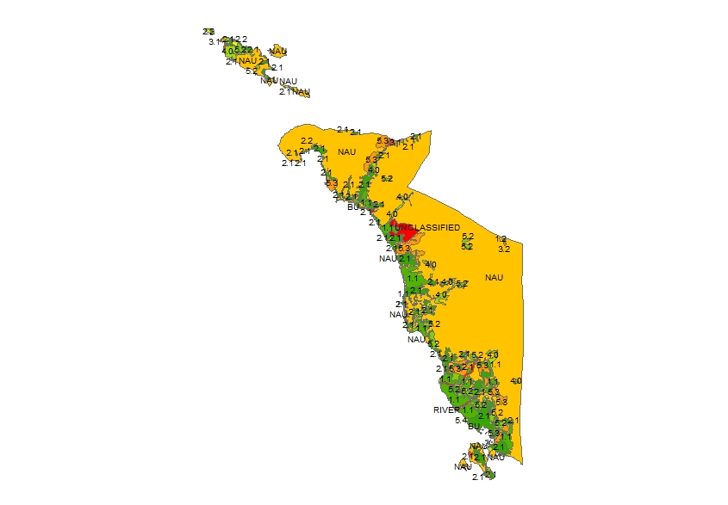
Figure 1. Land Type Map of Occidental Mindoro
14

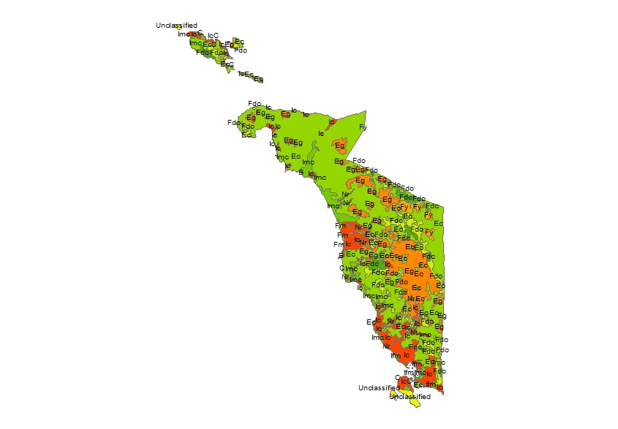
Figure 2. Land Use Map of Occidental Mindoro
Tables 2 and 3 lists the Land Type and Land Cover categories, respectively, considered for determining the feasible and infeasible locations for solar farm installation.
Table 2. Land Type Categories.[34]
FEASIBLE LOCATIONS | INFEASIBLE LOCATIONS
Expansion Areas(4),  Gently Sloping Lands (Irrigable & Paddy rice- irrigated)(2.1,1.2),  Non-Agricultural (NAU),  Pasture Lands(5.3),  Potential Agro-Industrial Lands(4.2),  Erodible Lands(5.2),  Unclassified Lands | Alluvial Lands (Irrigable & Paddy rice-irrigated)(1.2, 2.1),  Built-Up Area(BU),  Fishponds/Saltbeds(5.4),  River(RIVER)
Table 3. Land Cover Categories.[33]
FEASIBLE LOCATIONS | INFEASIBLE LOCATIONS
Grassland(Eg),  Cultivated Area mixed with brushland(Ec),  Unclassified | Arable Land(Ic), Built-up Area(B), Closed(Fdc) and Open(Fdo), Canopy Forests, Coconut Plantation(Ipc), Coral Reef(C), Crop Land mixed with coconut plantation(Imc), Crop Land Mixed with other Plantations(Imo), Fishponds derived from mangrove (Ifm), Mangrove(Fm), Riverbeds(Nr), Siltation pattern (S)

The infeasible locations were selected from the Land Type and Land Cover maps, respectively. The resulting maps were combined into one map containing both the infeasible locations based from the Land Type and Land Cover maps. The goal of determining the infeasible locations for solar farm installation using Land Type and Land Cover Map was to avoid using medium to highly productive agricultural areas as installation sites.

IDENTIFY INFEASIBLE LOCATIONS BASED FROM PROTECTED AREAS
Additional infeasible locations were determined using the Protected Areas map of Occidental Mindoro shown in Figure 3. The protected areas were also avoided while selecting the suitable solar farm installation sites. The map containing the infeasible locations based from the Land Type and Land Cover was combined with the Protected Areas map into a single map.

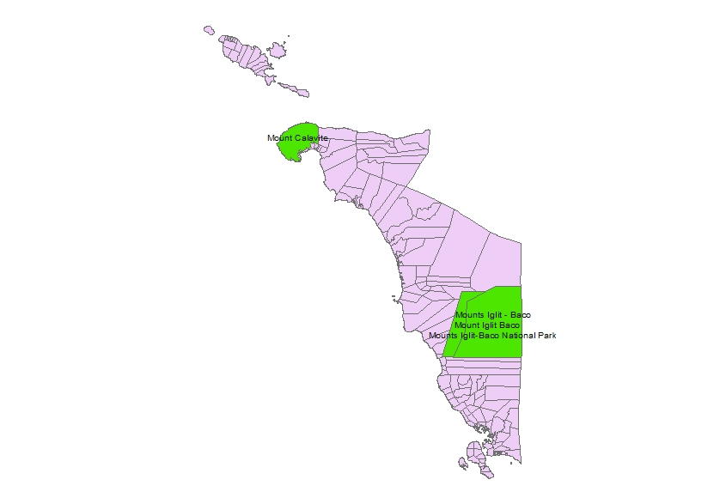
Figure 3. Protected Areas Map

IDENTIFY INFEASIBLE LOCATIONS BASED FROM ROADS
Roads were also avoided while selecting the feasible solar farm installation sites. Figure 4 shows the map of roads an streets in Occidental Mindoro. A 50-meter buffer on both sides of the road was set-up to keep the solar farm installation sites from occupying the road.

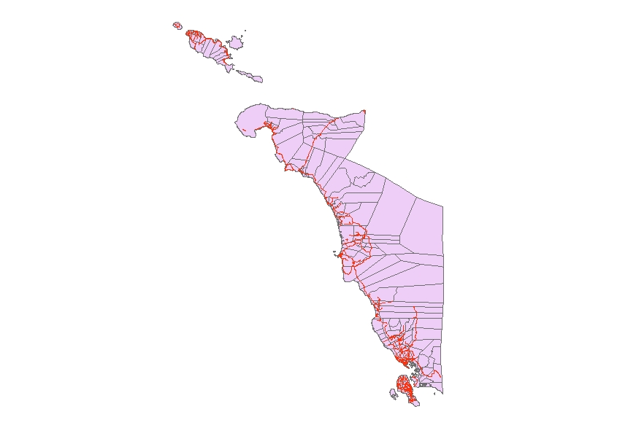
Figure 4. Road Map of Occidental Mindoro

IDENTIFY FEASIBLE LOCATIONS BASED FROM ASPECT and SLOPE
According to Kalogirou [37], fixed-tilt frame is typically used to increase the solar flux or concentrated sunlight received by the PV module. Two angles are considered in installing fixed-tilt frames: the collector tilt angle (associated with the slope of the installation site) and the collector azimuth angle (associated with aspect or orientation). Latitude tilt, tilting of the module at an angle equal to the local geographic latitude, is used to minimize the average incidence angle throughout the year. Choosing areas with slope greater than or equal to the local geographic latitude takes advantage of the effects of latitude tilt. Another way of increasing the solar flux received by the PV module is to set the azimuth angle of the module to the west of due south, maximizing the energy output during the afternoon when electricity demand is usually at its peak. Choosing south-facing installation areas can also achieve the similar effect of adjusting the azimuth angle.
In the study, it was assumed that the PV modules will be installed on fixed-tilt frames. The aspect or orientation values were derived from the Digital Elevation Model (DEM). The flat and South-facing values (south, southeast, and southwest) were extracted from the aspect map of Occidental Mindoro. Choosing flat and south-facing feasible installation sites was similar to adjusting the azimuth angle. Figure 5 shows the aspect map derived from the Digital Elevation Model of Occidental Mindoro.
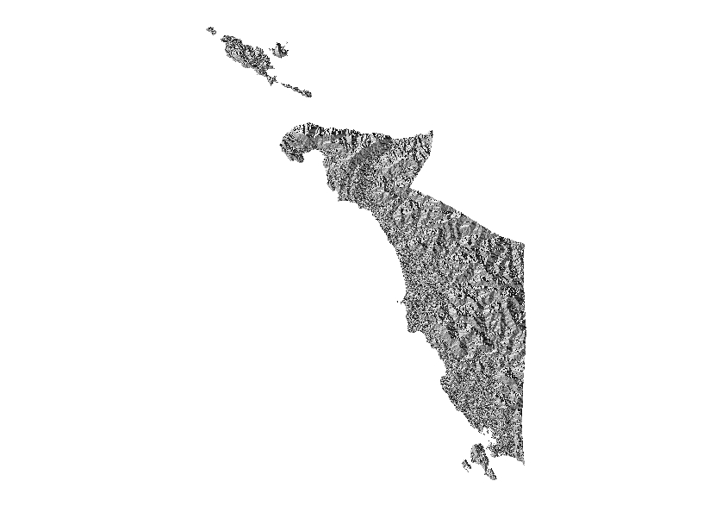
Figure 5. Aspect Map of Occidental Mindoro

Slope(degree) was then computed for each flat or south-facing locations. All the locations with a slope greater than the geographic latitude of Occidental Mindoro (12°) were selected. Choosing the areas with slope greater than the local geographic latitude took advantage of the effects of latitude tilt on the amount of solar flux received by the PV modules. Figure 6 shows the slope map derived from the Digital Elevation Model of Occidental Mindoro.
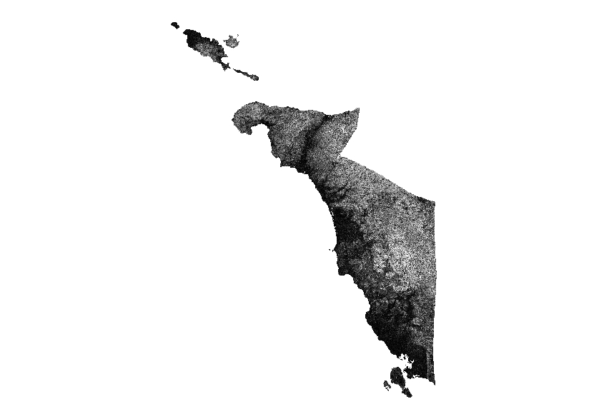
Figure 6. Slope Map of Occidental Mindoro

DETERMINE FEASIBLE LOCATIONS
The infeasible locations were removed from the map of barangays in Occidental Mindoro by removing the corresponding locations based from the combined Land Type, Land Cover, Protected Areas and buffered roads maps. The resulting map was composed of the feasible solar farm installation site based from land type, land cover, protected areas, and roads. Figure 7 shows the map of barangays in Occidental Mindoro while Figure 8 shows the infeasible locations based from the land type, land Cover, protected areas and buffered roads.

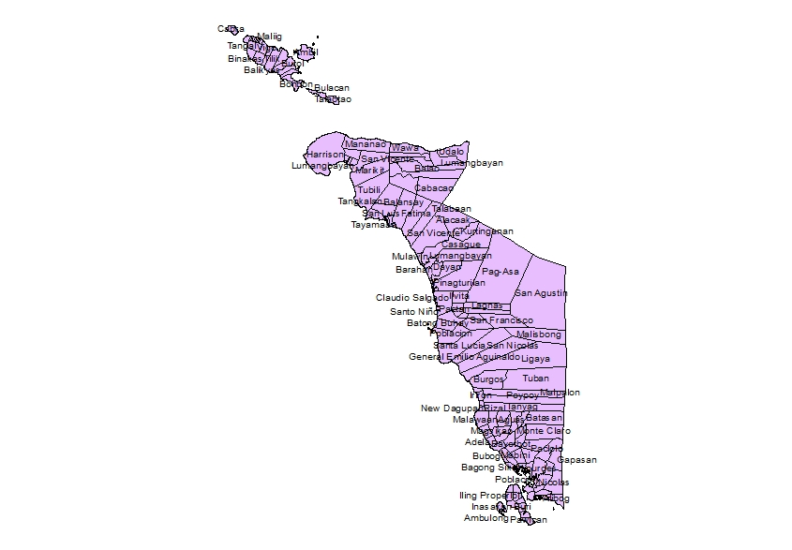
Figure 7. Map of Barangays in Occidental Mindoro
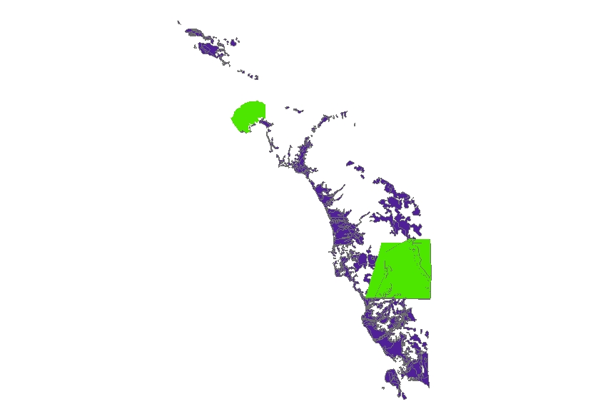

Figure 8. Infeasible Locations based from Land Type, Land Cover, Protected Areas, and Roads
The generated 'feasible locations' map was used as a mask to produce the solar irradiation map of the feasible locations. Figure 9 shows the Clear-sky annual avearage solar irradiation map of Occidental Mindoro used to determine the solar irradiation values in the feasible locations.
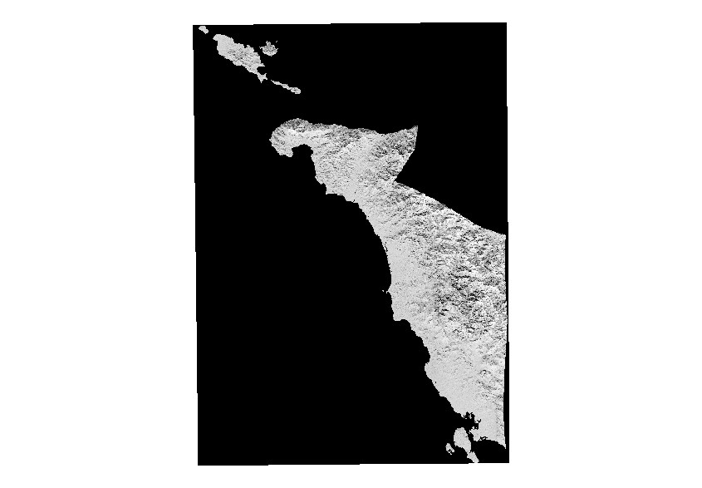
Figure 9. Annual Clear Sky GHI average solar irradiation of Occidental Mindoro

Using the Extract by Mask Tool in ArcGIS, the map of average solar irradiation of feasible locations was masked with the map of slopes of flat and south-facing locations. The resulting map contained the final average solar irradiation of flat and south-facing locations with slope greater than 12°.
The resulting map, which is a raster map, was converted to aggregate polygons. The area (in acres) for each polygon was computed.
According to the National Renewable Energy Laboratory (NREL), the total-area capacity-weighted average in the United States is 8.9 acres/MWac [44]. In the present study, contiguous land areas that were less than 8.9 acres were not considered. Then, the resulting map was used as a mask on the solar irradiation map to extract the solar irradiation values of the resulting feasible solar farm installation sites. For each feasible site, the mean solar irradiation for the area was computed. Also, using the Feature to Point Tool in ArcGIS, the center point of each feasible location was determined. Each point represented a feasible site. Then, using the mean solar irradiation map, the solar irradiation value for each specific point was extracted.
DETERMINE THE NEAREST DISTANCES OF EACH FEASIBLE LOCATION FROM ROADS, TRANSMISSION LINES, AND BUILT-UP AREAS
The distances from the nearest road, transmission line, and built-up area was computed for each feasible solar farm installation site. A CSV file containing the area, mean solar irradiation, and distances from the nearest road, built-up area, and transmission line was generated. The CSV file will be used as an input to the solver in Stage II.
STAGE II: OPTIMAL SOLAR FARM LOCATIONS
After identifying the feasible solar farm installation sites, the optimal solar farm locations were determined using Weighted Goal Programming (WGP) . The Analytic Heirarchy Process (AHP) was also used to determine the weights of each goal.
DETERMINE WEIGHTS OF GOALS USING ANALYTIC HEIRARCHY PROCESS
In this study, there were five factors considered in solving for the 'optimal' locations of the solar farms: (1) total energy produced from the solar farms, (2) distance from transmission line, (3) distance from road, (4) distance from built-up area, (5) total installation cost of the solar farms and (6) total maintenance cost. AHP was used to determine the weights of each goal or driving objectives by determining the weights of these factors. AHP was performed using the BPMSG AHP Priority Calculator developed by Goepel [45]. Table 4 shows the rating scale used in AHP (based from Memarian et al. Table 5) [45][46].

Table 4. Analytic Heirarchy Process scale used in BPMSG AHP Priority Calculator
Level of Importance | Description | Explanation
1 | Equal Importance | Two factors have equal contribution to the objective/goal
3 | Moderate Importance | Slightly favor one factor over the other
5 | Strong Importance | Strongly favor one factor over the other
7 | Very Strong Importance | One factor is very strongly favored over the other and its dominance is demonstrated in practice
9 | Extreme Importance | There is an evidence with the highest possible order of affirmation that favors one factor over the other
2,4,6,8 |  | Values in between

WEIGHT NORMALIZATION
Since the goals/factors had different measurement units, it is required to implement a normalization technique to overcome the problem of incommensurability [47]. In the study, percentage normalization method was used to normalize the objective function. Percentage normalization converts each deviation into a percentage value away from the target value by dividing the weight by the target value.
FORMULATING THE MODEL USING WEIGHTED GOAL PROGRAMMING
After determining the weigths of each factor, the functional relationship of each factor was determined. The following set of equations show the functional relationship of each factor.
- Total energy produced
The total energy produced by all the installed solar farms should be greater than an expected total output Y as illustrated in Equation 2. The ouput energy of a solar farm,, is given by
(Equation 1)

where:
= total area of the installation site
= average yearly global irradiation at installation site j (W/m²)
= PV module effieciency
= Inverter efficiency
(Equation 2)
converting it to goal constraint form,
(Equation 3)
where
= positive and negative deviations of the first goal from the target value Y

Since the goal for the total energy was to produce a total energy from all the installed solar farms that is greater than or equal to the target energy output Y, was minimized.
- Distance from transmission line
Proximity to existing transmission lines can affect the cost and efficiency of the installed solar farm. Sites that are far from the existing transmission lines require longer interconnection cables and can suffer from transmission loss due to increase in resistance. The chosen installation sites should be atmost 3000 meters away from the nearest existing transmission lines [31]. Equation 4 shows the functional relationship for the distance from transmission line.
(Equation 4)
converting Equation 4 to goal constraint form yields
(Equation 5)
where:
= distance of the jth solar farm location from the nearest transmission line
= set of numbers representing the selected feasible sites
t = 2, 3,…,m+1.
Since the goal for the distance from transmission line of each installed solar farms was to have a distance that is less than or equal to 3000 meters, were minimized.
- Distance from road
The distance of the solar farm installation site from the existing road network gives an idea about the accessibility of the installation site. It gives an idea on the cost of transporting and installing the materials and equipments used to construct the solar farm. It also affects the cost of maintaining the solar farm. Installation sites that are far from the existing road network has a higher installation and maintenance cost while installation sites that are too close to the road network is also not a good idea. In this study, sites that are too close to the existing road network, distance is less than or equal to 50 m, were eliminated at Stage I so the target goal considered in Stage II was to make sure that solar farms are not too far from the existing road network. The target distance from the nearest road was set to be less than or equal to 1000 meters, as illustrated by Equation 6 [31].
(Equation 6)
converting Equation 6 to goal constraint form yields
(Equation 7)
where:
= distance of the jth solar farm location from the nearest road
= set of numbers representing the selected feasible sites
t = m+2, m+3,…,2m+1.
Since the goal for the distance from road of each installed solar farms was to have a distance that is less than or equal to 1000 meters, were minimized.
- Distance from built-up area
According to Uyan, Solar farms should not be constructed within 500 meters from rural and urban residential areas since the solar farms can cause negative environmental impact on the urban growth and population [31]. Equation 8 shows that functional relationship for the distance of solar farm installation sites to the nearest built-up area.
(Equation 8)
converting Equation 8 to goal constraint form yields
(Equation 9)
where:
= distance of the jth solar farm location from the nearest built-up area
= set of numbers representing the selected feasible sites
t = 2m+2, 2m+3,…,3m+1.
Since the goal for the distance from built-up area of each installed solar farms was to have a distance that is greater than or equal to 500 meters, were minimized.
- Total installation cost of the solar farms
The total installation cost for all the installed solar farms should not exceed the allocated budget, TC as illustrated in Equation 10. Total installation cost, , factors in the cost of buying or leasing the installation site, cost of the materials and equipments used in the installation, and the transportation cost.
(Equation 10)
converting it to goal constraint form,
(Equation 11)
where
= positive and negative deviations of the first goal from the target value TC

Since the goal for the total installation cost for all the installed solar farms was to stay within the specified budget TC, was minimized.

- Total Maintenance cost
The total mintenance cost for all the installed solar farms should be within the allocated budget, TMC as illustrated in Equation 12. Total installation cost, , factors in the annual maintenance cost of equipments(i.e. PV modules, inverters, and cables) and the transportation cost.
(Equation 12)
converting it to goal constraint form,
(Equation 13)
where
= positive and negative deviations of the first goal from the target value TC

Since the goal for the total maintenance cost for all the installed solar farms was to stay within the specified budget TMC, was minimized.
Using Weighted Goal Programming in determining the 'optimal' locations of the solar farm installation sites, the overall objetive is to find the values of so as to
(Equation 14)
subject to:
(Equation 3)
where t= 2,3,…,m+1 (Equation 5)
where t=m+2,m+3,…,2m+1 (Equation 7)
where t=2m+2,2m+3,…,3m+1 (Equation 9)
(Equation 11)
(Equation 13)
where t=3m+4, 3m+5,…,4m+3 (Equation 15)
(Equation 16)
and

for t=1,2,…,4m+4 (Equation 17)

The objective function given by Equation 14 was used to attempt to minimize the sum of the unwanted deviations that were present in Equations 3,5,7,9,11,and 13 which represents the functional relationships of the factors considered in chosing the 'optimal' solar farm site locations. Equation 17 made sure that the positive and negative deviation values were non-negative. MATLAB optimization toolbox was used to solve the Weighted Goal Programming formulation.

RESULTS AND DISCUSSION

The study presented a two-stage GIS-based methodology for determining the optimal solar farm installation sites in the province of Occidental Mindoro, Philippines. Figure 10 shows the feasible locations determined at stage I where feasible locations were determined based on land type, land cover, protected areas, roads, aspect, and slope of the area.
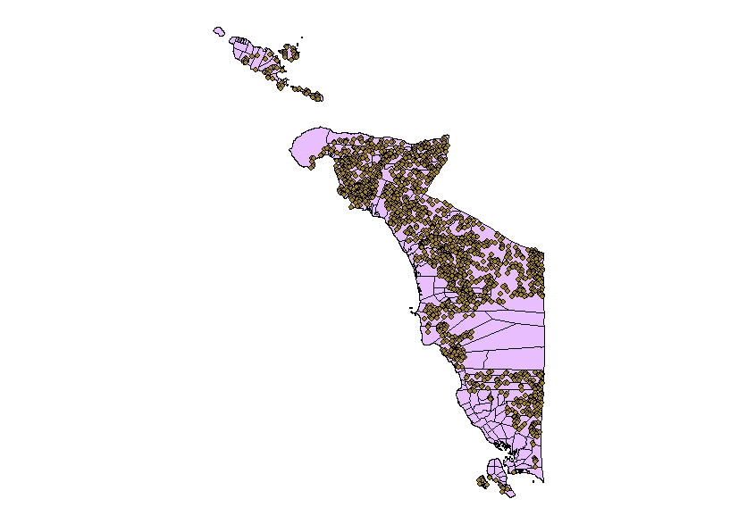
Figure 10. Identified Feasible Solar Farm installation sites in Occidental Mindoro
Literature Cited
11
[1] Aran-Carrion J, Espin-Estrella A, Aznar-Dols F, Zamorano-Toro M, Rodriguez M, Ramos-Ridao A.(2008).Environmental decision support systems for evaluating the carrying capacity of land areas:optimal site selection for grid-connected photovoltaic power plants. Renewable and Sustainable Energy Reviews, 12(9), 2358-2380. doi:10.1016/j.rser.2007.06.011
[2] Arifin S. (2010). Location Allocation Problem Using Genetic Algorithm and Simulated Annealing: A Case Study Based on School in Enschede (Thesis Manuscript). Retrieved from https://www.itc.nl/library/papers_2011/msc/gfm/arifin.pdf
[3] Charabi Y and A Gastli.(2011). PV site suitability analysis using GIS-based spatial fuzzy multi-criteria evaluation. Renewable Energy, 36(9), 2554-2561.doi:10.1016/j.renene.2010.10.037
[4] Cavallaro F. (2010). Fuzzy TOPSIS approach for assessing thermal-energy storage in concentrated solar power (CSP) systems. Applied Energy, 87(2), 496-503. doi:10.1016/j.apenergy.2009.07.009
[5] Ellorin B. (2012, August 18). Green energy offers hope to Mindanao. Inquirer Mindanao. Retrieved from http://newsinfo.inquirer.net/252532/green-energy-offers-hope-to-mindanao
[6] Dumlao A.(2013, August 12) . Ilocos Norte towns, Korean firmink deal for country's biggest solar plant. PhilStar Global. Retrieved from http://www.philstar.com/nation/2013/08/12/1082361/ilocos-norte-towns-korean-firm-ink-deal-countrys-biggest-solar-plant.
[7] Flores AM. (2013, June 18) . Govt okays 30-MW Leyte solar station. Manila Standard Today. Retrieved from http://manilastandardtoday.com/business/106234/govt-okays-30-mw-leyte-solar-station.html
[8] Georgopoulou E, D Lalas, L Papagiannakis. (1997). A multicriteria decision aid approach for energy planning problems: the case of renewable energy option. European Journal of Operational Research, 103(1), 38-54. doi:10.1016/S0377-2217(96)00263-9
[9] Goodchild MF and CM Hosage.(1986). Discrete Space Location-Allocation Solutions from Genetic Algorithms. Annals of Operations Research, 6(2), 35-46. doi:10.1007/BF02027381
[10] Gonzales I. (2015, May 18). Mindoro reeling from power outages. The Philippine Star. Retrieved from http://www.philstar.com/nation/2015/05/18/1455759/mindoro-reeling-power-outages
[11] Heo EY, JS Kim, KJ Boo. (2010). Analysis of the assessment factors for renewable energy dissemination program evaluation using fuzzy AHP. Renewable and Sustainable energy Reviews, 14(8), 2214-2220. doi:10.1016/j.rser.2010.01.020
[12] Heyns AM and JH van Vuuren.(n.d.).A multi-objective approach towards GIS-based facility location.
[13]United States Agency International Development. (September 2010). Philippine Utility Scale Photovoltaic Case Study:Kern, E. Retrieved from http://www.energytoolbox.org/gcre/photovoltaic_case_study.pdf
[14] Krpan L, V Steko, and Z Koren. 2012.Model for Selecting Location for Construction of Solar Power Plants. Gradevinar, 64(9), 741-748.
[15] Lacson N. (2015, December 12). Zamboanga to be hub of Asia's largest solar power plant. Manila Bulletin. Retrieved from http://www.mb.com.ph/zamboanga-to-be-hub-of-asias-largest-solar-power-plant
[16] Solar Electric Power Association .(2014, March). Predicting Solar Power Production: Irradiance Forecasting Models, Applications and Future Prospects. Retrieved from http://www.solarelectricpower.org/media/144099/sepa-forecastreport-2014.pdf
[17] MATLAB & SIMULINK. (n.d.). How Genetic Algorithm Works – MATLAB & SIMULINK. Retrieved from http://www.mathworks.com/help/gads/how-the-genetic-algorithm-works.html#f13721
[18] MATLAB & SIMULINK. (n.d.). Fitness Scaling – MATLAB & SIMULINK. Retrieved from http://www.mathworks.com/help/gads/fitness-scaling.html
[19] Milidiu RLD, JS Duarte and CN dos Santos. Evolutionary TBL Template Generation. Journal of the Brazilian Computer Society, 13(4). 2007. pp. 39-50.
[20] Ownergy. (2011). Planning Aspects of Solar Parks Site Location:Solar Park Development Proposals. Retrieved from http://www.ownergy.co.uk/library/gosple/D2PLAN1.pdf
[21] Parida B, S Iniyan, and R Goic. (2011). A review of Solar Photovoltaic Technologies. Renewable and Sustainable Energy Reviews, 15(3),1625-1636. doi:10.1016/j.rser.2010.11.032
[22] Philipine Statistics Authority. (2013, December 27). Electricity is the most common source of energy used by households. Retrieved from https://psa.gov.ph/content/electricity-most-common-source-energy-used-households
[23] Philipine Statistics Authority. (2005, January 15). Fuel consumption of Filipino Households – HECS Highlights SR -1995 . Retrived from https://psa.gov.ph/content/fuel-consumption-filipino-households-hecs-highlights-sr-1995
[24] Reno MJ , CW Hansen, and JS Stein. (2012). Global Horizontal Irradiance Clear Sky Models: Implementation and Analysis. Sandia Report. Retrieved from http://prod.sandia.gov/techlib/access-control.cgi/2012/122389.pdf
[25] Republic of the Philippines Department of Energy. (2013). Philippine Power Statistics. Retrieved from https://www.doe.gov.ph/doe_files/pdf/02_Energy_Statistics/Power-Statistics-2013.pdf
[26] Republic of the Philippines Department of Energy. (n.a.). Republic Act No. 9513 – An Act Promoting the Development, Utilization, and Commercialization of Renewable Energy Resources and For Other Purposes. Retrieved from https://www.doe.gov.ph/issuances/republic-act/627-ra-9513.
[27] Republic of the Philippines Department of Energy.(n.d.). Solar Energy Potential Sites. Retrieved from https://www.doe.gov.ph/renewable-energy-res/resource-maps/278-solar
[28] San Carlos Solar Energy. (n.d.). San Carlos Solar Energy: About Us. San Carlos Solar Energy website. Retrieved from http://www.sacasol.com/about.html
[29] Sarmiento B.( 2014, November 5). PHL's largets proposed solar plant in SouthCot gets DENR, NCIP permits. Minda News. Retrieved from http://www.mindanews.com/top-stories/2014/11/05/phls-largest-proposed-solar-plant-in-southcot-gets-denr-ncip-permits
[30] Sanchez-Lozano JM, J Teruel-Solano, PL Soto-Elivira, and M Socorro Garcia-Cascales M. (2013). Geographical Information Systems (GIS) and Multi-Criteria Decision Making (MCDM) methods for the evaluation of solar farms locations: Case Study in South-Eastern Spain. Renewable and Sustainable Energy Reviews, 24, 544-556. doi:10.1016/j.rser.2013.03.019
[31] Uyan, M. (2013). GIS-based solar farms site selection using Analytic Hierarchy Process (AHP) in Karapinar Region, Konya/ Turkey. Renewable and Sustainable Energy Reviews, 28, 11-17. doi: 10.1016/j.rser.2013.07.042
[32] Zhang FL, D Johnson and JW Sutherland. (2011). A GIS-based method for identifying the optimal location for a facility to convert forest biomass to biofuel. Biomass and Bioenergy 35(9), 3951-3961. doi:10.1016/j.biombioe.2011.06.006
[33] Philippine Working Group(PGP) on Community Resoure Management, Environmental Science for Social Change. (2009 March). Philippine Forest Land: Where are we going? An updated Approach to the Philippine Uplands for Action. Retrieved from:http://essc.org.ph/content/wp-content/uploads/2009/04/pwg_meeting_report_4mar09.pdf
[34] Carating RB, RG Galanta and CD Bacatio.(2014).The Soils of the Philippines (pp 232). Retrieved from: https://books.google.com.ph/books?id=sY7EBAAAQBAJ&pg=PA232&lpg=PA232&dq=5.2+Erodible+Lands+5.3+Pasture+lands&source=bl&ots=fJ1F5tPkt4&sig=ukTmZDCumgYE9CGPjf7pLsDE9tU&hl=en&sa=X&redir_esc=y#v=onepage&q=5.2%20Erodible%20Lands%205.3%20Pasture%20lands&f=false
[35]Fuentes X. Land Type(Palawan). Retrieved from: http://www.philgis.org/freegisdata.htm
[36]Fuentes X. Land Cover. Retrieved from: http://www.philgis.org/freegisdata.htm
[37] Kalogirou SA.(2014).Solar Energy Engineering:Processes and Systems Second Edition. pp. 480-538
[38] Bostan I, et al.(2013).Resilient Energy Systems Renewables:Wind, Solar, Hydro. pp. 146
[39] Dumalao-Abadilla D. (2016, March 1). PH largest solar farm up in Batangas. Philippine Daily Inquirer. Retrieved from http://technology.inquirer.net/46928/ph-largest-solar-farm-up-in-batangas
[40] 100% Brownout-Free Occidental Mindoro. (2015, April 9). News: Occidental Mindoro residents launch online petition against brownouts, “culture of impunity”. Change.org. Retrieved from https://www.change.org/p/energy-secretary-carlos-jericho-petillla-department-of-energy-consumer-welfare-promotion-office-end-the-culture-of-impunity-that-has-prevented-the-residents-of-occidental-mindoro-from-gaining-access-to-stable-reliable-and-affordable-electricity-2/u/10405056
[41] Rivera D. (2016, January 18). NEA clears Occidental Mindoro power supply deal. The Philippine Star. Retrieved from http://www.philstar.com/business/2016/01/18/1543559/nea-clears-occidental-mindoro-power-supply-deal
[42] Department of Energy.(2013). 2013 Energy Investment 2013: Renewable Energy. Retrieved from http://www.doe.gov.ph/microsites/ipo%20web/linked%20files/2013/EIK13/re.pdf
[43] Department of Energy.(2013). 2013 Energy Investment Kit: Power Sector. Retrieved from http://www.doe.gov.ph/microsites/ipo%20web/eik13.htm
[44] National Renewable Energy Laboratory. (2013, June). Land-Use Requirements for Solar Power Plants in the United States (NREL/TP-6A20-56290). Retrieved from http://www.nrel.gov/docs/fy13osti/56290.pdf
[45] Goepel K. (2016). BPMSG AHP Online System. (available at http://bpmsg.com/academic/ahp.php)
[46] Memarian H et al. (2014). Integration of Analytic Heirarchy Process and Weighted Goal Programming for Land Use Optimization at the Watershed Scale. Turkish Journal of Engineering & Environmental Sciences 38: 139-158 doi:10.3906/muh-1303-21.
[47] Jones D. (2016). Goal Programming Tutorial.Presentation Slides. Retrieved from www.mat.ucm.es/imeio/cursos/EPS_MCDM/.../Dj-euro_phdschool.pdf

