AP Calculus AB

Concepts and practice English edition
First edition for the 2027 exam
This independently authored book supports high-school students learning calculus and teachers preparing them for AP Calculus AB. Learn through concise notes and worked examples, explain reasoning in unit practice, and then apply those skills under exam timing.
Component | Count
Units and worked examples | 8 / 16
Prerequisite diagnostic MCQ | 12
Unit practice MCQ and FRQ | 48 / 16
Mock exam MCQ and FRQ | 42 / 6
Total assessment questions | 124

Answers are separated into the teacher guide and linked by question ID. Use the diagnostic to identify prerequisite skills; a single score should not determine a student’s potential.
All questions and solutions are independently authored. This is neither a reproduction of official exam questions nor a College Board endorsed publication. AP is a registered trademark of College Board.

Course sequence and classroom use
Unit | Focus | Suggested weeks
1 | Limits and continuity | 1-3
2 | Derivative definition and basic rules | 4-5
3 | Composite implicit and inverse derivatives | 6-7
4 | Contextual applications of differentiation | 8-9
5 | Analytical applications of differentiation | 10-12
6 | Integration and accumulation of change | 13-16
7 | Differential equations | 17-18
8 | Applications of integration | 19-21

This is a suggested 21-week sequence with two 90-minute meetings per week. Use week 22 for the mock exam and review. This pacing is an instructional suggestion, not an official requirement. Add algebra or trigonometry support as the diagnostic indicates.
Before class, read the notes and redo examples with solutions covered. During class, connect definitions, diagrams, formulas, and units. For homework, follow MCQ with FRQ and write one sentence explaining each error.
In free response, state theorem hypotheses, variable meanings, integral bounds, and units. Show an expression before a numerical answer. Calculator work still requires mathematical setup and interpretation.

Exam format and solution conventions
Part | Questions | Minutes | Calculator
I A | 29 | 62 | Not permitted
I B | 13 | 38 | Graphing calculator required
II A | 2 | 30 | Graphing calculator required
II B | 4 | 60 | Not permitted

The table reflects the official format effective May 2027. On the hybrid exam, students answer MCQ and view FRQ in Bluebook, then handwrite FRQ answers in paper booklets. This print book reproduces timing practice rather than the testing software.
Angles are in radians unless stated otherwise. Retain full precision during calculator work and round only final numerical answers to three decimals. Exact expressions are acceptable. This is the rounding convention for this practice book.
Weight MCQ and FRQ at 50% each. Each original FRQ here has three 3-point parts, totaling 9. These instructional rubrics are author-created and do not constitute official scoring guidelines or an AP 1-to-5 score conversion.
$C=50\frac{M}{42}+50\frac{R}{54}$
Here $M$ is correct mock MCQ and $R$ is total mock FRQ points. The result $C$ is a classroom percentage metric.

Prerequisite diagnostic 1 to 3
Work without a calculator and identify prerequisite gaps

D01
What is the larger root of $x^{2}−5x+6=0$?
A. $3$
B. $6$
C. $2$
D. $5$
Work

D02
For $x≠4$, simplify $(x^{2}−16)/(x−4)$.
A. $x+4$
B. $x^{2}+4$
C. $x−4$
D. $4$
Work

D03
Find $sin(π/6)$.
A. $0$
B. $\frac{1}{2}$
C. $\frac{\sqrt{3}}{2}$
D. $1$
Work

Prerequisite diagnostic 4 to 6

D04
Find $ln(e^{3})$.
A. $0$
B. $3$
C. $e^{3}$
D. $1$
Work

D05
If $f(x)=x^{2}+1$ and $g(x)=2x−3$, find $f(g(2))$.
A. $7$
B. $10$
C. $1$
D. $2$
Work

D06
Find the slope through $(1,3)$ and $(5,11)$.
A. $2$
B. $\frac{1}{2}$
C. $8$
D. $4$
Work

Prerequisite diagnostic 7 to 9

D07
What is the real domain of $ln(x−2)$?
A. $x≥2$
B. All real numbers
C. $x>2$
D. $x<2$
Work

D08
For $f(x)=3x+5$, find $f^{−1}(11)$.
A. $2$
B. $\frac{16}{3}$
C. $38$
D. $\frac{1}{11}$
Work

D09
For $x>0$, simplify $x^{3/2}/x^{1/2}$.
A. $x$
B. $\sqrt{x}$
C. $1$
D. $x^{2}$
Work

Prerequisite diagnostic 10 to 12

D10
What is $\sin^{2}x+\cos^{2}x$?
A. $1$
B. $sin\left(2x\right)$
C. $2$
D. $0$
Work

D11
Find the minimum of $x^{2}−6x+11$.
A. $11$
B. $3$
C. $2$
D. $−6$
Work

D12
Find the sum of the two solutions of $|x−2|=5$.
A. $10$
B. $−3$
C. $4$
D. $7$
Work

Unit 1 Limits and continuity
Distinguish function values from limits and justify conclusions using continuity and theorem hypotheses.

Reading approaching values
A limit describes nearby outputs as the input approaches a point. The value at that point may be missing or different. A two-sided finite limit exists only when both one-sided limits agree. Distinguish open and filled points on graphs. A finite table suggests behavior but does not prove a limit.
$\lim_{x→a^{−}}{f(x)}=\lim_{x→a^{+}}{f(x)}=L$

Algebra and the squeeze theorem
Try substitution first. The form $0/0$ calls for further analysis. Factoring and canceling preserve the expression near the point, not necessarily at the point. Conjugates help with radicals. Trigonometric limit identities use radians. The squeeze theorem applies when bounding functions approach the same value.
$\lim_{x→0}{\frac{sinx}{x}}=1$

Continuity and discontinuities
Continuity requires a defined value, an existing limit, and equality of the two. At interval endpoints use the one-sided limit from within the interval. A removable hole can be repaired by redefining a value; jumps and infinite discontinuities cannot. Retain domain restrictions from an original rational denominator.
$\lim_{x→a}{f(x)}=f(a)$

Infinity and intermediate values
Infinite limits describe unbounded behavior near vertical asymptotes. Limits at infinity describe end behavior. Compare leading terms of rational functions and check signs. The intermediate value theorem requires continuity on a closed interval and a target between endpoint values. It guarantees existence, not uniqueness.
$f(a)<N<f(b) ⟹ f(c)=N\text{ for some }c∈(a,b)$

Unit 1 Learning through examples

Example 1
Find $\lim_{x→4}{(x^{2}−16)/(x−4)}$.
For $x≠4$, factor the numerator as $(x−4)(x+4)$. The nearby expression is $x+4$, so the limit is $8$. The original expression is undefined at $4$, yet its limit exists.
Error check Do not conclude that a zero denominator alone makes the limit nonexistent.

Example 2
Explain why $f(x)=x^{3}+x−5$ has at least one zero in $(1,2)$.
The polynomial is continuous on $[1,2]$. Its endpoint values are $−3$ and $5$, which straddle zero. The intermediate value theorem gives a point $c∈(1,2)$ with $f(c)=0$.
Error check State continuity and endpoint signs, not only the theorem name.
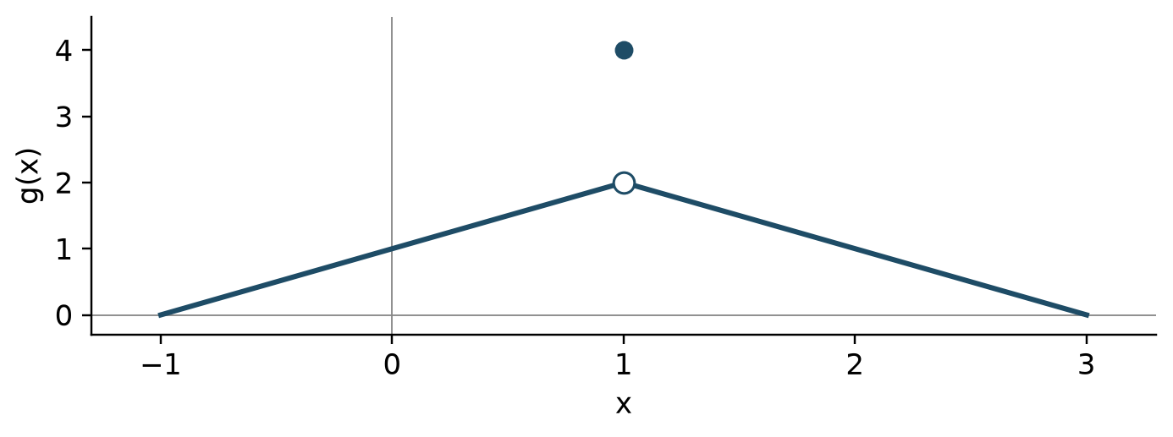
An open point can separate a limit from the actual value.

Unit 1 Multiple choice practice 1 to 3

U1-M01
Evaluate $\lim_{x→3}{(x^{2}−9)/(x−3)}$.
A. $3$
B. $0$
C. $6$
D. $9$
Work

U1-M02
Let $f(x)=2+x$ for $x<0$ and $f(x)=5−x$ for $x≥0$. What is the two-sided limit at $0$?
A. $5$
B. $7/2$
C. Does not exist
D. $2$
Work

U1-M03
For $x<2$, $f(x)=kx+1$; for $x≥2$, $f(x)=x^{2}+5$. Which $k$ makes $f$ continuous?
A. $4$
B. $9$
C. $2$
D. $5$
Work

Unit 1 Multiple choice practice 4 to 6

U1-M04
Evaluate $\lim_{x→0}{x^{2}sin(1/x)}$.
A. $2$
B. $1$
C. $0$
D. $−1$
Work

U1-M05
Evaluate $\lim_{x→∞}{(3x^{2}−x)/(2x^{2}+7)}$.
A. $\frac{2}{3}$
B. $3$
C. $0$
D. $\frac{3}{2}$
Work

U1-M06
A continuous $f$ on $[0,4]$ satisfies $f(0)=−2$ and $f(4)=6$. Which must be true?
A. There is $c∈(0,4)$ with $f(c)=1$
B. There is exactly one zero
C. $f$ is increasing
D. $f(2)=2$
Work

U1-F01 Free response
Calculator not permitted
Define $f(x)=x^{2}+a$ for $x<1$, $f(1)=b$, and $f(x)=3x−1$ for $x>1$.
(a) Find the left and right limits at $1$.
Work and justification
(b) Find $a,b$ that make $f$ continuous everywhere.
Work and justification
(c) Use part (b). Justify the existence of $c∈(0,2)$ with $f(c)=3$, and find one such value.
Work and justification

U1-F02 Free response
Calculator not permitted
The graph follows segments from $(−1,0)$ to $(1,2)$ to $(3,0)$, with a hole at $(1,2)$ and actual value $g(1)=4$.
(a) Find the two-sided limit and the function value at $1$.
Work and justification
(b) Redefine one value to make $g$ continuous at $1$.
Work and justification
(c) For the original function, $g(0)=1$ and $g(1)=4$. Can IVT guarantee the value $3$ on $[0,1]$? Does such a point actually exist?
Work and justification

Unit 2 Derivative definition and basic rules
Define instantaneous rate by a limit and apply basic differentiation rules accurately.

From average to instantaneous change
A secant slope is an average rate over an interval; a tangent slope is an instantaneous rate. The derivative is the limit of a difference quotient. A centered difference is often useful for estimates from tables, but distinguish an estimate from an exact derivative.
$f^{′}(a)=\lim_{h→0}{\frac{f(a+h)−f(a)}{h}}$

Differentiability and continuity
Differentiability implies continuity. A continuous function can still have a corner, cusp, or vertical tangent and fail to have a finite derivative. At a piecewise junction first check continuity, then compare one-sided slopes. A tangent line needs both a function value and a derivative.
$y=f(a)+f^{′}(a)(x−a)$

Basic derivatives
Combine the power, constant-multiple, and sum rules. Use the basic exponential, logarithmic, and trigonometric derivatives. The real domain of $lnx$ is $x>0$, while the derivative of $ln|x|$ is $1/x$ for $x≠0$. Trigonometric derivatives assume radian measure.
$(e^{x})^{′}=e^{x},(sinx)^{′}=cosx,(cosx)^{′}=−sinx$

Products and quotients
A product derivative has two terms. A quotient derivative divides by the denominator squared and requires the correct subtraction order. Decide whether expanding or simplifying first is easier. Derivatives of tangent, cotangent, secant, and cosecant follow from sine and cosine ratios.
$(uv)^{′}=u^{′}v+uv^{′},{\left(\frac{u}{v}\right)}^{′}=\frac{u^{′}v−uv^{′}}{v^{2}}$

Unit 2 Learning through examples

Example 1
Use the definition to find $f^{′}(3)$ for $f(x)=x^{2}$.
The quotient is $((3+h)^{2}−9)/h=6+h$. Taking $h→0$ gives $f^{′}(3)=6$. The tangent line is $y−9=6(x−3)$.
Error check Parenthesize the entire numerator of the difference quotient.

Example 2
Differentiate $f(x)=x^{2}e^{x}$.
The product rule gives $f^{′}(x)=2xe^{x}+x^{2}e^{x}=e^{x}(x^{2}+2x)$. Multiplying the two derivatives is not the product rule.
Error check Include both terms in the product rule.
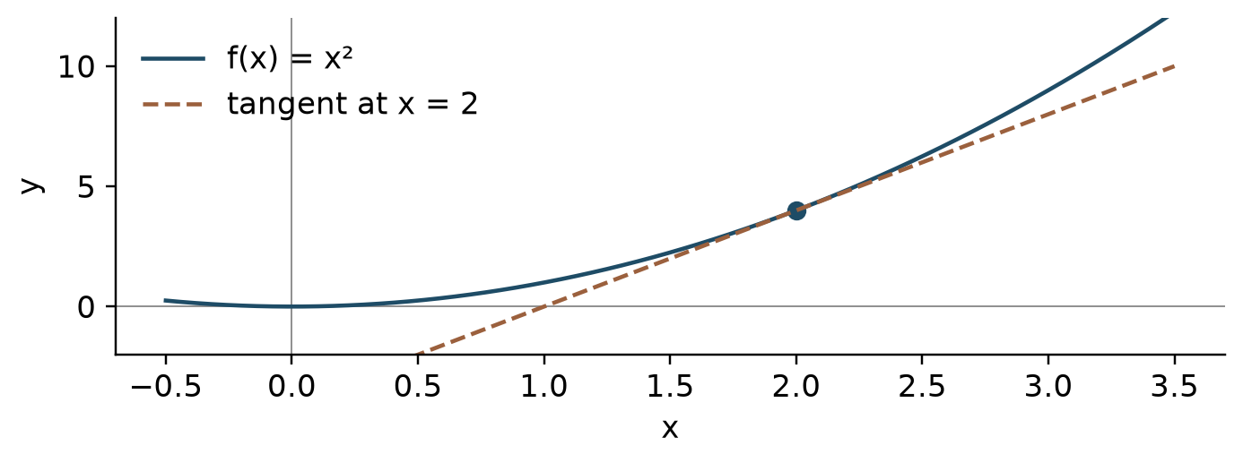
A tangent slope gives the instantaneous rate.

Unit 2 Multiple choice practice 1 to 3

U2-M01
Evaluate $\lim_{h→0}{((2+h)^{3}−8)/h}$.
A. $4$
B. $12$
C. $6$
D. $8$
Work

U2-M02
If $f(x)=x^{2}sinx$, find $f′(π/2)$.
A. $0$
B. $2$
C. $π$
D. $\frac{π^{2}}{4}$
Work

U2-M03
For $f(x)=(x^{2}+1)/(x+1)$, find $f′(1)$.
A. $1$
B. $\frac{1}{2}$
C. $2$
D. $0$
Work

Unit 2 Multiple choice practice 4 to 6

U2-M04
For $f(x)=tanx$, find $f′(π/4)$.
A. $\sqrt{2}$
B. $1$
C. $2$
D. $0$
Work

U2-M05
Which describes $f(x)=|x−2|$ at $x=2$?
A. Continuous but not differentiable
B. Its derivative is $0$
C. Continuous and differentiable
D. Discontinuous
Work

U2-M06
The values of $f$ at $x=1.8,2,2.2$ are $4.1,4.8,5.7$. Estimate $f′(2)$ using the outer two points.
A. $4$
B. $0.8$
C. $8$
D. $2$
Work

U2-F01 Free response
Calculator not permitted
Let $f(x)=x^{3}−2x$.
(a) Expand the difference quotient to find $f′(−1)$ from the definition.
Work and justification
(b) Find the tangent line at $x=−1$.
Work and justification
(c) Find $f^{′′}(−1)$ and explain whether it is the tangent slope.
Work and justification

U2-F02 Free response
Calculator not permitted
$P(t)$ is plant height in centimeters, where $t$ is weeks. Assume $P$ is differentiable and use the table.
t | P(t)
0 | 2
1 | 3.5
2 | 6
3 | 10

(a) Use $t=1,3$ to estimate $P′(2)$ and give units.
Work and justification
(b) Find the average height rate on $[0,3]$.
Work and justification
(c) Use the estimated slope in (a) to approximate $P(2.2)$.
Work and justification

Unit 3 Composite implicit and inverse derivatives
Read function structure and select chain, implicit, or inverse differentiation.

Inside and outside
For a composition, evaluate the outer derivative at the inner function and multiply by the inner derivative. With several layers include one derivative from each layer. Combine chain rules with product or quotient rules when needed. Naming the layers before calculating helps prevent omissions.
$\frac{d}{dx}f(g(x))=f^{′}(g(x))g^{′}(x)$

Implicit and higher derivatives
Because $y$ depends on $x$, differentiating a term involving $y$ produces a factor of $y^{′}$. Isolate $y^{′}$ after differentiating. For a second derivative retain that dependence and use the product rule. If a slope formula has zero denominator, examine the original curve and numerator before classifying the tangent.
$x^{2}+y^{2}=r^{2}⟹y^{′}=−\frac{x}{y}(y≠0)$

Slopes of inverse functions
An inverse derivative is the reciprocal of the original derivative at the corresponding original input. Do not confuse an inverse input with an original input. The formula requires a local inverse and a nonzero original derivative. The two graphs reflect across $y=x$.
$(f^{−1})^{′}(b)=\frac{1}{f^{′}(a)}\text{when }f(a)=b$

Inverse trigonometry and notation
Use the derivatives of arcsine and arctangent and include a chain factor for a composition. In this context $\sin^{−1}x$ denotes an inverse function, not $1/sinx$. A higher derivative comes from differentiating the preceding derivative as a function.
$(arcsinx)^{′}=\frac{1}{\sqrt{1−x^{2}}},(arctanx)^{′}=\frac{1}{1+x^{2}}$

Unit 3 Learning through examples

Example 1
Differentiate $y=(1+3x^{2})^{4}$.
Differentiate the outer fourth power, then multiply by the inner derivative $6x$. Thus $y^{′}=4(1+3x^{2})^{3}(6x)=24x(1+3x^{2})^{3}$.
Error check Do not omit the inner derivative.

Example 2
If $f(2)=7$, $f^{′}(2)=5$, and $g=f^{−1}$, find $g^{′}(7)$.
Since $g(7)=2$, the derivative is $g^{′}(7)=1/f^{′}(2)=1/5$. The value $f^{′}(7)$ is not needed.
Error check Find the corresponding point before taking a reciprocal.
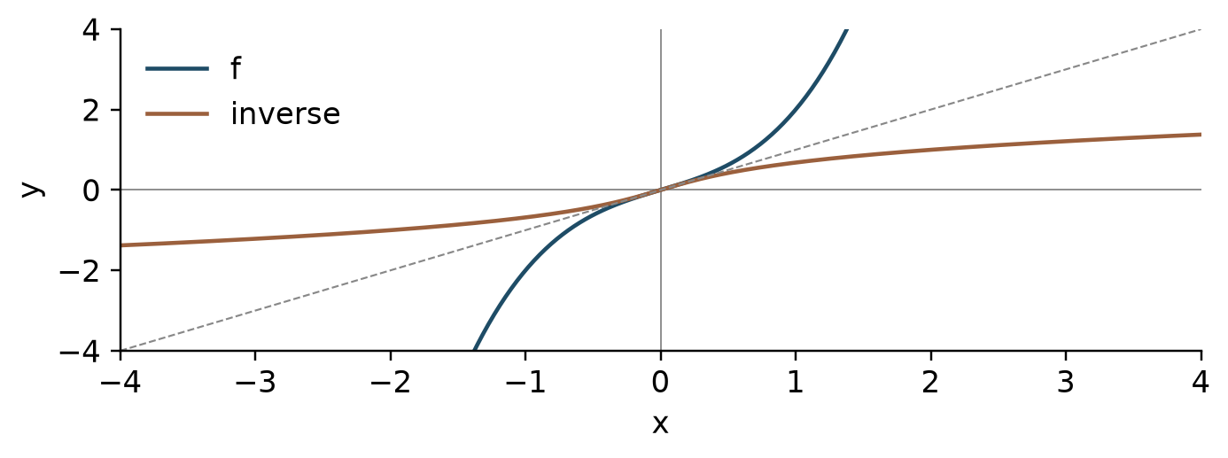
A function and its inverse reflect across y=x.

Unit 3 Multiple choice practice 1 to 3

U3-M01
If $f(x)=(2x^{3}+1)^{4}$, find $f′(1)$.
A. $108$
B. $648$
C. $216$
D. $72$
Work

U3-M02
On $x^{2}+xy+y^{2}=7$, find $dy/dx$ at $(1,2)$.
A. $−\frac{5}{4}$
B. $−\frac{1}{2}$
C. $\frac{4}{5}$
D. $−\frac{4}{5}$
Work

U3-M03
If $f(3)=8$, $f′(3)=4$, and $g$ is its local inverse, find $g′(8)$.
A. $3$
B. $4$
C. $\frac{1}{4}$
D. $\frac{1}{8}$
Work

Unit 3 Multiple choice practice 4 to 6

U3-M04
For $f(x)=arctan(3x)$, find $f′(0)$.
A. $3$
B. $\frac{1}{3}$
C. $0$
D. $1$
Work

U3-M05
For $f(x)=sin(2x)$, find $f^{′′}(π/4)$.
A. $−2$
B. $4$
C. $0$
D. $−4$
Work

U3-M06
Let $g$ be the inverse of $f(x)=lnx$. Find $g′(ln5)$.
A. $5$
B. $\frac{1}{5}$
C. $log\left(5\right)$
D. $1$
Work

U3-F01 Free response
Calculator not permitted
Consider the point $(3,4)$ on $x^{2}+y^{2}=25$.
(a) Find $dy/dx$ in terms of $x,y$ and evaluate it at the point.
Work and justification
(b) Find the tangent line at the point.
Work and justification
(c) Find $d^{2}y/dx^{2}$ at the point.
Work and justification

U3-F02 Free response
Calculator not permitted
Let $f(x)=x^{3}+x$ and $g=f^{−1}$.
(a) Explain why the inverse exists and find $g(10)$.
Work and justification
(b) Find $g′(10)$.
Work and justification
(c) If $H(x)=g(5x)$, find $H′(2)$.
Work and justification

Unit 4 Contextual applications of differentiation
Interpret derivative units and apply derivatives to motion, related rates, and approximation.

Units and motion
Derivative units are output units divided by input units. Velocity is the derivative of position and acceleration is the derivative of velocity. Speed is absolute velocity, so a moving particle speeds up when velocity and acceleration have the same sign. Direction and speeding up are separate questions.
$v(t)=s^{′}(t),a(t)=v^{′}(t),\text{speed}=|v(t)|$

Related rates
Draw a diagram and identify quantities that vary with time. Write their relationship, differentiate with respect to time, then substitute values for the specified instant. In conical-tank problems use similar triangles to eliminate a variable first. Track length and volume units through the calculation.
$V=\frac{4}{3}πr^{3}⟹\frac{dV}{dt}=4πr^{2}\frac{dr}{dt}$

Linearization
Approximate a nearby function value with a tangent at an easy base point. Linearization is local. If the function is concave down between the base and target points, the tangent overestimates; if concave up, it underestimates. State the relevant concavity condition when judging error direction.
$f(a+Δx)≈f(a)+f^{′}(a)Δx$

L Hospital rule
First check for a $0/0$ or infinity-over-infinity form. Under the theorem's differentiability and denominator-derivative conditions, use the limit of the ratio of derivatives. This is different from differentiating the original quotient. Rewrite other indeterminate forms before applying the theorem.
$lim\frac{f(x)}{g(x)}=lim\frac{f^{′}(x)}{g^{′}(x)}\text{when the hypotheses hold}$

Unit 4 Learning through examples

Example 1
A sphere has radius $2$ cm and $dr/dt=3$ cm/s. Find its volume rate.
Substitute into $dV/dt=4πr^{2}(dr/dt)$ to obtain $4π(2)^{2}(3)=48π$ cm³/s.
Error check Do not replace the changing radius with a constant before differentiating.

Example 2
Use linearization to estimate $\sqrt{9.12}$.
Since $f(9)=3$ and $f^{′}(9)=1/6$, the estimate is $3+(1/6)(0.12)=3.02$. The square-root function is concave down, so this is an overestimate.
Error check Multiply the derivative by the input change.
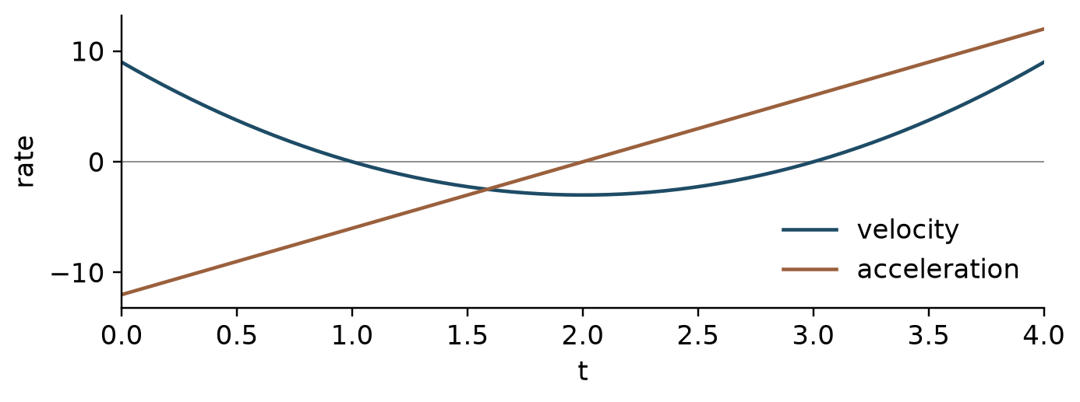
Compare velocity and acceleration signs together.

Unit 4 Multiple choice practice 1 to 3

U4-M01
A particle has velocity $v(t)=3t^{2}−12t+9$. At $t=3/2$ it is:
A. Moving in the negative direction and slowing down
B. At rest
C. Moving in the positive direction and speeding up
D. Moving in the negative direction and speeding up
Work

U4-M02
When a sphere has radius $3$ cm, $dr/dt=2$ cm/s. Find $dV/dt$ in cm³/s.
A. $18π$
B. $24π$
C. $36π$
D. $72π$
Work

U4-M03
Use linearization at $x=16$ to estimate $\sqrt{16.2}$.
A. $4$
B. $\frac{41}{10}$
C. $\frac{161}{40}$
D. $\frac{81}{20}$
Work

Unit 4 Multiple choice practice 4 to 6

U4-M04
Evaluate $\lim_{x→0}{(e^{2x}−1)/x}$.
A. $1$
B. $0$
C. $4$
D. $2$
Work

U4-M05
$W(t)$ is water volume in liters and $t$ is hours. Interpret $W′(3)=−4$.
A. The rate itself decreases by $4$ liters per hour each hour
B. At hour $3$, water volume decreases at $4$ liters per hour
C. Volume fell by $4$ liters over the first $3$ hours
D. There are $4$ liters at hour $3$
Work

U4-M06
A $10$ m ladder has its foot $6$ m from a wall, moving outward at $2$ m/s. Find the top height rate in m/s.
A. $\frac{3}{2}$
B. $−2$
C. $−\frac{8}{3}$
D. $−\frac{3}{2}$
Work

U4-F01 Free response
Calculator not permitted
A particle has position $s(t)=t^{3}−6t^{2}+9t$ meters for $0≤t≤4$, with time in seconds.
(a) Find formulas for velocity and acceleration.
Work and justification
(b) At $t=1.5$, justify the direction and whether the particle is speeding up.
Work and justification
(c) Use linearization at $1.5$ to estimate $s(1.6)$.
Work and justification

U4-F02 Free response
Calculator not permitted
An inverted cone has height $8$ cm and top radius $4$ cm. Water enters at $3π$ cm³/s. At a certain instant its water depth is $2$ cm.
(a) Express water volume using only depth $h$.
Work and justification
(b) Find $dh/dt$ at that instant.
Work and justification
(c) Linearly estimate the depth $0.1$ second later. Justify whether it overestimates the actual depth.
Work and justification

Unit 5 Analytical applications of differentiation
Use theorem hypotheses and derivative signs to analyze graphs and extrema.

Mean and extreme values
The mean value theorem needs continuity on a closed interval and differentiability inside; it guarantees an instantaneous rate equal to the average rate. The extreme value theorem guarantees at least one absolute minimum and maximum for a continuous function on a closed bounded interval. Distinguish their hypotheses.
$f^{′}(c)=\frac{f(b)−f(a)}{b−a}\text{for some }c∈(a,b)$

Monotonicity and extrema
A critical number is in the function domain and has zero or undefined derivative. Positive derivative gives increase and negative derivative gives decrease. A change from positive to negative gives a local maximum; the reverse gives a minimum. For absolute extrema compare original function values at critical numbers and endpoints. A zero derivative alone is insufficient.
$f^{′}(x)>0⇒f\text{ increases},f^{′}(x)<0⇒f\text{ decreases}$

Concavity and connected graphs
When $f^{″}>0$, the first derivative increases and the graph is concave up. An inflection point requires a genuine concavity change; $f^{″}=0$ only produces candidates. The second derivative test uses the sign of $f^{″}$ where $f^{′}=0$. If $f^{″}=0$, that test is inconclusive. Do not mistake a derivative graph for a function graph.
$f^{′}(c)=0, f^{″}(c)>0⇒\text{local minimum at }c$

Optimization and implicit analysis
In optimization separate the objective from constraints and identify the feasible domain. Reduce to one variable, then compare critical values with endpoints or boundary behavior. For implicit curves use $y^{′}$ and $y^{″}$ to analyze tangents and concavity. Check that results meet the original length, time, or quantity restrictions.
$A(x)=x(P−2x)\text{for a three-sided enclosure of fence length }P$

Unit 5 Learning through examples

Example 1
Find absolute extrema of $f(x)=x^{3}−3x$ on $[−2,2]$.
Critical numbers are $−1$ and $1$. Values at endpoints and critical numbers are $−2,2,−2,2$, respectively. The absolute maximum is $2$ and minimum is $−2$, each attained twice.
Error check Include endpoints and all locations attaining a tied extreme value.

Example 2
A river forms one side of a rectangle; $48$ m of fence covers the other three. Find the maximum area.
Let the perpendicular side be $x$. The other side is $48−2x$, with $0<x<24$. Setting $A^{′}=48−4x=0$ gives sides $12$ and $24$. The concave-down quadratic has maximum area $288$ m².
Error check Do not count the river side as fenced.
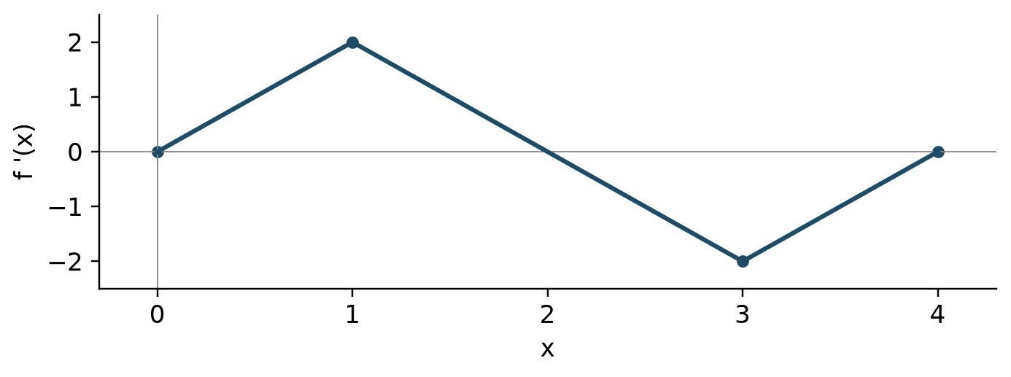
This graph represents a derivative rather than the original function.

Unit 5 Multiple choice practice 1 to 3

U5-M01
For $f(x)=x^{2}$ on $[1,5]$, find the mean-value-theorem point $c$.
A. $4$
B. $2$
C. $3$
D. $6$
Work

U5-M02
Find the absolute maximum value of $f(x)=x^{3}−3x$ on $[−2,2]$.
A. $−2$
B. $0$
C. $2$
D. $6$
Work

U5-M03
Which describes $x=0$ for $f(x)=x^{3}$?
A. A local minimum
B. Not a critical number
C. An inflection point but no local extremum
D. A local maximum
Work

Unit 5 Multiple choice practice 4 to 6

U5-M04
If $f′(x)=(x−1)(x−3)$, where is $f$ increasing?
A. $(1,3)$
B. $(−∞,1)$ and $(3,∞)$
C. All real numbers
D. $(−∞,3)$
Work

U5-M05
If $f^{′′}(x)=6x−12$ everywhere, find the inflection input.
A. $6$
B. $2$
C. $12$
D. $0$
Work

U5-M06
What is the maximum area in m² of a rectangle with perimeter $40$ m?
A. $80$
B. $200$
C. $400$
D. $100$
Work

U5-F01 Free response
Calculator not permitted
Analyze $f(x)=x^{3}−6x^{2}+9x+1$ on $[0,4]$.
(a) Justify intervals of increase and decrease and locate interior local extrema.
Work and justification
(b) Find absolute extreme values and every location attaining them.
Work and justification
(c) Find the inflection point and explain the concavity change.
Work and justification

U5-F02 Free response
Calculator not permitted
Cut squares of side $x$ cm from each corner of an $18$ cm square sheet and fold an open-top box.
(a) Write the volume function and physically feasible domain.
Work and justification
(b) Justify the maximizing cut size and find the maximum volume.
Work and justification
(c) If equipment restricts cuts to $0<x≤2$, what is the maximum volume?
Work and justification

Unit 6 Integration and accumulation of change
Interpret a definite integral as signed accumulation and use the fundamental theorem and substitution.

Riemann sums and numerical integration
Partition the interval and add width times representative height. Left, right, and midpoint sums differ in their sample points. Trapezoids average endpoint heights. With unequal widths multiply each width separately. A definite integral gives signed area, so regions below the axis contribute negatively.
$\int_{a}^{b}{f(x)dx=\lim_{n→∞}{\sum_{i=1}^{n}{f(a+iΔx)Δx}}}$

Accumulation and the fundamental theorem
For a continuous integrand, differentiating accumulation from a fixed lower endpoint to a variable upper endpoint returns the integrand. Include a chain factor for a composed upper endpoint. If both endpoints vary, write a difference of accumulations. Integrand signs control accumulation's increase and integrand slopes control its concavity.
$\frac{d}{dx}\int_{a}^{g(x)}{f(t)dt=f(g(x))g^{′}(x)}$

Antiderivatives and integral properties
An antiderivative differentiates to the integrand; include $C$ for an indefinite integral. A definite integral equals an antiderivative's endpoint difference. Reversing bounds changes the sign, and adjacent intervals add. Odd and even symmetry can simplify symmetric intervals. Check an antiderivative by differentiating it.
$\int_{a}^{b}{f(x)dx=F(b)−F(a)\text{when }F^{′}=f}$

Substitution and algebraic preparation
Try substitution when an inner expression appears with its derivative. For definite integrals change the bounds or return to the original variable before evaluating. Polynomial division and completing the square can reveal basic forms. Recognize arctangent and arcsine patterns. Integration by parts, partial fractions, and improper integrals are reserved for the BC extension.
$∫f(g(x))g^{′}(x)dx=F(g(x))+C$

Unit 6 Learning through examples

Example 1
Evaluate $\int_{0}^{1}{2x(x^{2}+1)^{3}dx}$.
Set $u=x^{2}+1$ and $du=2xdx$; the new bounds are $1$ and $2$. Then $\int_{1}^{2}{u^{3}du=[u^{4}/4]_{1}^{2}=15/4}$.
Error check Do not mix transformed variables with original bounds.

Example 2
If $F(x)=\int_{1}^{x^{2}}{costdt}$, find $F^{′}(x)$.
Evaluate the integrand at the upper endpoint and multiply by its derivative: $F^{′}(x)=2xcos(x^{2})$.
Error check Do not omit the upper-endpoint derivative $2x$.
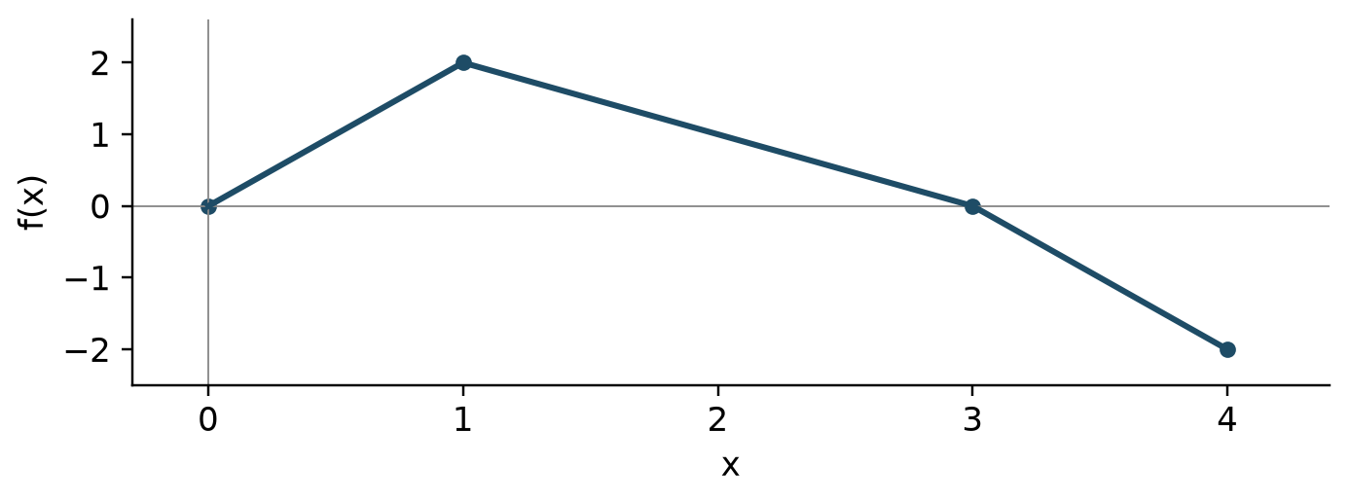
Areas below the axis contribute negatively to a signed integral.

Unit 6 Multiple choice practice 1 to 3

U6-M01
Evaluate $\int_{0}^{2}{(3x^{2}+1)dx}$.
A. $14$
B. $8$
C. $6$
D. $10$
Work

U6-M02
If $F(x)=\int_{0}^{x^{2}}{\sqrt{1+t}dt}$, find $F′(2)$.
A. $4\sqrt{5}$
B. $2\sqrt{5}$
C. $4\sqrt{3}$
D. $\sqrt{5}$
Work

U6-M03
At $t=0,1,3$, the values of $r(t)$ are $2,4,8$. Estimate $\int_{0}^{3}{r(t)dt}$ with two trapezoids.
A. $14$
B. $18$
C. $12$
D. $15$
Work

Unit 6 Multiple choice practice 4 to 5

U6-M04
Evaluate $\int_{0}^{1}{6x(1+3x^{2})^{2}dx}$.
A. $63$
B. $7$
C. $21$
D. $16$
Work

U6-M05
For $x>0$, which is an antiderivative of $(x^{2}+1)/x$?
A. $2x−\frac{1}{x^{2}}$
B. $log\left(x^{2}+1\right)$
C. $x^{2}+log\left(x\right)$
D. $\frac{x^{2}}{2}+log\left(x\right)$
Work

Unit 6 Multiple choice practice 6 to 6

U6-M06
The graph of $f$ consists of line segments. If $F(x)=\int_{0}^{x}{f(t)dt}$, find $F(3)$.
A. $6$
B. $4$
C. $3$
D. $2$
Work

U6-F01 Free response
Calculator not permitted
The graph shows $f$. Define $F(x)=1+\int_{0}^{x}{f(t)dt}$ on $0≤x≤4$.
(a) Find $F(3)$ and $F(4)$.
Work and justification
(b) Find $F′(2)$ and $F^{′′}(2)$.
Work and justification
(c) Justify the absolute maximum of $F$ and its location.
Work and justification

U6-F02 Free response
Calculator not permitted
$r(t)$ is inflow in liters per minute. Initially a tank contains $20$ liters. Assume $r$ is continuous and water only enters.
t | r(t)
0 | 3
2 | 5
5 | 4
6 | 7

(a) Estimate $\int_{0}^{6}{r(t)dt}$ with a left Riemann sum on the three tabulated intervals.
Work and justification
(b) Use trapezoids over the same intervals.
Work and justification
(c) Use (b) to estimate volume at $6$ and average inflow on $[0,6]$.
Work and justification

Unit 7 Differential equations
Interpret slope fields and use separation with initial conditions.

Equations and slope fields
A differential equation relates a function to its rate of change. Each slope-field segment gives the derivative at its $(x,y)$ location. If the rate depends only on $y$, slopes agree along horizontal rows; if only on $x$, along vertical columns. An equation may have infinitely many solutions.
$\frac{dy}{dx}=F(x,y)$

Verification and equilibrium
Verify a candidate by substituting both the function and its derivative into the original equation, then check the initial condition separately. An equilibrium solution is constant. When dividing by a factor during separation, check whether zero values of that factor yield equilibrium solutions that would otherwise be lost.
$y^{′}=k(y−M)⟹y=M\text{ is an equilibrium}$

Separation and initial values
For $dy/dx=g(x)h(y)$, separate as $dy/h(y)=g(x)dx$ on an interval where division is valid. Integrate and determine the constant from the initial condition. When solving with logarithms or square roots retain the appropriate branch and domain. Differentiate the result to check the equation and initial value.
$∫\frac{1}{h(y)}dy=∫g(x)dx$

Exponential models and cooling
A rate proportional to the quantity produces an exponential model. If the rate is proportional to the difference from a baseline, model that difference first. Find half-lives or doubling times by substituting into the exponential equation. Euler's method and detailed logistic modeling belong to the later BC extension.
$y^{′}=k(y−M)⟹y=M+Ce^{kx}$

Unit 7 Learning through examples

Example 1
Solve $y^{′}=2xy$ with $y(0)=3$.
Separate to get $ln|y|=x^{2}+C$, hence $y=Ae^{x^{2}}$. The initial condition gives $A=3$. Differentiating $3e^{x^{2}}$ returns $2xy$.
Error check Determine the integration constant from the initial value.

Example 2
Solve $T^{′}=−0.2(T−20)$ with $T(0)=70$.
The excess temperature is $T−20=Ce^{−0.2t}$. The initial condition gives $C=50$, so $T=20+50e^{−0.2t}$, approaching $20$ over time.
Error check Exponentially decay the excess temperature, not the entire initial temperature.
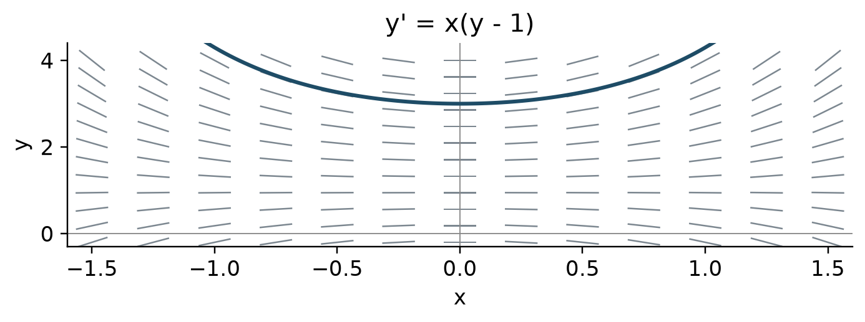
Short segments show local slopes. The curve solves the displayed equation with y(0)=3.

Unit 7 Multiple choice practice 1 to 3

U7-M01
If $y′=3y$ and $y(0)=2$, find $y(ln2)$.
A. $8$
B. $16$
C. $4$
D. $6$
Work

U7-M02
For $y′=x−y$, what is the slope at $(1,3)$?
A. $−2$
B. $−4$
C. $4$
D. $2$
Work

U7-M03
For $y′=x/y$ with $y(0)=2$, find $y(1)$.
A. $\sqrt{3}$
B. $−\sqrt{5}$
C. $5$
D. $\sqrt{5}$
Work

Unit 7 Multiple choice practice 4 to 6

U7-M04
Find the equilibrium solution of $y′=−2(y−7)$.
A. $−7$
B. $7$
C. $0$
D. $2$
Work

U7-M05
Which equation is satisfied by $y=Ce^{−2x}$ for every constant $C$?
A. $y′=y^{2}$
B. $y′=2y$
C. $y′=−2y$
D. $y′=−2x$
Work

U7-M06
If $T′=−\frac{1}{2}(T−20)$ and $T(0)=60$, find $T(2)$.
A. $\frac{40}{e}+20$
B. $\frac{40}{e}$
C. $20+\frac{60}{e}$
D. $\frac{60}{e}$
Work

U7-F01 Free response
Calculator not permitted
Consider $y′=x(y−1)$ with $y(0)=3$.
(a) Describe where the slope field has zero slope and find the initial tangent slope.
Work and justification
(b) Solve the initial-value problem.
Work and justification
(c) Determine the solution concavity on the real line.
Work and justification

U7-F02 Free response
Calculator not permitted
Temperature satisfies $T′=−k(T−18)$ with $k>0$, $T(0)=82$, and $T(10)=50$. Time is in minutes and temperature in degrees Celsius.
(a) Express $T$ in terms of $k,t$.
Work and justification
(b) Find the exact value of $k$.
Work and justification
(c) Find the time when temperature reaches $26$.
Work and justification

Unit 8 Applications of integration
Use integration for averages, accumulated quantities, area, and volume with appropriate units.

Average values and accumulated quantities
A function's average value is its integral divided by interval length; it is not average rate of change. Final amount equals initial amount plus net change. Integrate inflow minus outflow when both occur. To maximize an amount compare times when the net rate is zero with interval endpoints.
$f_{avg}=\frac{1}{b−a}\int_{a}^{b}{f(x)dx}$

Displacement and distance
Integrating velocity gives displacement; integrating absolute velocity gives total distance. Find velocity zeros and split intervals when the sign changes. Add the initial position to recover position. Zero displacement can coexist with positive distance traveled.
$Δs=\int_{a}^{b}{v(t)dt,D=\int_{a}^{b}{|v(t)|dt}}$

Areas between curves
For vertical slices integrate top minus bottom with respect to $x$; for horizontal slices integrate right minus left with respect to $y$. Find all intersections and split where ordering changes. Distinguish signed integrals from geometric area. Check that the diagram and integral describe the same region.
$A=\int_{a}^{b}{(\text{top}−\text{bottom})dx}$

Cross sections and solids of revolution
Volume is the integral of cross-sectional area. A square has area side squared, an equilateral triangle has area $\sqrt{3}/4$ times side squared, and a semicircle with diameter $d$ has area $πd^{2}/8$. Disk and washer radii are distances from the rotation axis. Redefine these distances for shifted horizontal or vertical axes.
$V=\int_{a}^{b}{A(x)dx,V=π\int_{a}^{b}{(R^{2}−r^{2})dx}}$

Unit 8 Learning through examples

Example 1
For $v(t)=t−2$ on $0≤t≤4$, find displacement and total distance.
Displacement is $\int_{0}^{4}{(t−2)dt=0}$. Split at $t=2$: distance is $−\int_{0}^{2}{(t−2)dt+\int_{2}^{4}{(t−2)dt=4}}$.
Error check Opposite directions do not cancel in total distance.

Example 2
Rotate the region between $y=x$ and $y=x^{2}$, $0≤x≤1$, about the $x$-axis. Find its volume.
The outer radius is $x$ and inner radius is $x^{2}$, so $V=π\int_{0}^{1}{(x^{2}−x^{4})dx=2π/15}$.
Error check Integrate the difference of squares, not the square of a difference.
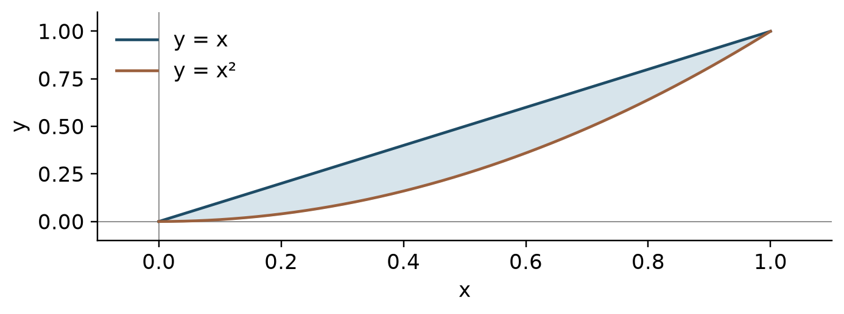
The vertical slice length is top curve minus bottom curve.

Unit 8 Multiple choice practice 1 to 2

U8-M01
Find the average value of $f(x)=x^{2}$ on $[0,3]$.
A. $9$
B. $6$
C. $\frac{9}{2}$
D. $3$
Work

U8-M02
A particle has $v(t)=t−1$ m/s for $0≤t≤3$. Find total distance in meters.
A. $\frac{3}{2}$
B. $3$
C. $2$
D. $\frac{5}{2}$
Work

Unit 8 Multiple choice practice 3 to 4

U8-M03
Find the area between $y=x$ and $y=x^{2}$ on $0≤x≤1$.
A. $\frac{2}{3}$
B. $\frac{1}{3}$
C. $\frac{1}{6}$
D. $\frac{1}{2}$
Work

U8-M04
Rotate the region bounded by $y=\sqrt{x}$, the $x$-axis, and $x=4$ about the $x$-axis. Find the volume.
A. $4π$
B. $\frac{32π}{3}$
C. $8π$
D. $16π$
Work

Unit 8 Multiple choice practice 5 to 6

U8-M05
A solid has base between $y=x$ and $y=x^{2}$. Cross sections perpendicular to the $x$-axis are squares. Find its volume.
A. $\frac{1}{15}$
B. $\frac{1}{30}$
C. $\frac{1}{6}$
D. $\frac{π}{30}$
Work

U8-M06
Find the area enclosed by $x=y^{2}$ and $x=2y$.
A. $\frac{8}{3}$
B. $4$
C. $\frac{4}{3}$
D. $\frac{2}{3}$
Work

U8-F01 Free response
Calculator not permitted
A particle has $v(t)=(t−1)(t−3)$ m/s, $s(0)=2$ meters, and $0≤t≤4$.
(a) Find $s(4)$.
Work and justification
(b) Find total distance traveled.
Work and justification
(c) Find the absolute maximum position and all times attaining it.
Work and justification

U8-F02 Free response
Calculator not permitted
Let $R$ be the bounded region between $y=x$ and $y=x^{2}$.
(a) Find the intersection inputs and area.
Work and justification
(b) Find the volume when $R$ revolves about the $x$-axis.
Work and justification
(c) Find the volume when $R$ revolves about $y=2$.
Work and justification

Mock exam I A 1 to 3
29 questions 62 minutes no calculator

E01
Evaluate $\lim_{x→4}{(\sqrt{x+5}−3)/(x−4)}$.
A. $\frac{1}{3}$
B. $\frac{1}{6}$
C. $0$
D. $3$
Work

E02
For $f(x)=e^{x}+x^{−2}$, find $f′(1)$.
A. $e$
B. $−2+e$
C. $−1+e$
D. $2+e$
Work

E03
Find the tangent slope at $(1,2)$ on $xy+y^{2}=6$.
A. $−\frac{2}{5}$
B. $−\frac{5}{2}$
C. $−\frac{1}{2}$
D. $\frac{2}{5}$
Work

Mock exam I A 4 to 6

E04
$T(t)$ is degrees Celsius and $t$ is minutes. What does $T′(5)=3.2$ mean?
A. It rose $3.2$ degrees over five minutes
B. The temperature rate increases by $3.2$ each minute
C. The temperature at minute $5$ is $3.2$ degrees
D. At minute $5$, temperature rises at $3.2$ degrees per minute
Work

E05
For $f(x)=lnx$ on $[1,e^{2}]$, find the MVT point $c$.
A. $\frac{2}{−1+e^{2}}$
B. $\frac{1}{2}+\frac{e^{2}}{2}$
C. $e$
D. $−\frac{1}{2}+\frac{e^{2}}{2}$
Work

E06
Evaluate $\int_{−1}^{1}{(3x^{2}+2x)dx}$.
A. $4$
B. $0$
C. $2$
D. $6$
Work

Mock exam I A 7 to 9

E07
If $y′=2y$ and $y(0)=5$, find $y(1)$.
A. $7$
B. $5e^{2}$
C. $10$
D. $5e$
Work

E08
Find the area bounded by $y=2x−x^{2}$ and the $x$-axis.
A. $\frac{2}{3}$
B. $\frac{8}{3}$
C. $2$
D. $\frac{4}{3}$
Work

E09
Evaluate $\lim_{x→2}{1/(x−2)^{2}}$.
A. $0$
B. $∞$
C. $−∞$
D. $1$
Work

Mock exam I A 10 to 12

E10
At $x=1,2,3$, $f(x)=5,8,15$. Estimate $f′(2)$ using $x=1,3$.
A. $10$
B. $3$
C. $5$
D. $7$
Work

E11
For $f(x)=arcsin(x/2)$, find $f′(1)$.
A. $\frac{2\sqrt{3}}{3}$
B. $\sqrt{3}$
C. $\frac{1}{2}$
D. $\frac{\sqrt{3}}{3}$
Work

E12
Evaluate $\lim_{x→0}{ln(1+3x)/sin(2x)}$.
A. $3$
B. $0$
C. $\frac{3}{2}$
D. $\frac{2}{3}$
Work

Mock exam I A 13 to 14

E13
The graph shows $f′$. On which open intervals is $f$ concave up?
A. $(1,3)$
B. $(0,2)$
C. $(2,4)$
D. $(0,1)$ and $(3,4)$
Work

E14
Evaluate $\lim_{n→∞}{\sum_{i=1}^{n}{(2/n)(1+2i/n)^{2}}}$.
A. $9$
B. $\frac{8}{3}$
C. $\frac{26}{3}$
D. $\frac{13}{3}$
Work

Mock exam I A 15 to 17

E15
When separating $y′=x(y+4)$, one divides by $y+4$. Which constant solution must be checked separately?
A. $0$
B. $−4$
C. $−x$
D. $4$
Work

E16
Find the average value of $sinx$ on $[0,π]$.
A. $1$
B. $2$
C. $\frac{π}{2}$
D. $\frac{2}{π}$
Work

E17
Which correctly justifies a zero of $p(x)=x^{3}+2x−1$ in $(0,1)$?
A. Continuity and $p(0)=−1<0<2=p(1)$ allow IVT
B. Because $p(0)+p(1)>0$
C. Opposite endpoint signs suffice without continuity
D. Every cubic has a zero in $(0,1)$
Work

Mock exam I A 18 to 20

E18
For $f(x)=xsinx$, find $f′(π)$.
A. $π$
B. $−1$
C. $0$
D. $−π$
Work

E19
Water depth rises at $3$ m/min in a cylinder of fixed radius $2$ m. Find the volume rate in m³/min.
A. $24π$
B. $12π$
C. $4π$
D. $6π$
Work

E20
Find the absolute minimum of $f(x)=x^{4}−4x^{2}$ on $[−2,2]$.
A. $−4$
B. $4$
C. $0$
D. $−8$
Work

Mock exam I A 21 to 23

E21
Evaluate $\int_{0}^{1}{1/(1+x^{2})dx}$.
A. $\frac{π}{4}$
B. $\frac{1}{2}$
C. $\frac{π}{2}$
D. $log\left(2\right)$
Work

E22
Rotate the region bounded by $x=\sqrt{y}$, the $y$-axis, and $y=4$ about the $y$-axis. Find the volume.
A. $8π$
B. $16π$
C. $\frac{32π}{3}$
D. $4π$
Work

E23
Evaluate $\lim_{x→0}{sin(5x)/(3x)}$.
A. $\frac{3}{5}$
B. $1$
C. $\frac{5}{3}$
D. $0$
Work

Mock exam I A 24 to 26

E24
Let $f(x)=ax+b$ for $x<1$ and $f(x)=x^{2}$ for $x≥1$. If $f$ is differentiable at $1$, find $b$.
A. $1$
B. $0$
C. $2$
D. $−1$
Work

E25
What is the concavity of $y=\sqrt{9−x^{2}}$ on $−3<x<3$?
A. Concave up throughout
B. Concavity changes at zero
C. Linear
D. Concave down throughout
Work

E26
Which is an antiderivative of $1/(x^{2}−2x+5)$?
A. $atan\left(x−1\right)$
B. $log\left(x^{2}−2x+5\right)$
C. $2atan\left(\frac{x}{2}−\frac{1}{2}\right)$
D. $\frac{atan\left(\frac{x}{2}−\frac{1}{2}\right)}{2}$
Work

Mock exam I A 27 to 29

E27
Cross sections are semicircles of diameter $2−x$ for $0≤x≤2$. Find the volume.
A. $\frac{4π}{3}$
B. $\frac{2π}{3}$
C. $\frac{π}{3}$
D. $\frac{8}{3}$
Work

E28
If $f′(x)=x^{2}(x+1)$, which statement about local extrema is correct?
A. A local minimum at $−1$ and no extremum at $0$
B. There is a maximum at $−1$
C. Both points are minima
D. Only $0$ is a maximum
Work

E29
If $F(x)=\int_{x}^{2x}{cos(t^{2})dt}$, find $F′(0)$.
A. $0$
B. $1$
C. $2$
D. $−1$
Work

Mock exam I B 1 to 3
13 questions 38 minutes graphing calculator required

E30
Find the zero of $p(x)=x^{3}+x−4$ in $[1,2]$ to three decimal places.
A. $1.812$
B. $1.379$
C. $1.587$
D. $1.213$
Work

E31
For $f(x)=x^{2}e^{x}$, find $f′(0.7)$.
A. $0.987$
B. $3.806$
C. $1.904$
D. $2.819$
Work

E32
Let $f(x)=x+e^{x}$ and $g=f^{−1}$. If $b=1.2+e^{1.2}$, find $g′(b)$.
A. $0.432$
B. $0.231$
C. $4.32$
D. $0.301$
Work

Mock exam I B 4 to 6

E33
If $v(t)=sin(t^{2})+0.2t$ m/s, find acceleration at $t=1.4$ in m/s².
A. $0.862$
B. $−0.862$
C. $−0.379$
D. $1.205$
Work

E34
Where does $f(x)=x^{2}+e^{−x}$ attain its absolute minimum on $[0,2]$?
A. $0.693$
B. $1.0$
C. $1.256$
D. $0.352$
Work

E35
Find the absolute maximum value of $f(x)=2sinx−x^{2}/2$ on $[0,π]$.
A. $1.03$
B. $2.0$
C. $0.816$
D. $1.184$
Work

Mock exam I B 7 to 8

E36
Evaluate $\int_{0}^{1}{e^{−x^{2}}dx}$ numerically.
A. $0.842$
B. $0.632$
C. $1.128$
D. $0.747$
Work

E37
For $F(x)=\int_{0}^{lnx}{e^{−t^{2}}dt}$, find $F′(2)$.
A. $0.24$
B. $0.309$
C. $0.619$
D. $0.347$
Work

Mock exam I B 9 to 10

E38
Use three trapezoids from the table to estimate $\int_{0}^{2}{f(x)dx}$.
x | f(x)
0 | 1
0.5 | 1.6
1.5 | 2.1
2 | 2.4

A. $3.45$
B. $4.1$
C. $3.8$
D. $3.625$
Work

E39
If $y′=0.4(10−y)$ and $y(0)=2$, when does $y$ first reach $8$?
A. $3.466$
B. $1.733$
C. $2.5$
D. $5.198$
Work

Mock exam I B 11 to 13

E40
Find the area enclosed by $y=e^{−x}$, $y=x/2$, and the $y$-axis.
A. $0.574$
B. $0.853$
C. $0.608$
D. $0.392$
Work

E41
For $v(t)=cost−0.2$ m/s, find total distance on $[0,4]$ in meters.
A. $3.517$
B. $2.969$
C. $0.757$
D. $1.557$
Work

E42
If $T(t)=20+80e^{−0.3t}$, find $T′(4)$.
A. $44.096$
B. $−7.229$
C. $−24.096$
D. $7.229$
Work

EF01 Free response
II A 2 questions total 30 minutes
Graphing calculator required
A tank initially contains $40$ liters. For $0≤t≤4$ minutes, inflow is $R(t)=12+3sin(t^{2}/4)$ L/min and outflow is $D(t)=8+t$ L/min.
(a) Find the volume at $t=4$ to three decimal places.
Work and justification
(b) Justify the time when water volume is greatest on $[0,4]$.
Work and justification
(c) At $t=2$, is the water-volume rate increasing? Justify.
Work and justification

EF02 Free response
II A 2 questions total 30 minutes
Graphing calculator required
Let $f(x)=e^{−x^{2}}+x/4$ and $F(x)=\int_{0}^{x}{f(t)dt}$ for $0≤x≤2$.
(a) Find $F(2)$ and the average value of $f$ on the interval.
Work and justification
(b) Find the absolute maximum value of $f$ and show candidate comparisons.
Work and justification
(c) Justify whether $F$ increases throughout the interval.
Work and justification

EF03 Free response
II B 4 questions total 60 minutes
Calculator not permitted
The graph shows a continuous $f$ and $G(x)=\int_{0}^{x}{f(t)dt}$ on $[0,4]$.
(a) Find $G(4)$ and $G′(2)$.
Work and justification
(b) Justify the absolute maximum of $G$ and its location.
Work and justification
(c) Find all inflection inputs of $G$ and explain why $x=1$ is included.
Work and justification

EF04 Free response
II B 4 questions total 60 minutes
Calculator not permitted
Consider $y′=2x(y+2)$ with $y(0)=1$.
(a) Find the initial tangent line and use it to estimate $y(0.1)$.
Work and justification
(b) Find an explicit solution by separation.
Work and justification
(c) Use the second derivative to decide whether the estimate in (a) is high or low.
Work and justification

EF05 Free response
II B 4 questions total 60 minutes
Calculator not permitted
Let $R$ be the region bounded by $y=4−x^{2}$ and the $x$-axis.
(a) Find the area of $R$.
Work and justification
(b) Find the volume when $R$ revolves about the $x$-axis.
Work and justification
(c) A different solid has base $R$ and equilateral-triangle cross sections perpendicular to the $x$-axis. Find its volume.
Work and justification

EF06 Free response
II B 4 questions total 60 minutes
Calculator not permitted
Let $f(x)=ax+b$ for $x<1$ and $f(x)=x^{2}+1$ for $x≥1$. Choose parameters so that $f$ is differentiable at $1$.
(a) Find $a,b$ and state both matching conditions.
Work and justification
(b) Justify MVT on $[0,2]$ and find a point $c∈(0,2)$ satisfying it.
Work and justification
(c) Find the average value of $f$ on $[0,2]$.
Work and justification

Derivative and integral reference
Use each formula on its valid domain. Angles are radians and C is an integration constant. Compositions require an additional chain factor or substitution.
$(x^{n})′=nx^{n−1}$
$(ln|x|)′=\frac{1}{x}(x≠0)$
$(a^{x})′=a^{x}lna(a>0)$
$(tanx)′=\sec^{2}x,(cotx)′=−\csc^{2}x$
$(secx)′=secxtanx,(cscx)′=−cscxcotx$
$(arcsinx)′=\frac{1}{\sqrt{1−x^{2}}},(arctanx)′=\frac{1}{1+x^{2}}$
$∫x^{n}dx=\frac{x^{n+1}}{n+1}+C(n≠−1)$
$∫\frac{1}{x}dx=ln|x|+C$
$∫e^{x}dx=e^{x}+C,∫cosxdx=sinx+C$
$∫sinxdx=−cosx+C$
$∫\frac{1}{1+x^{2}}dx=arctanx+C$
$∫\frac{1}{\sqrt{1−x^{2}}}dx=arcsinx+C$

Bilingual calculus vocabulary
English | 한국어
limit / one-sided limit | 극한 / 한쪽 극한
continuity / differentiability | 연속성 / 미분가능성
derivative / second derivative | 도함수 / 둘째 도함수
average rate / instantaneous rate | 평균변화율 / 순간변화율
tangent line / linearization | 접선 / 선형근사
implicit / inverse function | 음함수 / 역함수
critical number / local extremum | 임계수 / 극값
absolute maximum and minimum | 절대최댓값과 절대최솟값
concavity / inflection point | 오목성 / 변곡점
mean value theorem | 평균값정리
extreme value theorem | 최대최소정리
intermediate value theorem | 중간값정리
antiderivative / definite integral | 원시함수 / 정적분
accumulation / net change | 누적 / 순변화
Riemann sum / trapezoidal sum | 리만합 / 사다리꼴합
fundamental theorem of calculus | 미적분의 기본정리
slope field / equilibrium solution | 기울기장 / 평형해
separation of variables | 변수분리
displacement / total distance | 변위 / 총 이동거리
cross section / washer | 단면 / 와셔

Sources and the BC extension plan
Official framework checked October 28 2026
AP Calculus AB course framework
Open the official College Board source
AP Calculus AB exam
Open the official College Board source
Fall 2026 clarifications
Open the official College Board source
Calculus course and exam description
Open the official College Board source

Sequence for the BC extension
1. Retain the eight AB units and repair diagnostic gaps.
2. Add integration by parts, linear partial fractions, improper integrals, Euler's method, logistic models, and arc length.
3. Write the unit on parametric, vector-valued, and polar functions.
4. Write sequences and series, convergence tests, power series, Taylor polynomials, and error bounds.
5. Publish BC-specific problems and mixed practice exams after separate validation. This package does not contain the BC textbook itself.

