F20MX - Mobile Communications and Programming - 2021-2022  
Quiz Application

Coursework Q1  
Harry Wilson  
25/03/2022

Contents

Abstract 3

Introduction 3

Task 3

Workplace 3

Application 3

Background 4

Design 4

Android Development 5

Firebase What is Firebase? 6

Firebase for the Quiz Application 6

Aims 6

Objectives 6

Application Discussion 7

Simplicity 7

Speed 8

Good image resolution 8

Flexibility 9

Security 9

Colour Schemes 10

Technical Quality 10

Login 10

Quiz 11

Scoreboard 12

Conclusion 13

References 13

# Abstract

This report will be looking into the design, implementation, and evaluation of a Quiz application. The report will detail why design decisions have been chosen and detail how the android application had been created to meet the specification of the project.

# Introduction

## Task

As a part of my Mobile Communications and Programming course within the university, I have been tasked to design and create a mobile application.

## Workplace

Currently, I work within Borders College, a further education provider located within the Scottish Borders. I work with the IT team within the college. I organised meetings with the head of IT and the senior developer to see if there is a suitable task which could be carried out within the college to meet the specification of the task. After consulting it was decided that there was no suitable workplace application that could be created or updated within the college as there are no mobile applications created and maintained by the college.

## Application

Due to there being no workplace application available to work, I was recommended to create an extension to the provided quiz application which I agreed upon. I then later decided to create a whole quiz application from scratch rather than editing an existing application so I could gain a better knowledge of mobile development. The application I am creating will have all the features as originally proposed within the extension along with making a custom quiz.

# Background

## Design

Before development could begin designs had to be created to gain an understanding of how the user interface (UI) and user experience (UX) of the application will work. UI and UX are very important as improving these features will keep users engaged with the application longer (Berezhnoi, 2019). Nick Babich describes the “4 Golden Rules of UI Design” to be as follows:

* Place users in control of the interface
* Make it comfortable to interact with a product
* Reduce cognitive load
* Make user interfaces consistent (Babich, 2019)

Based on the 4 golden rules initial designs have been created to gain an idea of how the application should look as shown below for home screen, quiz screen and login.

These designs meet the given principles as each of the pages have a consistent theme with the app title at the top and an array of large easy to press buttons, these buttons allow easy and simple navigation between the pages. The simple design makes it comfortable to interact with as there are no unnecessary elements on the page. There are no large sums of text, only simple keywords which all users will understand. The visual clarity and lack of pages to click through reduces the cognitive load on the user improving the user experience.

These designs meet the given principles as each of the pages have a consistent theme with the app title at the top and an array of large easy to press buttons, these buttons allow easy and simple navigation between the pages. The simple design makes it comfortable to interact with as there are no unnecessary elements on the page. There is no large sums of text, only simple keywords which all Diagram
users will understand. The visual clarity and lack of pages to click through reduces the cognitive load on the user improving the user experience.

## Android Development

I decided to use Android Studio to develop the quiz application as it has been selected as the best development environment for android applications as it has built in emulator for android devices of different screen sizes, its free, allows for live code changes and lots of inbuilt integrations. (Abdullah, 2020). One of the in-built integrations is with Firebase which will be used for authentication and storing scores values which will be described in greater detail in further sections. I had prior experience in Android Studio which also influenced this decision although I needed a reminder in the basics, for this I looked to the resources provided in the course on android development to help with my knowledge going into the development of the application. Along with this I also looked to YouTube videos and online pages before and throughout development.

### Firebase What is Firebase?

Firebase is a central part of googles development kit which was originally a real-time database but now includes high level front end tools which integrate with the databases beneath including system to automatically setup user authentication. (Wayner, 2021)

### Firebase for the Quiz Application

Firebase will be used for two different purposes within the quiz application. Firstly it will be used for the authentication, Firebase is a great free solution to simple authentication, it makes the setup easy and provides a secure system.

# Aims

The aim of this project initially proposed to be to:

* Add Authentication to the application
* Create a menu that is responsive to small screen sizes

# Objectives

Based on the aims described in the previous section, objectives have been identified to achieve the given aims.

* Create quiz within the application
* Create home screen
* Ensure application works with different screen sizes
* Setup a Firebase Project linked to the android application
* Add Firebase authentication
* Create Firebase Database

# Application Discussion

In this section we will look into the implementation of the application and how the application meets the requirements within the specification of the application.

## Simplicity

The design has keep consistent between each of the screen with a simple design. The login button is bold and visible to make it easy to login and register.

Similar to the login screens the home screen has 3 clear buttons allowing you to access the two other pages and also log out of the system.

Navigation to the quiz page

Navigation to the top scores page

Sign out as current user

## Speed

The application works quickly with all pages loading quick and fast response times. This due to the app only containing essential features, the only data which comes from online is the query to get the saved scores from there realtime database which uses Firebase optimised query’s to ensure that the data is received quickly and efficiently. All other data and views is saved directly to the application and loads quickly.

## Good image resolution

The image quality of the application stays good no matter the screen in which the application is on this is because android studio uses vector images for the on screen items meaning that they all scale without losing quality, this results in a consistent theme and no lack in image quality. No external images are used for the application as they are not necessary.

## Flexibility

The application works on all screen sizes due to being designed in a Linear Layout and following this design scheme for all screens. This layout follows a top down approach, by giving elements on the screen an id, the element below can use the “layout_below” option to specify it should always be below the given element. Another design decision made to improve flexability and ensure that the application works on different screens sizes is using Density-independent pixels (dp) and Scaleable Pixels (sp) instead of traditional pixels (px) and or millimetres (mm). PX and MM have a fixed size which will not scale nicely to other screen sizes unlike dp and sp which ensures similar user experience no matter the device.

The application will only work on android devices, so the application will not easily work on windows or IOS, this is because as there was only android materials provided to us I assumed that we would be making an android app as if an app is to work on other devices it would need to be created in a completely different way. Given I read the spec in more detail in the beginning I would of created the app in a framework like flutter or react native to allow one source code that could create an app for all devices.

## Security

There are very little security risks involved within the application. The main point of security concern would be the authentication, This is not a risk as Firebase is a secure method of authentication, hosted The password field on the logon and the register screens make use of ‘inputType=”textPassword”’, this ensures that once a character is typed it is replaced with an asterisk to prevent people from seeing a user’s password as they type it.

## Colour Schemes

I have selected a white and purple colour this is a good contrast as it allows the purple to highlight the key details on the screen, bringing the users attention to the key details of the screen. Purple has been selected as it has mysterious connotations which fit the quiz theme (Cherry, 2022).

## Technical Quality

The initial plan of the application was to extent an existing app to add a home page and authentication, I wanted to add more technical complexity so I decided to first create the app from start as shown in images previously. I then decided I would extend the application to submit the user results to a Firebase Database and then have a page which can query the top results.

### Login

The login and register functionality mainly lives within the LoginActivity.class and RegisterActivity.class files respectively. The login functionality mainly comes from the firebase functions as shown below.





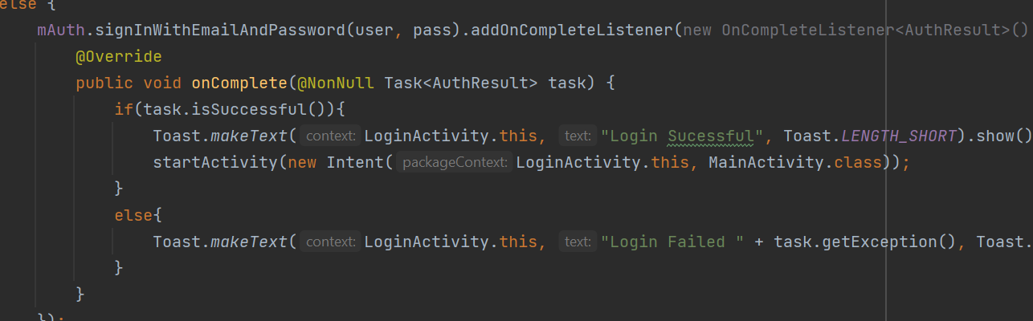

These functions connect to the online Firebase service which the authentication has been setup on as shown below.

### Quiz

The quiz uses an array of questions in which update the UI elements on button click to the next question in the array and loops until the number of loops is equal to the size of the questions array.

Once the quiz is complete the results are then submitted to the Firebase real-time database:

### Scoreboard

Unfortunately due to time constraints I was unable to finish this functionality, The page has been created and the data is being successfully entered into the database and queried out but unfortunately not had time to add the data to the display. See image below for UI design.

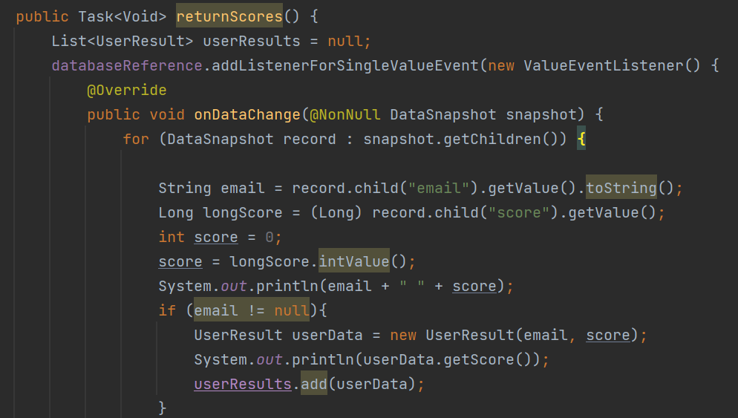The page follows the same design as the other pages but uses a table layout to display the results. The email addresses of the users would appear under the user column and score of the user under the score. The page also has a functioning return to home button. This page uses ScoreBoardActivity.class and UserResultDAO.class to query the data. The function below shows the incomplete function to return the data from the query it is currently able to print it to console but not display on screen yet.

# Conclusion

In conclusion I have managed to meet the specification of the app originally proposed creating a quiz application with a home screen menu and authentication. For future upgrades I would like to complete the scoreboard and I would also like to read the questions in from and external file which are read in randomly. Other than these changes I would like to make I am overall happy with the application.

# References

Abdullah, M., 2020. *10 Best IDE For Android App Development in 2021.* [Online]   
Available at: https://www.intelvue.com/10-best-ide-for-android-app-development/

Babich, N., 2019. *The 4 Golden Rules of UI Design.* [Online]   
Available at: https://xd.adobe.com/ideas/process/ui-design/4-golden-rules-ui-design/

Berezhnoi, R., 2019. *What is UI Design and why is it important?.* [Online]   
Available at: https://f5-studio.com/articles/what-is-user-interface-design-and-why-is-it-important/  
[Accessed 25 03 2022].

Cherry, K., 2022. *Color Psychology: What Does the Color Purple Mean?.* [Online]   
Available at: https://www.verywellmind.com/the-color-psychology-of-purple-2795820

Wayner, P., 2021. *What is Firebase?.* [Online]   
Available at: https://venturebeat.com/2021/08/02/what-is-firebase/