Amazon India Sales Dashboard
Detailed Solution Report • Sales, Profit, Products, Orders, Payment, Fulfilment & Geography

Dataset analysed: Amazon Sales Data India.xlsx
Requirements source: Amazon India Dashboard.docx

Core KPI | Calculated Result
Total Sales | ₹155,789,893.89
Total Profit | ₹33,167,008.49
Total Orders | 10,000
Total Units Sold | 24,926
Average Order Value | ₹15,578.99
Profit Margin | 21.29%
Return Rate | 4.85%
Cancellation Rate | 5.00%

Purpose: This report translates the supplied business requirements into a complete, management-friendly analytical solution. The calculations below are derived from the 10,000-row Sheet1 dataset; the supplied Word document defines the dashboard objectives and expected insights.

1. Business Requirements & Analytical Approach
The supplied requirements call for a simple, easy-to-understand management dashboard covering Sales, Profit, Products, Orders, Customer Order Status, Payment, Fulfilment and Geographic Performance. fileciteturn0file0L3-L18

Dashboard sections required
- Overall Sales & Profit Performance: Total Sales, Total Profit, Total Orders, Total Units Sold, Average Order Value, Profit Margin %, and monthly Sales & Profit Trend. fileciteturn0file0L19-L33
- Category & Product Performance: Category-wise Sales, Profit and Units Sold, plus Top 10 Products by Sales. fileciteturn0file0L34-L44
- Order Status & Revenue Loss: Delivered, Shipped, Returned and Cancelled orders; Return Rate %, Cancellation Rate %, and category-wise returns/cancellations. fileciteturn0file0L45-L60
- Payment, Fulfilment & Geographic Performance: Sales/Profit by payment and fulfilment, plus state-wise Sales, Profit and Orders. fileciteturn0file0L61-L77

Data preparation checks
- The analysis uses Sheet1, containing 10,000 order-level records and 13 fields.
- Order_Date was converted to a true date and a Month field was derived for monthly trend analysis.
- Order_ID was treated as the order identifier; it is unique across the 10,000 records in the supplied data.
- Sales and Profit were aggregated from Total_Sales_INR and Profit_INR respectively; Quantity was aggregated as Units Sold.
- Rates are calculated using order counts, consistent with the requirement's order-status framing.

Recommended calculated fields / formulas
Metric | Formula
Average Order Value | Total Sales ÷ Total Orders
Profit Margin % | Total Profit ÷ Total Sales
Return Rate % | Returned Orders ÷ Total Orders × 100
Cancellation Rate % | Cancelled Orders ÷ Total Orders × 100
Monthly Sales | SUM(Total_Sales_INR) grouped by Year-Month
Category Sales | SUM(Total_Sales_INR) grouped by Category
State Profit | SUM(Profit_INR) grouped by Ship_State

2. Solution — Overall Sales & Profit Performance
Business question: How is the business performing overall?
KPI | Result | Interpretation
Total Sales | ₹155,789,893.89 | Overall revenue represented in the supplied dataset.
Total Profit | ₹33,167,008.49 | Aggregate profit generated across all orders.
Total Orders | 10,000 | Number of unique orders.
Total Units Sold | 24,926 | Total quantity across all orders.
Average Order Value | ₹15,578.99 | Average sales value per order.
Profit Margin | 21.29% | Profit generated as a share of sales.
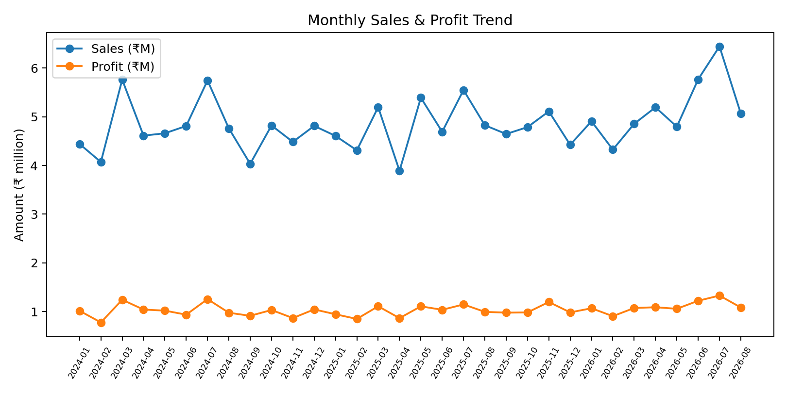
Observed trend points: the highest monthly sales occur in 2026-07 at ₹6,443,679.00; the highest monthly profit occurs in 2026-07 at ₹1,329,442.03; the lowest monthly sales occur in 2025-04 at ₹3,889,801.47. These are descriptive observations from the supplied records.

Dashboard implementation
- Place six KPI cards across the top: Total Sales, Total Profit, Total Orders, Total Units, AOV and Profit Margin.
- Use a line chart with Month on the X-axis and Sales/Profit on the Y-axis. If using Power BI, use a continuous Month/Date axis and tooltips for exact values.
- Add slicers for Order Date, Category, Order Status, Payment Method, Fulfillment and Ship State so management can filter the entire page.

3. Solution — Category & Product Performance
Business question: Which products and categories are driving the business?
Category | Sales | Profit | Units | Orders
Electronics & Mobiles | ₹123,569,507.07 | ₹26,310,257.24 | 7,579 | 3,045
Home & Kitchen | ₹17,973,218.93 | ₹3,837,268.36 | 4,684 | 1,888
Apparel & Fashion | ₹9,831,025.09 | ₹2,085,354.00 | 6,452 | 2,580
Beauty & Personal Care | ₹2,889,178.50 | ₹604,390.41 | 3,734 | 1,499
Pantry & Groceries | ₹1,526,964.30 | ₹329,738.48 | 2,477 | 988
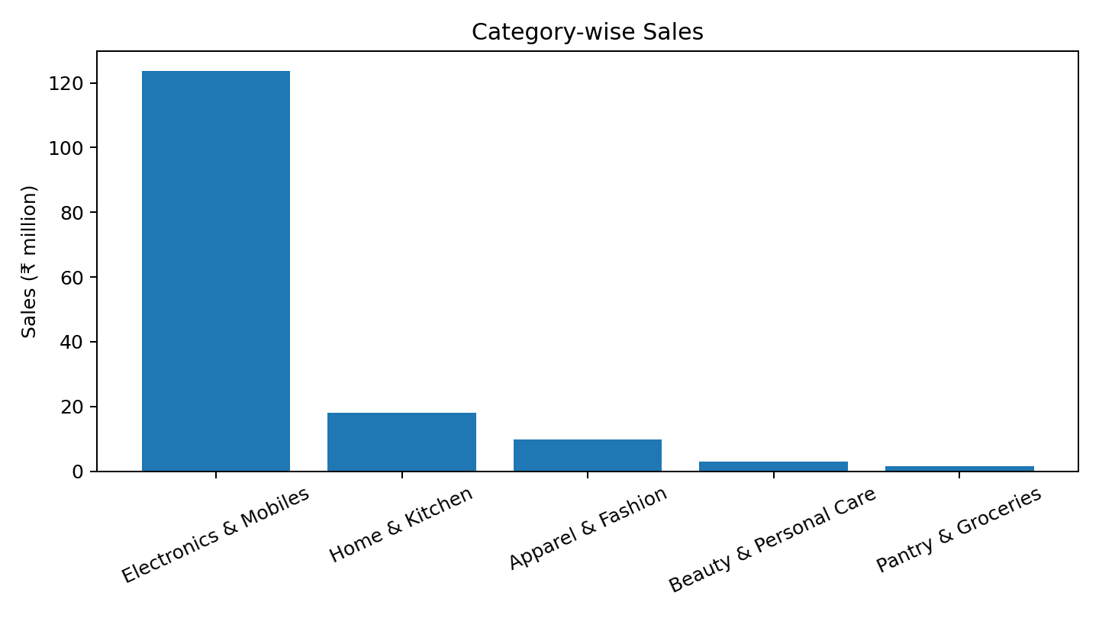

Top 10 products by sales
Rank | Product | Sales | Profit | Units
1 | Laptop Backpack | ₹26,529,187.41 | ₹5,628,644.03 | 1,641
2 | Power Bank 20000mAh | ₹25,548,449.07 | ₹5,496,680.51 | 1,573
3 | 5G Smartphone | ₹24,330,766.23 | ₹5,109,132.92 | 1,478
4 | Wireless Earbuds | ₹23,848,640.89 | ₹5,204,191.90 | 1,475
5 | Smartwatch | ₹23,312,463.47 | ₹4,871,607.88 | 1,412
6 | Stainless Steel Dinner Set | ₹3,865,114.25 | ₹819,333.80 | 953
7 | Cotton Bedsheet Double | ₹3,789,133.82 | ₹843,105.06 | 998
8 | Water Purifier | ₹3,785,924.80 | ₹794,225.82 | 992
9 | Induction Cooktop | ₹3,510,999.56 | ₹761,204.61 | 907
10 | Mixer Grinder 750W | ₹3,022,046.50 | ₹619,399.07 | 834
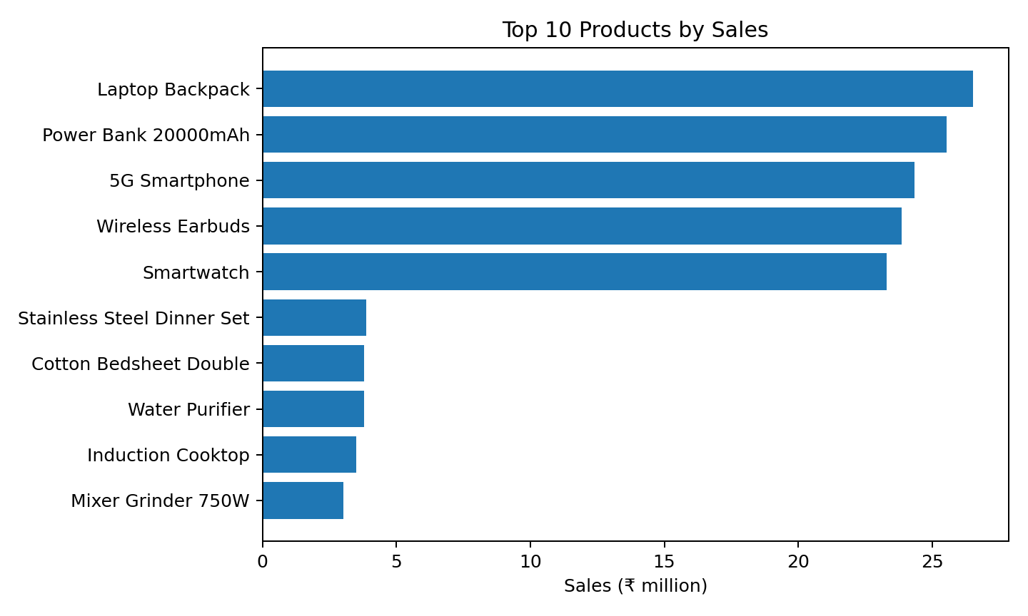
Key descriptive finding: Electronics & Mobiles is the largest category by sales and profit in the supplied dataset. The leading individual products by sales are concentrated in electronics, with Laptop Backpack, Power Bank 20000mAh, 5G Smartphone, Wireless Earbuds and Smartwatch appearing at the top of the ranking.

4. Solution — Order Status & Revenue Loss
Business question: How many orders are successfully completed and how many are being lost?
Status | Orders | Sales | Profit | Units | Share of Orders
Delivered | 8,147 | ₹125,894,209.85 | ₹29,697,472.88 | 20,257 | 81.47%
Shipped | 868 | ₹14,246,941.40 | ₹3,469,535.61 | 2,179 | 8.68%
Returned | 485 | ₹7,960,583.45 | ₹0.00 | 1,226 | 4.85%
Cancelled | 500 | ₹7,688,159.19 | ₹0.00 | 1,264 | 5.00%
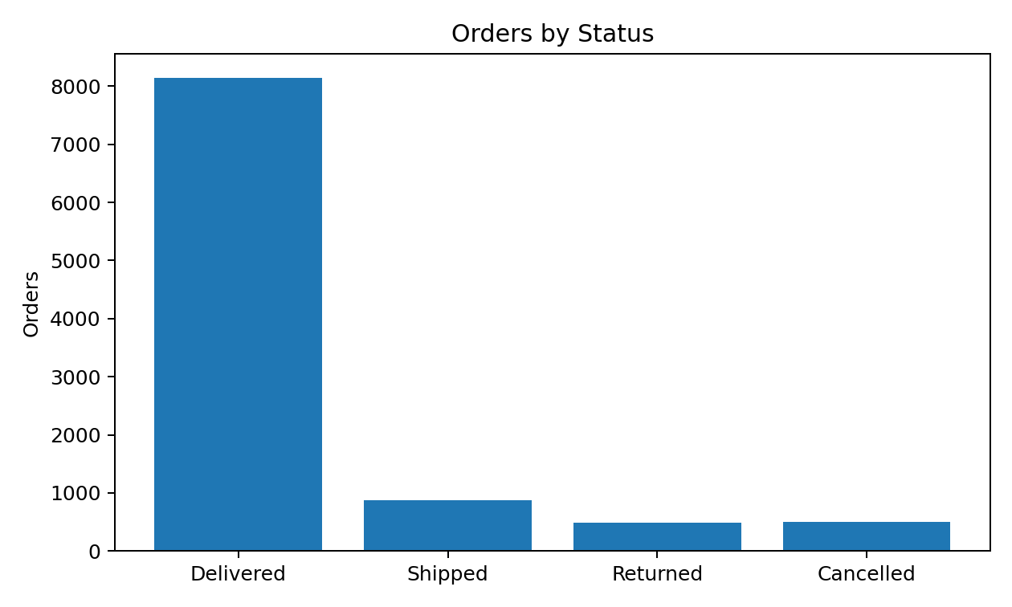

Overall status rates
Metric | Calculation | Result
Return Rate | 485 returned ÷ 10,000 orders | 4.85%
Cancellation Rate | 500 cancelled ÷ 10,000 orders | 5.00%
Delivered Share | 8,147 delivered ÷ 10,000 orders | 81.47%
Shipped Share | 868 shipped ÷ 10,000 orders | 8.68%

Category-wise returns & cancellations
Category | Returned | Cancelled | Return Rate | Cancellation Rate
Apparel & Fashion | 110 | 148 | 4.26% | 5.73%
Beauty & Personal Care | 75 | 84 | 5.00% | 5.59%
Electronics & Mobiles | 164 | 136 | 5.39% | 4.46%
Home & Kitchen | 90 | 91 | 4.77% | 4.81%
Pantry & Groceries | 46 | 41 | 4.66% | 4.13%
Descriptive finding: 8,147 orders are marked Delivered, while 485 are Returned and 500 are Cancelled. Among categories, Electronics & Mobiles has the highest return rate (5.39%) in this dataset, while Apparel & Fashion has the highest cancellation rate (5.73%).

5. Solution — Payment Method Performance
The requirements ask for Sales by Payment Method and Profit by Payment Method. fileciteturn0file0L61-L68
Payment Method | Sales | Profit | Orders | Profit Margin
UPI | ₹78,515,436.26 | ₹16,653,494.14 | 4,972 | 21.21%
Credit/Debit Card | ₹31,069,230.90 | ₹6,525,646.17 | 2,074 | 21.00%
Cash on Delivery (COD) | ₹23,101,583.64 | ₹5,008,107.37 | 1,458 | 21.68%
Net Banking | ₹15,419,486.46 | ₹3,292,296.82 | 1,024 | 21.35%
Amazon Pay Later | ₹7,684,156.63 | ₹1,687,463.99 | 472 | 21.96%
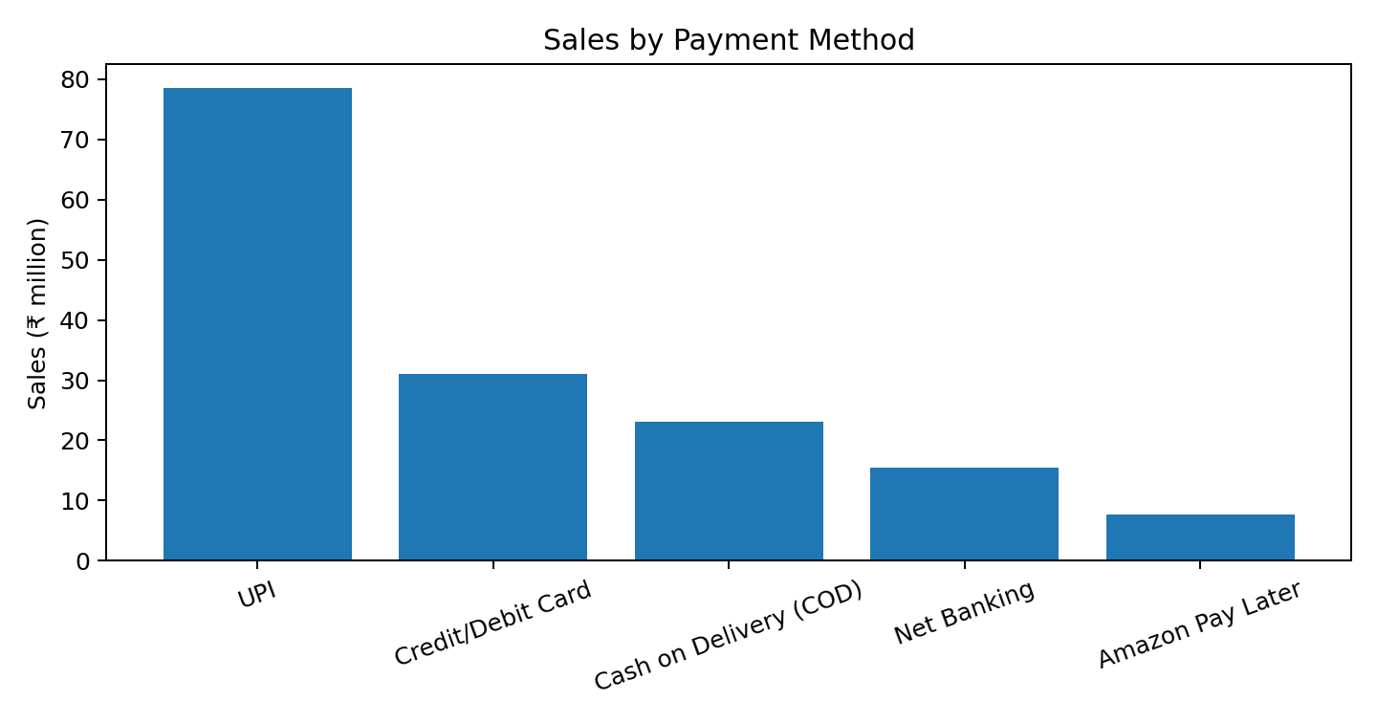

Recommended dashboard visual
- Use a clustered bar chart for Sales by Payment Method.
- Use a second bar chart for Profit by Payment Method.
- Show Order Count in the tooltip or as a data label to distinguish high-value payment channels from high-volume channels.
- UPI is the largest payment method by both sales and profit in the supplied data.

6. Solution — Fulfilment Performance
The requirements specify Sales by Fulfillment Method and Profit by Fulfillment Method. fileciteturn0file0L68-L70
Fulfillment | Sales | Profit | Orders | Profit Margin
Amazon (FBA) | ₹107,528,288.07 | ₹22,882,414.52 | 7,054 | 21.28%
Seller Flex | ₹31,198,391.98 | ₹6,815,054.52 | 1,966 | 21.84%
Merchant (FBM) | ₹17,063,213.84 | ₹3,469,539.45 | 980 | 20.33%

Geographic Performance
The dashboard should provide state-wise Sales, Profit and Orders so management can identify important markets. fileciteturn0file0L71-L77
State | Sales | Profit | Orders
Maharashtra | ₹29,554,237.21 | ₹6,301,731.56 | 1,840
Karnataka | ₹24,415,704.16 | ₹5,273,235.35 | 1,515
Delhi | ₹22,361,687.04 | ₹4,699,095.38 | 1,444
Tamil Nadu | ₹17,889,855.25 | ₹3,856,864.11 | 1,109
Uttar Pradesh | ₹14,140,675.36 | ₹2,978,266.81 | 991
Telangana | ₹13,961,458.53 | ₹2,944,127.16 | 906
West Bengal | ₹10,864,550.51 | ₹2,344,788.08 | 665
Gujarat | ₹9,369,304.18 | ₹2,008,021.80 | 591
Rajasthan | ₹6,620,697.25 | ₹1,383,028.68 | 456
Kerala | ₹6,611,724.40 | ₹1,377,849.56 | 483
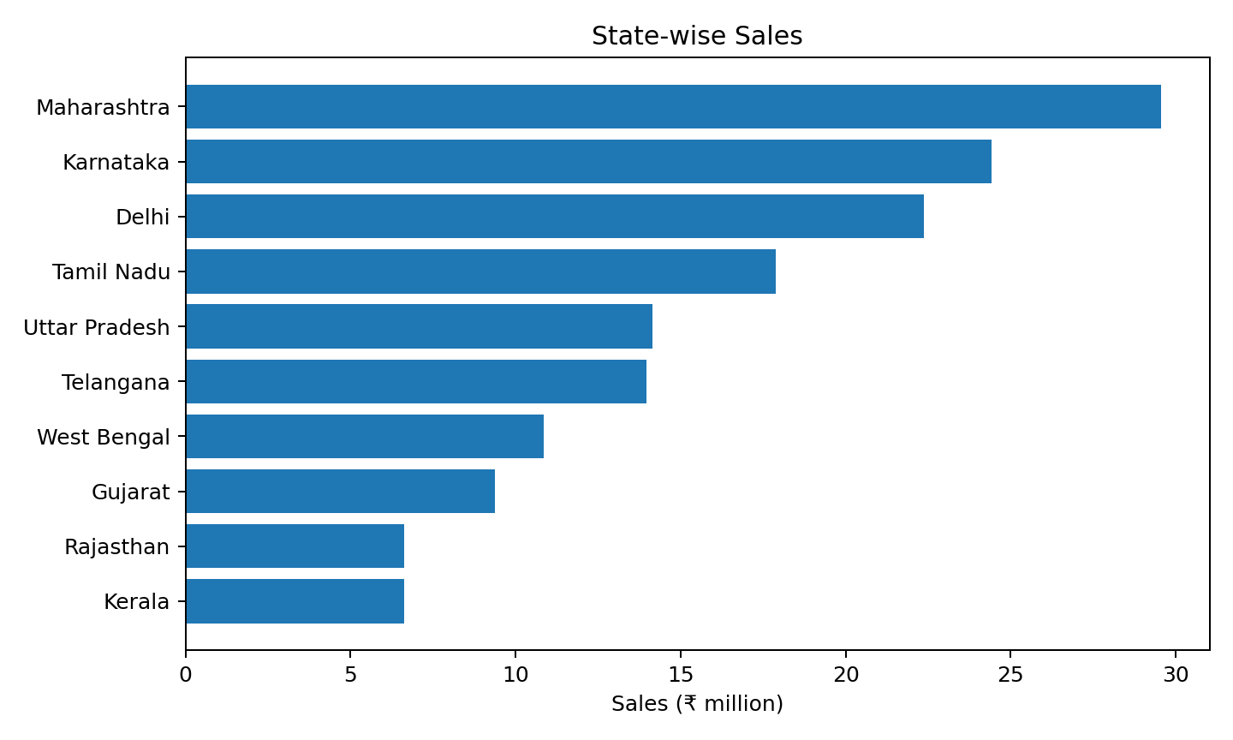
Descriptive finding: Maharashtra has the highest sales, profit and order count among the states in the supplied dataset. Karnataka and Delhi follow it on sales, while the state-level ranking can be explored through the dashboard's geographic filters.

7. Dashboard Layout & Build Instructions

Recommended one-page layout
Area | Visual / KPI | Purpose
Top row | 6 KPI Cards | Instant view of business performance
Middle-left | Monthly Sales & Profit line chart | Trend monitoring
Middle-right | Category Sales / Profit | Category contribution
Lower-left | Top 10 Products | Product concentration
Lower-middle | Order Status | Delivered vs Shipped vs Returned vs Cancelled
Lower-right | Payment & Fulfilment | Channel contribution
Bottom | State Sales / Profit / Orders | Geographic performance
Side / top slicers | Date, Category, Status, Payment, Fulfilment, State | Interactive filtering

Power BI implementation steps
- Load Amazon Sales Data India.xlsx and select Sheet1.
- Set Order_Date to Date; Quantity and order counts to numeric; Total_Sales_INR and Profit_INR to currency/decimal measures.
- Create measures: Total Sales = SUM(Total_Sales_INR); Total Profit = SUM(Profit_INR); Total Units = SUM(Quantity); Total Orders = DISTINCTCOUNT(Order_ID).
- Create AOV = DIVIDE([Total Sales],[Total Orders]) and Profit Margin % = DIVIDE([Total Profit],[Total Sales]).
- Create Returned Orders and Cancelled Orders using CALCULATE with Order_Status filters; divide by Total Orders for the corresponding rates.
- Create a Month/Year field from Order_Date and use it for the trend visual.
- Use bar/column charts for category, product, payment and fulfilment analysis; use a map or filled map for state-level sales if the environment supports reliable India state mapping.
- Keep titles in plain business language because the manager is specified as non-technical. Use consistent number formatting: ₹ for money, whole numbers for orders/units, and percentages with 1–2 decimals.

Quality checks before submission
- Verify that KPI totals reconcile to the source: Sales ₹155,789,893.89; Profit ₹33,167,008.49; Orders 10,000; Units 24,926.
- Check that category totals, payment totals, fulfilment totals and state totals each reconcile to overall sales/profit.
- Confirm order-status counts sum to 10,000.
- Use the same date filter across every visual.
- Check that cancelled/returned orders are not accidentally counted twice in any loss-rate measure.

8. Management Insights & Recommended Actions

Data-supported observations
- Overall sales are ₹155.79 million and profit is ₹33.17 million, producing a 21.29% aggregate profit margin in the supplied records.
- Electronics & Mobiles contributes the largest share of sales and profit among the five categories.
- UPI is the largest payment method by sales and profit.
- Amazon (FBA) is the largest fulfilment method by sales and profit.
- Maharashtra is the largest state market in the dataset by sales, profit and orders.
- Returned and cancelled orders together represent 985 orders, or 9.85% of all orders.
- Monthly sales vary materially across the observed period; the dashboard trend should therefore be used to monitor peaks and troughs rather than relying only on the aggregate KPI.

Action framework for management
Area | What to monitor | Possible management action
Sales & Profit | Monthly sales, profit and margin | Investigate months with sharp changes and replicate strong-period practices where appropriate.
Products | Top 10 sales products and category contribution | Maintain availability of high-sales products and review underperforming products.
Returns | Return rate by category/product | Review product quality, descriptions, sizing/specifications and customer feedback for high-return segments.
Cancellations | Cancellation rate by category | Investigate stock availability, delivery promises and order-processing delays.
Payment | Sales/profit by payment method | Track channel mix and ensure high-volume methods remain operational.
Fulfilment | Sales/profit by fulfilment method | Compare performance and operational outcomes across fulfilment channels.
Geography | State sales, profit and orders | Identify high-volume markets and investigate lower-volume markets for growth opportunities.

Final deliverable structure
- Page 1: Executive KPI summary.
- Page 2: Requirements, data preparation and formulas.
- Page 3: Overall Sales & Profit.
- Page 4: Category & Product Performance.
- Page 5: Order Status & Revenue Loss.
- Page 6: Payment Method Performance.
- Page 7: Fulfilment & Geographic Performance.
- Page 8: Dashboard layout and Power BI build instructions.
- Page 9: Management insights and action framework.

End of Solution Report

